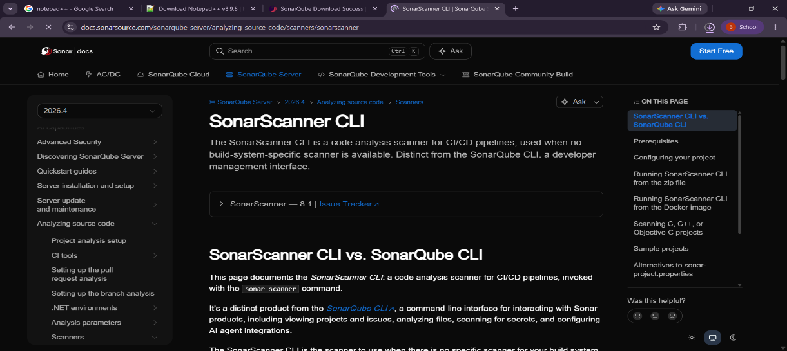


Experiment:8-SonarQube
Name : J. Lasya Geethika
roll no : 2420030686
Step 1:install SonarQube
step 2 : install sonarscanner
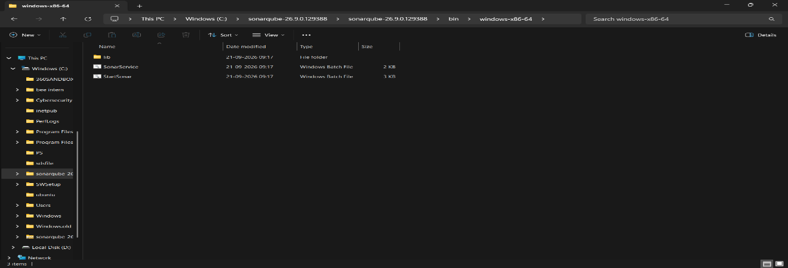
step 3 : extract them to the c drive
step 4: copy the path
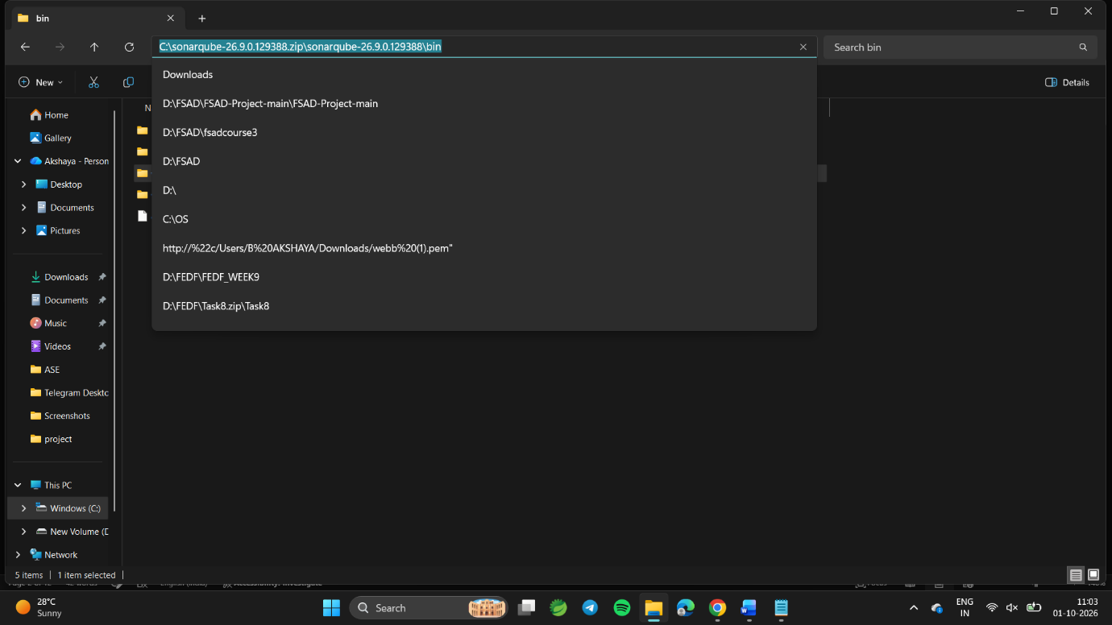
-> open edit the environment variable
click on path->edit
click on new
paste the sonar qube link there
click ok 3 times
copy the path
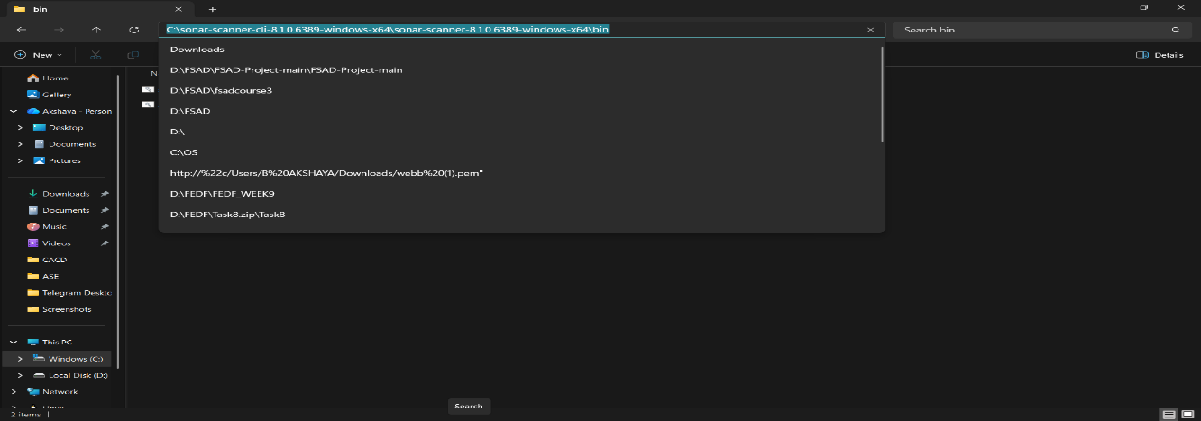
open edit the environment variable
click on path->edit
click on new
paste the sonar scanner link there
click ok 3 times

step 5: open cmd->type "StartSonar" and press enter
procces[ce] is up
SonarQube is operational
the above 2 lins should come for sure
we should not close the cmd ,minimize it
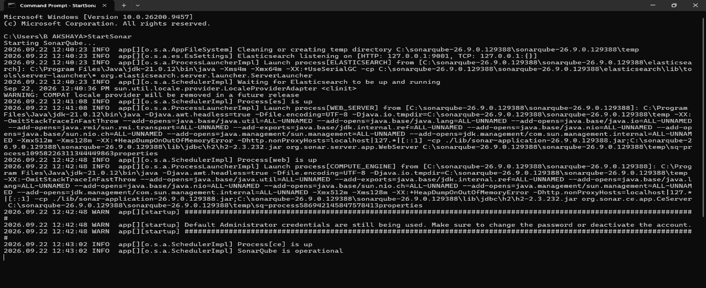
open webbrowser localhost:9000
by default
username :admin
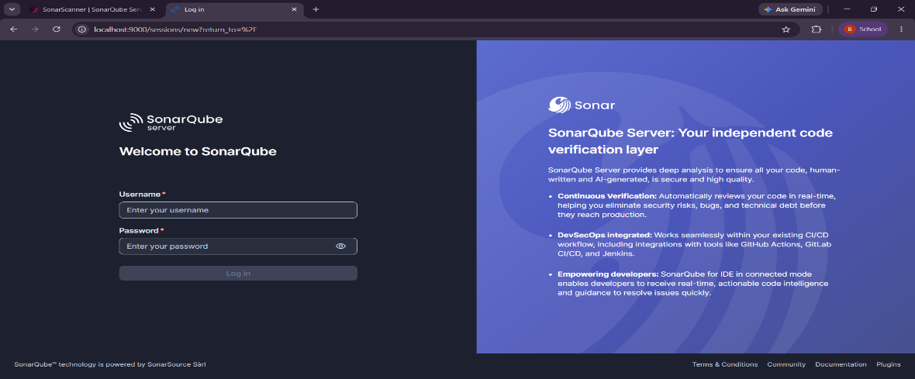
password :admin

after login change the password
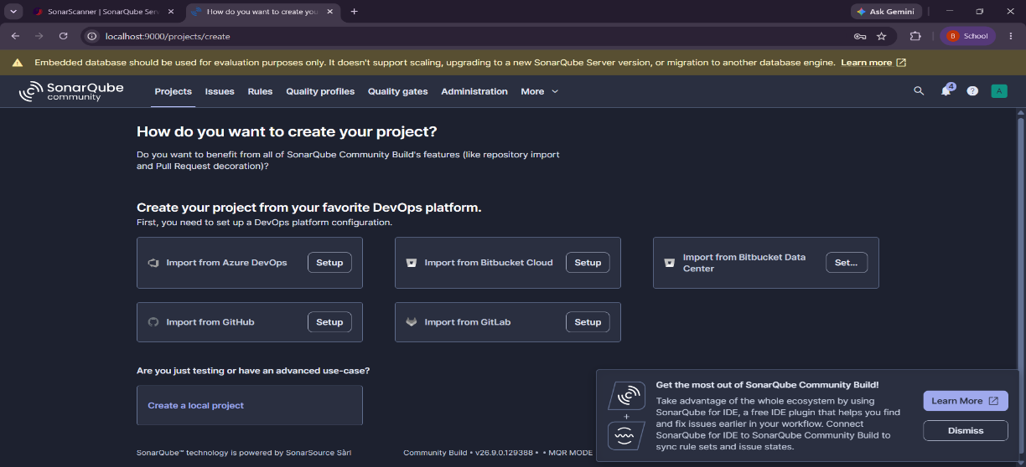
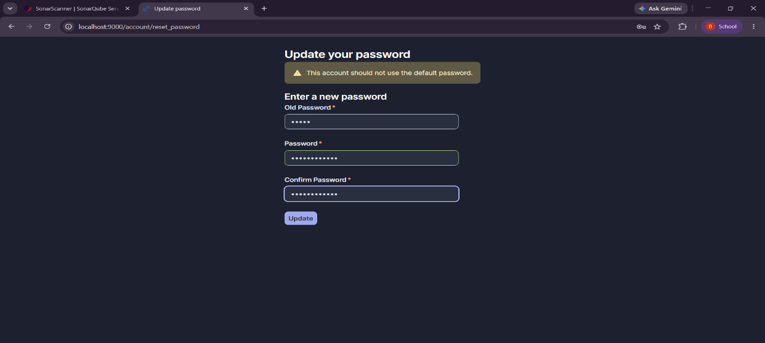
click on create a local project
enter a project name,key name
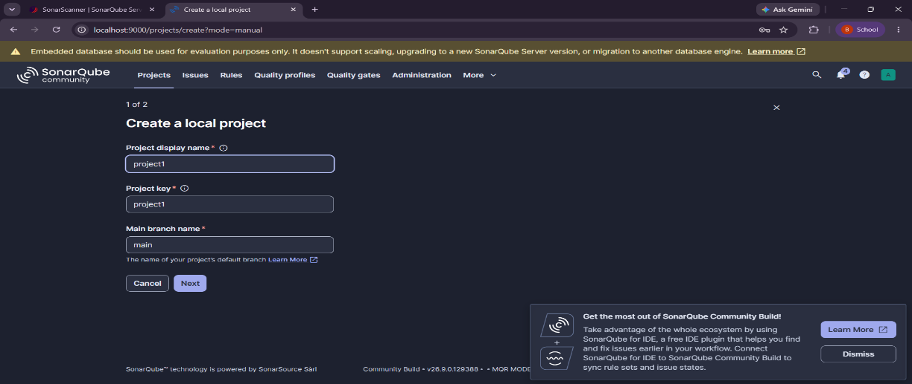
click o next

click on follow instance's default
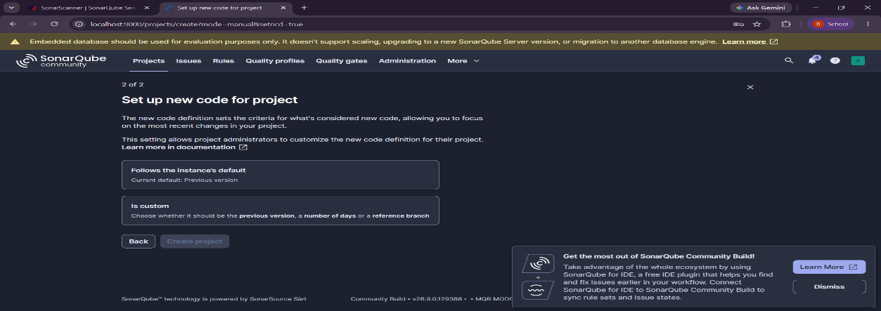
and click on create project

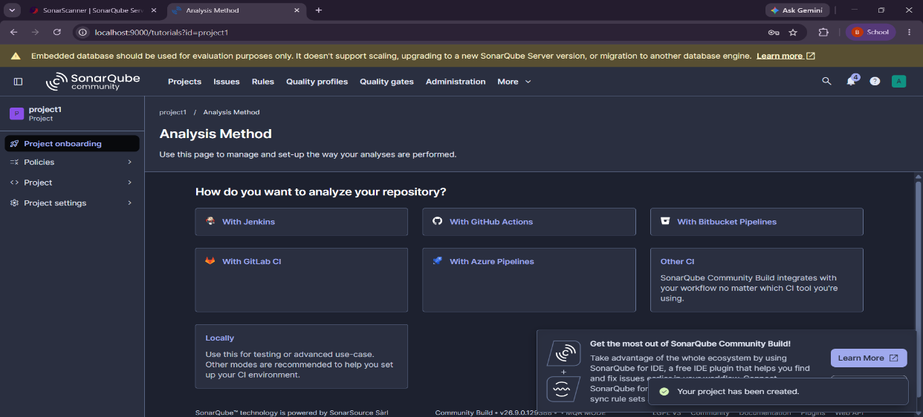
then click on locally
click on generate
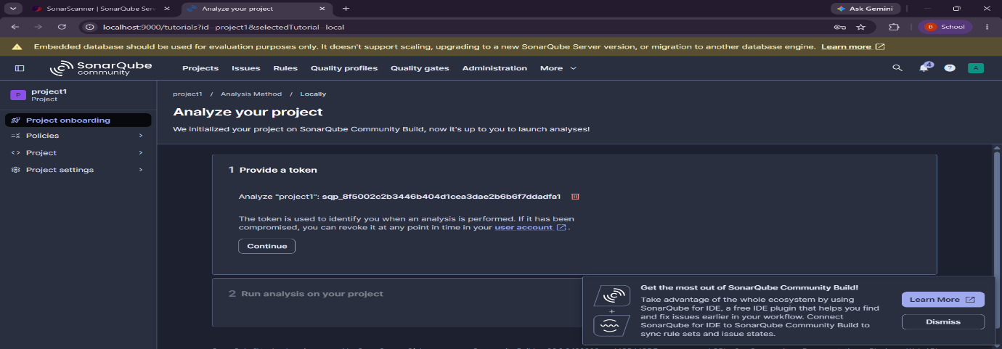
give the token name ,copy the token
check the installion of solarscanner
open the new cmd
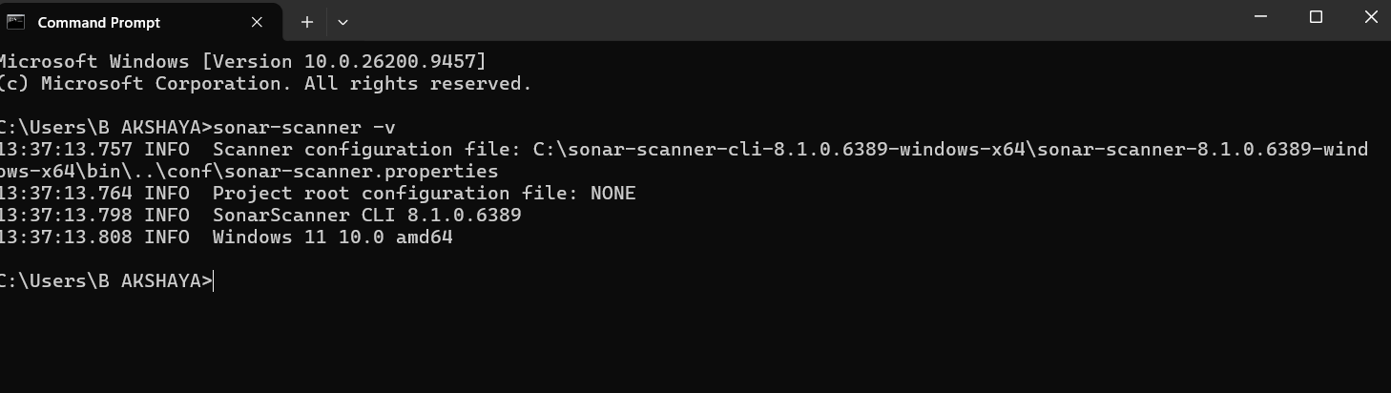
type"sonar-scanner -v"
in c drive open new folder
name it sonarqubes1
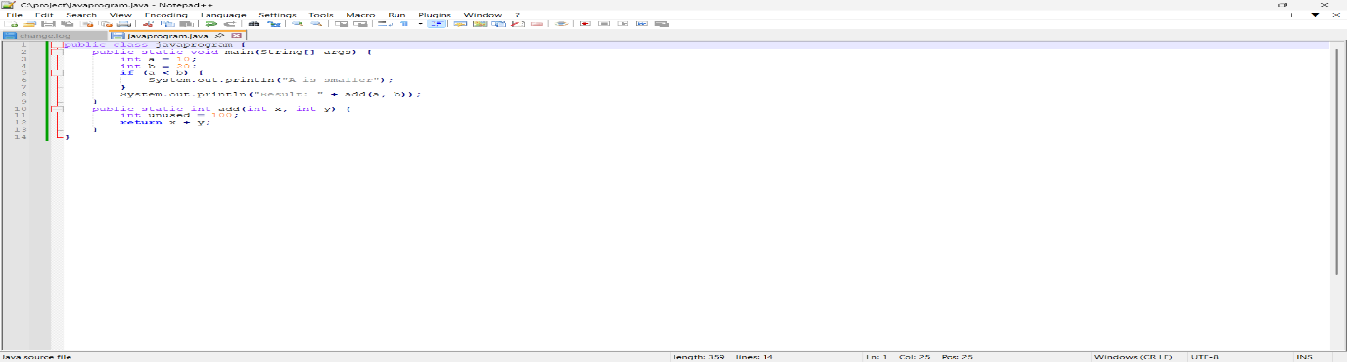
open notepad and paste the java code and save it in sonarqubes1
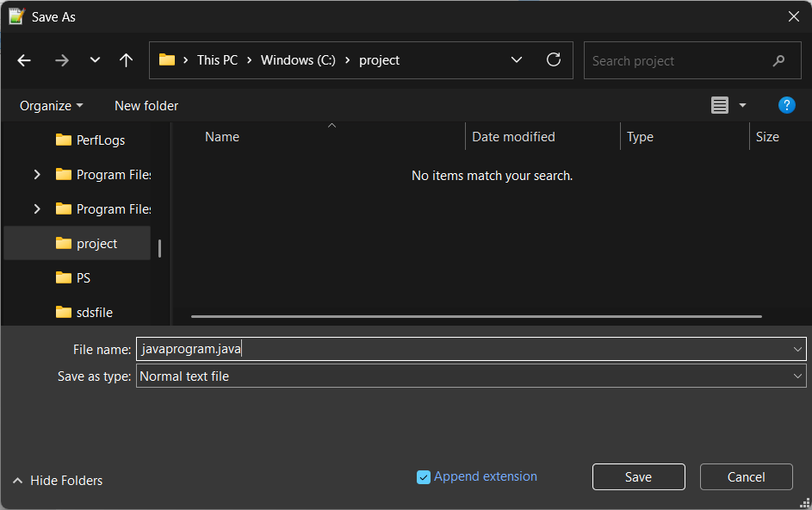
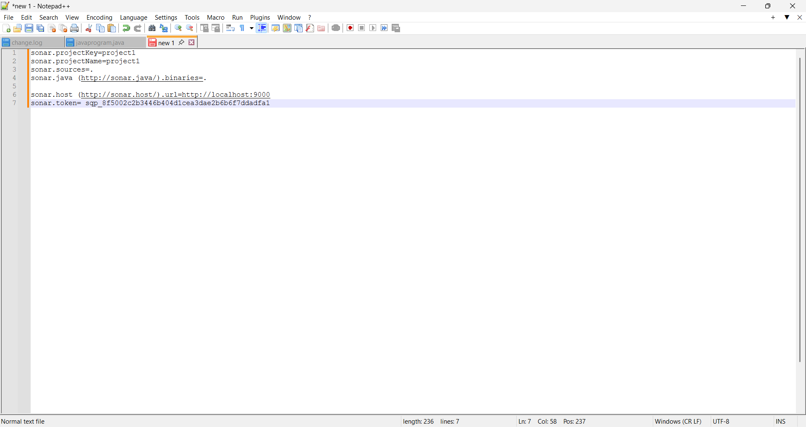
paste the sonar properties code
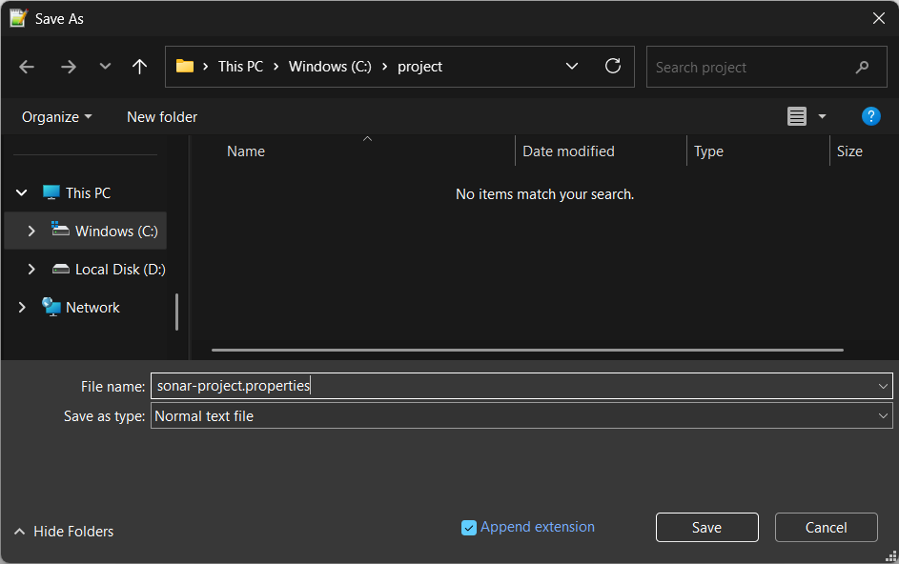
then save it

in cmd type cd c:\project ,
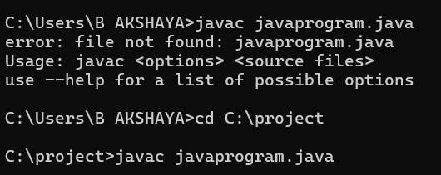
then javac javaprogram.java

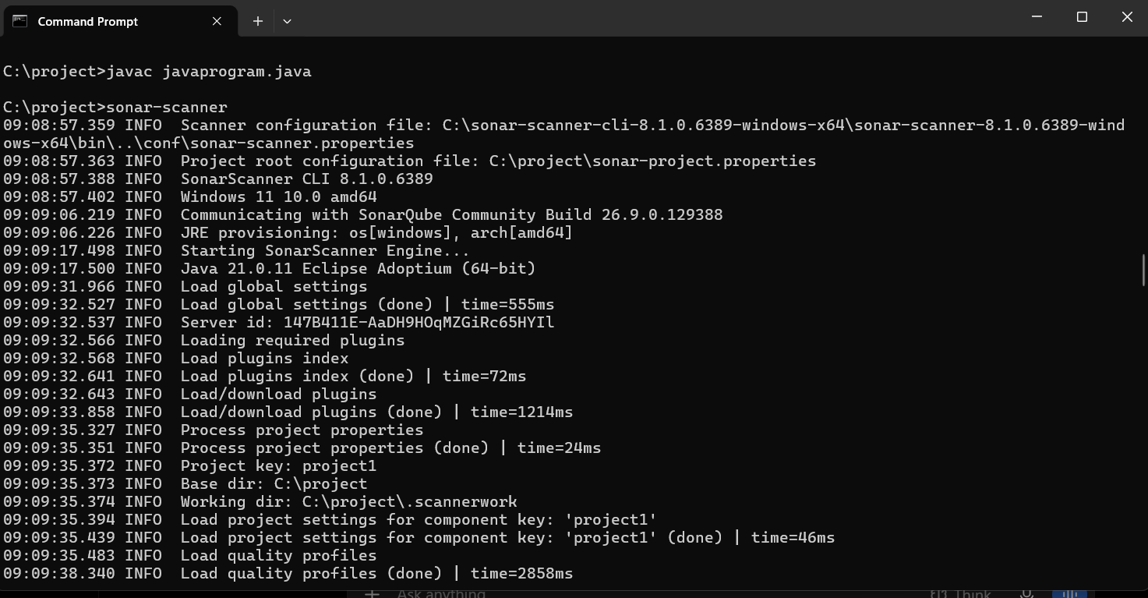
Then type sonar-scanner

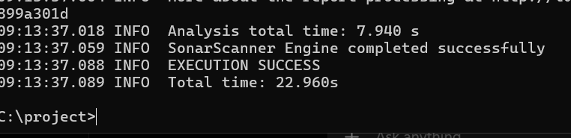

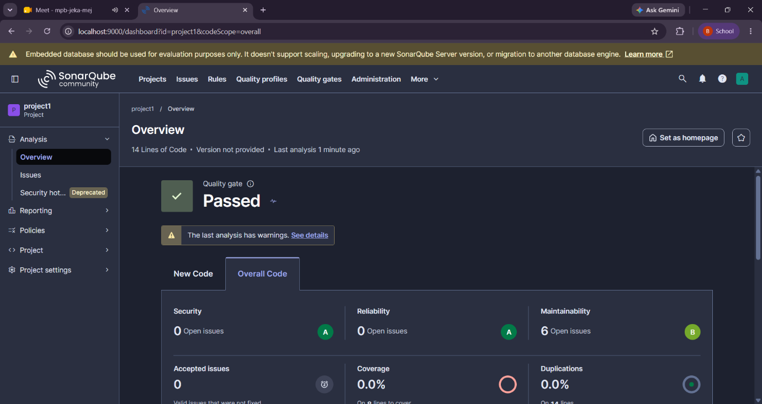
Then open local host 9000,

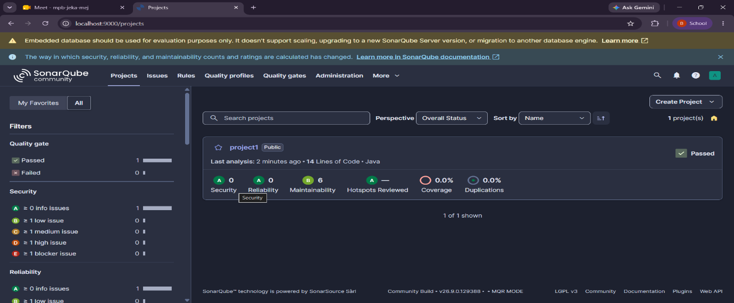

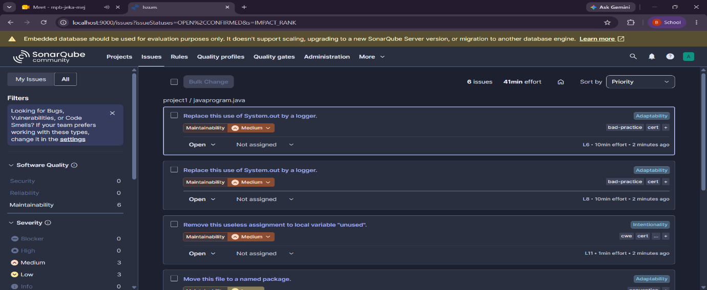
Then check issues

Then exit the sonar qube
