NAME : YARRABOLU LASYA
REG.NO: 192524123
COURSE CODE: ITA0605
COURSE NAME : MANCHINE LEARNING
TOPIC:

DESIGN OF A CRIME PREDICTION SYSTEM USING MACHINE LEARNING

CO1-SDG

DESIGN OF A CRIME PREDICTION SYSTEM USING MACHINE LEARNING

ABSTRACT
Crime prediction is an application of Machine Learning that uses historical crime data to identify patterns and predict possible crime categories under given conditions. The proposed system analyses factors such as crime location, time, month, year, and previous crime occurrences. The collected data is preprocessed and important features are selected before training a Machine Learning model.
In this project, a Random Forest Classifier is used to classify crime categories based on historical patterns. The model is trained using a crime dataset and evaluated using accuracy, precision, recall, F1-score, and a confusion matrix. Data visualization is also used to understand crime distributions and important factors affecting predictions.
The system can assist authorities and city planners in understanding crime trends, identifying areas requiring additional attention, and supporting data-driven resource planning. However, the system is intended for analysing crime patterns rather than predicting whether a particular person will commit a crime.

INTRODUCTION
Crime is an important social issue that affects the safety and quality of life of communities. Traditional crime analysis mainly depends on manually examining historical records, which can be time-consuming when large amounts of data are involved.
Machine Learning provides techniques for analysing large datasets and identifying patterns that may not be easily visible through manual analysis. A Crime Prediction System can use historical crime records to learn relationships between factors such as location, time, month, and crime type.
The proposed system uses Machine Learning to classify the likely category of crime based on selected input features. The system follows a complete workflow consisting of data collection, preprocessing, feature selection, model training, prediction, and evaluation.
PROBLEM STATEMENT
Traditional crime analysis methods may require significant time and human effort to examine large volumes of historical crime records. There is a need for a data-driven system that can analyse previous crime patterns and provide predictions about possible crime categories.
The problem is to design and implement a Machine Learning-based system that can learn from historical crime data and classify the likely crime category based on factors such as location and time.
4. OBJECTIVES
The main objectives of the project are:
- To collect or generate a suitable historical crime dataset.
- To preprocess the crime data and remove unnecessary or inconsistent information.
- To identify important features that influence crime classification.
- To train a Machine Learning classification model.
- To predict crime categories from input conditions.
- To evaluate the performance of the trained model.
- To visualize crime patterns using graphs.
- To demonstrate how Machine Learning can support data-driven crime analysis.
- To promote responsible use of predictive systems without targeting individuals.
EXISTING SYSTEM
In the existing system, crime analysis is often performed using:
- Manual examination of police records.
- Basic statistical reports.
- Historical crime maps.
- Human interpretation of crime trends.
- Conventional database queries.

Disadvantages of the Existing System
- Analysis can be time-consuming.
- Large datasets are difficult to analyse manually.
- Hidden patterns may not be easily identified.
- Prediction accuracy depends heavily on human analysis.
- Real-time analysis can be difficult.
- It may not efficiently handle large and complex datasets.
PROPOSED SYSTEM
The proposed system uses Machine Learning to analyse historical crime
data and predict crime categories.
The system first collects the dataset and performs preprocessing operations such as handling missing values, converting categorical data into numerical form, and selecting relevant features. The processed data is divided into training and testing datasets.
A Random Forest Classifier is then trained using the training data. After training, the model predicts crime categories for previously unseen test data. The results are evaluated using different performance metrics.
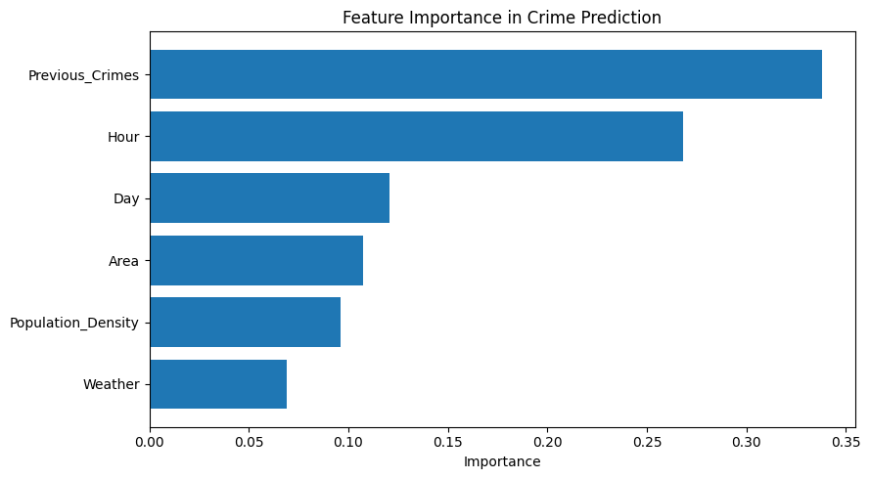

ADVANTAGES
- Faster analysis of large datasets.
- Automated pattern identification.
- Supports crime trend analysis.
- Provides measurable model performance.
- Can be integrated with visualization tools.
- Can assist in data-driven resource planning.
SYSTEM ARCHITECTURE
The proposed system consists of the following stages:
Crime Dataset
↓
Data Preprocessing
↓
Feature Selection
↓
Train-Test Split
↓
Random Forest Model
↓
Model Training
↓
Crime Prediction
↓
Performance Evaluation
↓
Visualization and Results

ARCHITECTURE EXPLANATION
The Crime Dataset contains historical crime records.
The Data Preprocessing stage cleans the dataset and converts the data into a format suitable for Machine Learning.
During Feature Selection, relevant attributes such as location, month, year, day, and hour are selected.
The dataset is divided into training and testing data. The training data is used to build the model, while the testing data is used to evaluate it.
The Random Forest Classifier learns patterns from the training dataset and predicts the crime category.
Finally, the model is evaluated using performance metrics and the results are represented using graphs and charts.
DATASET DESCRIPTION
The dataset contains historical crime-related information. Important attributes used in the project include:
Feature | Description
Year | Year in which the crime was recorded
Month | Month of occurrence
Day | Day of the month
Hour | Approximate hour of occurrence
Location | Location where the incident was recorded
District | Administrative area
Previous Crime Count | Number of previously recorded crimes
Crime Category | Category of the recorded crime
The Crime Category is considered the target variable that the Machine Learning model attempts to predict.
DATA PREPROCESSING
Data preprocessing is an important step because raw datasets may
contain missing, duplicate, or inconsistent values.
The following preprocessing steps are performed:

Handling Missing Values
Missing values are identified and either replaced with suitable values or removed when appropriate.

Removing Duplicate Records
Duplicate records are removed to prevent repeated observations from affecting model training.

Encoding Categorical Variables
Categorical variables such as location and district cannot be directly processed by many Machine Learning algorithms. Therefore, they are converted into numerical representations using encoding techniques.

Feature Selection
Relevant features are selected to improve model performance and reduce unnecessary information.

Train-Test Splitting
The dataset is divided into:
- Training data: Used to train the Machine Learning model.
- Testing data: Used to evaluate the trained model.
A common split is 80% training and 20% testing.

FEATURE SELECTION
The important features selected for the proposed system include:
- Year
- Month
- Day
- Hour
- Location
- District
- Previous crime count
These features provide information about the temporal and geographical patterns associated with recorded crimes.
Feature selection helps reduce unnecessary information and allows the model to focus on variables that are useful for classification.
MACHINE LEARNING ALGORITHM

Random Forest Classifier
Random Forest is a supervised Machine Learning algorithm used for classification and regression problems.
It creates multiple decision trees and combines their predictions to produce a final result.
Instead of depending on a single decision tree, Random Forest uses an ensemble of trees. This generally makes the model more robust and reduces the risk of overfitting compared with a single decision tree.

Working Process
- The training dataset is provided to the Random Forest algorithm.
- Multiple decision trees are created.
- Each tree learns different patterns from the training data.
- Each tree produces a prediction.
- The predictions are combined.
- The category receiving the majority of votes becomes the final prediction.

12. MODEL TRAINING
After preprocessing, the dataset is divided into training and testing sets.
The training data is provided to the Random Forest Classifier. During training, the algorithm learns relationships between the input features and the crime category.
After training is completed, the model is tested using data that was not used during training.
This allows the performance of the model to be evaluated on unseen data.
CRIME PREDICTION
The trained model can accept input information such as:
- Year
- Month
- Day
- Hour
- Location
- District
- Previous crime count
The model processes these inputs and produces a predicted crime category.
For example:
Input:
- Year: 2024
- Month: 7
- Day: 15
- Hour: 21
- Location: Street
- District: Central
- Previous Crime Count: 12
Output:
Predicted Crime Category: Theft
The exact prediction will depend on the dataset and trained model.
MODEL EVALUATION
Model evaluation is performed to determine how effectively the
Machine Learning model classifies crime categories.
The following metrics are used:

Accuracy
Accuracy represents the percentage of correctly classified instances.
Accuracy = Correct Predictions / Total Predictions

Precision
Precision measures how many of the cases predicted as a particular class actually belong to that class.

Recall
Recall measures how many actual cases of a particular class were correctly identified by the model.

F1-Score
F1-score combines precision and recall into a single metric.
F1-score = 2 × (Precision × Recall) / (Precision + Recall)

Confusion Matrix
A confusion matrix shows the number of correct and incorrect predictions for each crime category.
DATA VISUALIZATION
Visualization helps understand patterns in the crime dataset.
The following graphs can be generated:

Crime Category Distribution
A bar chart can show the number of records belonging to each crime category.



Crime by Month
A graph can show how the number of recorded crimes changes across different months.
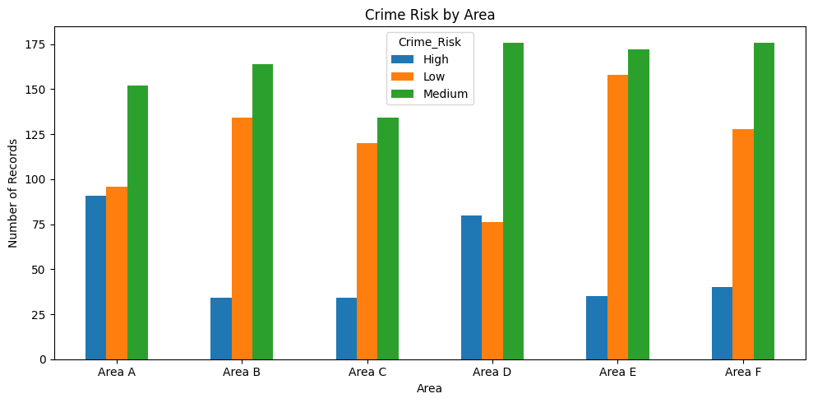

Crime by Hour
A graph can show crime occurrences across different hours of the day.

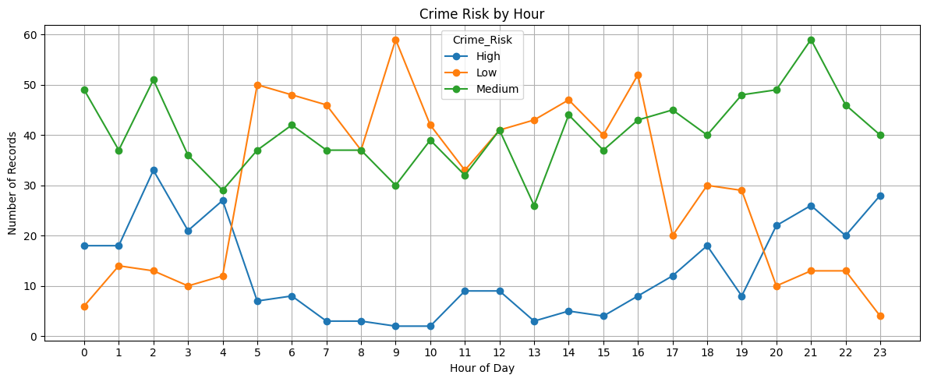

Confusion Matrix
The confusion matrix represents the actual and predicted crime categories.
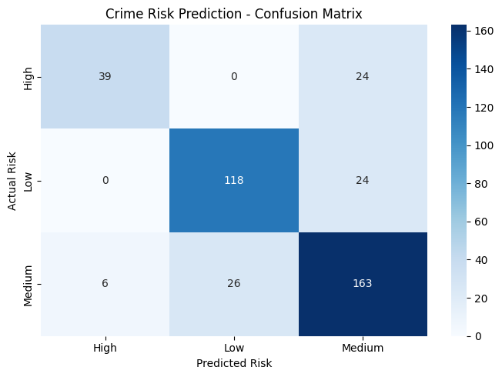

Feature Importance
Random Forest can provide the relative importance of different features used by the model.

IMPLEMENTATION PLATFORM
The project can be implemented using Google Colab, which provides a cloud-based Python programming environment.

Software Requirements
- Google Colab
- Python
- Pandas
- NumPy
- Scikit-learn
- Matplotlib
- Seaborn

Hardware Requirements
- Computer/Laptop
- Internet connection
- Web browser
Google Colab is suitable because it does not require extensive local software installation and allows Python programs to be executed directly in a browser.
IMPLEMENTATION STEPS
The implementation follows these steps:
- Open Google Colab.
- Import the required Python libraries.
- Load or generate the crime dataset.
- Display the first few records.
- Check missing values.
- Perform data preprocessing.
- Encode categorical variables.
- Select input features and target variable.
- Split the dataset into training and testing data.
- Create the Random Forest Classifier.
- Train the model.
- Generate predictions.
- Calculate accuracy, precision, recall, and F1-score.
- Generate a confusion matrix.
- Generate visualization graphs.
- Test the model with sample input.
- Display the predicted crime category.
RESULTS
The proposed Crime Prediction System successfully demonstrates the
use of Machine Learning for crime-category classification.
The Random Forest model learns patterns from historical crime data and produces predictions for unseen data. Model performance is evaluated using accuracy, precision, recall, and F1-score.
The visualization results help identify crime distributions across different categories, months, hours, and locations.
Important: Insert your actual Google Colab results here instead of making up values.
Example format:
Metric | Result
Accuracy | ___ %
Precision | ___
Recall | ___
F1-Score | ___
APPLICATIONS
The proposed system can be used for:
- Crime trend analysis.
- Historical crime pattern identification.
- Resource planning.
- Public safety analysis.
- Law-enforcement planning support.
- Identifying areas requiring additional attention.
- Academic research and demonstration of Machine Learning.
The system should be used as a decision-support tool, with human oversight and fairness checks.
LIMITATIONS
The system has several limitations:
- Prediction quality depends on the quality of the historical dataset.
- Historical data may contain biases.
- Crime patterns can change over time.
- Predictions are not guaranteed to be correct.
- External factors such as social and economic conditions may not be included.
- The model should not be used to label individuals as potential criminals.
- Human expertise is required when interpreting the predictions.
FUTURE ENHANCEMENTS
The project can be enhanced by:
- Using real-time data sources.
- Developing an interactive crime-analysis dashboard.
- Adding geographical maps.
- Comparing multiple Machine Learning algorithms.
- Using time-series models for crime trend forecasting.
- Adding additional contextual features.
- Implementing fairness and bias monitoring.
- Deploying the model as a web application.
- Providing periodic model retraining as new data becomes available.
CONCLUSION
The Crime Prediction System Using Machine Learning demonstrates
how historical crime data can be analysed to identify patterns and classify crime categories. The system performs data preprocessing, feature selection, model training, prediction, and evaluation using a Random Forest Classifier.
The use of Machine Learning can make large-scale crime data analysis faster and more systematic. The generated visualizations and evaluation metrics provide useful information about the performance of the model.
The system can support authorities and researchers in understanding crime trends and planning resources. However, predictions should be treated as analytical assistance rather than absolute conclusions, and responsible use of data is essential to avoid unfair or biased outcomes.

