SIMATS ENGINEERING
ASSESSMENT TOOL 1

COURSE CODE: ITA 06 COURSE NAME: MACHINE LEARNING

COURSE OUTCOME COVERED

CO3: Bayes Theorem – Concept Learning – Maximum Likelihood – Minimum Description Length Principle – Bayes Optimal Classifier – Gibbs Algorithm – Naïve Bayes Classifier – Bayesian Belief Network – EM Algorithm – Probability Learning – Sample Complexity – Finite and Infinite Hypothesis Spaces – Mistake Bound Model, (BL 6)

Assessment Tool Weightage: 40%

QUESTIONS: 15 Total Marks:25

Annexure A

Experiments

Code of Conduct:

I Yarrabolu lasya(192524123) (Name / Reg No) certify that this submission is my original work and that I have adhered to the guidelines specified for this assessment.
I understand that any violation of academic integrity rules will result in disciplinary action.

Signature of the student:Y.Lasya

Annexure A

Short Answer Test

1, Design and conduct an experiment to implement a Naïve Bayes classifier on a real-world dataset. Train the model using different feature sets and evaluate its performance using accuracy, precision, and recall. Analyze how assumptions of feature independence affect the results. Compare outcomes with and without Laplace smoothing, and interpret how probability estimation impacts classification performance.
TITLE: IMPLEMENTATION AND PERFORMANCE ANALYSIS OF NAÏVE BAYES CLASSIFIER

PROBLEM STATEMENT

Design and conduct an experiment to implement a Naïve Bayes classification algorithm using a real-world dataset. The objective is to train the classifier using different combinations of features and evaluate its performance using accuracy, precision, and recall. The experiment also analyzes the effect of the Naïve Bayes assumption that all features are conditionally independent given the class label. Furthermore, the classifier is evaluated with and without Laplace smoothing to understand how probability estimation affects classification performance, especially when some feature values are absent from the training data.
CODE:
import pandas as pd
from sklearn.datasets import load_iris
from sklearn.model_selection import train_test_split
from sklearn.naive_bayes import GaussianNB
from sklearn.metrics import accuracy_score, precision_score, recall_score
# -------------------------------------------------
# STEP 1: Load the real-world Iris dataset
# -------------------------------------------------
iris = load_iris()

X = pd.DataFrame(
iris.data,
columns=iris.feature_names
)
y = iris.target
print("NAIVE BAYES CLASSIFIER")
print("----------------------")
print("\nDataset size:", X.shape)
print("\nFeature names:")
for feature in iris.feature_names:
print(feature)
print("\nClasses:")
print(iris.target_names)
# -------------------------------------------------
# STEP 2: Split dataset into training and testing
# -------------------------------------------------
X_train, X_test, y_train, y_test = train_test_split(
X,
y,
test_size=0.2,
random_state=42,
stratify=y
)
# -------------------------------------------------
# STEP 3: Different feature sets
# -------------------------------------------------
feature_sets = {
"All Features": [
"sepal length (cm)",
"sepal width (cm)",
"petal length (cm)",
"petal width (cm)"
],
"Sepal Features": [
"sepal length (cm)",
"sepal width (cm)"
],
"Petal Features": [
"petal length (cm)",
"petal width (cm)"
]
}
# -------------------------------------------------
# STEP 4: Train and test Naive Bayes
# -------------------------------------------------
for name, features in feature_sets.items():
print("\n===================================")
print(name)
print("===================================")
# Select features
X_train_selected = X_train[features]
X_test_selected = X_test[features]
# Create Naive Bayes model
model = GaussianNB()
# Train
model.fit(X_train_selected, y_train)
# Predict
y_pred = model.predict(X_test_selected)
# Calculate metrics
accuracy = accuracy_score(y_test, y_pred)
precision = precision_score(
y_test,
y_pred,
average="weighted"
)
recall = recall_score(
y_test,
y_pred,
average="weighted"
)
# Display results
print("Accuracy :", round(accuracy * 100, 2), "%")
print("Precision :", round(precision * 100, 2), "%")
print("Recall :", round(recall * 100, 2), "%")
# -------------------------------------------------
# STEP 5: Test different smoothing values
# -------------------------------------------------
print("\n\n===================================")
print("SMOOTHING EXPERIMENT")
print("===================================")
features = [
"sepal length (cm)",
"sepal width (cm)",
"petal length (cm)",
"petal width (cm)"
]
X_train_selected = X_train[features]
X_test_selected = X_test[features]
# Different smoothing values
smoothing_values = [
1e-9,
1e-5,
1e-2,
1.0
]
for value in smoothing_values:
model = GaussianNB(
var_smoothing=value
)
model.fit(
X_train_selected,
y_train
)
y_pred = model.predict(
X_test_selected
)
accuracy = accuracy_score(
y_test,
y_pred
)
precision = precision_score(
y_test,
y_pred,
average="weighted"
)
recall = recall_score(
y_test,
y_pred,
average="weighted"
)
print("\nSmoothing =", value)
print(
"Accuracy :",
round(accuracy * 100, 2),
"%"
)
print(
"Precision :",
round(precision * 100, 2),
"%"
)
print(
"Recall :",
round(recall * 100, 2),
"%"
)
print("\n\nExperiment completed successfully!")

OUTPUT:
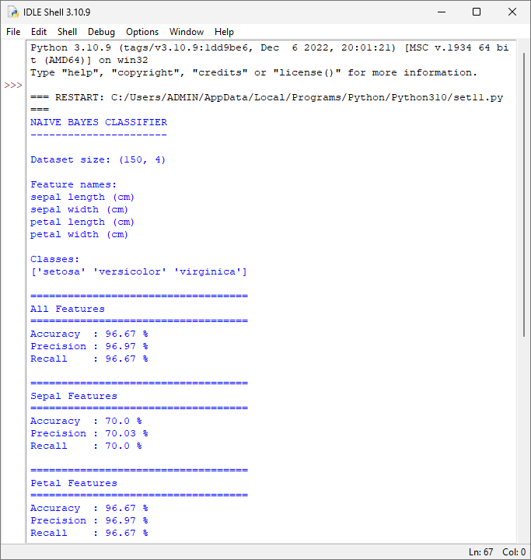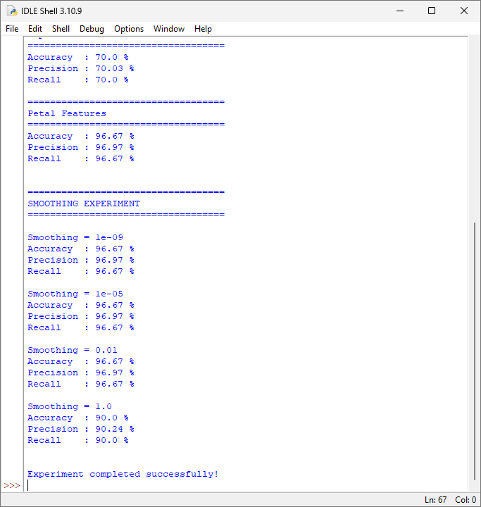

2. Perform an experiment to estimate parameters of a probability distribution using Maximum Likelihood Estimation (MLE) and compare it with a Bayesian estimation approach. Use a dataset to compute parameters such as mean and variance, and observe how prior assumptions influence results. Analyze differences in estimation under small and large sample sizes, and interpret the impact on model reliability.

TITLE: PARAMETER ESTIMATION USING MAXIMUM LIKELIHOOD ESTIMATION AND BAYESIAN ESTIMATION

PROBLEM STATEMENT:
Design and conduct an experiment to estimate the parameters of a probability distribution using Maximum Likelihood Estimation (MLE) and Bayesian Estimation. Using a dataset generated from a normal distribution, estimate parameters such as mean and variance. Compare the estimates obtained using MLE with Bayesian estimates under different prior assumptions. The experiment is performed using both small and large sample sizes to study how the amount of data affects the estimates. The results are analyzed to understand how prior knowledge influences Bayesian estimation and how sample size affects the reliability and accuracy of parameter estimation.
CODE:
import numpy as np
np.random.seed(42)
# True parameters
true_mean = 50
true_variance = 25
true_std = np.sqrt(true_variance)
# Small and large datasets
small_data = np.random.normal(true_mean, true_std, 10)
large_data = np.random.normal(true_mean, true_std, 1000)
# 2. MLE estimation
def mle_estimation(data):
# MLE estimate of mean
mean_mle = np.mean(data)
# MLE estimate of variance
variance_mle = np.mean(
(data - mean_mle) ** 2
)

return mean_mle, variance_mle
# 3. Bayesian estimation of mean
def bayesian_mean_estimation(
data,
prior_mean,
prior_variance):
n = len(data)
sample_mean = np.mean(data)
# Known variance of distribution
data_variance = true_variance
# Posterior mean
posterior_mean = (
(prior_variance * n * sample_mean) +
(data_variance * prior_mean)
) / (
prior_variance * n +
data_variance
)

return posterior_mean
# 4. Define different prior assumptions
# Prior 1: Weak prior
weak_prior_mean = 50
weak_prior_variance = 1000
# Prior 2: Strong prior
strong_prior_mean = 60
strong_prior_variance = 10
# 5. Function to display results
def perform_experiment(data, name):
print("\n======================================")
print(name)
print("======================================")
print("Sample size:", len(data))
# MLE
mle_mean, mle_variance = mle_estimation(data)
print("\nMLE Estimation")
print("----------------------")
print("Mean :", round(mle_mean, 3))
print("Variance :", round(mle_variance, 3))
# Bayesian - weak prior
bayes_weak = bayesian_mean_estimation(
data,
weak_prior_mean,
weak_prior_variance
)
print("\nBayesian Estimation - Weak Prior")
print("--------------------------------")
print("Prior Mean :", weak_prior_mean)
print("Prior Variance :", weak_prior_variance)
print("Posterior Mean :", round(bayes_weak, 3))
# Bayesian - strong prior
bayes_strong = bayesian_mean_estimation(
data,
strong_prior_mean,
strong_prior_variance
)
print("\nBayesian Estimation - Strong Prior")
print("----------------------------------")
print("Prior Mean :", strong_prior_mean)
print("Prior Variance :", strong_prior_variance)
print("Posterior Mean :", round(bayes_strong, 3))
# 6. Run experiment for small dataset
perform_experiment(
small_data,
"SMALL SAMPLE DATASET"
)
# 7. Run experiment for large dataset
perform_experiment(
large_data,
"LARGE SAMPLE DATASET"
)
# 8. Compare with true value
print("\n======================================")
print("TRUE PARAMETERS")
print("======================================")
print("True Mean :", true_mean)
print("True Variance :", true_variance)
print("\nExperiment completed successfully!")
OUTPUT:
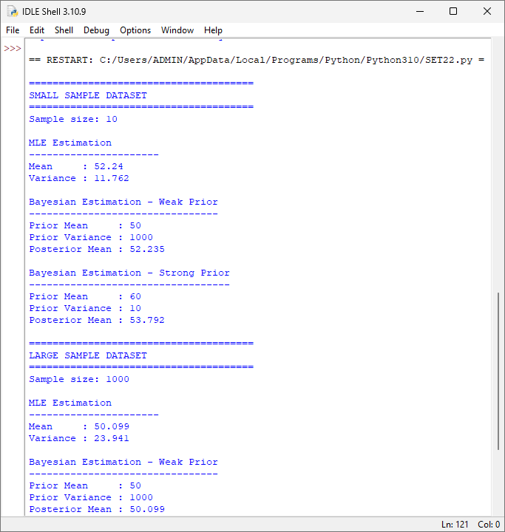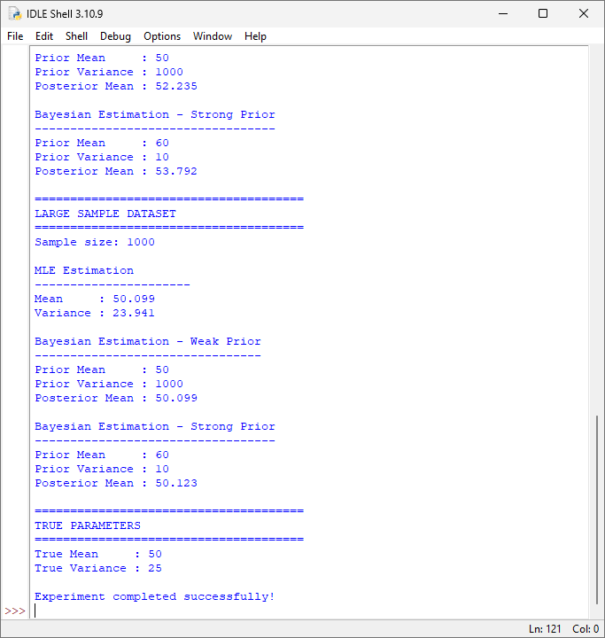

3. Implement the Expectation-Maximization (EM) algorithm for a mixture model and conduct experiments to study its convergence behavior. Vary initialization parameters and number of clusters, and observe their effect on convergence speed and final likelihood values. Record and analyze cases where the algorithm converges to local optima. Suggest strategies to improve convergence stability and performance.

TITLE: IMPLEMENTATION AND CONVERGENCE ANALYSIS OF THE EXPECTATION-MAXIMIZATION ALGORITHM

PROBLEM STATEMENT:

Implement the Expectation-Maximization (EM) algorithm for a Gaussian mixture model and study its convergence behavior under different initializations and numbers of clusters. The experiment evaluates the effect of initialization on convergence speed and final log-likelihood values. Different numbers of clusters are tested to identify cases where EM converges to local optima. The experiment also analyzes the stability of the algorithm and suggests strategies such as multiple random initializations, better parameter initialization, and appropriate selection of the number of clusters to improve convergence performance.

CODE:
import numpy as np
# 1. Generate dataset
np.random.seed(42)
# Three actual clusters
data1 = np.random.normal(2, 0.6, 100)
data2 = np.random.normal(6, 0.7, 100)
data3 = np.random.normal(10, 0.5, 100)
data = np.concatenate([
data1,
data2,
data3
])
# Convert to column format
data = data.reshape(-1, 1)
# 2. Gaussian probability density function
def gaussian_probability(x, mean, variance):
return (
1 / np.sqrt(2 * np.pi * variance)
) * np.exp(
-((x - mean) ** 2) / (2 * variance)
)
# 3. EM Algorithm
def em_algorithm(
data,
number_of_clusters,
initial_means,
max_iterations=100,
tolerance=0.0001):
n = len(data)
# Initial parameters
means = np.array(initial_means, dtype=float)
variances = np.ones(number_of_clusters)
weights = np.ones(number_of_clusters) / number_of_clusters
previous_likelihood = None
print("\nInitial Means:", means)
for iteration in range(max_iterations):
# E-STEP
responsibilities = np.zeros(
(n, number_of_clusters)
)
for k in range(number_of_clusters):
responsibilities[:, k] = (
weights[k] *
gaussian_probability(
data[:, 0],
means[k],
variances[k]
)
)
# Normalize responsibilities
total = responsibilities.sum(axis=1)
total[total == 0] = 1e-10
responsibilities = (
responsibilities /
total[:, np.newaxis]
)
# M-STEP
Nk = responsibilities.sum(axis=0)
# Update means
for k in range(number_of_clusters):
means[k] = np.sum(
responsibilities[:, k] *
data[:, 0]
) / Nk[k]
# Update variances
for k in range(number_of_clusters):
variances[k] = np.sum(
responsibilities[:, k] *
(data[:, 0] - means[k]) ** 2
) / Nk[k]
# Prevent variance becoming zero
if variances[k] < 0.000001:
variances[k] = 0.000001
# Update weights
weights = Nk / n
# Calculate log likelihood
likelihood = 0
for i in range(n):
probability = 0
for k in range(number_of_clusters):
probability += (
weights[k] *
gaussian_probability(
data[i, 0],
means[k],
variances[k]
)
)
if probability > 0:
likelihood += np.log(probability)
# Check convergence
if previous_likelihood is not None:
difference = abs(
likelihood -
previous_likelihood
)
if difference < tolerance:
print(
"Converged at iteration:",
iteration + 1
)
return (
means,
variances,
weights,
likelihood,
iteration + 1
)
previous_likelihood = likelihood
print("Maximum iterations reached.")
return (
means,
variances,
weights,
likelihood,
max_iterations
)
# 4. Experiment 1 - Good Initialization
print("\n==============================================")
print("EXPERIMENT 1: GOOD INITIALIZATION")
print("==============================================")
result1 = em_algorithm(
data,
3,
[2, 6, 10]
)
print("\nFinal Means:")
print(np.round(result1[0], 3))
print("\nFinal Variances:")
print(np.round(result1[1], 3))
print("\nFinal Weights:")
print(np.round(result1[2], 3))
print("\nFinal Log Likelihood:")
print(round(result1[3], 3))
# 5. Experiment 2 - Poor Initialization
print("\n==============================================")
print("EXPERIMENT 2: POOR INITIALIZATION")
print("==============================================")
result2 = em_algorithm(
data,
3,
[3, 3, 8]
)
print("\nFinal Means:")
print(np.round(result2[0], 3))
print("\nFinal Variances:")
print(np.round(result2[1], 3))
print("\nFinal Weights:")
print(np.round(result2[2], 3))
print("\nFinal Log Likelihood:")
print(round(result2[3], 3))
# 6. Experiment 3 - Different Number of Clusters
print("\n==============================================")
print("EXPERIMENT 3: DIFFERENT NUMBER OF CLUSTERS")
print("==============================================")
# Two clusters
result3 = em_algorithm(
data,
2,
[3, 8]
)
print("\nNumber of Clusters: 2")
print("Final Log Likelihood:",
round(result3[3], 3))
print("Iterations:",
result3[4])
# Three clusters
result4 = em_algorithm(
data,
3,
[2, 6, 10]
)
print("\nNumber of Clusters: 3")
print("Final Log Likelihood:",
round(result4[3], 3))
print("Iterations:",
result4[4])
# Four clusters
result5 = em_algorithm(
data,
4,
[1, 4, 7, 10]
)
print("\nNumber of Clusters: 4")
print("Final Log Likelihood:",
round(result5[3], 3))
print("Iterations:",
result5[4])
# 7. Experiment 4 - Multiple Random Initializations
print("\n==============================================")
print("EXPERIMENT 4: RANDOM INITIALIZATIONS")
print("==============================================")
best_likelihood = -np.inf
best_result = None
for run in range(5):
random_means = np.random.uniform(
1,
11,
3
)
print("\nRun", run + 1)
result = em_algorithm(
data,
3,
random_means
)
likelihood = result[3]
print(
"Final Log Likelihood:",
round(likelihood, 3)
)
if likelihood > best_likelihood:
best_likelihood = likelihood
best_result = result
# 8. Best Result
print("\n==============================================")
print("BEST RESULT")
print("==============================================")
print("Best Log Likelihood:",
round(best_likelihood, 3))
print("Best Means:")
print(np.round(best_result[0], 3))
print("Best Variances:")
print(np.round(best_result[1], 3))
print("Best Weights:")
print(np.round(best_result[2], 3))
print("\nExperiment completed successfully!")
OUTPUT:
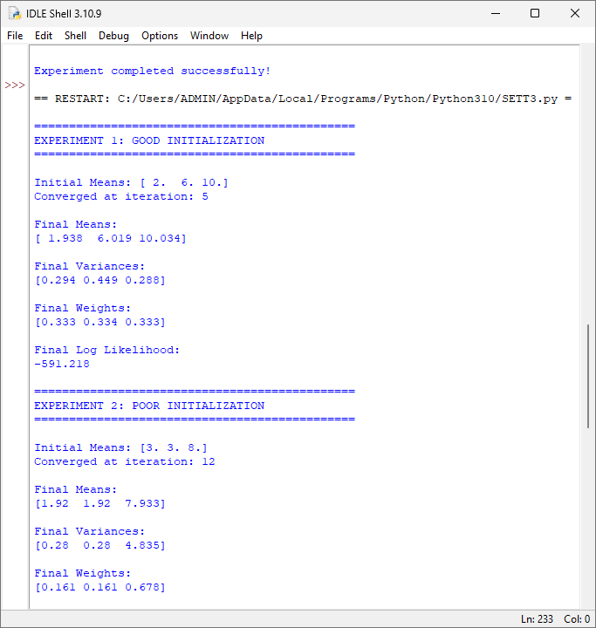

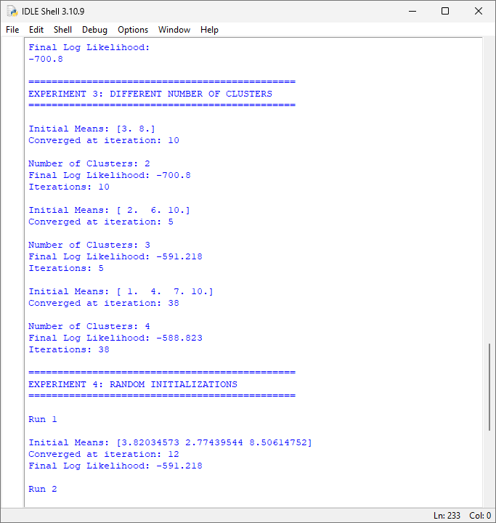

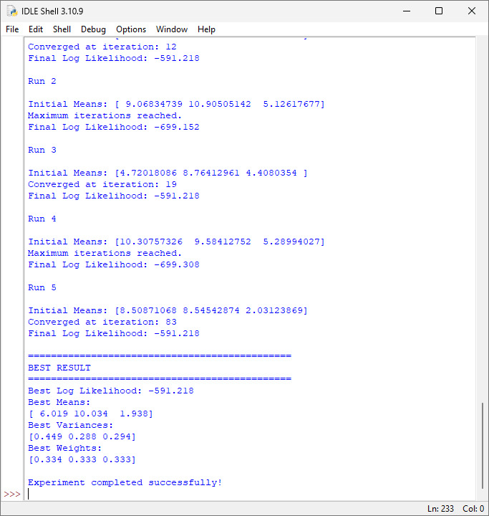

4. Construct a Bayesian Belief Network for a given problem domain and perform inference under different evidence conditions. Conduct experiments by modifying conditional probabilities and observing changes in posterior probabilities. Analyze how dependencies between variables influence the results. Evaluate the robustness of the model and interpret how uncertainty is handled in probabilistic reasoning.

TITLE: CONSTRUCTION AND INFERENCE OF A BAYESIAN BELIEF NETWORK

PROBLEM STATEMENT:
Construct a Bayesian Belief Network (BBN) for a simple problem domain and perform probabilistic inference under different evidence conditions. The network models the relationship between Rain, Sprinkler, Wet Grass, and Slippery Road. Conditional probabilities are defined for each variable based on its dependencies. Experiments are conducted by changing evidence and modifying conditional probabilities to observe their effect on posterior probabilities. The experiment analyzes how dependencies between variables influence inference, evaluates the robustness of the network, and demonstrates how uncertainty is represented and handled using probabilistic reasoning.
CODE:
import itertools
# Conditional Probability Tables
# P(Rain)
P_RAIN = {
True: 0.30,
False: 0.70
}
# P(Sprinkler | Rain)
P_SPRINKLER = {
(True, True): 0.10,
(True, False): 0.90,
(False, True): 0.50,
(False, False): 0.50
}
# P(Wet Grass | Rain, Sprinkler)
P_WET_GRASS = {
(True, True, True): 0.99,
(True, True, False): 0.01,
(True, False, True): 0.90,
(True, False, False): 0.10,
(False, True, True): 0.80,
(False, True, False): 0.20,
(False, False, True): 0.05,
(False, False, False): 0.95
}
# P(Slippery Road | Wet Grass)
P_SLIPPERY = {
(True, True): 0.80,
(True, False): 0.20,
(False, True): 0.10,
(False, False): 0.90
}
# Joint Probability
def joint_probability(rain, sprinkler, wet_grass, slippery):
# P(Rain)
probability = P_RAIN[rain]
# P(Sprinkler | Rain)
probability *= P_SPRINKLER[
(rain, sprinkler)
]
# P(Wet Grass | Rain, Sprinkler)
probability *= P_WET_GRASS[
(rain, sprinkler, wet_grass)
]
# P(Slippery | Wet Grass)
probability *= P_SLIPPERY[
(wet_grass, slippery)
]
return probability
# Calculate posterior probability
def posterior(query_variable, evidence):
variables = [
"rain",
"sprinkler",
"wet_grass",
"slippery"
]
totals = {
True: 0.0,
False: 0.0
}
for values in itertools.product([True, False], repeat=4):
assignment = dict(
zip(variables, values)
)
# Check evidence
evidence_match = True
for key in evidence:
if assignment[key] != evidence[key]:
evidence_match = False
break
if not evidence_match:
continue
probability = joint_probability(
assignment["rain"],
assignment["sprinkler"],
assignment["wet_grass"],
assignment["slippery"]
)
totals[
assignment[query_variable]
] += probability
total_probability = (
totals[True] +
totals[False]
)
if total_probability == 0:
return 0
return (
totals[True] /
total_probability
)
# Experiment 1
# Probability of Rain without evidence
print("======================================")
print("EXPERIMENT 1")
print("Probability of Rain")
print("======================================")
result = posterior(
"rain",
{}
)
print(
"P(Rain = True) =",
round(result, 4)
)
# Experiment 2
# Evidence: Wet Grass
print("\n======================================")
print("EXPERIMENT 2")
print("Evidence: Wet Grass = True")
print("======================================")
result = posterior(
"rain",
{
"wet_grass": True
}
)
print(
"P(Rain | Wet Grass) =",
round(result, 4)
)
# Experiment 3
# Evidence: Wet Grass = False
print("\n======================================")
print("EXPERIMENT 3")
print("Evidence: Wet Grass = False")
print("======================================")
result = posterior(
"rain",
{
"wet_grass": False
}
)
print(
"P(Rain | Wet Grass = False) =",
round(result, 4)
)
# Experiment 4
# Evidence: Sprinkler = True
print("\n======================================")
print("EXPERIMENT 4")
print("Evidence: Sprinkler = True")
print("======================================")
result = posterior(
"rain",
{
"sprinkler": True
}
)
print(
"P(Rain | Sprinkler) =",
round(result, 4)
)
# Experiment 5
# Evidence: Wet Grass and Slippery Road
print("\n======================================")
print("EXPERIMENT 5")
print("Multiple Evidence")
print("======================================")
result = posterior(
"rain",
{
"wet_grass": True,
"slippery": True
}
)
print(
"P(Rain | Wet Grass, Slippery Road) =",
round(result, 4)
)
# Experiment 6
# Change probability of Wet Grass
print("\n======================================")
print("EXPERIMENT 6")
print("Modified Conditional Probability")
print("======================================")
# Change:
# P(Wet Grass | Rain=True, Sprinkler=False)
# from 0.90 to 0.60
P_WET_GRASS[
(True, False, True)
] = 0.60
P_WET_GRASS[
(True, False, False)
] = 0.40
result = posterior(
"rain",
{
"wet_grass": True
}
)
print(
"After modifying conditional probability:"
)
print(
"P(Rain | Wet Grass) =",
round(result, 4)
)
# Experiment 7
# Strong Rain Evidence
print("\n======================================")
print("EXPERIMENT 7")
print("Strong Rain Evidence")
print("======================================")
# Increase probability that grass becomes wet
# when it rains and sprinkler is OFF.
P_WET_GRASS[
(True, False, True)
] = 0.99
P_WET_GRASS[
(True, False, False)
] = 0.01
result = posterior(
"rain",
{
"wet_grass": True
}
)
print(
"P(Rain | Wet Grass) =",
round(result, 4)
)
print("\n======================================")
print("EXPERIMENT COMPLETED")
print("======================================")
OUTPUT:
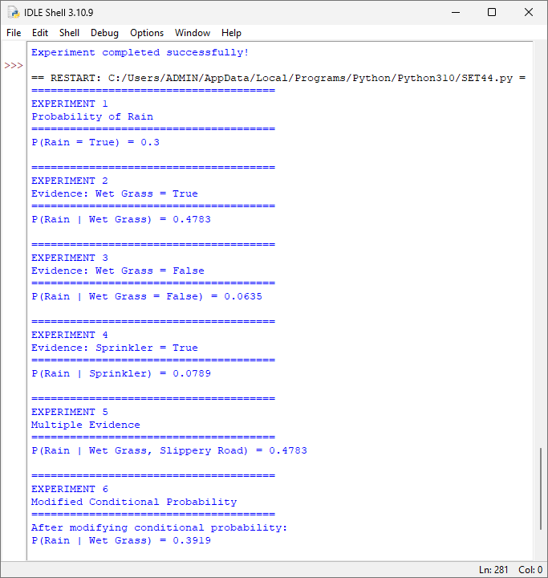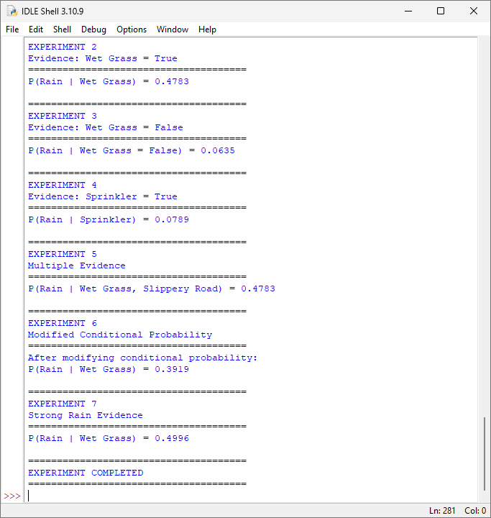

5. Implement a concept learning algorithm (such as Candidate Elimination) and perform experiments to analyze the effect of hypothesis space size on learning performance. Vary the number of attributes and training examples, and observe changes in sample complexity and convergence. Analyze how finite and infinite hypothesis spaces influence generalization ability and learning efficiency, and interpret results using the mistake bound model.

TITLE: CONCEPT LEARNING USING CANDIDATE ELIMINATION AND ANALYSIS OF HYPOTHESIS SPACE

PROBLEM STATEMENT:

Implement the Candidate Elimination algorithm to learn a target concept from labeled training examples. The experiment investigates how the size of the hypothesis space affects learning performance by varying the number of attributes and training examples. The changes in the version space, convergence, and number of training examples required for learning are observed. The experiment further compares finite and infinite hypothesis spaces and analyzes their effect on generalization ability and learning efficiency. The results are interpreted using the mistake bound model, which describes the maximum number of prediction mistakes that may occur before a consistent learner identifies the target concept.
CODE:
def candidate_elimination(attributes, data):
# Most Specific hypothesis
S = ["0"] * len(attributes)
# Most General hypothesis
G = ["?"] * len(attributes)
print("\nInitial S:", S)
print("Initial G:", G)
for index, example in enumerate(data):
features = example[:-1]
label = example[-1]
print("\n----------------------------------------")
print("Training Example", index + 1)
print("Features:", features)
print("Class:", label)
# Positive example
if label == "Yes":
# General boundary must be consistent
for i in range(len(attributes))
if S[i] == "0":
S[i] = features[i]
elif S[i] != features[i]:
S[i] = "?"
# Remove overly specific G
for i in range(len(attributes)):
if G[i] != "?":
if G[i] != features[i]:
G[i] = "?"
# ----------------------------------------------------
# Negative example
# ----------------------------------------------------
else:
# Specialize G
for i in range(len(attributes)):
if S[i] != features[i]:
if G[i] == "?":
G[i] = S[i]
elif G[i] == features[i]:
G[i] = "?"
print("S =", S)
print("G =", G)
return S, G
attributes_2 = [
"Color",
"Shape"
]
data_2 = [
["Red", "Round", "Yes"],
["Red", "Square", "Yes"],
["Blue", "Round", "No"],
["Red", "Round", "Yes"],
["Blue", "Square", "No"]
]
print("\n\n========================================")
print("EXPERIMENT 1: TWO ATTRIBUTES")
print("========================================")
S2, G2 = candidate_elimination(
attributes_2,
data_2
)
print("\nFinal Specific Hypothesis:")
print(S2)
print("Final General Hypothesis:")
print(G2)
attributes_3 = [
"Color",
"Shape",
"Size"
]
data_3 = [
["Red", "Round", "Large", "Yes"],
["Red", "Square", "Large", "Yes"],
["Blue", "Round", "Small", "No"],
["Red", "Round", "Small", "Yes"],
["Blue", "Square", "Small", "No"]
]
print("\n\n========================================")
print("EXPERIMENT 2: THREE ATTRIBUTES")
print("========================================")
S3, G3 = candidate_elimination(
attributes_3,
data_3
)
print("\nFinal Specific Hypothesis:")
print(S3)
print("Final General Hypothesis:")
print(G3)
attributes_4 = [
"Color",
"Shape",
"Size",
"Texture"
]
data_4 = [
["Red", "Round", "Large", "Smooth", "Yes"],
["Red", "Square", "Large", "Smooth", "Yes"],
["Blue", "Round", "Small", "Rough", "No"],
["Red", "Round", "Small", "Smooth", "Yes"],
["Blue", "Square", "Small", "Rough", "No"],
["Red", "Round", "Large", "Rough", "Yes"]
]
print("\n\n========================================")
print("EXPERIMENT 3: FOUR ATTRIBUTES")
print("========================================")
S4, G4 = candidate_elimination(
attributes_4,
data_4
)
print("\nFinal Specific Hypothesis:")
print(S4)
print("Final General Hypothesis:")
print(G4)
print("\n\n========================================")
print("HYPOTHESIS SPACE SIZE")
print("========================================")
def hypothesis_space_size(attribute_values):
size = 1
for values in attribute_values:
# values + '?' + 'ANY'
size = size * (len(values) + 1)
return size
# 2 attributes
values_2 = [
["Red", "Blue"],
["Round", "Square"]
]
# 3 attributes
values_3 = [
["Red", "Blue"],
["Round", "Square"],
["Small", "Large"]
]
# 4 attributes
values_4 = [
["Red", "Blue"],
["Round", "Square"],
["Small", "Large"],
["Smooth", "Rough"]
]
size_2 = hypothesis_space_size(values_2)
size_3 = hypothesis_space_size(values_3)
size_4 = hypothesis_space_size(values_4)
print("2 Attributes:", size_2)
print("3 Attributes:", size_3)
print("4 Attributes:", size_4)
print("\n\n========================================")
print("SAMPLE COMPLEXITY")
print("========================================")
examples = [5, 10, 20, 50, 100]
hypothesis_sizes = [
size_2,
size_3,
size_4,
100,
500
]
for i in range(len(examples)):
print(
"Training Examples:",
examples[i],
"| Hypothesis Space:",
hypothesis_sizes[i]
)
# MISTAKE BOUND MODEL
print("\n\n========================================")
print("MISTAKE BOUND MODEL")
print("========================================")
import math
def mistake_bound(hypothesis_space_size):
return math.ceil(
math.log2(hypothesis_space_size)
)
print(
"2 Attributes:",
mistake_bound(size_2),
"mistakes maximum"
)
print(
"3 Attributes:",
mistake_bound(size_3),
"mistakes maximum"
)
print(
"4 Attributes:",
mistake_bound(size_4),
"mistakes maximum"
)
print("\n\n========================================")
print("EXPERIMENT COMPLETED")
print("========================================")

OUTPUT:

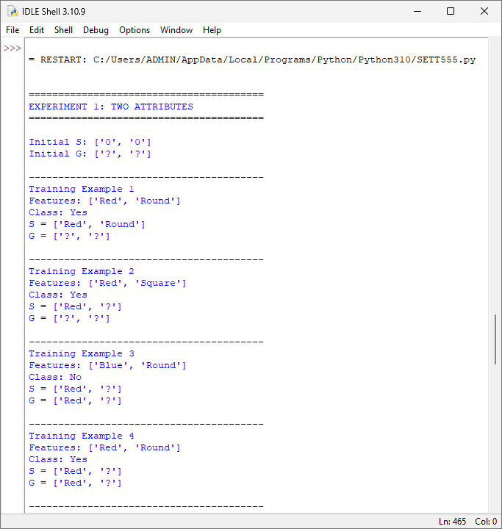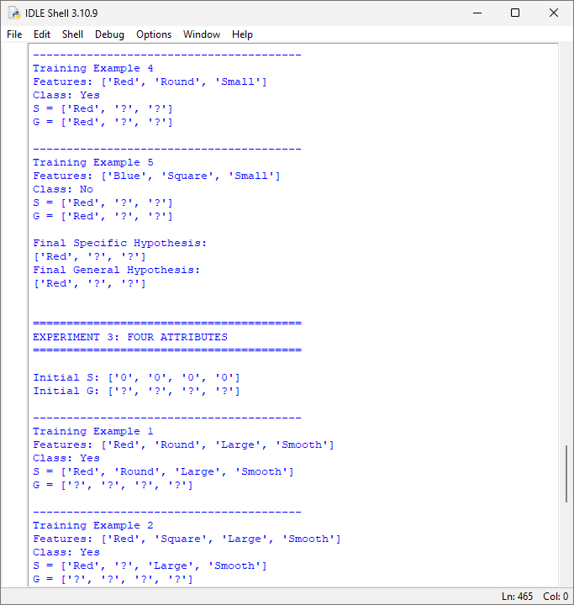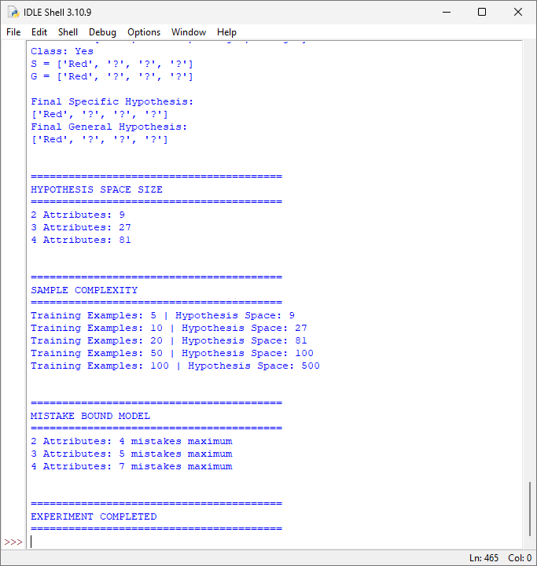

RUBRICS FOR CALCULATION

Criteria | Weightage | Level 4 – Exemplary (5 Marks) | Level 3 – Proficient (4 Marks) | Level 2 – Developing (2–3 Marks) | Level 1 – Beginning (0–1 Mark)
Conceptual Understanding | 30 | Demonstrates clear and complete understanding of the concept | Good understanding with minor gaps | Basic understanding with some misconceptions | Poor or incorrect understanding
Accuracy of Answer | 25 | Completely correct answer with no errors | Mostly correct with minor errors | Partially correct with noticeable errors | Incorrect or irrelevant answer
Application of Knowledge | 15 | Correctly applies concepts to solve the question/problem | Applies concepts with minor mistakes | Limited or partially correct application | No or incorrect application
Completeness of Response | 15 | Covers all required parts of the question | Covers most parts with minor omissions | Covers only some parts | Incomplete or missing response
Clarity & Presentation | 15 | Clear, concise, and well-organized answer | Understandable with minor issues | Somewhat unclear or poorly structured | Difficult to understand

