HEALTHSCOPE – PUBLIC HEALTH ANALYTICS & RISK PREDICTION PLATFORM

A Project Report Submitted in
the partial fulfillment of the requirements for the award of the degree of

BACHELOR OF TECHNOLOGY
In

DEPARTMENT OF COMPUTER SCIENCE AND ENGINEERING
By
T.Lasya Priya - 2420030258
Rishikesh-2420030012

Under the Esteemed Guidance of

B.Prathusa
Associate Professor

Department of Computer Science and Engineering

AY-2026–2027

Semester: Odd




K L (Deemed to be) University
DEPARTMENT OF COMPUTER SCIENCE AND ENGINEERING

Declaration

The Project Report entitled “HealthScope – Public Health Analytics and Risk Prediction Platform Using Machine Learning” is a record of Bonafide work of Lasya Priya 2420030258, Rishikesh 2420030012 submitted in partial fulfillment for the award of B. Tech in Computer Science and Engineering to the K L University. The results embodied in this report have not been copied from any other departments/University/Institute.

T.Lasya Priya - 2420030258
M. Rishikesh - 2420030012

K L (Deemed to be) University
Department of Computer Science and Engineering

CERTIFICATE

This is certify that the mini project based report entitled “HealthScope – Public Health Analytics and Risk Prediction Platform Using Machine Learning” is a bonafide work done and submitted by Lasya Priya 2420030258, Rishikesh 2420030012 in partial fulfillment of the requirements for the award of the degree of BACHELOR OF TECHNOLOGY in Department of Computer Science and Engineering, K L (Deemed to be University), during the academic year 2026-2027.

_____________________  Signature of the Guide  B Prathusha  Associate Professor, CSE | _____________________  Course Coordinator  Dr. N. Sunanda  Department of CSE | _____________________  Head of the Department  Dr. P. Venkateswara Rao  Department of CSE

ACKNOWLEDGEMENT
The success in this project would not have been possible but for the timely help and guidance rendered by many people. Our wish to express my sincere thanks to all those who has assisted us in one way or the other for the completion of my project.

Our greatest appreciation to my Course Coordinator and my guide Dr. N. Sunanda Associate Professor, Department of Computer Science and Engineering which cannot be expressed in words for her tremendous support, encouragement and guidance for this project.

We express our gratitude to Dr. P. Venkateswar Rao, Head of the Department of Computer Science and Engineering for providing us with adequate facilities, ways and means by which we are able to complete this project-based Lab.

We thank all the members of teaching and non-teaching staff members, and also who have assisted me directly or indirectly for successful completion of this project. Finally, I sincerely thank my parents, friends and classmates for their kind help and cooperation during my work.

T.Lasya Priya - 2420030258
M. Rishikesh - 2420030012

Abstract
Public health data contains valuable information about the demographic, lifestyle and clinical factors that influence the health of a population. However, raw survey data is large, complex and difficult to interpret manually. Converting such data into meaningful insights and early risk indicators is an important application of Data Science and Machine Learning.
The project “HealthScope – Public Health Analytics and Risk Prediction Platform” is an interactive web application that combines data processing, exploratory analysis, machine learning and visualization in a single dashboard. Using 21 health and lifestyle indicators, the application classifies a person’s health status into three classes: No Diabetes, Prediabetes and Diabetes.
The system uses a public-health survey dataset of 253,680 records with 21 predictor variables (clinical, lifestyle, personal and demographic) and a three-class target, Diabetes_012. The dataset is highly imbalanced: 213,703 records (84.24%) belong to No Diabetes, 4,631 (1.83%) to Prediabetes and 35,346 (13.93%) to Diabetes. Before prediction, the age entered by the user is converted into one of thirteen age categories and the input is standardized using a StandardScaler.
A multi-class Logistic Regression model, trained with Scikit-learn and stored using Joblib, performs the classification. The Streamlit dashboard provides four sections: a health prediction form, a public health analytics view showing how diabetes status relates to BMI, blood pressure, physical activity and general health, a model performance view with evaluation metrics and a confusion matrix, and an About section describing the workflow.
When evaluated on the complete dataset, the model achieved an accuracy of 65.41%, with a weighted precision of 84.89%, weighted recall of 65.41% and weighted F1-score of 72.54%. The class-wise results show that the model identifies the No Diabetes class with high precision (94.89%) but finds the minority Prediabetes class difficult (precision 3.16%, recall 29.19%). This is a limitation of the current model and an important direction for future work. HealthScope is built with Python, Pandas, Scikit-learn, Matplotlib and Streamlit for educational and analytical purposes and is not a medical diagnosis tool.
Keywords: Public Health Analytics, Diabetes Risk Prediction, Machine Learning, Logistic Regression, Exploratory Data Analysis, Data Visualization, Streamlit.
Index
S. No. | Chapters | Topics | Page.no
 |  | Acknowledgement | 4
 |  | Abstract | 5
1 | Introduction | 1.1 Background of the Project  1.2 Problem Statement  1.3 Scope of the Project  1.4 Objectives  1.5 Importance of the Application  1.6 Target Users/Audience  1.7 Literature Survey | 1  1  2  2  3  3  4
2 | System Requirements | 2.1 Hardware Requirements  2.2 Software Requirements  2.3 Development Tools and Frameworks | 5  5  6
3 | Technology Stack | 3.1 Front-end – Streamlit  3.2 Application Logic – Python  3.3 Machine Learning – Scikit-learn  3.4 Data Processing – Pandas and NumPy  3.5 Data Visualization – Matplotlib  3.6 Model Storage – Joblib | 7  7  7  8  8  8
4 | System Architecture | 4.1 High-Level Architecture Diagram  4.2 Description of System Modules  4.3 Application Execution Architecture | 9  9  10
5 | Design | 5.1 User Interface Design and Screenshots  5.2 System Workflow / Data Flow Diagram | 11  12
6 | Implementation | 6.1 Module-wise Implementation  6.2 Dataset Description  6.3 Data Preprocessing  6.4 Exploratory Data Analysis  6.5 Logistic Regression Model Implementation  6.6 Prediction and Performance Analysis | 14  15  16  17  19  20
7 | Features | 7.1 List of Main Features  7.2 Working of Each Feature  7.3 Interactive Health Assessment Form  7.4 Analytics and Model Performance Dashboard | 21  21  23  23
8 | Testing | 8.1 Functional Testing  8.2 Integration Testing  8.3 Tools Used for Testing  8.4 Test Cases and Results  8.5 Model Performance Evaluation | 25  25  25  26  27
9 | Deployment | 9.1 Steps to Run the Application  9.2 Python Environment Configuration  9.3 Local Application Execution | 30  30  31
10 | Challenges & Limitations | 10.1 Issues Faced During Development  10.2 Solutions Applied  10.3 Current Limitations | 32  32  33
11 | Future Enhancements | 11.1 Planned Features  11.2 Model Improvement and Additional Algorithms  11.3 Cloud Deployment and API Integration | 34  34  35
12 | Conclusion | 12.1 Summary of the Project  12.2 What Was Achieved  12.3 Skills Learned During Development | 36  36  37
13 | References | Dataset, Research and Technical Documentation | 38
14 | Appendices | 14.1 Application Screenshots  14.2 Sample Code Snippets  14.3 Installation and Setup Instructions  14.4 User Manual  14.5 Team Contributions | 39  40  41  42  42

1
Introduction
1.1 Background of the Project
Public health organisations collect large amounts of survey and clinical data about the demographic, nutritional, lifestyle and clinical characteristics of the population. Such data can reveal which factors are associated with chronic diseases such as diabetes, but its size and complexity make it difficult to analyse manually.
Data Science and Machine Learning help to solve this problem. Data processing prepares the raw records, exploratory analysis reveals patterns and relationships, and machine learning models learn from labelled examples so that they can classify new cases. Interactive dashboards then make the results available to people who are not programmers.
In this project, we developed HealthScope, a public-health analytics and risk-prediction platform. HealthScope uses a survey dataset of 253,680 records and 21 health indicators to estimate whether a person falls into the No Diabetes, Prediabetes or Diabetes class. The platform follows the end-to-end workflow Collect → Clean → Analyze → Predict → Visualize and is delivered as a Streamlit web application.
1.2 Problem Statement
Large-scale public-health datasets contain valuable demographic, nutritional, lifestyle and clinical variables, but converting raw data into meaningful and actionable insight is difficult. The main challenges are:
- Data quality – missing, inconsistent or duplicate records hinder analysis.
- Scale – large volumes of records cannot be analysed manually and require automation.
- Complex relationships – interactions between several health factors can remain hidden.
- Limited reporting – conventional static reports offer little interaction and visualization for decision-makers.
The central question addressed by this project is: how can raw public-health data be efficiently processed, analysed and transformed into meaningful insights and health-risk predictions?
1.3 Scope of the Project
The scope of this project includes:
- Loading and summarising a public-health dataset of 253,680 records and 22 columns.
- Exploring the data through summary cards and charts (diabetes status, BMI, blood pressure, physical activity and general health).
- Collecting 21 health, lifestyle and demographic inputs through an interactive form.
- Converting the entered age into one of 13 age categories and standardizing the inputs.
- Classifying health status into No Diabetes, Prediabetes or Diabetes using a Logistic Regression model.
- Displaying the predicted class in a result card with an educational disclaimer.
- Evaluating the model with accuracy, precision, recall, F1-score and a confusion matrix.
- Providing an About section that explains the project workflow.
The current implementation uses one trained model (Logistic Regression) for diabetes-related health status. It is an academic project intended for analytics and decision-support demonstration and does not provide a medical diagnosis.
1.4 Objectives
The main objectives of this project are:
- To build an integrated public-health analytics platform using Python and Streamlit.
- To process and understand a large public-health dataset through exploratory analysis.
- To identify the health and lifestyle factors that are associated with diabetes status.
- To train and store a machine learning model for three-class diabetes status classification.
- To provide an interactive form for entering health information and obtaining a prediction.
- To evaluate the model using accuracy, precision, recall, F1-score and a confusion matrix.
- To present all insights through a user-friendly dashboard.
1.5 Importance of the Application
Early identification of people who may be at risk of diabetes supports timely lifestyle changes and medical consultation. HealthScope shows how a public-health dataset can be turned into analytics and a simple risk-screening tool that anyone can operate from a browser.
The project also gives practical experience in the complete data-science pipeline: data handling, feature scaling, exploratory analysis, model training, evaluation and dashboard development. It further demonstrates the importance of looking beyond a single accuracy figure when the classes are imbalanced.
1.6 Target Users/Audience
The intended users of the application include:
- Students learning Data Science and Machine Learning.
- Faculty members and academic researchers.
- Public-health analysts who need quick exploratory views of survey data.
- Developers experimenting with health-risk classification.
- Educational institutions demonstrating end-to-end data-science applications.
1.7 Literature Survey
Existing studies apply machine learning to population health prediction, disease-specific risk modelling and chronic disease detection. They demonstrate the potential of these methods but also expose gaps in validation and generalisation. The main directions reviewed for this project are summarised below.
- Population health prediction – machine learning applied to diverse data sources; robust validation and deployment planning are still needed.
- Diabetes (NFHS-5) – Decision Tree, Random Forest and XGBoost models identify demographic and health risk factors, but the focused scope limits generalisation.
- Infant mortality (NFHS-5) – Random Forest and logistic models reveal socio-economic and maternal factors; class imbalance and survey design matter.
- Chronic disease prediction – KNN, Random Forest and neural networks are commonly used; studies vary in data quality and cross-population applicability.
These studies motivate the design of HealthScope: a transparent and interpretable baseline model (Logistic Regression), combined with exploratory analysis and an interactive dashboard, with a clear path to compare further algorithms such as Decision Tree, Random Forest and KNN.
CHAPTER 2
System Requirements
2.1 Hardware Requirements
The following hardware configuration is suitable for running the project. The dashboard loads the full dataset (about 22 MB CSV) into memory and evaluates the model on all records, so 8 GB of RAM is recommended.
Processor : Intel Core i3 / i5 or equivalent
RAM : 4 GB minimum, 8 GB recommended
Storage : At least 1 GB of free space
Input Devices : Keyboard and Mouse
Display : Standard Laptop or Desktop Display
GPU : Not required

2.2 Software Requirements
The software requirements used for the project are:
- Operating System: Windows 10 or Windows 11 (Linux and macOS are also supported).
- Programming Language: Python 3.x.
- Development Environment: Visual Studio Code / Jupyter Notebook / Google Colab.
- Application Framework: Streamlit.
- Machine Learning Library: Scikit-learn.
- Data Handling: Pandas and NumPy.
- Data Visualization: Matplotlib (and Streamlit’s built-in charts).
- Model Storage: Joblib.
- Web Browser: Any modern browser (Chrome, Edge, Firefox).
The Python libraries required by the application are listed in the file requirements.txt: streamlit, pandas, numpy, scikit-learn, matplotlib and joblib.
2.3 Development Tools and Frameworks
Python:
Python is the main programming language used in this project. It is used for data processing, model loading, prediction and application development.
Streamlit:
Streamlit is used to create the interactive web application. It provides the tabs, input widgets, metric cards, charts and the prediction result display.
Scikit-learn:
Scikit-learn provides the Logistic Regression model, the StandardScaler and the evaluation metrics (accuracy, precision, recall, F1-score and confusion matrix).
Pandas:
Pandas is used to read the CSV dataset, build the input row for prediction and create the cross-tabulations used in the analytics charts.
NumPy:
NumPy supports numerical operations on the arrays handled by Pandas and Scikit-learn.
Matplotlib:
Matplotlib is used to draw the confusion matrix in the Model Performance tab.
Joblib:
Joblib is used to load the saved model and scaler when the application starts.
CHAPTER 3
Technology Stack
3.1 Front-end – Streamlit
Streamlit is an open-source Python framework for building interactive web applications. In HealthScope it provides the whole user interface: a hero banner, summary metric cards, four tabs, select boxes, number inputs and sliders for data entry, a prediction button, charts and tables.
Custom CSS is injected through st.markdown to give the application a consistent pink-and-purple visual theme, styled cards and rounded controls.
3.2 Application Logic – Python
Python implements the application logic. It loads the dataset, model and scaler, converts the age to a category, assembles the input row, scales it, calls the model for prediction and computes the evaluation metrics. Python also connects all modules so that user input flows through the complete prediction process.
3.3 Machine Learning – Scikit-learn
Scikit-learn is the machine learning library used in the project. The following components are used:
- LogisticRegression – a probability-based classification model with interpretable coefficients. In this project it is used as a multi-class classifier for the classes No Diabetes, Prediabetes and Diabetes.
- StandardScaler – standardizes each feature to zero mean and unit variance so that features measured on different scales (for example BMI and binary indicators) contribute fairly to the model.
- Metrics – accuracy_score, precision_score, recall_score, f1_score, confusion_matrix and ConfusionMatrixDisplay.
3.4 Data Processing – Pandas and NumPy
Pandas reads healthscope_data.csv into a DataFrame, counts the records in each class and creates cross-tabulations such as High Blood Pressure versus diabetes status. NumPy provides the underlying array operations used by Pandas and Scikit-learn.
3.5 Data Visualization – Matplotlib
Matplotlib draws the confusion matrix using the “PuRd” colour map. The distribution and relationship charts in the analytics tab use Streamlit’s native bar and line charts, which are interactive and built on the same DataFrames.
3.6 Model Storage – Joblib
Joblib stores the trained model and the fitted scaler as serialized files (healthscope_logistic_model.pkl and healthscope_scaler.pkl). The application loads them at start-up, so the model does not have to be trained every time the application runs.
CHAPTER 4
System Architecture
4.1 High-Level Architecture Diagram
The architecture of HealthScope mirrors the data-science pipeline. Public-health data is cleaned and explored, features are scaled, the machine learning model produces a classification, the results are evaluated and everything is presented through the Streamlit dashboard.
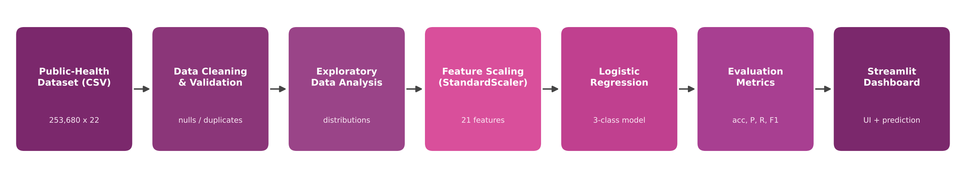
Figure 4.1: High-level architecture of HealthScope
4.2 Description of System Modules
1. Data Layer
The public-health dataset (healthscope_data.csv) is read into a Pandas DataFrame. It contains 253,680 records, 21 predictor columns and the target column Diabetes_012.
2. Preprocessing Layer
The age entered by the user is converted to one of 13 categories, the 21 inputs are arranged in the exact column order used during training and the values are standardized with the saved scaler.
3. Machine Learning Layer
The saved Logistic Regression model receives the scaled input and returns one of three class labels.
4. Prediction Layer
The predicted label is converted to text (No Diabetes, Prediabetes or Diabetes), shown in a result card with a colour icon and accompanied by a medical disclaimer.
5. Analytics and Performance Layer
This layer shows population statistics, relationship charts, evaluation metrics and the confusion matrix, so that users can understand both the data and the quality of the model.
4.3 Application Execution Architecture
The application is a single Python script (app.py) executed by Streamlit. When it starts, the script loads the model, the scaler and the dataset. Streamlit renders the interface in the browser and re-runs the script from top to bottom whenever the user interacts with a widget.
All four tabs are produced by the same script. The prediction runs only when the “Predict Health Status” button is pressed, whereas the analytics and performance tabs are computed from the dataset on every run. Front-end and back-end therefore run in one process on the local machine, and no separate REST API is required.
CHAPTER 5
Design
5.1 User Interface Design and Screenshots
The application has a soft, card-based interface. A hero banner introduces the platform, three metric cards summarise the dataset, and four tabs organise the functionality:
- Health Prediction – the input form and the prediction result.
- Public Health Analytics – population statistics and relationship charts.
- Model Performance – evaluation metrics, confusion matrix and metric guide.
- About HealthScope – project overview, workflow and important notes.
The input form is divided into Clinical Factors, Lifestyle Factors, Personal Factors and Demographic Information so that related questions are grouped together.
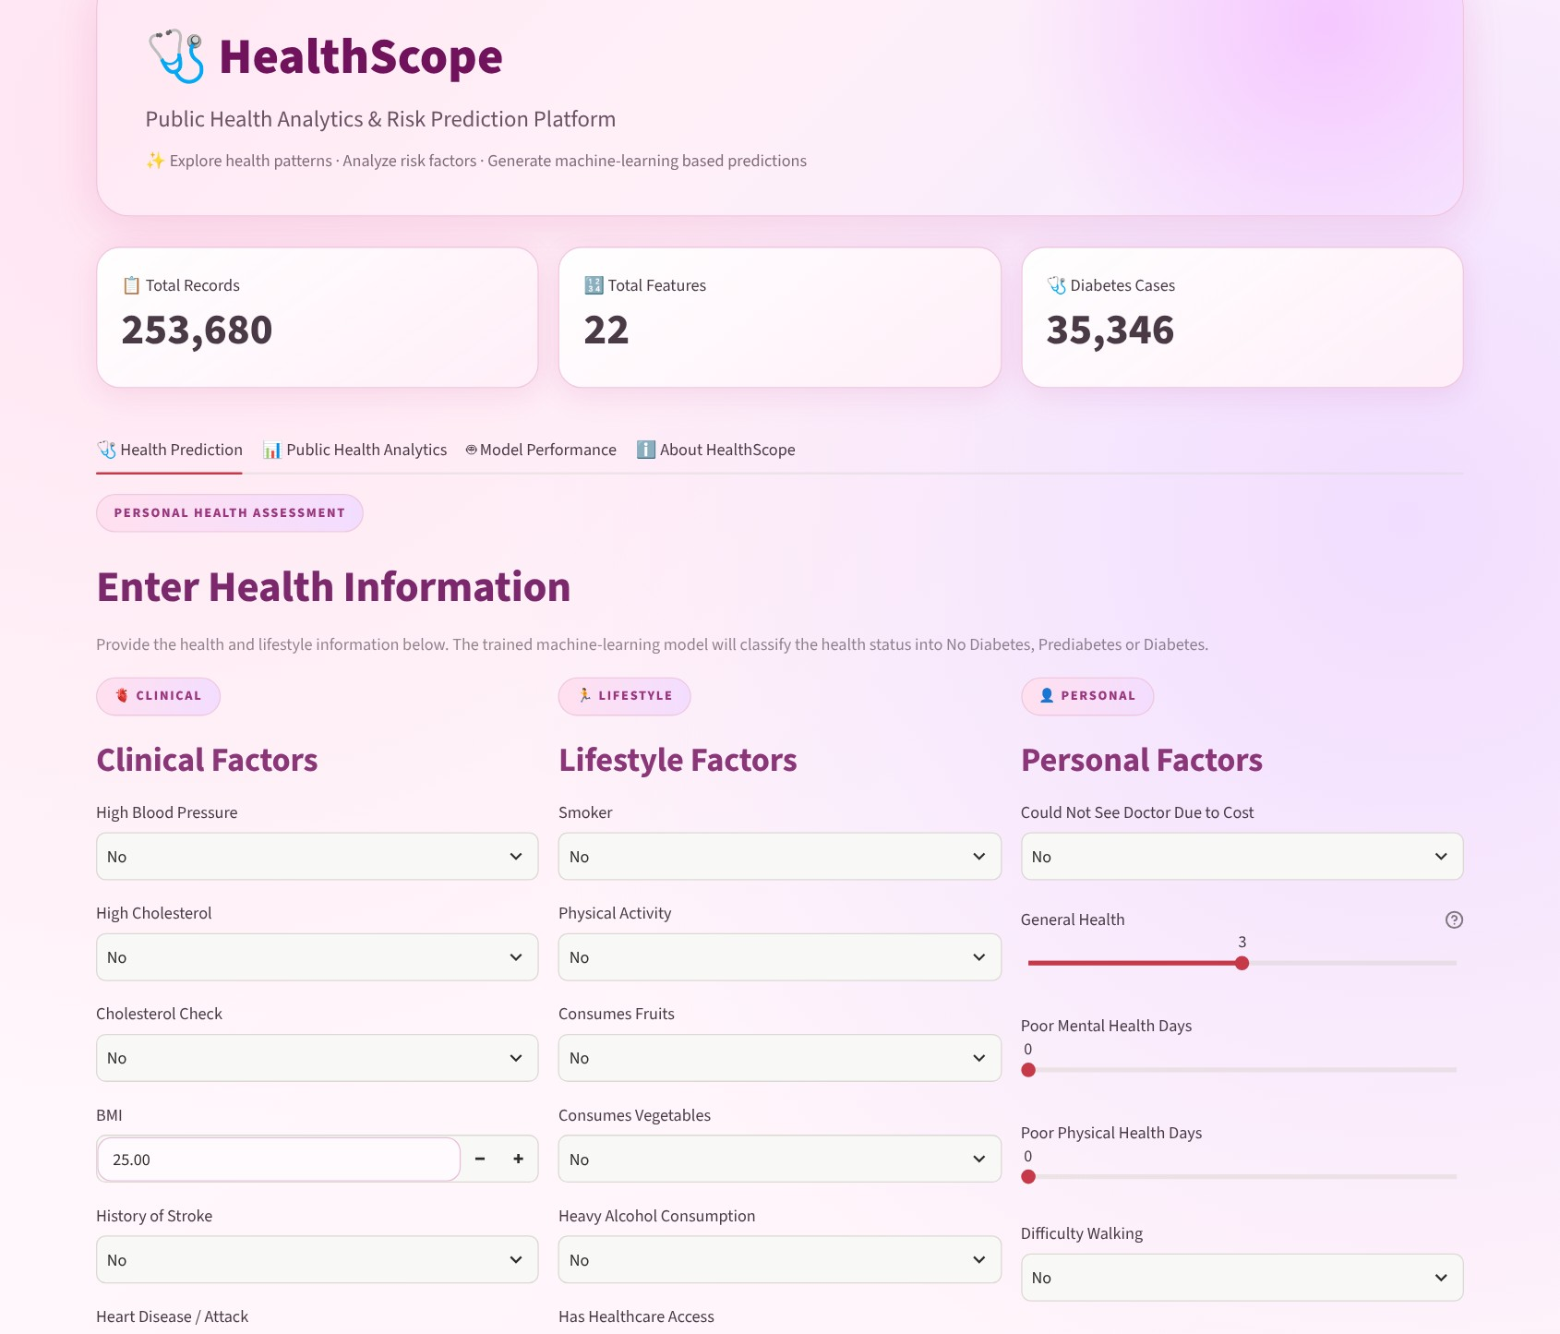
Figure 5.1: Main screen with summary cards and the health information form
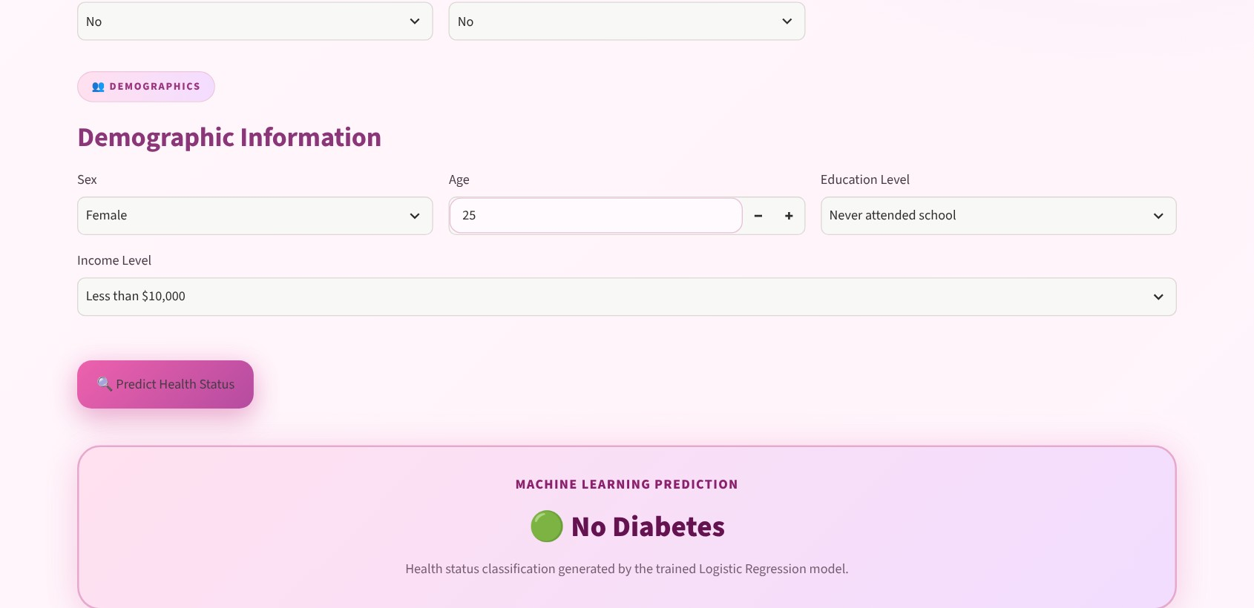
Figure 5.2: Demographic inputs, prediction button and result card
5.2 System Workflow / Data Flow Diagram
The data flow describes how a single prediction request moves through the system. The user enters the health information; the age is converted into a category; the 21 values are arranged into a DataFrame row; the scaler standardizes the row; the model predicts a class; and the result card is displayed.
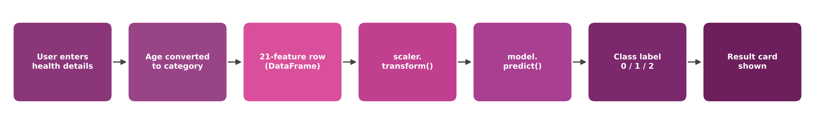
Figure 5.3: Data flow of a prediction request
At project level, HealthScope follows the five-stage workflow shown in the About tab:
Stage | Process | Purpose
1 | Collect | Load public-health data
2 | Clean | Prepare and validate data
3 | Analyze | Discover patterns and relationships
4 | Predict | Generate ML-based classification
5 | Visualize | Present insights through the dashboard

Table 5.1: End-to-end workflow of HealthScope
CHAPTER 6
Implementation
6.1 Module-wise Implementation
The project is divided into four major modules.
Module 1: Data Loading and Summary Module
This module loads the dataset, the model and the scaler, and displays the headline statistics.
Input: `healthscope_data.csv`.
Output: DataFrame and summary metrics (records, features, diabetes cases).

Module 2: Preprocessing Module
This module converts age to a category, builds the input DataFrame in training column order and applies the saved StandardScaler.
Input: Values entered in the form.
Output: Scaled 21-feature input row.

Module 3: Classification Module
This module uses the Logistic Regression model to predict the health status and shows it in the result card.
Input: Scaled input row.
Output: Predicted class (0, 1 or 2) and its label.

Module 4: Analytics and Performance Module
This module explores the dataset visually and evaluates the model on all records.
Input: Dataset and model predictions.
Output: Charts, accuracy, precision, recall, F1-score and confusion matrix.

6.2 Dataset Description
HealthScope uses a public-health survey dataset stored in healthscope_data.csv. The structure of the file (253,680 records, 21 health indicators and the target column Diabetes_012) corresponds to the publicly available Diabetes Health Indicators dataset derived from the CDC’s Behavioral Risk Factor Surveillance System (BRFSS) survey. All values are stored as numbers.
The dataset has no missing values. It contains 23,899 exact duplicate rows (9.42%), which are retained in the data used by the dashboard. The target variable Diabetes_012 has three classes and is strongly imbalanced, as shown in Figure 6.1.
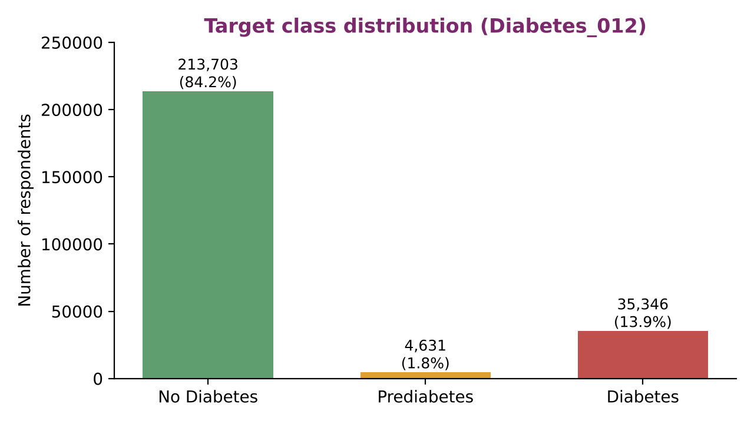
Figure 6.1: Class distribution of the target variable
The 21 predictor variables are described in Table 6.1. Fourteen are binary indicators, four are ordinal scales and three are numeric.
No. | Feature | Meaning (label used in the app) | Type / values | Mean
1 | HighBP | High blood pressure | Binary (0/1) | 0.43
2 | HighChol | High cholesterol | Binary (0/1) | 0.42
3 | CholCheck | Cholesterol check done | Binary (0/1) | 0.96
4 | BMI | Body Mass Index | Numeric (12–98) | 28.38
5 | Smoker | Smoker | Binary (0/1) | 0.44
6 | Stroke | History of stroke | Binary (0/1) | 0.04
7 | HeartDiseaseorAttack | Heart disease / heart attack | Binary (0/1) | 0.09
8 | PhysActivity | Physical activity | Binary (0/1) | 0.76
9 | Fruits | Consumes fruits | Binary (0/1) | 0.63
10 | Veggies | Consumes vegetables | Binary (0/1) | 0.81
11 | HvyAlcoholConsump | Heavy alcohol consumption | Binary (0/1) | 0.06
12 | AnyHealthcare | Has healthcare access | Binary (0/1) | 0.95
13 | NoDocbcCost | Could not see doctor due to cost | Binary (0/1) | 0.08
14 | GenHlth | General health (1 = Excellent, 5 = Poor) | Ordinal (1–5) | 2.51
15 | MentHlth | Poor mental health days (last 30) | Numeric (0–30) | 3.18
16 | PhysHlth | Poor physical health days (last 30) | Numeric (0–30) | 4.24
17 | DiffWalk | Difficulty walking | Binary (0/1) | 0.17
18 | Sex | Sex (0 = Female, 1 = Male) | Binary (0/1) | 0.44
19 | Age | Age category | Ordinal (1–13) | 8.03
20 | Education | Education level | Ordinal (1–6) | 5.05
21 | Income | Income level | Ordinal (1–8) | 6.05

Table 6.1: Features of the HealthScope dataset
6.3 Data Preprocessing
Before a prediction is made, the following preprocessing steps are applied:
Data Validation:
The dataset was checked for missing values (none found) and duplicates (23,899 duplicate rows). The input widgets restrict values to valid ranges: BMI between 10 and 100, age between 18 and 90, general health between 1 and 5, and mental and physical health days between 0 and 30.
Age Conversion:
The model was trained with age as one of 13 five-year categories. The function age_to_category() therefore converts the age in years entered by the user into the corresponding category.
Age (years) | Category | Age (years) | Category
18–24 | 1 | 55–59 | 8
25–29 | 2 | 60–64 | 9
30–34 | 3 | 65–69 | 10
35–39 | 4 | 70–74 | 11
40–44 | 5 | 75–79 | 12
45–49 | 6 | 80 and above | 13
50–54 | 7

Table 6.2: Age-to-category mapping used by the application
Input Assembly:
The 21 inputs are placed into a one-row DataFrame whose column names and order match the training data (HighBP, HighChol, CholCheck, BMI, … , Education, Income).
Feature Scaling:
The saved StandardScaler transforms every feature to zero mean and unit variance, using the mean and standard deviation learned from the data. The same scaler is used for single predictions and for evaluating the model on the whole dataset.
6.4 Exploratory Data Analysis
Exploratory analysis was carried out to understand the structure of the data and to identify the factors that are associated with diabetes. The Public Health Analytics tab presents the main views: diabetes status distribution, BMI distribution, blood pressure versus diabetes, physical activity versus diabetes and general health versus diabetes.
The group averages in Table 6.3 show a clear pattern: people with Prediabetes or Diabetes have a higher BMI, a higher prevalence of high blood pressure, lower physical activity, poorer general health and belong to older age categories.
Variable | No Diabetes | Prediabetes | Diabetes
Average BMI | 27.74 | 30.72 | 31.94
High blood pressure (share of group) | 37.1% | 62.9% | 75.3%
Physically active (share of group) | 77.9% | 67.8% | 63.1%
Average general health (1 = Excellent, 5 = Poor) | 2.37 | 2.98 | 3.29
Average age category (1–13) | 7.79 | 9.08 | 9.38

Table 6.3: Average values of key indicators by diabetes status
Other notable observations from the data are:
- Blood pressure: 24.45% of respondents with high blood pressure are in the Diabetes class, compared with 6.04% of those without high blood pressure.
- Physical activity: 21.14% of physically inactive respondents are in the Diabetes class, compared with 11.61% of active respondents.
- General health: the share of the Diabetes class rises steadily from 2.52% among those reporting excellent health to 37.89% among those reporting poor health.
Figure 6.2 shows the correlation of every feature with the target. General health (0.30), high blood pressure (0.27), BMI (0.22), difficulty walking (0.22), high cholesterol (0.21) and age (0.19) have the strongest positive association, while income (−0.17), education (−0.13) and physical activity (−0.12) have the strongest negative association. Because the target is coded 0, 1, 2, these Pearson coefficients are an approximate indication of association and do not imply causation.
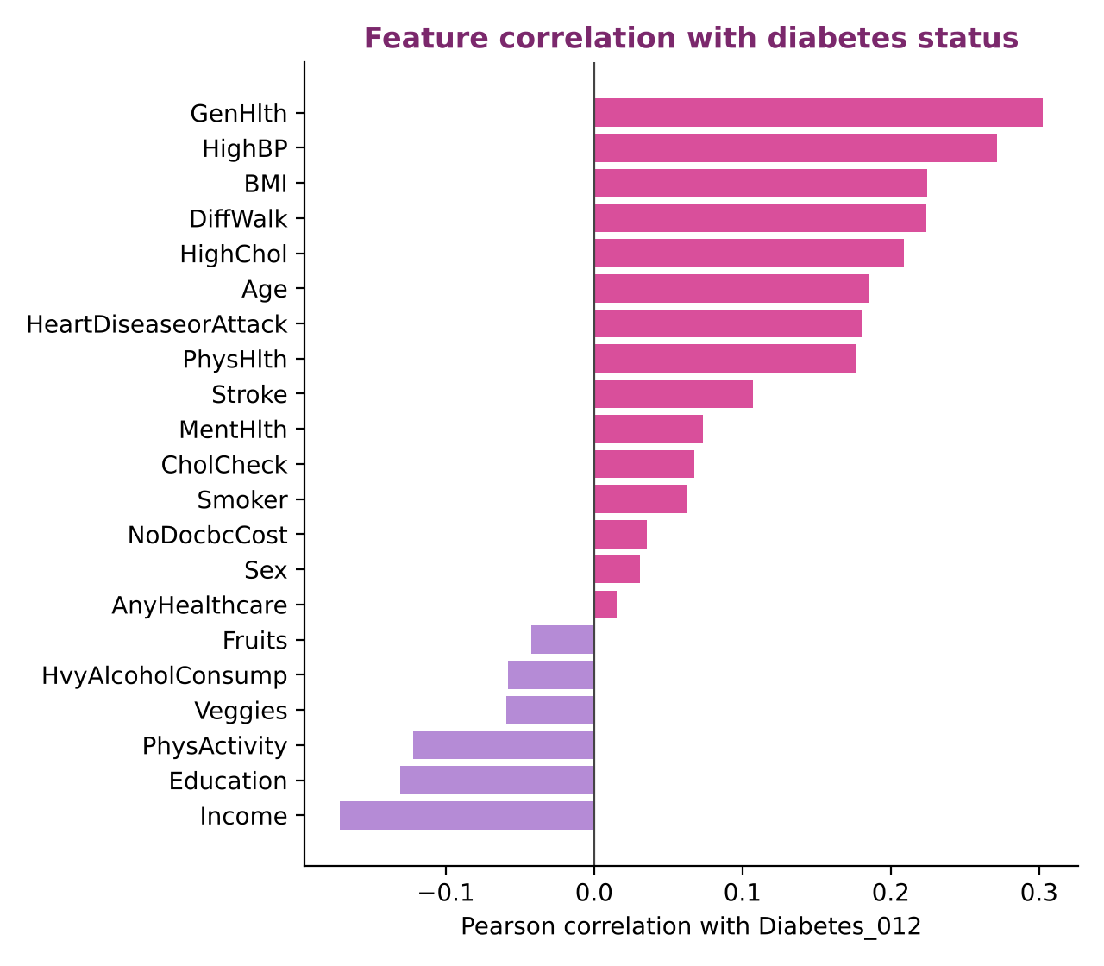
Figure 6.2: Correlation of each feature with Diabetes_012
6.5 Logistic Regression Model Implementation
Logistic Regression is a supervised classification algorithm. For each class it computes a weighted sum of the input features and converts the scores into class probabilities with the softmax function; the class with the highest probability is the prediction. Because the model is linear, its coefficients can be inspected to see how strongly each feature pushes a person towards a class.
The saved model has the configuration shown in Table 6.4.
Parameter | Value
Algorithm | LogisticRegression (multi-class, 3 classes: 0, 1, 2)
Regularization | L2 penalty, C = 1.0
Solver | lbfgs
Maximum iterations | 1000 (converged in 11 iterations)
Random state | 42
Class weights | None
Input features | 21 standardized features (coefficient matrix of shape 3 × 21)
Scaler | StandardScaler fitted on the same 21 features
Saved files | healthscope_logistic_model.pkl, healthscope_scaler.pkl (Scikit-learn 1.9.1)

Table 6.4: Configuration of the saved model and scaler
The algorithm used by the application follows these steps:
- Load the saved model and scaler using Joblib.
- Collect the 21 inputs and convert age to its category.
- Build a one-row DataFrame in the training column order.
- Standardize the row with scaler.transform().
- Predict the class with model.predict().
- Map the class (0, 1, 2) to No Diabetes, Prediabetes or Diabetes and display it.
Figure 6.3 shows the standardized coefficients of the Diabetes class. Because the inputs are standardized, the coefficients are directly comparable. General health (+0.262), BMI (+0.209), high blood pressure (+0.182) and age (+0.158) have the largest positive coefficients, i.e. they increase the score of the Diabetes class the most. Heavy alcohol consumption has a negative coefficient (−0.125); this reflects an association in the survey data and should not be read as a protective effect.
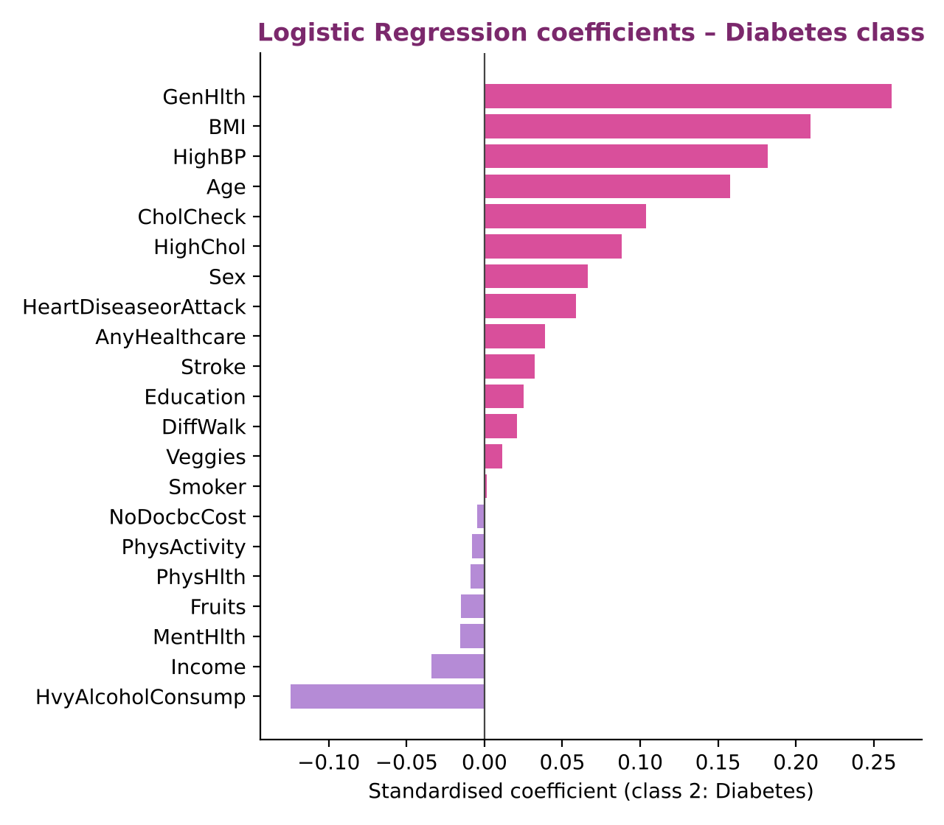
Figure 6.3: Logistic Regression coefficients for the Diabetes class
6.6 Prediction and Performance Analysis
When the user presses Predict Health Status, the application builds the input row, scales it and displays the predicted class in a result card with a green, yellow or red icon for No Diabetes, Prediabetes and Diabetes. A message states that the prediction is for educational and analytical purposes only.
The Model Performance tab evaluates the saved model on the dataset and displays:
- Accuracy
- Precision (weighted average)
- Recall (weighted average)
- F1-score (weighted average)
- Confusion matrix with a guide explaining how to read it
- A short guide describing each metric
CHAPTER 7
Features
7.1 List of Main Features
The major features of the application are:
- Dataset summary cards (total records, total features and diabetes cases).
- Interactive health assessment form with 21 inputs.
- Automatic conversion of age into an age category.
- Machine-learning based classification into No Diabetes, Prediabetes and Diabetes.
- Colour-coded prediction result card with an educational disclaimer.
- Public health analytics dashboard with five charts.
- Model performance dashboard with accuracy, precision, recall and F1-score.
- Confusion matrix visualization with an explanatory guide.
- Metric guide that explains each evaluation measure.
- About section describing the end-to-end workflow.
7.2 Working of Each Feature
Dataset Summary Cards:
Three cards at the top show 253,680 total records, 22 total features (21 predictors and the target) and 35,346 diabetes cases.
Health Assessment Form:
The user answers yes/no questions with select boxes, enters BMI and age as numbers, and rates general health and unhealthy days with sliders. Education and income are chosen from descriptive options that are internally converted to the numeric codes used by the model.
Prediction:
The inputs are scaled and passed to the Logistic Regression model, which returns the class. The result is displayed as “No Diabetes”, “Prediabetes” or “Diabetes” with a coloured icon.
Public Health Analytics:
Four summary cards (population, No Diabetes, Prediabetes and Diabetes counts) are followed by five charts: diabetes status, BMI distribution, blood pressure versus diabetes, physical activity versus diabetes and general health versus diabetes.
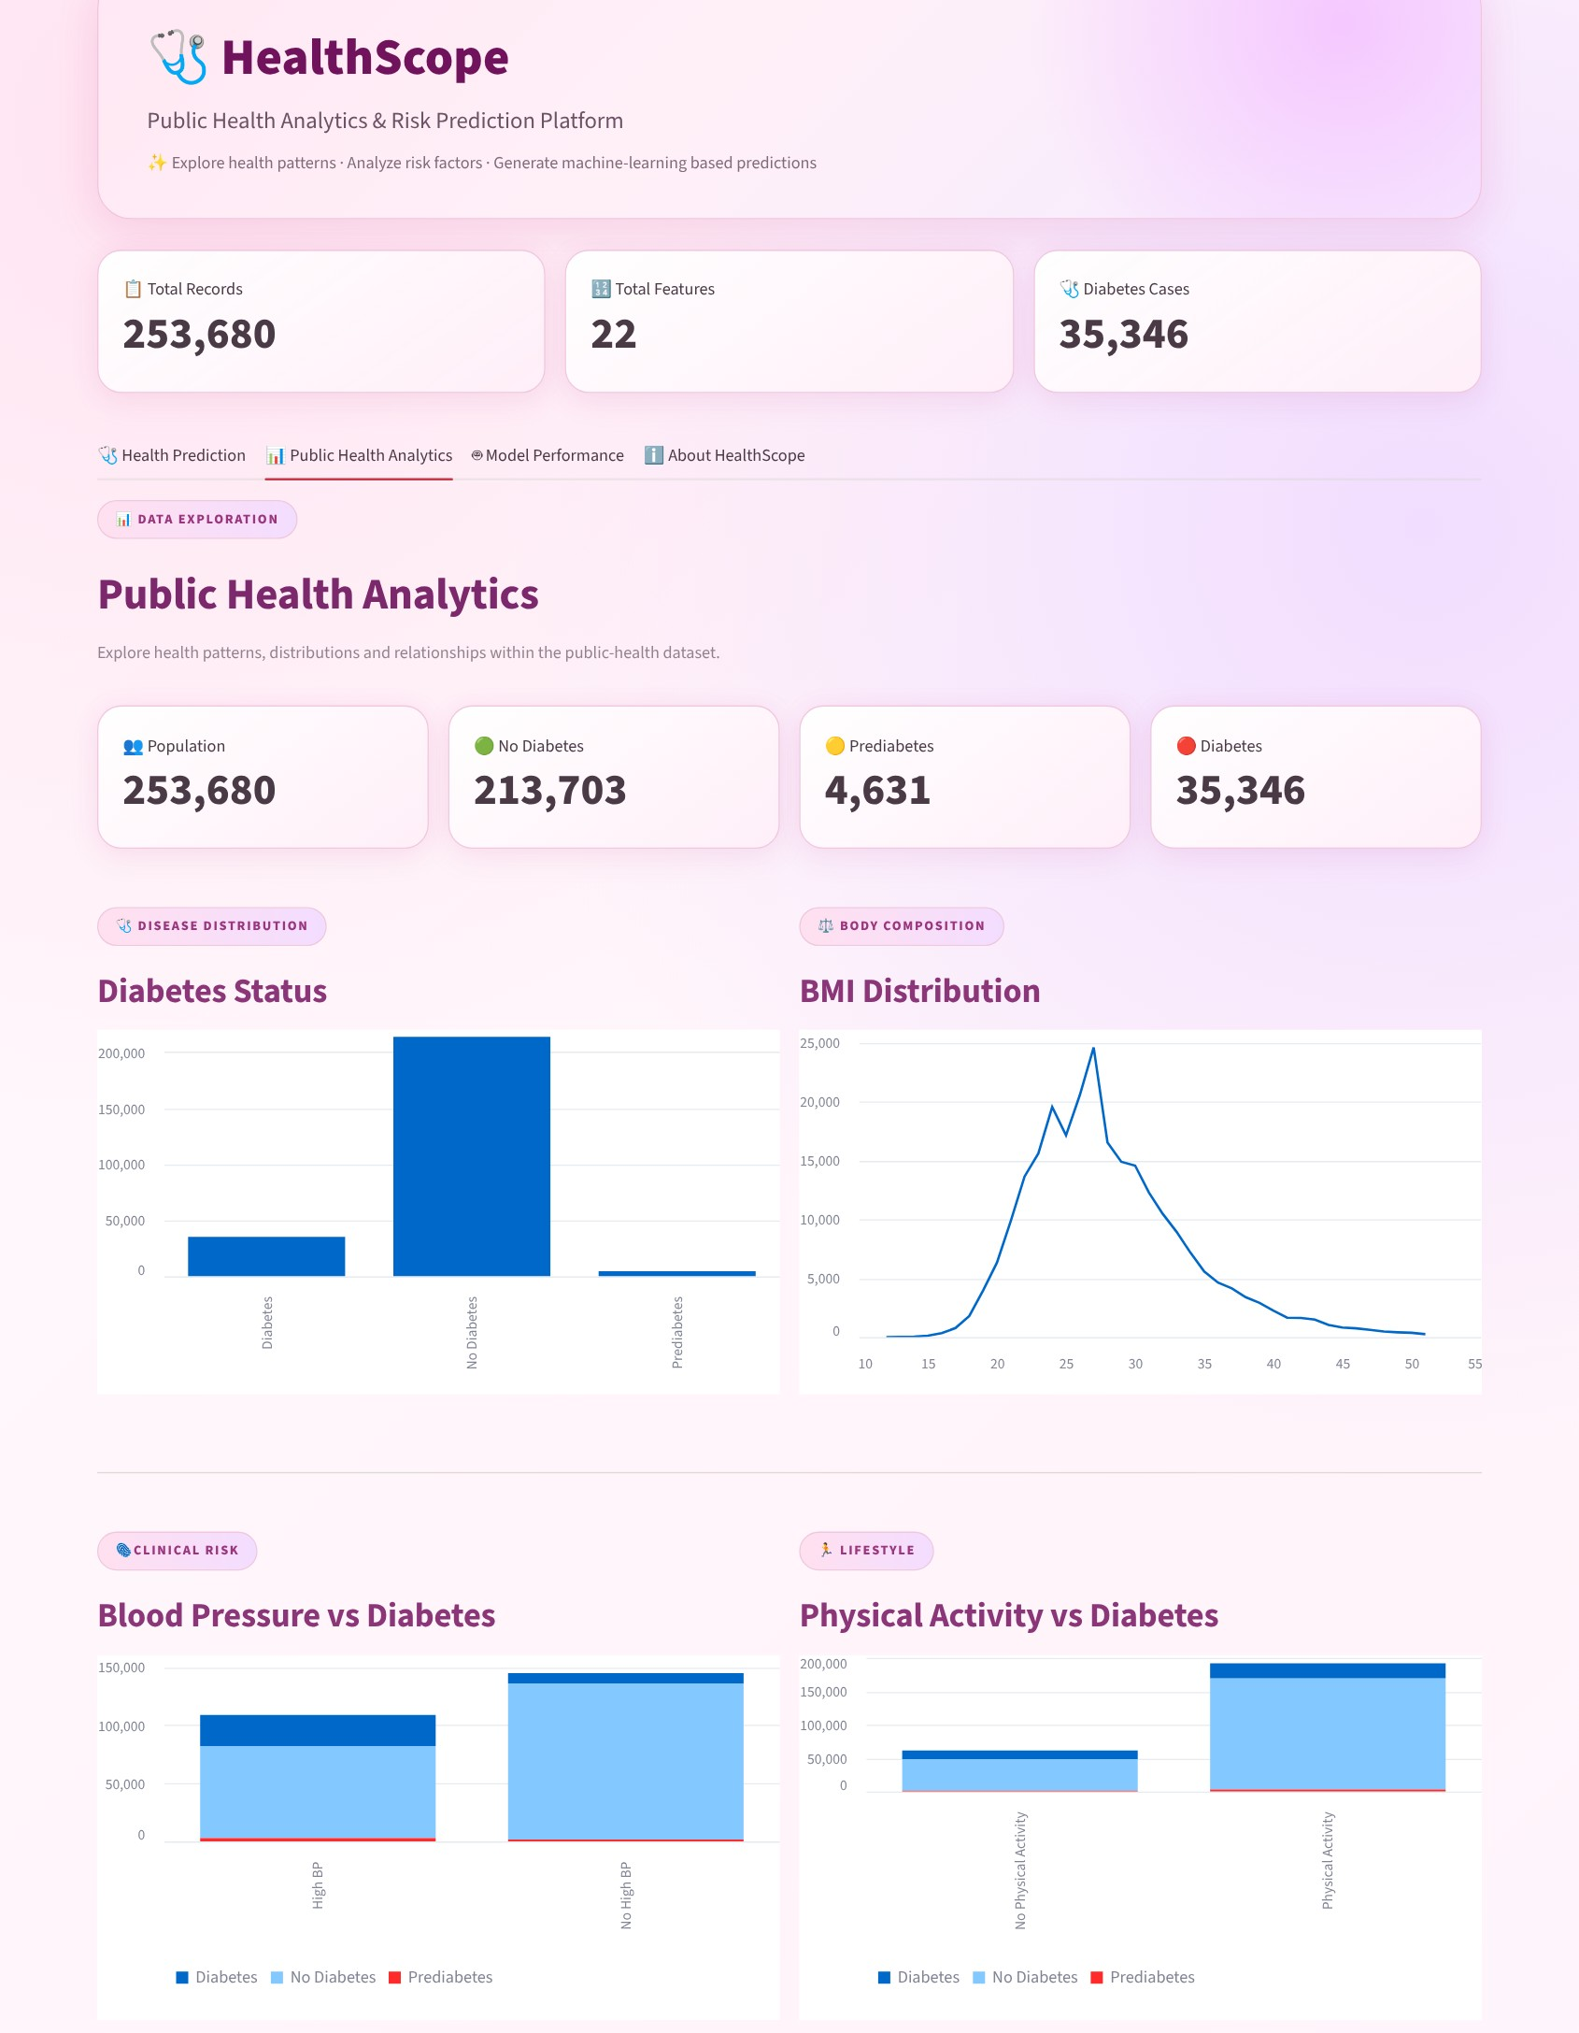
Figure 7.1: Public Health Analytics tab – status, BMI, blood pressure and activity
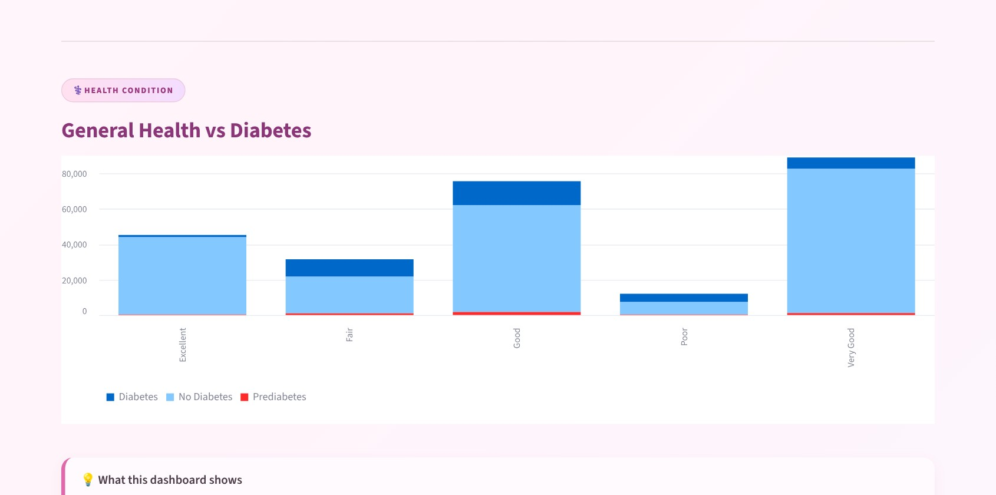
Figure 7.2: General health versus diabetes status
7.3 Interactive Health Assessment Form
The form has 21 inputs in four groups:
Group | Inputs
Clinical | High blood pressure, high cholesterol, cholesterol check, BMI, history of stroke, heart disease / attack
Lifestyle | Smoker, physical activity, fruits, vegetables, heavy alcohol consumption, healthcare access
Personal | Could not see doctor due to cost, general health (1–5), poor mental health days, poor physical health days, difficulty walking
Demographic | Sex, age (18–90 years), education level, income level

Table 7.1: Input groups of the health assessment form
7.4 Analytics and Model Performance Dashboard
The Model Performance tab summarises the model (Logistic Regression, multi-class classification, three classes), shows the four evaluation metrics as cards and draws the confusion matrix next to a guide that explains the diagonal and off-diagonal values.
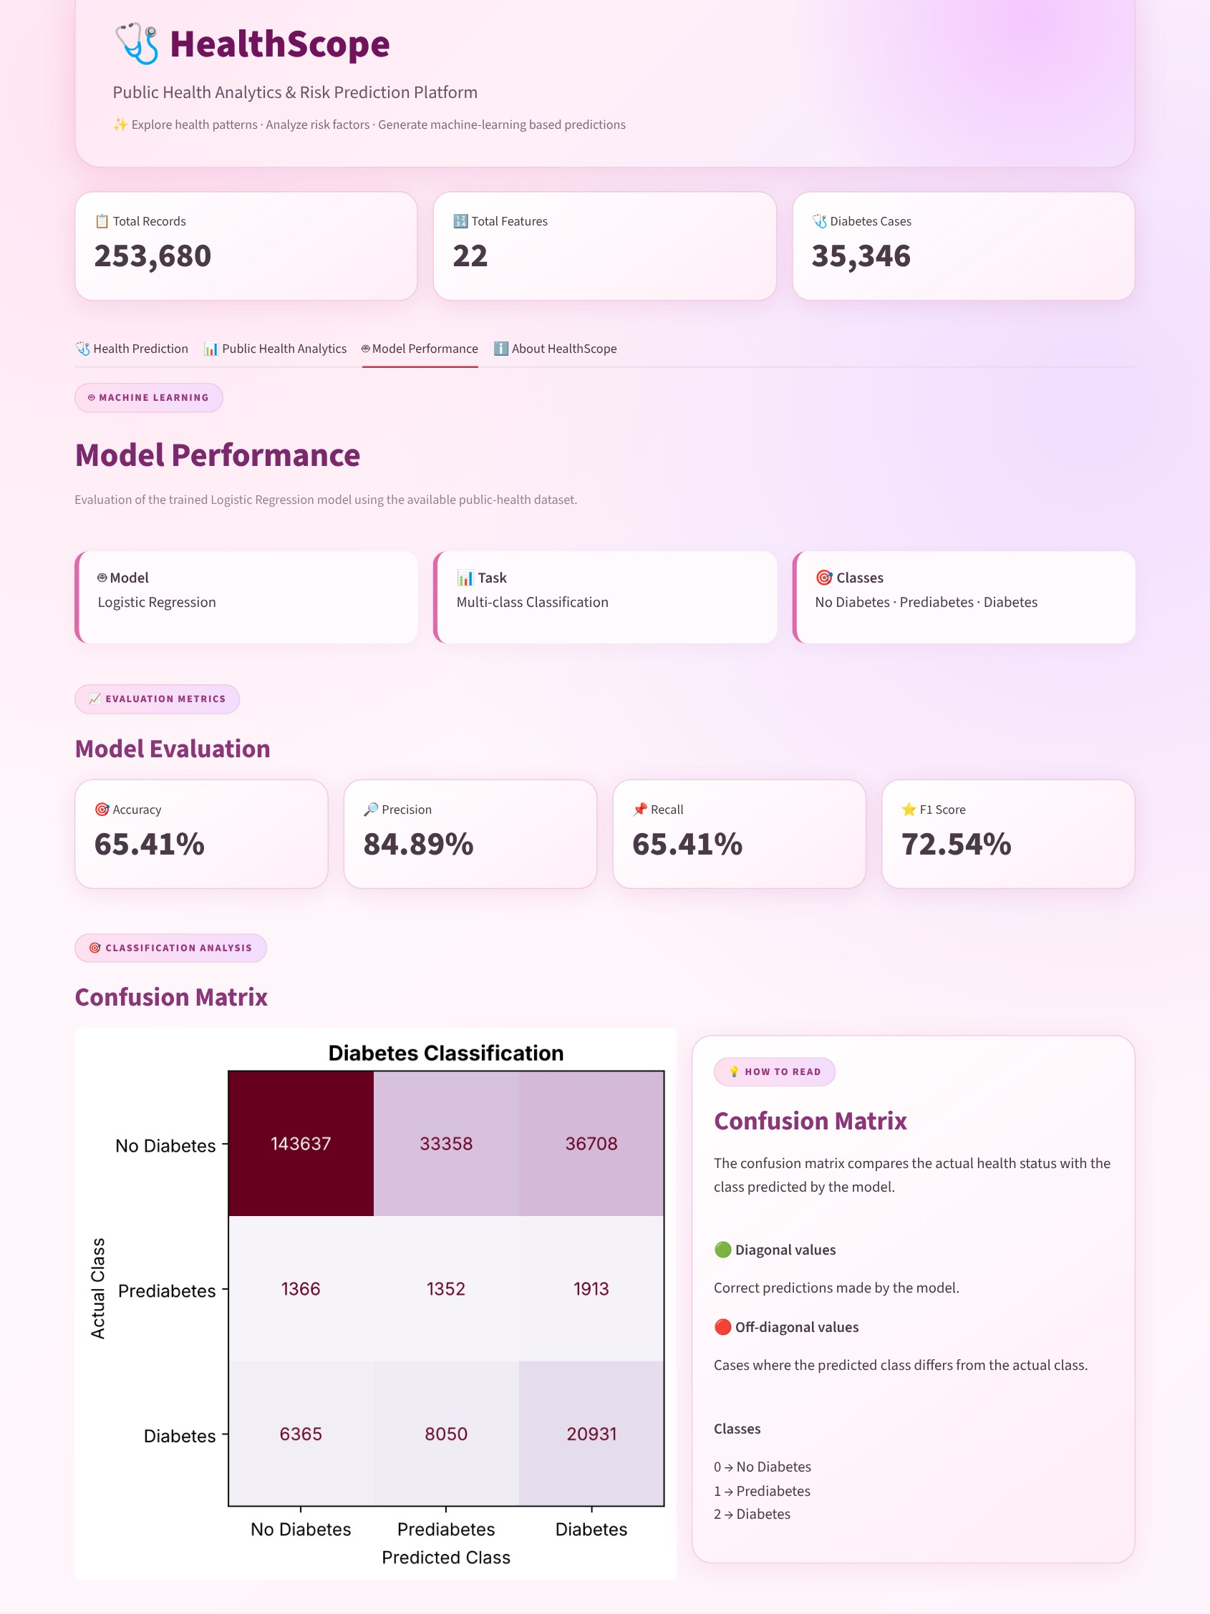
Figure 7.3: Model Performance tab with metrics and confusion matrix
CHAPTER 8
Testing
8.1 Functional Testing
Functional testing verifies whether the main features of the application work as expected. The following operations were tested:
- Starting the application and loading the dataset, model and scaler.
- Displaying the dataset summary cards.
- Converting age to the correct category.
- Generating predictions for low-risk and high-risk input profiles.
- Enforcing input ranges for BMI and age.
- Displaying the evaluation metrics and the confusion matrix.
- Navigating between the four tabs.
8.2 Integration Testing
Integration testing checks whether the modules work together correctly. The following sequence was verified:
- The user enters values in the form.
- The age is converted and the input row is built in the training column order.
- The saved scaler transforms the row (21 features).
- The saved model returns a class label.
- The label is displayed in the result card.
- The same scaler and model produce the metrics shown in the Model Performance tab.
8.3 Tools Used for Testing
- Streamlit’s AppTest framework (streamlit.testing.v1) to run the application headlessly, set widget values, click the prediction button and read the rendered output.
- Scikit-learn metrics to recompute the confusion matrix and verify the dashboard figures.
- Python 3.12, Streamlit 1.67 and Scikit-learn 1.9.1 as the test environment.
- A headless Chromium browser (Playwright) to capture the application screenshots in this report.
Postman testing is not applicable because the current implementation does not use a separate REST API backend.
8.4 Test Cases and Results
The test cases below were executed against the application and the actual results were recorded.
ID | Test Case | Expected Result | Actual Result | Status
TC-01 | Application start-up | App loads with no exception; four tabs are created | exceptions=0, tabs=4 | Pass
TC-02 | Dataset summary cards | 253,680 records, 22 columns, 35,346 diabetes cases | 253,680, 22, 35,346 | Pass
TC-03 | Age to category conversion | 18-24→1, 25-29→2, … , 75-79→12, 80+→13 | 18→1, 24→1, 25→2, 34→3, 44→5, 59→8, 79→12, 80→13, 90→13 | Pass
TC-04 | Prediction with default (low-risk) input | Result card displayed with a valid class label | exceptions=0, label=No Diabetes | Pass
TC-05 | Prediction with high-risk profile (age 68, BMI 38, high BP, poor health) | Predicted class is an elevated-risk class (Diabetes expected) | Prediabetes (probabilities 16.7% / 43.1% / 40.2%) | Partial
TC-06 | Prediction with healthy profile (age 22, BMI 21, excellent health) | Predicted class = No Diabetes | label=No Diabetes | Pass
TC-07 | Input range validation | BMI limited to 10–100, Age limited to 18–90 | BMI 10.0–100.0, Age 18.0–90.0 | Pass
TC-08 | Scaler / model feature alignment | 21 features; order identical in scaler, model and app input | scaler=21, model coef=(3, 21), same order=True | Pass
TC-09 | Model performance dashboard metrics | Accuracy 65.41%, Precision 84.89%, Recall 65.41%, F1 72.54% | 65.41%, 84.89%, 65.41%, 72.54% | Pass
TC-10 | Confusion matrix consistency | Matrix total equals number of records (253,680); row sums equal class counts | total=253,680, row sums=[213703, 4631, 35346] | Pass
TC-11 | Tab navigation | Prediction, Analytics, Model Performance and About tabs are available | 🩺 Health Prediction; 📊 Public Health Analytics; 🤖 Model Performance; ℹ️ About HealthScope | Pass

Table 8.1: Test cases and results
10 of the 11 test cases passed fully and 1 passed partially. In TC-05 the high-risk profile was classified as an elevated-risk class, but as Prediabetes (43.1%) instead of Diabetes (40.2%). The two probabilities are very close, which shows that the boundary between the Prediabetes and Diabetes classes is not sharp in the current model (see Section 8.5).
8.5 Model Performance Evaluation
The Model Performance tab evaluates the saved model on all 253,680 records of the dataset. Table 8.2 gives the overall results.
Evaluation Metric | Value
Accuracy | 65.41%
Precision (weighted) | 84.89%
Recall (weighted) | 65.41%
F1-score (weighted) | 72.54%
Macro-average F1-score | 42.84%

Table 8.2: Overall performance of the Logistic Regression model
Because the classes are imbalanced, the class-wise results in Table 8.3 are more informative than the overall accuracy.
Class | Precision | Recall | F1-score | Support
No Diabetes | 94.89% | 67.21% | 78.69% | 213,703
Prediabetes | 3.16% | 29.19% | 5.71% | 4,631
Diabetes | 35.15% | 59.22% | 44.11% | 35,346

Table 8.3: Class-wise performance
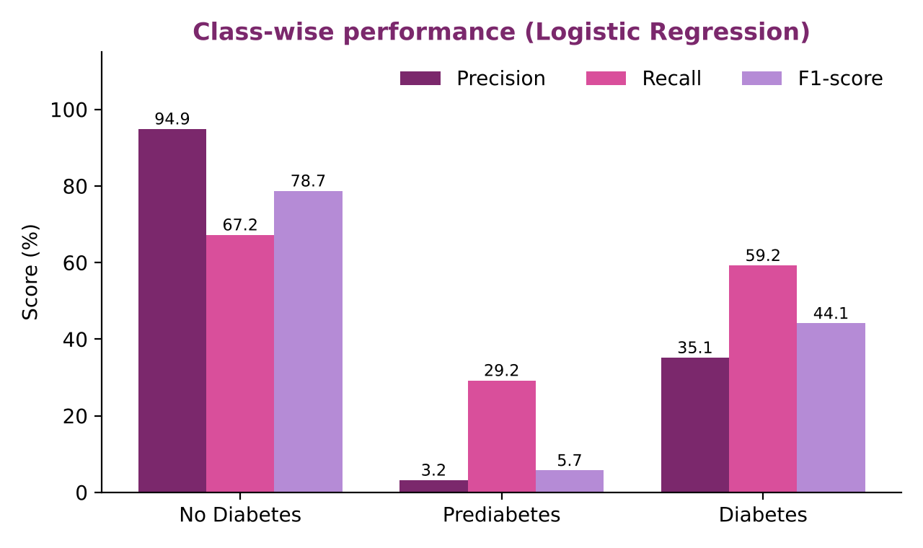
Figure 8.1: Class-wise precision, recall and F1-score
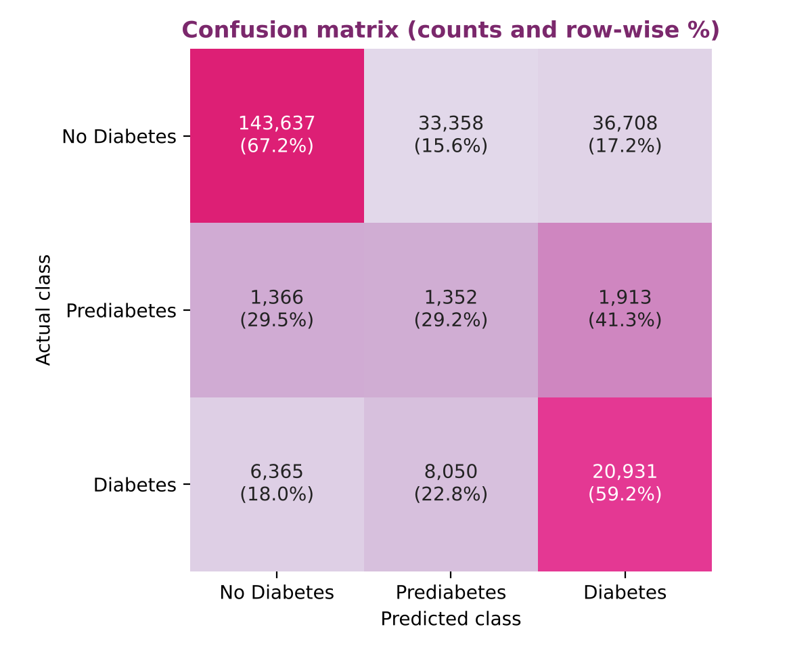
Figure 8.2: Confusion matrix of the model on the complete dataset
Interpretation of the results
- The model classified 165,920 of the 253,680 records correctly, giving the accuracy of 65.41%.
- The weighted precision (84.89%) is high mainly because 84.24% of the records belong to the No Diabetes class, which the model predicts with 94.89% precision.
- Of the 35,346 respondents with Diabetes, the model identified 20,931 (59.22% recall); 6,365 were predicted as No Diabetes and 8,050 as Prediabetes.
- The model over-predicts the risk classes: 36,708 healthy respondents were predicted as Diabetes and 33,358 as Prediabetes. This lowers the precision of the Diabetes class to 35.15%.
- The Prediabetes class is the most difficult one: only 1,352 of 4,631 cases (29.19%) were recognised and only 3.16% of the Prediabetes predictions were correct. The macro-average F1-score of 42.84% reflects this weakness.
Note on evaluation: the dashboard computes these metrics on the complete dataset, which includes the records that were used to fit the model. The figures therefore describe how well the model fits the available data. For a statement about performance on unseen people, the model should additionally be evaluated on a held-out test set or with cross-validation (see Chapter 11).
CHAPTER 9
Deployment
9.1 Steps to Run the Application
The application can be executed locally using the following steps:
- Install Python 3 on the computer.
- Copy the project files into one folder (see Section 9.2).
- Open the project folder in Visual Studio Code.
- Create and activate a Python virtual environment.
- Install the required libraries with pip install -r requirements.txt.
- Run the Streamlit application.
Command to execute the application:
python -m streamlit run app.py

After executing the command, Streamlit displays a local URL in the terminal. Open that URL in a web browser to access HealthScope.
9.2 Python Environment Configuration
The project uses a Python virtual environment to manage the required libraries. All four project files must be present in the same folder because the application loads them with relative paths:
healthscope/
├── app.py
├── healthscope_data.csv
├── healthscope_logistic_model.pkl
├── healthscope_scaler.pkl
└── requirements.txt

The libraries listed in requirements.txt are streamlit, pandas, numpy, scikit-learn, matplotlib and joblib. The saved model and scaler were created with Scikit-learn 1.9.1; using the same version avoids version-mismatch warnings when the files are loaded.
9.3 Local Application Execution
The application runs locally through Streamlit. The user interface and the application logic operate in the same Python process, so separate front-end and back-end hosting is not required for the current implementation. The same files can later be deployed to a cloud platform such as Streamlit Community Cloud (see Chapter 11).
CHAPTER 10
Challenges and Limitations
10.1 Issues Faced During Development
Class Imbalance:
Only 1.83% of the records belong to the Prediabetes class and 13.93% to Diabetes, while 84.24% are No Diabetes. This makes it hard for any model to learn the minority classes.
Duplicate Records:
The dataset contains 23,899 exact duplicate rows (9.42%), which must be understood when interpreting counts and model results.
Mixed Feature Encodings:
Binary indicators, ordinal scales (general health, age, education, income) and numeric measurements (BMI, unhealthy days) are mixed and must be scaled and entered consistently.
Age Representation:
The model expects an age category from 1 to 13, whereas users naturally enter age in years.
Consistency Between Training and Prediction:
The input row must have exactly the same 21 columns, in the same order, as the data used for training.
Environment Configuration:
Managing Python libraries, virtual environments and saved model files required careful configuration.
10.2 Solutions Applied
- A dedicated age_to_category() function converts age in years into the 13 model categories.
- A StandardScaler stored with Joblib ensures that all inputs are scaled exactly as during training.
- The input DataFrame is built with the same column names and order as the training data.
- Input widgets restrict values to valid ranges (for example BMI 10–100 and age 18–90).
- Descriptive options for education and income are mapped internally to numeric codes.
- Class-wise precision, recall and F1-score and the confusion matrix are examined in addition to accuracy, so that weaknesses on the minority classes are visible.
- An educational disclaimer is shown with every prediction.
10.3 Current Limitations
The current system has the following limitations:
- Only one model (Logistic Regression) is used; Decision Tree, Random Forest and KNN have not yet been compared.
- Prediabetes is predicted poorly (precision 3.16%, recall 29.19%).
- The model over-predicts the risk classes: 36,708 healthy respondents were predicted as Diabetes.
- Performance is reported on the complete dataset, including the data used to fit the model, instead of on a separate test set.
- The data are self-reported survey responses and show association, not causation.
- The model uses only the 21 indicators in the dataset and does not use laboratory results such as blood glucose.
- The dataset, model and metrics are loaded and recomputed on every Streamlit run, which can slow the interface because no caching is used.
- The application is designed for local execution and is not a medical diagnosis tool.
CHAPTER 11
Future Enhancements
11.1 Planned Features
Additional Datasets:
Integrate further healthcare and public-health datasets, for example NFHS-5 survey data, to broaden the analysis.
User-specific Reporting:
Generate a downloadable report for each prediction with the entered values and the class probabilities.
Enhanced Dashboard:
Add filters, trend visualizations and comparisons of health indicators across population groups.
Explainability:
Show which inputs contributed most to an individual prediction.
Performance Optimisation:
Cache the dataset, model and metrics with Streamlit’s caching functions to make the interface faster.
11.2 Model Improvement and Additional Algorithms
- Train and compare Decision Tree, Random Forest and KNN models with Logistic Regression, as planned in the project design, and select the best model for each prediction task.
- Address class imbalance with class weights or resampling techniques and tune the decision thresholds, especially for the Prediabetes class.
- Evaluate every model on a held-out test set and with cross-validation, and report class-wise metrics.
- Display class probabilities instead of only the predicted label.
- Explore advanced machine learning and deep learning models.
11.3 Cloud Deployment and API Integration
The application can be hosted online, for example on Streamlit Community Cloud, so that users can access it without a local installation. In a larger deployment the models can be exposed through APIs and microservices, and the platform can be extended with cloud-based and real-time data processing.
CHAPTER 12
Conclusion
12.1 Summary of the Project
The project “HealthScope – Public Health Analytics and Risk Prediction Platform” was developed as an interactive data-science application. It integrates data processing, exploratory analysis, machine learning and visualization to analyse a public-health dataset of 253,680 records and to classify health status into No Diabetes, Prediabetes and Diabetes.
The exploratory analysis showed that general health, high blood pressure, BMI, age and physical inactivity are strongly associated with diabetes. A Logistic Regression model with standardized inputs achieved an accuracy of 65.41% and a weighted F1-score of 72.54% on the dataset. The class-wise evaluation revealed that the Prediabetes class is difficult to predict, which identifies clear directions for improvement.
The final workflow of the platform is Collect → Clean → Analyze → Predict → Visualize, which provides a foundation for data-driven public-health analysis, early risk identification and informed decision support.
12.2 What Was Achieved
The major achievements of the project include:
- Developed an interactive public-health analytics and prediction platform with Streamlit.
- Analysed a dataset of 253,680 records and 21 health indicators.
- Built an analytics dashboard that relates diabetes status to BMI, blood pressure, physical activity and general health.
- Implemented a three-class diabetes status prediction using a saved Logistic Regression model and scaler.
- Created an input form with automatic age conversion and range validation.
- Evaluated the model with accuracy, precision, recall, F1-score and a confusion matrix.
- Identified the limitations of the model on the minority Prediabetes class through class-wise analysis.
- Tested the application with automated test cases.
12.3 Skills Learned During Development
Through this project, we gained practical experience in:
- Python programming.
- Data handling and exploratory data analysis with Pandas.
- Feature scaling and preprocessing.
- Machine learning classification with Logistic Regression.
- Model evaluation and handling of imbalanced classes.
- Streamlit application development and interface design.
- Data visualization.
- Model saving and loading with Joblib.
- Software testing.
- Team collaboration and technical documentation.
CHAPTER 13
References
- Centers for Disease Control and Prevention, “Behavioral Risk Factor Surveillance System (BRFSS).” Available at: https://www.cdc.gov/brfss/
- A. Teboul, “Diabetes Health Indicators Dataset,” Kaggle. Available at: https://www.kaggle.com/datasets/alexteboul/diabetes-health-indicators-dataset
- Scikit-learn Documentation, “Logistic Regression.” Available at: https://scikit-learn.org/stable/modules/linear_model.html#logistic-regression
- Scikit-learn Documentation, “StandardScaler.” Available at: https://scikit-learn.org/stable/modules/generated/sklearn.preprocessing.StandardScaler.html
- Scikit-learn Documentation, “Model evaluation: quantifying the quality of predictions.” Available at: https://scikit-learn.org/stable/modules/model_evaluation.html
- Streamlit Documentation. Available at: https://docs.streamlit.io/
- Pandas Documentation. Available at: https://pandas.pydata.org/docs/
- NumPy Documentation. Available at: https://numpy.org/doc/
- Matplotlib Documentation. Available at: https://matplotlib.org/stable/
- Joblib Documentation. Available at: https://joblib.readthedocs.io/
CHAPTER 14
Appendices
14.1 Application Screenshots
The following screenshots demonstrate the working of the application:
- Main screen with summary cards and the health information form (Figure 5.1).
- Prediction button and result card (Figure 5.2).
- Public Health Analytics tab (Figures 7.1 and 7.2).
- Model Performance tab with metrics and confusion matrix (Figure 7.3).
- Metric guide (Figure A.1).
- About HealthScope tab (Figure A.2).
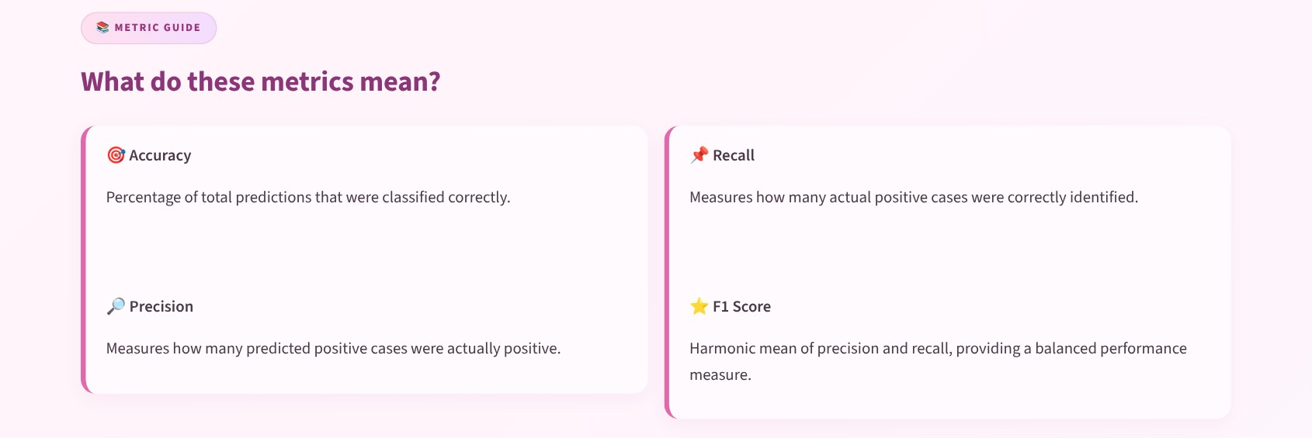
Figure A.1: Metric guide in the Model Performance tab
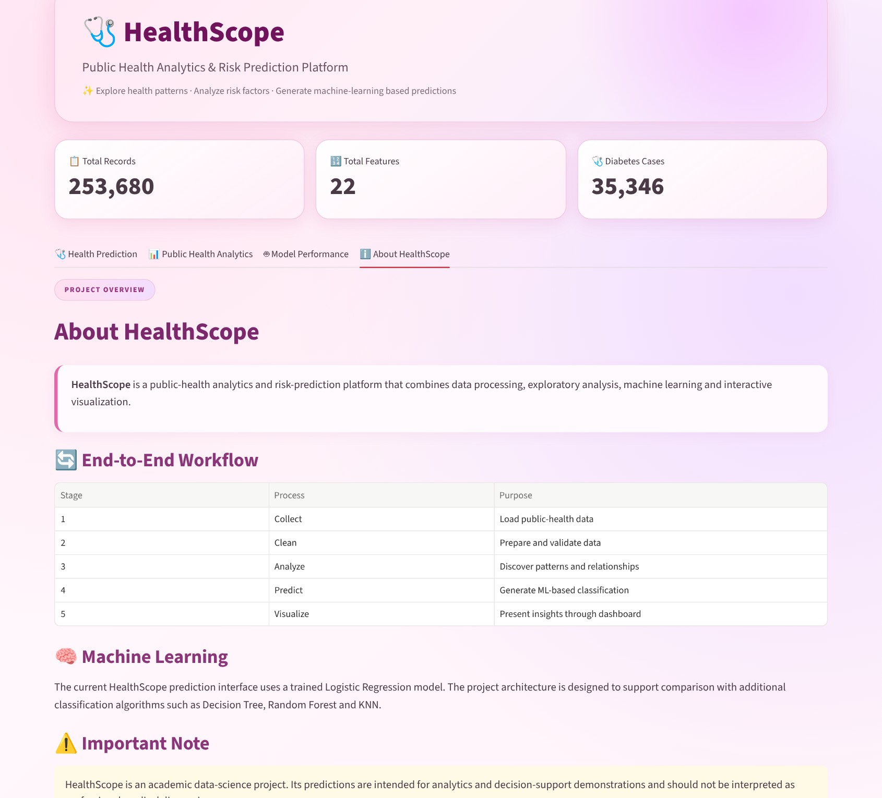
Figure A.2: About HealthScope tab
14.2 Sample Code Snippets
Age conversion (from app.py):
def age_to_category(age):
if age <= 24: return 1
elif age <= 29: return 2
elif age <= 34: return 3
# ... one step for every five years ...
elif age <= 79: return 12
else: return 13

Prediction (simplified from app.py):
model = joblib.load("healthscope_logistic_model.pkl")
scaler = joblib.load("healthscope_scaler.pkl")

input_data = pd.DataFrame([{ "HighBP": high_bp, "HighChol": high_chol,
"BMI": bmi, "GenHlth": general_health,
"Age": age, "Income": income }) # all 21 features

scaled_input = scaler.transform(input_data)
prediction = int(model.predict(scaled_input)[0])
labels = {0: "No Diabetes", 1: "Prediabetes", 2: "Diabetes"}
result = labels.get(prediction, "Unknown")

Evaluation (from app.py):
X_scaled = scaler.transform(df[feature_columns])
y_pred = model.predict(X_scaled)

accuracy = accuracy_score(y, y_pred)
precision = precision_score(y, y_pred, average="weighted", zero_division=0)
recall = recall_score(y, y_pred, average="weighted", zero_division=0)
f1 = f1_score(y, y_pred, average="weighted", zero_division=0)
cm = confusion_matrix(y, y_pred, labels=[0, 1, 2])

Model configuration as stored in healthscope_logistic_model.pkl (the training notebook is not part of the submitted files):
from sklearn.linear_model import LogisticRegression
from sklearn.preprocessing import StandardScaler

scaler = StandardScaler() # fitted on the 21 features
model = LogisticRegression(max_iter=1000, random_state=42) # C=1.0, L2, lbfgs
model.fit(scaler.transform(X_train), y_train)
joblib.dump(model, "healthscope_logistic_model.pkl")
joblib.dump(scaler, "healthscope_scaler.pkl")

14.3 Installation and Setup Instructions
Step 1: Install Python 3.x.
Step 2: Open the project folder in Visual Studio Code.
Step 3: Create and activate a virtual environment.
python -m venv venv
.\venv\Scripts\Activate.ps1

Step 4: Install the required libraries.
pip install -r requirements.txt

Step 5: Run the application.
python -m streamlit run app.py

Step 6: Open the local URL displayed in the terminal.
14.4 User Manual
The application can be used through the following steps:
- Open the HealthScope application in a browser.
- Review the dataset summary cards at the top of the page.
- In the Health Prediction tab, enter the clinical, lifestyle, personal and demographic information.
- Click the “Predict Health Status” button.
- Read the predicted class in the result card (green: No Diabetes, yellow: Prediabetes, red: Diabetes).
- Open the Public Health Analytics tab to explore the data patterns.
- Open the Model Performance tab to view the metrics and the confusion matrix.
- Open the About HealthScope tab to read the project workflow and important notes.
Important: the predictions are intended for educational and analytical purposes only and must not be used as a medical diagnosis.
14.5 Team Contributions
The project was carried out by a team of three students.
Team Member | Roll Number
Hasini Peddi | 2420030784
G. Greeshma Sai | 2420030550
B. Keerthi Reddy | 2420030774

Table 14.1: Project team
All three team members contributed to data analysis, model integration, dashboard development, testing, debugging and documentation.

