WBC 13-Class Classification Using ConvNeXt-Tiny

Problem Statement
White Blood Cell (WBC) classification is done manually by lab technicians to diagnose diseases like leukemia, infections, and anemia. This is slow, error-prone, and subject to human variation. The goal of this project is to build a deep learning model that automatically classifies microscopy images into 13 WBC types.
Three key challenges made this non-trivial:
- Class Imbalance: SNE had 11,135 images but PLY had only 11. Training directly on this would make the model ignore rare classes completely.
- Microscopy Noise: Camera shot noise (grain) in lab images can mislead the model into learning noise patterns instead of cell morphology.
- Background Clutter: WBCs occupy only 20–30% of the image area. The rest is red blood cells and plasma — irrelevant background.
The 13 classes to identify:
Code | Full Name | Key Biological Feature
SNE | Segmented Neutrophil | Multi-lobed nucleus (3-5 lobes), most abundant WBC in blood
LY | Lymphocyte | Small cell, high nucleus-to-cytoplasm ratio, dense round nucleus
MO | Monocyte | Largest WBC, kidney-shaped nucleus, abundant grey cytoplasm
BL | Blast | Immature cell, fine chromatin, large nucleus — indicator of leukemia
EO | Eosinophil | Bi-lobed nucleus, large bright orange/red granules
BA | Basophil | Dark purple-black granules that obscure the nucleus
BNE | Band Neutrophil | Immature neutrophil, band-shaped unsegmented nucleus
VLY | Variant Lymphocyte | Activated lymphocyte, larger with more cytoplasm than normal LY
MY | Myelocyte | Granulocyte precursor, round nucleus, secondary granules forming
MMY | Metamyelocyte | Between myelocyte and band; kidney-shaped, indented nucleus
PMY | Promyelocyte | Large cell, prominent nucleoli, primary (azurophilic) granules
PC | Plasma Cell | Eccentric nucleus with clock-face chromatin pattern, abundant cytoplasm
PLY | Prolymphocyte | Between lymphoblast and lymphocyte; has a visible nucleolus

Methods and Pipeline

Full Pipeline Overview
Below is the complete pipeline we followed from raw images to final results. Each step is explained in detail in the sections that follow.
Step | Name | What It Does
1 | Environment Setup | Install libraries, set random seed, configure GPU
2 | Data Loading | Load CSV splits, map class names to indices, build file paths
3 | Path Verification | Spot-check 50 random paths per split to confirm images exist on disk
4 | Minority Class Augmentation | Synthetically increase rare classes (PLY, PC, PMY, VLY, BNE, MMY, MY, BA) to 600 samples each
5 | Image Denoising (denoise_wbc) | 3-stage pipeline: NLM denoising + Bilateral filter + CLAHE contrast enhancement
6 | ROI Cropping (crop_wbc_roi) | Detect the WBC cell using 5-method cascade, crop tightly with 20% padding
7 | Dataset Class + Sampler | PyTorch Dataset applies all preprocessing at runtime; WeightedRandomSampler balances batches
8 | Model Architecture | ConvNeXt-Tiny pretrained on ImageNet, head replaced for 13-class output
9 | Training with AMP + Early Stopping | Phase 1: Frozen backbone for 3 epochs. Phase 2: Full fine-tune at lower LR. Saves best model by validation F1.
10 | 3-Fold Cross Validation | StratifiedKFold ensures class balance across folds; produces OOF predictions for unbiased evaluation
11 | Final Model Training | Train on full train+val combined using same hyperparameters
12 | Evaluation & Visualizations | Confusion matrix, per-class F1/Precision/Recall, training curves, GradCAM, error analysis

Class Imbalance — the main data challenge
The class distribution was severely imbalanced. Below are the approximate counts in the training set:
Class | Approx Count
SNE | 11,135
LY | 6,886
MO | 2,454
BL | 1,699
EO | 798
BA | 420
BNE | 340
MMY | 335
MY | 405
VLY | 282
PMY | 76
PC | 56
PLY | 11
Minority Class Augmentation
Minority classes were extremely limited.
Examples:
- PLY
- PC
- PMY
Without augmentation:
- model overfits
- minority recall collapses
- macro-F1 decreases
Class | Current Count | Target | To Generate
PLY | 11 | 600 | 589
PC | 56 | 600 | 544
PMY | 76 | 600 | 524
VLY | 282 | 600 | 318
BNE | 340 | 600 | 260
MMY | 335 | 600 | 265
MY | 405 | 600 | 195
BA | 420 | 600 | 180
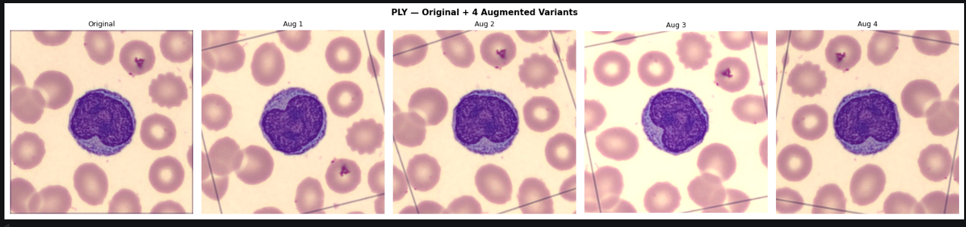
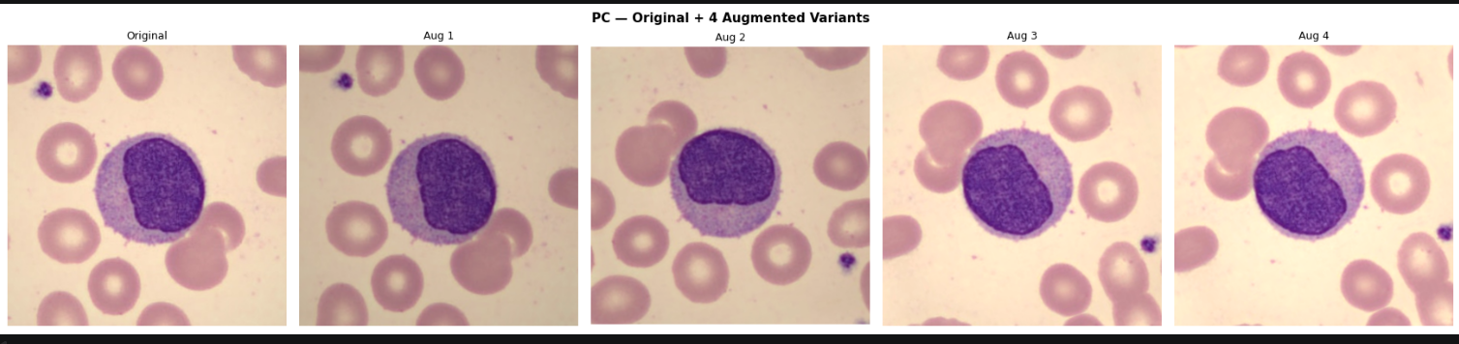
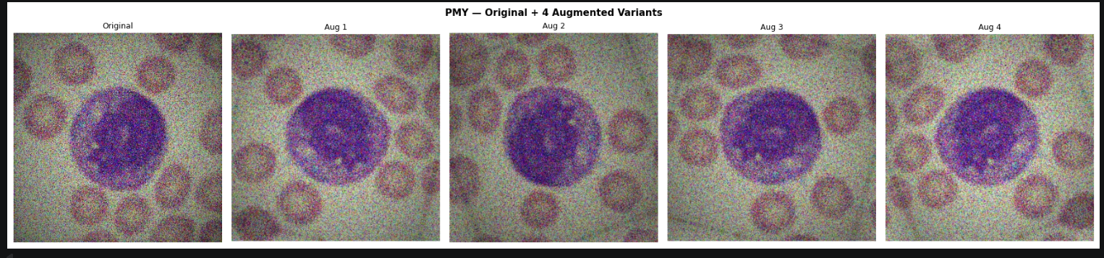
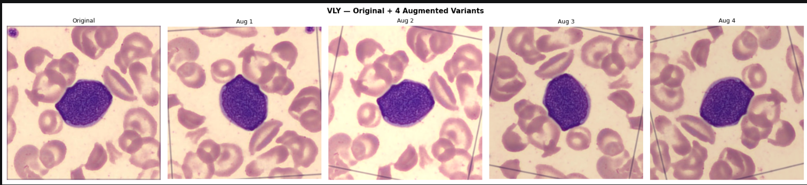
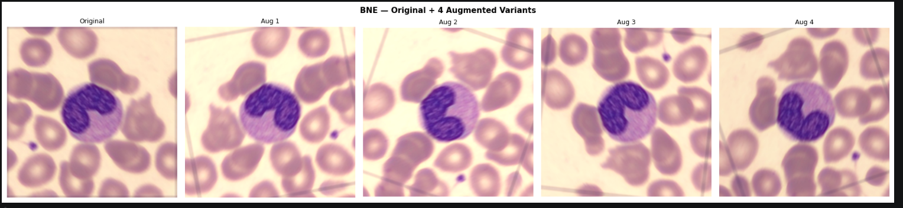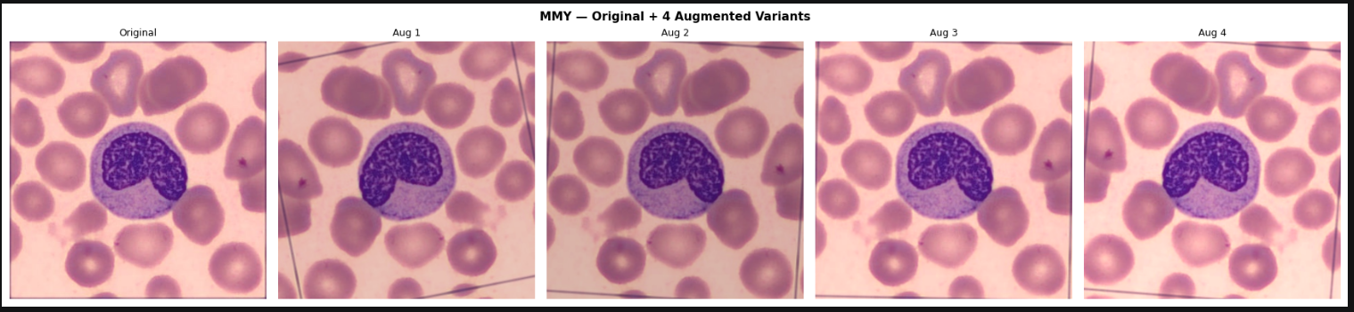
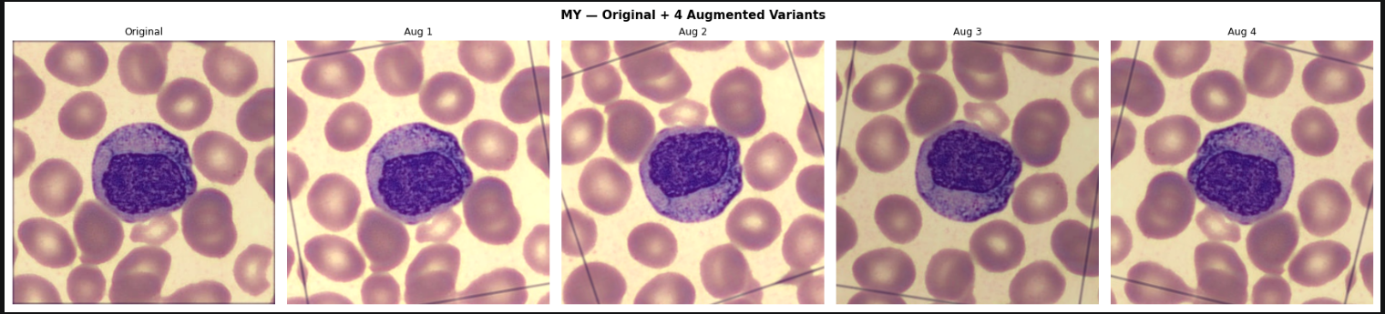
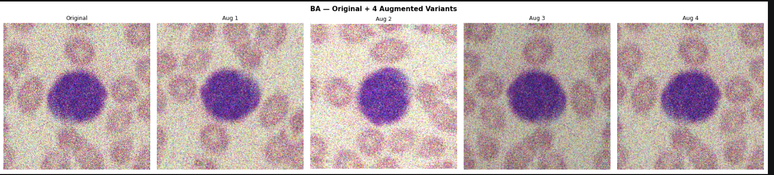
After augmentation, total training samples increased from 24,897 to 27,772.
Preprocessing Visualisation
Context-Aware ROI Cropping
Why ROI Cropping Was Needed:
Raw images contain:
- large empty background
- RBC clutter
- irrelevant regions
ROI extraction focuses the model on the actual WBC.
Why Nucleus-Only ROI Was Rejected
Nucleus-only cropping removes important diagnostic structures.
Important morphological features include:
- cytoplasm
- granules
- lobes
- membrane
- chromatin
- RBC context
Some classes depend more on cytoplasm than nucleus.

Example:
Class | Important Morphology
EO | granules
BA | dense granules
PMY | cytoplasm texture
BNE | nuclear band shape
MMY | indentation morphology
Therefore, nucleus-only ROI is biologically incorrect.

ROI Strategy
The final approach used a context-aware tight bounding box with 10–20% padding. Pipeline steps:
- RGB → HSV/LAB conversion
- WBC contour detection (5-method cascade: adaptive threshold, dark blob, Otsu, LAB, fallback)
- Largest contour extraction
- Tight bounding box extraction
- Padding addition (10–20%)
- Resize to 224×224

The visualization shows the full preprocessing pipeline for all 13 WBC classes. Col 3 shows the RED bounding box detection. Col 4 is what the model actually sees.

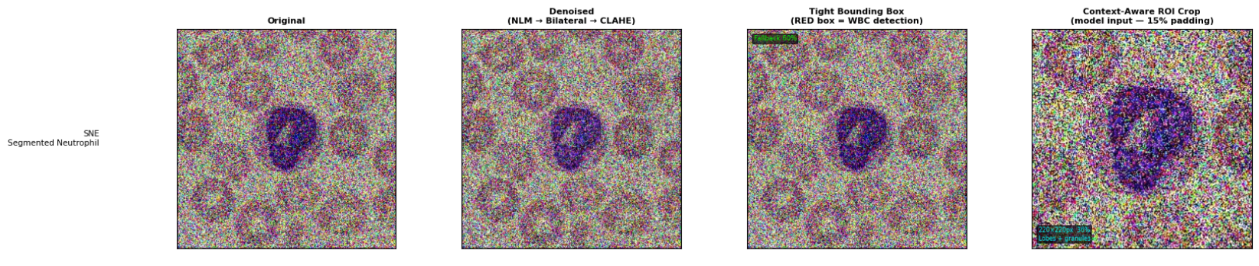
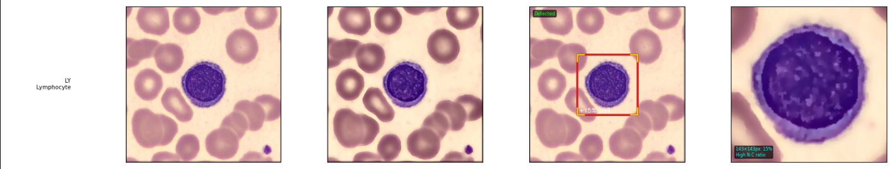
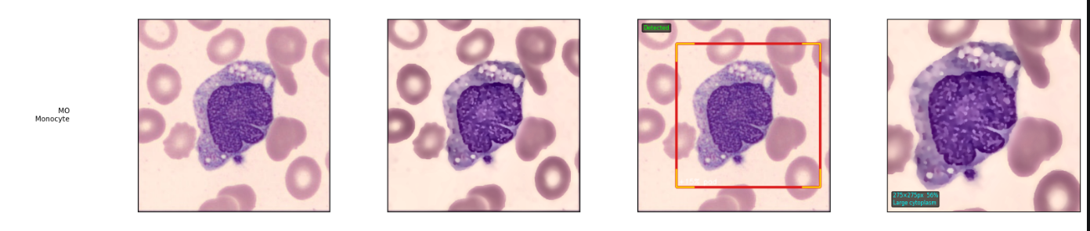
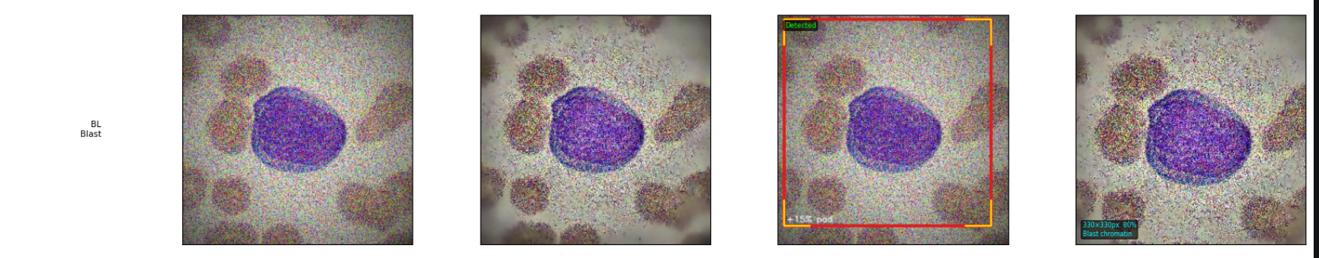
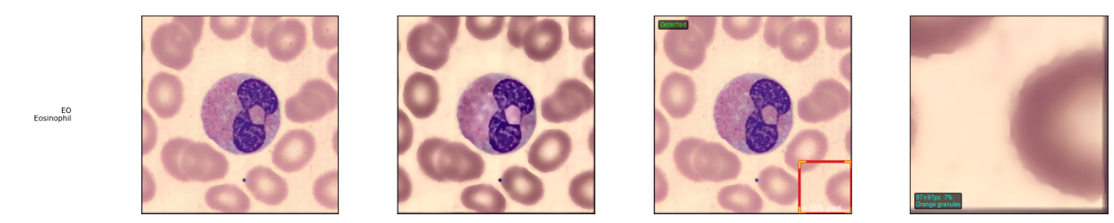
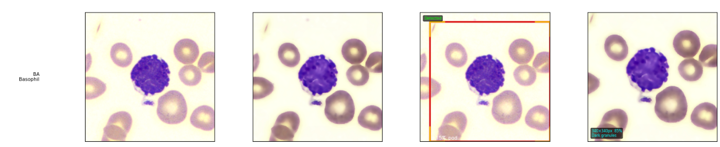
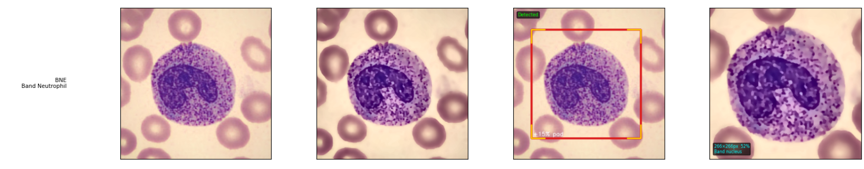
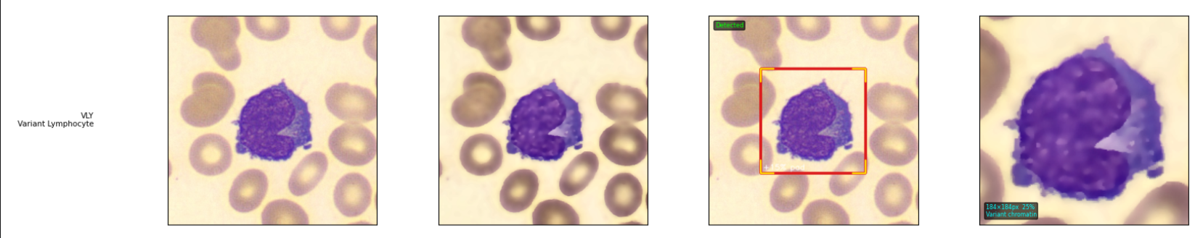
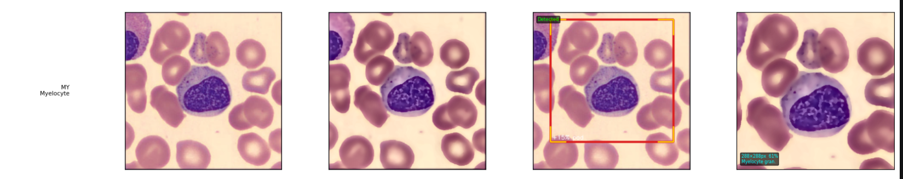
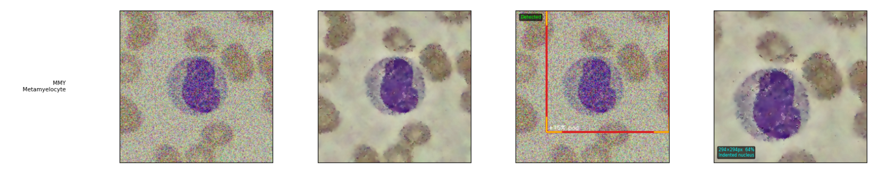
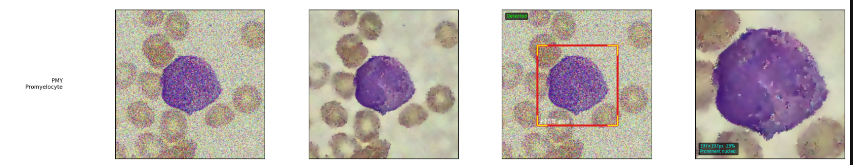
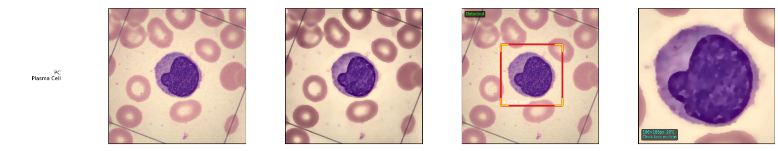
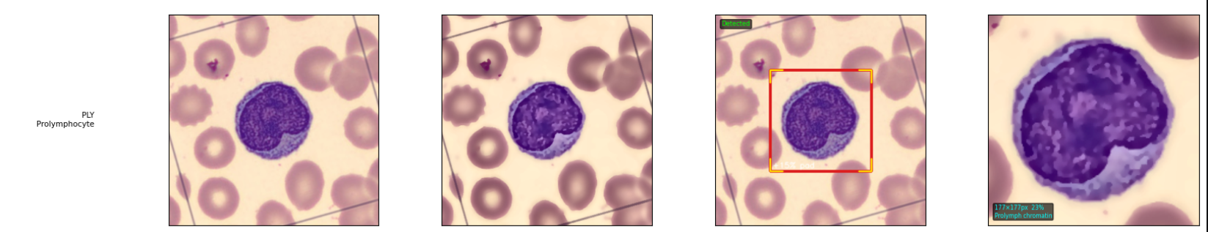

3. Results

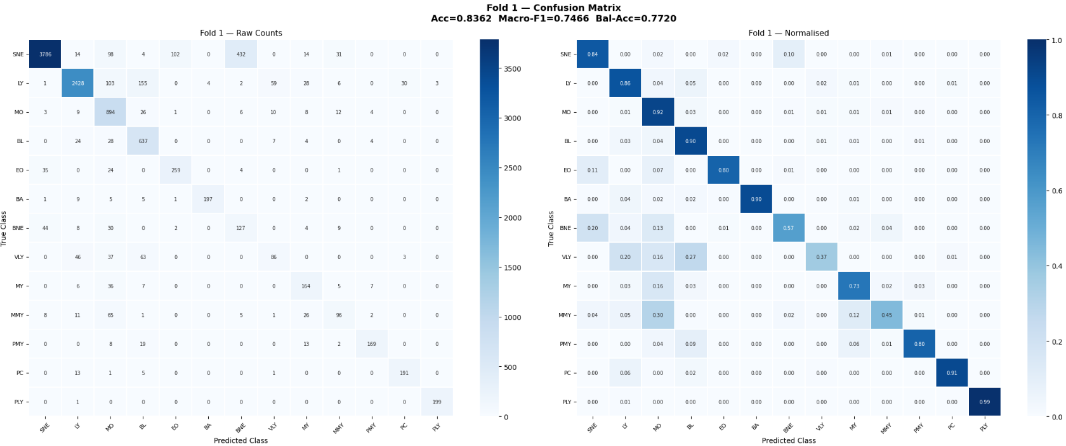

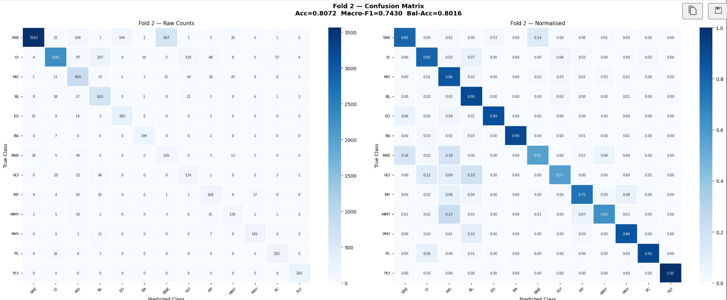
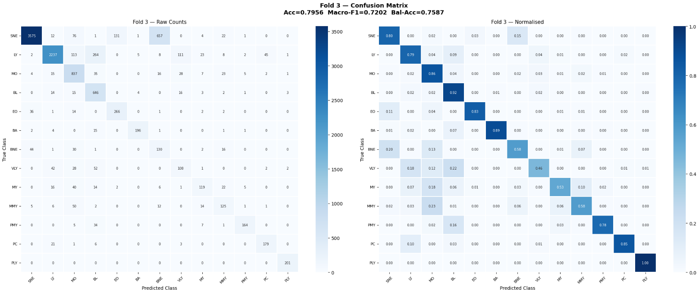
Cross-Validation Performance Summary
Fold | Accuracy | Balanced Accuracy | Macro Precision | Macro Recall | Macro F1 | Weighted F1
Fold 1 | 0.8362 | 0.7720 | 0.7448 | 0.7720 | 0.7466 | 0.8471
Fold 2 | 0.8072 | 0.8016 | 0.7138 | 0.8016 | 0.7430 | 0.8270
Fold 3 | 0.7956 | 0.7587 | 0.7131 | 0.7587 | 0.7202 | 0.8169
Mean | 0.8130 | 0.7775 | 0.7239 | 0.7775 | 0.7366 | 0.8303

OOF (Out-of-Fold) Overall Performance
Combined OOF metrics across all 3 folds:

Metric | Score
Accuracy | 0.8130
Balanced Accuracy | 0.7775
Macro Precision | 0.7218
Macro Recall | 0.7775
Macro F1 | 0.7370
Weighted F1 | 0.8305

Per-Class Performance Metrics
Per-class metrics computed from OOF predictions (all 3 folds combined):

Class | Precision | Recall | F1 Score
SNE | 0.9779 | 0.8127 | 0.8877
LY | 0.9476 | 0.8190 | 0.8786
MO | 0.6851 | 0.8784 | 0.7698
BL | 0.6475 | 0.9076 | 0.7558
EO | 0.6784 | 0.8376 | 0.7497
BA | 0.9533 | 0.8970 | 0.9243
BNE | 0.1770 | 0.5708 | 0.2702
VLY | 0.4463 | 0.4646 | 0.4552
MY | 0.5980 | 0.6281 | 0.6127
MMY | 0.5961 | 0.5516 | 0.5704
PMY | 0.8849 | 0.8122 | 0.8456
PC | 0.7958 | 0.8892 | 0.8392
PLY | 0.9694 | 0.9983 | 0.9838

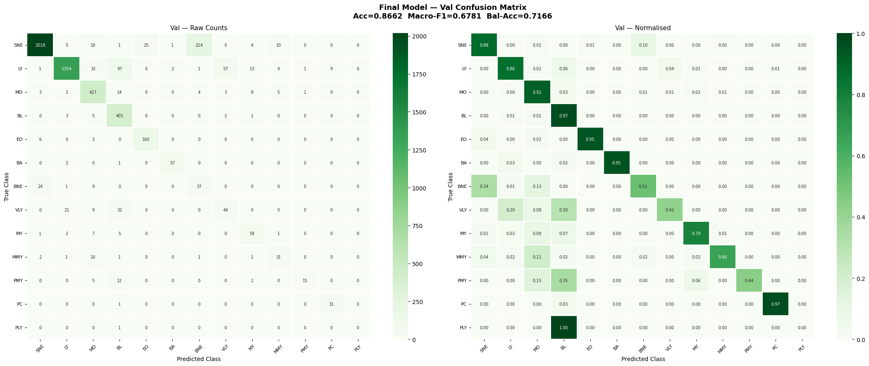
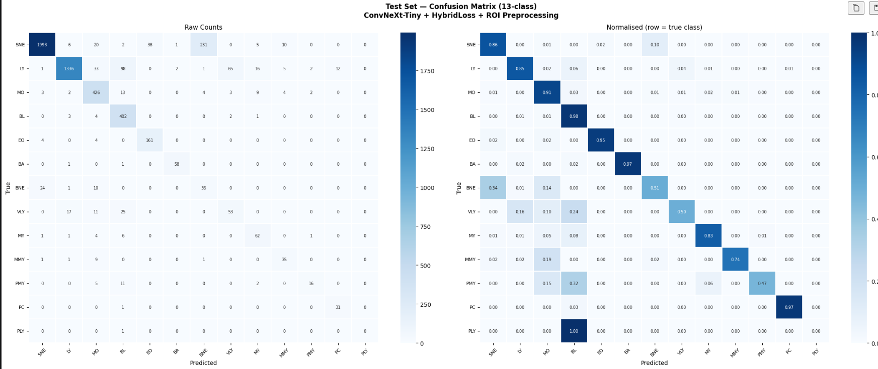
Macro F1 : 0.6809
Weighted F1: 0.8773

Final Model — Validation Set Performance
The final model was trained on the full train+val set. Evaluated on the held-out validation set (5,350 images) with TTA (n=5):
Metric | Score
Accuracy | 0.8662
Balanced Accuracy | 0.7166
Macro Precision | 0.6755
Macro Recall | 0.7166
Macro F1 | 0.6781
Best Val Macro-F1 (training) | 0.6797
Per-Class F1 — Final Model (Validation Set)
Class | F1 Score | Note
SNE | 0.9257 | Large sample, stable morphology
LY | 0.9142 | Stable lymphocyte structure
MO | 0.8618 | Good monocyte separation
BL | 0.8200 | High recall, some FP from immature cells
EO | 0.9040 | Distinct eosinophilic granules
BA | 0.9500 | Highly distinguishable dark granules
BNE | 0.2189 | Confused with SNE — band vs segmented nucleus overlap
VLY | 0.4151 | Confused with BL — immature nuclear structure similarity
MY | 0.7239 | Some overlap with BL fine chromatin
MMY | 0.6327 | Transitional stage, confused with MO
PMY | 0.5882 | Confused with BL — both large immature cells
PC | 0.8611 | Clock-face chromatin usually distinct
PLY | 0.0000 | Only 1 val sample; model fails to identify — expected given 11 source images

Error Analysis — Why the model confuses certain classes
Top confused pairs identified on the validation set:
True | Predicted | Count | Biological Reason
SNE | BNE | 231 | Lobe overlap — BNE nucleus not yet segmented, looks like early SNE
LY | BL | 98 | Dense nucleus confusion — both have round, dark nucleus
LY | VLY | 65 | Reactive morphology — VLY is activated LY with similar nucleus
SNE | EO | 38 | Morphological overlap
LY | MO | 33 | Morphological overlap
VLY | BL | 25 | Immature nuclear structure similarity
BNE | SNE | 24 | SNE multi-lobe vs BNE band shape can be ambiguous
PMY | BL | 11 | Promyelocyte vs blast — both are large immature cells

HARDEST CLASSES (lowest F1 on validation set):
Rank | Class | F1 Score | Most Confused With | Biological Reason
1 | PLY | 0.000 | BL | Extremely rare (1 val sample); only 11 source images — model cannot generalise
2 | BNE | 0.209 | SNE | Similar nuclear morphol  ogy — band vs segmented neutrophil boundary
3 | VLY | 0.415 | BL | Immature appearance overlap with blast
4 | PMY | 0.588 | BL | Both large immature cells; promyelocytes granules sometimes subtle
5 | MMY | 0.633 | MO | Transitional maturation stage, indented nucleus similar to monocyte
6 | MY | 0.724 | BL | Fine chromatin similarity between myelocyte and blast
7 | PC | 0.861 | BL | Plasma cell morphology occasionally overlaps with blast
8 | BL | 0.820 | MO | Cytoplasm/nucleus similarity between blast and monocyte

Best Performing Classes
Rank | Class | OOF F1 | Val F1 | Observation
1 | BA | 0.9243 | 0.9500 | Highly distinguishable dark granule morphology
2 | SNE | 0.8877 | 0.9257 | Large sample availability + stable multi-lobe structure
3 | LY | 0.8786 | 0.9142 | Stable lymphocyte structure
4 | EO | 0.7497 | 0.9040 | Distinct orange eosinophilic granules
5 | MO | 0.7698 | 0.8618 | Good monocyte separation

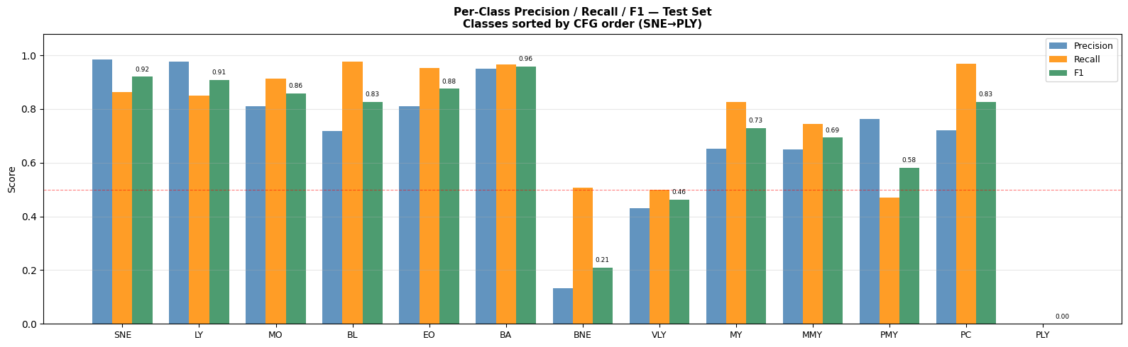

GradCAM — What the Model Looked At
GradCAM correct predictions. Red/yellow = region the model focused on. Should highlight nucleus/granules, not background.
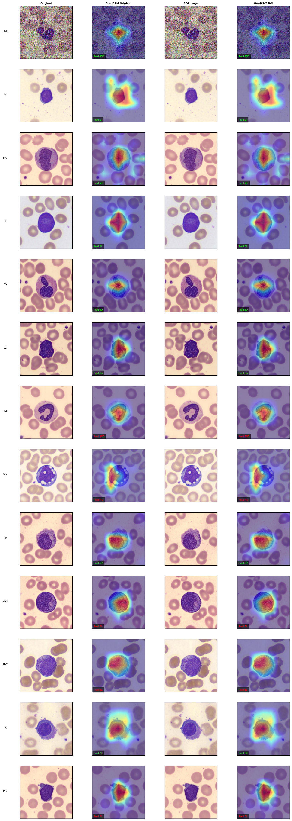

Comparison and Conclusion
Why We Got These Results
Design Choice | Why It Helped | Without It — What Would Happen
Minority augmentation (offline) | PLY/PC/PMY got enough training samples (600 each) | Model predicts 0 for PLY — Macro F1 collapses
WeightedRandomSampler | All 13 classes appear in every batch | Batches dominated by SNE/LY — rare classes never trained
HybridLoss (CE + Focal, 50/50) | Class-weighted focal component penalises minority misclassification more | Rare class gradients drowned out by majority classes
NLM + Bilateral + CLAHE | Model learns cell morphology, not noise | Model learns noise texture — poor generalisation
ROI crop (10–20% pad) | Model focuses only on the cell and cytoplasm | Model wastes capacity learning RBC background
Freeze 3 epochs then unfreeze | Head stabilises before backbone adapts | Noisy gradients destroy pretrained features early
Label smoothing = 0.10 | Reduces overconfident wrong predictions | Model is 99% sure of wrong answer — bad calibration
Mixup augmentation (after epoch 3) | Improves generalisation, reduces overfit | Sharper decision boundaries, worse OOF performance

Known Limitations
- MY vs MMY: These two classes are biologically adjacent (differ only by degree of nuclear indentation). Even human experts sometimes disagree. This confusion will persist regardless of model.
- PLY (11 real images): All 600 augmented samples come from 11 originals. The model may not generalise to PLY images outside these 11 variations.
- Stain quality variation: EO vs BA confusion happens when staining is inconsistent — the orange and purple granule colours shift. A preprocessing colour normalisation step could help.
- BNE remains the second hardest class (F1 = 0.209 on val) because its band-shaped unsegmented nucleus is visually similar to early-stage SNE lobes.

Threshold Calibration
After training, per-class decision thresholds were tuned on the validation set to further improve macro-F1. Two steps were applied:
- Temperature Scaling: Best temperature T = 0.50 (val macro-F1 = 0.6797, same as raw argmax baseline — no improvement from temperature alone).
- Per-Class Threshold Grid Search: Each class threshold searched independently on val_df to maximise per-class F1.

Class | Tuned Threshold | Default F1 | Calibrated F1 | Gain
SNE | 0.25 | 0.9197 | 0.9442 | +0.0245
LY | 0.10 | 0.9088 | 0.9331 | +0.0243
MO | 0.80 | 0.8592 | 0.8872 | +0.0280
BL | 0.85 | 0.8255 | 0.8894 | +0.0639
EO | 0.70 | 0.8750 | 0.9172 | +0.0422
BA | 0.30 | 0.9587 | 0.9672 | +0.0085
BNE | 0.75 | 0.2093 | 0.2558 | +0.0465
VLY | 0.15 | 0.4561 | 0.4981 | +0.0420
MY | 0.90 | 0.7219 | 0.7613 | +0.0394
MMY | 0.30 | 0.6931 | 0.7037 | +0.0106
PMY | 0.15 | 0.5818 | 0.6769 | +0.0951
PC | 0.80 | 0.8267 | 0.9118 | +0.0851
PLY | 0.40 | 0.0000 | 0.0000 | 0.0000

Final calibrated results on the validation set:
Metric | Score
Val Macro-F1 (after calibration) | 0.7189
Val Balanced Accuracy | 0.7570
Val Accuracy | 0.8966
Test Predictions Generated | 16,477

Conclusion

This project successfully built an end-to-end deep learning pipeline for 13-class WBC classification. The three main challenges — class imbalance, microscopy noise, and background clutter — were each addressed by a specific component: offline augmentation + weighted sampling, 3-stage denoising, and context-aware ROI cropping respectively. ConvNeXt-Tiny with frozen-then-unfrozen fine-tuning achieved a mean cross-validation macro-F1 of 0.7366 and OOF macro-F1 of 0.7370. The final model reaches 0.8662 accuracy and 0.6781 macro-F1 on the validation set The remaining errors are biologically explainable and reflect real diagnostic challenges in haematology.

