1. FIRST STEP: PROJECT TITLE SELECTION
Team: Team-3
Team Members Names and Roll Numbers:
S.No | Name | Roll No
1 | KOTTAM CHARITHA | 25102A040282
2 | PASAM LASYA PRIYA | 25102A040286
3 | GAJULAPALLI THISAI VELU | 25102A040305
4 | SADHU HARI | 25102A040313
5 | SHAIK AFRIZ | 25102A040324
Project Title:
Students Feedback Analysis Model Using Deep Learning-Based Method and Linguistic Knowledge for Intelligent Educational Systems
2. PROJECT TITLE BASE PAPER
A. Abdi, G. Sedrakyan, B. Veldkamp, J. van Hillegersberg and S. M. van den Berg, “Students feedback analysis model using deep learning-based method and linguistic knowledge for intelligent educational systems,” Soft Computing, vol. 27, pp. 14073–14094, 2023. DOI: 10.1007/s00500-023-07926-2.
3. PROJECT ABSTRACT
3.1 Introduction
At the end of every term, colleges ask students to fill in a feedback form. The rating questions are easy to total up, but the written comments are where students actually say what went wrong and what helped them. A single course can easily get hundreds of such comments, and reading all of them by hand takes a lot of time. In practice many comments are skimmed or never read at all, and useful points get lost.
Sentiment analysis, which is a part of natural language processing, can sort comments into positive and negative automatically. This is harder for student comments than it sounds. A sentence like “the course material was good, but the teacher’s knowledge was not enough” has both a positive and a negative part, and the word “not” or “but” can flip the meaning completely. Our project is based on the model proposed by Abdi et al. (2023), which handles these problems by combining deep learning with sentiment and language rules. We study this model, rebuild it, and add a few improvements of our own.
3.2 Abstract
Analysing student feedback manually is slow and does not scale when the number of comments is large. This project builds an automated system that reads a student’s comment and decides whether it is positive or negative. The system follows the DTLP model from the base paper, where a convolutional neural network (CNN) picks up local word patterns, a bidirectional LSTM (BiLSTM) reads the sentence in both directions, and an attention layer gives more weight to the words that matter most. The model is fed with word embeddings, several combined sentiment lexicons, negation and “but” clause rules, sentence type and part-of-speech information. As an extension, we replace the general-purpose word2vec vectors with contextual embeddings from a pre-trained transformer, and we add aspect-wise results (teaching, course content, facilities and assessment) shown on a simple web dashboard. The aim is to give teachers a quick and readable summary of what students are saying, instead of a pile of raw comments.
3.3 Existing System
Earlier work on student feedback mostly used lexicon-based methods or traditional machine learning. Lexicon-based systems count positive and negative words using a sentiment dictionary. Machine learning systems such as SVM, Naive Bayes and Random Forest turn each comment into a bag-of-words or TF-IDF vector and train a classifier on it. These systems are simple and quick to set up, which is why they were widely used. In the comparison reported in the base paper, the best traditional method (SVM) reached only about 63% accuracy on the same data.
Disadvantages
- Bag-of-words and n-gram vectors are very sparse and high dimensional, and they ignore the order of the words.
- A single sentiment dictionary does not cover all the words students use.
- Negation (“not good”) and contrast words (“but”, “however”) are often not handled, so the polarity of the sentence comes out wrong.
- Basic word embeddings such as word2vec place opposite words like “like” and “dislike” close together, and give one vector to a word with many meanings.
- Sentence types such as questions, conditional sentences and sarcasm are usually ignored.
- Traditional machine learning needs features to be designed by hand, which takes expert effort.
- Most existing tools only give a positive or negative label and do not show why the student felt that way.
3.4 Proposed System
The proposed system implements the DTLP model from the base paper. Each comment is first cleaned (tokenization, stop-word removal, stemming and POS tagging). After that, a combined feature vector is built from word embeddings, ten sentiment lexicons merged into one, negation and contrast rules, and sentence-level features such as the count of positive and negative words and whether the sentence is a question. The word-level features go through a CNN and then a BiLSTM. An attention layer picks out the important words, and its output is joined with the sentence-level features before the final fully connected layer gives the label. The system also shows word clouds and a summary of positive and negative comments.
Advantages
- The base paper reports 88.78% accuracy and an F1-score of 0.8991, which is better than CNN-BiLSTM without attention (84.52%) and BERT (83.33%) on its data.
- Combining all feature groups gave better results than using any smaller subset of features.
- Handles negation, contrast words and different sentence types.
- Learns features automatically, so no hand-made feature engineering is needed.
- Output can be used by teachers to find which topics students find hard.
Limitations
- About 16,000 of the 17,500 sentences in the base paper’s data come from a single source, so the results may not carry over to other colleges.
- The word2vec model used is trained on general web text, not on education data. The authors themselves mention this as a limitation.
- Only English comments are supported, and only two classes (positive and negative) are predicted.
3.5 Extension
We plan to add the following on top of the base paper:
- Contextual embeddings: the word2vec input is replaced (or combined) with embeddings from DistilBERT, fine-tuned on student feedback. We will train both versions on the same data and keep the one that gives better results.
- Aspect-wise analysis: each comment is tagged with the aspect it talks about (teaching, course content, facilities, assessment), so the result shows, for example, that students are happy with the lab but not with the study material.
- Web dashboard: a small Flask application where a user uploads a CSV file of comments and gets the charts, word cloud and summary in the browser.
- Local data: along with the public student feedback dataset, we will collect a small set of comments from our own college through a Google Form to test the model.
Advantages
- Contextual embeddings understand a word from its sentence, which helps with words that have more than one meaning.
- Embeddings that are fine-tuned on feedback data address the domain limitation of the general word2vec model.
- Aspect-wise results are more useful to a teacher than a single positive or negative percentage.
- The dashboard lets a non-technical user run the analysis without writing any code.
3.6 System Architecture
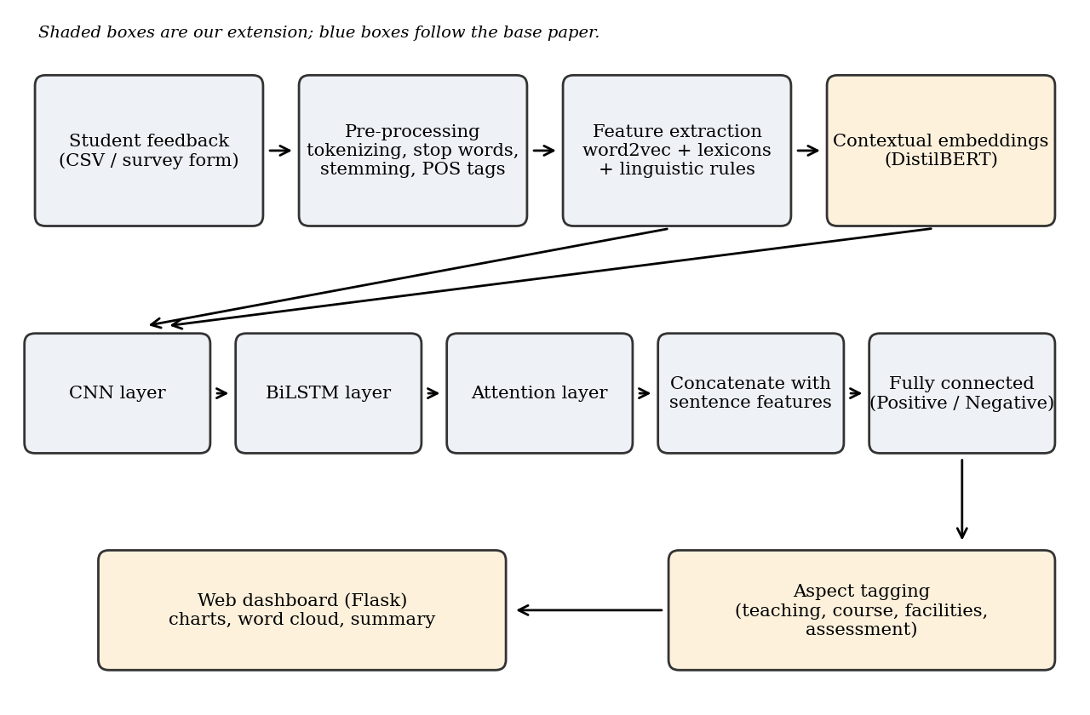
Fig. 1: Proposed system architecture
3.7 Requirements
Hardware Requirements
- Processor: Intel Core i5 or above
- RAM: 8 GB minimum (16 GB preferred for training)
- Hard disk: 256 GB SSD or 500 GB HDD
- GPU: optional; Google Colab free GPU can be used for training
Software Requirements
- Operating system: Windows 10 or 11
- Language: Python 3.9 or above
- Libraries: TensorFlow/Keras, Hugging Face Transformers, gensim, NLTK, scikit-learn, NumPy, Pandas, Matplotlib, WordCloud
- Web framework: Flask
- Tools: Jupyter Notebook or Google Colab, VS Code, and a web browser
3.8 Conclusion
Student comments hold useful information, but reading them by hand does not work when the numbers are large. The base paper shows that a CNN-BiLSTM model with attention, fed with sentiment and linguistic features, classifies student feedback much better than traditional methods. In this project we will implement that model and test it ourselves, then try contextual embeddings and aspect-wise reporting on top of it. If it works as planned, teachers will be able to see quickly which parts of a course students like and which parts need to be improved.
3.9 Future Scope
- Add a neutral class so that comments like “the class was okay” are not forced into positive or negative.
- Support regional languages and mixed language comments such as Telugu-English.
- Improve detection of sarcasm in comments.
- Analyse feedback in real time during the course, so that teachers can fix problems early.
- Connect the dashboard with a college learning management system.

