**Lilla Nagy GRADE: 10/10**

**Testing Part 1 - Homework**

Download and test the Contact Keeper application. Create a Word document with the following information:

* Short description on what the application does
* Summaries of the bugs. Keep the summary short, clear and easy to understand. Add screenshots if necessary. E.g. Future date of birthdays are allowed (min 5)
* Conclusions related to the application, like if it’s easy to use it, if bugs were found.

Short description:

The Contact Keeper application is an easily used contact information keeper, which helps us create a database very quickly, being able to store names, birthdates, phone numbers, addresses, email addresses and other information we associate with a contact. - It recognizes leap-years, and accepts years from 0. It makes it possible to search the contact database, to edit it, and all information can be downloaded in different formats.

Possible bugs:

- It might be a feature rather than a bug: when installed, it automatically appeared in Hungarian, as my Windows is in Hungarian, so I didn’t have to chose the language I wanted it to be installed… what if I wanted to have English or Romanian, I think it should have asked me first (even though I can change that later).

- When I wanted to enter a birthdate, I had to go to the very left part of the field, otherwise it automatically went to the next field.

- It doesn’t let me write a phone number by clicking just once, only if I double click, and a pop up comes out to introduce number there.

- It automatically organised the introduced names into alphabetical order, but when I wanted to find a name according to a letter (which would mean I want a name beginning with that letter), it gave me all names containing that letter.

- If I search a name by the quicksearch, it gives me all matching names. After this if I want to search using the search button and if I want to do a more detailed search and introduce a family name other than I chose by the quicksearch, it doesn’t give me any name. The result comes only if I click into the quicksearch field.

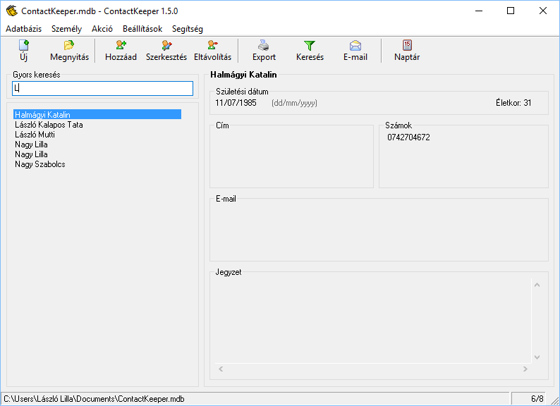

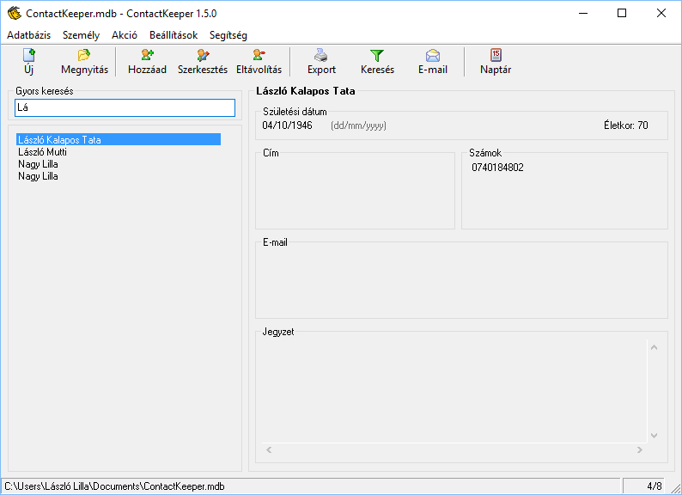

- If I introduce into the day or month field a number that does not exist, it gives me a pop up saying the date is incorrect, but if I write an exaggeratedly big birthyear, like 9999, it accepts it and stores it as being correct. The age pf that person appears to be 0.

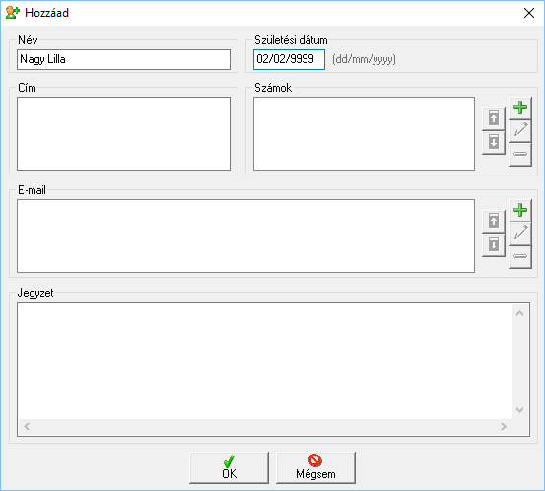

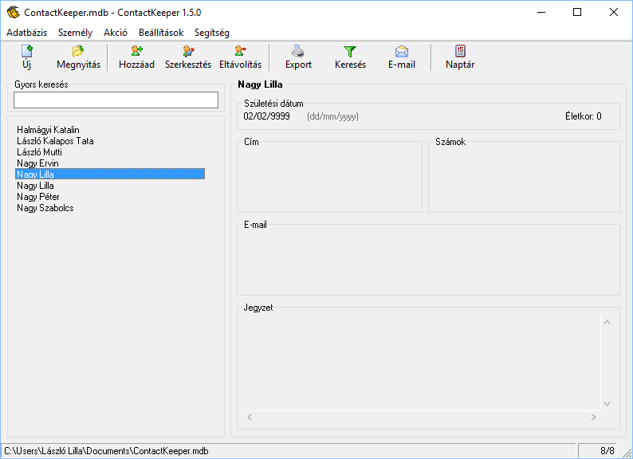

-It lets me introduce the same person with exactly the same data more times.

As seen above I have found several issues that can be considered bugs, thing that may not be correct and may cause misinterpretation. But beside these I think it is a very useful and easy-to-use application that helps keeping in mind birthdays and other information about someone’s contacts.