Documentation

1. 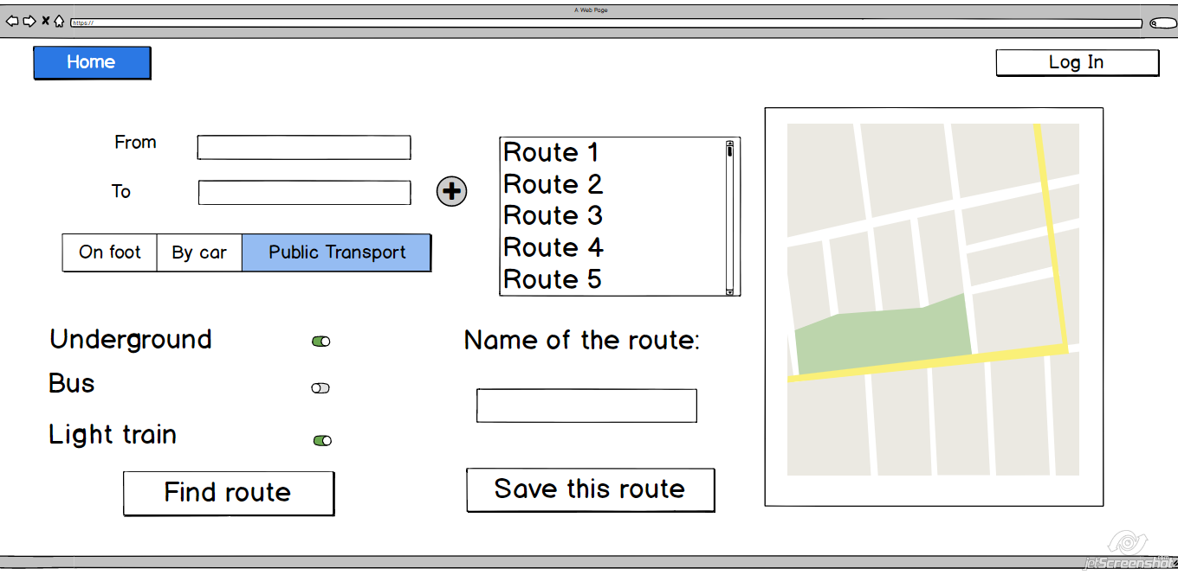User interface:
2. **Components:**
   1. Home Button
   2. Log-in Button
   3. From/To forms
   4. Traveling mode picker
   5. Options for means of transportation
   6. Find route search button
   7. Saved routes lists
   8. New route name form
   9. Save the route button
   10. Google direction window
3. **API calls:**
   1. **GET /** directions/json?origin=”Bucharest, street…nr…”&destination=”Bucharest, street…nr…”&key=<API-key>&mode=”driving” etc
   2. **POST/** routes/ json?action=save
   3. **GET**/ routes/ json?id=11
   4. **PUT/** routes/ json?action=update&id=11
4. **User Actions:**
   1. Search for a route
   2. Choose the means of transportation
   3. Save the route in a list
   4. Give the route a name
   5. See the saved routes in a list