# *Mitochondrion*

# Meta-analysis of gene expression patterns in Down syndrome highlights significant alterations in mitochondrial and bioenergetic pathways

**Laszlo Pecze and Csaba Szabo**

Chair of Pharmacology, Section of Medicine, University of Fribourg, Switzerland

Individuals with Down syndrome have an extra copy of chromosome 21*.* Clinical observations and preclinical studies both suggest that Down syndrome is associated with altered bioenergetic pathways. Several studies have reported that differentially expressed genes in DS are located not only on chromosome 21 but also on all other chromosomes. Numerous sets of microarray and RNA-seq data are publicly accessible through the Gene Expression Omnibus. We have conducted a meta-analysis on differentially expressed genes between Down syndrome and control subjects. Data deposited before July 1, 2020, were identified by using the search terms “Down syndrome” or “trisomy 21” and “human”. Gene expression data were analyzed and normalized for each study. The mixed effect model was used to identify the differentially expressed genes. We conclude that more than 60% of the genes located on chromosome 21 are significantly upregulated and none of them is downregulated. Moreover, several genes are significantly upregulated in bioenergetic pathways located either on chromosome 21, for instance PFKL or on other chromosomes, such as ACLY. Several genes mapped not to chromosome 21 are significantly downregulated. Genes involved in oxidative phosphorylation are mostly downregulated. These findings are consistent with the development of significant metabolic disturbances (“pseudohypoxia”) in Down syndrome cells, which, in turn, may explain some of the well-known functional defects (ranging from neuronal dysfunction to reduced exercise tolerance) associated with this condition.

**Key Words:** glycolysis, gene expression, citric acid cycle, oxidative phosphorylation, meta- analysis

**\*Correspondence:** [csaba.szabo@unifr.ch](mailto:csaba.szabo@unifr.ch)

**Running title:** Down Syndrome and bioenergetics

**Author contributions:** L.P., & C.S.: literature review and article writing

**Grant support:** LeJeune Foundation (Paris)

# Introduction

In 1959, Jerome LeJeune and his colleagues discovered that Down syndrome (DS), is caused by an extra copy of chromosome 21 (Lejeune et al., 1959). Later, LeJeune hypothesized that not all loci are required for the manifestation of DS: there should be a selected number of culprits among many non-detrimental genes. This theory is supported by the analysis of the extremely rare cases of partial trisomy 21, where genes that may be critical for the pathogenesis of DS were mapped to the distal part of the 21q22.13 sub-band (Pelleri et al., 2019). The elevated levels of these gene products might accelerate or inhibit some biochemical reactions. The “Lejeune Machine” – originally proposed by Lejeune, 1990 and further expanded and refined by several investigators (Lejeune, 1990, Carcausi et al., 2018) is often used to illustrate some of the biochemical and metabolic alterations that are hypothesized to be especially relevant for DS.

It is well-documented that, DS individuals have lower resting metabolic rates compared with control subjects (Allison et al., 1995). Moreover, DS is associated with an increased risk for obesity, with an estimated prevalence of 47-48% in adults and 30-50% in children with DS (Xanthopoulos et al., 2017). An increased prevalence of obesity and other metabolic diseases such as Type II diabetes also points to significant alterations of metabolic and bioenergetic pathways in DS (Dierssen et al., 2020). There are several metabolic pathways for the biotransformation of the fuel molecules to high-energy compounds such as adenosine-5′- triphosphate (ATP), reduced nicotinamide adenine dinucleotide (NADH) (Dashty, 2013). Glucose is the most important source of energy, but other monosaccharides, fatty acids, ketone bodies, amino acids, and nucleosides can also be used as an energetic source in a cell-specific manner (Berg et al., 2006). We have recently demonstrated that mitochondrial Complex IV activity is markedly inhibited in DS fibroblasts, at least in part due to the inhibitory effect of the upregulation of the endogenous gaseous transmitter hydrogen sulfide (Panagaki et al., 2019; Panagaki et al., 2020). In addition, we have conducted a meta-analysis of the metabolomic alterations in DS, which revealed (among other changes) marked alterations in various Krebs cycle intermediates, as well as a pathophysiological deterioration of high energy phosphates and cellular energy charge, pointing to the existence of a cellular ‘pseudohypoxic’ state in DS (Pecze et al., 2020). However, none of these studies have focused on the potential underlying changes in gene expression in DS.

Understanding the alterations in molecules provides important information for determining the molecular mechanisms of diseases. “Omics” technologies permit the universal detection of genes (genomics), mRNA (transcriptomics), proteins (proteomics) and metabolites (metabolomics) in biological samples (Ishihara and Akiba, 2017). In DS, the genes encoded on chromosome 21 are exclusively upregulated (and none of them are downregulated), supporting the “gene dosage theory” of DS i.e. that the extra chromosome 21 results in the upregulation of its gene products, which, in turn, directly or indirectly changes development and affects various cellular functions. However, approximately 90% of the differentially expressed genes in DS (which include both upregulated and downregulated genes) are encoded on chromosomes other than chromosome 21, indicating dysregulated signaling cascades and/or compensatory gene regulation mechanisms regulating gene expression processes linked to chromosomes other than chromosome 21 (Araya et al., 2019; Letourneau et al., 2014; Lockstone et al., 2007).

Individual gene expression studies are “noisy”. Differentially expressed gene lists are often inconsistent between different published studies due to several factors including false positive and false negative results (Type I and II error, respectively) (Benjamini and Hochberg, 1995; Maleki et al., 2019). A meta-analysis of gene expression data can combine results from multiple studies to identify common expression patterns that sometimes cannot be identified in an individual study (Waldron and Riester, 2016).

With the above considerations in mind, we have conducted a meta-analysis of transcriptomic alterations DS vs. control, with special attention on the genes encoding enzymes involved in energy-producing metabolic reactions.

# Materials and methods

***Data collection and identification of studies***

The NCBI GEO (National Center for Biotechnology Information-Gene Expression Omnibus) (Barrett and Edgar, 2006) genomic repository was searched for “Down syndrome” OR “trisomy 21” AND “Homo sapiens” [Organism]. Moreover, the EBI (European Bioinformatics Institute) ArrayExpress database of functional genomics experiments was searched at the website for the terms “Down syndrome” OR “Trisomy 21” choosing “Homo sapiens” as organism (Brazma et al., 2003).

***Inclusion and exclusion criteria***

Inclusion criteria were as follows: 1) We only included studies that measured the level of mRNA expression (transcriptome profile). 2) Studies had to include both a sample from DS individuals and a control comparison group 3) Studies had to provide gene expression levels and information about sample sizes for both groups. At least data from 3 DS and 3 normal biosamples needed to be presented 4) Only human samples were considered (data derived from animal models of DS were excluded). 5) Studies providing data for gene expression in different tissues were handled separately. 6) Studies measuring gene expression levels after a treatment were excluded, similarly if the analysis was performed on malignant cells. 7) Only publicly available datasets were used. In total 14 published reports with 20 biosamples were identified and subjected to analysis.

***Data preprocessing***

Data collection and preprocessing were performed in the R statistical program (Team, 2013) using the following packages *GEOquery* (Davis and Meltzer, 2007), *limma* (Ritchie et al., 2015), *origo* (Carvalho and Irizarry, 2010). Quantile normalization (Amaratunga and Cabrera, 2001) was applied for each set of biosamples. The R codes were deposited on Github. In order to meet normality assumptions of several parametric tests, data were log2 transformed. Twenty biosamples met the inclusion criteria, were preprocessed, and steps are summarized in **Table 1.**

***Meta-analysis on individual genes***

A random-effects model (Borenstein et al., 2010) was used to determine the expected high degree of heterogeneity across studies using Hedges’ g as the standardized mean difference (Hedges, 1981). Besides that, the 95% confidence intervals (CI) were estimated. Positive and negative standardized mean difference values indicated higher and lower levels of gene expression in DS group, relative to the control group. When at least 4 studies provide information for the expression level of the selected gene, the calculated overall effect was recorded. Statistical significance was set at p<0.05.

***Collecting the overall effects per gene per chromosomes***

Overall effects for gene expression levels were distributed according to the gene mapping to chromosomes. Significantly upregulated or downregulated genes were counted.

***Selection of genes involved in bioenergetic pathways***

Based on the knowledge on cell energy metabolism the following genes were selected:

*Oxidative phosphorylation:* From KEGG database (Kanehisa and Goto, 2000), genes in "Oxidative phosphorylation" were extracted and distributed according to their contribution to mitochondrial complex assembly (I –V).

*Glycolysis-gluconeogenesis:* From the KEGG database, genes in "Glycolysis / Gluconeogenesis" were extracted. This list of genes was reduced by removing the genes involved in ethanol biosynthesis; i.e. alcohol dehydrogenases and aldehyde dehydrogenases.

*Lactate and glucose transporters:* Genes encoding the main types of lactate and glucose transporters were extracted from publications (Halestrap, 2012; Navale and Paranjape, 2016)

*Pentose phosphate pathway:* From the KEGG database, genes in "Pentose phosphate pathway" were extracted.

*Citric acid cycle:* From the KEGG database, genes in "Citrate cycle (TCA cycle)" were extracted.

*Fatty acid degradation and biosynthesis:* From the KEGG database, genes in "Fatty acid degradation", "Fatty acid biosynthesis", and "Fatty acid elongation" were extracted. This list was completed with Fatty acid binding proteins.

*Glutamine metabolism:* From the Reactome pathway database (Jassal et al., 2020), genes in “Glutamate and glutamine metabolism” have been extracted.

***Principal component analysis (PCA)***

Standardized mean differences for the abovementioned genes per each biosample were calculated and principal component analysis was performed. PCA involves the assignment of data to new coordinates (principal components, or PCs) having two important properties. First, the variance of observed coordinates in each PC occurs in decreasing order, observations projected on PC1 have a greater variance than the same observations projected on PC2, and so on. Second, PCs are not correlated, each one represents a piece of information from the original data. Samples with close scores along the *same* PC are similar and are plotted close to each other*.*

***Plotting overall effects***

Overall effects for the selected genes were plotted on a forest plot. Significantly up or downregulated genes were labeled with red and blue colors, respectively.

# Results

***60% of the genes encoded on chromosome 21 are significantly upregulated in DS***

In total 17,805 genes were identified. The number of downregulated genes was 1003 and the number of upregulated genes was 912. In total, 178 were mapped to chromosome 21. From these 178 Chromosome 21 - genes, 109 was found to be upregulated and none were found to be downregulated. This means that more than 60% of genes mapped on chromosome 21 are significantly upregulated.

Nevertheless, there is a genome-wide effect of the presence of the additional Chromosome 21 in DS. Genes expression analysis for two genes (*CBS* and *PFKL*) is shown in **Fig. 1A** and **Fig. 1B**. These genes are mapped to chromosome 21. *CBS* encoding the cystathionine b-synthase is involved in the production of H2S, a gaseous signaling molecule. The PFKL gene encodes the liver (L) subunit of phosphofructokinase that catalyzes the conversion of D-fructose 6-phosphate to D-fructose 1,6-bisphosphate.

Overall, only 5% of the differentially expressed genes in DS are mapped to chromosome 21; the vast majority of the genes are encoded on all other chromosomes and on these chromosomes, both gene upregulation and gene downregulation can be detected, suggesting a complex adaptive/compensatory and/or dysregulated gene expression response (**Fig. 1C**). A list of the affected genes is presented in **Suppl. 1**.

***PCA plots show no significant separation based on the age, the method used, and tissue type***

PCA analysis of all the measured differences in biosamples was not able to separate fetal and adult groups, the different transcriptome analysis methods and the different tissues (**Fig. 2**). Thus, changes in the standardized mean differences are not sensitive to the abovementioned factors.

***Genes related to oxidative phosphorylation are mostly downregulated in D****S*

Five genes related to oxidative phosphorylation were detected to be upregulated and these were the following: NADH:ubiquinone oxidoreductase subunit V3 (*NDUFV3*), cytochrome c oxidase assembly homolog COX15 (*COX15*) ATPase H+ transporting V1 subunit H (*ATP5PF*), ATPase H+ transporting V1 subunit H (*ATP6V1H*), ATP synthase peripheral stalk subunit OSCP (*ATP5PO*). Out of these five genes, three of them are mapped to chromosomes 21 (*ATP5PF*, *NDUFV3*, and *ATP5PO)*. Nine genes related to oxidative phosphorylation were identified to be downregulated: NADH:ubiquinone oxidoreductase core subunit S2 (*NDUFS2*), NADH:ubiquinone oxidoreductase core subunit S1 (*NDUFS1*), NADH:ubiquinone oxidoreductase subunit A10 (*NDUFA10*), cytochrome c oxidase subunit 7C (*COX7C*), cytochrome c oxidase assembly factor 1 homolog (*COA1*), ATPase H+ transporting V1 subunit B1 (*ATP6V1B1*), ATP synthase membrane subunit c locus 1 (*ATP5MC1*), ATP synthase F1 subunit epsilon (*ATP5F1E*), and ATPase H+/K+ transporting non-gastric alpha2 subunit (*ATP12A*). The above gene products involved in oxidative phosphorylation are essential in the formation of mitochondrial complexes, namely Complex I (NADH dehydrogenase), Complex II (Succinate dehydrogenase), Complex III (Ubiquinol cytochrome C oxidoreductase), Complex IV (Cytochrome C oxidase), and Complex V (ATP synthase) (**Fig. 3**), which, in turn, are essential in catalyzing mitochondrial electron transport and aerobic ATP generation in all mammalian cells. Dysregulation of these genes would predict significant disturbances in these processes.

***DS is associated with significant alterations in genes that regulate glycolysis, gluconeogenesis, and the pentose phosphate pathway***

Our meta-analysis demonstrates that *PFKL* and *GPI* are upregulated in DS. The gene encoding phosphofructokinase, liver type (*PFKL*) is mapped on chromosome 21. This gene encodes the liver (L) subunit of an enzyme that catalyzes the conversion of D-fructose 6-phosphate to D- fructose 1,6-bisphosphate. The *GPI* gene encodes a member of the glucose phosphate isomerase protein family. In the cytoplasm, the gene product functions as a glucose-6-phosphate isomerase that interconverts glucose-6-phosphate and fructose-6-phosphate.

The following genes are significantly downregulated: *PGK2*, *PFKM*, *GCK*, *FBP1*, and *ALDOB*. Phosphoglycerate kinase 2 (*PGK2*) catalyzes the reversible conversion of 1,3- bisphosphoglycerate to 3-phosphoglycerate. Phosphofructokinase, muscle type (*PFKM*) functions as subunits of the mammalian tetramer phosphofructokinase, which catalyzes the phosphorylation of fructose-6-phosphate to fructose-1,6-bisphosphate. Glucokinase (*GCK)* encodes a member of the hexokinase family of proteins. Hexokinases phosphorylate glucose to produce glucose-6-phosphate, the first step in glucose metabolism pathways. Fructose-1,6- bisphosphatase 1, a gluconeogenesis regulatory enzyme, catalyzes the hydrolysis of fructose 1,6-bisphosphate to fructose 6-phosphate and inorganic phosphate. Fructose-1,6-bisphosphate aldolase (*ALDOB*) is a tetrameric glycolytic enzyme that catalyzes the reversible conversion of fructose-1,6-bisphosphate to glyceraldehyde 3-phosphate and dihydroxyacetone phosphate (**Fig. 4A**).

When examining the expression of genes encoding glucose and lactate transporters we can observe several changes associated with DS. The mRNA levels for the genes S*LC2A1, SLC16A1* and *SLC16A3* are significantly increased, while *SLC2A16A8* is downregulated. S*LC2A1* encodes the major glucose transporter (Glucose Transporter Type 1), the most important energy carrier in the brain. The gene products of *SLC16A1, SLC16A3, SLC16A8* (Monocarboxylic Acid Transporter 1, Monocarboxylate Transporter 4, and Monocarboxylate Transporter 3, respectively) are involved in lactic acid and pyruvate transport across plasma membranes (**Fig. 4B**).

In the pentose phosphate pathway, an additional gene ribulose-5-phosphate-3-epimerase (*RPE*) is upregulated in DS (**Fig. 4C**).

***DS is associated with the dysregulation of multiple genes of the citric acid cycle***

In the citric acid cycle, two genes are significantly upregulated. ATP citrate lyase (*ACLY*) is the primary enzyme responsible for the synthesis of cytosolic acetyl-CoA in many tissues. The enzyme is a tetramer (relative molecular weight approximately 440,000) of apparently identical subunits. It catalyzes the formation of acetyl-CoA and oxaloacetate from citrate and CoA with concomitant hydrolysis of ATP to ADP and phosphate. Oxoglutarate dehydrogenase (*OGDH*) gene encodes one subunit of the 2-oxoglutarate dehydrogenase complex. This complex catalyzes the overall conversion of 2-oxoglutarate (alpha-ketoglutarate) to succinyl- CoA and CO2 during the Krebs cycle. Isocitrate dehydrogenases (*IDH3G*) is downregulated and catalyzes the oxidative decarboxylation of isocitrate to 2-oxoglutarate (**Fig. 4C**).

***DS is associated with significant alterations in the expression of multiple genes regulating lipid metabolism***

We have identified 6 genes that relate to lipid metabolism that are upregulated in DS. The protein encoded by *EHHADH* gene is a bifunctional enzyme and is one of the four enzymes of the peroxisomal beta-oxidation pathway. The protein encoded by *ECHS1* gene functions in the second step of the mitochondrial fatty acid beta-oxidation pathway. The gene product of carnitine palmitoyltransferase 2 (*CPT2)* oxidizes long-chain fatty acids in the mitochondria. Carnitine palmitoyltransferase 1B encoded by *CPT1B* gene is the rate-controlling enzyme of the long-chain fatty acid beta-oxidation pathway. This enzyme is required for the net transport of long-chain fatty acyl-CoAs from the cytoplasm into the mitochondria. The protein encoded by *ALDH9A1* catalyzes the dehydrogenation of gamma-aminobutyraldehyde to gamma-aminobutyric acid (GABA). Acyl-coenzyme A oxidase 3 (*ACOX3*) is involved in the desaturation of 2-methyl branched fatty acids in peroxisomes. Downregulation was only noted for one single gene: *GCDH*, a member of the acyl-CoA dehydrogenase family (**Fig. 5**).

***Dysregulation of multiple genes affecting glutamate metabolism***

The gene *GLUD1* glutamate dehydrogenase 1 is upregulated and it encodes glutamate dehydrogenase, which is a mitochondrial matrix enzyme that catalyzes the oxidative deamination of glutamate to alpha-ketoglutarate and ammonia. The gene for glutaminase 2 (*GLS2*) is downregulated; the protein encoded by this gene is known to catalyze the hydrolysis of glutamine to stoichiometric amounts of glutamate and ammonia (**Fig. 6**).

***~~Integration of DS-associated changes in gene expression, protein expression and metabolomic alterations~~***

~~Generally, changes in mRNA expression are expected to be reflected in changes in the expression of the corresponding protein, which, in turn, is expected to affect the function of the protein, which, in case of enzymes involved in the regulation of key biochemical processes, would be reflected in the levels of the product and the substrate of these enzymes. However, this may not always be the case; for example, translation of mRNA to protein can be affected by multiple factors; protein levels are not only affected by protein synthesis, but also by changes in the degradation of the protein; enzymatic activity is not only the function of the expression (level) of the enzyme, but also posttranslational modifications (e.g. phosphorylation, sumoylation, glutathionylation, sulfhydration, nitration etc.) affecting its enzymatic activity, protein-protein interactions, changes in the intracellular distribution of the protein, and other factors. (see also: Discussion). Nevertheless, on a selected subset of genes and gene products, we have attempted to integrate the gene expression changes highlighted in the current report with the available proteomic and metabolomic information (~~**~~Table 2~~**~~). This integration is not straightforward, due to the fact that the published gene expression studies and the proteomic and metabolomic studies were conducted using different cell lines or clinical materials; to our knowledge, simultaneous, systematic investigation of gene expression, proteomic alterations and metabolomic changes in DS has not yet been completed. Nevertheless...~~

# Discussion

Several studies demonstrated that trisomy of chromosome 21 negatively affects mitochondrial function (reviewed in: Valenti et al., 2018; Pecze et al., 2020). Extracellular flux analysis of DS cells showed a significant impairment of the activity of mitochondrial electron transport complexes, which, in turn, reduced oxygen consumption, and ATP generation, which also impaired the cellular proliferation rate. The specific activity of Complex IV was found to be significantly inhibited in DS cells due to the excess production of H2S (Panagaki et al., 2019). An important source of H2S activity is the CBS enzyme, whose gene is mapped to chromosome 21. Downregulation of nuclear-encoded mitochondrial genes has been demonstrated in trisomic fetal heart samples (Conti et al., 2007), trisomic fetal brains (Mao et al., 2005), and trisomic cells of fibroblast origin (Sobol et al., 2019). In agreement with these findings, our meta-analysis identified a higher number of downregulated genes involved in the oxidative phosphorylation than upregulated genes. Out of the 5 upregulated genes, 3 genes are mapped to chromosome 21. Interestingly Liu and colleagues (Liu et al., 2017) has reported that ATP synthase peripheral stalk subunit F6 (ATP5PF) and ATP synthase peripheral stalk subunit OSCP (ATP5PO) are downregulated at protein levels, contrary to the significant upregulation of RNA levels (Liu et al., 2017). This finding illustrates that changes in protein expression levels (or protein activities) do not always mirror the corresponding level of the corresponding mRNA (see also below). Nevertheless, the body of published data (focusing either on the gene protein expression or on direct mitochondrial activity measurements) are consistent with a reduced electron flux through the complexes of oxidative phosphorylation, predicting impaired aerobic ATP generation (“pseudohypoxia”). In this context it is interesting to note that the functional inhibition of the activity of mitochondrial electron transport chain complexes, has been shown to have the potential to affect the expression of other mitochondrial complexes (Hargreaves et al., 2007).

Prior studies showed that there is a 50% increase of phosphofructokinase (PFK) and a 30% increase of glucose-6-phosphate dehydrogenase (G6PDH) activity in DS red blood cells compared with 20 normal controls (Magnani et al., 1987). PFK is a rate-limiting regulatory enzyme in glycolysis; it catalyzes the phosphorylation of fructose-6-phosphate to fructose-1, 6-biphosphate (Al Hasawi et al., 2014). Humans have three isoforms of PFK, namely PFKM, PFKL and PFKP. The active form of the enzyme is a tetramer, composed of three different subunits in various random combinations (Moss, 1982). Each of the three subunits have different biochemical properties and is expressed in a tissue specific manner. For example, PFKL is dominant in liver. It was shown that the increased expression of PFKL in cultured cells directly correlates to the increased glycolytic profile and efficiency (Zancan et al., 2010). Transgenic mice that overexpress PFK liver type showed alteration in glucose metabolism as it is characterized by increased metabolic flux in brain and reduced clearance from blood (Peled-Kamar et al., 1998). Besides the fructose-1,6-bisphosphate production by PFK, three other key flux-controlling steps have been identified: glucose import and phosphorylation, and lactate export (Tanner et al., 2018). Of note, we found one overexpressed gene (SLC2A1)in DS encoding the glucose transporter protein type 1 (GLUT1) and two overexpressed genes (SLC16A1 and SLC16A3) encoding the monocarboxylate transporter 1 (MCT1) and the monocarboxylate transporter 4 (MCT4), respectively. The latter two are involved in lactate export. It is also worth noting that in most cancer types, strong increases were seen in at least one isoform of GLUT, of PFK, and of MCT, representing three of the four key glycolytic flux-controlling nodes (Tanner et al., 2018). In our recent meta-analysis focusing on metabolomic alterations in DS (Pecze et al., 2020), we have found that lactate levels in DS biosamples are higher compared to control. All these findings indicate an increased glycolytic flux in DS, perhaps as a compensatory reaction to the mitochondrial inhibition (i.e. suppression of aerobic ATP generation).

Focusing on the citric acid cycle, genes encoding oxoglutarate dehydrogenase (OGDH) and ATP citrate lyase (ACLY) are upregulated in DS. The mechanism of this upregulation is unknown, although it is interesting to note that recent data indicate that H2S acts as a potent activator of ACLY’s promoter (Ascencao et al., 2020). Thus, we hypothesize that the elevated CBS expression and the subsequent increase in cellular H2S may be involved in the induction of ACLY. OGDH and ACLY are key metabolic enzymes also involved in glutaminolysis and lipid synthesis. If citrate is in excess of mitochondrial requirements, it is exported in the cytosol, converted into acetyl-CoA by ACLY, and used for lipogenesis. In line with our meta-analysis result, Converini and coworkers have found a significant rise of ACLY mRNA and protein levels in DS when compared with peripheral blood mononuclear cells of age‐matched controls. Convertini P, Menga A, Andria G, et al. The contribution of the citrate pathway to oxidative stress in Down syndrome. *Immunology*. 2016;149(4):423-431. doi:10.1111/imm.12659 .~~Oxoglutarate dehydrogenase~~ OGDH is a rate-limiting enzyme in the citric acid cycle. It is inhibited by its products, succinyl CoA and NADH, while low energy charge and calcium ions are allosteric activators of the enzyme.Of note, these two enzyme are also upregulated in ovarian cancer (Han et al., 2018). These changes would predict an increased flux in citric acid cycle in DS. Nevertheless, it is important to consider that in DS there could also be a reverse citric acid cycle flux (Filipp et al., 2012). This reverse citric acid cycle flux produces less NADH for the oxidative phosphorylation (electron transport) pathway, but direct energy is obtained as GTP via the reaction of succinyl- CoA to succinate. GTP and ATP can be converted into each other. Glutamine and some other amino acids enter the citric acid cycle can, in turn, produce ATP molecules.

Fats store more energy than carbohydrates or proteins, but they are also a very important building blocks for all cell types. Carnitine palmitoyl transferases (CPTs) encoded by CPT1A, CPT1B, CPT1C, and CPT2are responsible for the translocation of fatty acids from the cytosol to the mitochondrial matrix. However, fatty acid oxidation is a completely aerobic process in the mitochondria requiring a high flux of electrons in the oxidative phosphorylation. As this is not the case for DS, we hypothesize that overexpression of CPTs play role the transformation of dietary fatty acids into the building blocks of cells.

Integration of “omics” datasets may provide a tool to identify key networks, highlighting important processes/pathways in cellular responses to various perturbations. Nevertheless, “omics” approaches have many limitations. For instance, mRNA expression level is not always a good indicator for protein expression level (e.g. due to post-transcriptional regulation of protein stability)*,* and higher protein expression level does not necessarily mean a higher rate of an enzymatic reaction (for instance, because protein function is often regulated by post-transcriptional modifications, as well as by substrate and co-factor availability). Besides that, the contributions of individual enzymes in a certain pathway to the flux control is less well known. For instance, systems-level analyses of flux control for glycolysis has been studied only recently (Tanner et al., 2018), despite the fact that the glycolytic steps have been described one hundred years ago (Kresge et al., 2005). Finally, there are some key proteins in the mitochondrial electron transport chain that are encoded by the mitochondrial (and not the nuclear) DNA, including cytochrome c oxidase I (COX1; also known as mitochondrially encoded cytochrome c oxidase I or MT-CO1). The function of this presumably being that the cell maintains the possibility of rapid local control of the activity of the mitochondrial electron transport chain (Taanman et al., 1999). The mitochondrial transcriptome can also be regulated by the nuclear DNA (Ali et al., 2019), but changes in the expression of these proteins may require specialized analysis that is not part of many standard ‘omics’ approaches. The above issues represent some of the limitations of the current analysis. The complexity of this issue is further illustrated through the examples of ATP5PF/ATP5PO and CBS/H2S/cytochrome c oxidase. In the case of ATP5PF/ATP5PO, mRNA levels were found to be upregulated in DS, while protein levels were downregulated (Liu et al., 2017), due to unknown regulatory factors/processes. Moreover, the unrelated expression levels of mRNAs and proteins are not an exception for the abovementioned proteins. Most proteins translated from genes encoded on chromosome 21 did not show overexpression in DS compared to controls.

CITATION Protein levels of genes encoded on chromosome 21 in fetal Down syndrome brain: Challenging the gene dosage effect hypothesis (Part I-IV)

With respect to cytochrome c oxidase, there is no significant regulation of this protein at the mRNA and protein level, and yet its activity in DS is markedly (and reversibly) suppressed, due to the direct inhibitory effect of H2S (the levels of which are upregulated in DS) of this enzyme via binding to and subsequent reduction of its oxygen-reactive a3CuB binuclear center (Nicholls et al., 2013; Panagaki et al., 2019). It is conceivable, that a direct inhibition of key components of the mitochondrial electron transport chain’s function may be functionally more relevant in DS than a partial up- or down-regulation of various electron transport chain proteins. The above examples reinforce the necessity of integrating various methods of gene expression, protein expression, metabolomic analysis and functional cellular assessment when investigating the mitochondrial/bioenergetic alterations of complex diseases such as DS.

In summary, based on the gene expression pattern we can conclude that flux in oxidative phosphorylation is reduced, while fluxes in glycolysis, citric acid cycle and lipid metabolism are increased in DS cells compared to control. These findings are consistent with the development of significant metabolic disturbances (“pseudohypoxia”) in DS cells, which, in turn, may explain some of the well-known functional defects (ranging from neuronal dysfunction to reduced exercise tolerance) associated with this condition.

**DECLARATIONS**

* **Ethical Approval and Consent to participate**

not applicable

* **Consent for publication**

not applicable

* **Availability of supporting data**

not applicable

* **Competing interests**

none

* **Funding**

Jerome LeJeune Foundation (Paris)

* **Authors' contributions**

L.P. has conducted the meta-analysis. Both authors performed literature review and manuscript writing.

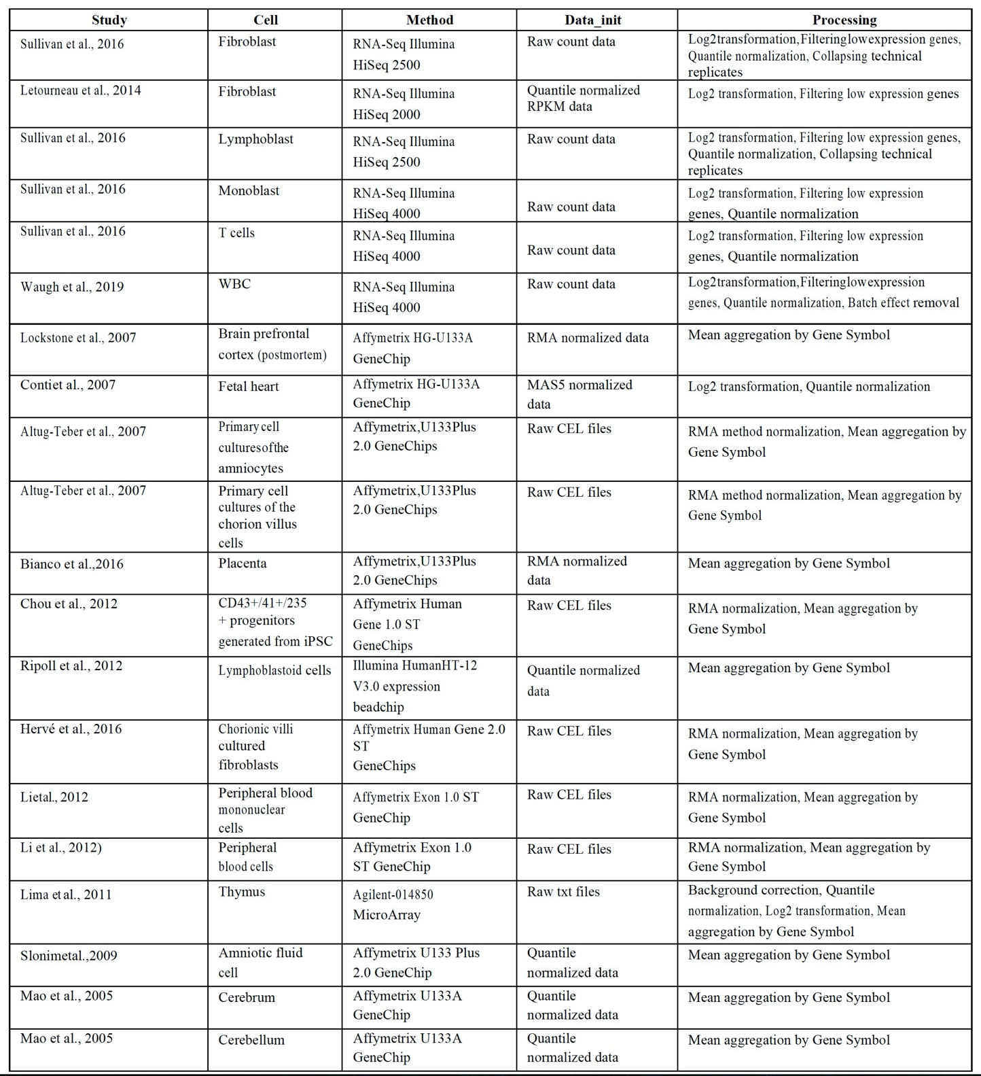

**Table 1. List of the studies used for the current meta-analysis.**

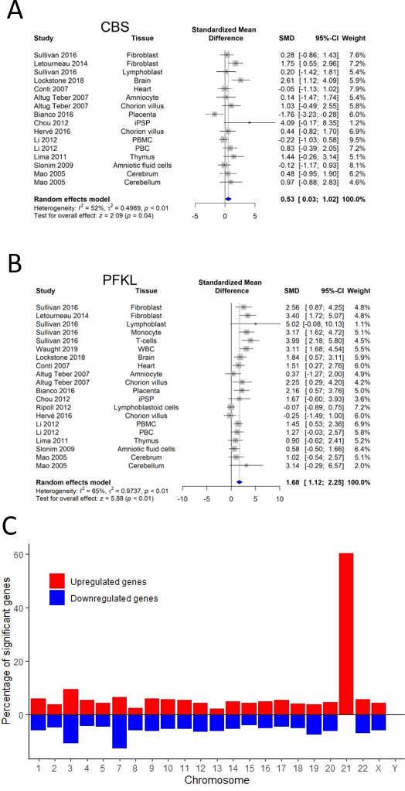

**Fig. 1. Changes in gene expression levels in Down syndrome**. **(A-B)** Forest plot showing relative weights, standardized mean difference (Hedge’s g) with confidence intervals for CBS and PFKL gene expression. These genes are mapped on chromosome 21. Overall average effect size is displayed by ◆. **(C)** Percentage of significant gene expression alteration highlights a profound effect of plus chromosome 21 in DS.

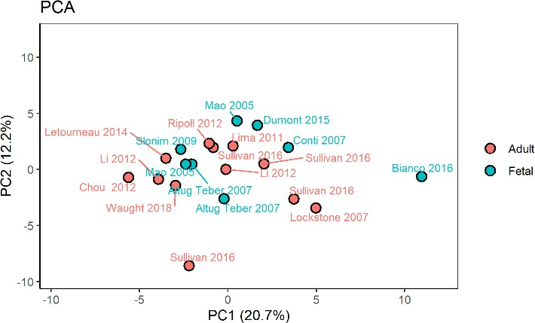

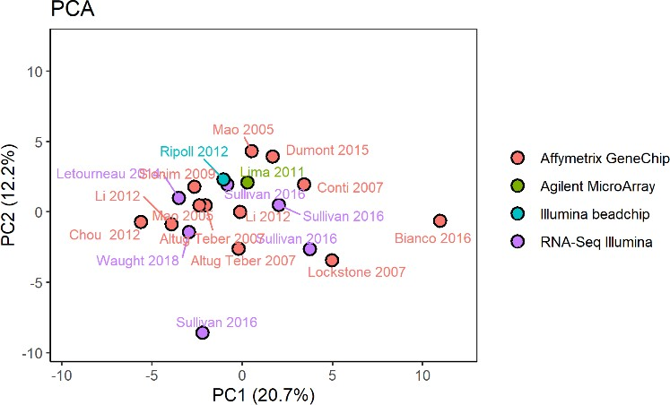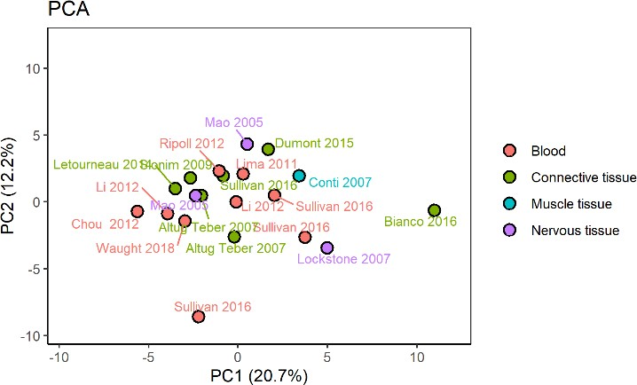

**Fig. 2 PCA plots on gene expression differences DS vs. control.** Only genes involved in energetic pathways were considered. Each dot represents one biosample per study. **(A)** Different methods used for gene expression analysis have no significant effect on the gene expression profile. **(B)** Tissue origins have no significant effect on the gene expression profile. **(C)** Tissue origins have no significant effect on the gene expression profile.

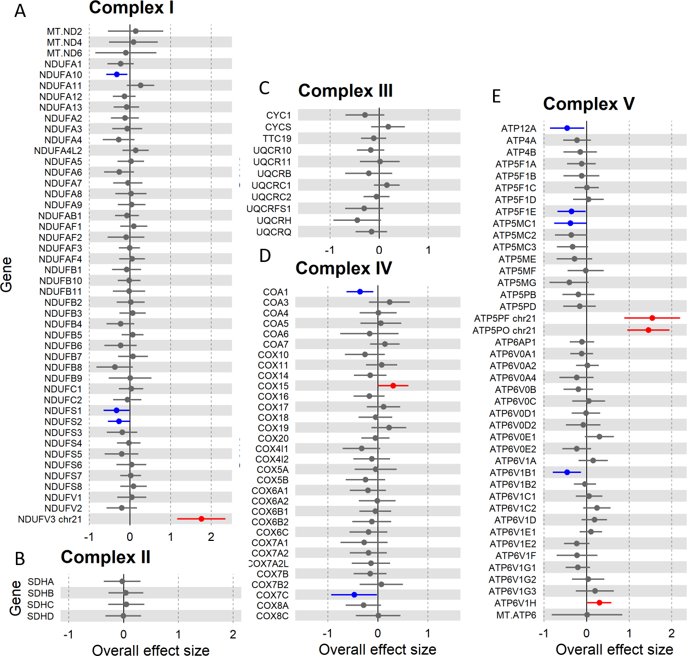

**Fig. 3. Gene expression differences in DS vs. control for genes involved in oxidative phosphorylation.**

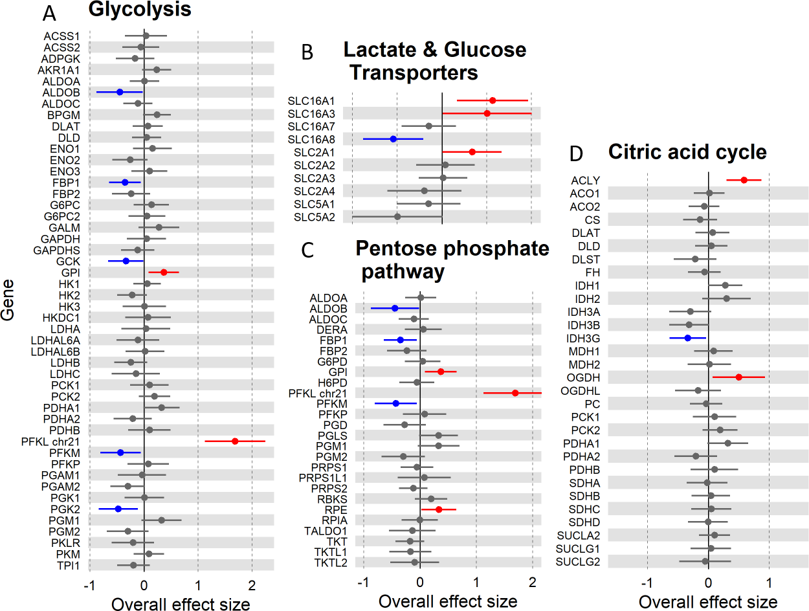

**Fig. 4. Gene expression differences in DS vs. control for genes involved in carbohydrate metabolism and cyclic acid cycle.**

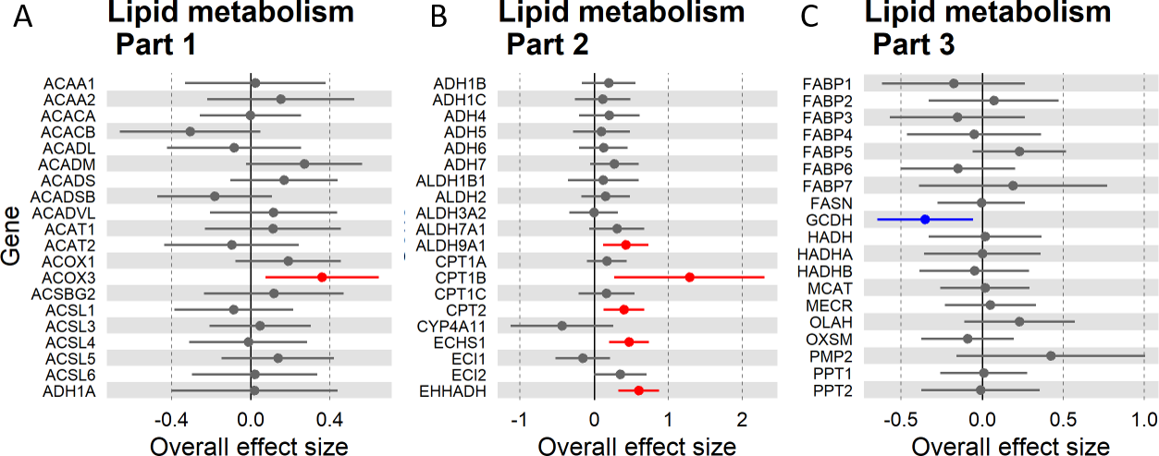

**Fig. 5. Gene expression differences in DS vs. control for genes involved in lipid metabolism.**

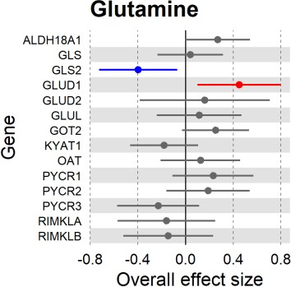

**Fig. 6. Gene expression differences in DS vs. control for genes involved in glutamine metabolism**.

**References**

Al Hasawi, N., Alkandari, M.F., and Luqmani, Y.A. (2014). Phosphofructokinase: a mediator of glycolytic flux in cancer progression. Crit Rev Oncol Hematol 92, 312-321.

Ali, A.T., Boehme, L., Carbajosa, G., Seitan, V.C., Small, K.S., and Hodgkinson, A. (2019). Nuclear genetic regulation of the human mitochondrial transcriptome. Elife 8, e41927.

Allison, D.B., Gomez, J.E., Heshka, S., Babbitt, R.L., Geliebter, A., Kreibich, K., and Heymsfield, S.B. (1995). Decreased resting metabolic rate among persons with Down Syndrome. Int J Obes Relat Metab Disord 19, 858-861.

Altug-Teber, O., Bonin, M., Walter, M., Mau-Holzmann, U.A., Dufke, A., Stappert, H., Tekesin, I., Heilbronner, H., Nieselt, K., and Riess, O. (2007). Specific transcriptional changes in human fetuses with autosomal trisomies. Cytogenet Genome Res 119, 171-184.

Ascenção, K., Dilek, N., Augsburger, F., Panagaki, T, Zuhra, K., and Szabo, C. (2020). Pharmacological induction of mesenchymal-epithelial transition via inhibition of H2S biosynthesis and consequent suppression of ACLY activity in colon cancer cells. Pharmacol Res., in press

Amaratunga, D., and Cabrera, J. (2001). Analysis of data from viral DNA microchips. Journal of the American Statistical Association 96, 1161-1170.

Araya, P., Waugh, K.A., Sullivan, K.D., Núñez, N.G., Roselli, E., Smith, K.P., Granrath, R.E., Rachubinski, A.L., Enriquez Estrada, B., Butcher, E.T., et al. (2019). Trisomy 21 dysregulates T cell lineages toward an autoimmunity-prone state associated with interferon hyperactivity. Proc Natl Acad Sci U S A 116, 24231-24241.

Barrett, T., and Edgar, R. (2006). [19] Gene Expression Omnibus: Microarray Data Storage, Submission, Retrieval, and Analysis. Methods in enzymology 411, 352-369.

Benjamini, Y., and Hochberg, Y. (1995). Controlling the false discovery rate: a practical and powerful approach to multiple testing. Journal of the Royal statistical society: series B (Methodological) 57, 289-300.

Berg, J.M., Tymoczko, J.L., and Stryer, L. (2006). Biochemistry. 5th. New York: WH Freeman 38, 76. Bianco, K., Gormley, M., Farrell, J., Zhou, Y., Oliverio, O., Tilden, H., McMaster, M., and Fisher, S.J. (2016). Placental transcriptomes in the common aneuploidies reveal critical regions on the trisomic chromosomes and genome‐wide effects. Prenatal diagnosis 36, 812-822.

Borenstein, M., Hedges, L.V., Higgins, J.P., and Rothstein, H.R. (2010). A basic introduction to fixed- effect and random-effects models for meta-analysis. Res Synth Methods 1, 97-111.

Brazma, A., Parkinson, H., Sarkans, U., Shojatalab, M., Vilo, J., Abeygunawardena, N., Holloway, E., Kapushesky, M., Kemmeren, P., and Lara, G.G. (2003). ArrayExpress—a public repository for microarray gene expression data at the EBI. Nucleic acids research 31, 68-71.

Caracausi, M., Ghini, V., Locatelli, C., Mericio, M., Piovesan, A., Antonaros, F., Pelleri, M.C., Vitale, L., Vacca, R.A., Bedetti, F., Mimmi, M.C., Luchinat, C., Turano, P., Strippoli, P., and Cocchi, G. (2018) Plasma and urinary metabolomic profiles of Down syndrome correlate with alteration of mitochondrial metabolism. Sci Rep. 8, 2977.

Carvalho, B.S., and Irizarry, R.A. (2010). A framework for oligonucleotide microarray preprocessing. Bioinformatics 26, 2363-2367.

Chou, S.T., Byrska-Bishop, M., Tober, J.M., Yao, Y., Vandorn, D., Opalinska, J.B., Mills, J.A., Choi, J.K., Speck, N.A., Gadue, P., et al. (2012). Trisomy 21-associated defects in human primitive hematopoiesis revealed through induced pluripotent stem cells. Proc Natl Acad Sci U S A 109, 17573-17578.

Conti, A., Fabbrini, F., D'Agostino, P., Negri, R., Greco, D., Genesio, R., D'Armiento, M., Olla, C., Paladini, D., Zannini, M., et al. (2007). Altered expression of mitochondrial and extracellular matrix genes in the heart of human fetuses with chromosome 21 trisomy. BMC Genomics 8, 268.

Dashty, M. (2013). A quick look at biochemistry: carbohydrate metabolism. Clin Biochem 46, 1339- 1352.

Davis, S., and Meltzer, P.S. (2007). GEOquery: a bridge between the Gene Expression Omnibus (GEO) and BioConductor. Bioinformatics 23, 1846-1847.

Dierssen, M., Fructuoso, M., Martínez de Lagrán, M., Perluigi, M., and Barone, E. (2020). Down Syndrome Is a Metabolic Disease: Altered Insulin Signaling Mediates Peripheral and Brain Dysfunctions. Frontiers in Neuroscience 14.

Filipp, F.V., Scott, D.A., Ronai, Z.e.A., Osterman, A.L., and Smith, J.W. (2012). Reverse TCA cycle flux through isocitrate dehydrogenases 1 and 2 is required for lipogenesis in hypoxic melanoma cells. Pigment cell & melanoma research 25, 375-383.

Halestrap, A.P. (2012). The monocarboxylate transporter family--Structure and functional characterization. IUBMB Life 64, 1-9.

Han, C., Lu, X., and Nagrath, D. (2018). Regulation of protein metabolism in cancer. Mol Cell Oncol 5, e1285384-e1285384.

Hargreaves, I.P., Duncan, A.J., Wu, L., Agrawal, A., Land, J.M., Heales, S.J. (2007). Inhibition of mitochondrial complex IV leads to secondary loss complex II-III activity: implications for the pathogenesis and treatment of mitochondrial encephalomyopathies. Mitochondrion. 7, 284-7.

Hasle, H., Friedman, J.M., Olsen, J.H., and Rasmussen, S.A. (2016). Low risk of solid tumors in persons with Down syndrome. Genetics in Medicine 18, 1151-1157.

Hedges, L.V. (1981). Distribution theory for Glass's estimator of effect size and related estimators. journal of Educational Statistics 6, 107-128.

Hervé, B., Coussement, A., Gilbert, T., Dumont, F., Jacques, S., Cuisset, L., Chicard, M., Hizem, S., Bourdoncle, P., and Letourneur, F. (2016). Aneuploidy: the impact of chromosome imbalance on nuclear organization and overall genome expression. Clinical genetics 90, 35-48.

Ishihara, K., and Akiba, S. (2017). A Comprehensive Diverse '-omics' Approach to Better Understanding the Molecular Pathomechanisms of Down Syndrome. Brain Sci 7.

Jassal, B., Matthews, L., Viteri, G., Gong, C., Lorente, P., Fabregat, A., Sidiropoulos, K., Cook, J., Gillespie, M., Haw, R., et al. (2020). The reactome pathway knowledgebase. Nucleic Acids Res 48, D498-d503.

Kanehisa, M., and Goto, S. (2000). KEGG: kyoto encyclopedia of genes and genomes. Nucleic acids research 28, 27-30.

Kresge, N., Simoni, R.D., and Hill, R.L. (2005). Otto Fritz Meyerhof and the elucidation of the glycolytic pathway. J Biol Chem 280, e3.

Lejeune, J. (1990). Pathogenesis of mental deficiency in trisomy 21. American Journal of Medical Genetics 37, 20-30.

Lejeune, J., Gauthier, M., and Turpin, R. (1959). [Human chromosomes in tissue cultures]. C R Hebd Seances Acad Sci 248, 602-603.

Letourneau, A., Santoni, F.A., Bonilla, X., Sailani, M.R., Gonzalez, D., Kind, J., Chevalier, C., Thurman, R., Sandstrom, R.S., Hibaoui, Y., et al. (2014). Domains of genome-wide gene expression dysregulation in Down's syndrome. Nature 508, 345-350.

Li, C., Jin, L., Bai, Y., Chen, Q., Fu, L., Yang, M., Xiao, H., Zhao, G., and Wang, S. (2012). Genome-wide expression analysis in Down syndrome: insight into immunodeficiency. PLoS One 7, e49130.

Lima, F.A., Moreira-Filho, C.A., Ramos, P.L., Brentani, H., Lima, L.d.A., Arrais, M., Bento-de-Souza, L.C., Bento-de-Souza, L., Duarte, M.I., and Coutinho, A. (2011). Decreased AIRE expression and global thymic hypofunction in Down syndrome. The Journal of Immunology 187, 3422-3430.

Liu, Y., Borel, C., Li, L., Müller, T., Williams, E.G., Germain, P.-L., Buljan, M., Sajic, T., Boersema, P.J., Shao, W., et al. (2017). Systematic proteome and proteostasis profiling in human Trisomy 21 fibroblast cells. Nature Communications 8, 1212.

Lockstone, H.E., Harris, L.W., Swatton, J.E., Wayland, M.T., Holland, A.J., and Bahn, S. (2007). Gene expression profiling in the adult Down syndrome brain. Genomics 90, 647-660.

Magnani, M., Stocchi, V., Novelli, G., Dachà, M., and Fornaini, G. (1987). Red blood cell glucose metabolism in Down's syndrome. Clin Physiol Biochem 5, 9-14.

Maleki, F., Ovens, K., McQuillan, I., and Kusalik, A.J. (2019). Size matters: how sample size affects the reproducibility and specificity of gene set analysis. Human Genomics 13, 42.

Mao, R., Wang, X., Spitznagel, E.L., Frelin, L.P., Ting, J.C., Ding, H., Kim, J.-w., Ruczinski, I., Downey, T.J., and Pevsner, J. (2005). Primary and secondary transcriptional effects in the developing human Down syndrome brain and heart. Genome biology 6, R107.

Moss, D.W. (1982). Isozymes. Current Topics in Biological and Medical Research. J Clin Pathol 35, 1040-1040.

Navale, A.M., and Paranjape, A.N. (2016). Glucose transporters: physiological and pathological roles. Biophys Rev 8, 5-9.

Nicholls, P., Marshall, D.C., Cooper, C.E. and Wilson, M.T. (2013). Sulfide inhibition of and metabolism by cytochrome c oxidase Biochem Soc Trans. 41, 1312-6.

Panagaki, T., Randi, E.B., Augsburger, F., and Szabo, C. (2019). Overproduction of H2S, generated by CBS, inhibits mitochondrial Complex IV and suppresses oxidative phosphorylation in Down syndrome. Proc Natl Acad Sci U S A. 116, 18769-18771.

Panagaki, T., Randi, E.B., and Szabo C. (2020). Role of 3-mercaptopyruvate sulfurtransferase in the regulation of proliferation and cellular bioenergetics in human Down syndrome fibroblasts. Biomolecules 10, 653.

Peled-Kamar, M., Degani, H., Bendel, P., and Groner, Y. (1998). Altered brain glucose metabolism in transgenic-PFKL mice with elevated L-phosphofructokinase: in vivo NMR studies. Brain research 810, 138-145.

Pelleri, M.C., Cicchini, E., Petersen, M.B., Tranebjærg, L., Mattina, T., Magini, P., Antonaros, F., Caracausi, M., Vitale, L., and Locatelli, C. (2019). Partial trisomy 21 map: Ten cases further supporting the highly restricted Down syndrome critical region (HR‐DSCR) on human chromosome 21. Molecular genetics & genomic medicine 7, e797.

Pecze L., Randi E.B., and Szabo C. (2020). Meta-analysis of metabolites involved in bioenergetic pathways reveals a pseudohypoxic state in Down syndrome. Molecular medicine, in press.

Ripoll, C., Rivals, I., Yahya-Graison, E.A., Dauphinot, L., Paly, E., Mircher, C., Ravel, A., Grattau, Y., Bléhaut, H., and Mégarbane, A. (2012). Molecular signatures of cardiac defects in Down syndrome lymphoblastoid cell lines suggest altered ciliome and Hedgehog pathways. PLoS One 7, e41616.

Ritchie, M.E., Phipson, B., Wu, D., Hu, Y., Law, C.W., Shi, W., and Smyth, G.K. (2015). limma powers differential expression analyses for RNA-sequencing and microarray studies. Nucleic acids research 43, e47-e47.

Slonim, D.K., Koide, K., Johnson, K.L., Tantravahi, U., Cowan, J.M., Jarrah, Z., and Bianchi, D.W. (2009). Functional genomic analysis of amniotic fluid cell-free mRNA suggests that oxidative stress is significant in Down syndrome fetuses. Proceedings of the National Academy of Sciences 106, 9425- 9429.

Sobol, M., Klar, J., Laan, L., Shahsavani, M., Schuster, J., Annerén, G., Konzer, A., Mi, J., Bergquist, J., Nordlund, J., et al. (2019). Transcriptome and Proteome Profiling of Neural Induced Pluripotent Stem Cells from Individuals with Down Syndrome Disclose Dynamic Dysregulations of Key Pathways and Cellular Functions. Mol Neurobiol 56, 7113-7127.

Sullivan, K.D., Lewis, H.C., Hill, A.A., Pandey, A., Jackson, L.P., Cabral, J.M., Smith, K.P., Liggett, L.A.,

Gomez, E.B., Galbraith, M.D., et al. (2016). Trisomy 21 consistently activates the interferon response. Elife 5, e16220.

Taanman. J-W. (1999). The mitochondrial genome: structure, transcription, translation and replication Biochimica et Biophysica Acta (BBA) – Bioenergetics 1410, 103-123.

Tanner, L.B., Goglia, A.G., Wei, M.H., Sehgal, T., Parsons, L.R., Park, J.O., White, E., Toettcher, J.E., and Rabinowitz, J.D. (2018). Four key steps control glycolytic flux in mammalian cells. Cell systems 7, 49- 62. e48.

Team, R.C. (2013). R: A language and environment for statistical computing. (Vienna, Austria). Valenti, D., Braidy, N., De Rasmo, D., Signorile, A., Rossi, L., Atanasov, A.G., Volpicella, M., Henrion- Caude, A., Nabavi, S.M., and Vacca, R.A. (2018). Mitochondria as pharmacological targets in Down syndrome. Free Radic Biol Med 114, 69-83.

Waldron, L., and Riester, M. (2016). Meta-analysis in gene expression studies. In Statistical Genomics (Springer), pp. 161-176.

Waugh, K.A., Araya, P., Pandey, A., Jordan, K.R., Smith, K.P., Granrath, R.E., Khanal, S., Butcher, E.T., Estrada, B.E., Rachubinski, A.L., et al. (2019). Mass Cytometry Reveals Global Immune Remodeling with Multi-lineage Hypersensitivity to Type I Interferon in Down Syndrome. Cell Rep 29, 1893- 1908.e1894.

Xanthopoulos, M.S., Walega, R., Xiao, R., Prasad, D., Pipan, M.M., Zemel, B.S., Berkowitz, R.I., Magge, S.N., and Kelly, A. (2017). Caregiver-Reported Quality of Life in Youth with Down Syndrome. J Pediatr 189, 98-104.e101.

Zancan, P., Sola-Penna, M., Furtado, C.M., and Da Silva, D. (2010). Differential expression of phosphofructokinase-1 isoforms correlates with the glycolytic efficiency of breast cancer cells. Molecular genetics and metabolism 100, 372-378.