©2007 RealTEK Semiconductor Corp. All rights reserved. No part of this document may be reproduced, transmitted, transcribed, stored in a retrieval system, or translated into any language in any form or by any means without the written permission of RealTEK Semiconductor Corp.

RTL8190 Mass Production UI
Guideline

Document Number: 01-001-G1-0001
Naming Rule: Reference Internal Engineer Development Document Code
Example: 01 0001 H1 01

Serial Number

RTL8190

Wireless NIC

High Level Design Firmware Architecture
Document Code Management
 |  |  | Code
RTL Document |  | Functional Spec | F1
 |  | High Level Design | H1
 |  | Low Level Design | L1
 |  | Test Plan, Test Report | T1
 |  | Guideline | G1
 |  | Meeting Notes, Decisions | M1

Realtek Semiconductor Corp.
Headquarters
1F, No. 2, Industry East Road IX, Science-based
Industrial Park, Hsinchu, 300, Taiwan, R.O.C.
Tel: 886-3-5780211 Fax: 886-3-5776047
http://www.realtek.com.tw/

Change History
Version | Editor | Date | Remarks
0.01 | MHC | 08/09/2007  08/13/2007 | - MP guide initial version.  - Move content from MPUsage.doc (Cosa).  - Cut picture for different setting and display block on MP UI.
0.02 | COSA | 08/23/2007 | - Replace Figure1. MP UI to the new one.  - Modify Setting Block content.  - Antenna B/C/D gain offset added.  - Crystal Cap added in the setting block.  - Replace Figure Rx Filter Block.  - Tx Power Block added.

“你可以開啟word → 檢視 → 文件導引模式來幫助你閱讀此份文件”

MP UI Interface
When you press “REALTEK RTL8190 WLAN NIC Mass Production Kit” icon, MP UI will be opened for your test and testing block is simply figured as below. We separate as several control blocks. (1). Setting Block. (2). Tx Packet Setting Block. (3). MAC Address Block. (4)Tx Power Block. (5). RX Filter Block. (6).MAC/RF Register Block. (7). EEPROM Block. (8). Test Result Display Block. We will describe the control blocks chapter by chapter. On MP UI, we only support several action items. (1). Start Testing → Enable operation after you finish the setting of control blocks. (2). Reset → Clear all content in TX Result Block. (3). Quit → Exit MP UI. (Or you can press “ESC” button to leave MP UI quickly).
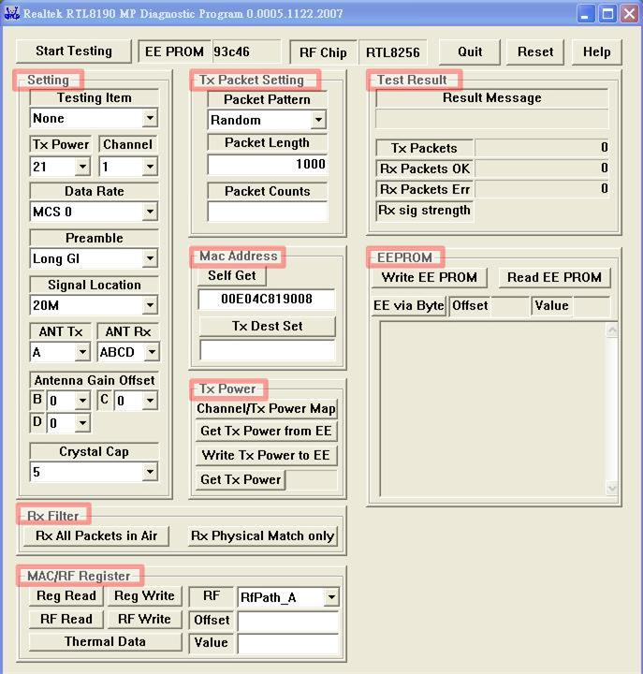
- MP UI

Setting Block
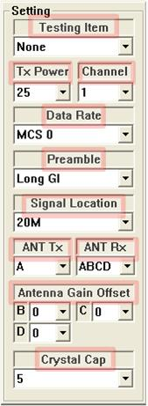
- MP UI → Setting Block

Testing Item
- Packets TX: To transmit packets.
- Packets Rx: To receive packets.
- Continuous TX: To do CCK and OFDM/MCS continuous TX.
- Carrier Suppression: To do CCK Carrier suppression.

TX Power
Choose the TX power index. Provide 0~36 power index.

Channel
Choose the channel you want to transmit packets. Provide channel 1~14.

Data Rate
- CCK : 1M, 2M, 5.5M, 11M
- OFDM : 6M, 9M, 12M, 18M, 24M, 36M, 48M, 54M
- MCS : 0~15

Preamble
- When Data Rate is CCK rate:
Only Long/Short Preamble make sense.
- When Data Rate is OFDM rate:
The preamble doesn’t make sense.
- When Data Rate is MCS rate:
Only Long/Short GI make sense.

Signal Location
You can choose 20M or 40M bandwidth.

ANT TX/RX
Select different antenna TX/RX path. Several combinations of the TX/RX RF are shown as the following table.
- Visible Antenna for Different Rate(2T4R solution)
Rate\ Antenna | TX | RX
CCK | A or C or AC | A or B or C or D
Legacy OFDM, MCS0~7 | A or C or AC | A or B or C or D or AC or BD or ALL
MCS 8~15 | AC | AC or BD or ALL

- Visible Antenna for Different Rate(1T2R solution)
Rate\ Antenna | TX | RX
CCK | A or C | (A or B) or (C or D)
Legacy OFDM, MCS0~7 | A or C | (A or B or AB) or(C or D or CD)

ANTENNA Gain Offset
Offset to calibrate the gain difference between ant-B/C/D and ant-A. The offset range is from -8 ~ +7.
Note: Only 8190P-2T4R support the antenna gain offset.

Crystal Cap
The Crystal Cap value is from 0 ~ 14.

TX Packet Setting Block
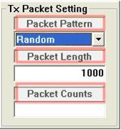
- MP UI → TX Packet Setting Block

- Packet Pattern: Choose the data pattern you want when transmit packets. You can choose random or some fixed data patterns.
- Packet Length: Before transmitting packets, you can set the packet length here. Range is from 64~1600.
- Packet Counts: Input a number before you start Packets TX testing. Once the transmitted packets reach the number, then MP stops Packets TX testing.

Mac Address Setting Block
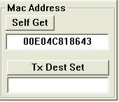
- MP UI → MAC Address Setting Block
You can get adapter’s MAC address here and set the destination Mac address.
- Self Get: Press the button to get adapter’s MAC address.
- Tx Dest Set: For unicast packet of MP, you can input the destination MAC address and press the button to do it. For example, you can input 112233445566 and press the button, and then all packets will be sent to detination with the MAC address.

Tx Power Block
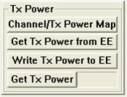
- MP UI → Tx Power Block

Channel/Tx Power Map
Push the button, you can get current tx power map by channel, CCK 2.4G channel 1~14, and OFDM 2.4G channel 1~14.

Get Tx Power from EE
Push the button, you can read the Tx Power by channel from eeprom, and overwrite these values to the Tx Power Map.

Write Tx Power to EE
Push the button, you can overwrite Current Tx Power Map values to eeprom.

Get Tx Power
Push the button, you can read the current Tx power index.

RX Filter Setting Block
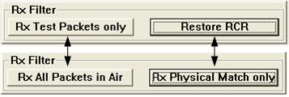
- MP UI → RX Filter Setting Block

When doing Packets Rx testing, this block can help you to filter received packets. You can force MP to receive the packet what you want.

Switch Rx Physical Match only / Restore RCR
When press the [Rx Physical Match only] button, then adapter only receive the packets with destination MAC address equal to that of the adapter. After that, the button will show [Restore RCR]. When you press [Restore RCR], the adapter receives all the packets, not only the matched MAC address packets, and the button will become [Rx Physical Match only] again.

Switch Rx Test Packets only / Rx All Packets in Air
Press [Rx Test Packets only] button, then only the special data pattern (packets transmitted by MP) will be counted in the Rx statistics. After that, the button will show [Rx All Packets in Air]. When press [Rx All Packets in Air], all packets in air will be counted in the Rx statistics.

MAC/RF Register Setting Block
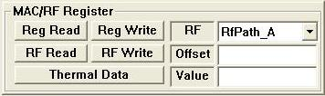
- MP UI → MAC/RF Register Setting Block
In the block, you can read or write dedicated MAC/RF register. Please refer to RTL8190 MAC and RF data sheet when you use the setting block. Otherwise, you may type incorrect register address and system will be crashed. There are several items in the block which we will explain as below.
- RF: When you want to read or write RF register, you must select dedicated RF to work. Now, we support RF A to D.
- Offset: MAC/RF register address. This is a HEX value. If you input A00, it means that you want to read or write MAC register 0xA00.
- Value: When you press REG/RF read button, the content of dedicated register address will be displayed in the column. On the other hand, the value in the column will be inserted into dedicate register address if you press write button. This us a HEX value.
- REG Read/ REG Write: Before you press read button, you must make sure that MAC register offset is legal. Before you press write button, you have to issue a legal register offset and value.
- RF Read/ RF Write: Before you press read button, you must make sure that RF path and register offset is legal. Before you press write button, you have to issue a legal register offset and value for dedicated RF path.
- Thermal Data: Press the button to get the Thermal data, which will be displayed on “Value” in the form 000’y’000’x’ which ‘x’ iss the Thermal data of RF-A, and ‘y’ is the Thermal data of RF-C.

EEPROM Setting Block
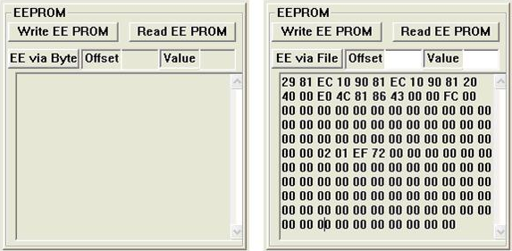
- MP UI → EEPROM Setting Block

In RTL8190, we support 128 bytes EEPROM now. You can read or modify EEPROM content by the control block. There are several items in the block which will be explained as below.
- Offset: When you press [EE via Byte], you have to input the offset to read/write EEPROM.
- Value: When you press [EE via Byte], you have to input the value to write EEPROM.
- EE via File/ EE via Byte: (1).After pressing [EE via Byte] button, you can read EEPROM by issuing the Offset or write EEPROM by issuing Offset and Value. At the moment, the button stays in [EE via File] (Figure 7-right). (2).After pressing [EE via File], Offset and Value column do not make sense (Figure 7-left). A. Pressing [Read EE PROM] button will display whole EEPROM content. B. Pressing [Write EE PROM] button will transfer the content “8190.map” into EEPROM. (You can modify the file under MP working directory.)
- Read EE PROM/Write EE PROM: Read/Write EEPROM in different way by switching [EE via Byte] and [EE via File] as described above.

TX Result Display Block

- TX Result Display Block
In the block, we provide five major messages now. They are explained as below.
- Result Message: When you press any action button on MP UI, the result message will be displayed here. For example, if you press [REG read] button and the column must display Read Registry OK. If you press [TX DEST Set] button, it must display Set DEST MAC Address OK.
- TX Packets: When you start to do “Packets TX” test, the transmitted packet number of MP is displayed in the column.
- RX Packets OK: When you start to do ‘Packet Rx’ test, the received packet number is displayed in the column.
- RX Packets ERR: When you start to do ‘Packet Rx’ test, the received packet number (CRC fail) is displayed in the column.
- RX Signal Strength: Percentage value from 0%~100%, It shows the signal strength of four antennas (RF A → D).

