You can find the Scriptable Object Table View under Enlit Games > Scriptable Object Table.
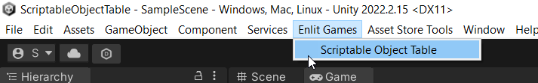
Next, you need to select the Scriptable Object which you want to edit together with other Scriptable Objects of the same type.
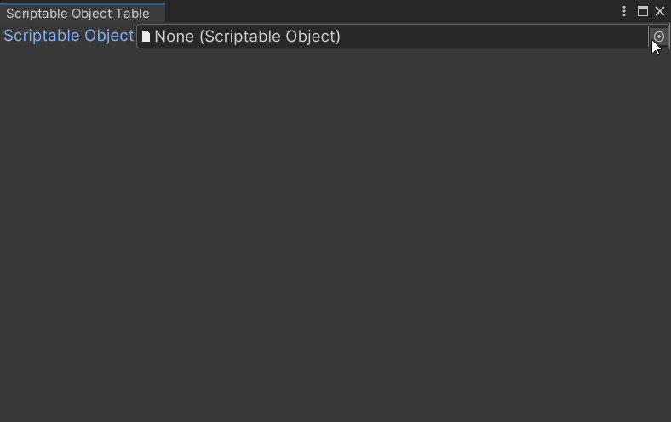
You should now see all the Scriptable Objects of the same type in a single table.
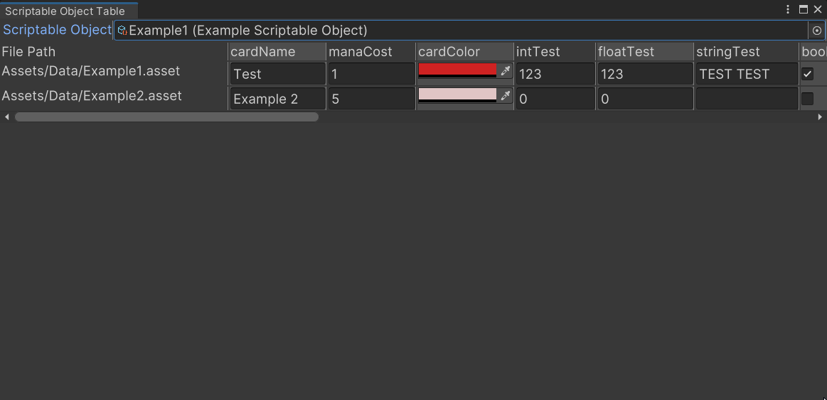
You can edit the values here and they will be changed on the actual Scriptable Object. Some more complex values are not supported, like lists or nested Scriptable Objects.

