Jenkins-Task-02:
1.Configure 2 slave machines in Jenkins master:
Navigate to ec2 and launch a instance.
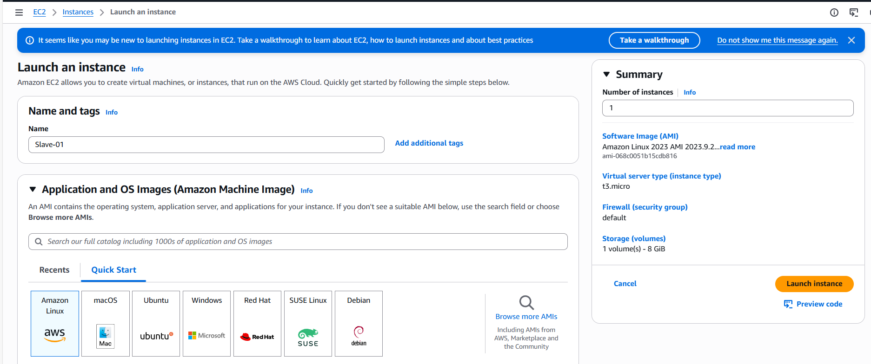
Instance launched successfully.
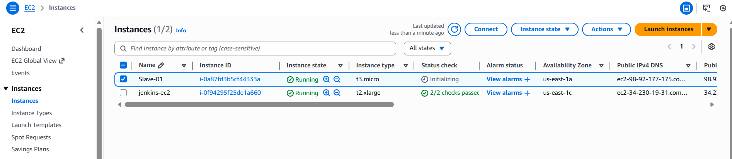
Install Java on Slave-01 ec2
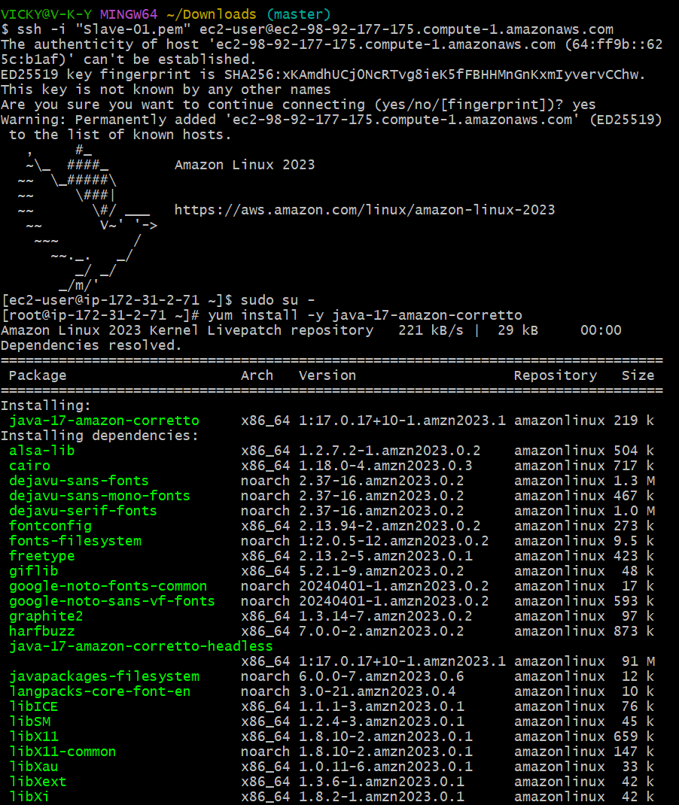
Steps to be done on Slave machine below.
Ssh-keygen -enter, enter.
Change directory to .ssh
Cat id_rsa.pub >> authorized_keys
Cat authorized_keys
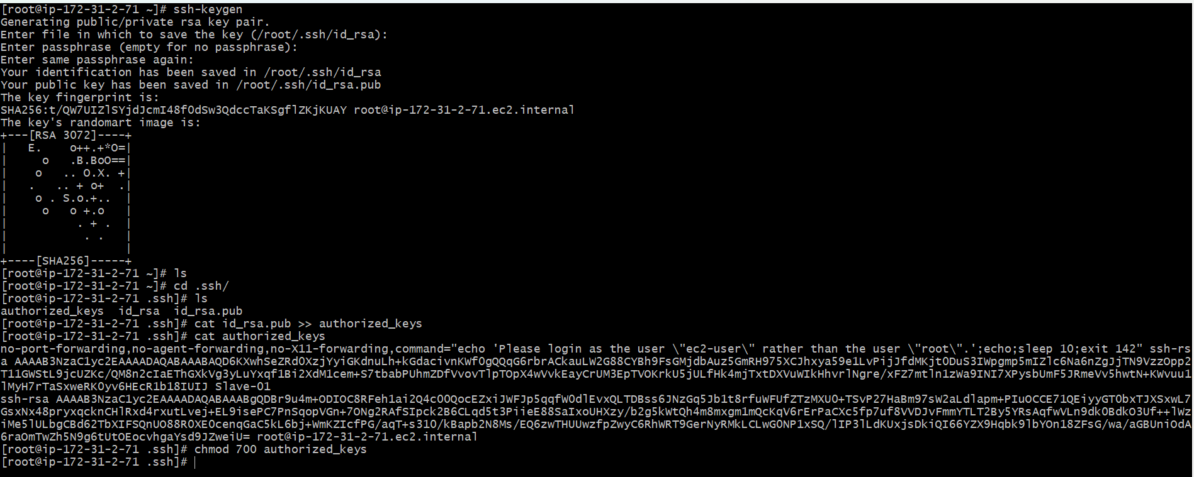
Steps to be done on Master machine
Login
Switch to root user
Create a directory – Mkdir -p /var/lib/Jenkins/.ssh
Change directory- cd /var/lib/Jenkins/.ssh
Now we need to paste the ssh-key from slave to machine- ssh-keyscan -H <Slave IP> /var/lib/Jenkins/.ssh/known_hosts
Chown Jenkins: Jenkins known_hosts
Chmod 700 known_hosts
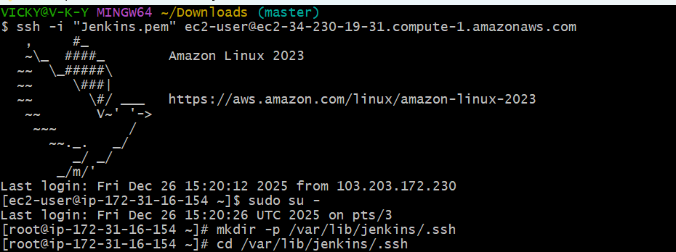
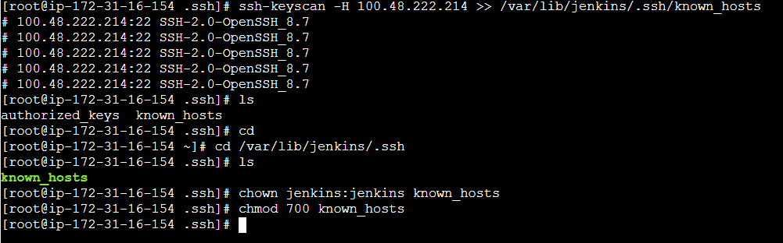
Navigate to Jenkins and search Nodes in Manage Jenkins
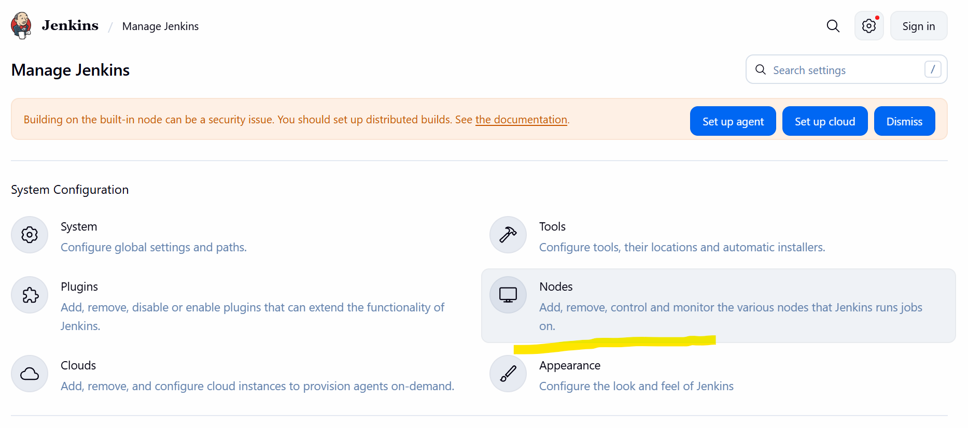
We have a built-In Node, so we shall create a new node and continue.
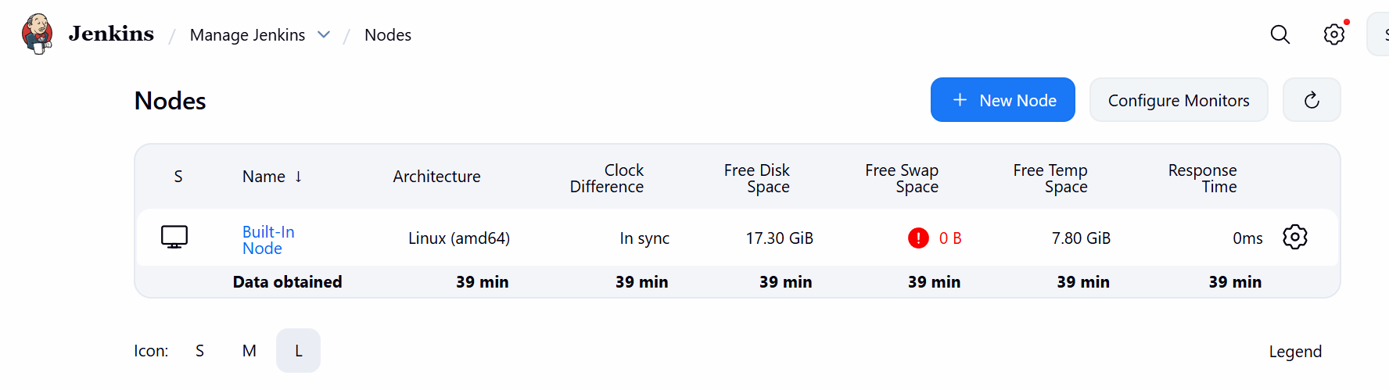
Created a new node name- Slave-01, as my “slave machine” name is Slave-01
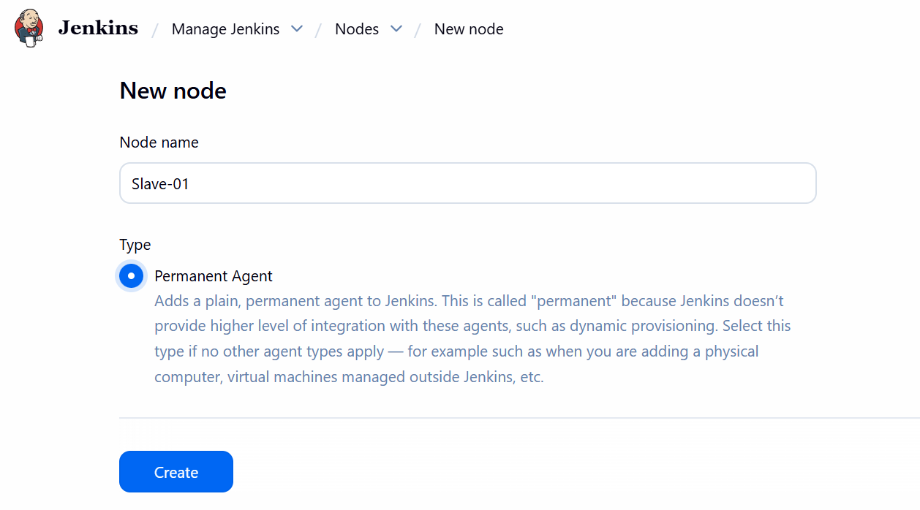
Configure the node and add a directory in ec2 in Slave machine.
Added a directory- workspace
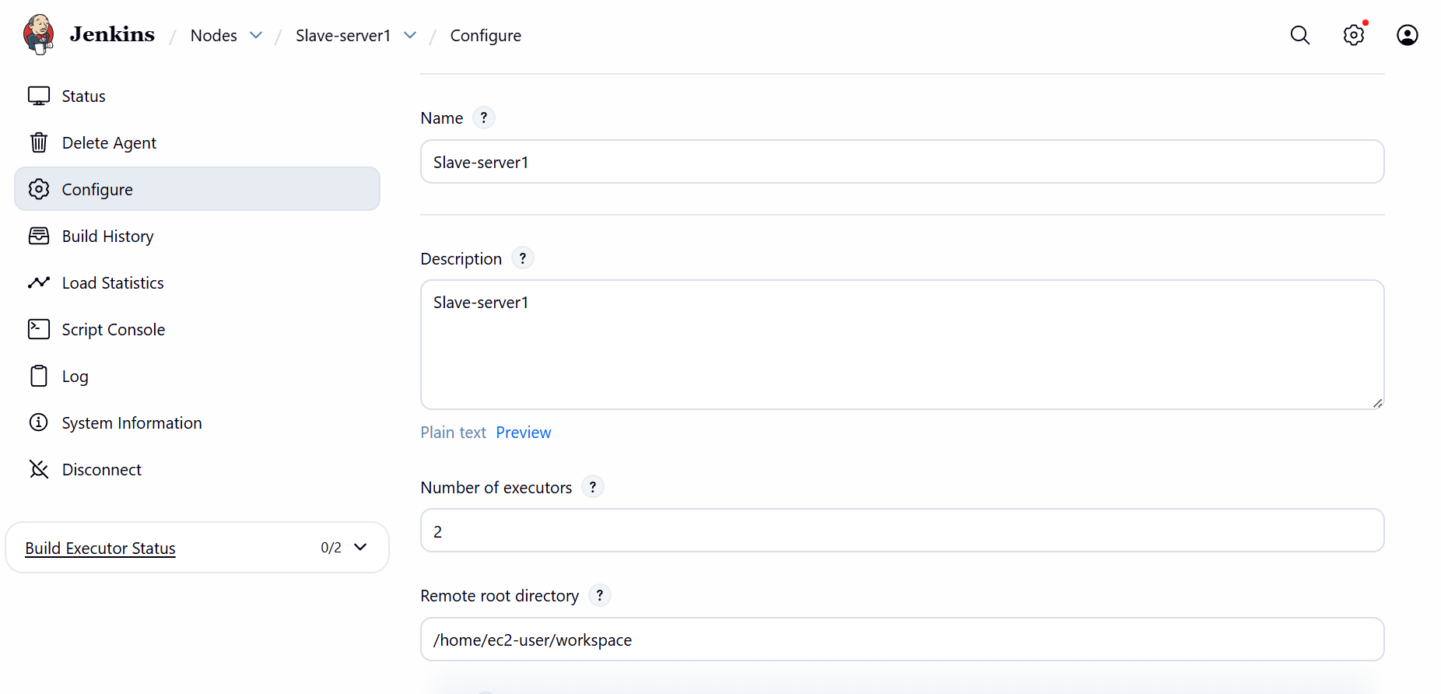
Launch method- Via SSH.
Credentials- ec2-user
Private IP- Pem.key from downloads.
Host- Slave Public IP.
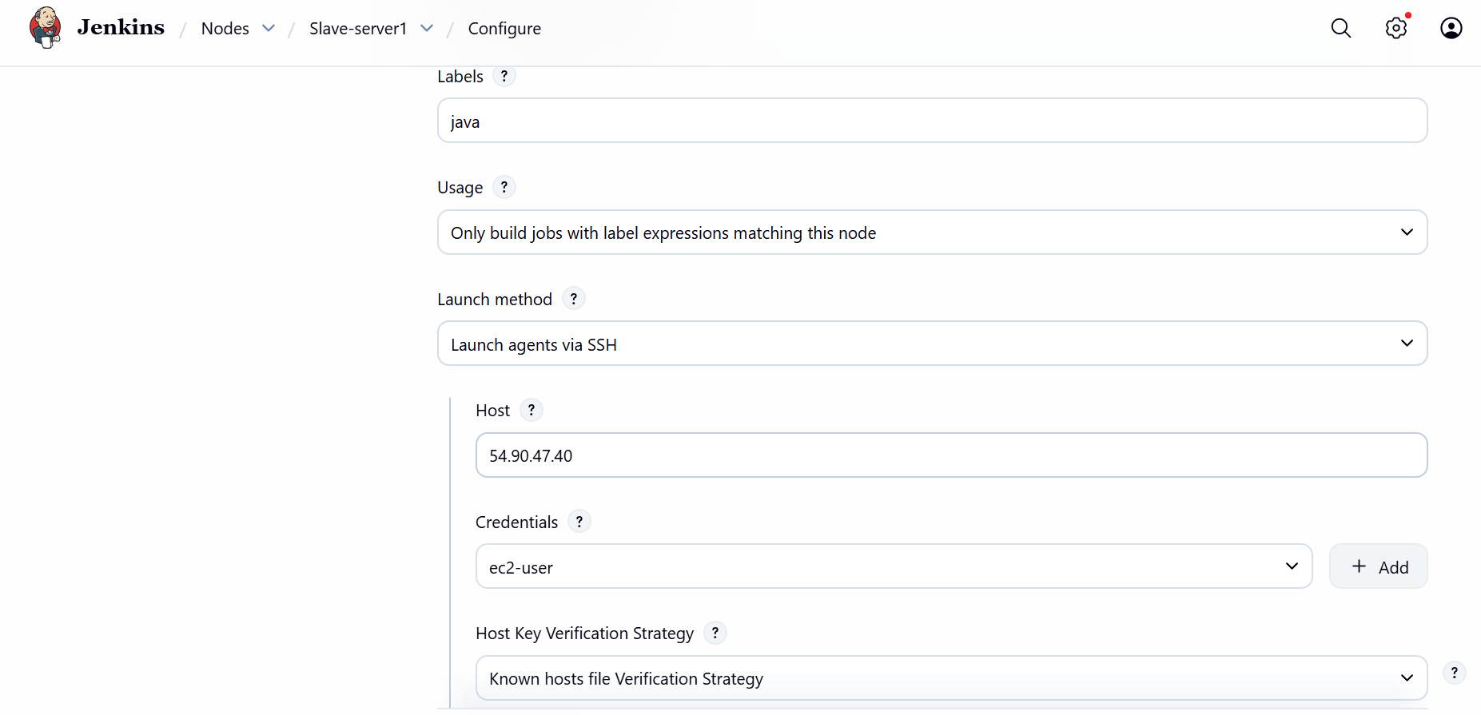

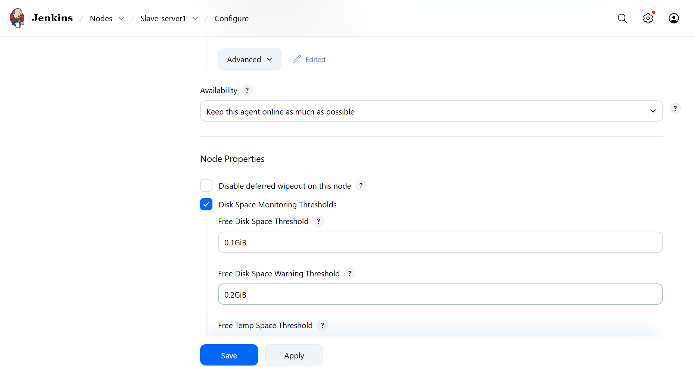

2.Configure webhooks to Jenkins job:
Navigate to Jenkins and add a new item.
Added new item named- Webhooks and selected- Free style project.
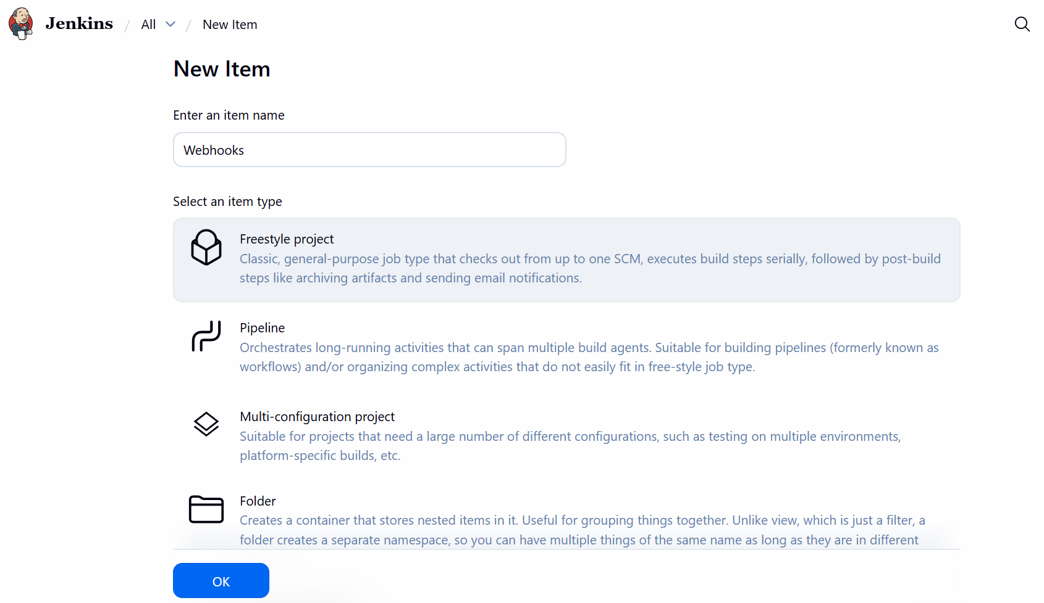
Updated Gi repo ssh from where I want to integrate with Webhooks.
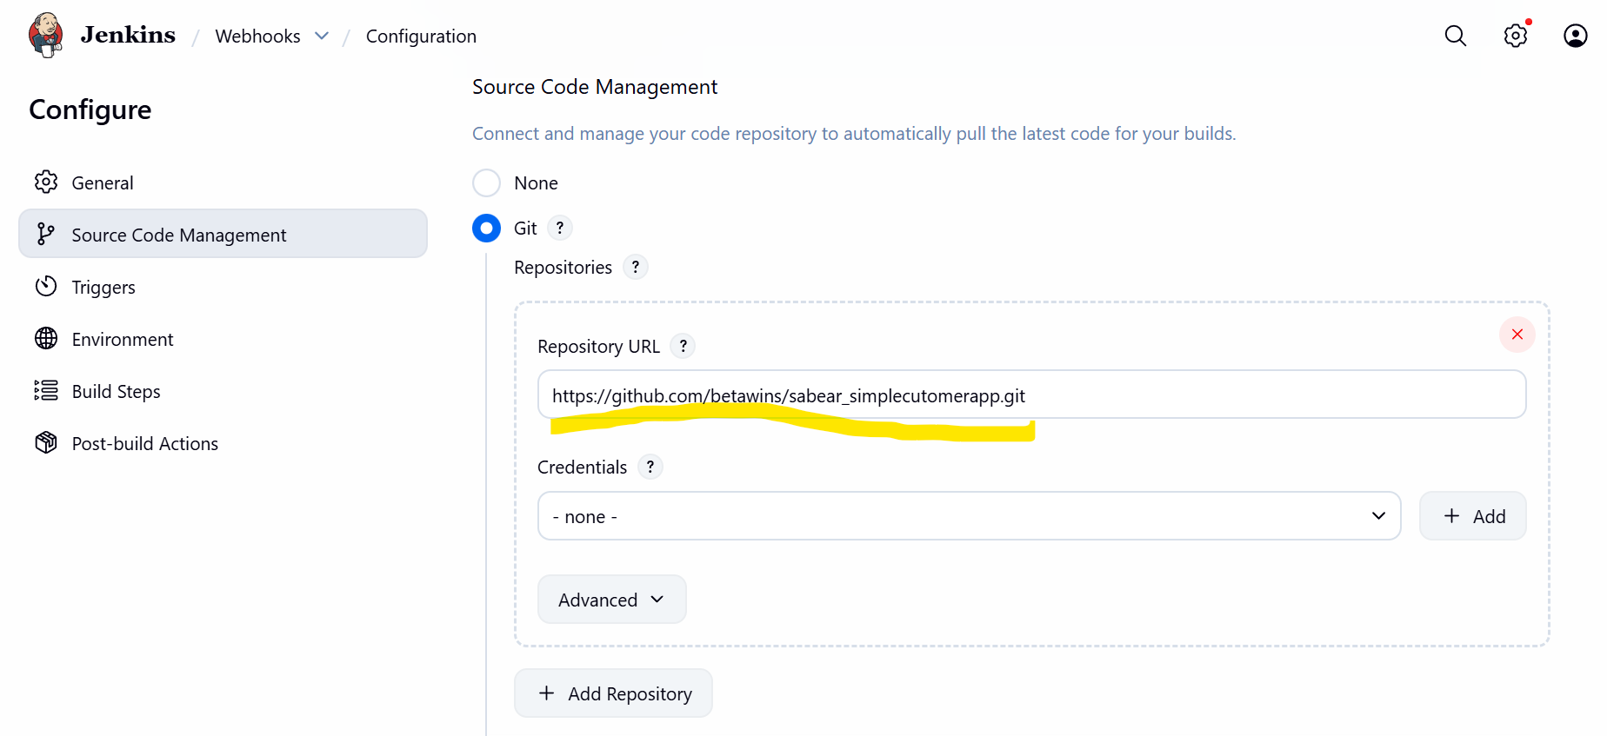

As per the requirement we need to trigger- Webhooks with GitHub for GITScm polling.
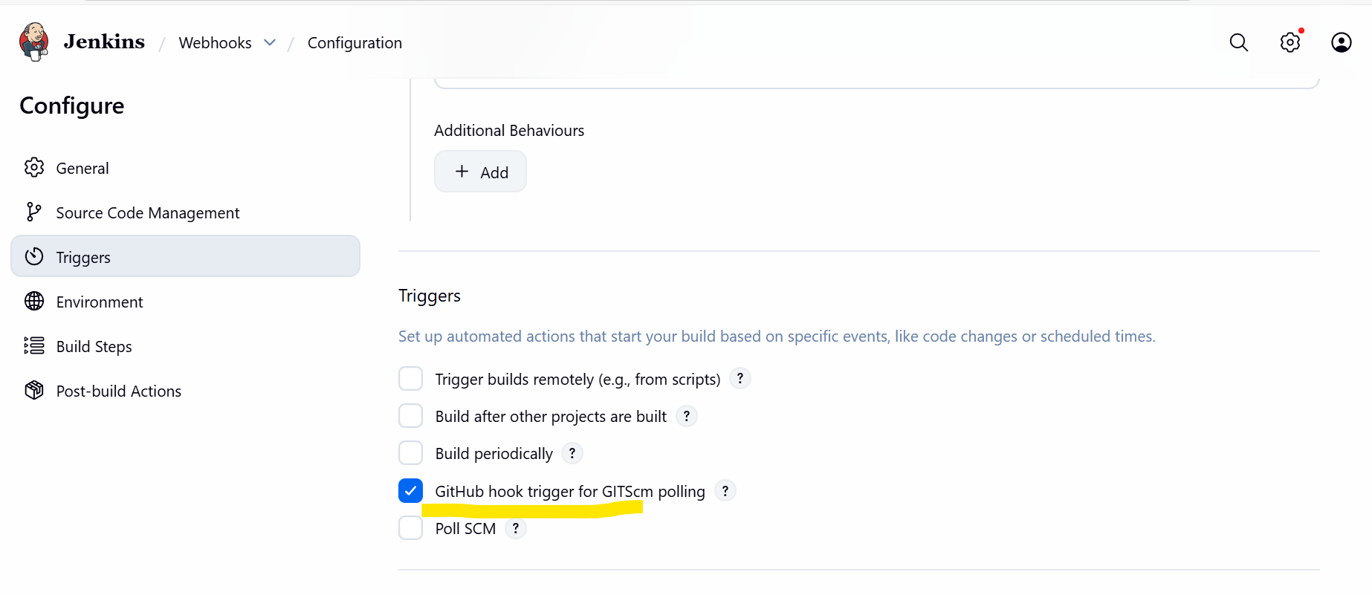
Save and navigate to GitHub to configure Webhooks.
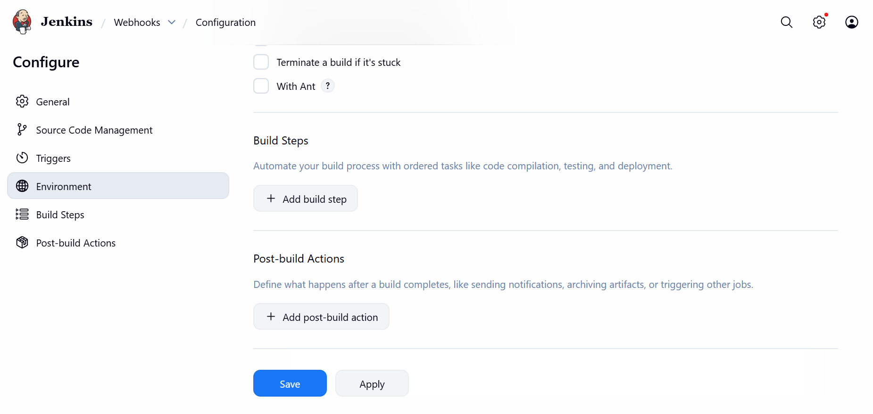
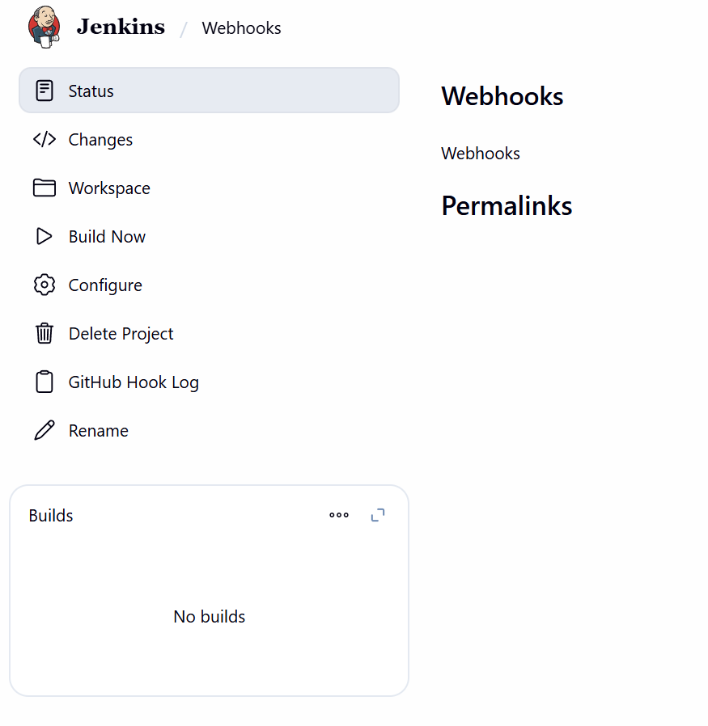

Navigate to GitHub repo and select settings
Select Webhooks from the category.
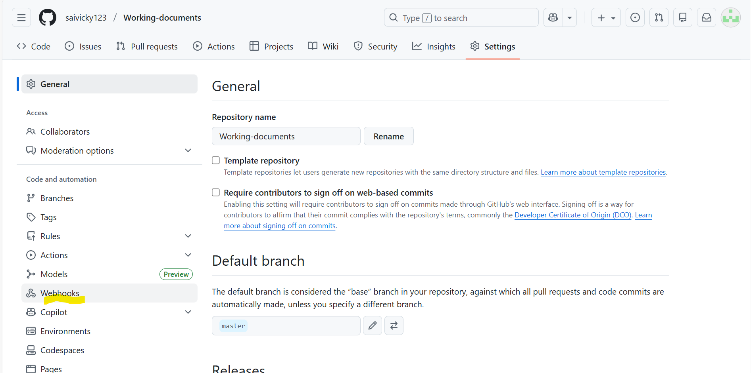
Add Webhook and continue.
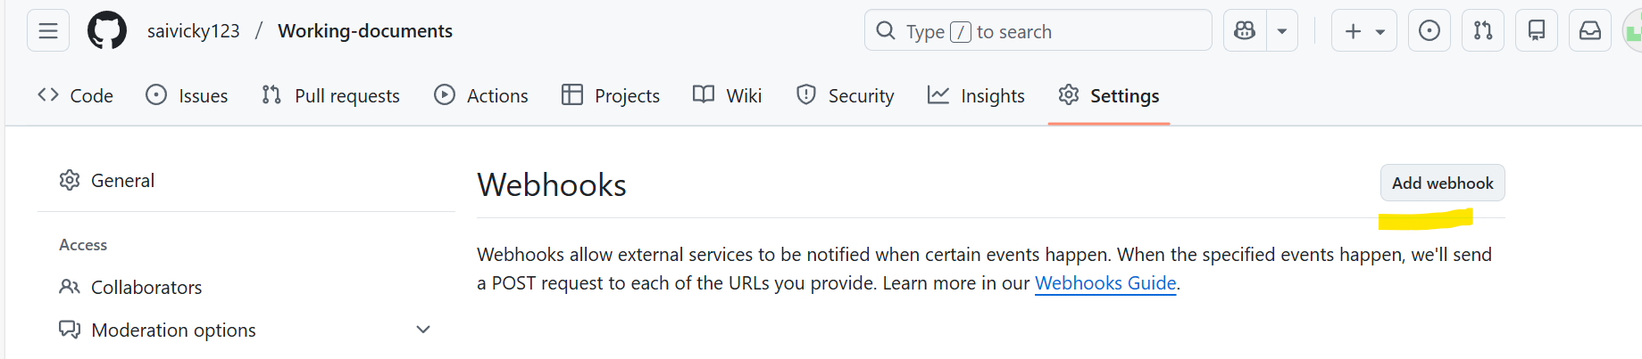
Payload URL will be our Jenkins URL
Content type- json/application
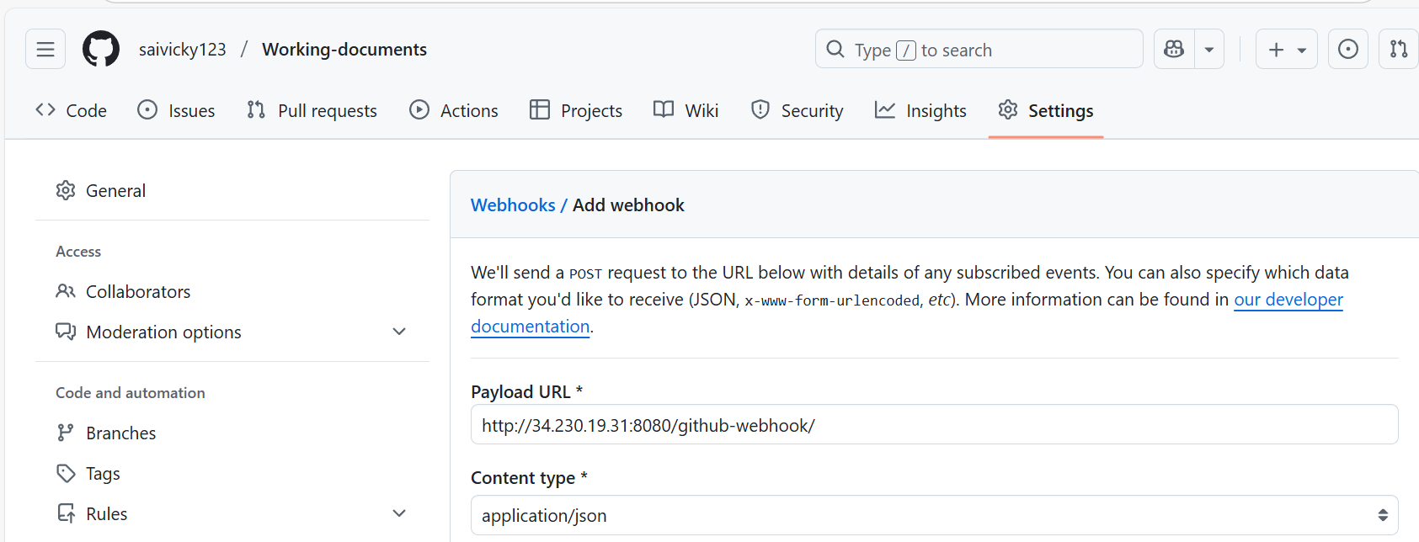
Just the push event for testing purposes.
Add Webhook
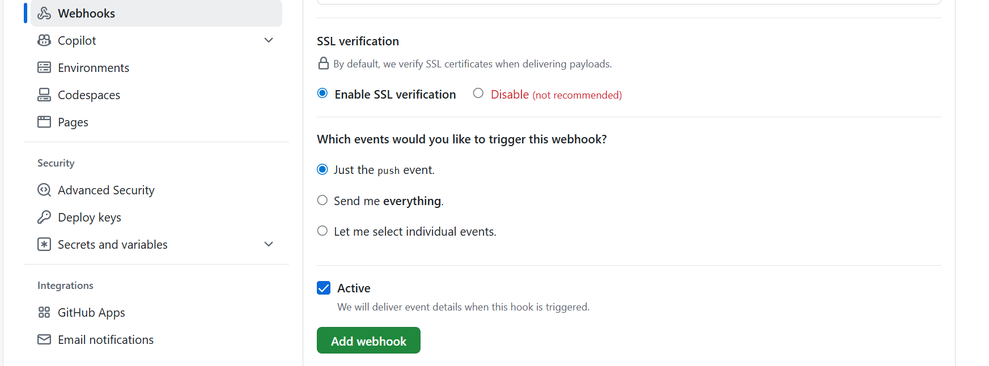
Started the build for webhooks.
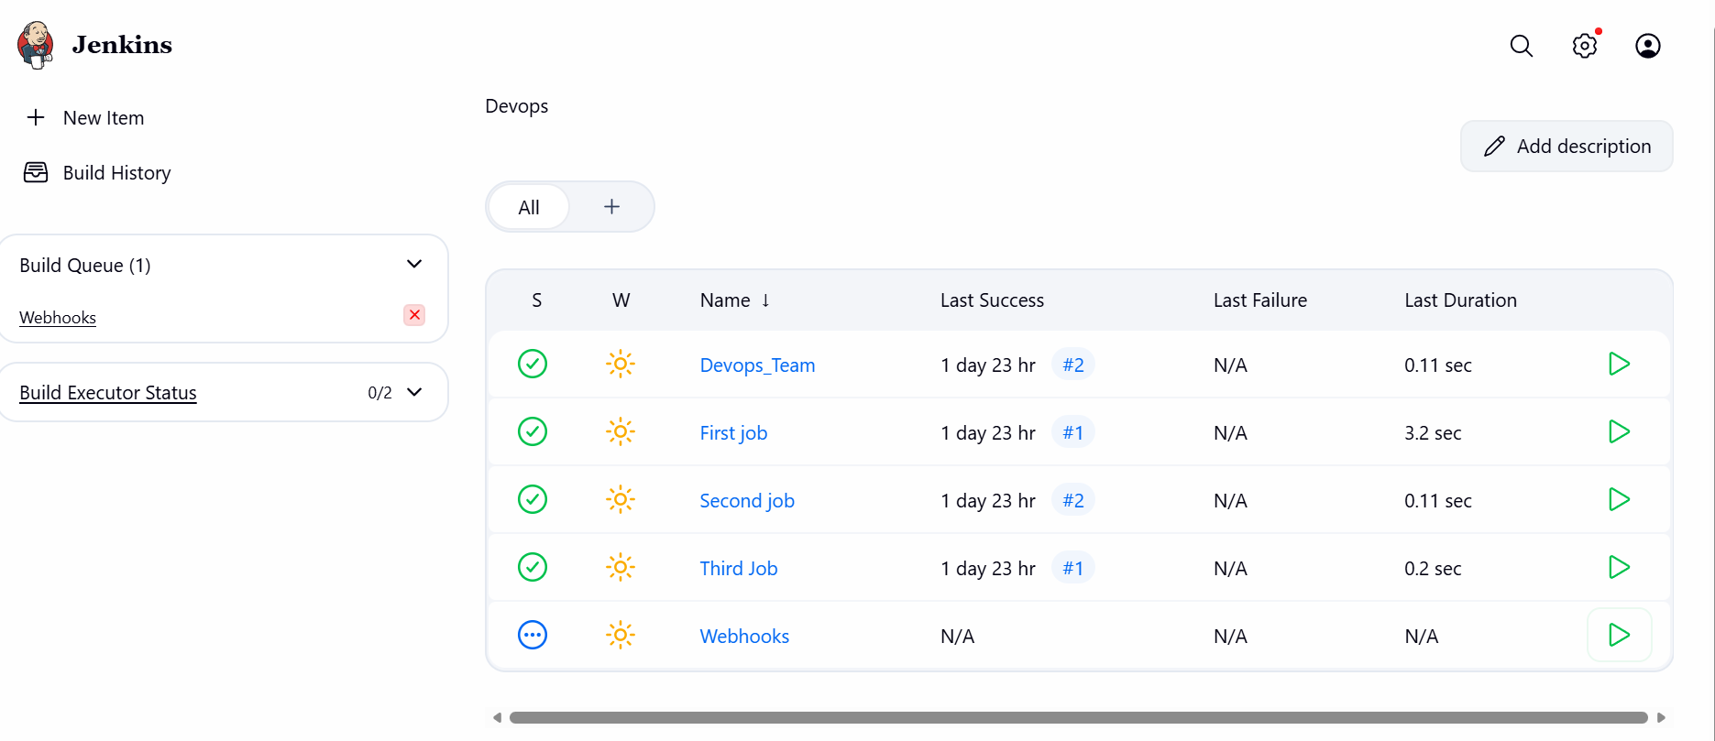
Webhooks connected successfully.
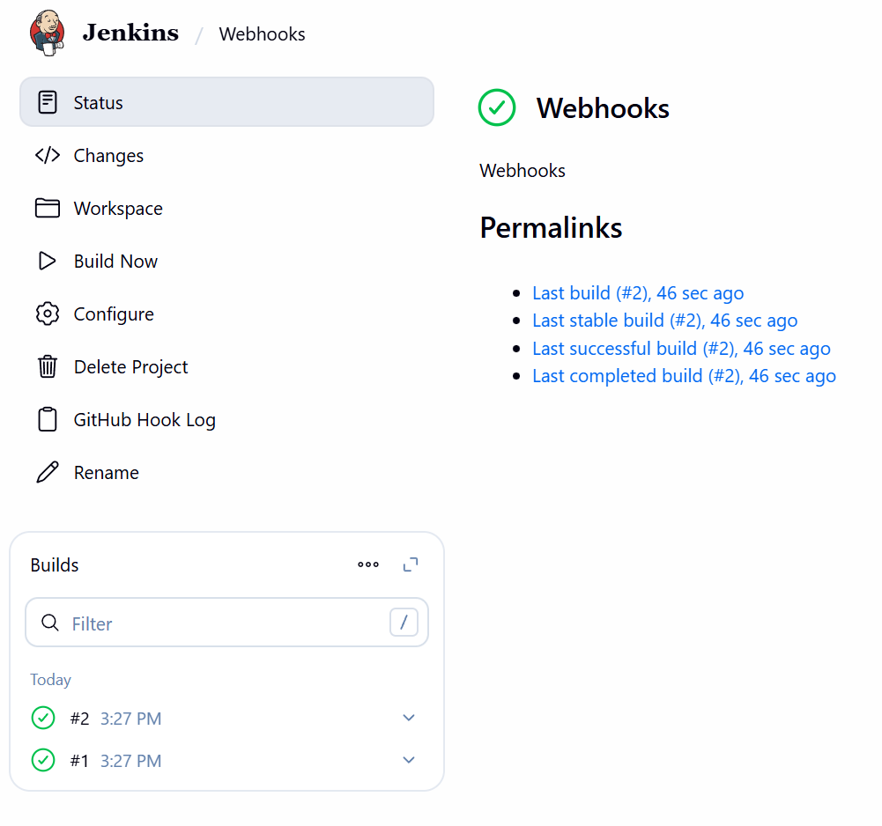Validation: Successful