Timeless time management system.

Table of contents.

System requirements:
- Pentium P6 family processor or later.
- 256MB RAM.
- 2GB HDD space.
- Microsoft (r) Windows (TM) XP or later.

Overview:
Timeless is an intranet application which is supposed to monitor and track time on PC at an internet cafe. Time management is guaranteed to be accurate to the granularity of one minute. The interface is easily modifiable, and the software is easily extensible, relying on very few software components, and using an all-in-one server daemon for the HTTP server component.
Very lightweight, and ideal for any small internet cafe business, requiring very little of the target machines in terms of hardware capabilities.

Disclaimer:
Timeless does not provide any guarantees of fitness for any purpose except as expressly outlined in this user manual. Any injury, loss, setback or inconvenience experienced as a result of using the system in ways not outlined in this manual, or using it in an environment not described by this manual are not covered by any liability terms.
Additionally, the author of Timeless gives no such guarantees at all, and in any jurisdiction where such guarantees must be made or are required by law, the author voids the user's license to use Timeless.

Menus:
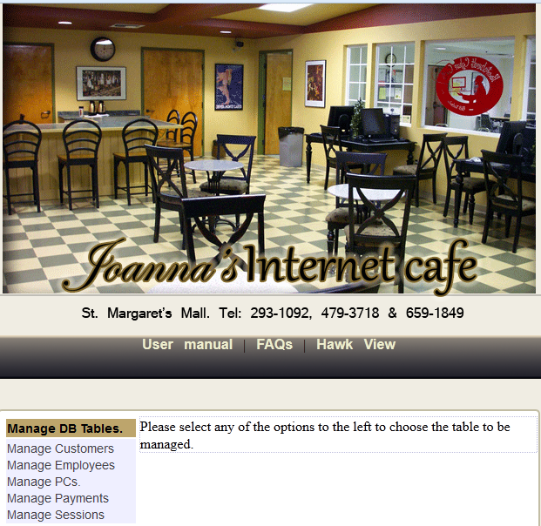
This is a screenshot of the main menu, and the home area. You may choose any of the tables to be managed from here, or choose to enter the Hawk View area to view all current sessions.
Following this, the various sub-menus will be shown:
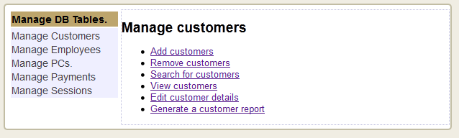
Customer submenu.
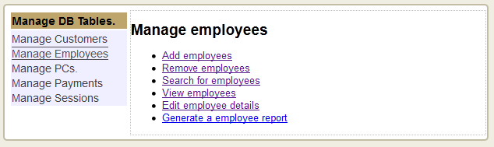
Employee submenu.
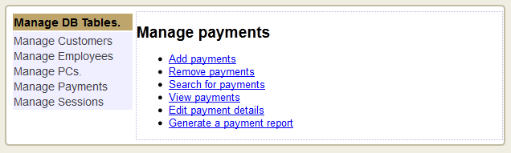
Payment submenu.
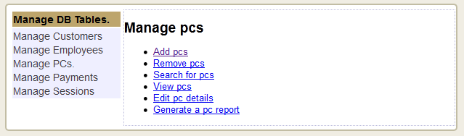
PC submenu.
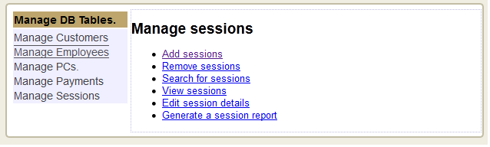
Session submenu.

Customer forms.

Add a customer:
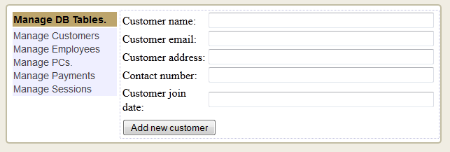
Enter the new customer's name, email address, home address, phone number and join date, and then click "Add new customer".

Delete a customer:
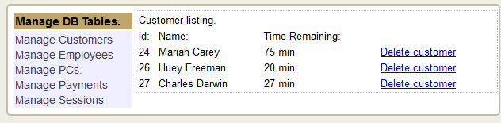
Choose any customer and click "delete customer".

Edit a customer's details:
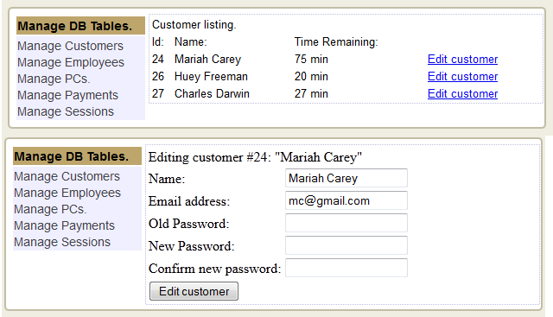
Choose any customer and click "edit customer", then change the details as desired, and finally click "edit customer" to save the changes.

View customer details:
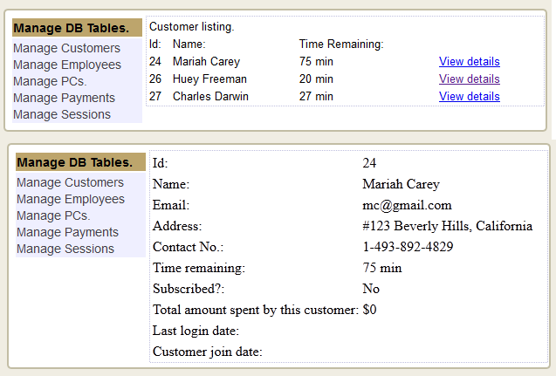
Choose any customer and click "View details" to view customer details.

Search for a customer:
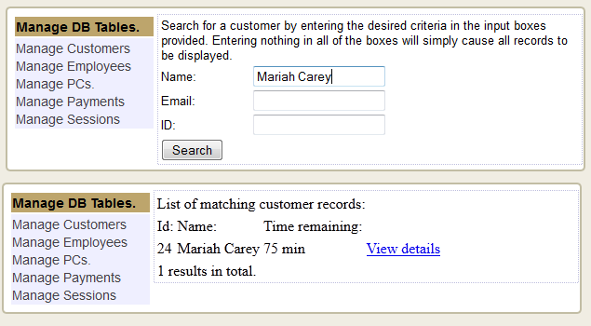
Open the search page, and input the search criteria as shown above, and if the customer is found, you will be given the option to view their details.

Employee forms:

Add an employee:
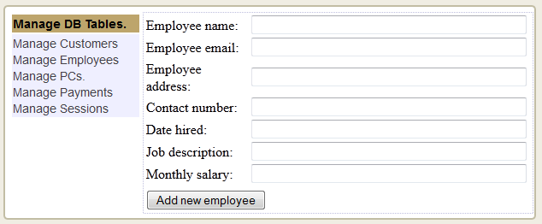
Enter the new employee's name, email address, home address, phone number, hire date, job description and monthly salary, and then click "Add new employee".

Delete an employee:
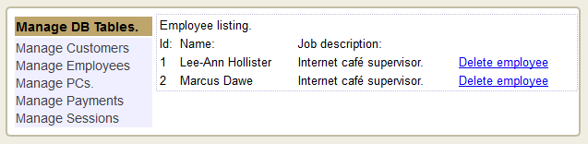
Choose any employee and click "Delete employee".

Edit an employee:
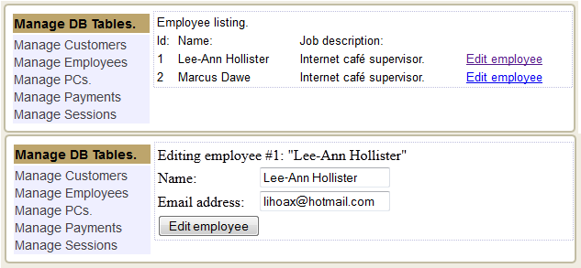
Choose any employee and click "edit employee", then enter new details as required, and finally click "Edit employee" to commit changes.

Search for an employee:
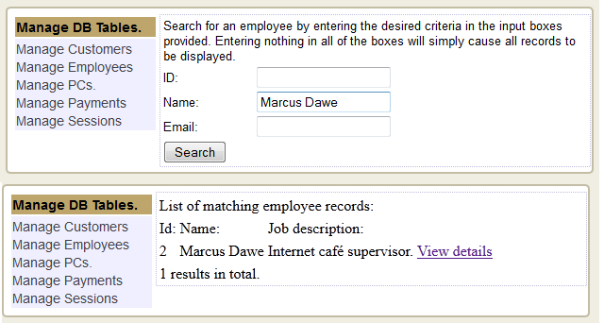
Open the search page, and enter the criteria as desired, and click "search". If the employee is found, the option to view his or her details will be shown.

View employee details:
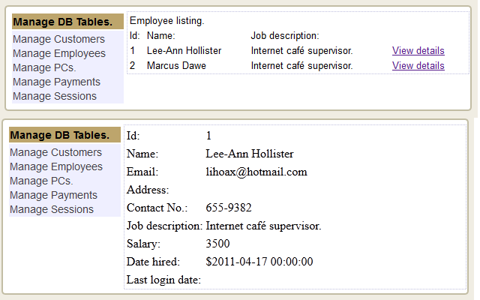
Choose any employee and click "view details".

Payment forms.

Add a payment:
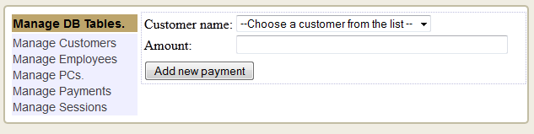
Open the "Add payment" form and choose a customer from the list, then add the amount that pertains to the payment, and click "Add new payment".

Delete a payment:

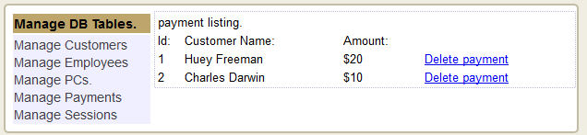
Choose any payment and click "Delete payment"

Edit a payment:

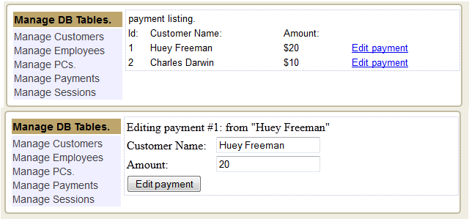
Choose any payment from the list and click "Edit payment". Enter the new customer or payment details and then click "Edit payment".

Search payments:
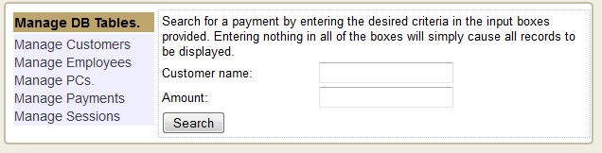
Open the payment search form, and enter either of the desired criteria, then click "search".

View payment details:
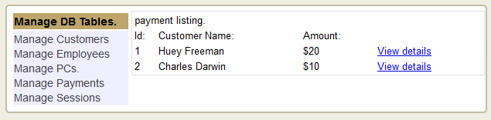
Choose any payment and click "view details" to view more details about a payment.

PC forms.

Add a PC:
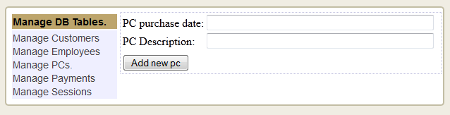
Enter the new PC's details, and click "Add new PC".

Remove a PC:
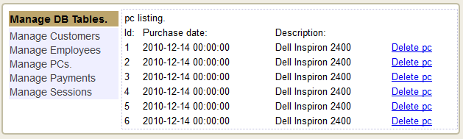
Choose any PC and click "Delete PC".

Edit PC details:
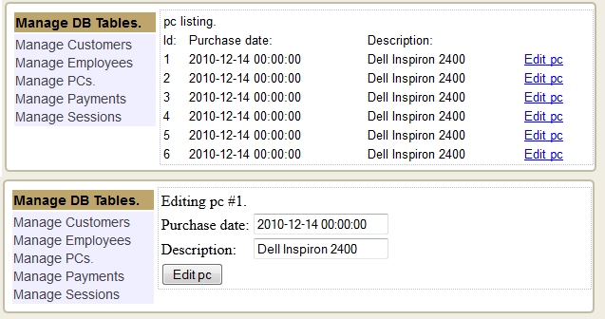
Choose any PC and click "Edit pc details", then change the details as desired, and click "Edit PC".

Search PCs:
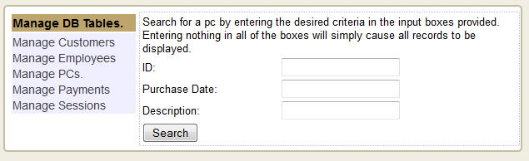
Search PCs by entering the desired criteria, and clicking "Search".

View PC details:
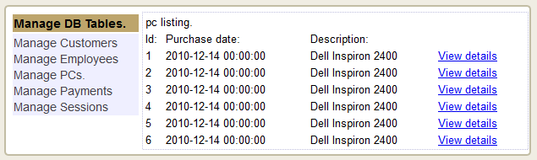Choose any PC and click "View details".

Session forms.

Create a new session:
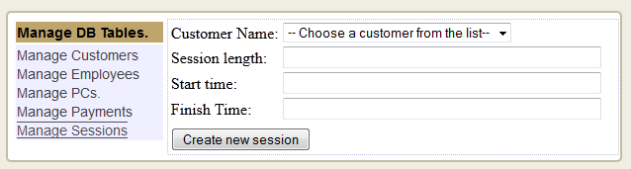
Choose the desired customer, and enter the session length and time constraints, then click "create new session".

Delete a session:
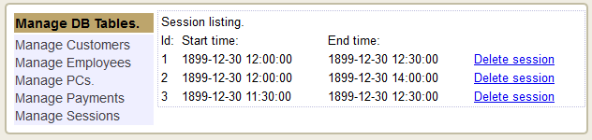
Choose any session and click "Delete session".

Edit a session:
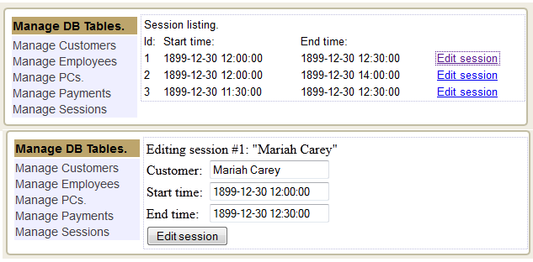
Choose any session and click "Edit session", then edit the details and click "Edit session" again.

Search sessions:
Choose any session and click "search sessions"

View session details.
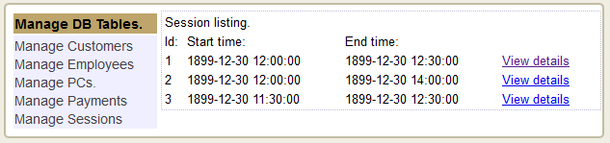
Choose any session and click "View details".

Reports.
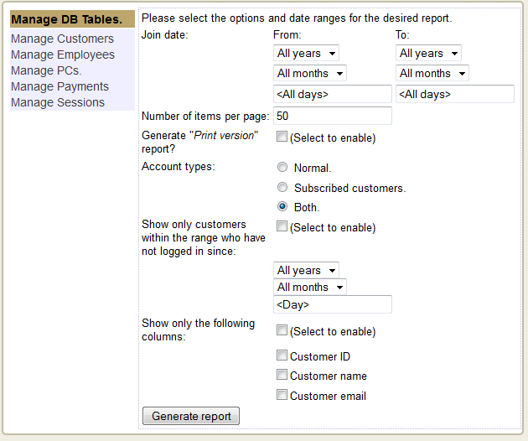
For all reports, just open the report, and enter the desired options, and click "Generate report".

User log-in:
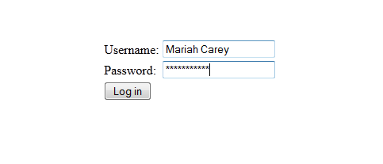
Enter your username and password, then click "Log in". Your session will begin and the remaining time will be displayed in the session status box.

Closing your session:
Locate the session status bar and click "Close session".

Login via Session ID:
After paying, you will be given a slip of paper with a session number on it. Enter this into the Session ID field of the Login Screen:
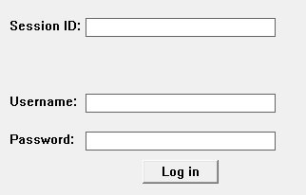
After this, just like with a normal sign-in, you will know whether or not your login wokred.

