Jersey hello world example
Jersey, reference implementation to develope RESTful web service based on the JAX-RS (JSR 311) specification.
In this tutorial, we show you how to develop a simple hello world REST web application with Jersey.
Technologies and Tools used in this article:
- Jersey 1.8
- JDK 1.6
- Tomcat 6.0
- Maven 3.0.3
- Eclipse 3.6
Note
If you want to know what and how REST works, just search on Google, ton of available resources.

1. Directory Structure
This is the final web project structure of this tutorial.
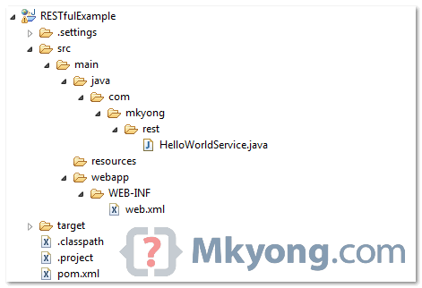

2. Standard Web Project
Create a standard Maven web project structure.
mvn archetype:generate -DgroupId=com.mkyong.rest -DartifactId=RESTfulExample
-DarchetypeArtifactId=maven-archetype-webapp -DinteractiveMode=false
Note
To support Eclipse, use Maven command :
mvn eclipse:eclipse -Dwtpversion=2.0

3. Project Dependencies
Jersey is published in Java.net Maven repository. To develop Jersey REST application , just declares “jersey-server” in Maven pom.xml.
File : pom.xml
<project ...>

<repositories>
<repository>
<id>maven2-repository.java.net</id>
<name>Java.net Repository for Maven</name>
<url>http://download.java.net/maven/2/</url>
<layout>default</layout>
</repository>
</repositories>

<dependencies>

<dependency>
<groupId>com.sun.jersey</groupId>
<artifactId>jersey-server</artifactId>
<version>1.8</version>
</dependency>

</dependencies>
</project>

4. REST Service
Simple REST service with Jersey.
package com.mkyong.rest;
import javax.ws.rs.GET;import javax.ws.rs.Path;import javax.ws.rs.PathParam;import javax.ws.rs.core.Response;
@Path("/hello")public class HelloWorldService {

@GET
@Path("/{param}")
public Response getMsg(@PathParam("param") String msg) {

String output = "Jersey say : " + msg;

return Response.status(200).entity(output).build();

}
}

5. web.xml
In web.xml, register “com.sun.jersey.spi.container.servlet.ServletContainer“, and puts your Jersey service folder under “init-param“, “com.sun.jersey.config.property.packages“.
File : web.xml
<web-app id="WebApp_ID" version="2.4"
xmlns="http://java.sun.com/xml/ns/j2ee"
xmlns:xsi="http://www.w3.org/2001/XMLSchema-instance"
xsi:schemaLocation="http://java.sun.com/xml/ns/j2ee
http://java.sun.com/xml/ns/j2ee/web-app_2_4.xsd">
<display-name>Restful Web Application</display-name>

<servlet>
<servlet-name>jersey-serlvet</servlet-name>
<servlet-class>
com.sun.jersey.spi.container.servlet.ServletContainer
</servlet-class>
<init-param>
<param-name>com.sun.jersey.config.property.packages</param-name>
<param-value>com.mkyong.rest</param-value>
</init-param>
<load-on-startup>1</load-on-startup>
</servlet>

<servlet-mapping>
<servlet-name>jersey-serlvet</servlet-name>
<url-pattern>/rest/*</url-pattern>
</servlet-mapping>
</web-app>

6. Demo
In this example, web request from “projectURL/rest/hello/” will match to “HelloWorldService“, via @Path("/hello").
And the “{any values}” from “projectURL/rest/hello/{any values}” will match to parameter annotated with @PathParam.
URL : http://localhost:8080/RESTfulExample/rest/hello/mkyong
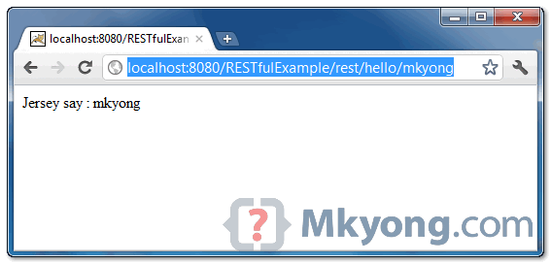

JSON example with Jersey + Jackson
By mkyong | July 19, 2011 | Updated : August 29, 2012 | Viewed : 467,597 times +2,897 pv/w
Jersey uses Jackson to convert object to / form JSON. In this tutorial, we show you how to convert a “Track” object into JSON format, and return it back to user.

1. Dependency
To make Jersey support JSON mapping, declares “jersey-json.jar” in Maven pom.xml file.
<dependency>
<groupId>com.sun.jersey</groupId>
<artifactId>jersey-server</artifactId>
<version>1.8</version></dependency>
<dependency>
<groupId>com.sun.jersey</groupId>
<artifactId>jersey-json</artifactId>
<version>1.8</version></dependency>
Note
Review the downloaded dependencies in your project classpath, Jackson and related libraries are inlcuded.

2. Integrate JSON with Jersey
In web.xml, declares “com.sun.jersey.api.json.POJOMappingFeature” as “init-param” in Jersey mapped servlet. It will make Jersey support JSON/object mapping.
<init-param>
<param-name>com.sun.jersey.api.json.POJOMappingFeature</param-name>
<param-value>true</param-value></init-param>
File : web.xml – full example.
<web-app ...>

<servlet>
<servlet-name>jersey-serlvet</servlet-name>
<servlet-class>com.sun.jersey.spi.container.servlet.ServletContainer</servlet-class>
<init-param>
<param-name>com.sun.jersey.config.property.packages</param-name>
<param-value>com.mkyong.rest</param-value>
</init-param>
<init-param>
<param-name>com.sun.jersey.api.json.POJOMappingFeature</param-name>
<param-value>true</param-value>
</init-param>
<load-on-startup>1</load-on-startup>
</servlet>

<servlet-mapping>
<servlet-name>jersey-serlvet</servlet-name>
<url-pattern>/rest/*</url-pattern>
</servlet-mapping>
</web-app>

3. Simple Object
A simple “Track” object, later Jersey will convert it into JSON format.
package com.mkyong;
public class Track {

String title;
String singer;

public String getTitle() {
return title;
}

public void setTitle(String title) {
this.title = title;
}

public String getSinger() {
return singer;
}

public void setSinger(String singer) {
this.singer = singer;
}

@Override
public String toString() {
return "Track [title=" + title + ", singer=" + singer + "]";
}
}

4. JAX-RS with Jersey
Annotate the method with @Produces(MediaType.APPLICATION_JSON). Jersey will use Jackson to handle the JSON conversion automatically.
package com.mkyong.rest;
import javax.ws.rs.Consumes;import javax.ws.rs.GET;import javax.ws.rs.POST;import javax.ws.rs.Path;import javax.ws.rs.Produces;import javax.ws.rs.core.MediaType;import javax.ws.rs.core.Response;
import com.mkyong.Track;
@Path("/json/metallica")public class JSONService {

@GET
@Path("/get")
@Produces(MediaType.APPLICATION_JSON)
public Track getTrackInJSON() {

Track track = new Track();
track.setTitle("Enter Sandman");
track.setSinger("Metallica");

return track;

}

@POST
@Path("/post")
@Consumes(MediaType.APPLICATION_JSON)
public Response createTrackInJSON(Track track) {

String result = "Track saved : " + track;
return Response.status(201).entity(result).build();

}
}

5. Demo
See demo for GET and POST request.
1. GET method
When URI pattern “/json/metallica/get” is requested, the Metallica classic song “Enter Sandman” will be returned in JSON format.
{
"singer":"Metallica",
"title":"Enter Sandman"
}
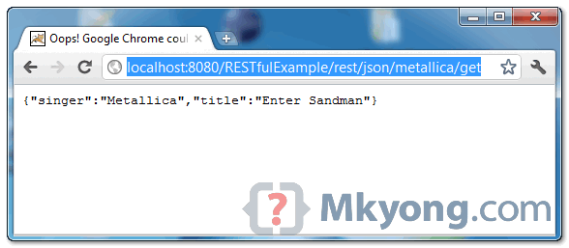
- POST method
To test post request, you can create a RESTful client (refer to this Jersey client APIs example), and “post” the json format string to URI pattern “/json/metallica/post“, the posted json string will be converted into “Track” object automatically.

Jersey + Spring integration example
By mkyong | July 20, 2011 | Updated : August 29, 2012 | Viewed : 237,283 times +1,109 pv/w
This tutorial show you how to integrate Jersey web application with Spring framework.
Technologies used :
- Jersey 1.8
- Spring 3.0.5.RELEASE
- Eclipse 3.6
- Maven 3

1. Project Dependency
Declares Jersey 1.8, Spring3 and “jersey-spring.jar” dependencies in Maven pom.xml file.
Note
In “jersey-spring.jar” version, it will download all the Spring 2.5.6 dependencies. To use Spring 3, you need to exclude those old Spring libraries manually.
<repositories>
<repository>
<id>maven2-repository.java.net</id>
<name>Java.net Repository for Maven</name>
<url>http://download.java.net/maven/2/</url>
</repository></repositories>
<dependencies>

<!-- Jersey -->
<dependency>
<groupId>com.sun.jersey</groupId>
<artifactId>jersey-server</artifactId>
<version>1.8</version>
</dependency>

<!-- Spring 3 dependencies -->
<dependency>
<groupId>org.springframework</groupId>
<artifactId>spring-core</artifactId>
<version>3.0.5.RELEASE</version>
</dependency>

<dependency>
<groupId>org.springframework</groupId>
<artifactId>spring-context</artifactId>
<version>3.0.5.RELEASE</version>
</dependency>

<dependency>
<groupId>org.springframework</groupId>
<artifactId>spring-web</artifactId>
<version>3.0.5.RELEASE</version>
</dependency>

<!-- Jersey + Spring -->
<dependency>
<groupId>com.sun.jersey.contribs</groupId>
<artifactId>jersey-spring</artifactId>
<version>1.8</version>
<exclusions>
<exclusion>
<groupId>org.springframework</groupId>
<artifactId>spring</artifactId>
</exclusion>
<exclusion>
<groupId>org.springframework</groupId>
<artifactId>spring-core</artifactId>
</exclusion>
<exclusion>
<groupId>org.springframework</groupId>
<artifactId>spring-web</artifactId>
</exclusion>
<exclusion>
<groupId>org.springframework</groupId>
<artifactId>spring-beans</artifactId>
</exclusion>
<exclusion>
<groupId>org.springframework</groupId>
<artifactId>spring-context</artifactId>
</exclusion>
</exclusions>
</dependency>
</dependencies>

2. Spring Bean
A simple “transactionBo” bean is registered in Spring Ioc container. Later you will inject this bean into Jersey service.
package com.mkyong.transaction;
public interface TransactionBo{

String save();
}
package com.mkyong.transaction.impl;
import com.mkyong.transaction.TransactionBo;
public class TransactionBoImpl implements TransactionBo {

public String save() {

return "Jersey + Spring example";

}
}
File : applicationContext.xml – Register bean and enable the component auto scanning feature.
<beans xmlns="http://www.springframework.org/schema/beans"
xmlns:xsi="http://www.w3.org/2001/XMLSchema-instance"
xmlns:context="http://www.springframework.org/schema/context"
xsi:schemaLocation="http://www.springframework.org/schema/beans
http://www.springframework.org/schema/beans/spring-beans-3.0.xsd
http://www.springframework.org/schema/context
http://www.springframework.org/schema/context/spring-context-3.0.xsd">

<context:component-scan base-package="com.mkyong.rest" />

<bean id="transactionBo"
class="com.mkyong.transaction.impl.TransactionBoImpl" />
</beans>

3. Jersey
In REST method, you can to auto inject the “transactionBo” bean from Spring into Jersey.
package com.mkyong.rest;
import javax.ws.rs.GET;import javax.ws.rs.Path;import javax.ws.rs.core.Response;import org.springframework.beans.factory.annotation.Autowired;import org.springframework.stereotype.Component;import com.mkyong.transaction.TransactionBo;
@Component@Path("/payment")public class PaymentService {

@Autowired
TransactionBo transactionBo;

@GET
@Path("/mkyong")
public Response savePayment() {

String result = transactionBo.save();

return Response.status(200).entity(result).build();

}
}

4. Integrate Jersey with Spring
The core integration is in web.xml
- Register Spring “ContextLoaderListener” listener class
- Change Jersey servlet from “com.sun.jersey.spi.container.servlet.ServletContainer” to “com.sun.jersey.spi.spring.container.servlet.SpringServlet“.
File : web.xml
<web-app id="WebApp_ID" version="2.4"
xmlns="http://java.sun.com/xml/ns/j2ee"
xmlns:xsi="http://www.w3.org/2001/XMLSchema-instance"
xsi:schemaLocation="http://java.sun.com/xml/ns/j2ee
http://java.sun.com/xml/ns/j2ee/web-app_2_4.xsd">
<display-name>Restful Web Application</display-name>

<context-param>
<param-name>contextConfigLocation</param-name>
<param-value>classpath:applicationContext.xml</param-value>
</context-param>

<listener>
<listener-class>
org.springframework.web.context.ContextLoaderListener
</listener-class>
</listener>

<servlet>
<servlet-name>jersey-serlvet</servlet-name>
<servlet-class>
com.sun.jersey.spi.spring.container.servlet.SpringServlet
</servlet-class>
<init-param>
<param-name>
com.sun.jersey.config.property.packages
</param-name>
<param-value>com.mkyong.rest</param-value>
</init-param>
<load-on-startup>1</load-on-startup>
</servlet>

<servlet-mapping>
<servlet-name>jersey-serlvet</servlet-name>
<url-pattern>/rest/*</url-pattern>
</servlet-mapping>
</web-app>

5. Demo
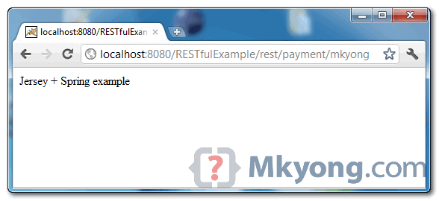

Download Source Code
Download it – Jersey-Spring-Integration-Example.zip (8 KB)

References
- Jersey Spring JavaDoc
- Spring 3 in Jersey
- Spring auto component scanning
- RESTEasy + Spring integration example

