

Red Hat Enterprise Server Release 6.4

Installation Guide

Red Hat Enterprise Linux Server release 6.1
Version: A.0.0
Release Date: 2013-4-24
Documentation History List
No&Name | Ver | Date | Modify Comment | Participants
Installation Guide for Red Hat Enterprise Server Release 6.1 | V1.0.0 | 2013-4-24 | Create | Xu Zewei
 | V1.1.0 | 2013-5-30 | Check and update | YBo3
 | V1.1.1 | 2016-08-01 | Update | GuoWei.WANG

Copyright Declaration
The Programs (which include both the software and documentation) contain proprietary information of GRG Banking Equipment Co., Ltd. (Abbr. GRGBanking) They are provided under a license agreement containing restrictions on use and disclosure and are also protected by copyright, patent and other intellectual and industrial property laws. Reverse engineering, disassembly or decompilation of the Programs, except to the extent required to obtain interoperability with other independently created software or as specified by law, is prohibited.
The information contained in this document is subject to change without notice. If you find any problems in the documentation, please report them to us in writing. GRGBanking Corporation does not warrant that this document is error-free. Except as may be expressly permitted in your license agreement for these Programs, no part of these Programs may be reproduced or transmitted in any form or by any means, electronic or mechanical, for any purpose, without the express written permission of GRGBanking Corporation.
If the Programs are delivered to the company, corporation, organization, institution or anyone licensing or using the programs on behalf of commerce, the following notice is applicable:
Any use, duplication, and disclosure of the Programs, including documentation, shall be subject to the licensing restrictions set forth in the applicable GRGBanking license agreement.
The Programs are not intended for use in any nuclear, aviation, mass transit, medical, or other inherently dangerous applications. It shall be the licensee's responsibility to take all appropriate fail-safe, backup, redundancy, and other measures to ensure the safe use of such applications if the Programs are used for such purposes, and GRGBanking Corporation disclaims liability for any damages caused by such use of the Programs.
FEEL is a registered trademark, and FEEL Switch, FEEL View, FEEL Distribution, FEEL Advertising, CardElite, CATalyst, and TellerMaster are trademarks or registered trademarks of GRG Banking Equipment Co., Ltd. Other names may be trademarks of their respective owners.

Copyright© 2007 by GRG Banking Equipment Co., Ltd.
All rights reserved.

Contents
Red Hat Enterprise Server Release 6.1 i
Installation Guide i
Red Hat Enterprise Linux Server release 6.1 i
Documentation History List i
Copyright Declaration i
Contents i
1. Prepare before installation 1
2. Installation 1
2.1. CD Test 1
2.2. Installation Screen 2
2.3. Language Selection 2
2.4. Keyboard Configuration 3
2.5. Choose Type Of Storage Devices 4
2.6. Setup Hostname 5
2.7. Select Time Zone 5
2.8. Setup The Password of Root User 6
2.9. Disk Partitioning Setup 6
2.10. Boot Loader Configuration 10
2.11. Customize The Software Selection 11
2.12. Finish Installation 13
3. Setup after Installation 14
3.1. Welcome 14
3.2. License agreement 15
3.3. Set Up Software Updates 16
3.4. System User 16
3.5. Date and Time 17
3.6. Kdump 18
3.7. Logon 18
4. Configuration System 19
4.1. Install Software Package Requirements 19
4.2. Create User feel and Directory 21

Prepare before installation
This guide describes how to install and configure RedHat Enterprise Server Release 6.4.
Check before installation:
The physical RAM of system must be more than 1G, and free disk space must be no less than 40G.

Installation
- Insert the Disk to the CD-ROM and reboot the server, then will appear the following picture, please choose <Install or upgrade an existing system> and continue.
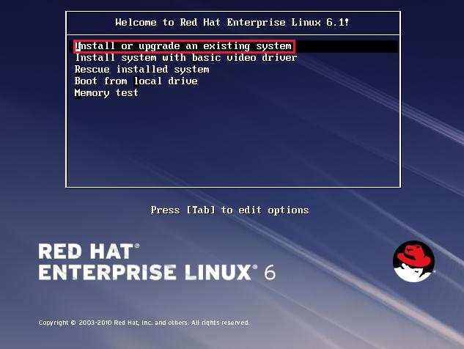

CD Test
- Its testing the CD media, press the tab key and choose <skip> if you are sure the disk is no problem.
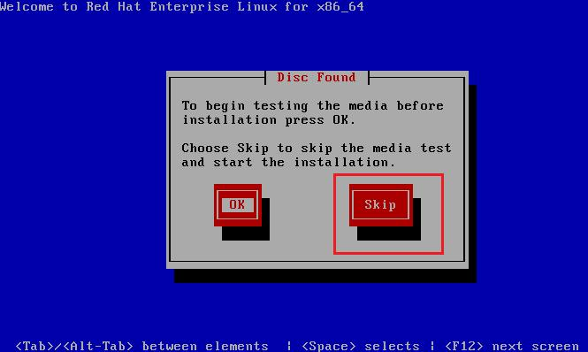

Installation Screen
- Screen of Red Hat Enterprise Linux 6 installation, click button <Next>
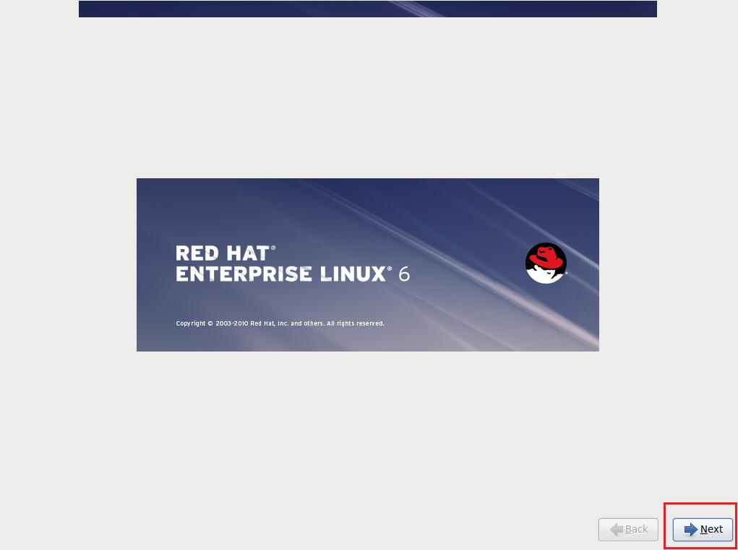

Language Selection
- Choose the language during the installation, choose <English>, click the button <Next>
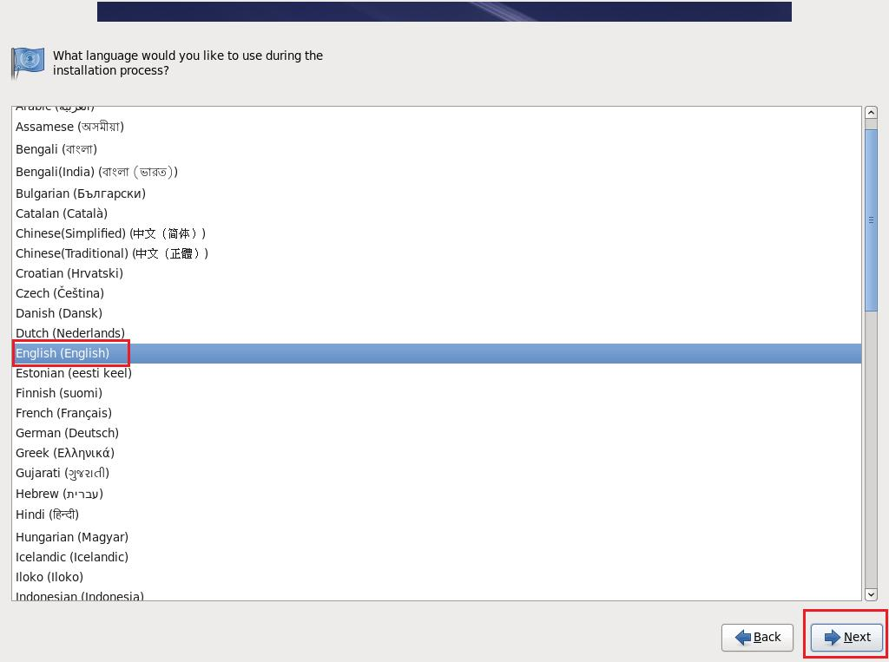

Keyboard Configuration
- Choose the layout type for the keyboard, The install processes will auto test the keyboard layout type, Then click button <Next>
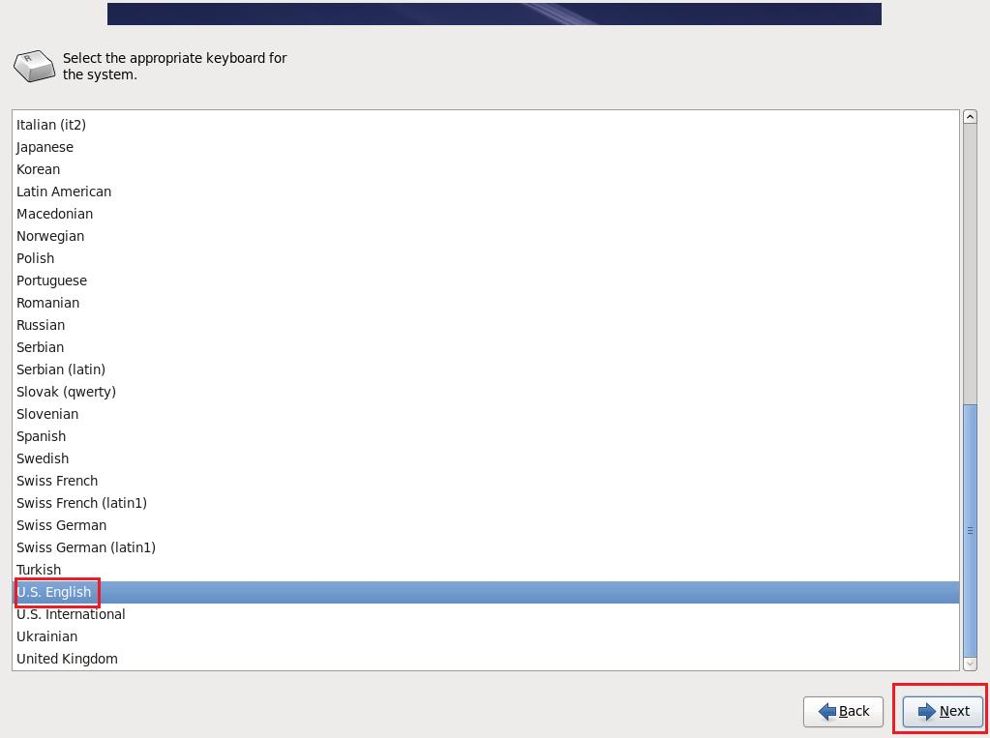

Choose Type Of Storage Devices
- Type of devices installation involve, choose <Basic Storage Devices>, then click <Next>
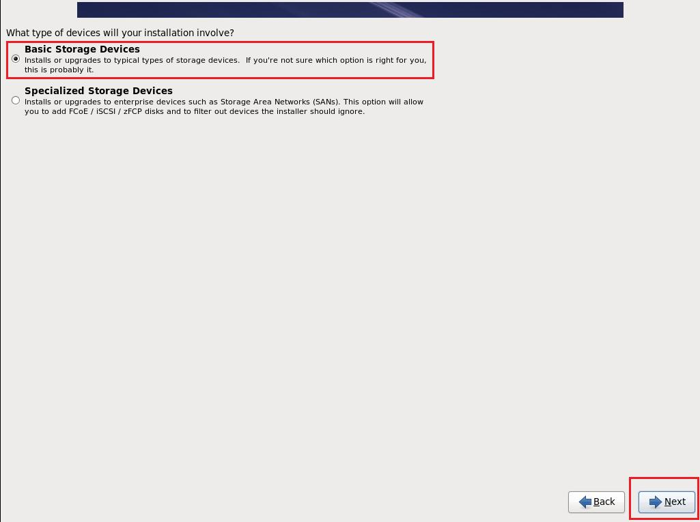
- Storage device warning, choose <Yes,discard any data>, then click <Next>
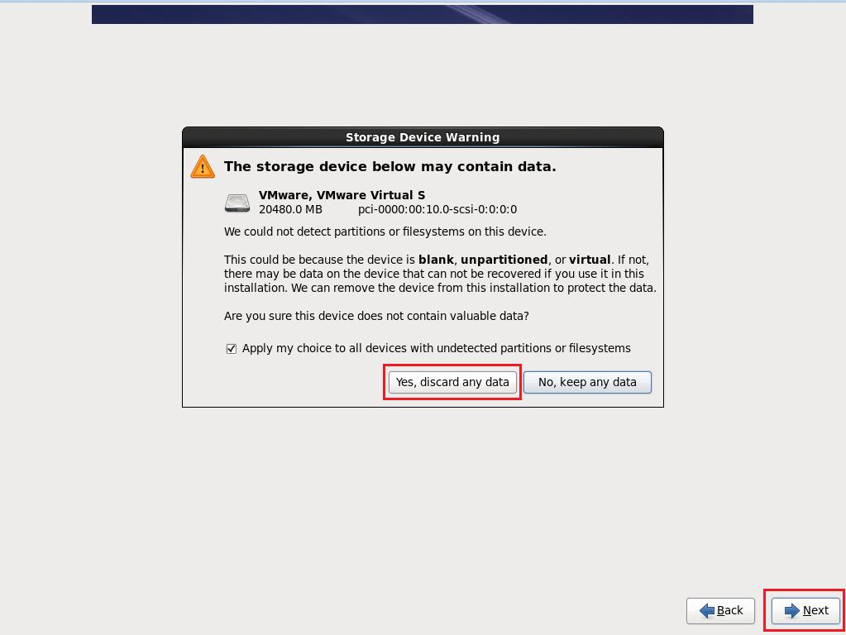

Setup Hostname
- Name hostname and then click button <Next>
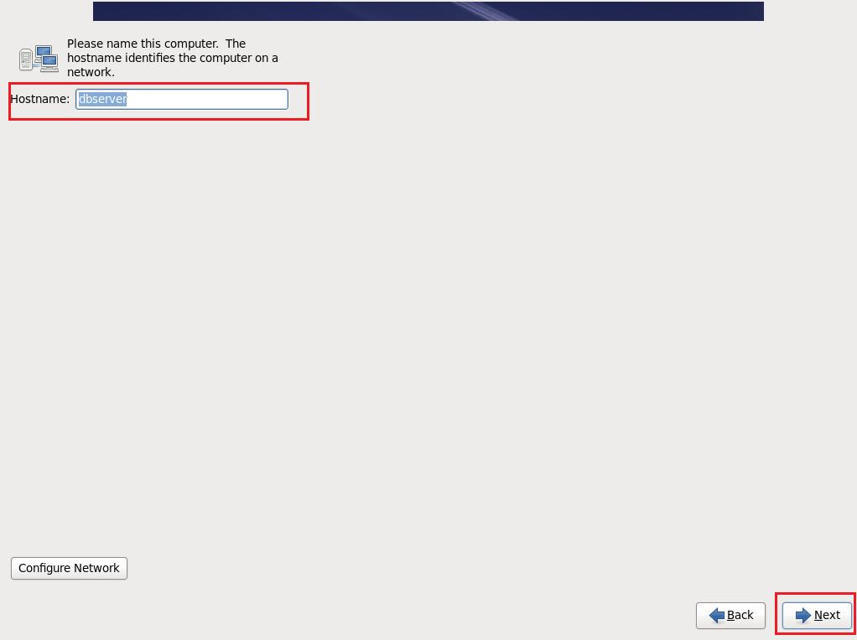

Select Time Zone
- Select time zone, China choose <Asia/Shanghai>, then click button <Next>
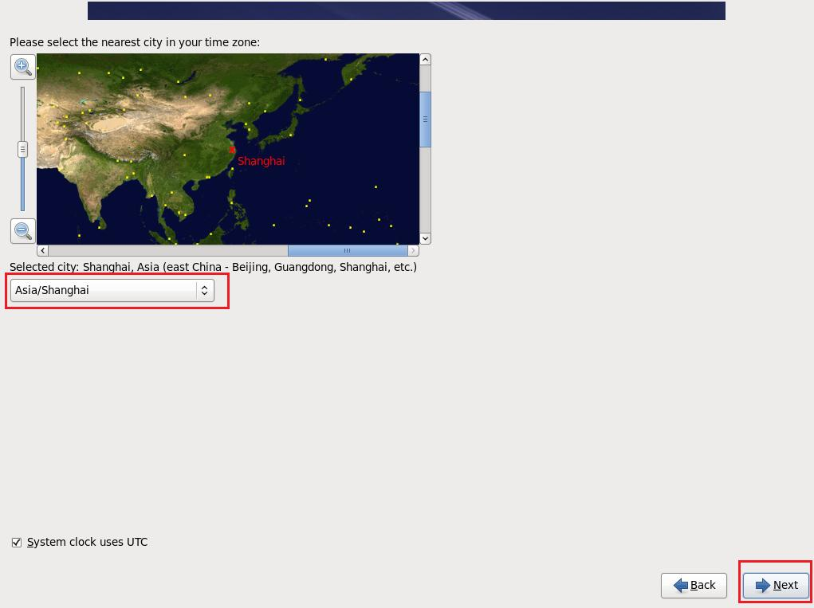

Setup The Password of Root User
- Input the password twice, then click <Next>
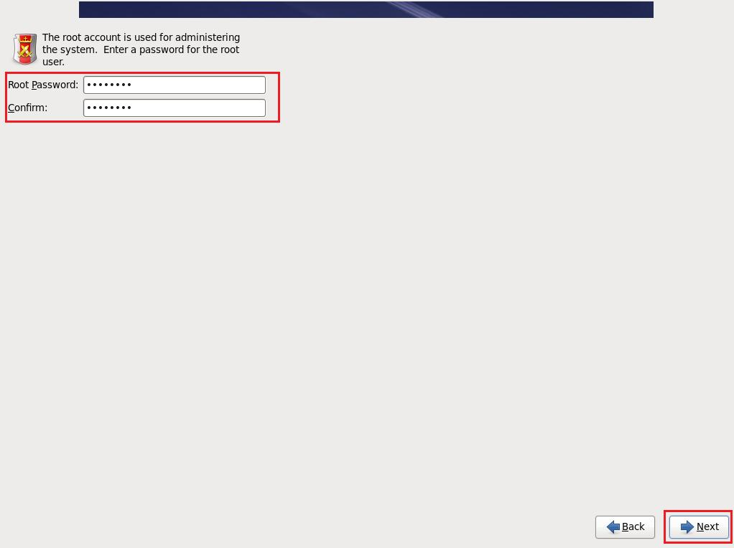
- If the password doesn’t match the system’s complexity rule, it will tell you it’s weak password ,you can choose <Use Anyway> if you are sure that it’s safe, and then click <Next>
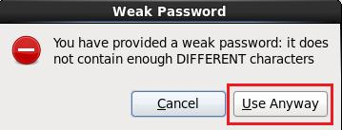

Disk Partitioning Setup
- Swap partitions space is required. The following table describes the relationship between installed RAM and the configured swap space requirement.
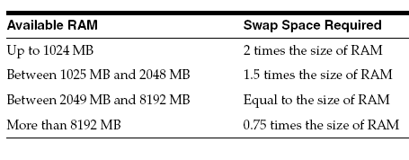
- Delete Hard Drives’s mount point, re-create mount point and size listed in the table, the result please refers the following table.
Mount Point | Size | Format | Explaination
/boot | 200MB | Ext4 | boot partition
swap | Memory*2 | Swap | Following the swap partitions space required  table describes
/ | All free space | Ext4 | system file

- Type of installation, Choose <Create Custom Layout> and click button<Next>
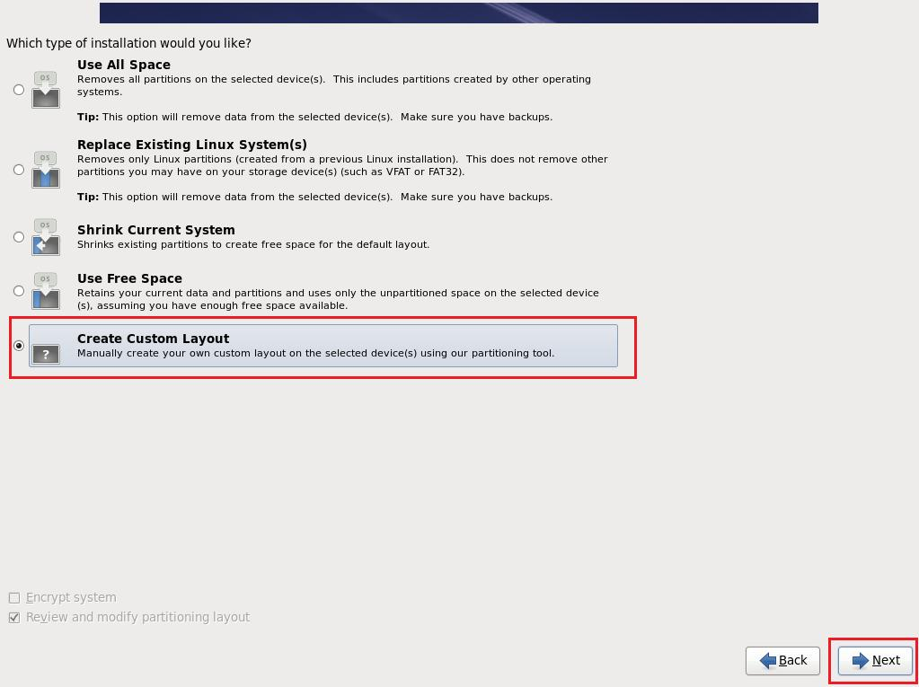

- Mounting the point step 1, choose <Create>
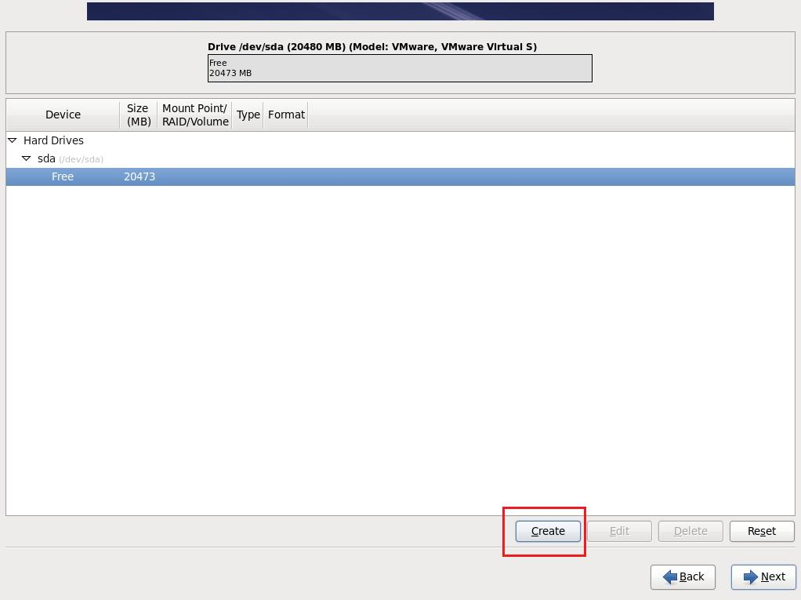
- Mounting the point step 2, choose <Standard Partiton> and then click <Create>
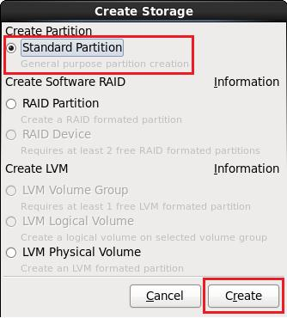
- Mounting the point step 3, choose or write the options – “Mount Point”, “File System Type”,Size”, then click <OK>.
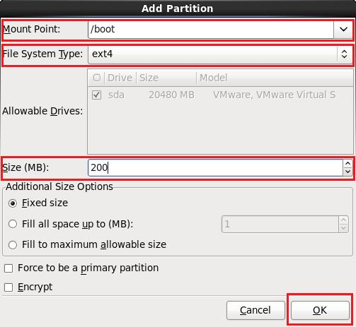
- The other mounting work are similar to the example above. After all the mounting work, then click <Next>
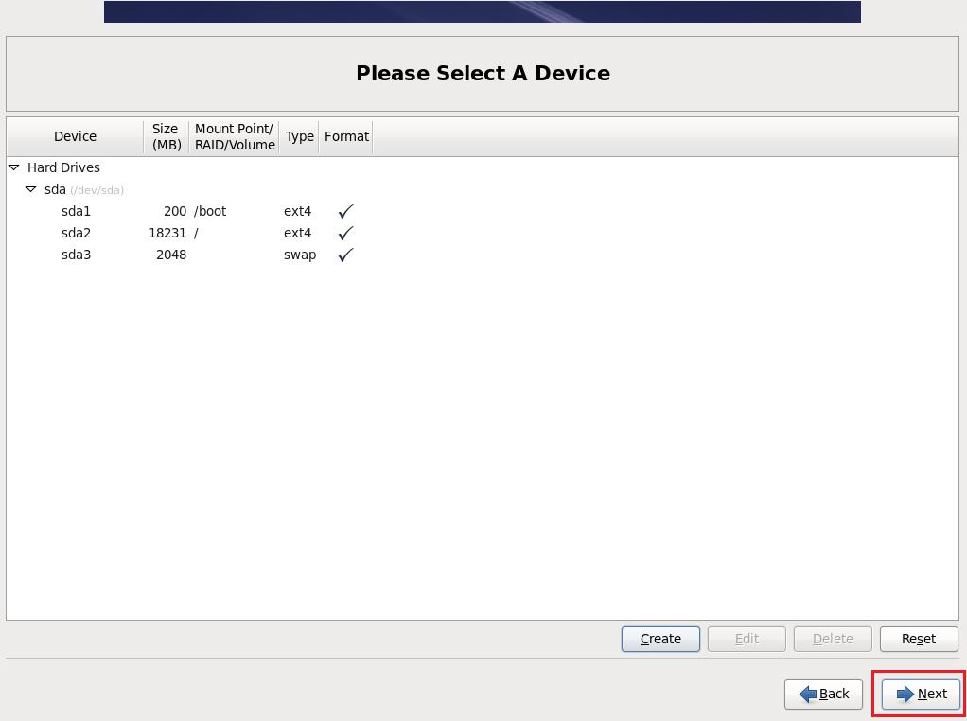
- Format Warning, choose <Format> if you are sure it doesn’t contain any data you need.
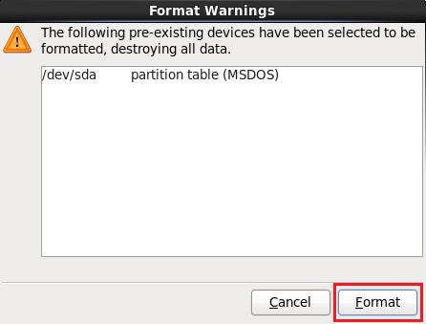

- Writing storage configuration to disk, choose <Write changes to disk>
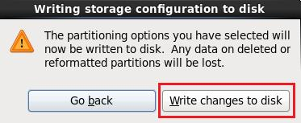

Boot Loader Configuration
- Boot loader configuration, click button <next>
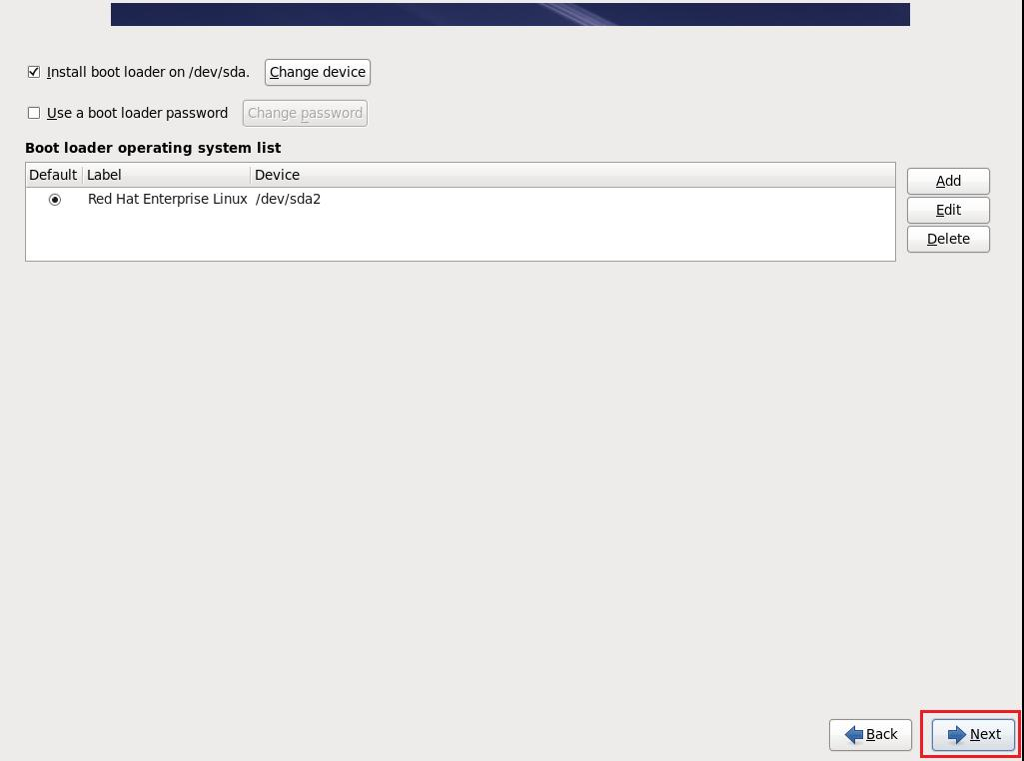

Customize The Software Selection
- Choose <Customize now>, select more software as installation files,then click <Next>
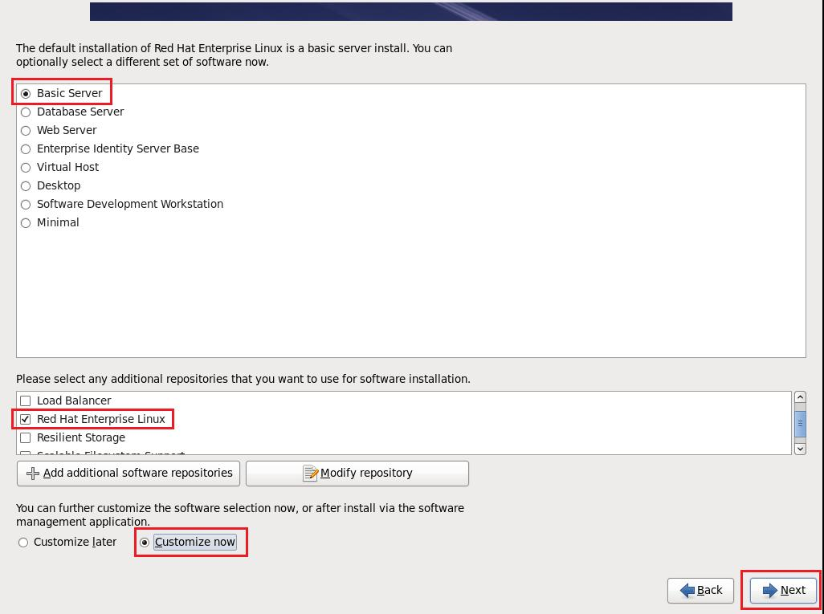
- Servers software choices, choose <FTP server>
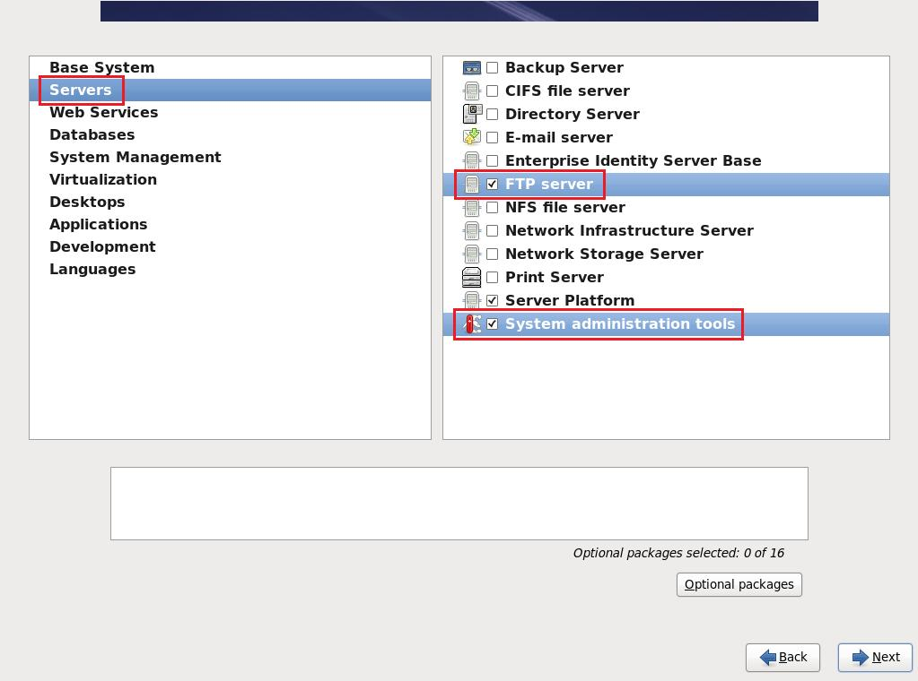
- Desktops software choices, choose <all>, then can use the graphical interfaces.
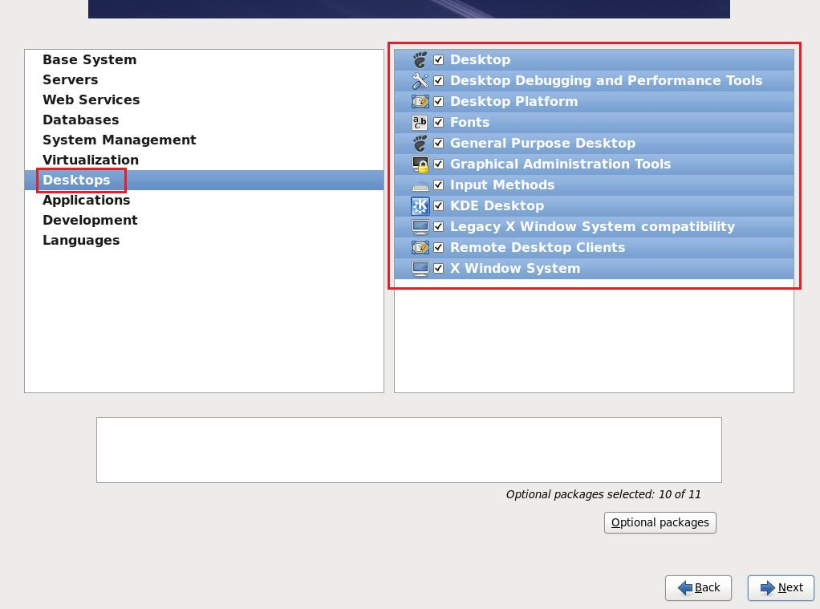
- Development software choices,choose <Development tools>
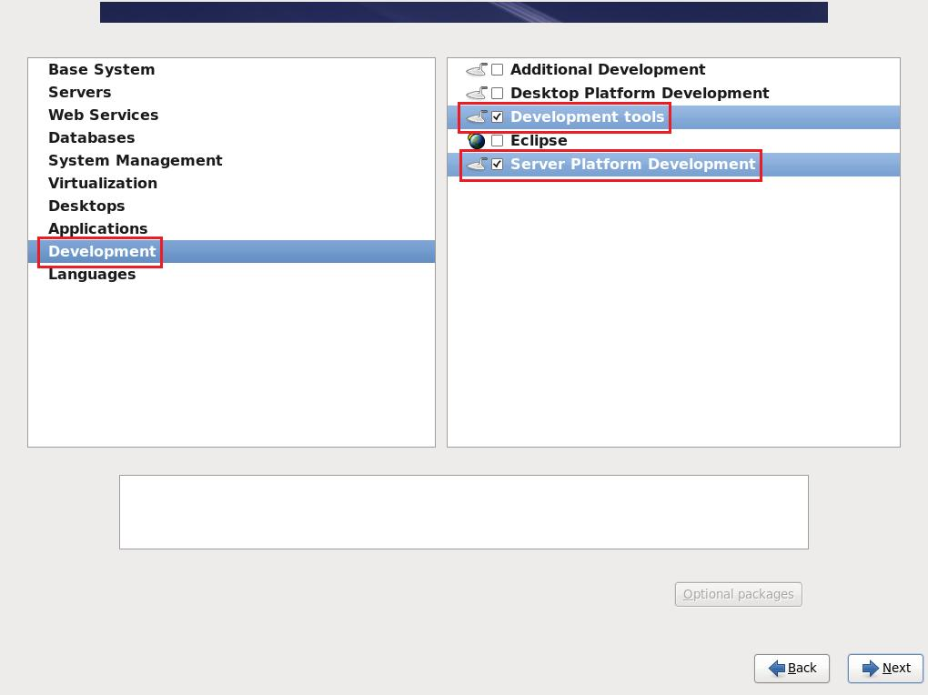
- Languages software choices, choose <Chinese Support>, then click <Next>
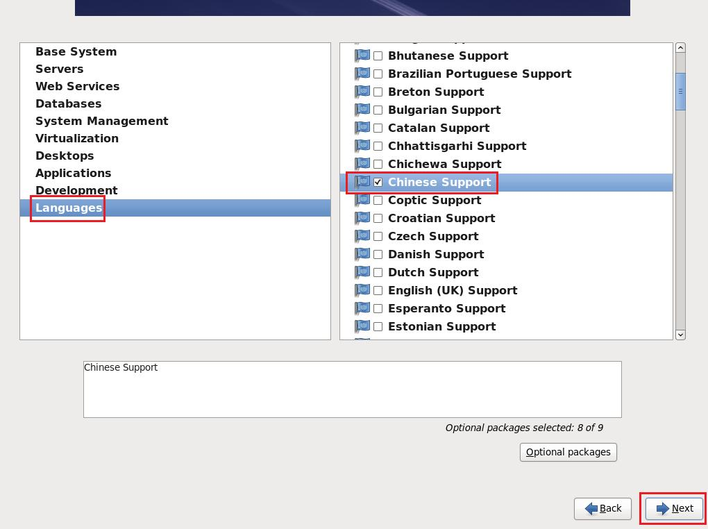

Finish Installation
- Finish the installation, click button <Reboot>.
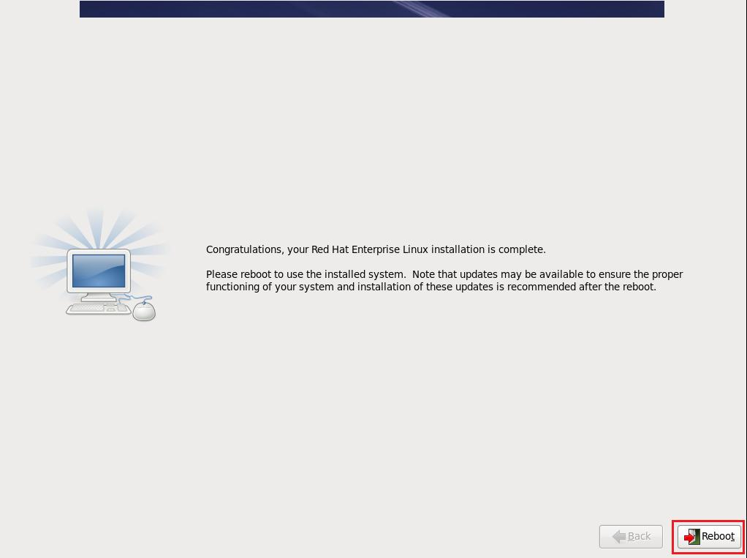

Setup after Installation

Welcome
- After successful installation, need register some information like basic configuration, click button <Farward>
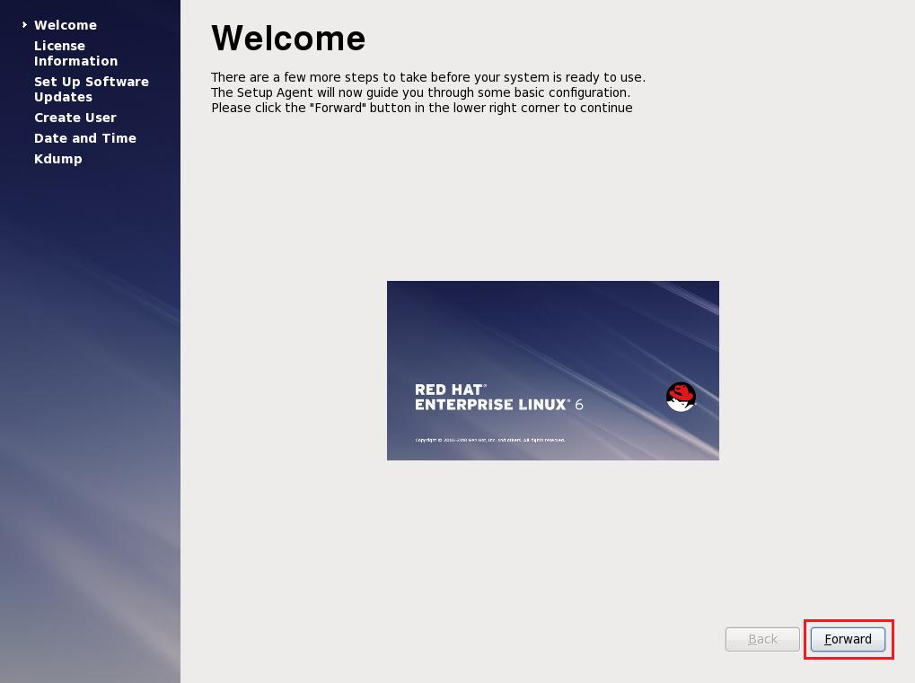

License agreement
- License agreement, choose <Yes, I agree to the License agreement > then click button <Farward>
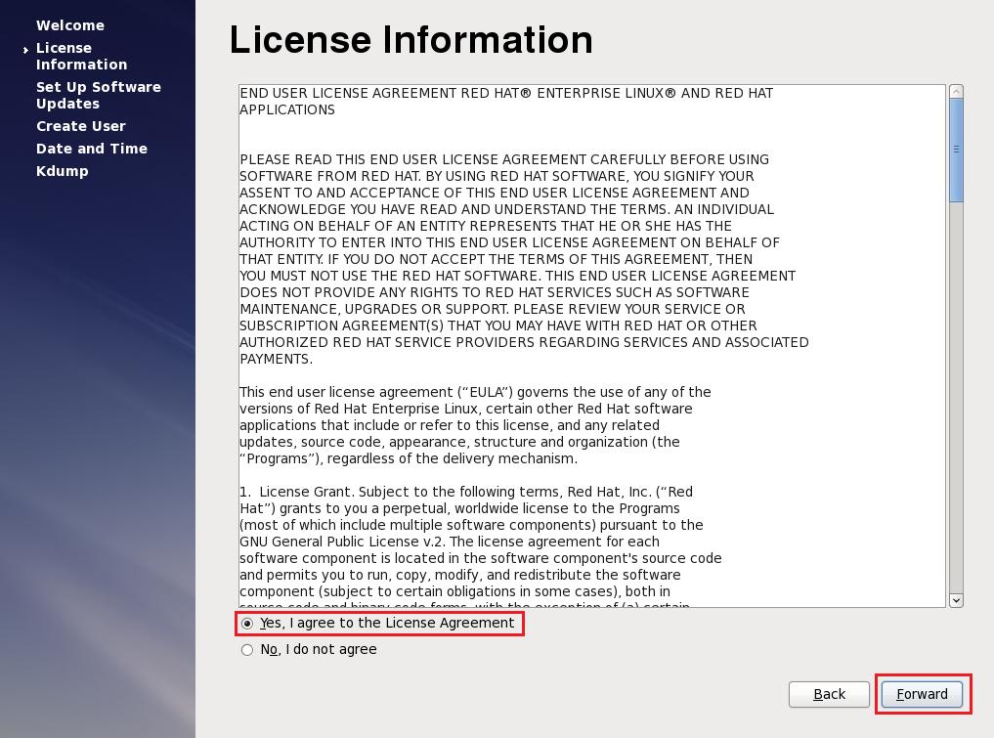

Set Up Software Updates
- Click the button <Farward>
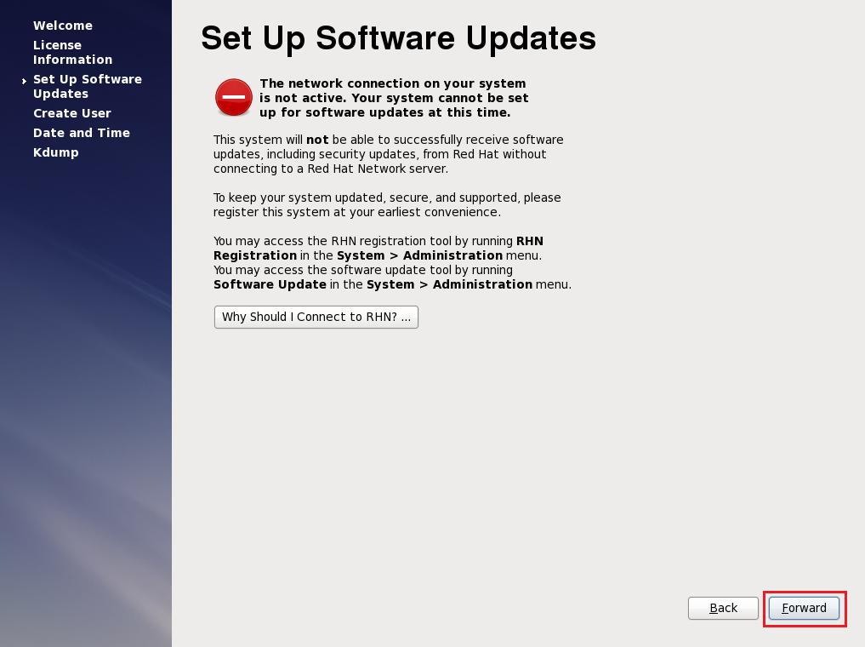

System User
- It’s no need to create the account , click button <Farward>
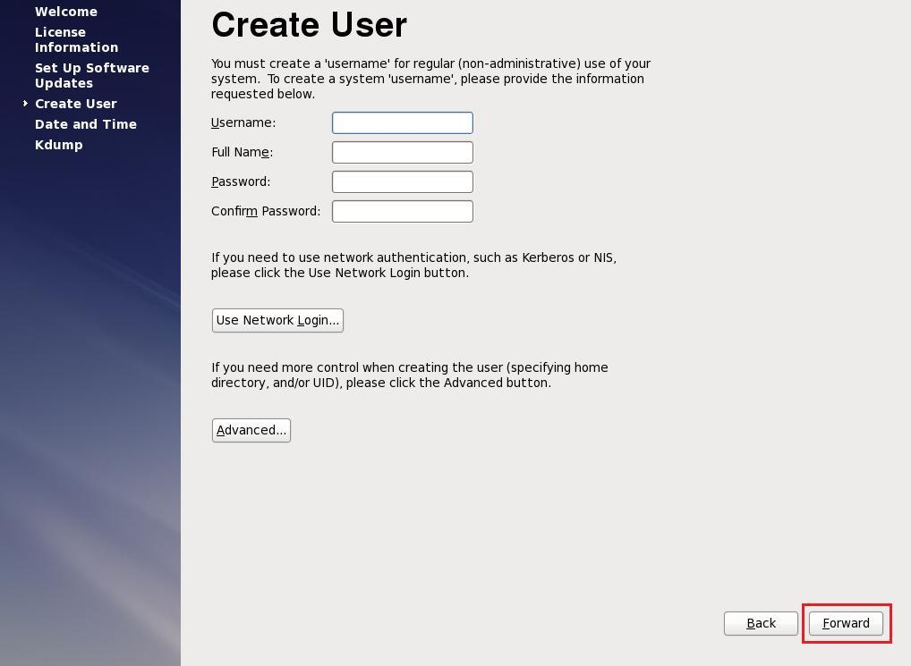

Date and Time
- Setup the date and time for the system,choose <Synchronize date and time over the network> then click the button <Next>
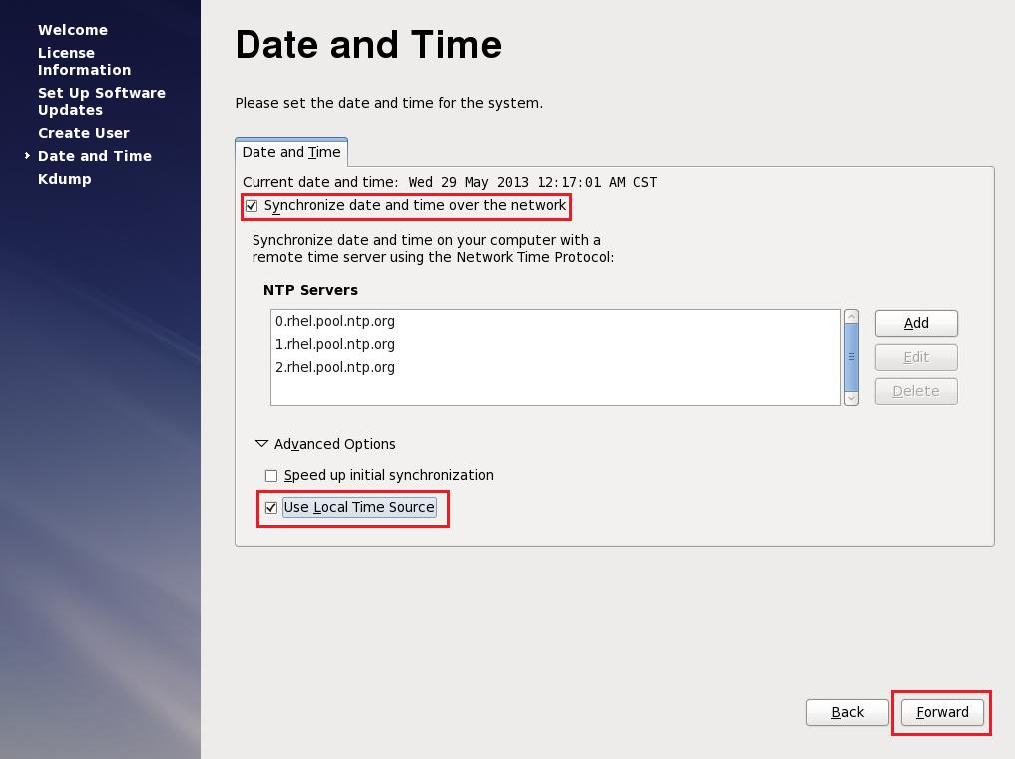

Kdump
- Warning that no more memory to configure kdump,click button <OK>
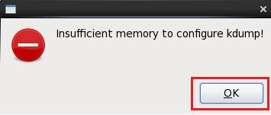
- Setup Kdump if have more physical memory, click button <Finish>.
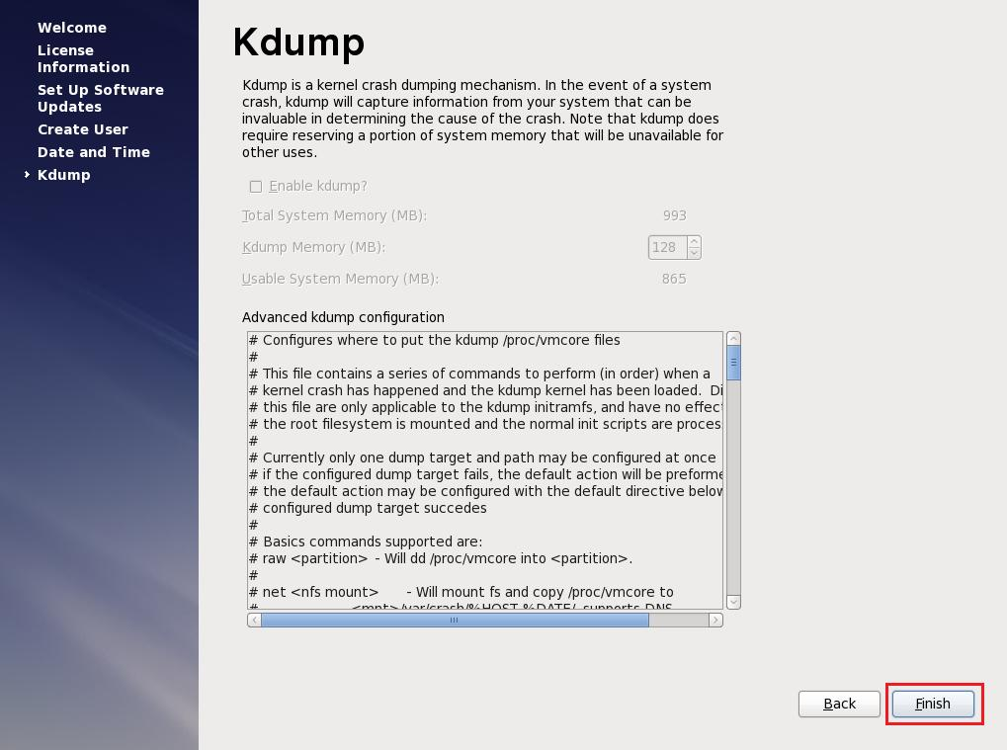

Logon
- After setup configuration, enter the logon screen, choose <Other>, use <root> as user logging.
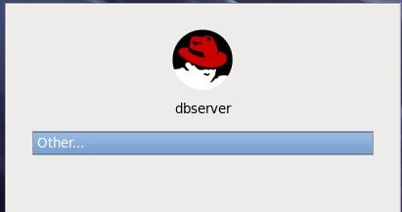
- Show the notice that Super user root try to running, choose <Do not show me this aggin>, and then click <Close>

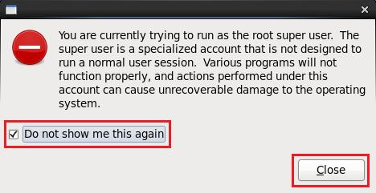

Configuration System

Install Software Package Requirements
To determine whether the required packages are installed, enter commands similar to the following:
# rpm -q package_name
Install RPM package
#rpm –Uvh package_name

- Insert the OS DVD to the CD-ROM Install Software package
[root@dbserver ~]#cd /media/ RHEL_6.1\ x86_64\ Disc\ 1/Packages
[root@dbserver Packages]# rpm -q vsftpd
[root@dbserver Packages]# chkconfig vsftpd on
[root@dbserver Packages]# service vsftpd start
- Check the packages weather they are installed
[root@dbserver grg]# rpm -q binutils compat-libstdc++-33 elfutils-libelf elfutils-libelf-devel gcc gcc-c++ glibc glibc-common glibc-devel glibc-headers kernel-headers ksh libaio libaio-devel libgcc libgomp libstdc++ libstdc++-devel make sysstat unixODBC unixODBC-devel
After run the command, it will show like this:
package compat-libstdc++ is not installed
package elfutils-libelf-devel is not installed
package elfutils-libelf-devel-static is not installed
package ksh is not installed
package libaio-devel is not installed
package unixODBC is not installed
package unixODBC-devel is not installed

Use command “rpm –Uvh package_name” to install the uninstalled packages :

rpm -Uvh compat-libstdc++-33-3.2.3-69.el6.x86_64.rpm
rpm -Uvh elfutils-libelf-devel-0.152-1.el6.x86_64.rpm
rpm -Uvh ksh-20100621-6.el6.x86_64.rpm
rpm -Uvh libaio-devel-0.3.107-10.el6.x86_64.rpm
rpm -Uvh unixODBC-2.2.14-11.el6.x86_64.rpm
rpm -Uvh unixODBC-devel-2.2.14-11.el6.x86_64.rpm
rpm -Uvh compat-libstdc++-33-3.2.3-69.el6.x86_64.rpm

Create User feel and Directory
Do not create usr feel if use db2 as the database.

