
DB2 v9.7(64 bit ) for
RedHat Linux Installation Guide
Version: A.0.0
Release Date: 2016-08-01

Documentation History List
No&Name | Ver | Date | Modify Comment | Participants
DB2 v9.7(64 bit ) for RedHat Linux Installation Guide | V1.0.0 | 2016-08-01 | Create | GuoWei.WANG

Copyright Declaration
The Programs (which include both the software and documentation) contain proprietary information of GRG Banking Equipment Co., Ltd. (Abbr. GRGBanking) They are provided under a license agreement containing restrictions on use and disclosure and are also protected by copyright, patent and other intellectual and industrial property laws. Reverse engineering, disassembly or decompilation of the Programs, except to the extent required to obtain interoperability with other independently created software or as specified by law, is prohibited.
The information contained in this document is subject to change without notice. If you find any problems in the documentation, please report them to us in writing. GRGBanking Corporation does not warrant that this document is error-free. Except as may be expressly permitted in your license agreement for these Programs, no part of these Programs may be reproduced or transmitted in any form or by any means, electronic or mechanical, for any purpose, without the express written permission of GRGBanking Corporation.
If the Programs are delivered to the company, corporation, organization, institution or anyone licensing or using the programs on behalf of commerce, the following notice is applicable:
Any use, duplication, and disclosure of the Programs, including documentation, shall be subject to the licensing restrictions set forth in the applicable GRGBanking license agreement.
The Programs are not intended for use in any nuclear, aviation, mass transit, medical, or other inherently dangerous applications. It shall be the licensee's responsibility to take all appropriate fail-safe, backup, redundancy, and other measures to ensure the safe use of such applications if the Programs are used for such purposes, and GRGBanking Corporation disclaims liability for any damages caused by such use of the Programs.
FEEL is a registered trademark, and FEEL Switch, FEEL View, FEEL Distribution, FEEL Advertising, CardElite, CATalyst, and TellerMaster are trademarks or registered trademarks of GRG Banking Equipment Co., Ltd. Other names may be trademarks of their respective owners.

Copyright© 2007 by GRG Banking Equipment Co., Ltd.
All rights reserved.

Contents
Documentation History List i
Copyright Declaration i
Contents 1
1. Hardware Requirements 1
2. Create the Oracle Group and user 2
3. Configuration System Parameters 2
3.1. Configuring Oracle User Profile 2
3.2. Configuring Host File 2
3.3. Configuring Kernel Parameters 2
3.4. Setting Shell Limits for the oracle User 3
3.5. Add The Login File 3
3.6. Depending on the oracle user's default shell, make the following changes to the default shell start-up file: 3
3.7. Reboot the system 4
3.8. Make directory for oracle install 4
3.9. If you need get the oracle setup package from other computers, you can get it by following way: 4
4. Install the Oracle Database Software 5
4.1. Configure Security Updates 5
4.2. Installation Option 5
4.3. Grid Options 6
4.4. Produce Languages 6
4.5. Database Edition 7
4.6. Installation Location 8
4.7. Create Inventory 8
4.8. Operating System Groups 9
4.9. Prerequisite Checks 9
4.10. Summary 11
4.11. Install Product 12
5. Create database 13
6. Configuration listener and net server 22

- Hardware Requirements
This guide describes how to install and configure Oracle Database 11g release 2 (64 bit) on RedHat Enterprise Server Release 6.1 ; The Red Hat Enterprise Linux Install please read < Installtion Guide for Red Hat Enterprise Server Release 6.1.doc >

Physical RAM | SWAP
Between 1024 MB and 2048 MB | 1.5 times the size of RAM
Between 2049 MB and 8192 MB | Equal to the size of RAM
More than 8192 MB | 0.75 times the size of RAM
At least 2 GB of disk space in the /tmp directory

Before you install the Oracle software, you must complete several tasks as the root user. To log in as the root user.

To ensure that the system meets these requirements:
  - To determine the physical RAM size, enter the following command:
[root@dbserver db]# grep MemTotal /proc/meminfo
If the size of the physical RAM is less than the required size, then you must install more memory before continuing.
  - To determine the size of the configured swap space, enter the following command:
[root@dbserver db]# grep SwapTotal /proc/meminfo
If necessary, refer to the operating system documentation for information about
how to configure additional swap space.
  - To determine the available RAM and swap space, enter the following command:
[root@dbserver db]# free
  - To determine the amount of disk space available in the /tmp directory,enter the following command:
[root@dbserver db]# df -k /tmp
At least 2 GB of disk space in the /tmp directory
  - To determine the amount of free disk space on the system, enter the following command:
[root@dbserver db] # df –k
At least 5GB of disk space in the Oracle Install directory
  - To determine whether the system architecture can run the software, enter the following command:
[root@dbserver db] # grep "model name" /proc/cpuinfo
  - To determine the kernel version and architecture of the system:
[root@dbserver db]#uname –rm
[root@dbserver db]#cat /etc/issue
- Create the Oracle Group and user
[root@dbserver db]# /usr/sbin/groupadd oinstall
[root@dbserver db]# /usr/sbin/groupadd dba
[root@dbserver db]# /usr/sbin/useradd -g oinstall -G dba oracle
[root@dbserver db]# passwd oracle
- Configuration System Parameters
  - Configuring Host File
Logging In to the System as root
[root@dbserver etc]# hostname
dbserver
Add the following line in the /etc/ hosts file, if it does not already exist:
[root@dbserver etc]# vi /etc/ hosts
192.168.230.33( Your Real IP ) dbserver dbserver.com
Note: 192.168.230.33 is the host computer’s IP address, you should change it.
  - Configuring Kernel Parameters
[root@dbserver etc]# vi /etc/sysctl.conf
# Controls the maximum shared segment size, in bytes
kernel.shmmax = 68719476736
# Controls the maximum number of shared memory segments, in pages
kernel.shmall = 2097152
#add by oracle
fs.aio-max-nr = 1048576
fs.file-max = 6815744
kernel.shmmni = 4096
kernel.sem = 250 32000 100 128
net.ipv4.ip_local_port_range = 9000 65500
net.core.rmem_default = 262144
net.core.rmem_max = 4194304
net.core.wmem_default = 262144
net.core.wmem_max = 1048586

Note: kernel.shmmax= Physical RAM （byte）, kernel.shmall = 2097152
  - Setting Shell Limits for the oracle User
Add the following lines to the limits.conf
[root@dbserver etc]# vi /etc/security/limits.conf
#add by oracle
oracle soft nproc 2047
oracle hard nproc 16384
oracle soft nofile 1024
oracle hard nofile 65536
  - Add The Login File
Add the following line in the /etc/pam.d/login file, if it does not already exist:
[root@dbserver etc]#vi /etc/pam.d/login
session required pam_limits.so
  - Depending on the oracle user's default shell, make the following changes to the default shell start-up file:
[root@dbserver etc]# vi /etc/profile
#add by oracle
if [ $USER = "oracle" ]; then
if [ $SHELL = "/bin/ksh" ]; then
ulimit -p 16384
ulimit -n 65536
else
ulimit -u 16384 -n 65536
fi
fi
  - Reboot the system
[root@dbserver etc]#reboot
  - Make directory for oracle install
[root@dbserver ~]# cd /grg
[root@dbserver grg]# mkdir oracle
[root@dbserver db]# chown oracle:oinstall oracle
[root@dbserver db]# cd /grg/oracle
[root@dbserver oracle]# mkdir oraInventory
[root@dbserver oracle]# chown oracle:oinstall oraInventory
[root@dbserver grg]# ls -l
drwxr-xr-x 2 oracle oinstall 1024 Feb 3 17:17 oracle
drwxr-xr-x 2 oracle oinstall 1024 Feb 3 17:17 temp
  - If you need get the oracle setup package from other computers, you can get it by following way:
upload oracle software to dbserver use ftp
C:\>ftp 192.168.230.33
Connected to 192.168.230.33.
220 (vsFTPd 2.0.1)
User (192.168.230.33:(none)): root
331 Please specify the password.
Password:
230 Login successful.
ftp> cd /root/Downloads
250 Directory successfully changed.
ftp> mput v9.7_linuxx64_server.tar.gz
ftp>bye

To extract the installation archive files, perform the following steps:
[root@dbserver Downloads]#ls
[root@dbserver Downloads]#v9.7_linuxx64_server.tar.gz
[root@dbserver Downloads]#tar -zxvf v9.7_linuxx64_server.tar.gz
[root@dbserver Downloads]#ls
[root@dbserver Downloads]#server v9.7_linuxx64_server.tar.gz

  - Run db2prereqcheck
[root@dbserver Downloads]#cd server
[root@dbserver Downloads]#./db2prereqcheck
WARNING:
The 32 bit library file libstdc++.so.6 is not found on the system.
32-bit applications may be affected.
WARNING:
The 32 bit library file libstdc++.so.5 is not found on the system.
32-bit applications may be affected.
WARNING:
DBT3534W The db2prereqcheck utility determined that ASLR is set to ON and that this could cause issues with some tools.
WARNING:
The 32-bit library file libpam.so is not found on the system.

Solution for four WARNINGs:
1.The 32 bit library file libstdc++.so.6 is not found on the system
rpm -ivh glibc-2.12-1.107.el6.i686.rpm nss-softokn-freebl-3.12.9-11.el6.i686.rpm
rpm -ivh libstdc++-4.4.7-3.el6.i686.rpm libgcc-4.4.7-3.el6.i686.rpm

2.The 32 bit library file libstdc++.so.5
rpm -ivh compat-libstdc++-33-3.2.3-69.el6.i686.rpm

3.DBT3534W The db2prereqcheck utility determined that ASLR is set to ON and that this could cause issues with some tools.
Vim /etc/sysctl.conf file
Add a line in the file
#Add for DB2
kernel.randomize_va_space = 0
Then sysctl -p

4. The 32-bit library file libpam.so is not found on the system.
rpm -ivh pam-1.1.1-13.el6.i686.rpm audit-libs-2.2-2.el6.i686.rpm cracklib-2.8.16-4.el6.i686.rpm db4-4.7.25-17.el6.i686.rpm libselinux-2.0.94-5.3.el6.i686.rpm
cd /lib
ln -s libpam.so.0 libpam.so

- Install the Oracle Database Software
Logging In to the System Xwindows as Root user,Open terminal command windwos
[root@dbserver Downloads]# cd /root/Downloads/server
[root@dbserver server]#ls
db2 db2ckupgrade db2_deinstall db2_install db2ls db2prereqcheck db2setup doc installFixPack
[root@dbserver server]#./db2setup
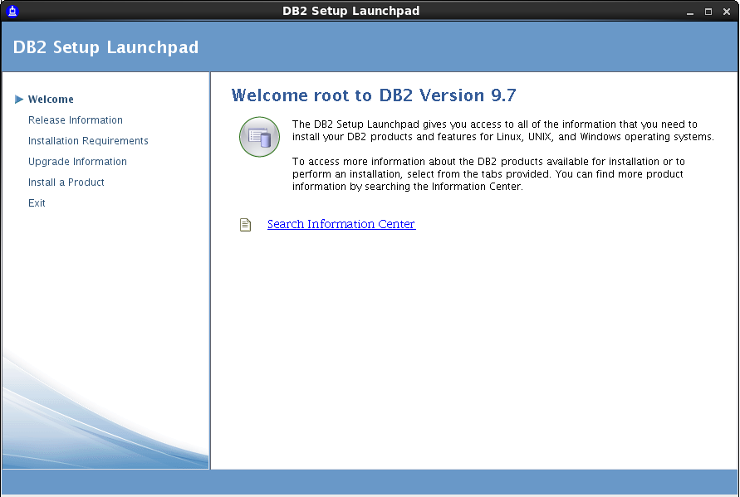
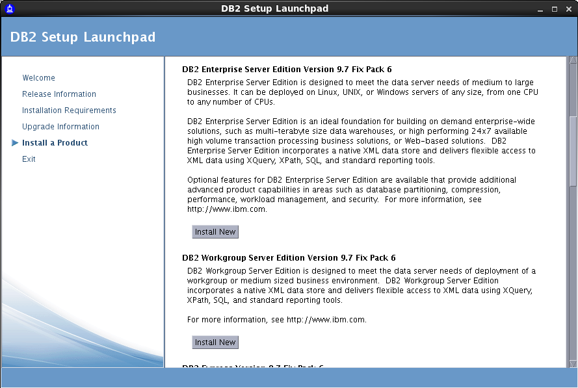
  - Intrduction
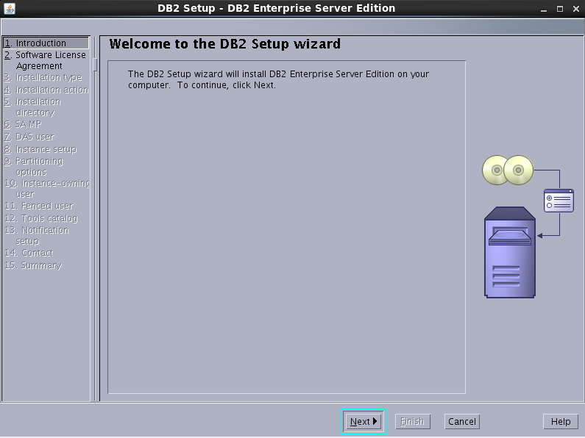

  - Software License Agreement
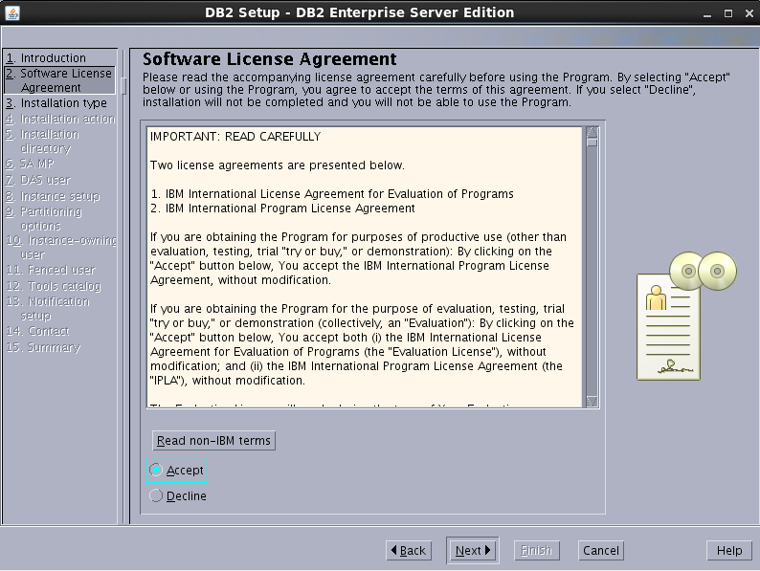
  - Install Type
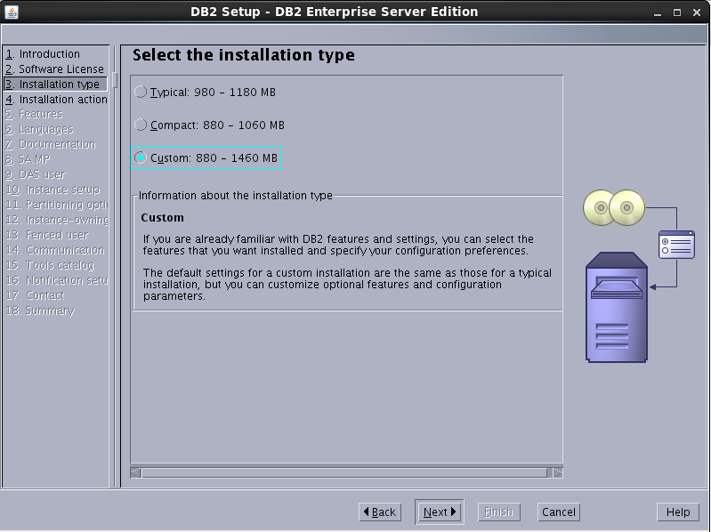
  - Install Action
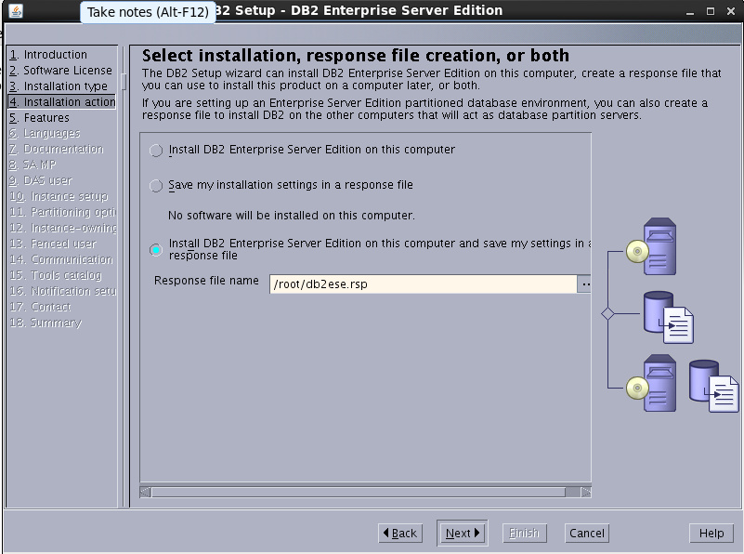
  - Features
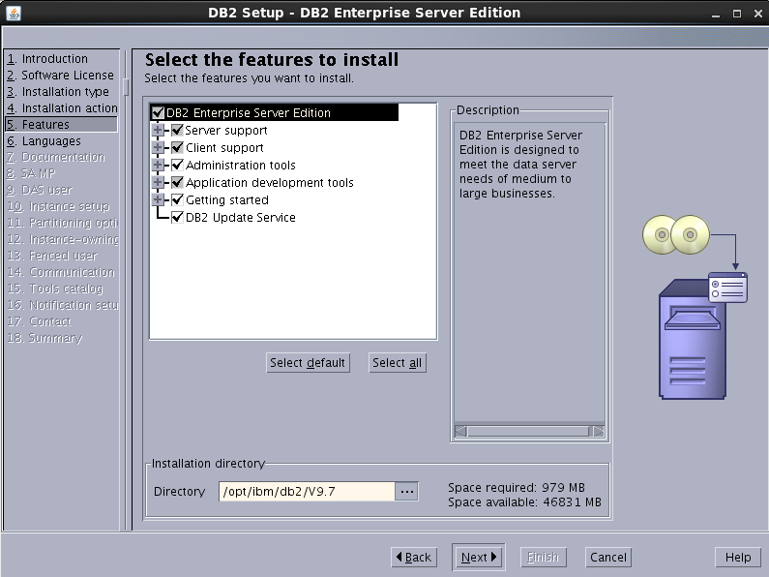
  - Product Languages
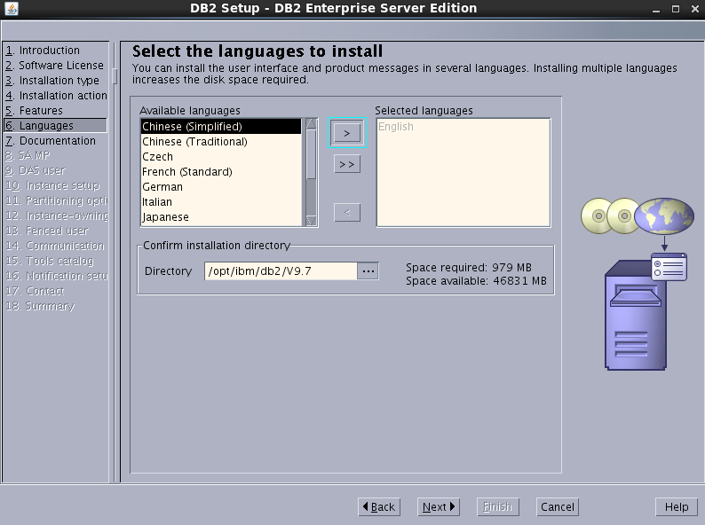
  - Documentation
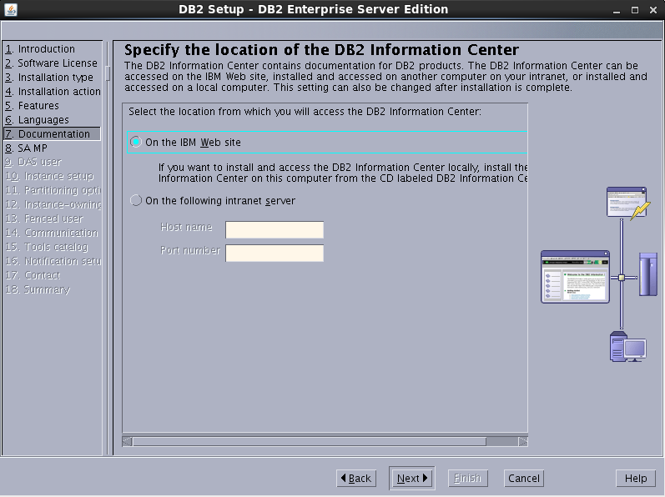
  - Sample
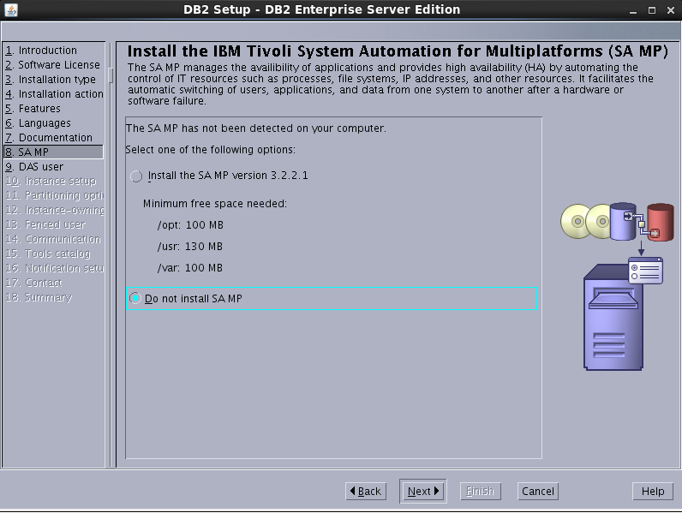
  - Das user
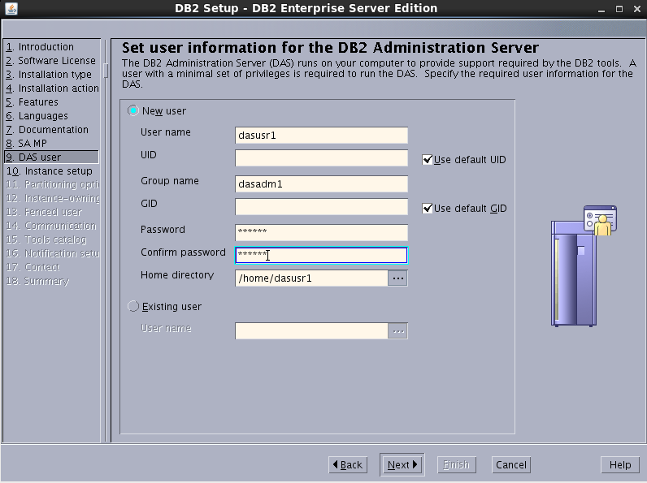
  - Instancce Setup
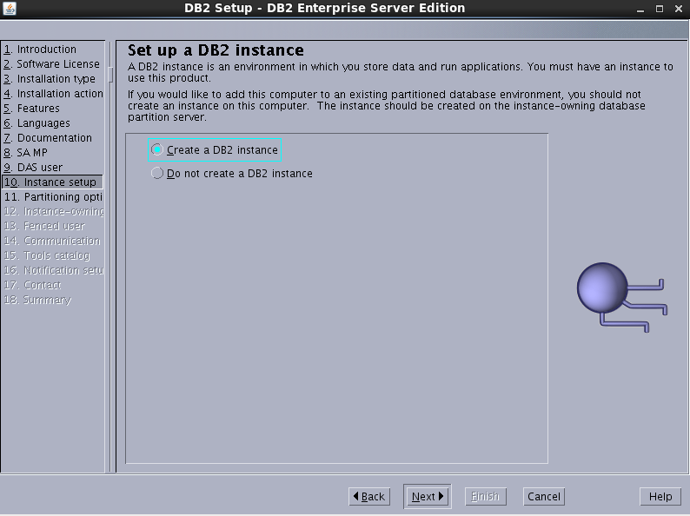
  - Partitioning Option
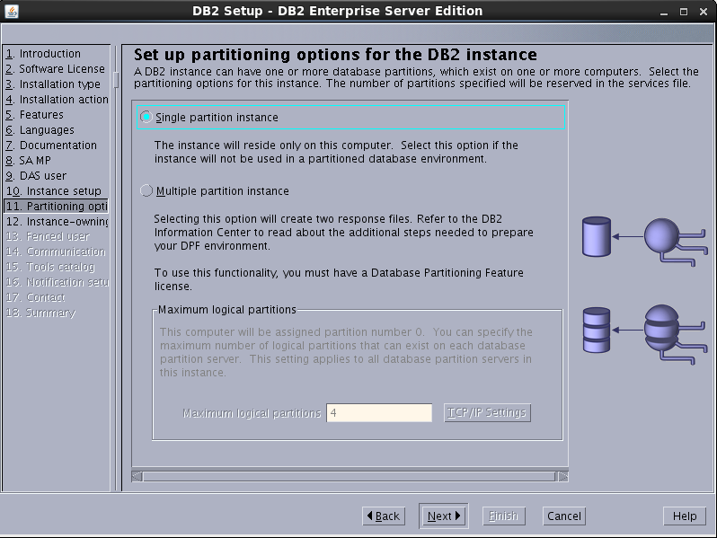
  - Instance-owner

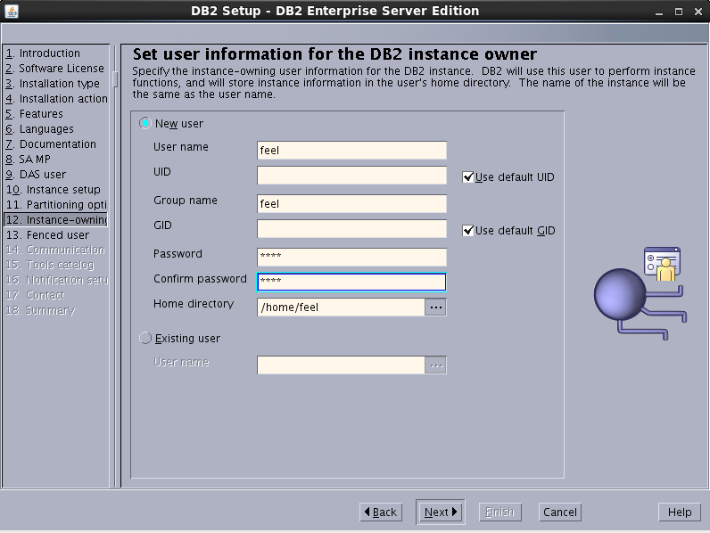

  - Fenced User
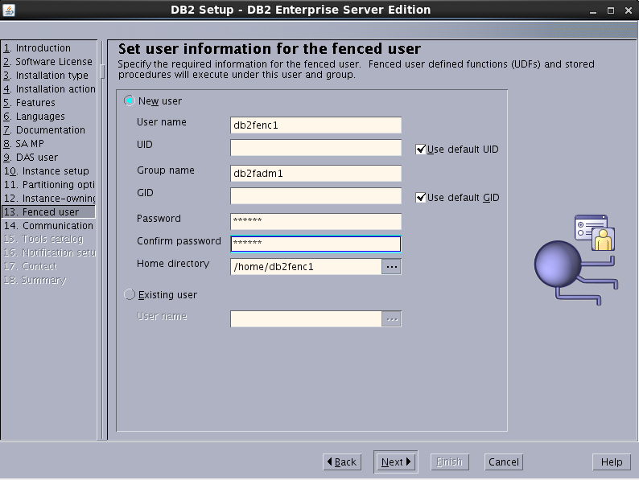
  - Communication
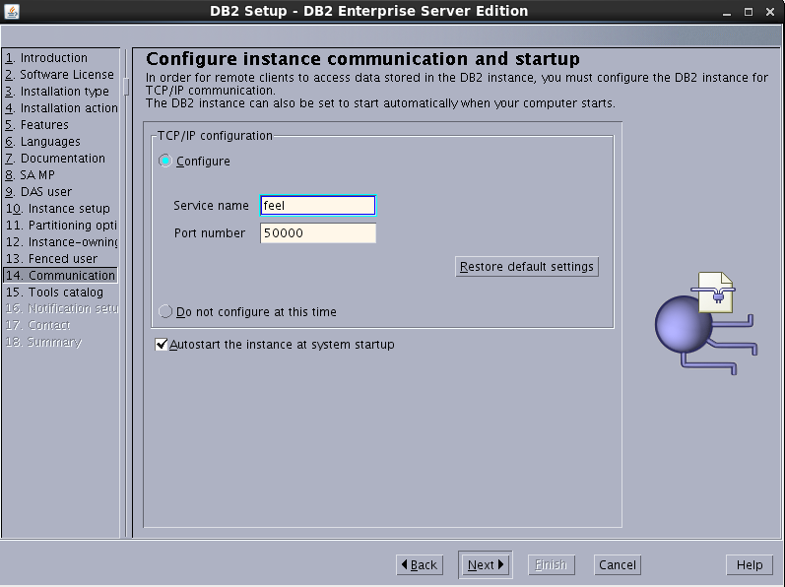
  - Tools Catalog
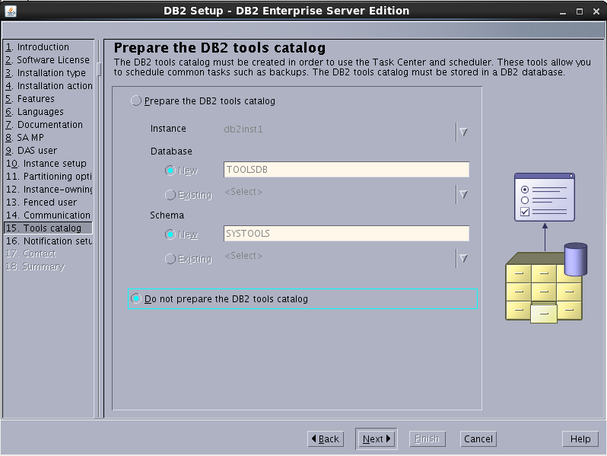
  - Schema Passwords
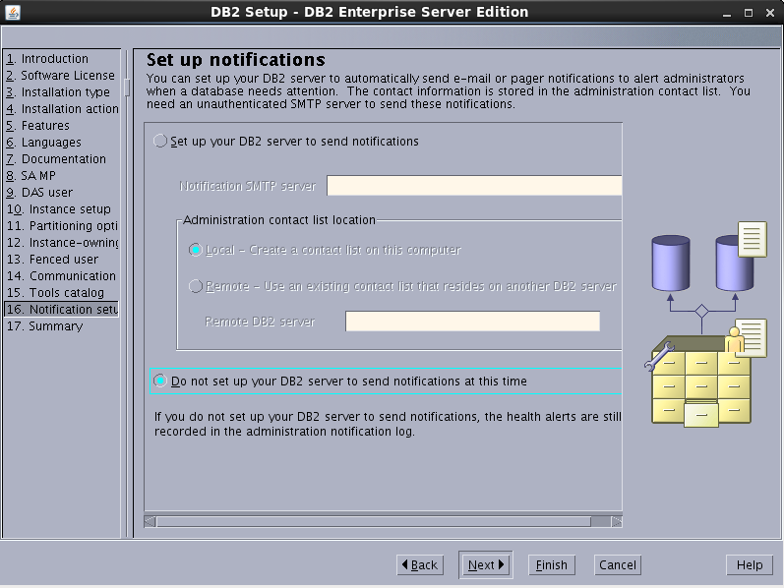

  - Summary
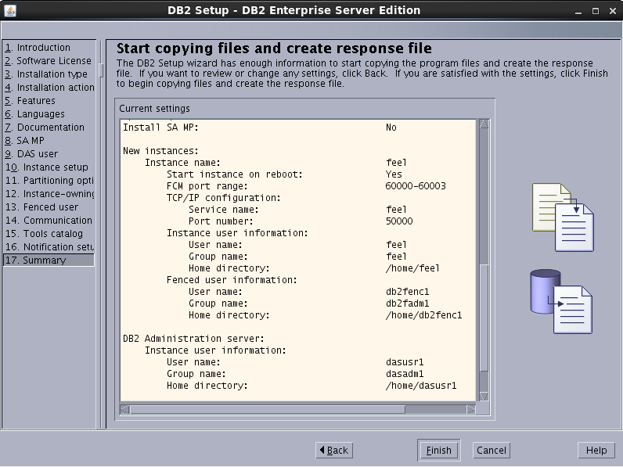
  - Install Product
After all above steps, the installation runs automatically and you’ll see the following images.

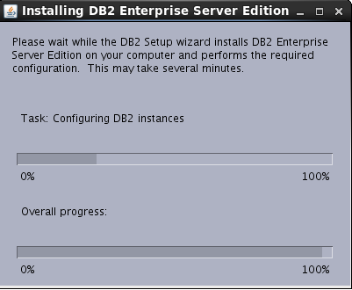

  - Finish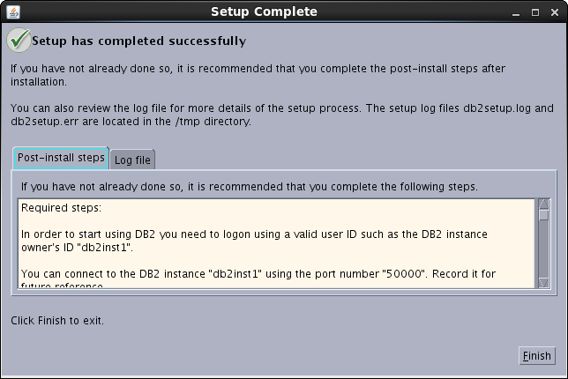

- Configureing user Profile
[root@dbserver server]# su - feel
[feel@dbserver ~]$ vim .bash_profile
# add for oracle
. /home/feel/Online/src/profile/bash_profile_linux_64_db2
# END add for oracle
- Create database
Logging In to the System as feel, execute command:
[feel@dbserver ~]$ db2 create db feel
DB20000I The CREATE DATABASE command completed successfully.

[feel@dbserver ~]$ db2 connect to feel
Database Connection Information

Database server = DB2/LINUXX8664 9.7.6
SQL authorization ID = FEEL
Local database alias = FEEL

- FAQ

- The hose name ‘dbserver’ is invalid.
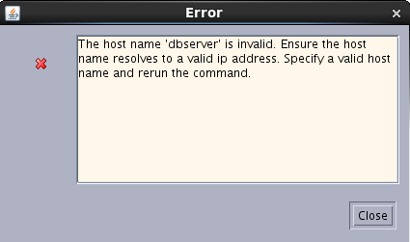
Vim /etc/hosts
#Add for db2
192.168.223.129(Your real IP address) dbserver

