Latesh Anjarlekar
Business analyst ABC Company

FRD - Checkout Funnel Optimization

E-commerce Checkout Funnel Optimization

- Context
This document defines functional changes based on analysis of user behaviour in the checkout funnel.
Key observations from data:
- Very high drop-off at Product View → Add to Cart (~87%)
- Checkout users (240) > Cart users (219) → non-linear flow
- Overall conversion rate is ~2.85% (49 / 1719)
This indicates:
- Weak product engagement
- Multiple entry paths into checkout
- Revenue loss at early funnel stages

- Problem Definition
Problem 1: Low Add-to-Cart Conversion
Users view products but do not take action.
- Evidence:
1719 views → 219 cart adds (~12.7%)

Problem 2: Non-linear Funnel Behaviour
Users are entering checkout without cart interaction.
- Evidence:
Checkout users (240) > Cart users (219)

Problem 3: Revenue Leakage at Top Funnel
Very low overall conversion.
- Evidence:
49 purchases from 1719 users (~2.85%)

- Root Cause Analysis
- Low Add-to-Cart Conversion
- Weak product page design (CTA visibility)
- Lack of trust signals (reviews, ratings)
- Pricing or value perception issues

- Non-linear Funnel Behaviour
- Presence of direct checkout options (Buy Now)
- Inconsistent event tracking
- Revenue Leakage
- High drop-off at early stage
- Low user engagement before cart stage

- Objectives
- Increase Add-to-Cart rate
- Reduce friction before checkout
- Improve overall conversion rate
- Capture more high-intent users

- Functional Requirements
FR-1: Improve Add-to-Cart Visibility
Priority: High
Problem: Users are not interacting with product page CTAs
Requirement:
- Add-to-Cart button must be:
- Visible without scrolling (above the fold)
- High contrast vs background
- Sticky on scroll (mobile + desktop)
Acceptance Criteria:
- Button visible on initial load
- Clickable across devices
- No overlap with other UI elements

FR-2: Add Product Trust Signals
Priority: High
Problem: Users hesitate before committing
Requirement:
- Show:
- Ratings (stars + count)
- Review snippets
- Return policy summary
- Delivery estimate
Acceptance Criteria:
- Ratings displayed near product title
- At least 1 review visible without scrolling

FR-3: Support Direct Checkout Entry (Buy Now)
Priority: High
Problem: Users bypass cart (already observed in data)
Requirement:
- Introduce / optimize “Buy Now” flow:
- Single-click navigation to checkout
- Skip cart stage
Acceptance Criteria:
- Clicking “Buy Now” opens checkout page
- Product is pre-added to order summary

FR-4: Standardize Checkout Entry Tracking
Priority: Medium
Problem: Funnel inconsistency → unclear user paths
Requirement:
- Track checkout entry source:
- From cart
- From buy now
- From other flows
Acceptance Criteria:
- Each checkout event must include entry source
- Data available for reporting

FR-5: Simplify Checkout Steps
Priority: High
Problem: Potential friction before purchase
Requirement:
- Reduce steps to:
- Address
- Payment
- Review
- Enable:
- Guest checkout
- Auto-fill for returning users
Acceptance Criteria:
- Max 3 steps
- Form fields minimized
- No forced login

- Non-Functional Requirements
NFR-1: Performance
- Page load time < 3 seconds
NFR-2: Usability
- UI should be mobile-friendly and responsive
NFR-3: Reliability
- Checkout flow should not fail during payment
NFR-4: Security
- Secure payment processing (SSL encryption)
NFR-5: Tracking Accuracy
- All events must be logged correctly (cart, checkout, purchase)

- TO-BE Process Flow
The diagram below represents the optimized checkout flow with both cart-based and direct checkout paths.
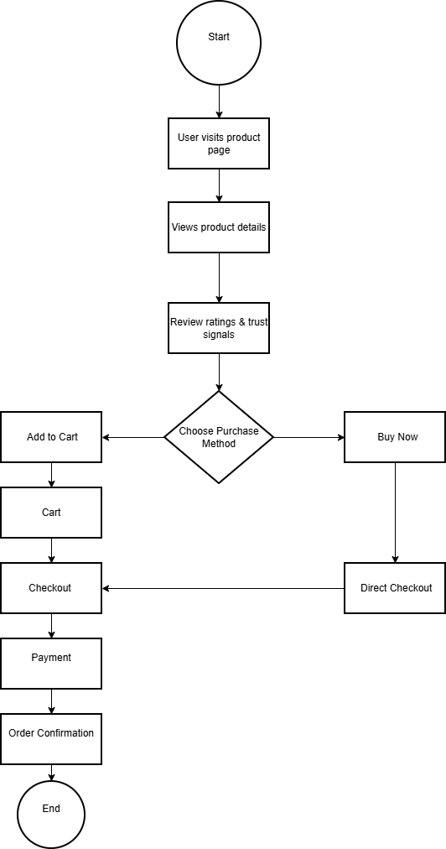

- Assumptions
- Users dropping early are influenced by product page experience
- Checkout completion is relatively stable (based on 22% conversion from cart)
- Non-linear flow is intentional (not purely data error)

- Constraints
- No redesign of entire platform
- Changes limited to:
- UI improvements
- Flow optimization
- Tracking enhancement

- Success Metrics
- Add-to-Cart rate → increase from ~12.7%
- Overall conversion → increase from ~2.85%
- Drop-off at product stage → reduce
- Checkout entry clarity → measurable via source tracking

