**Mission San Francisco De Solano**

**Introduction**

California's twenty-one Mexican missions make up some of this state's most breathtaking historical places. These missions were built from San Diego to Sonoma, California. In the series of missions, Mission San Francisco de Solano is the last and located at the northernmost end of the California’s chain of Missions.

In the 1820s, Pedro José Altimira, or Fr. José Altimira sailed from Spain to Alta California. At the time “California” consisted of what is now the state of California and Baja Peninsula of Mexico. It was divided into Alta (Upper) and Baja (Lower) California. He was one of the last Franciscans educated in Spain.

Altimira was assigned to [Mission San Francisco de Asís](http://missiontour.org/wp/sanfrancisco/mission-san-francisco-de-asis.html); in addition, he eventually became disenchanted with the conditions and made an ambitious plan for a new mission. Pedro Altimira was young ambitious and impatient for glory. He thought he would be more important than the great friar and mission founder Sir Francis Junípero Serra also known as Fray Serra.

Fray Serra was the missionary who built the first nine Franciscan missions from San Diego to San Francisco, in Alta California. Fray Serra was also a brave explorer and a devout Christian. He founded the first mission; mission San Diego De Alcala, in 1769. After that, he created a chain of missions along the coast of California. He built each mission 30 miles or a day’s journey apart from each other.

Altimira had a dream of constructing a mission somewhere in Alta California, along the far northern border. On July 4th 1823, Altamira founded the 21st and last California mission and named it Mission San Francisco De Solano which he built it in the Valley of the Moon in Sonoma. St. Francis Solano, a missionary to the Peruvian Indians was a big inspiration and the Mission San Francisco De Solano was named after him. All the Missions in the chain were built with prior approval except Mission San Francisco De Solano, as Father José Altimira and Governor Arguello conspired to stop a booming Russian presence. The road that links the missions is called “El Camino Real” which means “The Royal Road” in Spanish. Mission San Francisco De Solano is the last mission on the northern end of El Camino Real.

**Unique Characteristics**

Mission San Francisco De Solano has some very unique characteristics. Did you know that when building the mission, Fr. Altimira (or mission founder) was so impatient about building the mission that he didn’t even wait until the adobe was dry? So suddenly one day, it rained unexpectedly the adobe melted and that was the fall of Mission San Francisco De Solano.

On August 25th, 1823, the construction began. The mission’s general blue print consisted of a long building built in the shape of a square, this is called a quadrangle. A church was built in one corner of the quadrangle, and residences, a kitchen, workshops, and storage area completed the square shape. This church was made with wood, and then whitewashed with mud; it was used for three years. Later it was replaced by a much bigger and larger church. Now this church was made on the opposite compound plus it was made of adobe. It was then destroyed in 1838. After the Franciscans left, a new church was constructed on the original church site in 1840. This church claimed to be 105 feet long and 23 feet wide with a tile roof. Surrounding this they built a long, low wooden structure plastered inside and outside with white washed mud to be as living quarters for the neophytes.

At first there was no bell wall or tower. Only a single bell was there hung at the front of the mission on a wooden frame that was not even painted. The first bell at the mission was gifted by Russians at Fort Ross, and the present bell which is hung at the mission was made in Mexico in 1829. The mission barracks were the homes of Indians who lived at the Sonoma mission. The barracks are still standing today. There was a monastery that was a wing long and there was a low adobe structure and made shelter for the mission staff. It had a porch covered in square posts, it was better than the arched supports in the other missions. Workshops, a guardhouse, a granary, and also barracks were all in the monastery. In the padre’s quarters, there is a wing that is now a museum. The paintings that Chris Jorgensen drew are now displayed in what used to be the dining room.

Clearly, I think that Mission San Francisco De Solano has some very unique characteristics. For all there is to know about Mission San Francisco De Solano, it is fun to learn about. Also it is fun to do a project on.

**History**

During the 1840s many American settlers heard about free land in California and moved out to claim it. However the Mexican government did not ratify or approve. After hearing that, the Americans got angry and frustrated. A band of Americans then decided to challenge the Mexicans in a summer of 1846; they called themselves the Osos, or the bears. They chose one mission for the site of their revolt. That mission as Mission San Francisco de Solano. At dawn on June 14, 1846 thirty-three fully armed Osos rode to General Vallejo's house in Sonoma and pounded on his door. Instead of attacking them, Vallejo invited them inside for breakfast. He told the Americans he would join them, they believed him but still arrested him. Then the Osos declared Sonoma the capital of the republic of California. They made a new Californian flag and raise it at the Sonoma plaza. After drawing a grizzly bear on a white piece of paper they wrote CALIFORNIA REPUBLIC on the bottom. The Grizzly became the symbol of the new Bear Flag Republic. It is still the symbol of California today. Unfortunately the republic of California lasted only for 25 days, but on July 7, 1846, the American government declared California to all of the United States. The Osos agreed and took down the California republic flag then raised the Stars and Stripes.

After Fray Jose Altimira was driven from Mission San Francisco de Solano, his work was continued by Fray Buenaventura Fortuni. Unlike Fray Altimira, Fortuni treated the neophytes with respect. The Indians, who had left the mission with disgust of Fray Altimira, had returned to greet and welcome Fortuni. When Fortuni retired, he was then replaced by Fray Jose Gutierrez. Unfortunately the Indians did not like Gutierrez as much as they liked Fortuni. Some of the Indians left to re-join Indian tribes or they went to other missions.

During the early 1800s, Spain had control of California and New Spain (or what we now call Mexico). However the Mexican’s were fighting to regain control of their land. Finally in 1821, Mexico won independence from Spain taking control of California. Both Mexicans and Spanish had different ideas on what to do with the mission. In 1834 the Mexican government passed law to secularize the missions, meaning the missions were no longer under the financial control of the Catholic Church. Some of the Franciscan missionaries were sent back to Spain and replaced with special priests called *curas*, who did not do any of the missionary work. Secularization of the mission also meant that Indians were free to leave the mission.

Many of the missions fell apart after secularization. Then a plan was made to divide the mission lands between the settlers and neophytes. Unfortunately, corrupt officials and greedy settlers discovered a way around this and took the land for themselves. Some of the mission lands at Mission San Francisco De Solano were taken over by Lieutenant Mariano Vallejo. He grew rich and powerful by working the land at De Solano. Eventually he became an important general.

In 1903, as the walls began to tumble, the California Landmarks League was able to save the mission. They collected $13,000, bought the mission, and gave it to the land of California. It was 1911, the repairs began. Then in 1922, the mission was reopened as a museum. A large bell that disappeared from the mission in 1881 was found in a museum in San Francisco. It was by the Sonoma Women’s Club. The people brought it back and hung it in front of the museum. Today the mission is in the center attention of Sonoma.

**Mission life**

The daily life at the mission changed from day to day and from season to season. It was all the same throughout the week except on Sundays. The friars comforted the Indians with food, living quarters, and when they died, salvation in heaven. To pay them back, the Indians worked long and hard in the fields and learned how to be Christians.

The Indians were living their day to day life on bells at the mission. For waking up it was sort of like an alarm clock. On the other hand, the Indians worked in the fields until it was time to go and eat. After that, they went back to work. When it is time to sleep, the bell used to ring so it is like a reverse alarm clock then too. Sunday was the day off for the Indians. They did things without the ringing of the bells. All the activities that the Indians did on Sundays were the things that did not serve the missionaries.

The food that the missionaries ate at the mission was the same thing they ate every day. Everyone ate a porridge called *atole*, for breakfast, which was made out of corn. Also they ate a thick stew called *pozole*, which was also made out of corn.

When the Indians were assigned a work, they focused and completed that work before moving on with the next. For example, at Mission San Francisco de Solano, after building the friar’s quarters, and the guard’s quarters the Indians began working in the fields again. While working on the fields, they cut down the trees and they also prepared soil for new sprouting plants. They planted 300 fruit trees and 3000 purple grape vines.

Before making the food for missionaries, the Indians had to grow the ingredients. For meals, they grew beans, peas, and lentils. Then they planted large fields of wheat, corn and barley. In addition to them working in the fields, they tended hog pens, horses and cattle. For meat and clothing (made out of wool) they raised sheep. Also, after the Indians learned how to weave, they wove everything that was needed at the mission. Indians played a very crucial role in running the mission.

Life at Mission San Francisco de Solano wasn't always happy, healthy, or not even easy. When the Europeans came, they carried many diseases they didn’t even know they had. Some of these diseases were not deadly to the Europeans, but were deadly to the Indians. The Indians were not used to these sicknesses. Some of these diseases were so wide spread that it knocked out 90% of the Indian population, in 100 years.

To add to the unhappy and unhealthy life at the mission, Fray Altimira was a cruel man. If an Indian disobeyed him, he would whip them with a lash and on top of that he would imprison them. Even when the Indians tried to escape, the guards would always catch them. After bearing all these pains finally one day in 1826, the Indians challenged Altimira and the Indians who stood beside him. They told them to leave and never come back. Not long afterward, they left and were never seen at Mission San Francisco de Solano.

After knowing so many facts about the Indians, their way of living, the problems they went through and the way they opposed Altimira it can be observed that the life at Mission San Francisco de Solano was very interesting.

**Present Times**

By 1900, only a few rooms of the Mission remained standing. People throughout California took an interest in saving the mission and in 1903 the mission was purchased by the California Landmarks League for eventual protection. The mission was given to the state of California for complete restoration in 1906. Planned restoration could not execute because of the Great San Francisco Earthquake and Fire intervened and it took three years to regain the funds. Only 5 rooms were then restored and two further restorations have brought the mission to its present appearance. The Mission is now part of Sonoma State Historic Park and it’s operated by the California Department of parks and Recreation.

Luckily, few California Indians who survived have kept many of their ancient traditions and have reclaimed some of their land. In the 1960s Indian activists from all over the USA changed the way history of the American Indians is taught in schools and they revised school textbooks to explain the history.

Today Mission Solano sits at the center of the town of Sonoma. Sonoma Plaza, the huge shaded square designed by General Marino Vallejo, is surrounded by shops, restaurants and historic adobe buildings. The old Mexican barracks are still there along with some of the nineteenth-century hotels. General Vallejo’s house on the plaza, La Casa Grande, is now also a museum. The oldest surviving building at the mission is the wing of the Friars’ quarters that Fray Altimira built in 1825, just stands east of the present chapel. The original bell is still hanging in front of the mission. It once went missing in 1881 and was later found again.

The missions that still stand today help to show the two different points of view of the Franciscans and the American Indians. Visitors can view the exhibits of mission life, religious paintings and beautiful framed watercolors of all the California missions inside the present day mission chapel. Courtyard behind the mission stands olive trees, a wall of cactus and wooden benches around a small fountain where visitors can sit and rest. Kids come to visit the mission with their families and school field trips are also encouraged.

Sonoma is now best known as the birthplace of the California wine making. Fray José Altimira planted the first grapes in Sonoma to make wine for Mass. Today Sonoma wines are tasted all over the world.

The Mission trail marked three hundred years of Spanish-Mexican settlement from 1523-1823. The mission system spread way beyond California, as far south as Guatemala. Mission San Francisco Solano marks the last and northernmost outpost on the historic mission trail.

**Bibliography**

Introduction Websites:

<http://www.missionscalifornia.com/keyfacts/san-francisco-solano.html>

http://californiamissionsmuseum.com/the-missions/

Unique characteristics :

Book Name: **Mission San Francisco Solano** By Allison Stark Draper

<https://en.wikipedia.org/wiki/Mission_San_Francisco_Solano_(California)>

<http://factcards.califa.org/mis/sanfranciscosolano.html>

<http://www.athanasius.com/camission/sonoma.htm>

<http://missiontour.org/wp/sonoma/mission-san-francisco-solano-chapel.html>

<http://www.missionscalifornia.com/keyfacts/san-francisco-solano.html>

History:

Book Name: **Mission San Francisco Solano** by Allison Stark Draper

<https://www.missionscalifornia.com/keyfacts/san-francisco-solano.html>

<http://factcards.califa.org/mis/sanfranciscosolano.html>

Draper, Allison Stark. N.p.: n.p., n.d. Print.

Mission Life And Present Times:

Book Name: **Mission San Francisco Solano** by Allison Stark Draper

Introduction

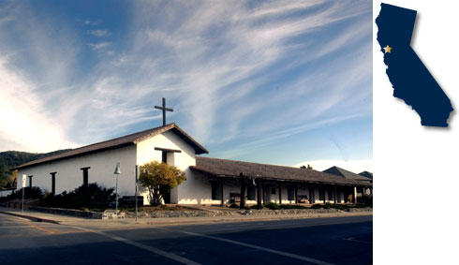

Unique Characteristics

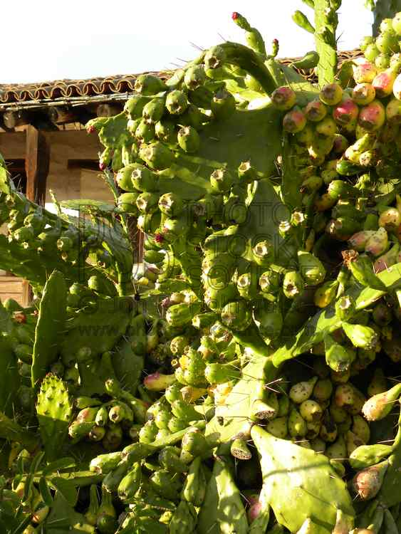

History

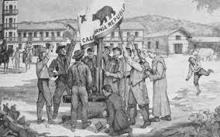

Mission Life

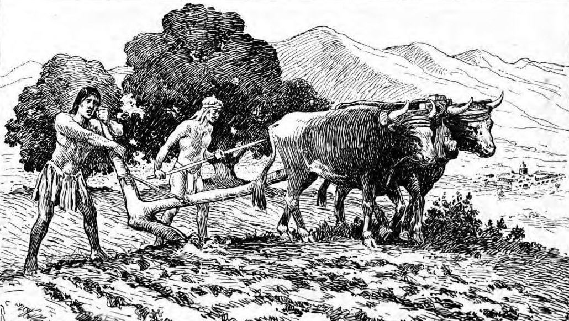

Present Times

