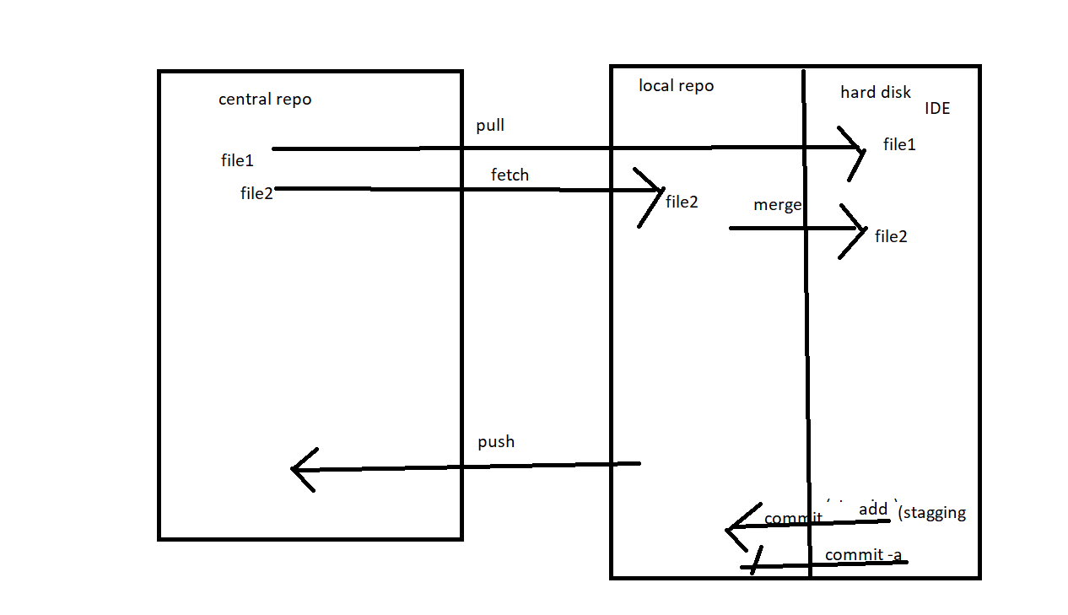

maven- build tool..selenium 2.8

login module..-- jar-->

 want to share your project with another team(registration module)..

 pom.xml.

github- within team. - version control- team- 7 ppl..

repository.

4 dev -

1 -dev- commit -

firstproject-- master-repo

git clone url

git init

git status--- red color-- file not present in local repo..

git add filename-- only that file send to local repo

git add . -- all file

git commit

git status -- all file green color. it is present in local repo.

git push origin master

git pull origin master

local repo and central repo-

2- qa-

JENKINS---  MANAGE PLUGIN --> GIT ,MAVEN-- DOWNLOAD , INSTALL- (RESTART, WITHOUT RESTART)

PLUGIN-GIT ,MAVEN

NEW JOB (DEMO)-- GIT REPO NAME-- FRIST REPO,  CLONE - URL, CREDENTIAL.

BUILD (FIRST)--- JENKINS- BUILD (DEMO)-- GITHUB-- PROJECT(.JAVA)

START BUILD... BUILD TRIGGER -COMMIT, PERIOD(30 MINS, 24 HR, 1 DAY 1 WEEK)

MAVEN

POM.XML-- INCLUDE DEPENDENCY ..JAR..

A -DEV- AUTOMATICALLY DOWNLOAD ALL DEPENDENCY..

B-DEV