Tell me about yourself?

what you did in your web services project?

what libraries you used in Rest api?

difference between Soap and Resp api?

What is payload in Rest or Soap api? Can we send unlimited payload?

Separate the Leader elements from the given array and put it in new array?

Given array --- {16,17,4,3,5,2 }

Out put array --- {17,5,2 }

Ask to write the code for given scenario (selenium complete code)?

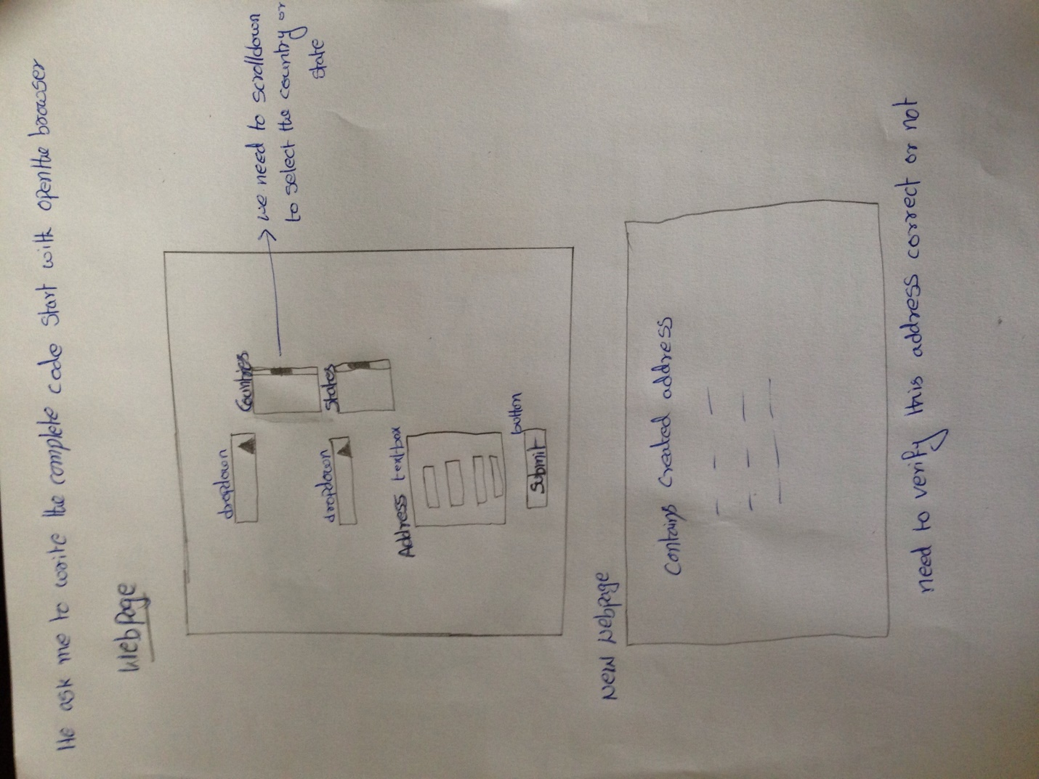

what is object repository, where we use this,why?

difference between Assert and verify?

what are the locators in selenium web driver?

If i am trying to load the webpage due to the internet connection problem it is loading very slow how to handle this situation?

Write the code for Explicit wait?

Experience with mobile testing?

While we are testing the ios devices if yo have any issues in the screen where we log this in ios and how will you contact with the developer and discuss?

Give me the example of the above scenario in your experience and explain it?

1.tell me about your experience???

2.what is your last project? What type of testing you done in your last project?

3.did h do webservices testing also? So how did u do webservices testing??

4.tell me about load testing? Did u do any load testing?

5.What are the locators in selenium?

6. Which one did u use in your project??

7. For dynamic data, why you are using xpath?

8.when filing a bug, what do you include?

9.asked how to do testing for search box in selenium??

10. How do you log files in mobile testing?

11.Difference between soap and rest?