Java Final Copy :

Programs : set of instructions.

Compiler : machine can only understand the machine level lang. we write the high level languages a normal English, which cannot be understood by computer. Compiler is the one which converts the high level languages to machine understandable languages directly all at once.

Interpreter: converts the high level languages (programs) to machine level languages (binary) line by line while executing the programs.

Examples for interpreted lang: Ryby, python etc…

Java is complier and interpreter language.

.java class are converted by compiler to byte code (.class)..and byte code is interpreted to machine understandable language while executing . hence java is platform independent and follows WORA principle Write Once Run Anywhere.

Java is called as Object Oriented Programming language.

**Features** :

Java is **simple** : because it won’t have the complex things like pointers and data structures, and memory management is mostly taken care by JVM.

Java is **Platform** **Independent**: programs written in any OS/platform can be executed in any other OS.

Java is **distributed**: it is distributed because it can communicate with different protocols tcp/ip, udp, ftp etc..

**Multithreaded**:

**Secure**:

**Robust**:

Java executions:

FirstProg.java ---–converted by compiler to byte code----🡪 FirstProg.class------interpreted to binary lang--------🡪then executed.

To Setup Java: we need to download JDK,JRE,JVM

JDK is the whole bundle of java including JRE(Runtime Environment) and JVM(virtual machine).

JDK is used for mainly for development purpose.

If we have JRE which internally consists of JVM then we can execute the java on our machine.

**JDK**: Java Development Kit: it contains all the libraries(packages and classes which are provided by java) required for java development + JRE

**JRE**: jre contains all the libraries required for execution of java program + JVM

For execution of programs we don’t need all the jdk libraries, with JRE we can run the program on any other systems.

**JVM**: jvm includes interpreter + JIT Compiler (Just I Time Compiler)

JVM is platform dependent which makes java as platform independent. when we download jdk in which JVM executable file will differ according to the OS.

While execution if there is any complex programming like repeated programs for interpret , in such scenarios JIT compiler takes the precedence over the interpreter and it compiles the code into machine lang and saved in memory and it can be reused whenever it is needed (for all iterations). Calling the JIT will be taken care by JVM.

**Installation**: oracle.com is the official website for downloading JAVA

Select the JDK according to your Operating System. select and download ..Extract the files.

After downloading we need to setup the environment variable for java.

Control panel—system—advanced settings—Environment variable—under system variables—new—give JAVA_HOME—give the complete path of the JDK folder where we copied in the system—and edit the PATH variable also—copy the same path till \bin—save.

Environment variables need to be set so that OS will understand where the java libraries and executable are present so that it can communicate .

For verification we can check in command pmt. Run the command

java – version : which gives the java details if it is successfully downloaded.

IDE: Integrated Development Environment, which assists the developer to create, execute, debug and manage projects easily. It helps in identifying the syntactical errors too.

There are many IDE’s for depending on the programming languages..

For Java – Eclipse, Intellij, Net Beans, Jet Brains

JavaScript -- Web Strom, Phpstrom

Andriod – andriodStudio

IOS – Xcode

Python – phycharm, Pydev

Downlaod the Eclipse IDE from [www.eclipse.ord](http://www.eclipse.ord), its an open source application..create an shortcut of the executable file.

Give a name for the workspace where all the code will be saved on harddisk.

Open the Ecllipse – goto Window Preferences—Java –Installed jre’s—point to the JDK folder (sometime with JRE some library files will be missing for development)---apply – ok.

Create a package (Package is a namespace / folder☺ structure for organizing the classes and interfaces in a logical manner which helps projects easier to manage: its helps in segregating all different classes)

First line in java program is the package name.

Source code is copied under src folder , once the class is saved then .class file if generated and saved under bin folder.

In java everything is defined as class and objects.

Class: Class is like a Blueprint from which objects are created. Class defines the stateand behavior of the object. Class is not physical.

Ex. Class is Building plan, MS-ppt Template

**Object**: Instance of a class which defines the sate through variables and behavior through methods.

State--Properties-variables

Behavior--Actions-Methods

State and behavior are physically exist through object.

**Method**: is a set of code which holds actual logic and can be called any point making the code reusable.

Syntax:

Access Modifier return Type/void method Name(input arguments if any/blank){

// method body

}

While writing the programs, if we violate java language standards and syntax rules we get compilation issues, and program is not executable unless they fixed.

Object Creation:

className ObjectName = new className();

new: is the keyword used which tells the JVM to create the object of class in memory..() invokes the constructor whenever the object is created.

Using the object we can call the methods from outside the class within the package or from other package depending the access modifier.

Objects when they are not initialized the default value is “null”, and for primitive it depends on datatypes.

Global or class variables are not initialized with data, then default primitive data type values are assigned.

OOPS:

**Inheritance in java** is a mechanism in which one object acquires all the properties and behaviors of parent object.

Inheritance represents the **IS-A relationship**, also known as *parent-child* relationship.

Why use inheritance in java

* For Method Overriding (so runtime polymorphism can be achieved).
* For Code Reusability.

Syntax of Java Inheritance

1. **class** Subclass-name **extends** Superclass-name
2. {
3. //methods and fields
4. }

The **extends keyword** indicates that you are making a new class that derives from an existing class. The meaning of "extends" is to increase the functionality.

In the terminology of Java, a class which is inherited is called parent or super class and the new class is called child or subclass.

## Types of inheritance in java

On the basis of class, there can be three types of inheritance in java: single, multilevel and hierarchical.

In java programming, multiple and hybrid inheritance is supported through interface only. We will learn about interfaces later.

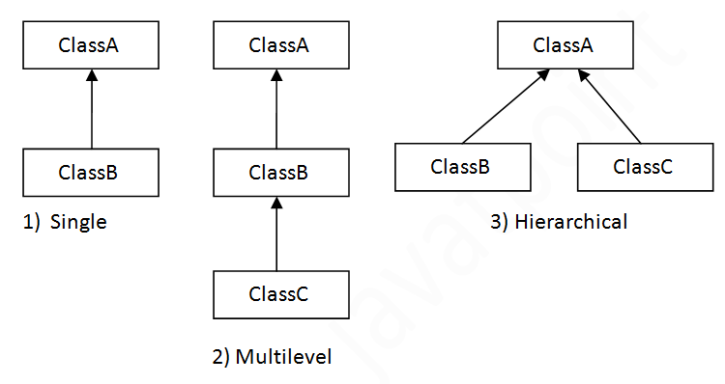

#### Note: Multiple inheritance is not supported in java through class.

When a class extends multiple classes i.e. known as multiple inheritance.

Program execution starts from main method.

4th December 2017 : new notes :

Java is high level object oriented language.

Compiler : it takes entire code as input at once and generates the intermediate object code (byte code).

Interpeter: it takes single line or instruction as the input and executes it , no intermediate code is generated, which makes it faster and memory efficient.

Byte code is the object code which is actually processed by Virtual machine, and it is different from machine code which processor can understand.

Hello.java –interpreter---> Hello.class (byte Code) : which is understood by java virtual machine which converts byte code further to machine code.

Java is both compiler and interpreted language.

Java follows WORA (Write Once Run AnyWhere) principle

Java is System Independent because of JVM, where as JVM is System Dependent which makes Java language System Independent.

JVM is also a Software..which is different for each O/S.

Hello.Java

Java Features:

Downloading Jva :

Download Java SE Development kit JDK – accept the aggrement—download the binary code according to OS

Set the environment Variables Java_Home and Edit the path variable and add till the bin directory ( Why we set the Env. Var : for machine to understand where the installation is located to execute the programs)

JDK : Java Deveopment Kit ( which consists of all libraries+javac Compiler + JRE)

JRE: Java Runtime Environment (which consists of some of the libraries which are required to run theprograms + JVM)

Class: Class is a Bluprint that defines variables (properties) and methods (actions).

Object : is an instance of class which allows to access variables and methods of class. Object is a thing which you see in the real world—animal, vehicle etc..

Access Modifiers : to define scope of the class, variables and methods.

Public: accessible by anyone

Private:

Protected:

Default:

Ex.

Public class Animal{

Public static void main(String[] args){

System.out.prinln(“hello”);

}

}

Static: can be accessed without creating the object

Main:this is the main method that jvm looks for to start the execution of the program.

Void: method is not returning anything back to whoever is calling the method

String [] args: method input parameters (args is the array name we can give any other name also)

[]: means its list/array of string elemets

**Object Cration Syntax :**

Classname objName= new classname();

Ex. Animal a = new Animal();

**Variable Syntax:**

AccessModifier VarName; Ex. Int a;

**Method Syntax:**

AccessModifier returnType MethodName(input parameters){

//statements // return and input parameters are optional

}

Ex. public void displayDetails(){

Sysout(“”);

}

public int addition(int a,int b){

return a+b;

}

IDE : integrated Development Environment : which helps in programing in a easier way with the syntax etc..

Ex. Eclipse, intellijIdea,NetBeans – for java

Different ide are present for diff languages..

Generally program execution starts from the main method, when ever you are calling the main methods .

Stack(LIFO) – stack is for method execution,all methods are stored in stack memory

HEAP(FIFO)—all the objects and variable data stored in Heap memory

Constructor: So whenever we are creating the object by default constructor is called by jvm without any code. We can use this constructors are used for initializing the object data at the time of creation of objects, and the constructors are executed first in the program.

Constructors are created using the same class name without any return type. we can have multiple constructors which is called as the constructor overloading, but only any one constructor is called at a time.

Encap:Hide the implementation expose the behavior using orivate

Hide the data expose the information

Inheritance: to avoid redundancy code

+++++++++++++++++++++++++++++++++++++++++++++++++++

INTERVIEW QUESTIONS:

* 1. What is Java and features?
  2. What are compiler and interpreter?
  3. Explain JDK,JRE and JVM?
  4. What is Constructor?