**CAN OBD-II fuel_flow_elap**

**This project utilizes an Arduino board with a MCP2515 CAN bus module to communicate with an ECU (Electronic Control Unit) via the OBD-II (On-Board Diagnostics II) interface. The goal of this project is to read the fuel_flow_elap data from the vehicle's ECU.**

**Components Required**

**Arduino Board: The microcontroller that executes the code.**

**MCP2515 CAN Module: A module used to interface with the CAN bus.**

**OBD-II Connector: A standard connector to communicate with the vehicle's ECU.**

**Wiring:**

* **7 Male to Female Jumper Wires: For connecting the Arduino to the MCP2515.**
* **2 Male to Male Jumper Wires: For connecting the MCP2515 to the OBD-II interface.**

**Connection Diagram**



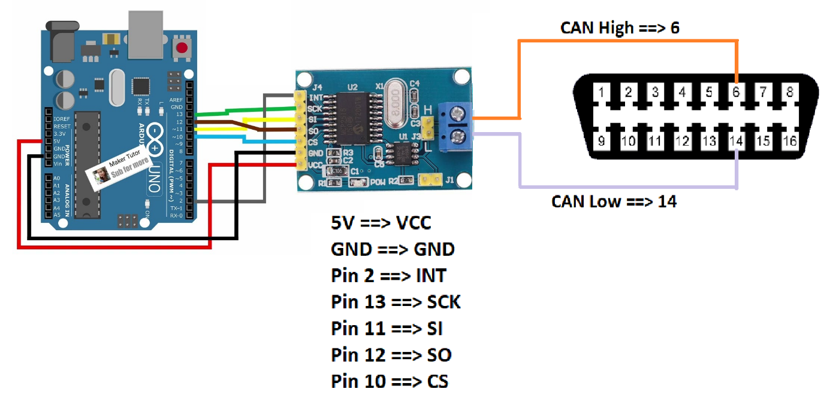

**This Arduino project successfully reads the fuel_flow_elap data from a vehicle's ECU through the OBD-II interface using the CAN bus protocol. It demonstrates basic CAN communication and data parsing, making it a valuable tool for automotive diagnostics.**