# **Project Setup Instruction** **Taxidi - Pack Your Bags**

Taxidi - Pack Your Bags is a tourism management system that allows tourists and travel agencies to register, create tour packages, manage bookings, handle payments, and complaints.

**Project Setup Instructions :**

**1. Connect MongoDB Atlas to MongoDB Compass**

1. Go to [MongoDB Atlas](https://www.mongodb.com/cloud/atlas) (Signup or Login)
2. Create a new cluster  
   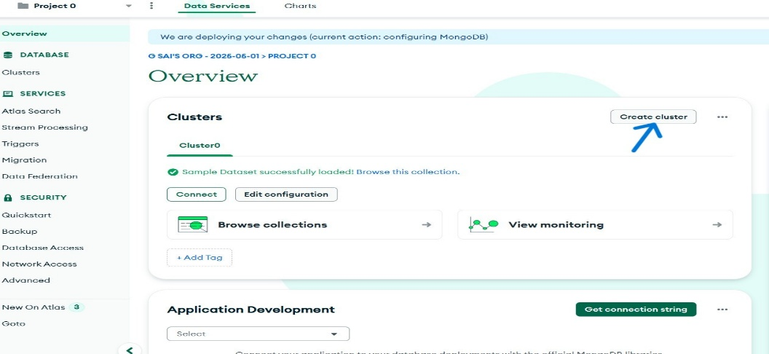
3. Now click on Connect and Download compass and Install.

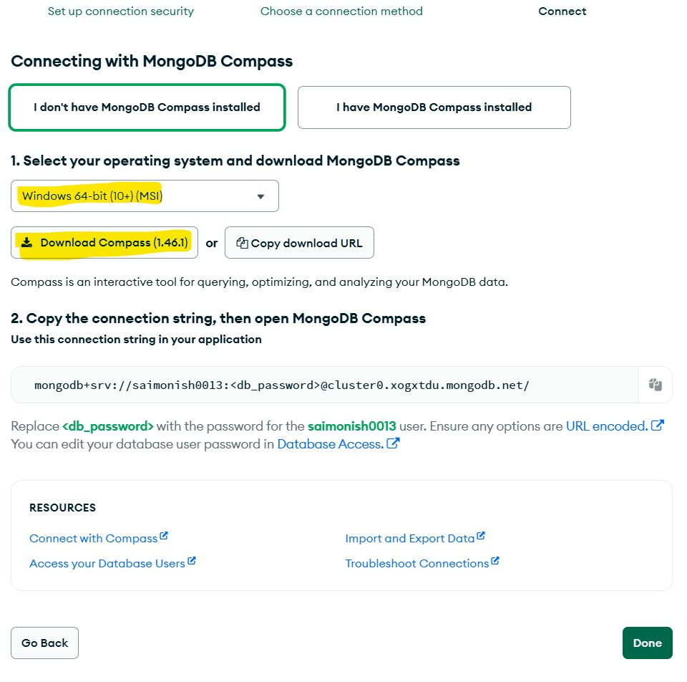

1. Create a database user with a password

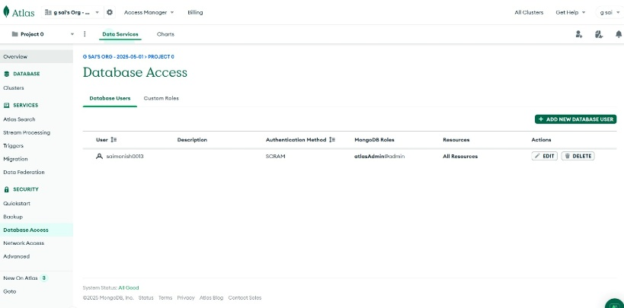

1. Whitelist your IP address 🡪 Network Access (make sure click on Allow Access From Anywhere)

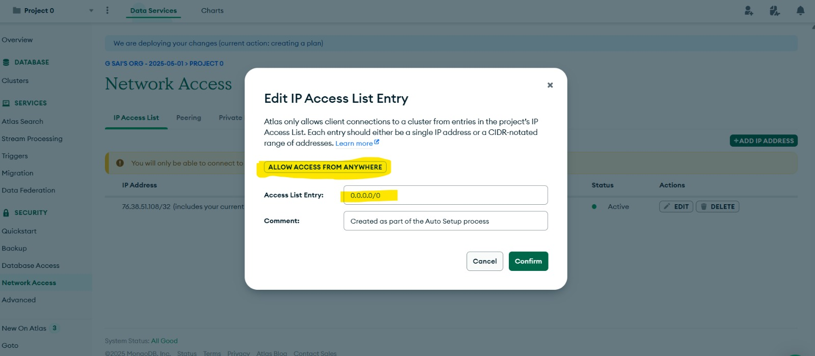

1. Now open Compass, Click on create Connection:  
   Copy the connection string (e.g.,  
   mongodb+srv://<username>:<password>@cluster0.mongodb.net/test?retryWrites=true&w=majority)  
   Replace <username > and <password>(You can get your user name and Password check step 4: (Database Access in MongoDB Atlas) click on edit)  
   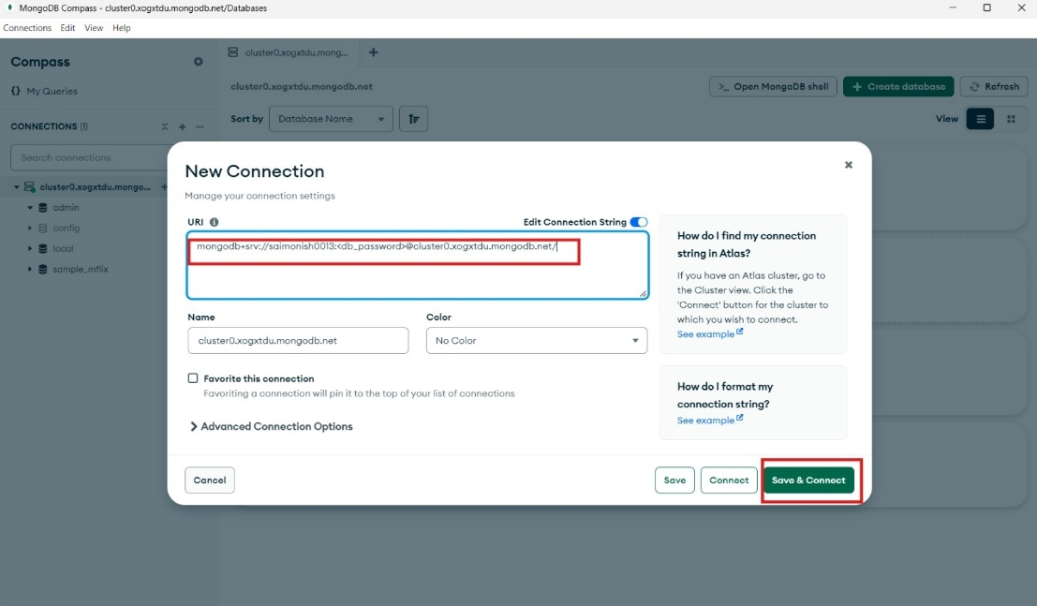
2. Open MongoDB Compass, paste the connection string, and ensure the connection is successful

**2. Clone the Project Repository :**

git clone <https://github.com/latha0624/Taxidi-pack-your-bags.git> or Download Zip file in Github

**3. Install Prerequisites :**

1. Python:

Install Python 3.8+  
🔗 [Download Python](https://www.python.org/downloads/)

**Check installation:**

pip --version

If not installed:

python -m ensurepip –upgrade

**4. Install Required Python Packages:**

**Install dependencies :**

pip install flask pymongo

**5. Install Missing Packages (Optional) :**

pip install google-auth-oauthlib

pip install --upgrade google-api-python-client google-auth-httplib2 google-auth-oauthlib

**6. Run the Application :**

**Use either of the following commands:**

**python main.py  
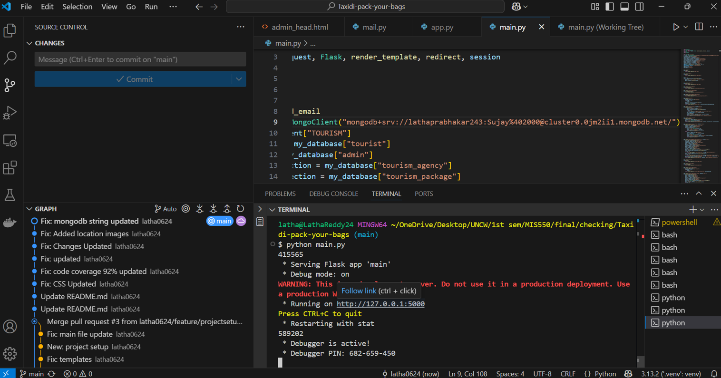**

Then visit: **🌐** [**http://127.0.0.1:5000**](http://127.0.0.1:5000/) **Testing and Code Coverage:  
Install:**pip install pytest coverage flask-testing  
pip install pytest mongomock pymongo

**Run:**  
coverage run -m pytest (while it shows collecting click CTRL+ C )   
coverage html (it gives you path of the folder **htmlcov** )  
