GANTA KALPALATHA
Lathaj1728@gmail.com

AWS Core Concepts
1. AWS
Amazon Web Services (AWS) is a cloud platform providing on-demand computing services like servers, storage, and databases.
2. EC2 (Elastic Compute Cloud)
EC2 provides virtual servers (instances) in the cloud.
3. Region
A geographical area where AWS data centers are located (e.g., ap-south-1 – Mumbai).
4. Availability Zone (AZ)
An isolated data center within a region to provide high availability.
5. AMI (Amazon Machine Image)
A template containing OS and software used to create EC2 instances.
6. Instance Type
Defines CPU, RAM, and network capacity (e.g., t2.micro).
7. Key Pair
Used to securely connect to EC2 instances using SSH.
8. Security Group
Acts as a virtual firewall controlling inbound and outbound traffic.

AWS EC2 Using Console and Terraform
Created EC2 Instance for Linux 2021 Server
Created EC2 instance by selecting AMI as Linux Windows Server 2021 and tested.
Ec2 instance is created in my personal aws account kalpalathaganta as shown in screenshot.
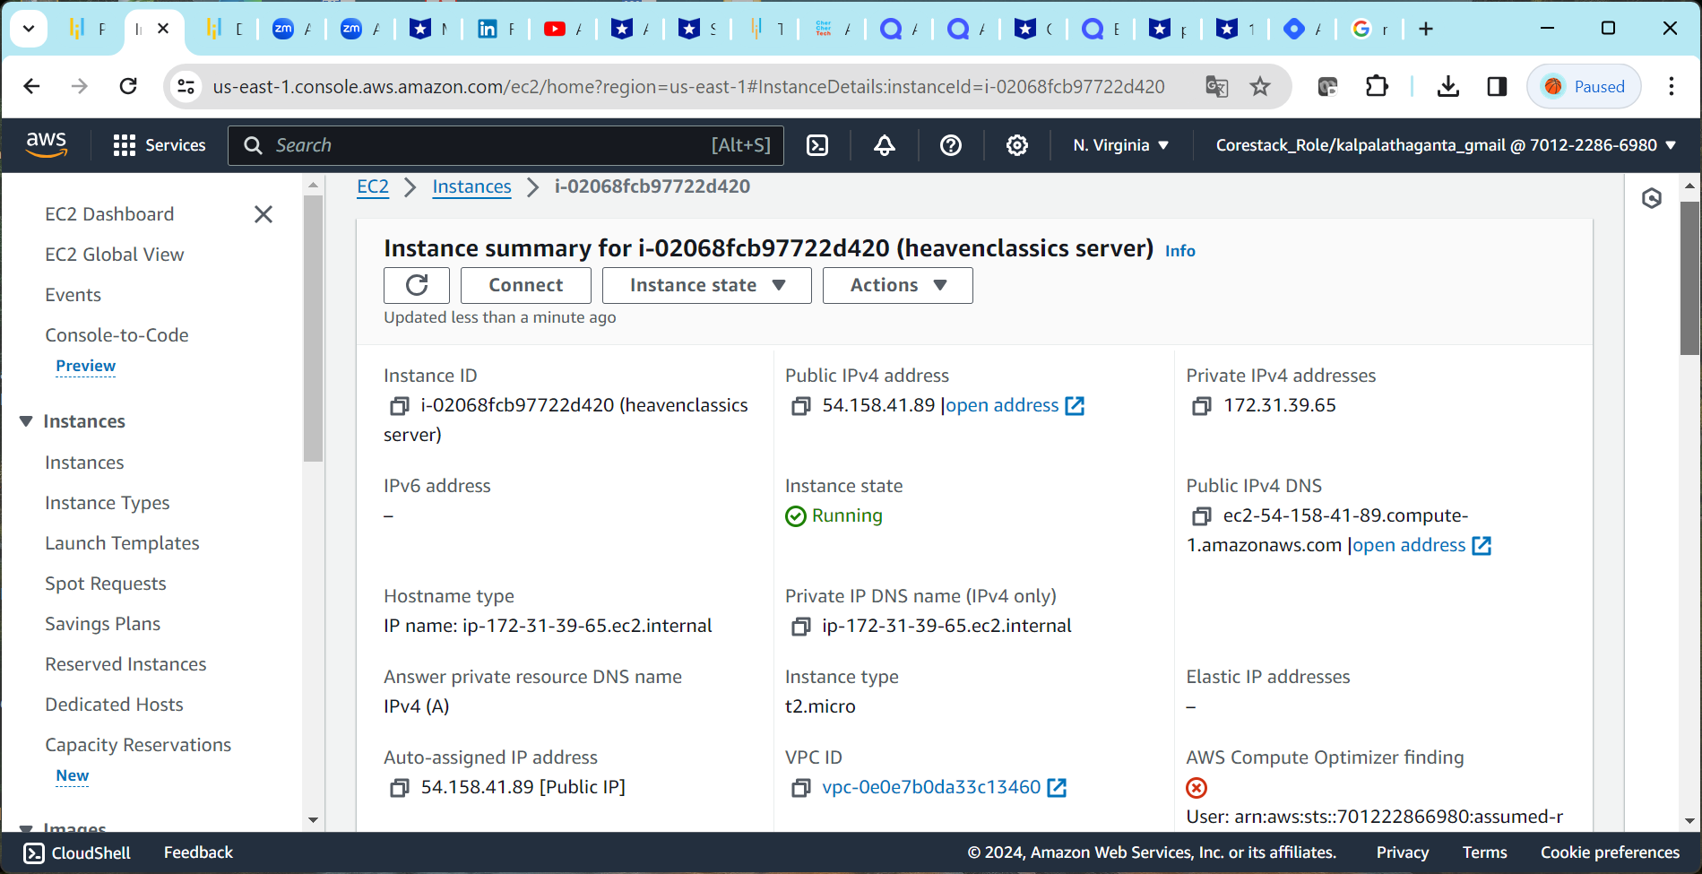

Source code- Access the launched instance via SSH, steps given below
- Click on the Instance ID and then click on Connect .
- Open an SSH client.
- Locate your private key file. The key used to launch this instance is heavenskey.pem
- Run this command, if necessary, to ensure your key is not publicly viewable.
chmod 400 "heavenskey.pem"
- Connect to your instance using its Public DNS:
ec2-31-172-39-65.compute-1.amazonaws.com

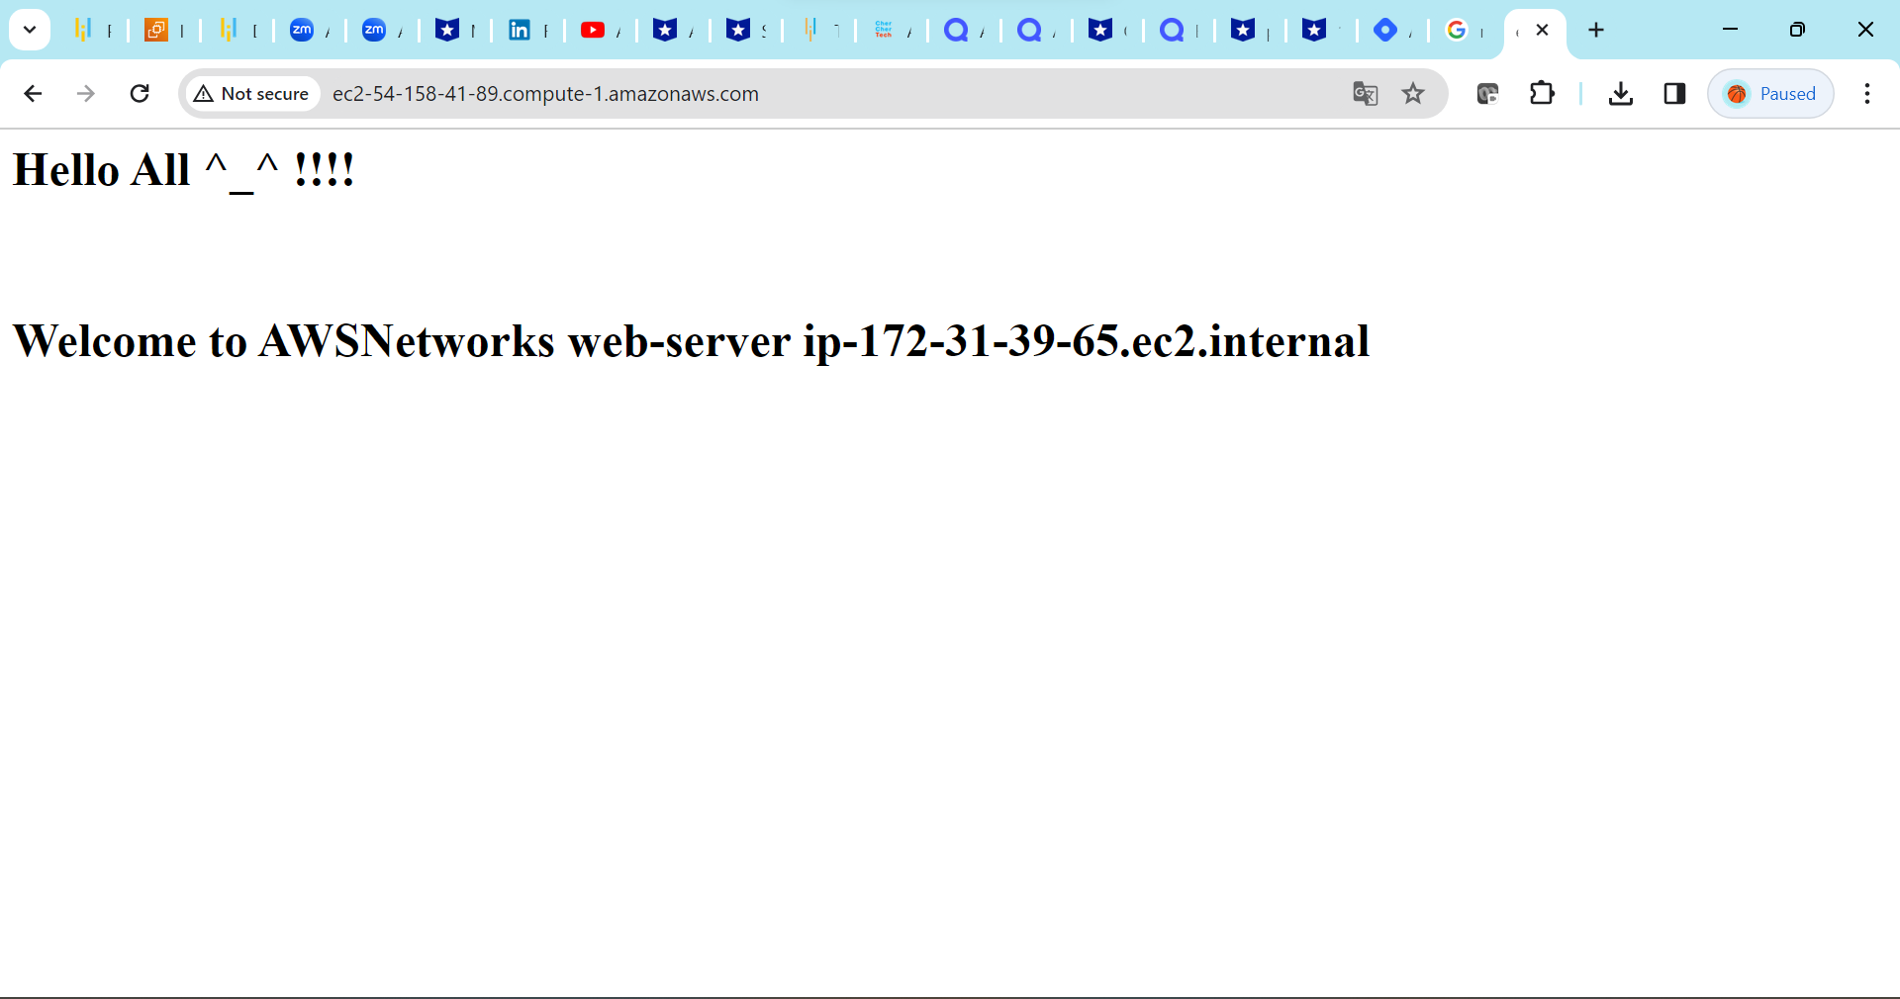

EC2 Provisioning Using Terraform
Tools Used
- Terraform
- AWS CLI

Terraform Configuration
File: `main.tf`

```hcl
provider "aws" {
region = "ap-south-1"
}

resource "aws_instance" "terraform_ec2" {
ami = "ami-0f58b397bc5c1f2e8"
instance_type = "t2.micro"

tags = {
Name = "terraform-ec2"
}
}
Terraform was used to provision an EC2 instance using Infrastructure as Code (IaC).
Commands used:
- terraform init [initialize the terraform]
- terraform plan [Creates an execution plan showing what Terraform will change before applying it]
- terraform apply [ Applies the changes defined in the Terraform configuration]
Terraform successfully created an EC2 instance using Infrastructure as Code.

