Fake Account Detection using Deep Learning Models and Behaviour Analysis

B. Naveen Kumar Latha K
Department of CSE - Data Science Department of CSE - Data Science
Geethanjali College of Engineering & Technology Geethanjali College of Engineering & Technology
Hyderabad, Telangana, India Hyderabad, Telangana, India
22r11a6752@gcet.edu.in 22r11a6767@gcet.edu.in

- Varsha K. Srilatha
Department of CSE - Data Science Assistant Professor
Geethanjali College of Engineering & Technology Department of CSE - Data Science Hyderabad, Telangana, India Geethanjali College of Engineering & Technology 22r11a6785@gcet.edu.in Hyderabad, Telangana, India
ksrilatha.cse@gcet.edu.in

Abstract—Social media platforms have experienced rapid growth in recent years, enabling large-scale communication and information sharing. However, the increasing number of fake accounts and automated bots has created serious challenges such as misinformation, spam, and manipulation of online discussions. Detecting such accounts has become essential for maintaining the credibility and security of social media ecosystems. This paper proposes a multi-signal artificial intelligence framework for detecting fake social media accounts by analyzing behavioral patterns, interaction networks, and textual content. The system integrates multiple techniques including Long Short-Term Memory (LSTM) for behavioral activity analysis, Transformer models for temporal pattern detection, graph-based analysis for identifying coordinated bot clusters, and Natural Language Processing methods for evaluating content authenticity. The outputs from these modules are combined through a fusion mechanism to generate a final risk score and classification. The proposed system provides an efficient and scalable approach for identifying suspicious accounts and improving the reliability of social media platforms.

Keywords—Fake account detection, social media bots, behavioral analysis, graph analysis, natural language processing, multi-signal AI

INTRODUCTION

Social media platforms have become one of the most widely used communication channels for sharing information, connecting with communities, and expressing opinions. Platforms such as Twitter, Facebook, and Instagram host billions of users who generate large volumes of online content every day. While these platforms offer significant benefits for communication and information exchange, they also face serious challenges due to the increasing presence of fake accounts and automated bots. These malicious accounts are often used to spread misinformation, manipulate engagement metrics, promote spam content, and influence public opinion in online discussions.
The detection of fake accounts has therefore become an important problem for maintaining the integrity and reliability of social media ecosystems. Traditional detection methods mainly rely on rule-based systems and simple machine learning models that analyze limited features such as posting frequency, follower counts, or account metadata. Although these approaches can identify basic spam accounts, they are often ineffective against sophisticated bots and coordinated bot networks that mimic human behavior. The complexity of user interactions, diverse content types, and dynamic activity patterns make fake account detection a challenging task..
To address these challenges, this work proposes a multi-signal artificial intelligence framework for detecting fake social media accounts by combining behavioral analysis, interaction graph intelligence, and content authenticity evaluation. The proposed system analyzes user activity patterns using deep learning models such as Long Short-Term Memory (LSTM) networks, evaluates temporal activity patterns using Transformer-based models, and detects coordinated bot clusters through graph-based interaction analysis. In addition, Natural Language Processing techniques are used to evaluate textual content and identify suspicious patterns. By integrating multiple intelligence layers through a fusion mechanism, the proposed system improves the reliability and robustness of fake account detection in large-scale social media environments.

LITERATURE REVIEW

As social media platforms continue to grow in popularity, the detection of fake accounts and automated bots has emerged as a crucial research area in cybersecurity and data science. Rule-based and classical machine learning methods that examined simple attributes of an account, such as the rate of posts, comparisons of followers to following, account age, and engagement patterns, defined earlier research. Support Vector Machines (SVM), Decision Trees, and Random Forest classification algorithms were common machine learning methods used to identify genuine users against suspect accounts. These approaches though effective for detecting simple spam accounts, relied on painstakingly crafted features and had little adaptability to the evolving behaviours of bots.
Other widely researched methods for detecting coordinated malicious activities on social networks have been graph-based. They include relational or interaction networks among users based on followers, mentions, replies, and shared content. Community detection, graph clustering, and network centrality have been used to identify suspicious classes of accounts, which interact with each other frequently. More unusually, researchers have started leveraging Graph Neural Networks (GNNs) for learning structural patterns from social network graphs. Such models have been shown to be effective in identifying coordinated clusters of bots and interaction structures. However, network topology is the priority of graph-based techniques while ignoring the behavioral activity signals and textual information.
Another line of work is based on behavioral and temporal analysis of the activities of the users. Posting patterns, activity frequency, and response time are some of the criteria considered distinctive for automated bot activities. Long short-term memory recurrent neural networks have found significant application in sequential pattern learning and anomaly detection in user behavior over time. Similarly, Transformer-based architectures have been used to capture long-range dependencies and detect abnormal activity bursts in the timeline. Although these models improve a detection of the automated behavior, they are usually weak when being used alone without integrating other signals such as network or content information.
Natural Language Processing (NLP) techniques have also been employed to analyze social media text contents. Some of the most common examples include the TF-IDF algorithm, text similarity analysis, sentiment analysis, and language models that can detect suspected bots or automatic posting patterns. The analysis of the content of published texts makes it possible to identify the presence of suspicious automated posting of messages with the same text content, advertising materials, or coordinated falsification of information. However, content-based approaches fail when bots generate human-like text or copy and forward posts from other users.
Due to these limitations, recent research emphasizes the need for multi-signal detection frameworks that combine various sources of information, including behavioral activity, networks of interactions, and textual content. The combination allows for detection to capture patterns that are not possible with analyzing a single facet of data. Thus, motivated by these findings, a multi-signal artificial intelligence framework that integrates behavioral intelligence, graph-based, and content evaluation to boost the reliability and robustness of fake social media accounts is proposed in this work.

EXISTING SYSTEM

Limited Feature Analysis
Many existing detection systems rely on a small set of manually designed features such as account age, number of posts, and follower statistics. These features are often insufficient to capture the complex behavioral patterns exhibited by automated bots. As bots become more advanced and imitate human activity more closely, rule-based systems and simple classifiers fail to accurately distinguish between genuine and fake accounts.
- Lack of Multi-Signal Integration
Most existing systems focus on a single type of signal, such as behavioral patterns, network structure, or textual content. For example, some approaches analyze user activity patterns while others focus only on interaction graphs or content analysis. However, fake accounts often manipulate multiple aspects of social media activity simultaneously. Systems that rely on only one signal may miss important indicators of coordinated malicious behavior..
- Difficulty in Detecting Coordinated Bot Networks
Another limitation of current detection systems is their inability to effectively identify groups of coordinated bots. Many fake accounts operate as part of organized networks that interact with each other to amplify misinformation or artificially increase engagement. Traditional machine learning models that analyze individual accounts often fail to capture the structural relationships between users within these networks

Poor Scalability and Adaptability
Existing detection systems also face challenges when applied to large-scale social media platforms with millions of users and continuously evolving behaviors. Models trained on specific datasets may not generalize well to new environments or unseen attack patterns. As a result, their performance decreases when deployed in real-world scenarios where user behavior and bot strategies constantly change.

PROPOSED SYSTEM

The proposed system introduces a multi-signal artificial intelligence framework for detecting fake social media accounts by integrating behavioral analysis, interaction graph intelligence, and content authenticity evaluation. Unlike traditional detection methods that rely on a single signal or limited features, the proposed framework analyzes multiple aspects of user activity to improve detection accuracy and robustness. The system processes social media activity data, extracts behavioral and structural features, and applies deep learning models to identify suspicious accounts. The outputs from different intelligence modules are combined through a fusion mechanism to generate a final risk score and classification.Some of the key features of the proposed system include:

Behavioral Activity Analysis
The system analyzes user activity patterns such as posting frequency, interaction behavior, and temporal activity sequences. A Long Short-Term Memory (LSTM) model is used to capture sequential patterns in user behavior and detect anomalies that may indicate automated or bot-like activity.

Temporal Pattern Modeling
To capture long-term dependencies and irregular activity bursts, Transformer-based models are applied to analyze temporal patterns in user activity. These models help identify unusual posting intervals and repetitive behavioral patterns that are commonly associated with automated accounts.

Interaction Graph Intelligence
The proposed system constructs interaction graphs representing relationships between users based on followers, mentions, replies, and shared interactions. Graph-based analysis techniques are used to detect suspicious communities and coordinated bot clusters that exhibit abnormal connectivity patterns.

Content Authenticity Evaluation
The textual content generated by social media accounts is analyzed using Natural Language Processing techniques such as TF-IDF. These methods help detect repetitive messages, promotional content, and suspicious linguistic patterns that are commonly associated with automated bots and fake accounts.

Fusion-Based Risk Scoring
The outputs from the behavioral, temporal, graph, and content intelligence modules are combined using a fusion mechanism to generate a final risk score and fake probability. This multi-signal approach improves detection reliability by integrating multiple sources of information instead of relying on a single detection signal.

SYSTEM ARCHITECTURE

The proposed fake social media account detection system is designed as a modular multi-signal intelligence framework that integrates behavioral analysis, graph-based interaction analysis, content evaluation, and fusion-based decision making into a unified pipeline. The architecture processes user activity data from social media platforms, extracts relevant behavioral and structural features, and applies machine learning models to identify suspicious accounts. The framework is implemented using Python-based technologies and deep learning libraries to support scalable analysis and visualization.
The architecture consists of three major layers: data processing layer, intelligence analysis layer, and decision fusion layer. These layers work together to transform raw social media activity data into meaningful detection results that help identify fake accounts and coordinated bot networks

Components
- Data Collection and Preprocessing Module:
The first component of the system is responsible for collecting and preprocessing social media activity data. The system processes user activity logs, interaction records, and textual content generated by accounts. Data preprocessing includes cleaning the dataset, removing noise, handling missing values, and extracting relevant features such as posting frequency, interaction counts, and content features. The processed data is then prepared for analysis by the intelligence modules.

Behavioral Intelligence Module
This module analyzes sequential patterns in user activity. User behavior such as posting frequency, interaction timing, and engagement patterns is converted into time-based activity sequences. A Long Short-Term Memory (LSTM) model is used to capture sequential behavioral patterns and detect anomalies that may indicate automated or bot-like activity.

Temporal Pattern Analysis Module
To capture long-term dependencies and irregular posting patterns, the system applies Transformer-based models that analyze temporal activity patterns. These models detect unusual activity bursts, repetitive posting intervals, and abnormal behavioral trends that may suggest automated account behavior

Interaction Graph Analysis Module
The system constructs interaction graphs representing relationships between users through followers, mentions, replies, and shared interactions. Each node in the graph represents a user account, while edges represent interactions between users. Graph-based analysis techniques are applied to identify suspicious clusters and coordinated bot networks that exhibit abnormal connectivity patterns.

Content Analysis Module
The content analysis module evaluates textual information generated by users. Natural Language Processing techniques such as TF-IDF are used to extract textual features from posts and messages. This module helps identify repetitive content, spam-like messages, and coordinated misinformation patterns that are commonly associated with fake accounts.
- Fusion and Decision Module
The final component of the system integrates outputs from all intelligence modules. The behavioral score, graph-based indicators, and content authenticity scores are combined using a fusion mechanism to generate a final risk score. Based on this score, the system classifies accounts as genuine or suspicious. The results are displayed through an interactive dashboard that allows visualization of account behavior and bot cluster detection.
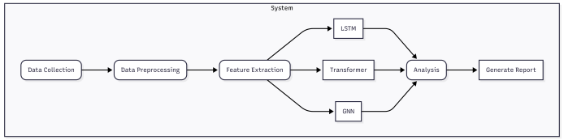

Fig. 1. System Architecture

OUTPUT SCREENS

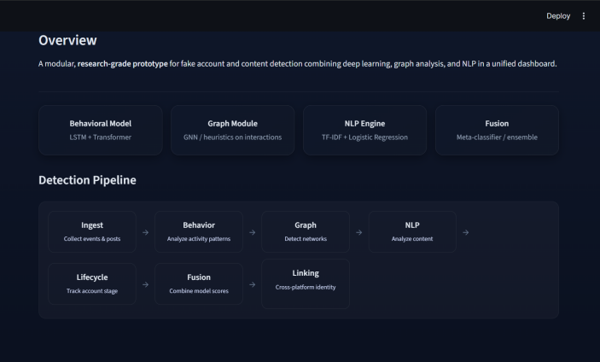
Fig. 2. Dashboard

RESULTS

The proposed Fake Social Media Account Detection system was evaluated using synthetic interaction and activity datasets integrated within the prototype dashboard. The system combines multiple analytical components including behavioral modeling (LSTM and Transformer), graph-based interaction analysis, content analysis using NLP techniques, lifecycle stage detection, and an ensemble fusion module.
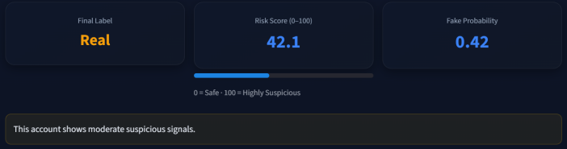
Fig. 3. Single fake account detection.
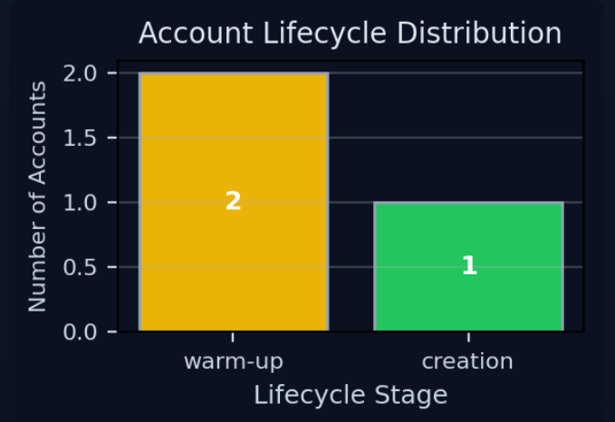
Fig. 4. Account life cycle stage representation

The final fusion model aggregates signals from behavioral, graph, and content modules to compute a risk score and classification label for each account. Experimental results demonstrate that combining multiple analytical perspectives significantly improves detection capability compared to using a single feature type. The system successfully identifies suspicious behavior patterns and highlights potentially coordinated accounts within the analyzed network.

CONCLUSION

This project presents a unified system for detecting fake and coordinated social media accounts by combining multiple analytical approaches, including behavioral modeling using LSTM and Transformer networks, graph-based interaction analysis, NLP-based content evaluation, lifecycle stage detection, and a fusion-based decision module. By analyzing user activity patterns, interaction networks, and textual features together, the system is able to identify suspicious behavior and estimate the likelihood that an account is automated or part of a coordinated campaign. The fusion model integrates signals from all modules to produce a final risk score and classification, improving detection reliability compared to single-method approaches. The developed prototype demonstrates how multi-modal machine learning techniques can be applied to monitor suspicious activity, detect bot clusters, and analyze cross-platform account similarity, providing a scalable framework for strengthening the integrity and security of social media platforms.

REFERENCES

- E. Ferrara, O. Varol, C. Davis, F. Menczer, and A. Flammini, “The rise of social bots,” Communications of the ACM, vol. 59, no. 7, pp. 96–104, 2016.

- S. Kudugunta and E. Ferrara, “Deep neural networks for bot detection,” Information Sciences, vol. 467, pp. 312–322, 2018..

- C. Cresci, R. Di Pietro, M. Petrocchi, A. Spognardi, and M. Tesconi, “The paradigm-shift of social spambots: Evidence, theories, and tools for the arms race,” in Proceedings of the 26th International World Wide Web Conference (WWW), 2017, pp. 963–972.

- W. L. Hamilton, R. Ying, and J. Leskovec, “Inductive representation learning on large graphs,” in Advances in Neural Information Processing Systems (NeurIPS), 2017, pp. 1024–1034.

- T. Kipf and M. Welling, “Semi-supervised classification with graph convolutional networks,” in Proceedings of the International Conference on Learning Representations (ICLR), 2017.
- A. Vaswani et al., “Attention is all you need,” in Advances in Neural Information Processing Systems (NeurIPS), 2017.

- S. Hochreiter and J. Schmidhuber, “Long short-term memory,” Neural Computation, vol. 9, no. 8, pp. 1735–1780, 1997.

- J. Devlin, M. Chang, K. Lee, and K. Toutanova, “BERT: Pre-training of deep bidirectional transformers for language understanding,” in Proceedings of NAACL-HLT, 2019.

