## Student: Latham, Ryan

## Course: ISMG 6020

## Project: 3A

### FormatException

**Form Area:** In either Weight or Age text boxes.

**Data:** anything that is nonnumeric.

**Example:** ss34%e

**Expected Result**

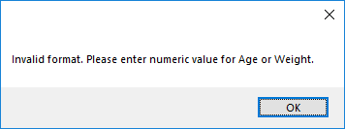

### Overflow Exception

**Form Area:** Random number input for demonstration text box.

**Data:** any number > 255

**Example:** 256

**Expected Result**

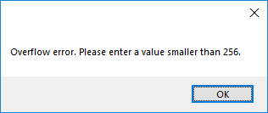

### DivideByZeroException*

**Form Area:** Random number input for demonstration text box.

**Data:** 0

**Example:** 0

**Expected Result**

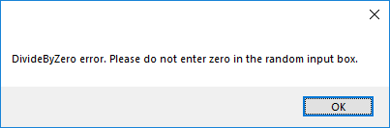

### A custom exception that you make up – Valid Age Range

**Form Area:** Age text box.

**Data:** Anything < 18 or > 125

**Example:** 7 or 132

**Expected Result**

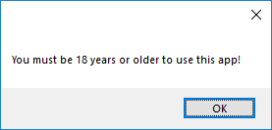 **or**

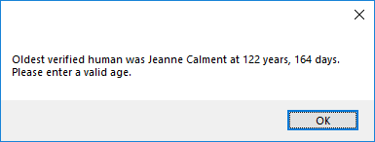

### A custom exception that you make up – Valid Weight Range

**Form Area:** Weight text box.

**Data:** Anything < 90 or > 499

**Example:** 89 or 500

**Expected Result**

