2403a51243

latha

Batch 11

**AI-ASSISTED-CODING**

Assignment-9.3

**Task Description#1:**

**Basic Docstring Generation**

• Write python function to return sum of even and odd numbers in the given list.

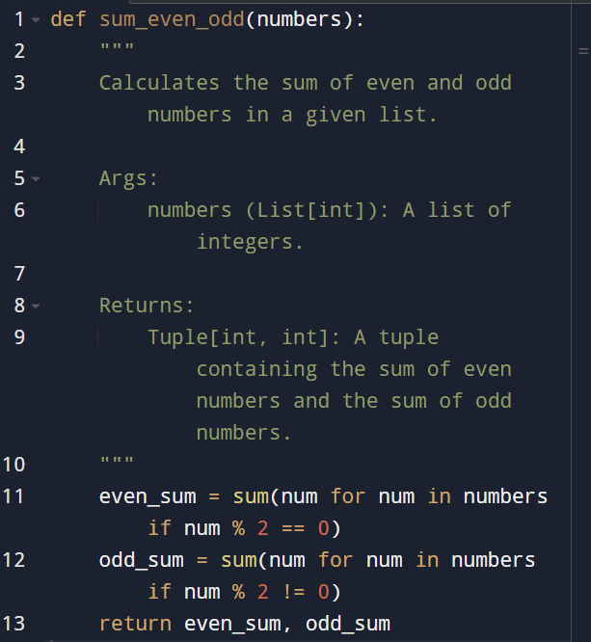

• Incorporate manual docstring in code with Google Style

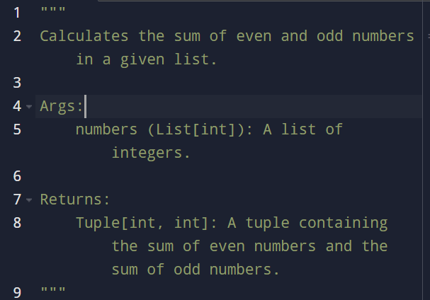

• Use an AI-assisted tool (e.g., Copilot, Cursor AI) to generate a docstring describing the function

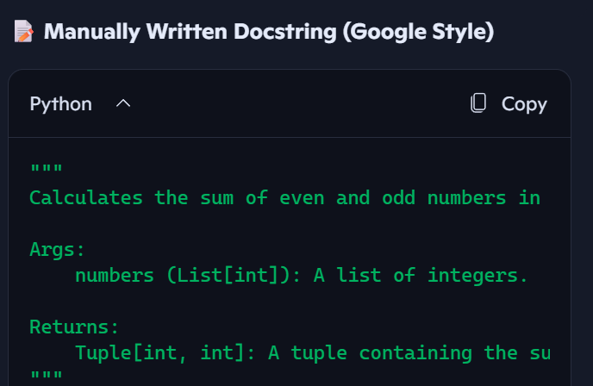

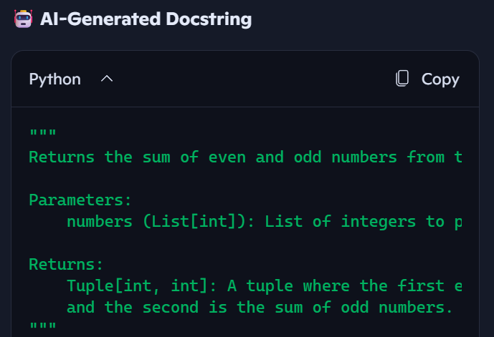

• Compare the AI-generated docstring with your manually written one.

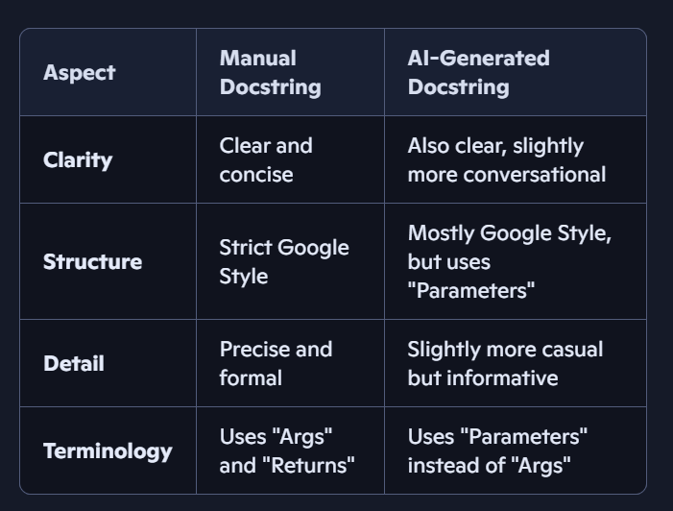

**Task Description#2 :**

**Automatic Inline Comments**• Write python program for sru_student class with attributes like name, roll no., hostel_status and fee_update method and display_details method.

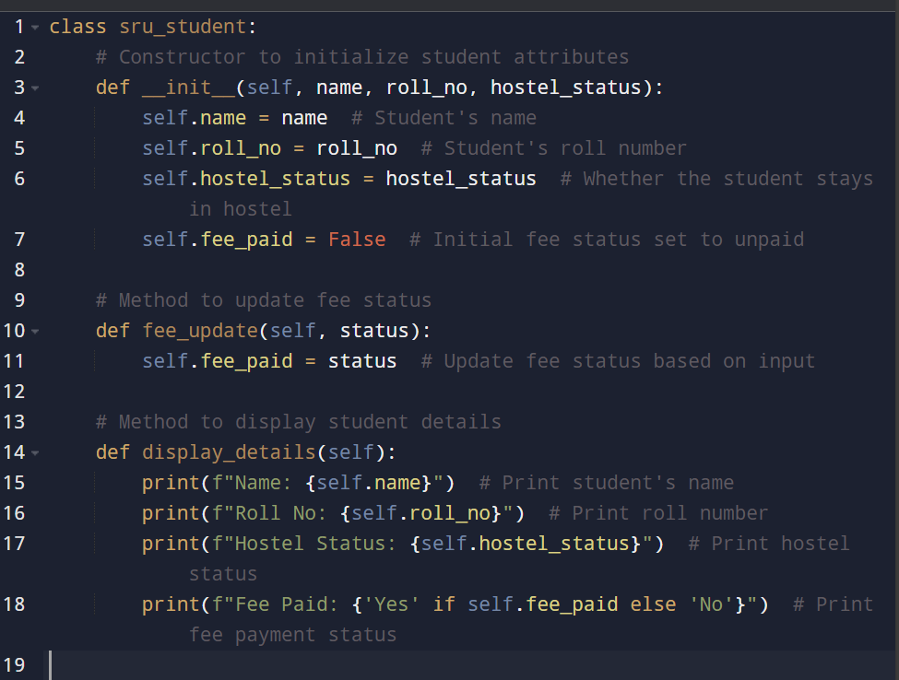

• Write comments manually for each line/code block

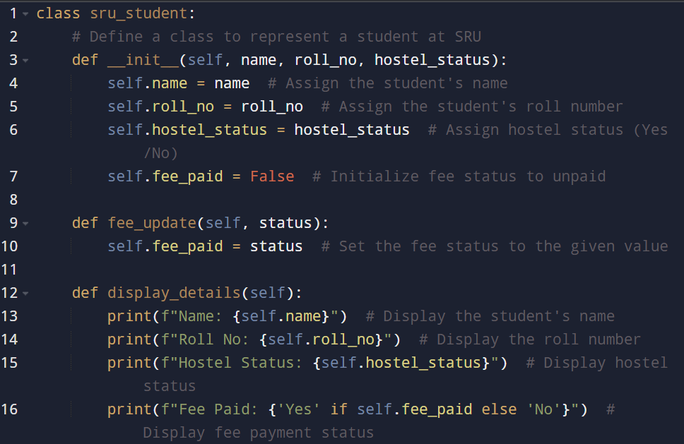

• Compare the AI-generated comments with your manually written one

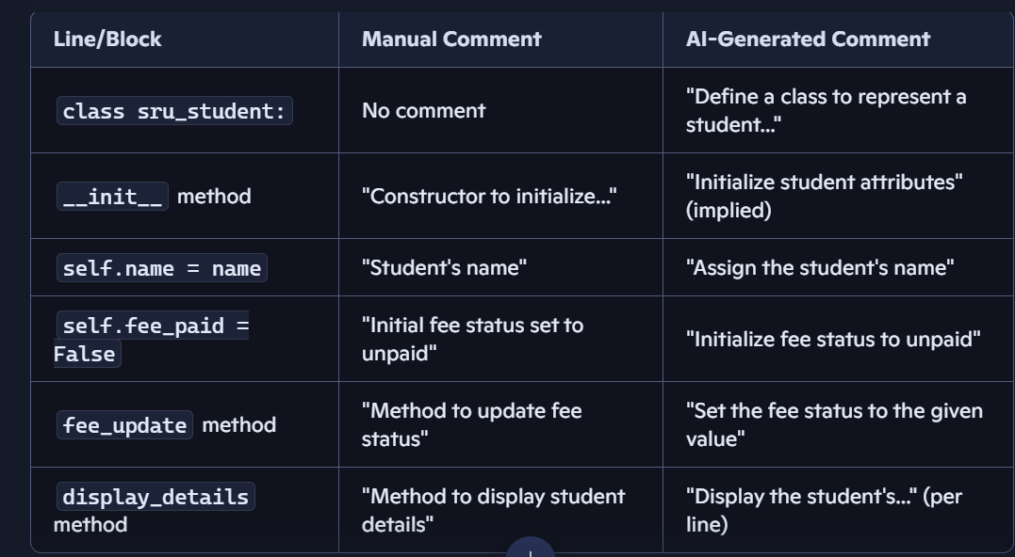

**Task Description#3:**  
• Write a Python script with 3–4 functions (e.g., calculator: add, subtract, multiply,  
divide). 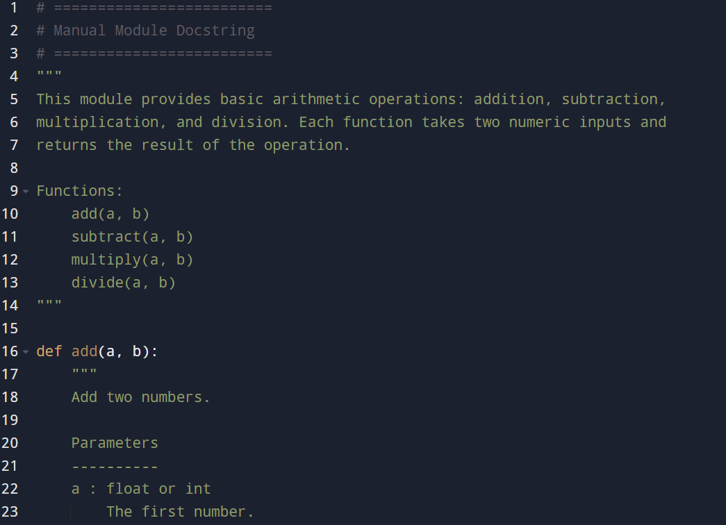

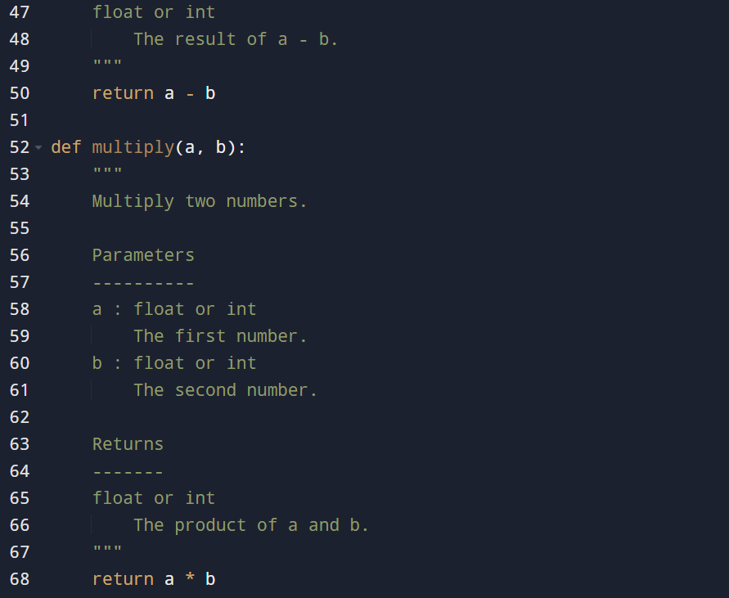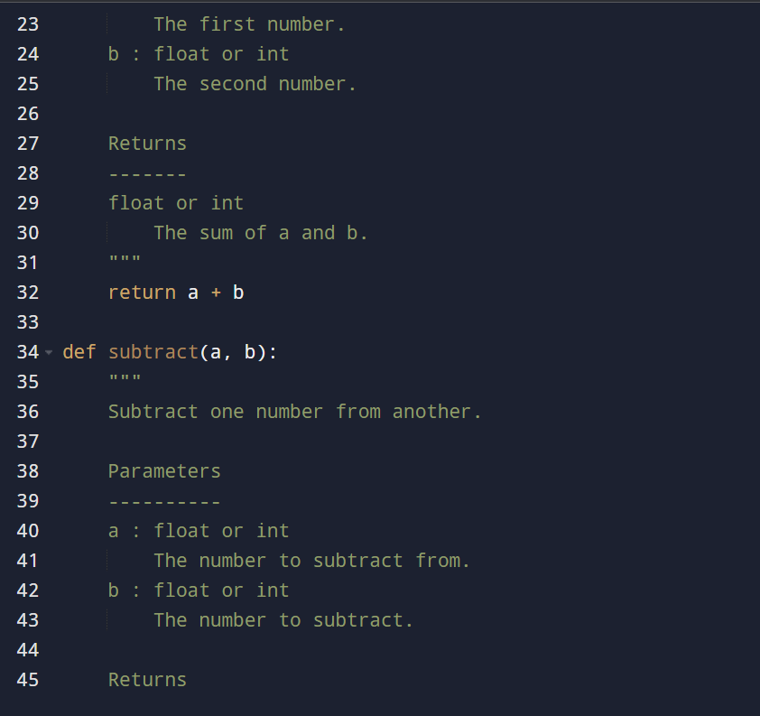

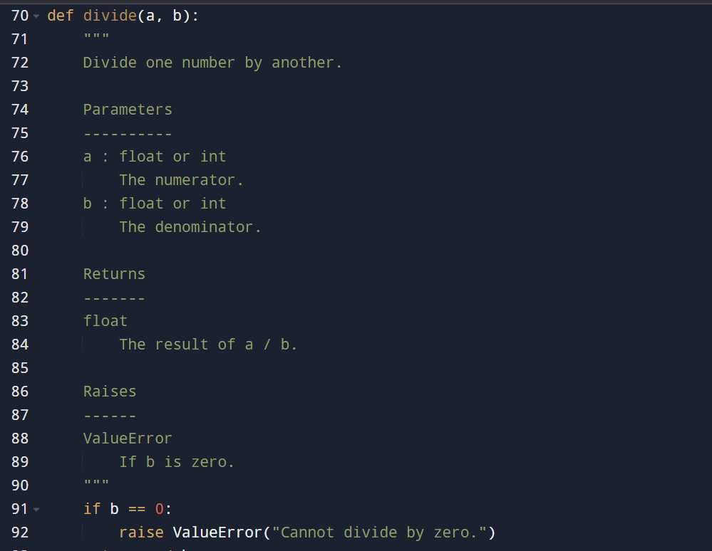

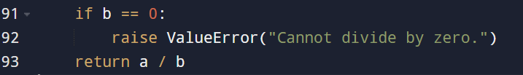

• Incorporate manual docstring in code with Numpy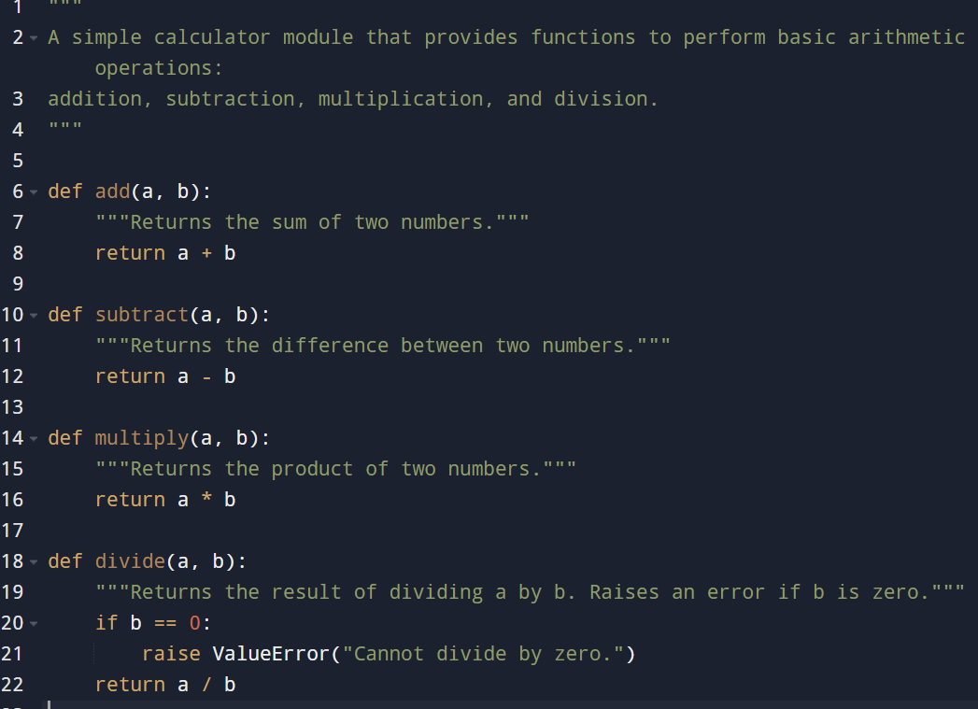  
• Use AI assistance to generate a module-level docstring + individual function  
docstrings.

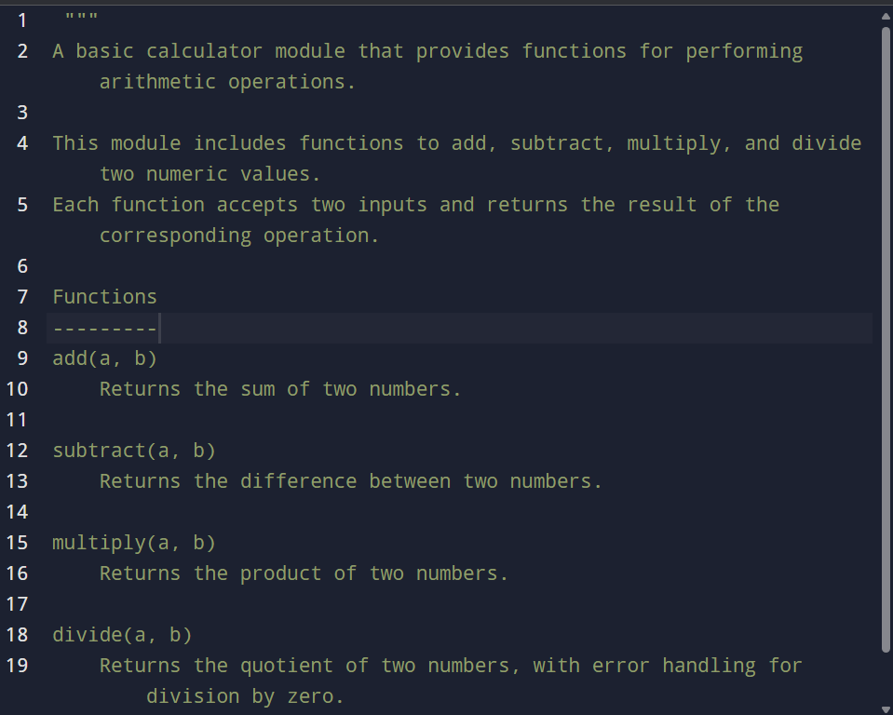  
• Compare the AI-generated docstring with your manually written one

