**Data Engineering – Final Assessment**

Contents

**Data Dictionary** 2

**Tasks** 3

**Data Discovery , Processing , Loading Task** 3

Task 1 3

a. Move the dataset onto S3 3

b. Create Glue database and 2 crawlers to crawl CSV and JSON folders using AWS CLI 3

c. Run the Crawlers from CLI 6

d. Confirm the data has been able to query from Athena 8

Task 2 10

a. Deploy GLUE locally 10

b. Develop a GLUE JOB to convert the CSV files to PARQUET from Local Development 11

c. Create crawler using AWS CLI on the parquet file 17

d. Run the crawler from CLI and confirm data from Athena 18

Task 3 20

a. Run basic Analytical queries on the dataset using Athena from AWS Console 20

**Data Versioning Task** 21

Task 1 Create a repository in github and upload the dataset 21

a. Create a repository in github.com 21

Task 2 Generate the Reports and upload them to github 22

a. Clone the repository that you created in task 1 22

b. Create a branch for this activity ,Create a file with all the queries from the above tasks 22

c. List the version history ( commit history) , status of the local repository 23

d. Commit the file to the branch 23

e. Push the changes to the github 24

**___________________**

**Pushpalatha Anbarasu**

# **Data Dictionary**

Register on AWS Data Exchange for COVID-19 data set

# **Tasks**

# **Data Discovery , Processing , Loading Task**

## Task 1

### a. Move the dataset onto S3

### b. Create Glue database and 2 crawlers to crawl CSV and JSON folders using AWS CLI

aws glue create-database --database-input Name="de-project-db" (creating database)

**Create crawler for CSV files**

aws glue create-crawler --name CSVCrawler --role Gluerole --database-name de-project-db --targets S3Targets=[{Path='s3://capstoneproject-bucket/covid19testing/states_current_csv/'},{Path='s3://capstoneproject-bucket/covid19testing/states_daily_csv/'},{Path='s3://capstoneproject-bucket/covid19testing/states_info_csv/'},{Path='s3://capstoneproject-bucket/covid19testing/states_screenshots_csv/'},{Path='s3://capstoneproject-bucket/covid19testing/us_current_csv/'},{Path='s3://capstoneproject-bucket/covid19testing/us_daily_csv/'}]



**Create crawler for JSON files**

aws glue create-crawler --name JSONCrawler --role Gluerole --database-name de-project-db --targets S3Targets=[{Path='s3://capstoneproject-bucket/covid19testing/us_daily_json/'},{Path='s3://capstoneproject-bucket/covid19testing/states_current_json/'},{Path='s3://capstoneproject-bucket/covid19testing/states_daily_json/'},{Path='s3://capstoneproject-bucket/covid19testing/states_info_json/'},{Path='s3://capstoneproject-bucket/covid19testing/states_screenshots_json/'},{Path='s3://capstoneproject-bucket/covid19testing/us_current_json/'}] 

### c. Run the Crawlers from CLI

**Start the CSVCrawler**

aws glue start-crawler --name CSVCrawler

**Start the JSONCrawler**

aws glue start-crawler --name JSONCrawler

### d. Confirm the data has been able to query from Athena

## Task 2

### a. Deploy GLUE locally

**Docker image for AWS Glue version 4.0**



docker run -it -v %WORKSPACE_LOCATION%\aws:/home/glue_user/.aws -v %WORKSPACE_LOCATION%:/home/glue_user/workspace/ -e AWS_PROFILE=%PROFILE_NAME% -e DISABLE_SSL=true --rm -p 4041:4041 -p 18081:18081 --name glue_pyspark amazon/aws-glue-libs:glue_libs_4.0.0_image_01 pyspark

Visual Studio code with AWS glue image container

### b. Develop a GLUE JOB to convert the CSV files to PARQUET from Local Development

**Pyspark script for GLUE job:**

**csv_to_parquet.py (uploaded this script in S3 location)**

import sys

from awsglue.transforms import *

from awsglue.utils import getResolvedOptions

from awsglue.context import GlueContext

from pyspark.context import SparkContext

from pyspark.sql import SparkSession

# Create a SparkContext

sc = SparkContext()

# Create a GlueContext and SparkSession

glueContext = GlueContext(sc)

spark = glueContext.spark_session

# Get the job parameters

args = getResolvedOptions(sys.argv, ['JOB_NAME', 'input_path', 'output_path'])

# Get the input and output paths from Glue job parameters

input_path = args['input_path']

output_path = args['output_path']

# Read the CSV files from the input path using Spark DataFrame API

input_data = spark.read.csv(input_path, header=True, inferSchema=True)

# Convert CSV to Parquet

input_data.write.parquet(output_path)

# Stop the SparkContext

sc.stop()

**Glue job creation**

aws glue create-job --name "CSVToParquetJob" --role "arn:aws:iam::667409444611:role/project-glue-service-role" --command '{"Name": "glueetl", "ScriptLocation":"s3://capstoneproject-bucket/covid19testing/csv_to_parquet.py"}'

Glue job “CSVTOParquerJob” got created using CLI and details of it can be seen using “aws glue get-jobs”

**Run the job**

aws glue start-job-run --job-name CSVToParquetJob --arguments '{"--input_path": "s3://capstoneproject-bucket/covid19testing/states_current_csv/", "--output_path": "s3://capstoneproject-bucket/covid19testing/parquet-output-folder/"}'

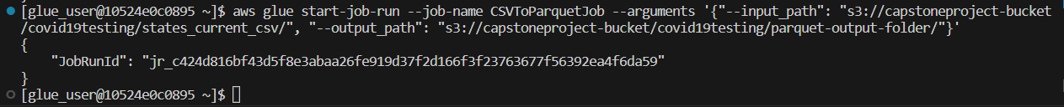

**Job run status**

aws glue get-job-run --job-name CSVToParquetJob --run-id jr_c424d816bf43d5f8e3abaa26fe919d37f2d166f3f23763677f56392ea4f6da59

Job run status from AWS GLUE STUDIO

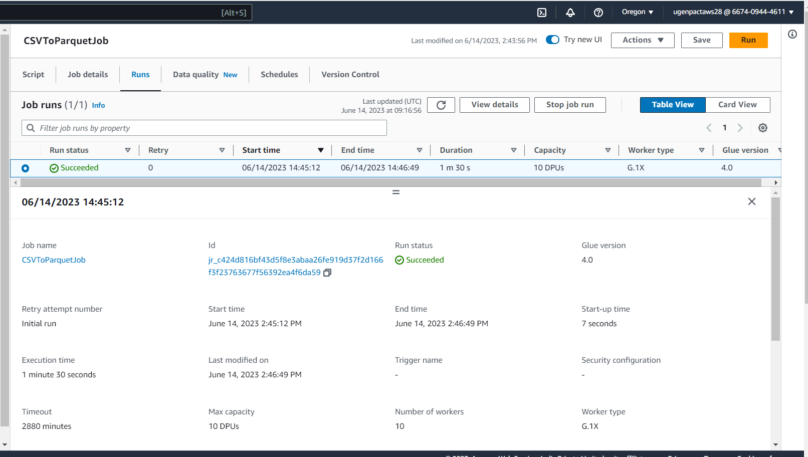

**Run the same job for multiple csv files in the source**

S3 folder with multiple csv files

aws glue start-job-run --job-name CSVToParquetJob --arguments '{"--input_path": "s3://capstoneproject-bucket/covid19testing/dataset/csv/", "--output_path": "s3://capstoneproject-bucket/covid19testing/parquet-output-multiple_files/"}' A computer code on a black background

**Job run status**

### c. Create crawler using AWS CLI on the parquet file

**Create PARQUETCrawler**

aws glue create-crawler --name PARQUETCrawler --role Gluerole --database-name de-project-db --targets S3Targets=[{Path='s3://capstoneproject-bucket/covid19testing/parquet-output-folder/output/'}] ****aws glue get-crawler --name PARQUETCrawler (details of crawler)A screenshot of a computer program

### d. Run the crawler from CLI and confirm data from Athena

aws glue start-crawler --name PARQUETCrawler

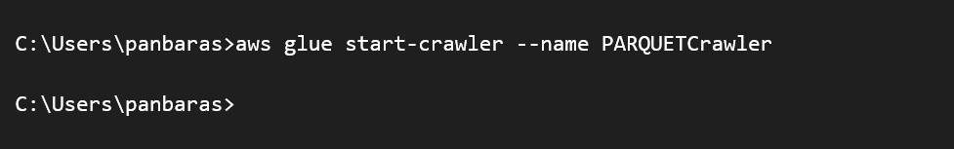

aws glue get-crawler-metrics (1 table got created by PARQUETcrawler)

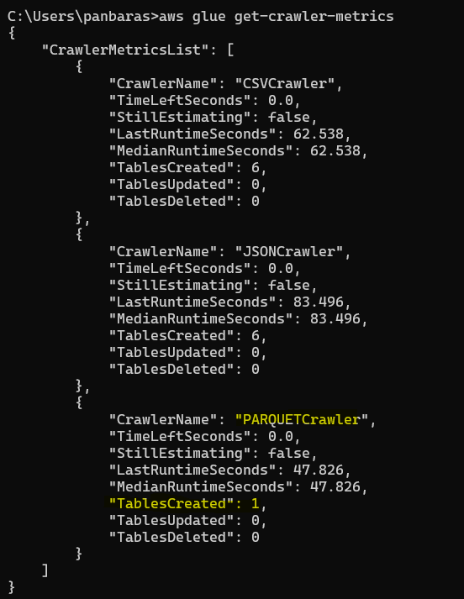

**

## Task 3

### a. Run basic Analytical queries on the dataset using Athena from AWS Console

# **Data Versioning Task**

## Task 1 Create a repository in github and upload the dataset

### a. Create a repository in github.com

Uploaded datasets to repository

## Task 2 Generate the Reports and upload them to github

### a. Clone the repository that you created in task 1

git clone <https://github.com/lathatirupur/Capstone_Project.git>

### b. Create a branch for this activity ,Create a file with all the queries from the above tasks

git branch capstone_project_activity

git checkout capstone_project_activity

### c. List the version history ( commit history) , status of the local repository

Display the commit history of the repository

git log

Status of the local repository

git status

### d. Commit the file to the branch

Add the file to the staging area

git add Capstone_project_queries.txt



git status

Commit the changes

git commit -m "Add project queries file"

### e. Push the changes to the github

git push origin activity-branch

Version history

Change got pushed to activity-branch in github

