PreFeeder 2500
Prefeeding Machine Dereeler Type

s
 |  | PreFeeder 2500
Concept |  | The Prefeeder 2500 is an ideal feeding system for wire, small cables and tubing. The feeding process allows rapid acceleration of the spool while maintaining low forces on the material being fed. The dereeler is available in a 40 or 80 kg version, based on maximum spool weight. The PreFeeder 2500 is easy to integrate into a processing line. The feed adjustment is carried out through a dancer arm type accumulator or through the optional PreFeederControl 2 wire loop control system. Both systems are optimally aligned to the capability of the PreFeeder 2500.  The PreFeeder 2500 is the perfect solution for feeding a wide spectrum of materials.
Function |  | - Quick loading and unloading  - Simple assembly of the required control elements for easy handling  - Adjustable forward and backward feed direction |  | 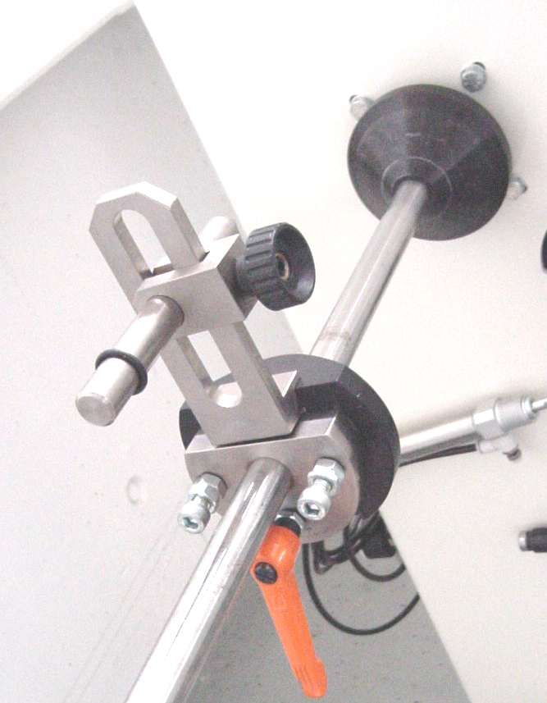
Customer Benefit |  | The PreFeeder 2500 is the perfect accessory for feeding material to downstream processing machines. The PreFeeder 2500 feeds material at variable speeds while minimizing stress to the material being fed. This allows the material to be processed with the highest possible precision by downstream processing units.  Easy handling when changing spools allows for short changeover time.
Options |  | - Prefeeder loop control with the PreFeederControl 2 instead of the standard dancer arm type accumulator.
 |  | Applications
With Dancer Arm Accumulator
- Flexible wire, cable and tubing up to 12 mm in diameter
With PreFeederControl 2
- Less flexible materials and larger cables in diameter
  Technical Specifications
 |  | Prefeeder 2500, 40 kg version | PreFeeder 2500, 80 kg version
Spool Diameter |  | 630 mm | 630 mm
Spool Width |  | 475 mm | 475 mm
Spool Arbor Diameter |  | 25 mm | 30 mm
Wire Spool Weight |  | 40 kg | 80 kg
Wire Diameter |  | Up to 12 mm with dancer arm accumulator  Larger cables in diameter with the PreFeederControl 2
Dereeling Speed |  | Maximum 265 rpm
Wire Tension Force |  | Minimum 2.5 N (depending on the wire)
Wire Storage Volume |  | Maximum 5.3 m (when using 9 pulleys on dancer arm accumulator)
Power Supply |  | 100/115 VAC at 60 Hz or 240 VAC at 50 Hz
CE - Conformity |  | The PreFeeder 2500 fully complies with all CE and EMC equipment guidelines relative to mechanical and electrical safety and electromagnetic compatibility.
Important Note |  | Schleuniger recommends that wire samples be submitted in cases where there is doubt as to the processing capabilities of a particular machine.

