Practical No:- 1
Aim:- Android Activity Lifecycle
MainActivity.java:-
package com.example.activitylifecycle;
import android.os.Bundle;
import android.util.Log;
import androidx.activity.EdgeToEdge;
import androidx.appcompat.app.AppCompatActivity;
import androidx.core.graphics.Insets;
import androidx.core.view.ViewCompat;
import androidx.core.view.WindowInsetsCompat;
public class MainActivity extends AppCompatActivity {
@Override
protected void onCreate(Bundle savedInstanceState) {
super.onCreate(savedInstanceState);
EdgeToEdge.enable(this);
setContentView(R.layout.activity_main);
ViewCompat.setOnApplyWindowInsetsListener(findViewById(R.id.main), (v, insets) -> {
Insets systemBars = insets.getInsets(WindowInsetsCompat.Type.systemBars());
v.setPadding(systemBars.left, systemBars.top, systemBars.right, systemBars.bottom);
Log.d("lifecycle", "onCreate invoked");
return insets;
});
}
@Override
protected void onStart() {
super.onStart();
Log.d("lifecycle", "onStart invoked");
}
@Override
protected void onResume() {
super.onResume();
Log.d("lifecycle", "onResume invoked");
}
@Override
protected void onPause() {
super.onPause();
Log.d("lifecycle", "onPause invoked");
}
@Override
protected void onStop() {
super.onStop();
Log.d("lifecycle", "onStop invoked");
}
@Override
protected void onRestart() {
super.onRestart();
Log.d("lifecycle", "onRestart invoked");
}
@Override
protected void onDestroy() {
super.onDestroy();
Log.d("lifecycle", "onDestroy invoked");
}
}
Output:-
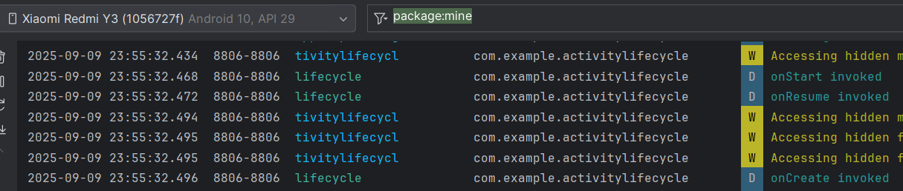
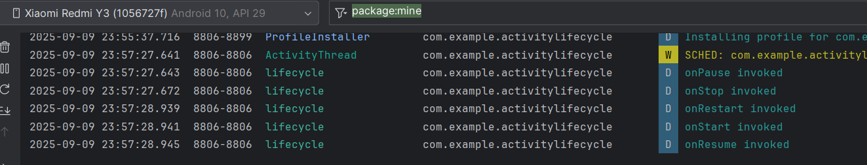

PRACTICAL -2
Aim:- Basic Layout (Text Display)
activity_main.xml:-
<?xml version="1.0" encoding="utf-8"?>
<androidx.constraintlayout.widget.ConstraintLayout
xmlns:android="http://schemas.android.com/apk/res/android"
xmlns:app="http://schemas.android.com/apk/res-auto"
xmlns:tools="http://schemas.android.com/tools"
android:layout_width="match_parent"
android:layout_height="match_parent"
tools:context=".MainActivity">
<EditText
android:id="@+id/editTextTextPersonName"
android:layout_width="0dp"
android:layout_height="wrap_content"
android:ems="10"
android:hint="Enter Text"
android:inputType="textPersonName"
app:layout_constraintEnd_toEndOf="parent"
app:layout_constraintStart_toStartOf="parent"
app:layout_constraintTop_toTopOf="parent"
app:layout_constraintBottom_toTopOf="@+id/button"
app:layout_constraintHorizontal_bias="0.5"
app:layout_constraintVertical_bias="0.3" />
<Button
android:id="@+id/button"
android:layout_width="wrap_content"
android:layout_height="wrap_content"
android:text="Submit"
app:layout_constraintEnd_toEndOf="parent"
app:layout_constraintStart_toStartOf="parent"
app:layout_constraintBottom_toBottomOf="parent"
app:layout_constraintTop_toBottomOf="@+id/editTextTextPersonName"
app:layout_constraintHorizontal_bias="0.5"
app:layout_constraintVertical_bias="0.5" />
<TextView
android:id="@+id/textview1"
android:layout_width="wrap_content"
android:layout_height="wrap_content"
android:text="Result will appear here"
app:layout_constraintTop_toBottomOf="@+id/button"
app:layout_constraintBottom_toBottomOf="parent"
app:layout_constraintStart_toStartOf="parent"
app:layout_constraintEnd_toEndOf="parent"
app:layout_constraintHorizontal_bias="0.5"
app:layout_constraintVertical_bias="0.5" />
</androidx.constraintlayout.widget.ConstraintLayout>

MainActivity.java:-
package com.example.display98;
import android.os.Bundle;
import androidx.appcompat.app.AppCompatActivity;
import android.view.View;
import android.widget.Button;
import android.widget.EditText;
import android.widget.TextView;
public class MainActivity extends AppCompatActivity {
private Button btn1;
private EditText ed1;
private TextView txt1;
@Override
protected void onCreate(Bundle savedInstanceState) {
super.onCreate(savedInstanceState);
setContentView(R.layout.activity_main);
// Initialize the views
btn1 = findViewById(R.id.button);
ed1 = findViewById(R.id.editTextTextPersonName);
txt1 = findViewById(R.id.textview1);
// Set up the button click listener
btn1.setOnClickListener(new View.OnClickListener() {
@Override
public void onClick(View view) {
// Get the text from EditText
String msg = ed1.getText().toString();
// Check if the EditText is not empty
if (!msg.isEmpty()) {
txt1.setText(msg);
} else {
txt1.setText("Please enter text");
}
}
});
}
}

OUTPUT :
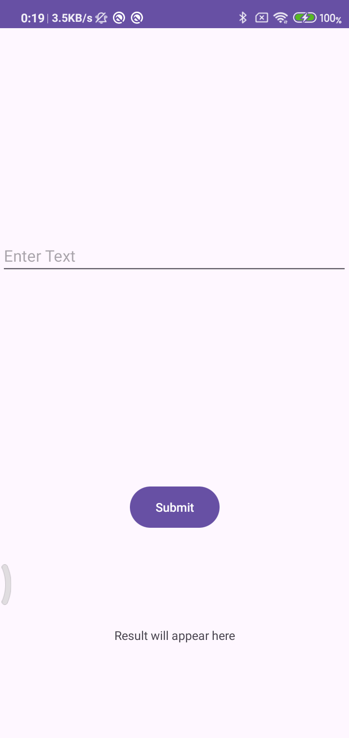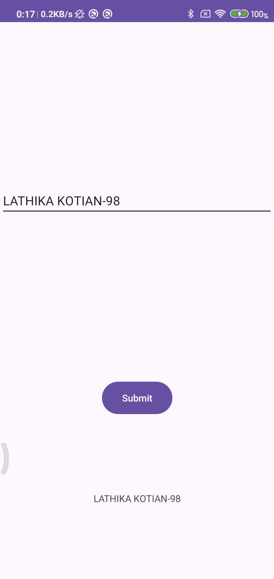

PRACTICAL -3
Aim:- TOAST
Code:-
Activity_main.xml
<?xml version="1.0" encoding="utf-8"?>
<androidx.constraintlayout.widget.ConstraintLayout
xmlns:android="http://schemas.android.com/apk/res/android"
xmlns:app="http://schemas.android.com/apk/res-auto"
xmlns:tools="http://schemas.android.com/tools"
android:layout_width="match_parent"
android:layout_height="match_parent"
tools:context=".MainActivity">
<Button
android:id="@+id/Div"
android:layout_width="wrap_content"
android:layout_height="wrap_content"
android:text="Toast"
android:onClick="Toaster"
app:layout_constraintTop_toTopOf="parent"
app:layout_constraintBottom_toBottomOf="parent"
app:layout_constraintStart_toStartOf="parent"
app:layout_constraintEnd_toEndOf="parent"/>
</androidx.constraintlayout.widget.ConstraintLayout>
MainActivity.java:-
package com.example.toastapp98;
import android.os.Bundle;
import androidx.appcompat.app.AppCompatActivity;
import android.view.View;
import android.widget.Toast;
public class MainActivity extends AppCompatActivity {
@Override
protected void onCreate(Bundle savedInstanceState) {
super.onCreate(savedInstanceState);
setContentView(R.layout.activity_main);
}
public void Toaster(View view) {
Toast.makeText(this, "Welcome Lathika-98 to Toast Application", Toast.LENGTH_LONG).show();
}
}

OUTPUT :
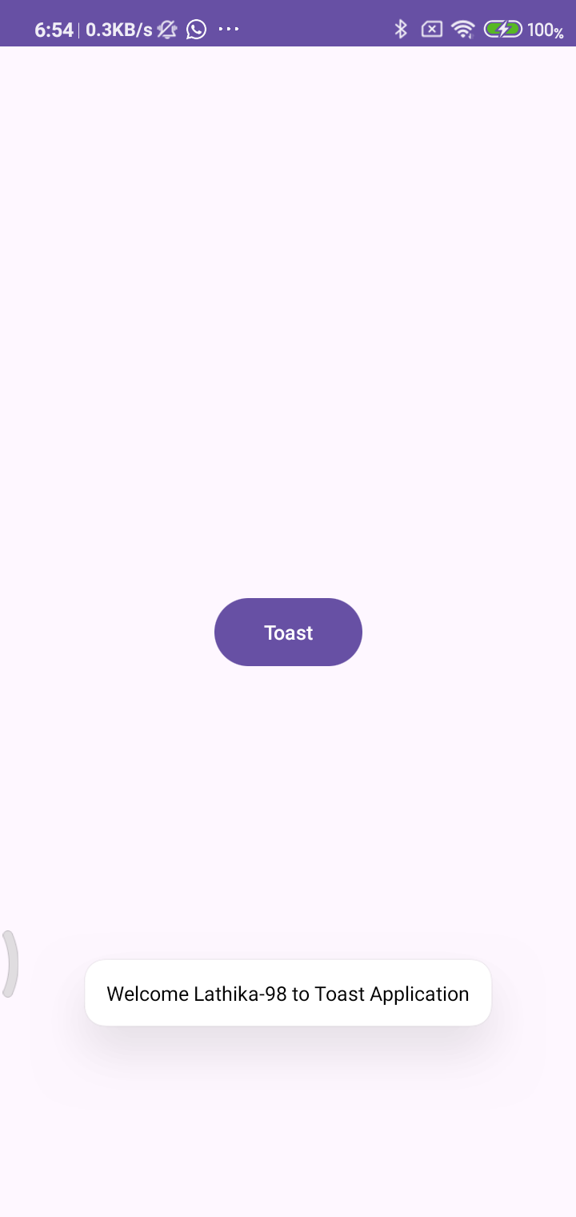

Practical No:- 4
Aim:- Create a Simple Calculator.
CODE :
activity_main.xml:-
<?xml version="1.0" encoding="utf-8"?>
<LinearLayout xmlns:android="http://schemas.android.com/apk/res/android"
xmlns:tools="http://schemas.android.com/tools"
android:layout_width="match_parent"
android:layout_height="match_parent"
android:orientation="vertical"
android:gravity="center"
android:padding="16dp"
tools:context=".MainActivity">
<TextView
android:id="@+id/textView"
android:layout_width="match_parent"
android:layout_height="wrap_content"
android:layout_marginBottom="60sp"
android:textSize="24sp"
android:textStyle="bold"
android:gravity="center"
android:text="SIMPLE CALCULATOR - Lathika(98)" />
<EditText
android:id="@+id/num1"
android:layout_width="match_parent"
android:layout_height="wrap_content"
android:hint="Enter Value 1"
android:inputType="numberDecimal" />
<EditText
android:id="@+id/num2"
android:layout_width="match_parent"
android:layout_height="wrap_content"
android:hint="Enter Value 2"
android:inputType="numberDecimal" />
<LinearLayout
android:layout_width="match_parent"
android:layout_height="wrap_content"
android:orientation="horizontal"
android:gravity="center"
android:layout_marginTop="16dp">
<Button
android:layout_width="wrap_content"
android:layout_height="wrap_content"
android:text="ADD"
android:onClick="ADD" />
<Button
android:layout_width="wrap_content"
android:layout_height="wrap_content"
android:text="SUB"
android:layout_marginStart="16dp"
android:onClick="SUB" />
</LinearLayout>
<LinearLayout
android:layout_width="match_parent"
android:layout_height="wrap_content"
android:orientation="horizontal"
android:gravity="center"
android:layout_marginTop="8dp">
<Button
android:layout_width="wrap_content"
android:layout_height="wrap_content"
android:text="MUL"
android:onClick="MUL" />
<Button
android:layout_width="wrap_content"
android:layout_height="wrap_content"
android:text="DIV"
android:layout_marginStart="16dp"
android:onClick="DIV" />
</LinearLayout>
<TextView
android:id="@+id/result"
android:layout_width="match_parent"
android:layout_height="wrap_content"
android:text="Result will appear here"
android:textSize="18sp"
android:textStyle="bold"
android:layout_marginTop="24dp"
android:gravity="center" />
</LinearLayout>
MainActivity.java:-
package com.example.simplecalculator98;
import android.os.Bundle;
import androidx.appcompat.app.AppCompatActivity;
import android.view.View;
import android.widget.EditText;
import android.widget.TextView;
import android.widget.Toast;
public class MainActivity extends AppCompatActivity {
EditText num1, num2;
TextView result;
@Override
protected void onCreate(Bundle savedInstanceState) {
super.onCreate(savedInstanceState);
setContentView(R.layout.activity_main);
num1 = findViewById(R.id.num1);
num2 = findViewById(R.id.num2);
result = findViewById(R.id.result);
}
private Float[] getInputs() {
String val1 = num1.getText().toString().trim();
String val2 = num2.getText().toString().trim();
if (val1.isEmpty() || val2.isEmpty()) {
Toast.makeText(this, "Please enter both numbers", Toast.LENGTH_SHORT).show();
return null;
}
try {
return new Float[]{Float.parseFloat(val1), Float.parseFloat(val2)};
} catch (NumberFormatException e) {
Toast.makeText(this, "Invalid input", Toast.LENGTH_SHORT).show();
return null;
}
}
public void ADD(View view) {
Float[] inputs = getInputs();
if (inputs != null) {
float sum = inputs[0] + inputs[1];
result.setText("Result: " + sum);
}
}
public void SUB(View view) {
Float[] inputs = getInputs();
if (inputs != null) {
float diff = inputs[0] - inputs[1];
result.setText("Result: " + diff);
}
}
public void MUL(View view) {
Float[] inputs = getInputs();
if (inputs != null) {
float product = inputs[0] * inputs[1];
result.setText("Result: " + product);
}
}
public void DIV(View view) {
Float[] inputs = getInputs();
if (inputs != null) {
if (inputs[1] == 0) {
result.setText("Error: Cannot divide by zero");
} else {
float quotient = inputs[0] / inputs[1];
result.setText("Result: " + quotient);
}
}
}
}
OUTPUT :-
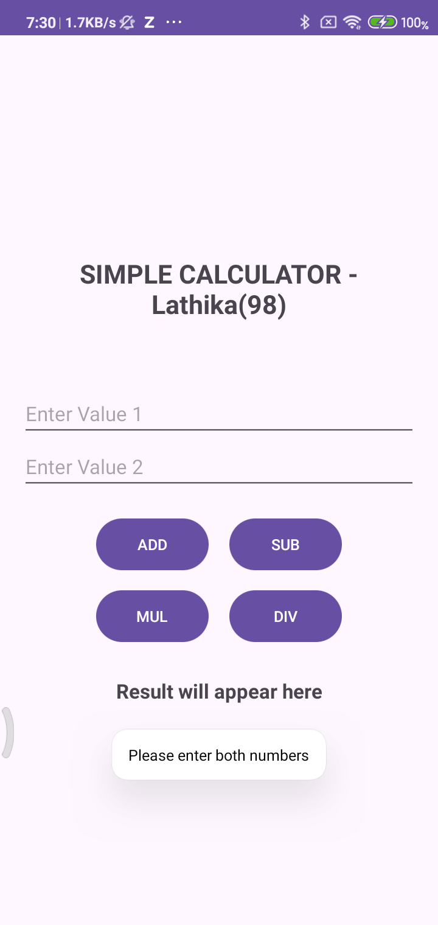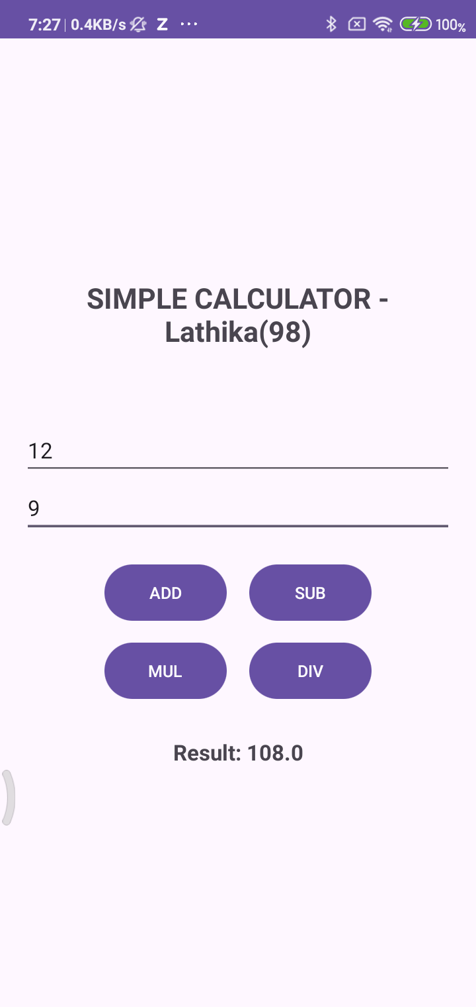
PRACTICAL NO : 5
Aim:- INTENT
Activity_main.xml:-
<?xml version="1.0" encoding="utf-8"?>
<androidx.constraintlayout.widget.ConstraintLayout xmlns:android="http://schemas.android.com/apk/res/android"
xmlns:app="http://schemas.android.com/apk/res-auto"
xmlns:tools="http://schemas.android.com/tools"
android:layout_width="match_parent"
android:layout_height="match_parent"
tools:context=".MainActivity">
<LinearLayout
android:layout_width="match_parent"
android:layout_height="match_parent"
android:orientation="vertical"
android:gravity="center"
tools:context=".MainActivity">
<Button android:id="@+id/Div"
android:layout_width="wrap_content"
android:layout_height="wrap_content"
android:onClick="Intenter"
android:text="Next Page >"
tools:layout_editor_absoluteX="209dp"
tools:layout_editor_absoluteY="377dp"
/>
</LinearLayout>
</androidx.constraintlayout.widget.ConstraintLayout>

Activity_main2.xml:-
<?xml version="1.0" encoding="utf-8"?>
<androidx.constraintlayout.widget.ConstraintLayout xmlns:android="http://schemas.android.com/apk/res/android"
xmlns:app="http://schemas.android.com/apk/res-auto" xmlns:tools="http://schemas.android.com/tools" android:layout_width="match_parent" android:layout_height="match_parent" tools:context=".MainActivity2">
<TextView
android:id="@+id/textView"
android:layout_width="282dp"
android:layout_height="60dp"
android:text="Welcome to new page Lathika Kotian -98"
android:textSize="22sp"
android:textStyle="bold"
app:layout_constraintBottom_toBottomOf="parent"
android:gravity="center"
app:layout_constraintEnd_toEndOf="parent"
app:layout_constraintStart_toStartOf="parent"
app:layout_constraintTop_toTopOf="parent" />
<TextView
android:id="@+id/textView2"
android:layout_width="wrap_content"
android:layout_height="wrap_content"
android:text="Intent Works!"
android:textSize="32sp"
android:textStyle="bold"
app:layout_constraintBottom_toTopOf="@+id/textView"
app:layout_constraintEnd_toEndOf="parent"
app:layout_constraintHorizontal_bias="0.498"
app:layout_constraintStart_toStartOf="parent"
app:layout_constraintTop_toTopOf="parent"
app:layout_constraintVertical_bias="0.87" />
</androidx.constraintlayout.widget.ConstraintLayout>

MainActivity.java:-
package com.example.intentapplication98;
import android.os.Bundle;
import android.content.Intent;
import androidx.appcompat.app.AppCompatActivity;
import android.view.View;
public class MainActivity extends AppCompatActivity
{
@Override
protected void onCreate(Bundle savedInstanceState) {
super.onCreate(savedInstanceState);
setContentView(R.layout.activity_main);
}
public void Intenter(View view){
Intent intent = new Intent(this,MainActivity2.class);
startActivity(intent);
}
}

MainActivity2.java:-
package com.example.intentapplication98;
import android.os.Bundle;
import androidx.appcompat.app.AppCompatActivity;
public class MainActivity2 extends AppCompatActivity {
@Override
protected void onCreate(Bundle savedInstanceState) {
super.onCreate(savedInstanceState);
setContentView(R.layout.activity_main2);
}
}
OUTPUT :-
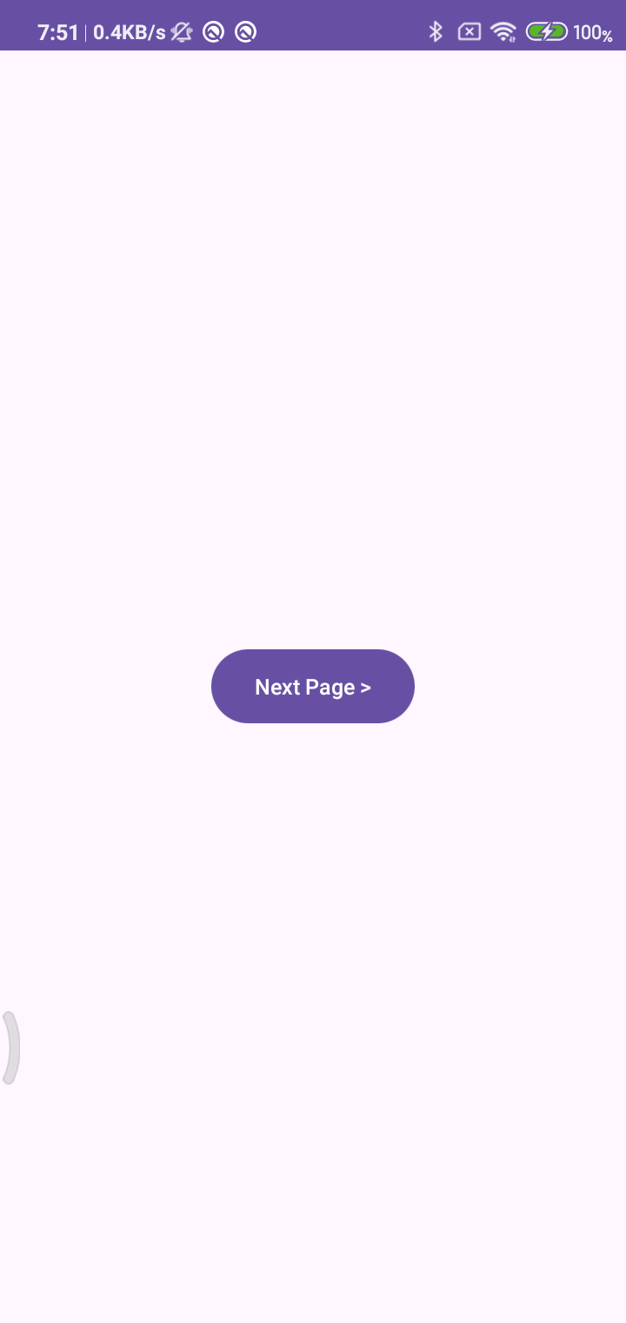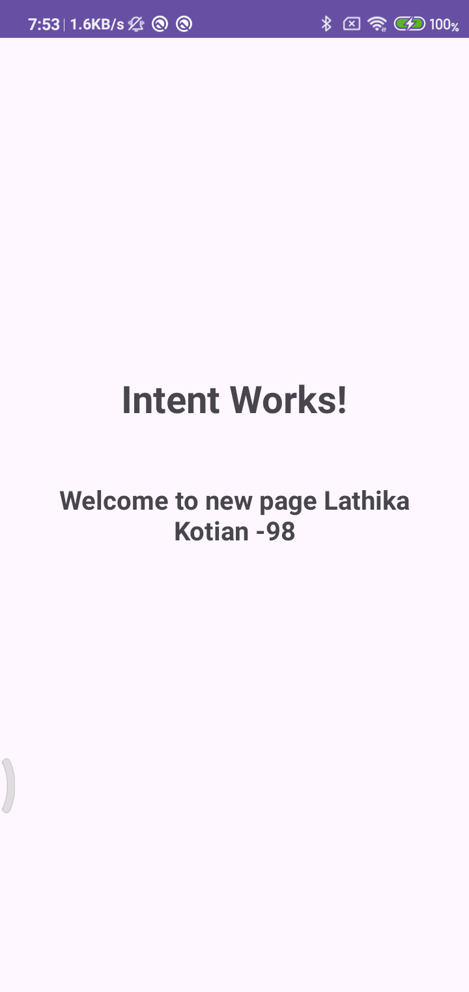

Practical No:- 6
Aim:- Create an Android application to display registration form using UI components.
CODE :
Activity_main.xml:-
<?xml version="1.0" encoding="utf-8"?>
<androidx.constraintlayout.widget.ConstraintLayout xmlns:android="http://schemas.android.com/apk/res/android"
xmlns:app="http://schemas.android.com/apk/res-auto"
xmlns:tools="http://schemas.android.com/tools"
android:layout_width="match_parent"
android:layout_height="match_parent"
tools:context=".MainActivity">
<TextView
android:id="@+id/tv1"
android:layout_width="335dp"
android:layout_height="78dp"
android:layout_marginLeft="61dp"
android:layout_marginTop="29dp"
android:layout_marginRight="49dp"
android:text="Registration Form"
android:gravity="center"
android:textSize="36sp"
app:layout_constraintBottom_toBottomOf="parent"
app:layout_constraintLeft_toLeftOf="parent"
app:layout_constraintRight_toRightOf="parent"
app:layout_constraintTop_toTopOf="parent"
app:layout_constraintVertical_bias="0.0" />
<TextView
android:id="@+id/tv_name"
android:layout_width="wrap_content"
android:layout_height="57dp"
android:layout_marginStart="32dp"
android:layout_marginTop="60dp"
android:text="Enter Name: "
android:textSize="24sp"
app:layout_constraintStart_toStartOf="parent"
app:layout_constraintTop_toBottomOf="@+id/tv1" />
<EditText
android:id="@+id/et1"
android:layout_width="160dp"
android:layout_height="wrap_content"
android:layout_marginStart="12dp"
android:layout_marginTop="64dp"
android:layout_marginEnd="28dp"
android:ems="10"
android:inputType="textPersonName"
android:textSize="24sp"
app:layout_constraintBottom_toBottomOf="parent"
app:layout_constraintEnd_toEndOf="parent"
app:layout_constraintStart_toEndOf="@+id/tv_name"
app:layout_constraintTop_toBottomOf="@+id/tv1"
app:layout_constraintVertical_bias="0.0" />
<RadioGroup
android:id="@+id/radiogp1"
android:layout_width="wrap_content"
android:layout_height="wrap_content"
app:layout_constraintLeft_toLeftOf="parent"
app:layout_constraintRight_toRightOf="parent"
app:layout_constraintTop_toBottomOf="@id/et1">
</RadioGroup>
<CheckBox
android:id="@+id/cb1"
android:layout_width="wrap_content"
android:layout_height="wrap_content"
android:layout_marginTop="28dp"
android:text="PHP"
android:textSize="20sp"
app:layout_constraintEnd_toEndOf="parent"
app:layout_constraintHorizontal_bias="0.094"
app:layout_constraintStart_toStartOf="parent"
app:layout_constraintTop_toBottomOf="@+id/rb1" />
<CheckBox
android:id="@+id/cb2"
android:layout_width="wrap_content"
android:layout_height="wrap_content"
android:layout_marginTop="16dp"
android:text="Java"
android:textSize="20sp"
app:layout_constraintEnd_toEndOf="parent"
app:layout_constraintHorizontal_bias="0.095"
app:layout_constraintStart_toStartOf="parent"
app:layout_constraintTop_toBottomOf="@+id/cb1" />
<RatingBar
android:id="@+id/ratingbar1"
android:layout_width="wrap_content"
android:layout_height="wrap_content"
app:layout_constraintBottom_toBottomOf="parent"
app:layout_constraintEnd_toEndOf="parent"
app:layout_constraintStart_toStartOf="parent"
app:layout_constraintTop_toTopOf="parent"
app:layout_constraintVertical_bias="0.727" />
<Button
android:id="@+id/b1"
android:layout_width="150dp"
android:layout_height="60dp"
android:layout_marginTop="25dp"
android:text="Submit"
android:textSize="20sp"
app:layout_constraintBottom_toBottomOf="parent"
app:layout_constraintEnd_toEndOf="parent"
app:layout_constraintStart_toStartOf="parent"
app:layout_constraintTop_toBottomOf="@+id/ratingbar1" />
<RadioButton
android:id="@+id/rb1"
android:layout_width="wrap_content"
android:layout_height="wrap_content"
android:layout_marginTop="36dp"
android:text="Female"
android:textSize="20sp"
app:layout_constraintEnd_toStartOf="@+id/rb2"
app:layout_constraintHorizontal_bias="0.415"
app:layout_constraintStart_toStartOf="parent"
app:layout_constraintTop_toBottomOf="@+id/tv_name" />
<RadioButton
android:id="@+id/rb2"
android:layout_width="wrap_content"
android:layout_height="wrap_content"
android:layout_marginTop="40dp"
android:layout_marginEnd="156dp"
android:text="Male"
android:textSize="20sp"
app:layout_constraintEnd_toEndOf="parent"
app:layout_constraintTop_toBottomOf="@+id/et1" />
</androidx.constraintlayout.widget.ConstraintLayout>

Activity_main2.xml:-
<RelativeLayout xmlns:android="http://schemas.android.com/apk/res/android"
xmlns:app="http://schemas.android.com/apk/res-auto"
xmlns:tools="http://schemas.android.com/tools"
android:id="@+id/main"
android:layout_width="match_parent"
android:layout_height="match_parent"
tools:context=".MainActivity2">
<TextView
android:id="@+id/tv1"
android:layout_width="306dp"
android:layout_height="wrap_content"
android:layout_alignParentStart="true"
android:layout_alignParentEnd="true"
android:layout_alignParentRight="true"
android:layout_alignParentBottom="true"
android:layout_marginStart="57dp"
android:layout_marginEnd="48dp"
android:layout_marginRight="48dp"
android:layout_marginBottom="521dp"
android:text="Welcome, Lathika Kotian 98 !!"
android:textSize="30sp"
android:textStyle="bold"/>
<TextView
android:id="@+id/tv_name"
android:layout_width="345dp"
android:layout_height="39dp"
android:layout_alignParentStart="true"
android:layout_alignParentLeft="true"
android:layout_alignParentTop="true"
android:layout_marginStart="28dp"
android:layout_marginLeft="28dp"
android:layout_marginTop="258dp"
android:layout_marginEnd="37dp"
android:layout_marginRight="37dp"
android:layout_marginBottom="525dp"
android:textSize="20sp" />
<TextView
android:id="@+id/tv_gender"
android:layout_width="343dp"
android:layout_height="wrap_content"
android:layout_alignParentStart="true"
android:layout_alignParentLeft="true"
android:layout_alignParentTop="true"
android:layout_marginStart="30dp"
android:layout_marginLeft="30dp"
android:layout_marginTop="328dp"
android:layout_marginEnd="38dp"
android:layout_marginRight="38dp"
android:layout_marginBottom="470dp"
android:textSize="20sp" />
<TextView
android:id="@+id/tv_Course"
android:layout_width="340dp"
android:layout_height="wrap_content"
android:layout_alignParentStart="true"
android:layout_alignParentLeft="true"
android:layout_alignParentTop="true"
android:layout_marginStart="28dp"
android:layout_marginLeft="28dp"
android:layout_marginTop="396dp"
android:layout_marginEnd="40dp"
android:layout_marginRight="40dp"
android:layout_marginBottom="414dp"
android:textSize="20sp" />
<TextView
android:id="@+id/tv_rating"
android:layout_width="338dp"
android:layout_height="wrap_content"
android:layout_alignParentStart="true"
android:layout_alignParentLeft="true"
android:layout_alignParentTop="true"
android:layout_marginStart="28dp"
android:layout_marginLeft="28dp"
android:layout_marginTop="462dp"
android:layout_marginEnd="41dp"
android:layout_marginRight="41dp"
android:layout_marginBottom="361dp"
android:textSize="20sp" />
</RelativeLayout>

MainActivity.java:-
package com.example.ui_component98;
import android.content.Intent;
import android.os.Bundle;
import android.view.View;
import android.widget.Button;
import android.widget.CheckBox;
import android.widget.EditText;
import android.widget.RadioButton;
import android.widget.RatingBar;
import androidx.appcompat.app.AppCompatActivity;
public class MainActivity extends AppCompatActivity {
EditText e1;
RadioButton r1, r2;
CheckBox c1, c2;
Button b1;
RatingBar rb1;
// Declare variables to store the data
String name = "";
String gender = "";
String course = "";
float rating = 0.0f;
@Override
protected void onCreate(Bundle savedInstanceState) {
super.onCreate(savedInstanceState);
setContentView(R.layout.activity_main);
// Initialize views
e1 = (EditText) findViewById(R.id.et1);
r1 = (RadioButton) findViewById(R.id.rb1);
r2 = (RadioButton) findViewById(R.id.rb2);
c1 = (CheckBox) findViewById(R.id.cb1);
c2 = (CheckBox) findViewById(R.id.cb2);
b1 = (Button) findViewById(R.id.b1);
rb1 = (RatingBar) findViewById(R.id.ratingbar1);
b1.setOnClickListener(new View.OnClickListener() {
@Override
public void onClick(View v) {
// Get name from EditText
name = e1.getText().toString();
// Get gender from RadioButtons
if (r1.isChecked()) {
gender = r1.getText().toString();
} else if (r2.isChecked()) {
gender = r2.getText().toString();
} else {
gender = "Not selected";
}
// Get course from CheckBoxes
course = ""; // Reset course string
if (c1.isChecked()) {
course = c1.getText().toString();
}
if (c2.isChecked()) {
if (!course.isEmpty()) {
course = course + ", " + c2.getText().toString();
} else {
course = c2.getText().toString();
}
}
if (course.isEmpty()) {
course = "No course selected";
}
// Get rating from RatingBar
rating = rb1.getRating();
// Create Intent and pass data to MainActivity2
Intent intent = new Intent(MainActivity.this, MainActivity2.class);
intent.putExtra("NAME", name);
intent.putExtra("GENDER", gender);
intent.putExtra("COURSE", course);
intent.putExtra("RATING", rating);
startActivity(intent);
}
});
}
}

MainActivity2.java:-
package com.example.ui_component98;
import android.content.Intent;
import android.os.Bundle;
import android.widget.TextView;
import androidx.activity.EdgeToEdge;
import androidx.appcompat.app.AppCompatActivity;
import androidx.core.graphics.Insets;
import androidx.core.view.ViewCompat;
import androidx.core.view.WindowInsetsCompat;
public class MainActivity2 extends AppCompatActivity {
@Override
protected void onCreate(Bundle savedInstanceState) {
super.onCreate(savedInstanceState);
EdgeToEdge.enable(this);
setContentView(R.layout.activity_main2);
// Get the data passed from MainActivity
Intent intent = getIntent();
String name = intent.getStringExtra("NAME");
String gender = intent.getStringExtra("GENDER");
String course = intent.getStringExtra("COURSE");
float rating = intent.getFloatExtra("RATING", 0.0f);
// Find the TextViews
TextView nameTextView = findViewById(R.id.tv_name);
TextView genderTextView = findViewById(R.id.tv_gender);
TextView courseTextView = findViewById(R.id.tv_Course);
TextView ratingTextView = findViewById(R.id.tv_rating);
// Set the text to display the received data
if (nameTextView != null) nameTextView.setText("Name: " + (name != null ? name : "Not provided"));
if (genderTextView != null) genderTextView.setText("Gender: " + (gender != null ? gender : "Not selected"));
if (courseTextView != null) courseTextView.setText("Course: " + (course != null ? course : "No course selected"));
if (ratingTextView != null) ratingTextView.setText("Rating: " + rating + "/5");
ViewCompat.setOnApplyWindowInsetsListener(findViewById(R.id.main), (v, insets) -> {
Insets systemBars = insets.getInsets(WindowInsetsCompat.Type.systemBars());
v.setPadding(systemBars.left, systemBars.top, systemBars.right, systemBars.bottom);
return insets;
});
}
}

OUTPUT :-
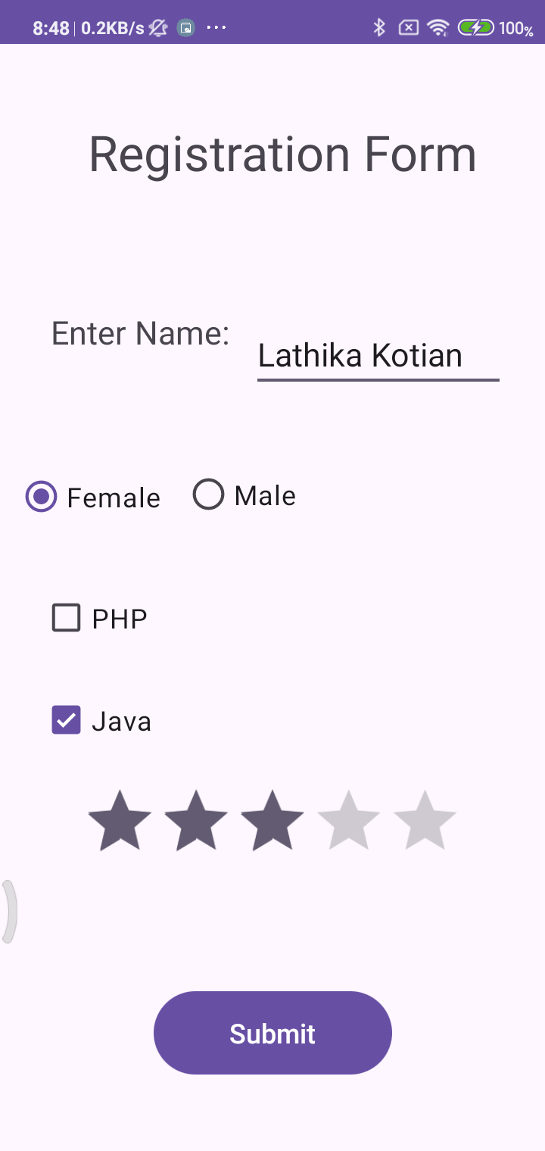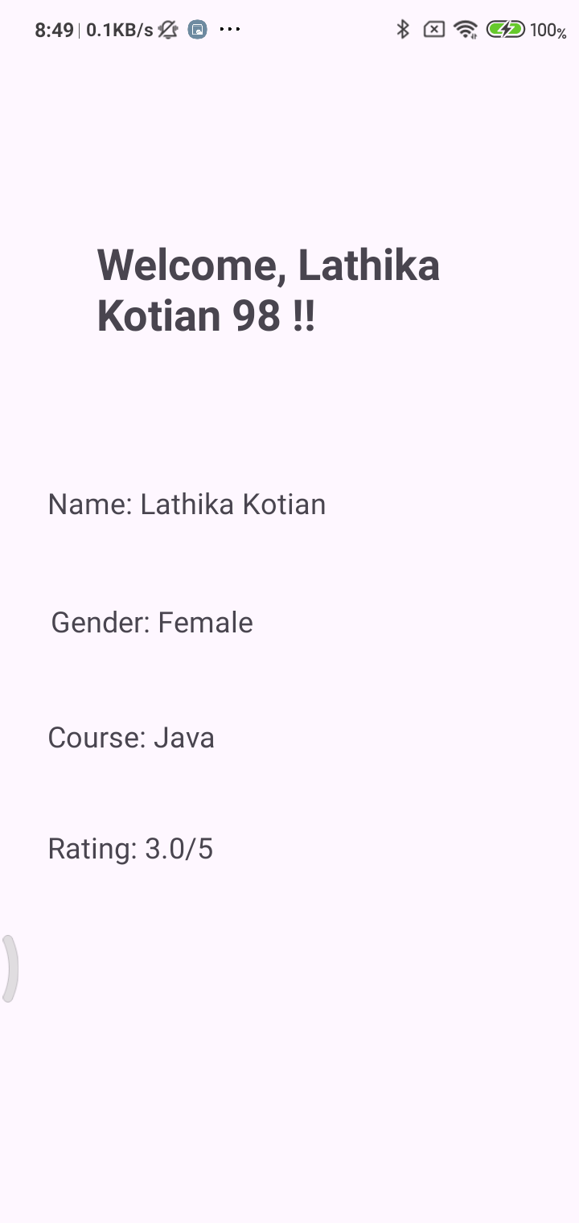

Practical No:- 7
Aim:- Firebase.
Steps :
- Create firebase project
Go to: https://console.firebase.google.com
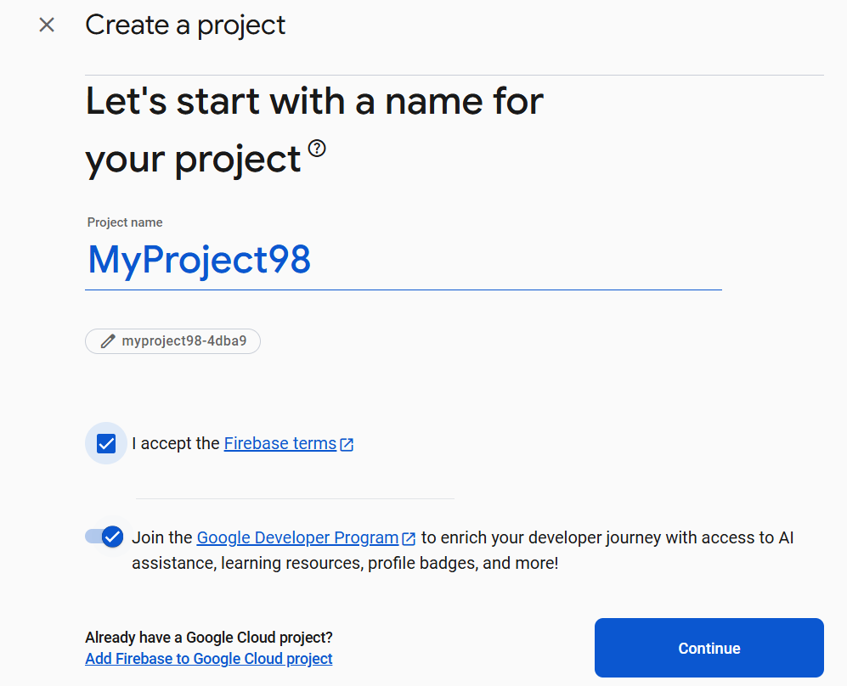

- Register Your Android App
- Download google-services.json and paste it in app directory
In Project-level build.gradle:
buildscript {
dependencies {
classpath 'com.google.gms:google-services:4.4.1'
}
}
In App-level(Add this) build.gradle:
plugins {
id 'com.android.application'
id 'com.google.gms.google-services' // Add this
}

dependencies {
// Firebase Realtime Database and Auth
implementation 'com.google.firebase:firebase-database:20.3.0'
implementation 'com.google.firebase:firebase-auth:22.3.0'
}
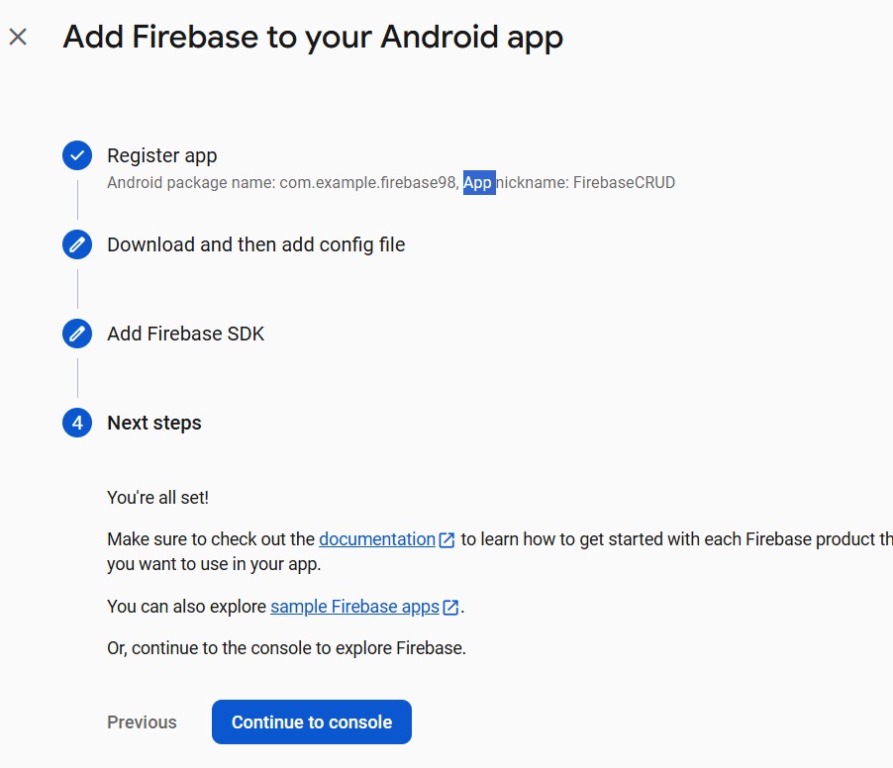

- Click "Sync Now" when prompted in Android Studio
- Enable Realtime Database in Firebase Console
- Go to Firebase Console → Your Project
- Open Build > Realtime Database
- Click "Create Database"

Activity_main.xml:-
<?xml version="1.0" encoding="utf-8"?>
<androidx.constraintlayout.widget.ConstraintLayout
xmlns:android="http://schemas.android.com/apk/res/android"
android:layout_width="match_parent"
android:layout_height="match_parent">
<LinearLayout
android:padding="16dp"
android:orientation="vertical"
android:layout_width="match_parent"
android:layout_height="match_parent"
android:fitsSystemWindows="true">
<EditText
android:id="@+id/etName"
android:hint="Name"
android:layout_width="match_parent"
android:layout_height="wrap_content"/>
<EditText
android:id="@+id/etEmail"
android:hint="Email"
android:layout_width="match_parent"
android:layout_height="wrap_content"/>
<Button
android:id="@+id/btnAdd"
android:text="Add User"
android:layout_width="match_parent"
android:layout_height="wrap_content"/>
<Button
android:id="@+id/btnUpdate"
android:text="Update User"
android:layout_width="match_parent"
android:layout_height="wrap_content"/>
<Button
android:id="@+id/btnDelete"
android:text="Delete User"
android:layout_width="match_parent"
android:layout_height="wrap_content"/>
<Button
android:id="@+id/btnViewAll"
android:text="View All Users"
android:layout_width="match_parent"
android:layout_height="wrap_content"/>
<ListView
android:id="@+id/listView"
android:layout_width="match_parent"
android:layout_height="0dp"
android:layout_weight="1"/>
</LinearLayout>
</androidx.constraintlayout.widget.ConstraintLayout>

MainActivity.java:-
package com.example.firebase98;
import static com.example.firebase98.R.*;
import android.os.Bundle;
import android.view.View;
import android.widget.*;
import androidx.annotation.NonNull;
import androidx.appcompat.app.AppCompatActivity;
import com.google.firebase.analytics.FirebaseAnalytics;
import com.google.firebase.database.*;
import java.util.*;
public class MainActivity extends AppCompatActivity {
EditText etName, etEmail;
Button btnAdd, btnUpdate, btnDelete, btnViewAll;
ListView listView;
FirebaseAnalytics firebaseAnalytics;
DatabaseReference dbRef;
List<User> userList;
String selectedUserId = "";
@Override
protected void onCreate(Bundle savedInstanceState) {
super.onCreate(savedInstanceState);
setContentView(R.layout.activity_main);
firebaseAnalytics = FirebaseAnalytics.getInstance(this);
// Initialize views
etName = findViewById(R.id.etName);
etEmail = findViewById(R.id.etEmail);
btnAdd = findViewById(R.id.btnAdd);
btnUpdate = findViewById(R.id.btnUpdate);
btnDelete = findViewById(R.id.btnDelete);
btnViewAll = findViewById(R.id.btnViewAll);
listView = findViewById(R.id.listView);
dbRef = FirebaseDatabase.getInstance().getReference("users");
userList = new ArrayList<>();
// Button actions
btnAdd.setOnClickListener(view -> {
addUser();
logEvent("add_user");
});
btnUpdate.setOnClickListener(view -> {
updateUser();
logEvent("update_user");
});
btnDelete.setOnClickListener(view -> {
deleteUser();
logEvent("delete_user");
});
btnViewAll.setOnClickListener(view -> {
retrieveUsers(); // Only fetch when View All is clicked
});
listView.setOnItemClickListener((adapterView, view, i, l) -> {
User user = userList.get(i);
etName.setText(user.getName());
etEmail.setText(user.getEmail());
selectedUserId = user.getId();
});
}
private void logEvent(String action) {
Bundle bundle = new Bundle();
bundle.putString(FirebaseAnalytics.Param.METHOD, action);
firebaseAnalytics.logEvent(FirebaseAnalytics.Event.SELECT_CONTENT, bundle);
}
private void addUser() {
String name = etName.getText().toString();
String email = etEmail.getText().toString();
if (name.isEmpty() || email.isEmpty()) {
Toast.makeText(this, "Enter name and email", Toast.LENGTH_SHORT).show();
return;
}
String id = dbRef.push().getKey();
User user = new User(id, name, email);
dbRef.child(id).setValue(user);
Toast.makeText(this, "User Added", Toast.LENGTH_SHORT).show();
etName.setText("");
etEmail.setText("");
}
private void updateUser() {
if (!selectedUserId.isEmpty()) {
String name = etName.getText().toString();
String email = etEmail.getText().toString();
User user = new User(selectedUserId, name, email);
dbRef.child(selectedUserId).setValue(user);
Toast.makeText(this, "User Updated", Toast.LENGTH_SHORT).show();
} else {
Toast.makeText(this, "Select a user to update", Toast.LENGTH_SHORT).show();
}
}
private void deleteUser() {
if (!selectedUserId.isEmpty()) {
dbRef.child(selectedUserId).removeValue();
Toast.makeText(this, "User Deleted", Toast.LENGTH_SHORT).show();
etName.setText("");
etEmail.setText("");
selectedUserId = "";
} else {
Toast.makeText(this, "Select a user to delete", Toast.LENGTH_SHORT).show();
}
}
private void retrieveUsers() {
dbRef.addListenerForSingleValueEvent(new ValueEventListener() {
@Override
public void onDataChange(@NonNull DataSnapshot snapshot) {
userList.clear();
for (DataSnapshot postSnapshot : snapshot.getChildren()) {
User user = postSnapshot.getValue(User.class);
userList.add(user);
}
List<String> displayList = new ArrayList<>();
for (User user : userList) {
displayList.add("Name: " + user.getName() + "\nEmail: " + user.getEmail());
}
ArrayAdapter<String> adapter = new ArrayAdapter<>(MainActivity.this,
android.R.layout.simple_list_item_1, displayList);
listView.setAdapter(adapter);
Toast.makeText(MainActivity.this, "Data displayed on device", Toast.LENGTH_SHORT).show();
}
@Override
public void onCancelled(@NonNull DatabaseError error) {
Toast.makeText(MainActivity.this, "Error: " + error.getMessage(), Toast.LENGTH_SHORT).show();
}
});
}
}
User.java
package com.example.firebase98;
public class User {
private String id;
private String name;
private String email;
public User() {
// Required for Firebase
}
public User(String id, String name, String email) {
this.id = id;
this.name = name;
this.email = email;
}
public String getId() { return id; }
public String getName() { return name; }
public String getEmail() { return email; }
public void setId(String id) { this.id = id; }
public void setName(String name) { this.name = name; }
public void setEmail(String email) { this.email = email; }
}

OUTPUT :-
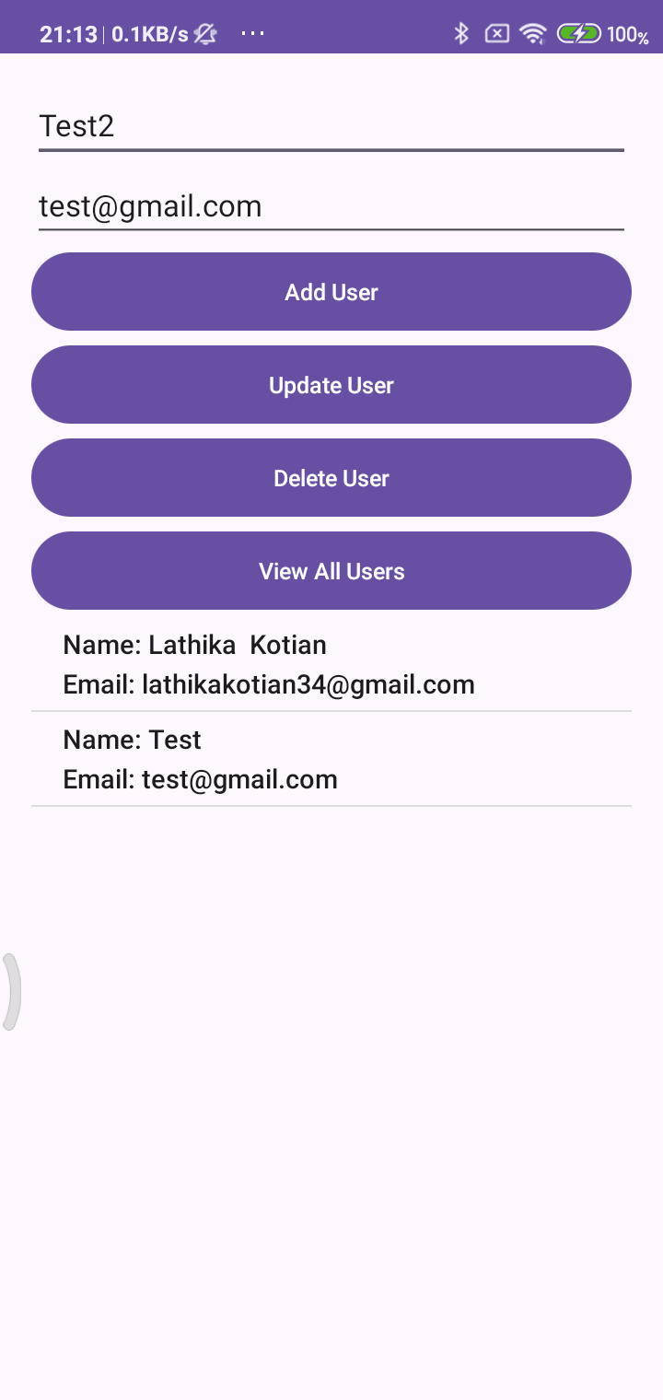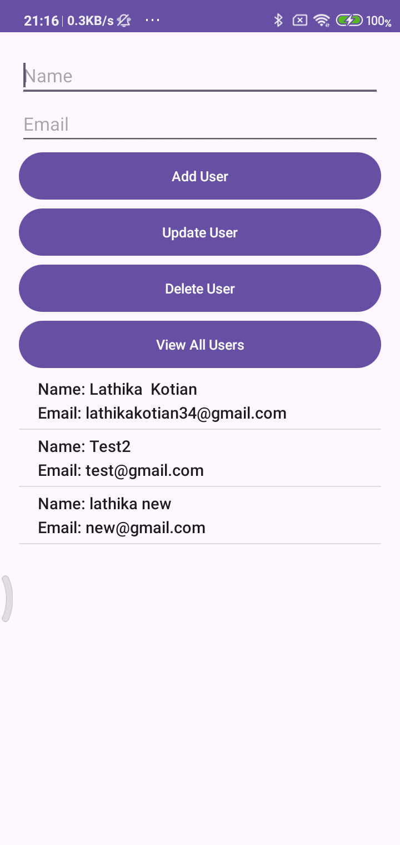

Practical No:- 8
Aim:- Canvas.
CODE : MainActivity.java:-
package com.example.canvas98;
import androidx.appcompat.app.AppCompatActivity;
import android.graphics.Canvas;
import android.graphics.Color;
import android.graphics.Paint;
import android.os.Bundle;
import android.content.Context;
import android.view.View;
public class MainActivity extends AppCompatActivity
{
@Override
protected void onCreate(Bundle savedInstanceState) {
super.onCreate(savedInstanceState);
setContentView(new Mview(this));
}
private class Mview extends View {
public Mview(Context fileprogss) {
super(fileprogss);
}
public void onDraw(Canvas canvas)
{
super.onDraw(canvas);
int x,y;
x= getWidth();
y= getHeight();
int rad=100;
Paint p = new Paint();
p.setStyle(Paint.Style.FILL);
p.setColor(Color.WHITE);
canvas.drawPaint(p);
p.setColor(Color.parseColor("yellow"));
canvas.drawCircle(x/2,y/2,rad,p);
canvas.drawRect(300,250,100,100,p);
}
}
}

OUTPUT :-
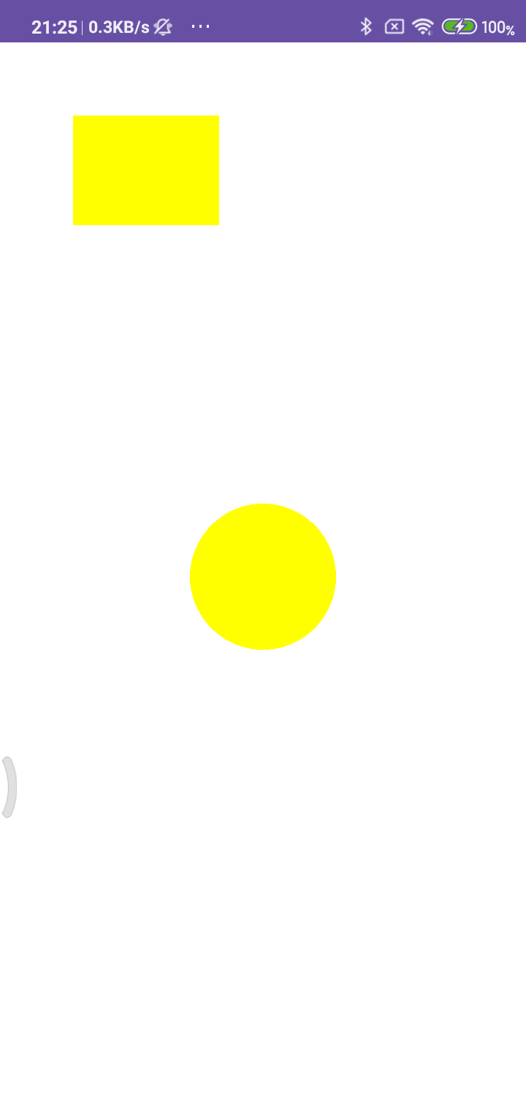

Practical No:- 9
Aim:- Alert Box.
CODE :
Activity_main.xml:-
<?xml version="1.0" encoding="utf-8"?>
<RelativeLayout xmlns:android="http://schemas.android.com/apk/res/android"
xmlns:app="http://schemas.android.com/apk/res-auto"
xmlns:tools="http://schemas.android.com/tools"
android:layout_width="match_parent"
android:layout_height="match_parent"
tools:context=".MainActivity">
<TextView
android:layout_width="356dp"
android:layout_height="wrap_content"
android:layout_alignParentEnd="true"
android:layout_marginEnd="30dp"
android:gravity="center"
android:text="Hello Lathika Kotian 98!!!"
android:textSize="30dp"
app:layout_constraintBottom_toBottomOf="parent"
app:layout_constraintLeft_toLeftOf="parent"
app:layout_constraintRight_toRightOf="parent"
app:layout_constraintTop_toTopOf="parent" />
<Button
android:id="@+id/Button"
android:layout_width="wrap_content"
android:layout_height="wrap_content"
android:layout_alignParentTop="true"
android:layout_centerHorizontal="true"
android:layout_marginTop="167dp"
android:text="Button"
tools:layout_editor_absoluteX="154dp"
tools:layout_editor_absoluteY="170dp" />
</RelativeLayout>

MainActivity.java:-
package com.example.alertbox98;
import androidx.appcompat.app.AlertDialog;
import androidx.appcompat.app.AppCompatActivity;
import android.os.Bundle;
import android.content.DialogInterface;
import android.widget.Button;
import android.view.View;
public class MainActivity extends AppCompatActivity {
@Override
protected void onCreate(Bundle savedInstanceState) {
super.onCreate(savedInstanceState);
setContentView(R.layout.activity_main);
Button button_sbm;
onButtonClickListener();
}
public void onButtonClickListener() {
Button button_sbm = (Button) findViewById(R.id.Button);
button_sbm.setOnClickListener(
new View.OnClickListener() {
@Override
public void onClick(View v) {
AlertDialog.Builder a_builder = new AlertDialog.Builder(MainActivity.this);
a_builder.setMessage("Do you Want to close this app")
.setCancelable(false)
.setPositiveButton("YES", new DialogInterface.OnClickListener() {
@Override
public void onClick(DialogInterface dialog, int which) {
finish();
}
})
.setNegativeButton("No", new DialogInterface.OnClickListener() {
public void onClick(DialogInterface dialog, int which) {
dialog.cancel();
}
});
AlertDialog alert = a_builder.create();
alert.setTitle("Alert!!");
alert.show();
}
}
);
}
}

OUTPUT :-
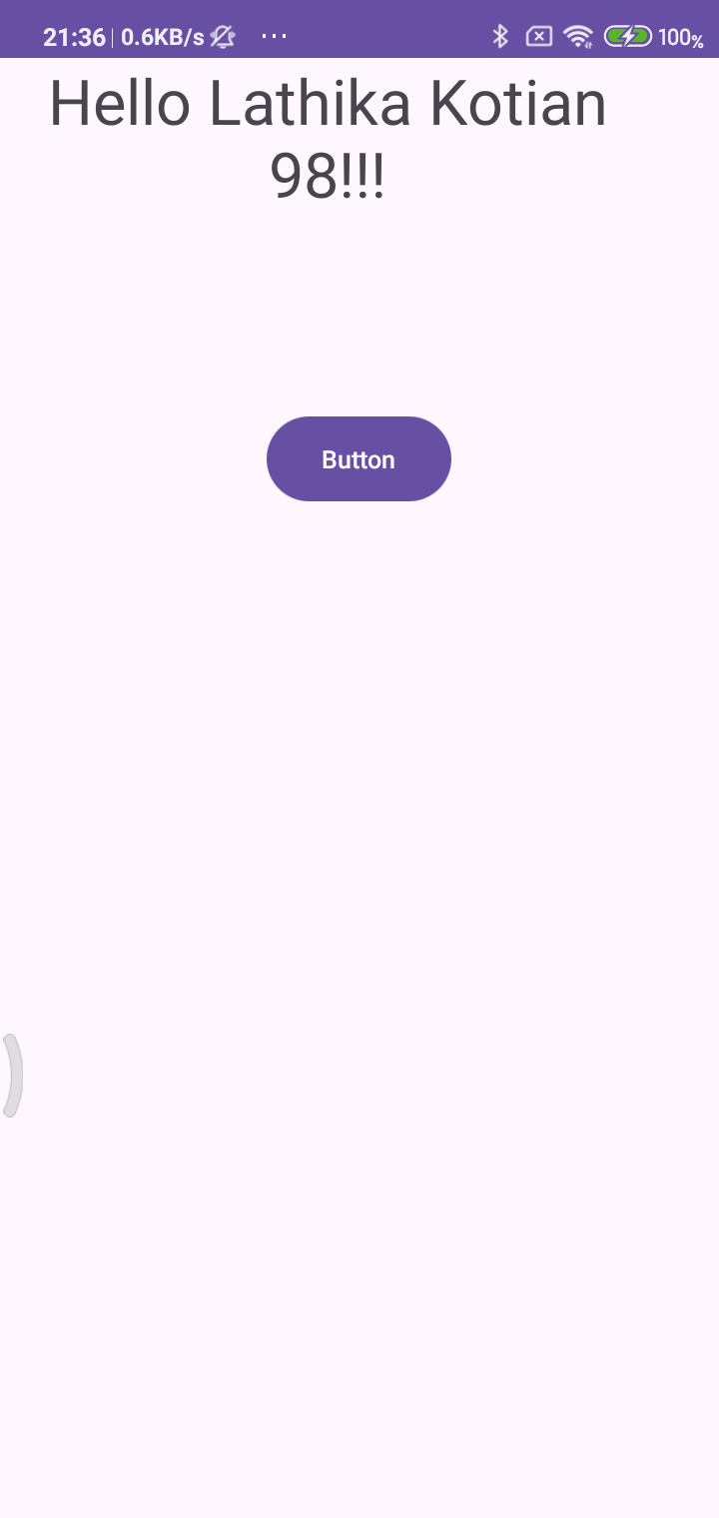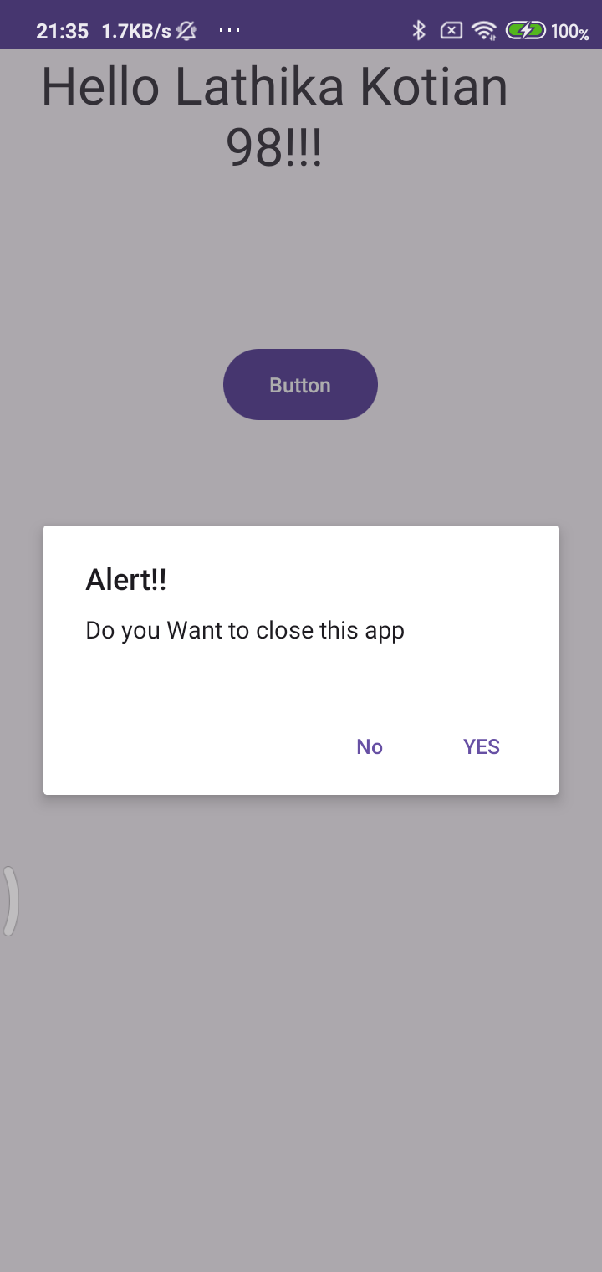

Practical No:- 10
Aim:- File Handling (Read, Write, Delete).
CODE :
Activity_main.xml:-
<RelativeLayout xmlns:android="http://schemas.android.com/apk/res/android"
xmlns:tools="http://schemas.android.com/tools"
android:layout_width="match_parent"
android:layout_height="match_parent"
tools:context=".MainActivity">
<EditText
android:id="@+id/txtcontent"
android:layout_width="match_parent"
android:layout_height="65dp"
android:layout_marginTop="31dp"
android:layout_alignParentTop="true"
android:layout_marginStart="16dp"
android:layout_marginEnd="16dp"
android:ems="10"
android:inputType="textPersonName" />
<Button
android:id="@+id/btnwrite"
android:layout_width="wrap_content"
android:layout_height="wrap_content"
android:text="Write"
android:layout_below="@id/txtcontent"
android:layout_marginTop="16dp"
android:layout_alignParentStart="true"
android:layout_marginStart="16dp" />
<Button
android:id="@+id/btnread"
android:layout_width="wrap_content"
android:layout_height="wrap_content"
android:text="Read"
android:layout_alignTop="@id/btnwrite"
android:layout_toEndOf="@id/btnwrite"
android:layout_marginStart="16dp" />
<Button
android:id="@+id/btn_clear"
android:layout_width="wrap_content"
android:layout_height="wrap_content"
android:text="Clear"
android:onClick="clearFile"
android:layout_alignTop="@id/btnwrite"
android:layout_toEndOf="@id/btnread"
android:layout_marginStart="16dp" />
<Button
android:id="@+id/btn_delete"
android:layout_width="wrap_content"
android:layout_height="wrap_content"
android:layout_below="@id/btnwrite"
android:layout_alignParentEnd="true"
android:layout_marginTop="-48dp"
android:layout_marginEnd="3dp"
android:onClick="deleteFile"
android:text="Delete" />
<TextView
android:id="@+id/textView"
android:layout_width="match_parent"
android:layout_height="wrap_content"
android:text="TextView"
android:layout_alignParentBottom="true"
android:layout_marginStart="16dp"
android:layout_marginEnd="16dp"
android:layout_marginBottom="32dp" />
</RelativeLayout>

MainActivity.java:-
package com.example.filehandling98;
import androidx.appcompat.app.AppCompatActivity;
import android.os.Bundle;
import android.content.Context;
import android.view.View;
import android.widget.EditText;
import android.widget.TextView;
import android.widget.Button;
import android.widget.Toast;
import java.io.File;
import java.io.FileInputStream;
import java.io.FileOutputStream;
public class MainActivity extends AppCompatActivity {
EditText et_Text;
Button b_read, b_write, b_delete;
TextView tv_Text;
String file_name = "file.txt";
@Override
protected void onCreate(Bundle savedInstanceState) {
super.onCreate(savedInstanceState);
setContentView(R.layout.activity_main);
et_Text = findViewById(R.id.txtcontent);
b_read = findViewById(R.id.btnread);
b_write = findViewById(R.id.btnwrite);
tv_Text = findViewById(R.id.textView);
b_delete = findViewById(R.id.btn_delete);
b_read.setOnClickListener(new View.OnClickListener() {
@Override
public void onClick(View view) {
// Read file content and show in TextView
tv_Text.setText(readFile(file_name));
}
});
b_write.setOnClickListener(new View.OnClickListener() {
@Override
public void onClick(View view) {
// Save text entered in EditText to file
saveFile(file_name, et_Text.getText().toString());
}
});
}
// Save the given text to the specified file
public void saveFile(String file_name, String text) {
try {
FileOutputStream fos = openFileOutput(file_name,
Context.MODE_PRIVATE);
fos.write(text.getBytes());
fos.close();
Toast.makeText(MainActivity.this, "File saved",
Toast.LENGTH_SHORT).show();
} catch (Exception e) {
e.printStackTrace();
Toast.makeText(MainActivity.this, "Error saving file",
Toast.LENGTH_SHORT).show();
}
}
// Read and return the content of the specified file
public String readFile(String file_name) {
String text = "";
try {
FileInputStream fis = openFileInput(file_name);
int size = fis.available();
byte[] buffer = new byte[size];
fis.read(buffer);
fis.close();
text = new String(buffer);
} catch (Exception e) {
e.printStackTrace();
Toast.makeText(MainActivity.this, "Error reading file",
Toast.LENGTH_SHORT).show();
}
return text;
}
// Clear the EditText content (called from XML via android:onClick)
public void clearFile(View view) {
et_Text.getText().clear();
}
// Delete the file (called from XML via android:onClick)
public void deleteFile(View view) {
File file = new File(getFilesDir(), file_name);
if (file.exists()) {
if (file.delete()) {
Toast.makeText(MainActivity.this, "File deleted",
Toast.LENGTH_SHORT).show();
// Optionally clear TextView after deletion
tv_Text.setText("");
} else {
Toast.makeText(MainActivity.this, "File could not be deleted",
Toast.LENGTH_SHORT).show();
}
} else {
Toast.makeText(MainActivity.this, "File not found",
Toast.LENGTH_SHORT).show();
}
}
}

OUTPUT :-
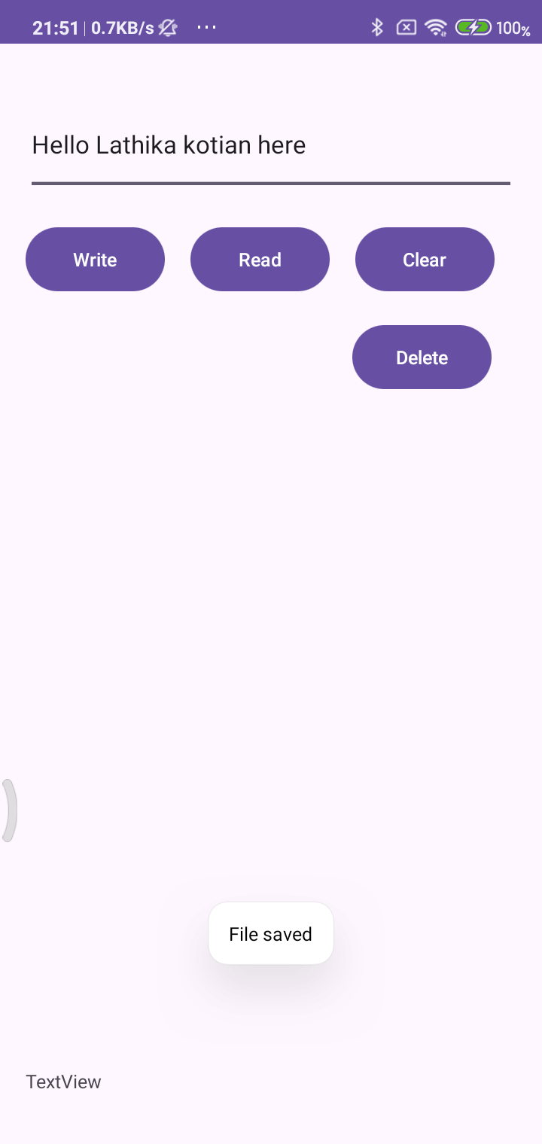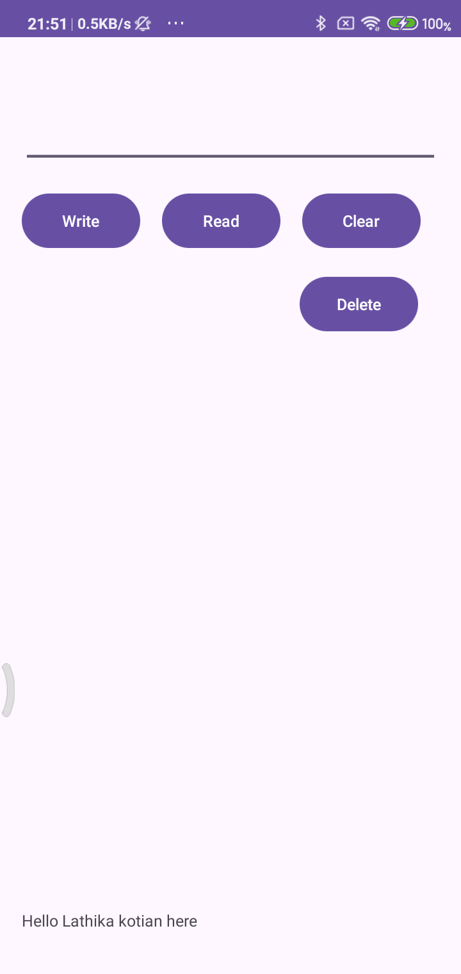

Practical No:- 11 &12
Aim:- Wifi, Bluetooth (Enable/Disable).
CODE :
Activity_main.xml:-
<androidx.constraintlayout.widget.ConstraintLayout xmlns:android="http://schemas.android.com/apk/res/android"
xmlns:app="http://schemas.android.com/apk/res-auto"
xmlns:tools="http://schemas.android.com/tools"
android:layout_width="match_parent"
android:layout_height="match_parent"
tools:context=".MainActivity">
<TextView
android:id="@+id/tv1"
android:layout_width="228dp"
android:layout_height="33dp"
android:text="WIFI Enable/Disable"
android:textSize="24sp"
app:layout_constraintBottom_toBottomOf="parent"
app:layout_constraintHorizontal_bias="0.164"
app:layout_constraintLeft_toLeftOf="parent"
app:layout_constraintRight_toRightOf="parent"
app:layout_constraintTop_toTopOf="parent"
app:layout_constraintVertical_bias="0.394" />
<TextView
android:id="@+id/tv"
android:layout_width="269dp"
android:layout_height="55dp"
android:text="Bluetooth Enable/Disable"
android:textSize="24sp"
app:layout_constraintBottom_toBottomOf="parent"
app:layout_constraintHorizontal_bias="0.163"
app:layout_constraintLeft_toLeftOf="parent"
app:layout_constraintRight_toRightOf="parent"
app:layout_constraintTop_toTopOf="parent" />
<Switch
android:id="@+id/switch1"
android:layout_width="wrap_content"
android:layout_height="wrap_content"
android:layout_marginStart="36dp"
android:textOff="OFF"
android:textOn="ON"
app:layout_constraintBottom_toBottomOf="parent"
app:layout_constraintEnd_toEndOf="parent"
app:layout_constraintHorizontal_bias="0.0"
app:layout_constraintStart_toEndOf="@+id/tv1"
app:layout_constraintTop_toTopOf="parent"
app:layout_constraintVertical_bias="0.399" />
<Switch
android:id="@+id/switch3"
android:layout_width="wrap_content"
android:layout_height="wrap_content"
android:textOff="OFF"
android:textOn="ON"
app:layout_constraintBottom_toBottomOf="parent"
app:layout_constraintEnd_toEndOf="parent"
app:layout_constraintStart_toEndOf="@+id/tv"
app:layout_constraintTop_toTopOf="parent" />
<TextView
android:id="@+id/textView"
android:layout_width="wrap_content"
android:layout_height="wrap_content"
android:layout_marginTop="40dp"
android:text="Lathika Kotian 98"
android:textSize="24dp"
android:textStyle="bold"
app:layout_constraintEnd_toEndOf="parent"
app:layout_constraintHorizontal_bias="0.498"
app:layout_constraintStart_toStartOf="parent"
app:layout_constraintTop_toTopOf="parent" />
</androidx.constraintlayout.widget.ConstraintLayout>

MainActivity.java:-
package com.example.wifi_blutooth_98;
import androidx.appcompat.app.AppCompatActivity;
import android.annotation.SuppressLint;
import android.bluetooth.BluetoothAdapter;
import android.content.Context;
import android.content.Intent;
import android.net.wifi.WifiManager;
import android.os.Bundle;
import android.widget.CompoundButton;
import android.widget.Switch;
import android.widget.Toast;
public class MainActivity extends AppCompatActivity {
Switch wifiiii, bluetooot;
WifiManager wifiManager;
BluetoothAdapter bluetoothAdapter = BluetoothAdapter.getDefaultAdapter();
@Override
protected void onCreate(Bundle savedInstanceState) {
super.onCreate(savedInstanceState);
setContentView(R.layout.activity_main);
wifiManager = (WifiManager) getApplicationContext(
).getSystemService(Context.WIFI_SERVICE);
wifiiii = (Switch) findViewById(R.id.switch1);
wifiiii.setOnCheckedChangeListener(new CompoundButton.OnCheckedChangeListener() {
public void onCheckedChanged(CompoundButton buttonView, boolean isChecked) {
if (isChecked) {
wifiManager.setWifiEnabled(true);
Toast.makeText(MainActivity.this, "WIFI ON", Toast.LENGTH_SHORT).show();
} else {
wifiManager.setWifiEnabled(false);
Toast.makeText(MainActivity.this, "WIFI Off", Toast.LENGTH_SHORT).show();
}
}
});
bluetooot = (Switch) findViewById(R.id.switch3);
bluetooot.setOnCheckedChangeListener(new CompoundButton.OnCheckedChangeListener() {
@SuppressLint("MissingPermission")
public void onCheckedChanged(CompoundButton buttonView, boolean isChecked) {
if (isChecked) {
if (bluetoothAdapter == null) {
Toast.makeText(getApplicationContext(), "Bluetooth not supported", Toast.LENGTH_SHORT).show();
} else {
if(!bluetoothAdapter.isEnabled())
{
Intent enableBtIntent = new Intent(BluetoothAdapter.ACTION_REQUEST_ENABLE);
startActivityForResult(enableBtIntent, 0);
Toast.makeText(getApplicationContext(),"Bluetooth Turned ON",Toast.LENGTH_SHORT).show();
}
}
} else {
bluetoothAdapter.disable();
Toast.makeText(getApplicationContext(), "Bluetooth Turned Off", Toast.LENGTH_SHORT).show();
}
}
});
}
}

OUTPUT :-
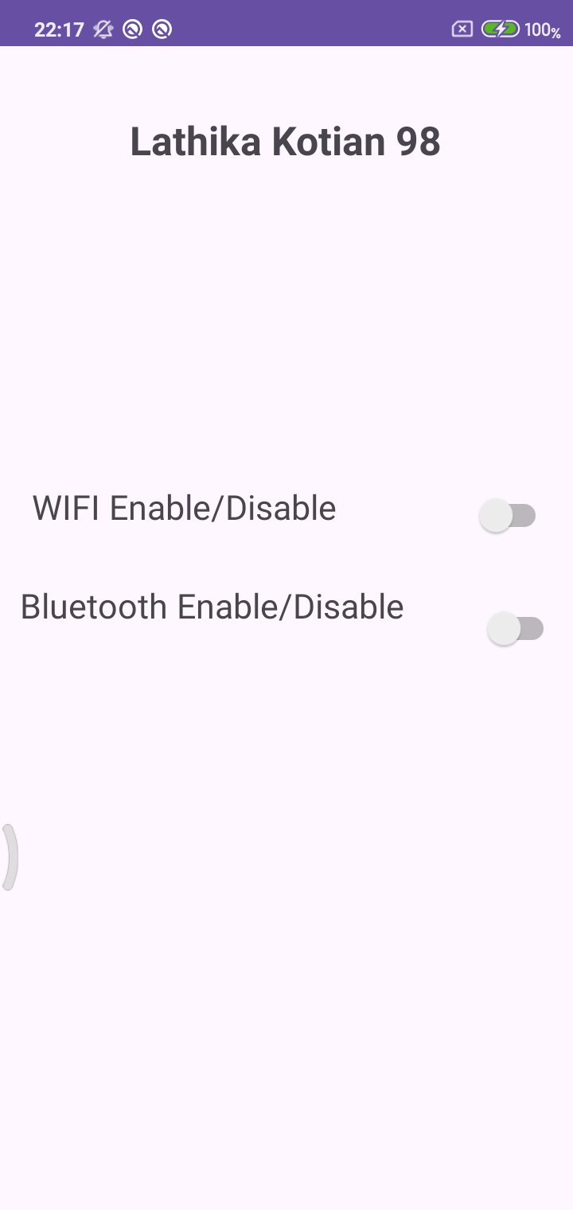

Practical No:- 13
Aim:- Create an application to CRUD operations in SQLite
CODE :
Activity_main.xml:-
<?xmlversion="1.0"encoding="utf-8"?>
<RelativeLayoutxmlns:android="http://schemas.android.com/apk/res/android"xmlns:app="http://schemas.android.com/apk/res-auto" xmlns:tools="http://schemas.android.com/tools" android:layout_width="match_parent"android:layout_height="match_parent"tools:context=".MainActivity">
<TextView
android:id="@+id/textView5"
android:layout_height="wrap_content"
android:layout_marginStart="122dp"
android:layout_marginTop="24dp"
android:layout_width="wrap_content"
android:text="Contact Us"
android:textColor="@color/colorAccent"
android:textSize="18sp"
android:textStyle="bold"
app:fontFamily="serif" /><EditText
android:hint="Enter Your Name"
android:id="@+id/editTextName"
android:inputType="textPersonName"
android:layout_height="wrap_content"
android:layout_marginStart="67dp"
android:layout_marginTop="99dp"
android:layout_width="match_parent" />
<EditText
android:hint="Enter Your Email Address"
android:id="@+id/editTextEmailAddress"
android:inputType="textEmailAddress"
android:layout_height="wrap_content"
android:layout_marginStart="67dp"
android:layout_marginTop="145dp"
android:layout_width="match_parent" />
<EditText
android:hint="Enter Your Message"
android:id="@+id/editTextMessage"
android:inputType="textMultiLine"
android:layout_height="wrap_content"
android:layout_marginStart="67dp"
android:layout_marginTop="196dp"
android:layout_width="match_parent" />
<Button
android:id="@+id/btnsave"
android:layout_below="@id/editTextMessage"
android:layout_height="wrap_content"
android:layout_marginStart="50dp"
android:layout_marginTop="16dp"
android:layout_width="wrap_content"
android:text="Save" />
<Button
android:id="@+id/btnupdate"
android:layout_below="@id/editTextMessage"
android:layout_height="wrap_content"
android:layout_marginStart="150dp"
android:layout_marginTop="16dp"
android:layout_width="wrap_content"
android:text="Update" /><Button
android:id="@+id/btndel"
android:layout_below="@id/editTextMessage"
android:layout_height="wrap_content"
android:layout_marginStart="250dp"
android:layout_marginTop="16dp"
android:layout_width="wrap_content"
android:text="Delete" />
<Button
android:id="@+id/btnselect"
android:layout_below="@id/btnsave"
android:layout_height="wrap_content"
android:layout_marginTop="16dp"
android:layout_width="wrap_content"
android:text="View" /><Button
android:id="@+id/btnselectperticular"
android:layout_below="@id/btnselect"
android:layout_height="wrap_content"
android:layout_marginTop="16dp"
android:layout_width="wrap_content"
android:text="Search" /><EditText
android:hint="Search"
android:id="@+id/editTextSearch"
android:inputType="text"
android:layout_below="@id/btnselectperticular"
android:layout_height="wrap_content"
android:layout_marginTop="16dp"
android:layout_width="match_parent" />
</RelativeLayout>

MainActivity.java:-
package com.example.sql_crud_98;
import androidx.appcompat.app.AppCompatActivity;
import android.content.Context;
import android.database.Cursor;
import android.database.sqlite.SQLiteDatabase;
import android.os.Bundle;
import android.view.View;
import android.widget.Button;
import android.widget.EditText;
import android.widget.Toast;
public class MainActivity extends AppCompatActivity implements View.OnClickListener {
SQLiteDatabase db;
EditText editSearchContact, editName, editEmailAddress, editMessage;
Button btnSave, btnDelete, btnModify, btnView, btnSearch;
@Override
protected void onCreate(Bundle savedInstanceState) {
super.onCreate(savedInstanceState);
setContentView(R.layout.activity_main);
// Create or open database
db = openOrCreateDatabase("ContactDb", Context.MODE_PRIVATE, null);
// Create table if it doesn't exist
db.execSQL("CREATE TABLE IF NOT EXISTS Contact (" +
"cId INTEGER PRIMARY KEY AUTOINCREMENT, " +
"Name VARCHAR, " +
"Mail VARCHAR, " +
"CMessage VARCHAR);");
// Initialize views
editSearchContact = findViewById(R.id.editTextSearch);
editName = findViewById(R.id.editTextName);
editEmailAddress = findViewById(R.id.editTextEmailAddress);
editMessage = findViewById(R.id.editTextMessage);
btnSave = findViewById(R.id.btnsave);
btnDelete = findViewById(R.id.btndel);
btnModify = findViewById(R.id.btnupdate);
btnView = findViewById(R.id.btnselect);
btnSearch = findViewById(R.id.btnselectperticular);
// Set click listeners
btnSave.setOnClickListener(this);
btnDelete.setOnClickListener(this);
btnModify.setOnClickListener(this);
btnView.setOnClickListener(this);
btnSearch.setOnClickListener(this);
}
private void showMessage(String message) {
Toast.makeText(this, message, Toast.LENGTH_SHORT).show();
}
@Override
public void onClick(View v) {
if (v.getId() == R.id.btnsave) {
saveData();
} else if (v.getId() == R.id.btnupdate) {
updateData();
} else if (v.getId() == R.id.btndel) {
deleteData();
} else if (v.getId() == R.id.btnselect) {
selectAllData();
} else if (v.getId() == R.id.btnselectperticular) {
selectParticularData();
}
}
private void saveData() {
if (isAnyFieldEmpty(editName, editEmailAddress, editMessage)) {
showMessage("Please enter all values");
return;
}
String sql = "INSERT INTO Contact(Name, Mail, CMessage) VALUES (?, ?, ?)";
db.execSQL(sql, new Object[]{
editName.getText().toString(),
editEmailAddress.getText().toString(),
editMessage.getText().toString()
});
clearFields();
showMessage("Response Noted, Thanks!!");
}
private void updateData() {
if (editSearchContact.getText().toString().trim().isEmpty()) {
showMessage("Enter Name");
return;
}
Cursor c = db.rawQuery("SELECT * FROM Contact WHERE Name=?",
new String[]{editSearchContact.getText().toString()});
if (c.moveToFirst()) {
String sql = "UPDATE Contact SET Name=?, Mail=?, CMessage=? WHERE Name=?";
db.execSQL(sql, new Object[]{
editName.getText().toString(),
editEmailAddress.getText().toString(),
editMessage.getText().toString(),
editSearchContact.getText().toString()
});
clearFields();
editSearchContact.getText().clear();
showMessage("Record Modified");
} else {
showMessage("Invalid Name");
}
c.close();
}
private void deleteData() {
if (editSearchContact.getText().toString().trim().isEmpty()) {
showMessage("Please enter Name");
return;
}
Cursor c = db.rawQuery("SELECT * FROM Contact WHERE Name=?",
new String[]{editSearchContact.getText().toString()});
if (c.moveToFirst()) {
db.execSQL("DELETE FROM Contact WHERE Name=?",
new String[]{editSearchContact.getText().toString()});
clearFields();
showMessage("Record Deleted");
} else {
showMessage("Invalid Name");
}
c.close();
}
private void selectAllData() {
Cursor c = db.rawQuery("SELECT * FROM Contact", null);
if (c.getCount() == 0) {
showMessage("No records found");
return;
}
StringBuilder buffer = new StringBuilder();
while (c.moveToNext()) {
buffer.append("Name: ").append(c.getString(1)).append("\n");
buffer.append("Mail: ").append(c.getString(2)).append("\n");
buffer.append("Message: ").append(c.getString(3)).append("\n\n");
}
showMessage(buffer.toString());
c.close();
}
private void selectParticularData() {
if (editSearchContact.getText().toString().trim().isEmpty()) {
showMessage("Enter Name");
return;
}
Cursor c = db.rawQuery("SELECT * FROM Contact WHERE Name=?",
new String[]{editSearchContact.getText().toString()});
if (c.moveToFirst()) {
editName.setText(c.getString(1));
editEmailAddress.setText(c.getString(2));
editMessage.setText(c.getString(3));
} else {
showMessage("Invalid Name");
}
c.close();
}
private boolean isAnyFieldEmpty(EditText... fields) {
for (EditText field : fields) {
if (field.getText().toString().trim().isEmpty()) {
return true;
}
}
return false;
}
private void clearFields() {
editName.getText().clear();
editEmailAddress.getText().clear();
editMessage.getText().clear();
}
}

OUTPUT :-
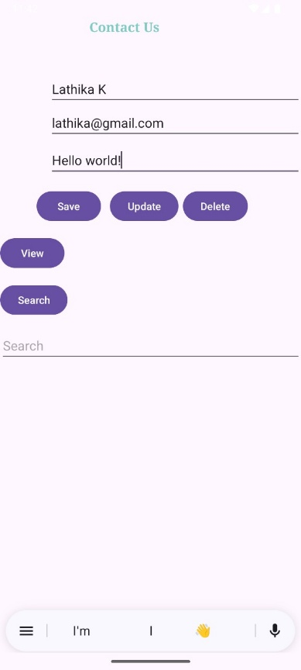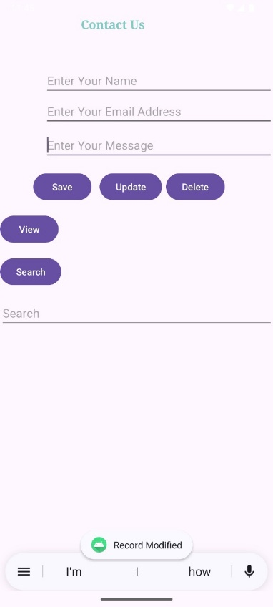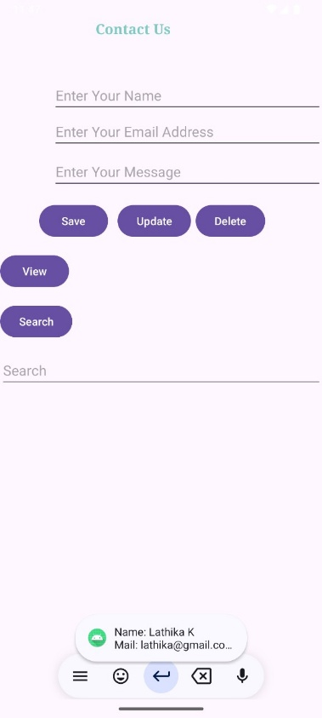

Practical No:- 14
Aim:- Create an application for animation(Fade, Rotate, Moveandblink) .
CODE :
Activity_main.xml:-
<?xml version="1.0" encoding="utf-8"?>
<RelativeLayout xmlns:android="http://schemas.android.com/apk/res/android"
xmlns:app="http://schemas.android.com/apk/res-auto"
xmlns:tools="http://schemas.android.com/tools"
android:layout_width="match_parent"
android:layout_height="match_parent"
tools:context=".MainActivity">
<ImageView
android:id="@+id/imageView"
android:layout_width="150dp"
android:layout_height="150dp"
android:layout_marginStart="8dp"
android:layout_marginEnd="8dp"
android:layout_marginTop="48dp"
android:layout_marginBottom="8dp"
android:layout_centerHorizontal="true"
app:srcCompat="@drawable/image" />
<Button
android:id="@+id/button"
android:layout_width="wrap_content"
android:layout_height="wrap_content"
android:layout_below="@id/imageView"
android:layout_centerHorizontal="true"
android:layout_marginTop="8dp"
android:onClick="move"
android:text="Move" />
<Button
android:id="@+id/button2"
android:layout_width="wrap_content"
android:layout_height="wrap_content"
android:layout_below="@id/button"
android:layout_centerHorizontal="true"
android:layout_marginTop="8dp"
android:onClick="fade"
android:text="Fade" />
<Button
android:id="@+id/button3"
android:layout_width="wrap_content"
android:layout_height="wrap_content"
android:layout_below="@id/button2"
android:layout_centerHorizontal="true"
android:layout_marginTop="8dp"
android:onClick="rotate"
android:text="Rotate" />
<Button
android:id="@+id/button4"
android:layout_width="wrap_content"
android:layout_height="wrap_content"
android:layout_below="@id/button3"
android:layout_centerHorizontal="true"
android:layout_marginTop="8dp"
android:onClick="blink"
android:text="Blink" />
<TextView
android:id="@+id/textView"
android:layout_width="wrap_content"
android:layout_height="wrap_content"
android:text="Animation done by Lathika Kotian-98" />
</RelativeLayout>

MainActivity.java:-
package com.example.animation98;
import androidx.appcompat.app.AppCompatActivity;
import android.os.Bundle;
import android.view.View;
import android.view.animation.Animation;
import android.view.animation.AnimationUtils;
import android.widget.ImageView;
public class MainActivity extends AppCompatActivity {
private ImageView imageView;
@Override
protected void onCreate(Bundle savedInstanceState) {
super.onCreate(savedInstanceState);
setContentView(R.layout.activity_main);
// Initialize ImageView
imageView = findViewById(R.id.imageView);
}
public void move(View view) {
startAnimation(R.anim.move);
}
public void fade(View view) {
startAnimation(R.anim.fade_in);
}
public void rotate(View view) {
startAnimation(R.anim.rotate);
}
public void blink(View view) {
startAnimation(R.anim.blink);
}
private void startAnimation(int animationResource) {
Animation animation = AnimationUtils.loadAnimation(this, animationResource);
imageView.startAnimation(animation);
}
}

OUTPUT :-
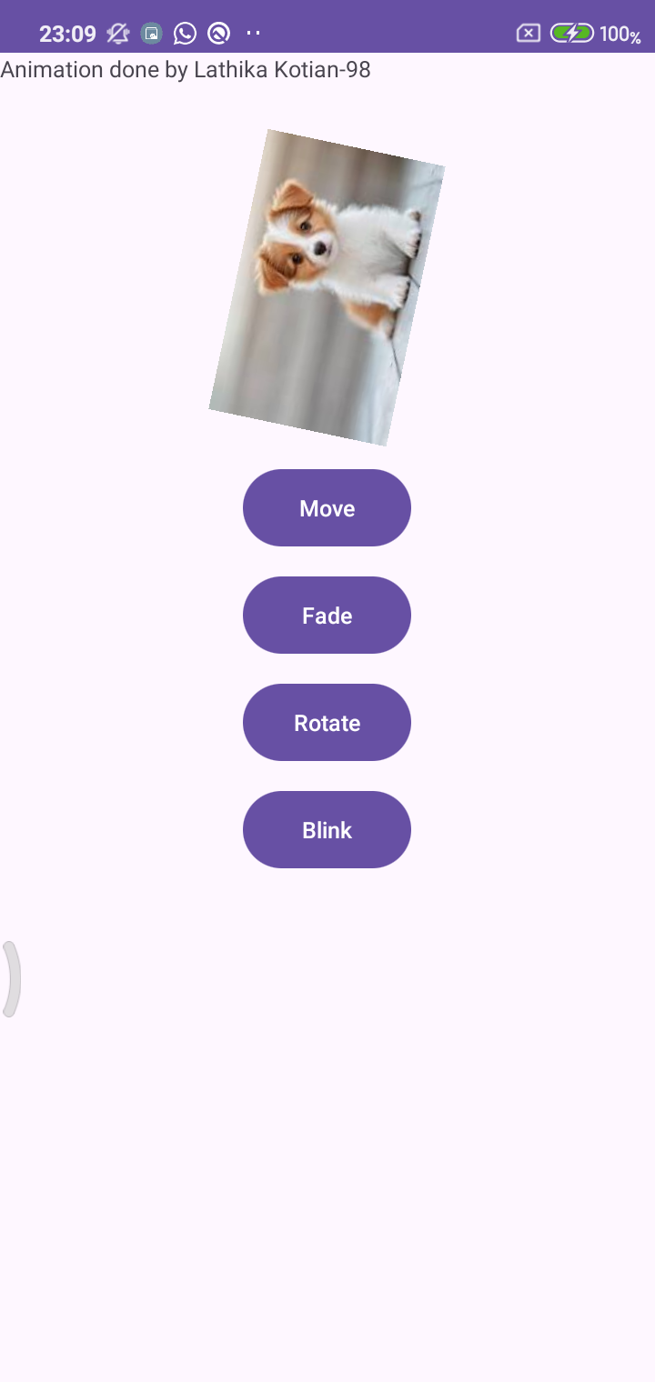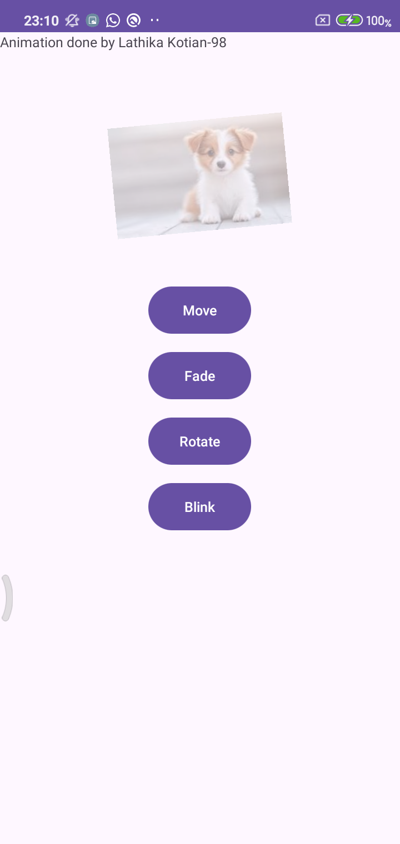
Practical No:- 15
Aim:- Shared reference.
CODE :
Activity_main.xml:-
<androidx.constraintlayout.widget.ConstraintLayout
xmlns:android="http://schemas.android.com/apk/res/android"
xmlns:app="http://schemas.android.com/apk/res-auto"
xmlns:tools="http://schemas.android.com/tools"
android:layout_width="match_parent"
android:layout_height="match_parent"
tools:context=".MainActivity">
<TextView
android:id="@+id/textView_emailId"
android:layout_width="wrap_content"
android:layout_height="wrap_content"
android:text="Email Id :"
android:textSize="24sp"
app:layout_constraintTop_toTopOf="parent"
app:layout_constraintStart_toStartOf="parent"
app:layout_constraintVertical_bias="0.22"
app:layout_constraintHorizontal_bias="0.095"
app:layout_constraintEnd_toEndOf="parent"
app:layout_constraintBottom_toBottomOf="parent" />
<TextView
android:id="@+id/textView_password"
android:layout_width="wrap_content"
android:layout_height="wrap_content"
android:text="Password :"
android:textSize="24sp"
app:layout_constraintTop_toTopOf="parent"
app:layout_constraintStart_toStartOf="parent"
app:layout_constraintVertical_bias="0.35"
app:layout_constraintHorizontal_bias="0.03"
app:layout_constraintEnd_toEndOf="parent"
app:layout_constraintBottom_toBottomOf="parent" />
<EditText
android:id="@+id/editText_email"
android:layout_width="202dp"
android:layout_height="54dp"
android:hint="Enter Email"
android:inputType="textEmailAddress"
android:textSize="24sp"
app:layout_constraintTop_toTopOf="parent"
app:layout_constraintStart_toStartOf="parent"
app:layout_constraintEnd_toEndOf="parent"
app:layout_constraintBottom_toBottomOf="parent"
app:layout_constraintVertical_bias="0.22"
app:layout_constraintHorizontal_bias="0.80" />
<EditText
android:id="@+id/editText_password"
android:layout_width="191dp"
android:layout_height="43dp"
android:hint="Enter Password"
android:inputType="textPassword"
android:textSize="24sp"
app:layout_constraintTop_toTopOf="parent"
app:layout_constraintStart_toStartOf="parent"
app:layout_constraintEnd_toEndOf="parent"
app:layout_constraintBottom_toBottomOf="parent"
/>
<CheckBox
android:id="@+id/checkBox"
android:layout_width="wrap_content"
android:layout_height="wrap_content"
android:text="Remember Me"
android:textSize="18sp"
app:layout_constraintTop_toTopOf="parent"
app:layout_constraintStart_toStartOf="parent"
app:layout_constraintEnd_toEndOf="parent"
app:layout_constraintBottom_toBottomOf="parent"
app:layout_constraintVertical_bias="0.48" />
<Button
android:id="@+id/button_signIn"
android:layout_width="wrap_content"
android:layout_height="wrap_content"
android:text="Sign In"
android:onClick="Save"
android:textSize="18sp"
app:layout_constraintTop_toTopOf="parent"
app:layout_constraintBottom_toBottomOf="parent"
app:layout_constraintStart_toStartOf="parent"
app:layout_constraintEnd_toEndOf="parent"
app:layout_constraintHorizontal_bias="0.22"
app:layout_constraintVertical_bias="0.64" />
<Button
android:id="@+id/button_clear"
android:layout_width="wrap_content"
android:layout_height="wrap_content"
android:text="Clear"
android:onClick="clear"
android:textSize="18sp"
app:layout_constraintTop_toTopOf="parent"
app:layout_constraintBottom_toBottomOf="parent"
app:layout_constraintStart_toStartOf="parent"
app:layout_constraintEnd_toEndOf="parent"
app:layout_constraintHorizontal_bias="0.53"
app:layout_constraintVertical_bias="0.76" />
<Button
android:id="@+id/button_getData"
android:layout_width="wrap_content"
android:layout_height="wrap_content"
android:text="Get Data"
android:onClick="Get"
android:textSize="18sp"
app:layout_constraintTop_toTopOf="parent"
app:layout_constraintBottom_toBottomOf="parent"
app:layout_constraintStart_toStartOf="parent"
app:layout_constraintEnd_toEndOf="parent"
app:layout_constraintHorizontal_bias="0.85"
app:layout_constraintVertical_bias="0.64" />
</androidx.constraintlayout.widget.ConstraintLayout>

MainActivity.java:-
package com.example.sharedref98;
import androidx.appcompat.app.AppCompatActivity;
import android.content.Context;
import android.content.SharedPreferences;
import android.os.Bundle;
import android.view.View;
import android.widget.CheckBox;
import android.widget.EditText;
import android.widget.Toast;
public class MainActivity extends AppCompatActivity {
SharedPreferences sharedPreferences;
EditText email, password;
CheckBox remember;
public static final String mypreferences = "mypref";
public static final String Email = "emailKey";
public static final String Password = "passwordKey";
@Override
protected void onCreate(Bundle savedInstanceState) {
super.onCreate(savedInstanceState);
setContentView(R.layout.activity_main);
email = findViewById(R.id.editText_email);
password = findViewById(R.id.editText_password);
remember = findViewById(R.id.checkBox);
sharedPreferences = getSharedPreferences(mypreferences, Context.MODE_PRIVATE);
if (sharedPreferences.contains(Email)) {
email.setText(sharedPreferences.getString(Email, ""));
}
if (sharedPreferences.contains(Password)) {
password.setText(sharedPreferences.getString(Password, ""));
}
}
public void Get(View view) {
if (sharedPreferences.contains(Email)) {
email.setText(sharedPreferences.getString(Email, ""));
}
if (sharedPreferences.contains(Password)) {
password.setText(sharedPreferences.getString(Password, ""));
}
}
public void Save(View view) {
if (remember.isChecked()) {
String e = email.getText().toString();
String p = password.getText().toString();
SharedPreferences.Editor editor = sharedPreferences.edit();
editor.putString(Email, e);
editor.putString(Password, p);
editor.apply();
Toast.makeText(getApplicationContext(), "Value stored in shared preference",
Toast.LENGTH_SHORT).show();
}
}
public void clear(View view) {
email.setText("");
password.setText("");
}
}
OUTPUT :-
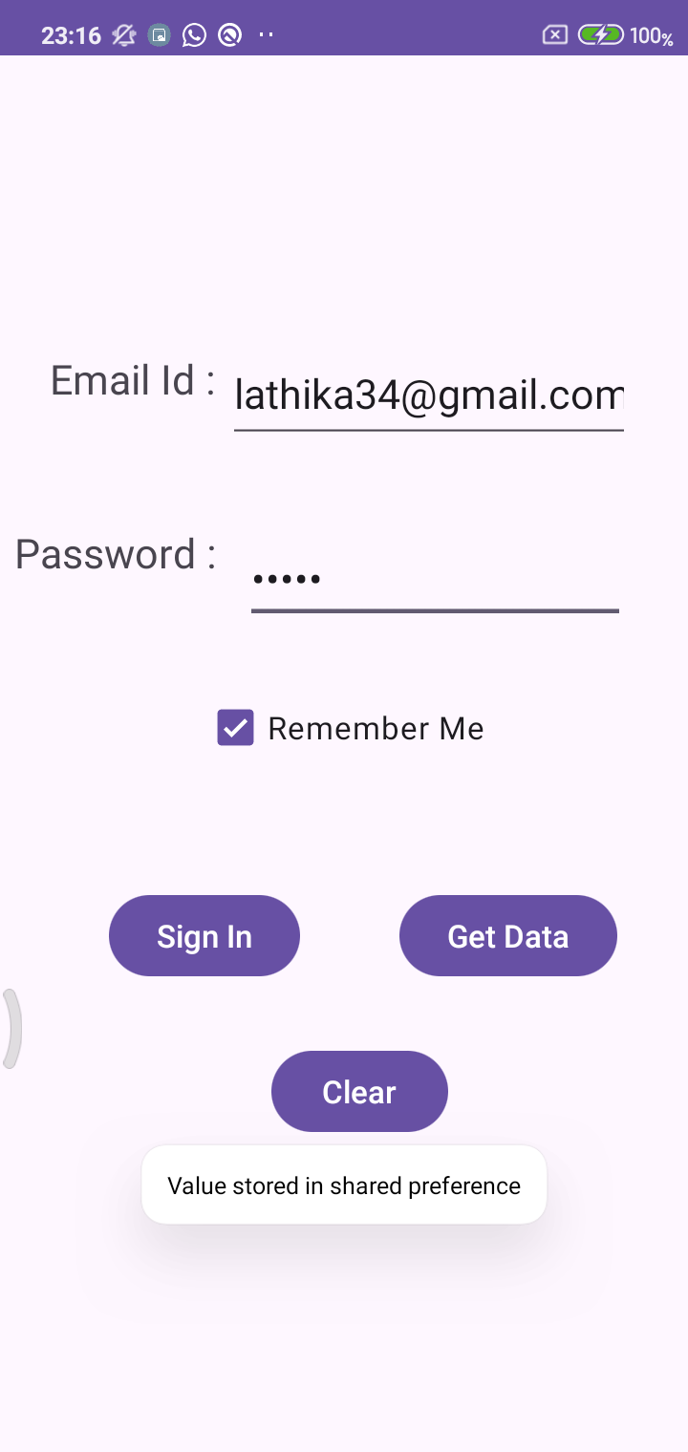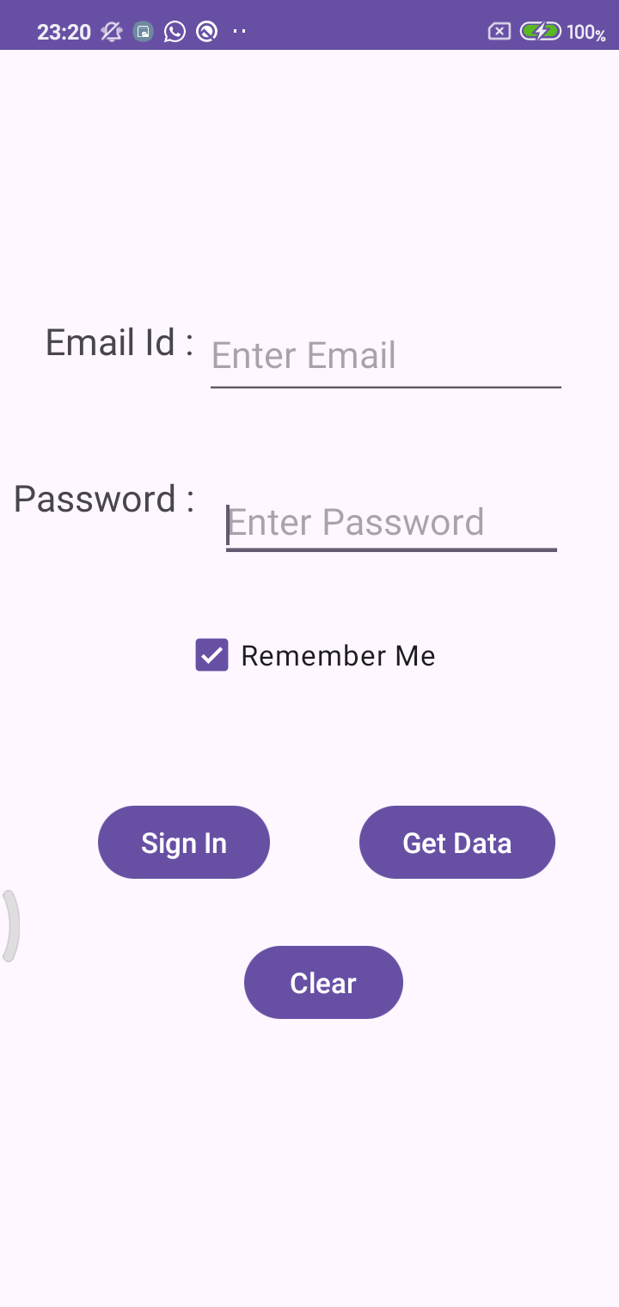
Practical No:- 16
Aim:- : Image Download.
CODE :
Activity_main.xml:-
<?xml version="1.0" encoding="utf-8"?>
<androidx.constraintlayout.widget.ConstraintLayout
xmlns:android="http://schemas.android.com/apk/res/android"
xmlns:app="http://schemas.android.com/apk/res-auto"
xmlns:tools="http://schemas.android.com/tools"
android:layout_width="match_parent"
android:layout_height="match_parent"
tools:context=".MainActivity">
<TextView
android:id="@+id/textView"
android:layout_width="wrap_content"
android:layout_height="wrap_content"
android:text="Web Page Image By Lathika Kotian-98"
android:textSize="25sp"
app:layout_constraintTop_toTopOf="parent"
app:layout_constraintBottom_toTopOf="@+id/imageView"
app:layout_constraintStart_toStartOf="parent"
app:layout_constraintEnd_toEndOf="parent"
app:layout_constraintVertical_bias="0.2" />
<ImageView
android:id="@+id/imageView"
android:layout_width="205dp"
android:layout_height="262dp"
android:scaleType="fitCenter"
app:layout_constraintTop_toBottomOf="@+id/textView"
app:layout_constraintBottom_toTopOf="@+id/button"
app:layout_constraintStart_toStartOf="parent"
app:layout_constraintEnd_toEndOf="parent"
app:srcCompat="@drawable/image"
app:layout_constraintVertical_bias="0.5" />
<Button
android:id="@+id/button"
android:layout_width="wrap_content"
android:layout_height="wrap_content"
android:text="Download"
android:textSize="20sp"
app:layout_constraintTop_toBottomOf="@+id/imageView"
app:layout_constraintBottom_toBottomOf="parent"
app:layout_constraintStart_toStartOf="parent"
app:layout_constraintEnd_toEndOf="parent"
app:layout_constraintVertical_bias="0.9" />
</androidx.constraintlayout.widget.ConstraintLayout>

MainActivity.java:-
package com.example.downloadimg_98;
import androidx.appcompat.app.AppCompatActivity;
import android.app.ProgressDialog;
import android.graphics.Bitmap;
import android.graphics.BitmapFactory;
import android.net.ConnectivityManager;
import android.net.NetworkInfo;
import android.os.Bundle;
import android.os.Handler;
import android.os.Message;
import android.view.View;
import android.widget.Button;
import android.widget.ImageView;
import android.widget.Toast;
import java.io.IOException;
import java.io.InputStream;
import java.net.HttpURLConnection;
import java.net.URL;
public class MainActivity extends AppCompatActivity {
private ProgressDialog progressDialog;
private Bitmap bitmap = null;
private ImageView imageView;
private Button downloadButton;
private final String imageUrl =
"https://upload.wikimedia.org/wikipedia/commons/thumb/3/3f/Fronalpstock_big.jpg/800px-Fronalpstock_big.jpg";
@Override
protected void onCreate(Bundle savedInstanceState) {
super.onCreate(savedInstanceState);
setContentView(R.layout.activity_main);
imageView = findViewById(R.id.imageView);
downloadButton = findViewById(R.id.button);
downloadButton.setOnClickListener(new View.OnClickListener() {
@Override
public void onClick(View v) {
if (checkInternetConnection()) {
downloadImage(imageUrl);
}
}
});
}
private void downloadImage(String urlStr) {
progressDialog = ProgressDialog.show(this, "", "Downloading image...");
new Thread(() -> {
InputStream in = null;
Message msg = Message.obtain();
msg.what = 1;
try {
in = openHttpConnection(urlStr);
bitmap = BitmapFactory.decodeStream(in);
Bundle b = new Bundle();
b.putParcelable("bitmap", bitmap);
msg.setData(b);
if (in != null) in.close();
} catch (Exception e) {
e.printStackTrace();
}
messageHandler.sendMessage(msg);
}).start();
}
private InputStream openHttpConnection(String urlStr) throws IOException {
InputStream in = null;
int responseCode;
URL url = new URL(urlStr);
HttpURLConnection httpConn = (HttpURLConnection) url.openConnection();
httpConn.setAllowUserInteraction(false);
httpConn.setInstanceFollowRedirects(true);
httpConn.setRequestMethod("GET");
httpConn.connect();
responseCode = httpConn.getResponseCode();
if (responseCode == HttpURLConnection.HTTP_OK) {
in = httpConn.getInputStream();
}
return in;
}
private final Handler messageHandler = new Handler(msg -> {
if (msg.what == 1) {
Bitmap bitmap = msg.getData().getParcelable("bitmap");
if (bitmap != null) {
imageView.setImageBitmap(bitmap);
Toast.makeText(MainActivity.this, "Download complete", Toast.LENGTH_SHORT).show();
} else {
Toast.makeText(MainActivity.this, "Failed to download image",
Toast.LENGTH_SHORT).show();
}
progressDialog.dismiss();
}
return true;
});
private boolean checkInternetConnection() {
ConnectivityManager connectivityManager = (ConnectivityManager)
getSystemService(CONNECTIVITY_SERVICE);
if (connectivityManager != null) {
NetworkInfo wifi = connectivityManager.getNetworkInfo(ConnectivityManager.TYPE_WIFI);
NetworkInfo mobile =
connectivityManager.getNetworkInfo(ConnectivityManager.TYPE_MOBILE);
if ((wifi != null && wifi.isConnected()) || (mobile != null && mobile.isConnected())) {
Toast.makeText(this, "Connected", Toast.LENGTH_SHORT).show();
return true;
}
}
Toast.makeText(this, "No internet connection", Toast.LENGTH_SHORT).show();
return false;
}
}

OUTPUT :-
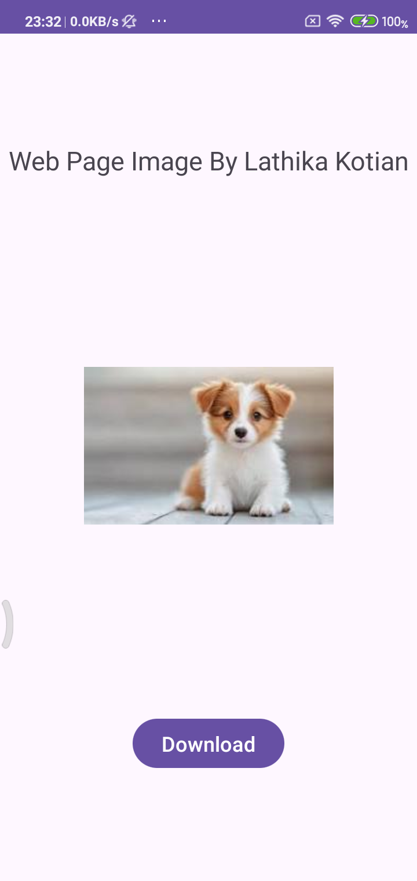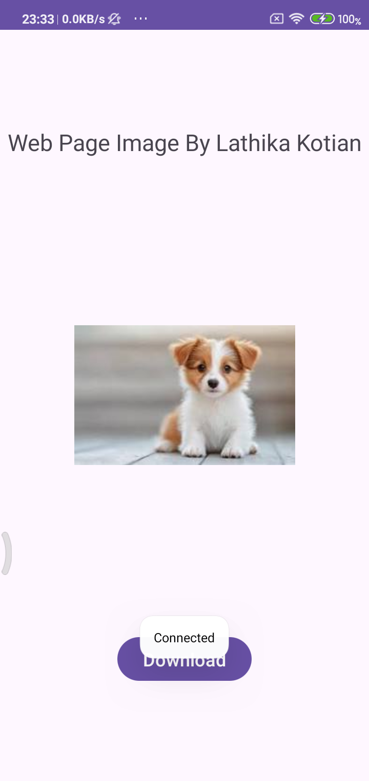

Practical No:- 17
Aim:- Video Player
CODE :
Activity_main.xml:-
<?xml version="1.0" encoding="utf-8"?>
<RelativeLayout xmlns:android="http://schemas.android.com/apk/res/android"
xmlns:tools="http://schemas.android.com/tools"
android:layout_width="match_parent"
android:layout_height="match_parent"
tools:context=".MainActivity">
<VideoView
android:id="@+id/videoView1"
android:layout_width="match_parent"
android:layout_height="wrap_content"
android:layout_centerInParent="true"
android:layout_margin="8dp" />
<TextView
android:id="@+id/textView"
android:layout_width="wrap_content"
android:layout_height="wrap_content"
android:text="Lathika Kotian (98) Video player "
android:textStyle="bold"
android:textSize="24dp"/>
</RelativeLayout>

MainActivity.java:-
package com.example.video_98;
import android.os.Bundle;
import android.widget.MediaController;
import android.widget.VideoView;
import androidx.appcompat.app.AppCompatActivity;
public class MainActivity extends AppCompatActivity {
VideoView videoid;
MediaController mediaController;
@Override
protected void onCreate(Bundle savedInstanceState) {
super.onCreate(savedInstanceState);
setContentView(R.layout.activity_main);
videoid = findViewById(R.id.videoView1);
mediaController = new MediaController(this);
// Set path to raw resource video
videoid.setVideoPath("android.resource://" + getPackageName() + "/" + R.raw.hello);
videoid.setMediaController(mediaController);
mediaController.setAnchorView(videoid);
videoid.start();
}
}
OUTPUT :-
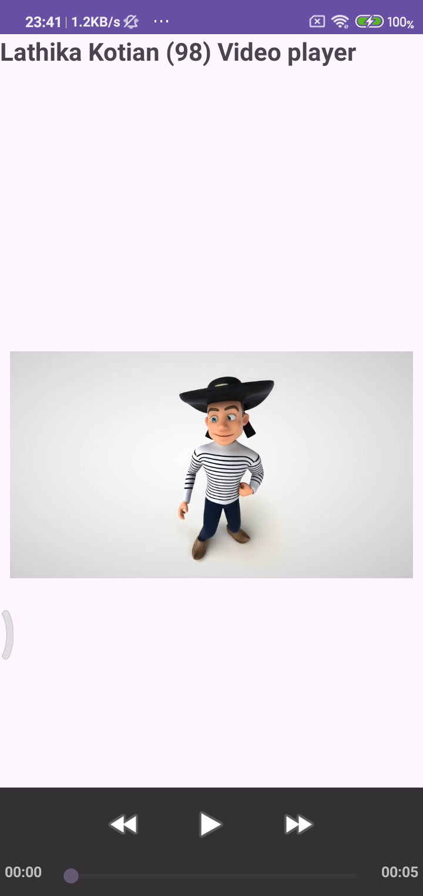

Practical -
Aim :- Create a flutter Application to display the message
CODE :
Main.dart :
import 'package:flutter/material.dart';
void main() {
runApp(const MyApp());
}
class MyApp extends StatelessWidget {
const MyApp({super.key});
@override
Widget build(BuildContext context) {
return MaterialApp(
title: 'Flutter Demo',
debugShowCheckedModeBanner: false
,
theme: ThemeData(
colorScheme: ColorScheme.fromSeed(seedColor: Colors.deepPurple),
),
home: Scaffold( body: Center(
child: Text(
'Lathika Kotian - 98!', style: TextStyle(fontSize: 32),
),
),
),
);
}
}

OUTPUT :
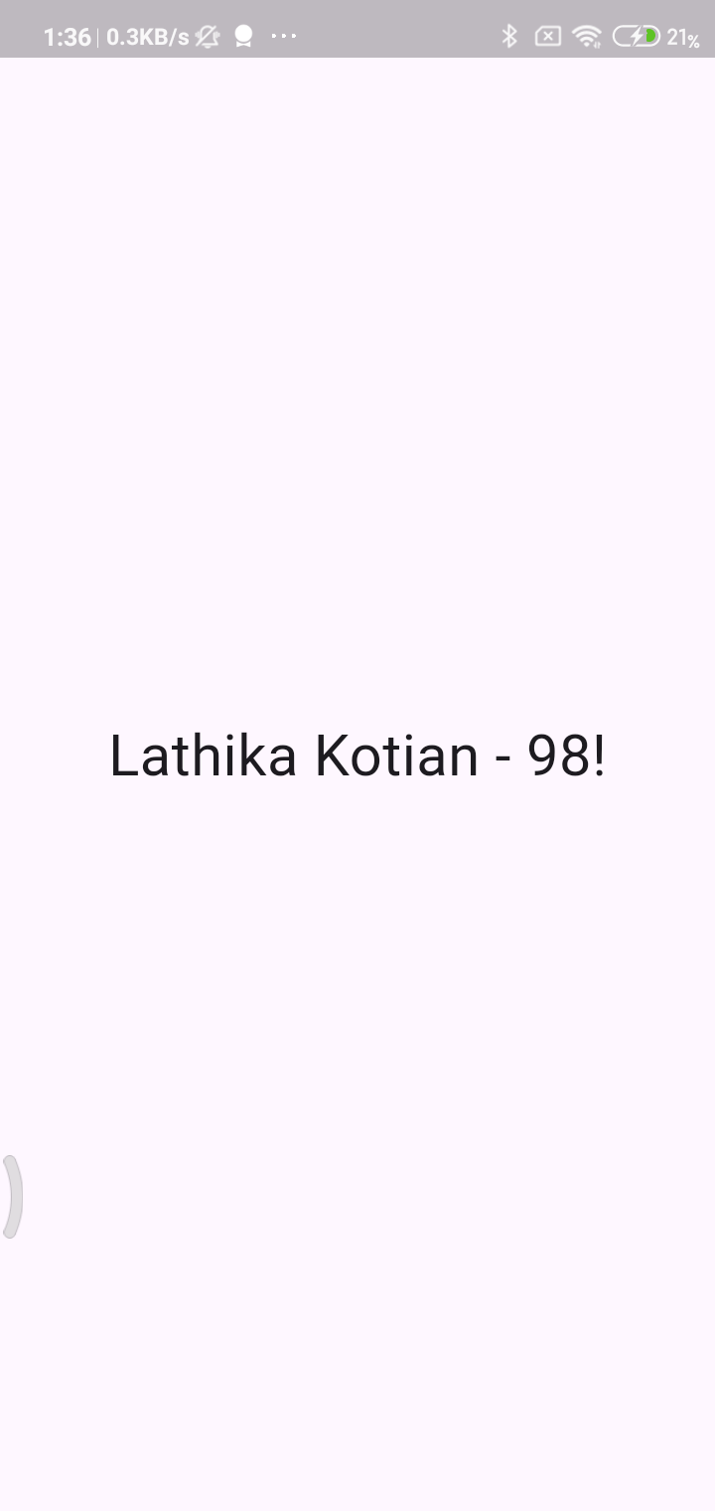

Practical -
Aim: Create a Flutter Application to display the Elevated Button.
CODE :
Main.dart :
import 'package:flutter/material.dart';
void main() {
runApp(const MyApp());
}
class MyApp extends StatelessWidget {
const MyApp({super.key});
@override
Widget build(BuildContext context) {
return MaterialApp(
title: 'Flutter Demo',
debugShowCheckedModeBanner: false,
theme: ThemeData(
colorScheme: ColorScheme.fromSeed(seedColor: Colors.deepPurple),
),
home: Scaffold(
appBar: AppBar(title: Text('Lathika Kotian - 98'),elevation: 2,),
body:Column(
mainAxisAlignment: MainAxisAlignment.center,
children: [
Text("Display Elevated Button",style: TextStyle(fontWeight: FontWeight.bold,fontSize: 16),),
SizedBox(height: 20,),
Center(
child: ElevatedButton(
onPressed: () {},
child: Text("Elevated Button", style: TextStyle(fontSize: 20.0)),
),
),
],
)
),
);
}
}

OUTPUT:
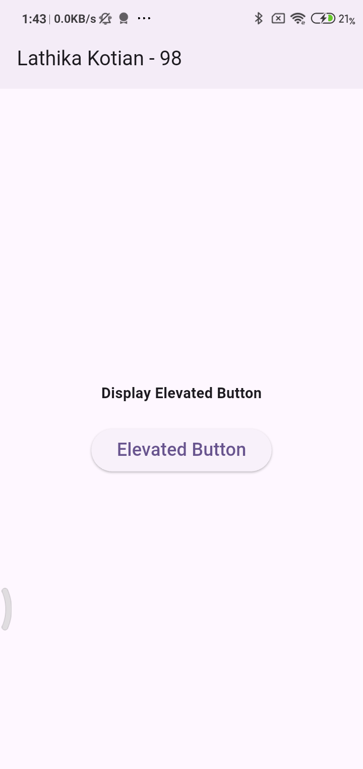

Practical -
Aim Create a Flutter Application to display an Image.
CODE :
- Create asset folder and paste image then in pubspec.yaml mention that image
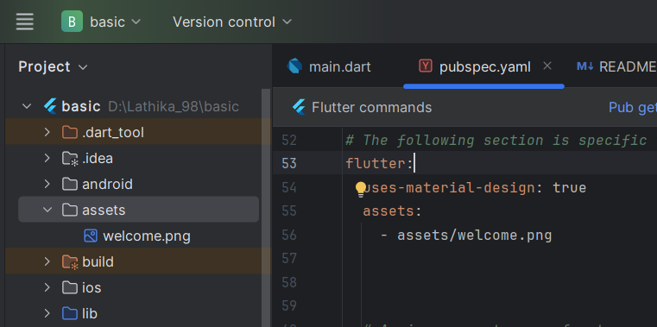
Main.dart :
import 'package:flutter/material.dart';
void main() {
runApp(const MyApp());
}
class MyApp extends StatelessWidget {
const MyApp({super.key});
@override
Widget build(BuildContext context) {
return MaterialApp(
title: 'Flutter Demo',
debugShowCheckedModeBanner: false,
theme: ThemeData(
colorScheme: ColorScheme.fromSeed(seedColor: Colors.deepPurple),
),
home: Scaffold(
appBar: AppBar(
centerTitle: true,
elevation: 2,
title: Text(
"Lathika Kotian - 98",
style: TextStyle(fontSize: 26.0, fontWeight: FontWeight.bold),
),
),
body: Center(
child: Column(
mainAxisAlignment: MainAxisAlignment.center,
children: [
Text(
"To display image",
style: TextStyle(fontSize: 18, fontWeight: FontWeight.bold),
),
SizedBox(height: 50),
Image.asset("assets/welcome.png"),
],
),
),
),
);
}
}

OUTPUT :
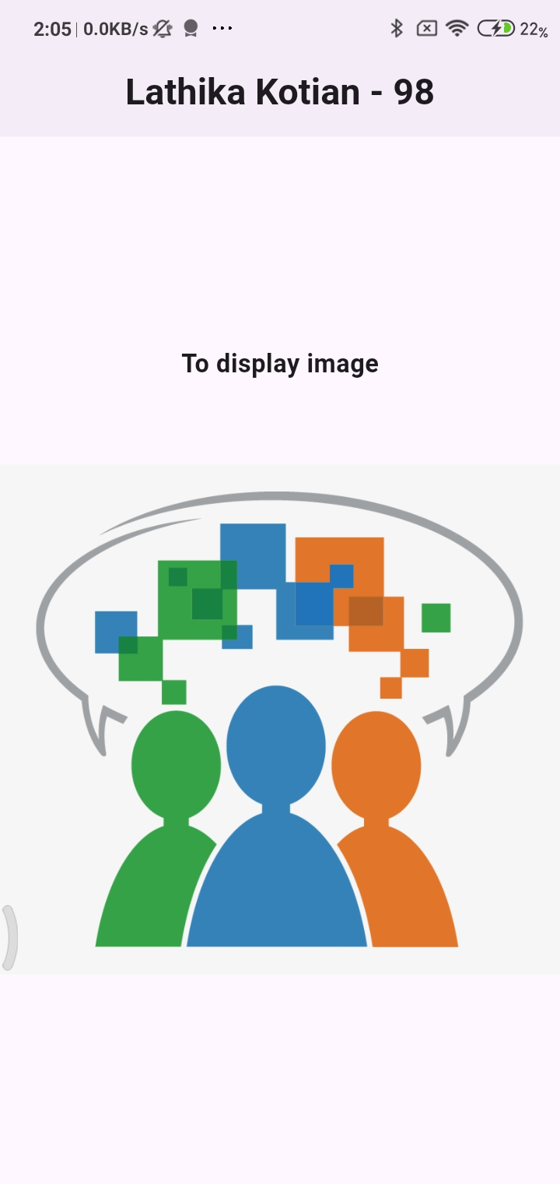

Practical -
Aim: Flutter Program based on Stateful and Stateless Widgets / Create a Flutter Application to display the message how many times the button has been clicked.
CODE :
Main.dart :
import 'package:flutter/material.dart';

void main() {
runApp(MyApp());
}

// StatelessWidget: The root of the application
class MyApp extends StatelessWidget {
@override
Widget build(BuildContext context) {
return MaterialApp(
title: 'Stateless vs Stateful Demo',
debugShowCheckedModeBanner: false,
theme: ThemeData(
primarySwatch: Colors.blue,
),
home: HomePage(),
);
}
}

// StatelessWidget: Represents the UI layout
class HomePage extends StatelessWidget {
@override
Widget build(BuildContext context) {
return Scaffold(
appBar: AppBar(
title: Text('Stateless & Stateful Widget'),
),
body: Center(
child: CounterWidget(), // Our StatefulWidget
),
);
}
}

// StatefulWidget: Holds the state (e.g., counter)
class CounterWidget extends StatefulWidget {
@override
_CounterWidgetState createState() => _CounterWidgetState();
}

// The state class that changes over time
class _CounterWidgetState extends State<CounterWidget> {
int _counter = 0;

void _incrementCounter() {
setState(() {
_counter++;
});
}

@override
Widget build(BuildContext context) {
return Column(
mainAxisAlignment: MainAxisAlignment.center,
children: [
Text(
'You have pressed the button this many times:',
),
Text(
'$_counter',
style: TextStyle(fontSize: 30, fontWeight: FontWeight.bold),
),
SizedBox(height: 20),
ElevatedButton(
onPressed: _incrementCounter,
child: Text('Increment Counter'),
),
SizedBox(height: 50),
Text("LATHIKA KOTIAN - 98", style: TextStyle(fontSize: 16, fontWeight: FontWeight.bold),)
],
);
}
}

OUTPUT :
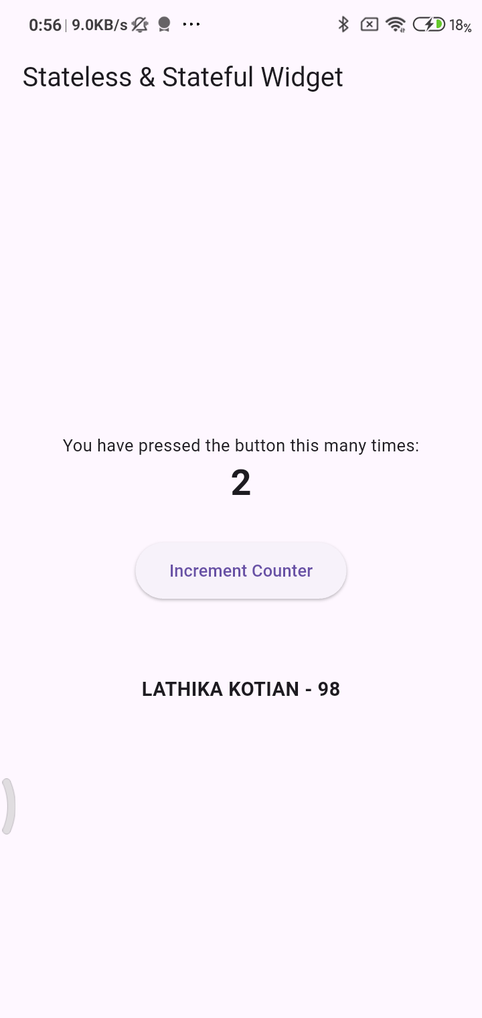

Practical -
Aim : Flutter Program using List
CODE :
main.dart
import 'package:flutter/material.dart';
void main() {
runApp(MyApp());
}
// Root widget
class MyApp extends StatelessWidget {
@override
Widget build(BuildContext context) {
return MaterialApp(
title: 'List Example',
debugShowCheckedModeBanner: false,
theme: ThemeData(
primarySwatch: Colors.green,
),
home: FruitListScreen(),
);
}
}
// StatelessWidget displaying a list
class FruitListScreen extends StatelessWidget {
// Sample list of fruits
final List<String> fruits = [
'Apple',
'Banana',
'Orange',
'Mango',
'Pineapple',
'Grapes',
'Strawberry',
'Watermelon',
'Papaya',
'Kiwi',
];
@override
Widget build(BuildContext context) {
return Scaffold(
appBar: AppBar(
title: Text('List of Fruits'),
),
body: ListView.builder(
itemCount: fruits.length,
itemBuilder: (context, index) {
return Card(
margin: EdgeInsets.symmetric(vertical: 6, horizontal: 12),
child: ListTile(
leading: CircleAvatar(
child: Text(fruits[index][0]),
),
title: Text(fruits[index]),
trailing: Icon(Icons.arrow_forward_ios),
onTap: () {
// You can handle tap event here
ScaffoldMessenger.of(context).showSnackBar(
SnackBar(content: Text('Lathika Kotian -98 you selected ${fruits[index]}',style: TextStyle(fontSize: 16, fontWeight: FontWeight.bold),)),
);
},
),
);
},
),
);
}
}

OUTPUT :
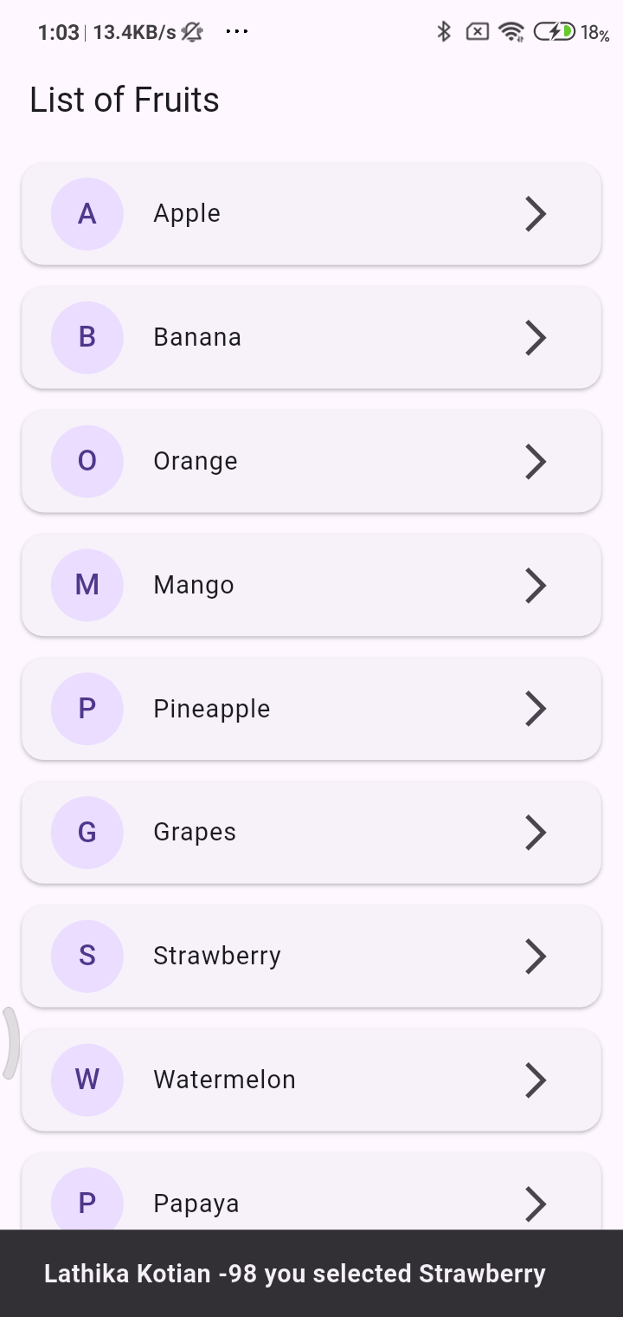

Practical -
Aim : Flutter Program using TextField, Check Box, Buttons, Drop down, Switch etc.
CODE :
main.dart :
import 'package:flutter/material.dart';
void main() {
runApp(MyApp());
}
class MyApp extends StatelessWidget {
@override
Widget build(BuildContext context) {
return MaterialApp(
title: 'Flutter Form Fields',
debugShowCheckedModeBanner: false,
theme: ThemeData(
primarySwatch: Colors.blue,
),
home: FormScreen(),
);
}
}
// StatefulWidget to manage form state
class FormScreen extends StatefulWidget {
@override
_FormScreenState createState() => _FormScreenState();
}
class _FormScreenState extends State<FormScreen> {
String name = '';
bool agreeToTerms = false;
bool notificationsEnabled = false;
String selectedGender = 'Male';
String result = '';
final TextEditingController nameController = TextEditingController();
final List<String> genderOptions = ['Male', 'Female', 'Other'];
void handleSubmit() {
setState(() {
name = nameController.text;
result =
'Name: $name\nGender: $selectedGender\nAgreed to Terms: ${agreeToTerms ? "Yes" : "No"}\nNotifications: ${notificationsEnabled ? "Enabled" : "Disabled"}';
});
}
@override
Widget build(BuildContext context) {
return Scaffold(
appBar: AppBar(
backgroundColor: Colors.white,
elevation: 2,
title: Text(
'User Info Form',
style: TextStyle(
color: Colors.black87,
fontWeight: FontWeight.bold,
letterSpacing: 0.5,
),
),
centerTitle: true,
),
body: SingleChildScrollView(
padding: EdgeInsets.all(16.0),
child: Column(
crossAxisAlignment: CrossAxisAlignment.start,
children: [
// TextField
TextField(
controller: nameController,
decoration: InputDecoration(
labelText: 'Enter your name',
border: OutlineInputBorder(),
),
),
SizedBox(height: 16),
// Dropdown
DropdownButtonFormField<String>(
value: selectedGender,
items: genderOptions
.map((gender) => DropdownMenuItem(
value: gender,
child: Text(gender),
))
.toList(),
onChanged: (value) {
setState(() {
selectedGender = value!;
});
},
decoration: InputDecoration(
labelText: 'Select Gender',
border: OutlineInputBorder(),
),
),
SizedBox(height: 16),
// Checkbox
CheckboxListTile(
title: Text('I agree to the terms and conditions'),
value: agreeToTerms,
onChanged: (value) {
setState(() {
agreeToTerms = value!;
});
},
),
// Switch
SwitchListTile(
title: Text('Enable Notifications'),
value: notificationsEnabled,
onChanged: (value) {
setState(() {
notificationsEnabled = value;
});
},
),
// Submit Button
Center(
child: ElevatedButton(
onPressed: handleSubmit,
child: Text('Submit'),
),
),
SizedBox(height: 20),
// Display result
if (result.isNotEmpty)
Text(
result,
style: TextStyle(fontSize: 16, fontWeight: FontWeight.bold),
),
],
),
),
); }}

OUTPUT:
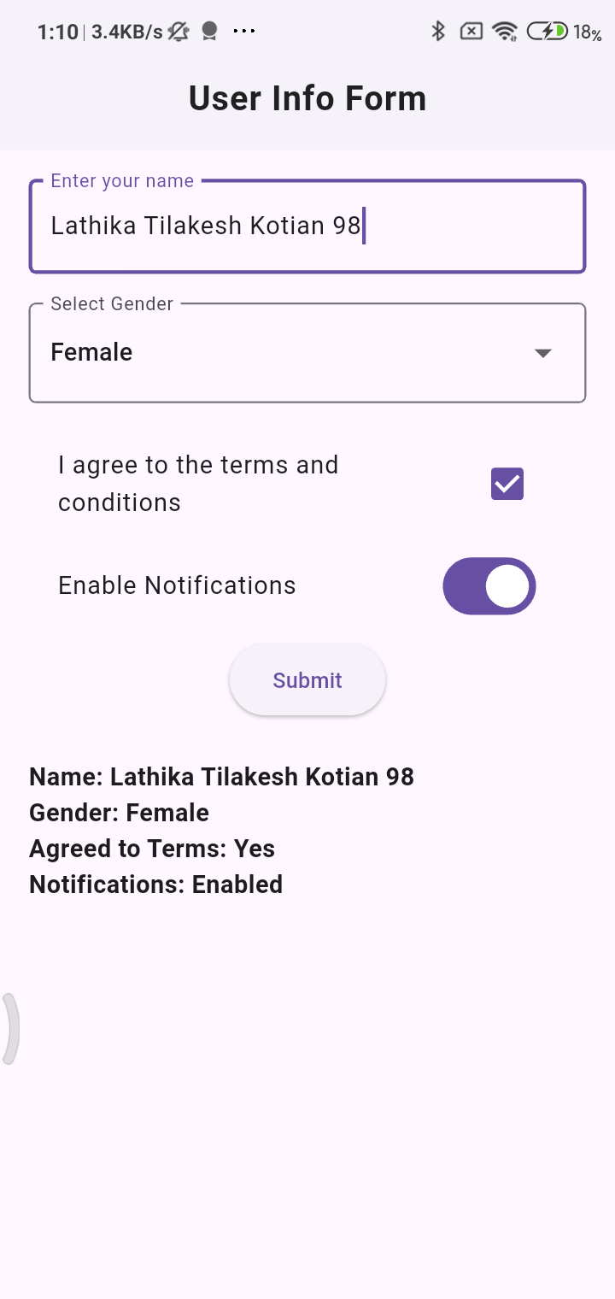

Practical -
Aim :- Program to demonstrate the use of SQFlite Database using flutter
CODE :
1. Add Dependencies:
pubspec.yaml
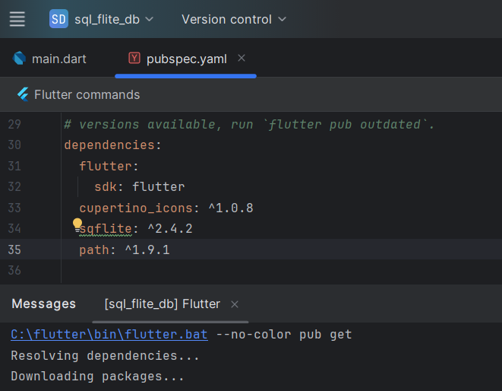

2. Define a Model Class:
Create a lib/user.dart file to define a model for your data (e.g., a User class):
user.dart :
class User {
final int? id;
final String name;
final int age;
User({this.id, required this.name, required this.age});
Map<String, dynamic> toMap() {
return {
'id': id,
'name': name,
'age': age,
};
}
factory User.fromMap(Map<String, dynamic> map) {
return User(
id: map['id'],
name: map['name'],
age: map['age'],
);
}
@override
String toString() {
return 'User{id: $id, name: $name, age: $age}';
}
}

3. Implement a Database Helper:
Create a lib/db_helper.dart file to manage database operations:
db_helper.dart :
import 'dart:async';
import 'package:path/path.dart';
import 'package:sqflite/sqflite.dart';
import 'user.dart'; // Import your User model
class DatabaseHelper {
static final DatabaseHelper _instance = DatabaseHelper._internal();
static Database? _database;
factory DatabaseHelper() {
return _instance;
}
DatabaseHelper._internal();
Future<Database> get database async {
if (_database != null) return _database!;
_database = await _initDatabase();
return _database!;
}
Future<Database> _initDatabase() async {
String path = join(await getDatabasesPath(), 'user_database.db');
return await openDatabase(
path,
version: 1,
onCreate: (db, version) {
return db.execute(
'CREATE TABLE users(id INTEGER PRIMARY KEY AUTOINCREMENT, name TEXT, age INTEGER)',
);
},
);
}
// Insert a user
Future<int> insertUser(User user) async {
final db = await database;
return await db.insert('users', user.toMap(),
conflictAlgorithm: ConflictAlgorithm.replace);
}
// Retrieve all users
Future<List<User>> getUsers() async {
final db = await database;
final List<Map<String, dynamic>> maps = await db.query('users');
return List.generate(maps.length, (i) {
return User.fromMap(maps[i]);
});
}
// Update a user
Future<int> updateUser(User user) async {
final db = await database;
return await db.update(
'users',
user.toMap(),
where: 'id = ?',
whereArgs: [user.id],
);
}
// Delete a user
Future<int> deleteUser(int id) async {
final db = await database;
return await db.delete(
'users',
where: 'id = ?',
whereArgs: [id],
);
}
}

4. Integrate into your Flutter App:
main.dart :
import 'package:flutter/material.dart';
import 'package:sql_flite_db/user.dart';
import 'db_helper.dart';
void main() {
WidgetsFlutterBinding.ensureInitialized();
runApp(const MyApp());
}
class MyApp extends StatelessWidget {
const MyApp({super.key});
@override
Widget build(BuildContext context) {
return MaterialApp(
title: 'SQFlite Demo',
debugShowCheckedModeBanner: false,
theme: ThemeData(
primarySwatch: Colors.blue,
),
home: const UserListScreen(),
);
}
}
class UserListScreen extends StatefulWidget {
const UserListScreen({super.key});
@override
State<UserListScreen> createState() => _UserListScreenState();
}
class _UserListScreenState extends State<UserListScreen> {
final DatabaseHelper _dbHelper = DatabaseHelper();
List<User> _users = [];
@override
void initState() {
super.initState();
_loadUsers();
}
Future<void> _loadUsers() async {
final users = await _dbHelper.getUsers();
setState(() {
_users = users;
});
}
Future<void> _addUser() async {
final newUser = User(name: 'Lathika Kotian - 98', age: 21);
await _dbHelper.insertUser(newUser);
_loadUsers();
}
Future<void> _updateUser(User user) async {
final updatedUser = User(id: user.id, name: '${user.name} (Updated)', age: user.age + 1);
await _dbHelper.updateUser(updatedUser);
_loadUsers();
}
Future<void> _deleteUser(int id) async {
await _dbHelper.deleteUser(id);
_loadUsers();
}
@override
Widget build(BuildContext context) {
return Scaffold(
appBar: AppBar(
title: const Text('SQFlite User List'),
actions: [
IconButton(
icon: const Icon(Icons.add),
onPressed: _addUser,
),
],
),
body: ListView.builder(
itemCount: _users.length,
itemBuilder: (context, index) {
final user = _users[index];
return ListTile(
title: Text(user.name),
subtitle: Text('Age: ${user.age}'),
trailing: Row(
mainAxisSize: MainAxisSize.min,
children: [
IconButton(
icon: const Icon(Icons.edit),
onPressed: () => _updateUser(user),
),
IconButton(
icon: const Icon(Icons.delete),
onPressed: () => _deleteUser(user.id!),
),
],
),
);
},
),
);
}
}

OUTPUT :
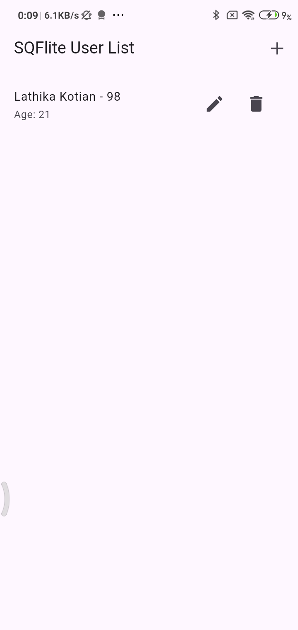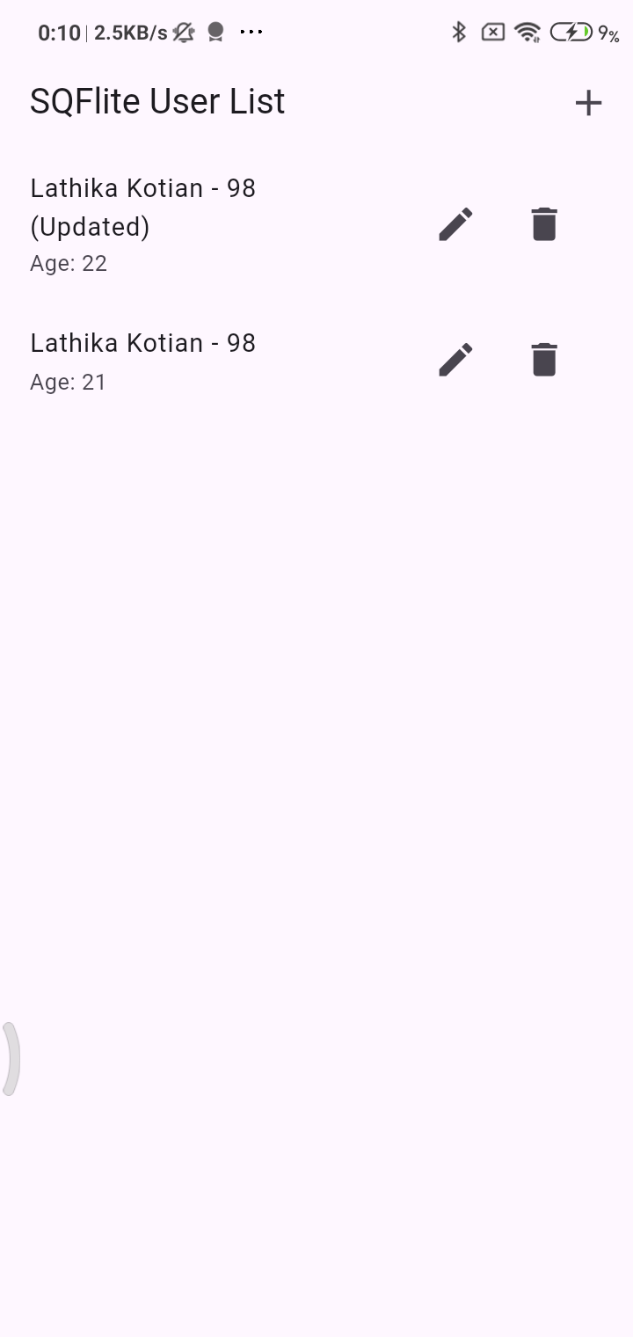

Practical-
Aim: Program to demonstrate the use of RESTAPI
CODE :
1. Project Setup:
- Create a new Flutter project or use an existing one.
- Add the http package to your pubspec.yaml file
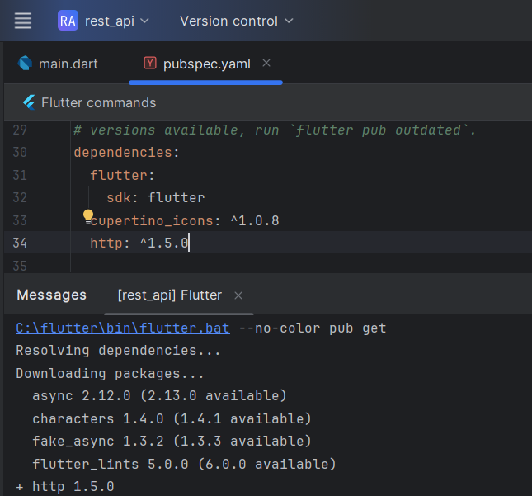

2. Data Model:
- Create a Dart class to represent the structure of the data you'll receive from the API. For JSONPlaceholder posts, this might look like:
post.dart :
class Post {
final int userId;
final int id;
final String title;
final String body;
Post({required this.userId, required this.id, required this.title, required this.body});
factory Post.fromJson(Map<String, dynamic> json) {
return Post(
userId: json['userId'],
id: json['id'],
title: json['title'],
body: json['body'],
);
}
}

3. API Service:
- Create a service class to handle API calls:
postService.dart :
import 'dart:convert';
import 'package:http/http.dart' as http;
import 'package:rest_api/post.dart';

class PostService {
static const String _baseUrl = 'https://jsonplaceholder.typicode.com';

Future<List<Post>> fetchPosts() async {
final response = await http.get(Uri.parse('$_baseUrl/posts'));

if (response.statusCode == 200) {
List<dynamic> body = json.decode(response.body);
return body.map((dynamic item) => Post.fromJson(item)).toList();
} else {
throw Exception('Failed to load posts');
}
}
}

4. UI Integration:
- Use a FutureBuilder in your UI to asynchronously fetch and display the data:
main.dart
import 'package:flutter/material.dart';
import 'package:rest_api/post.dart';
import 'package:rest_api/postService.dart';

void main() {
runApp(const MyApp());
}

class MyApp extends StatelessWidget {
const MyApp({super.key});
@override
Widget build(BuildContext context) {
return MaterialApp(
title: 'Rest API Practical Lathika Kotian- 98',
debugShowCheckedModeBanner: false,
theme: ThemeData(
colorScheme: ColorScheme.fromSeed(seedColor: Colors.deepPurple),
),
home: HomePage(),
);
}
}

class HomePage extends StatefulWidget {
@override
_HomePageState createState() => _HomePageState();
}

class _HomePageState extends State<HomePage> {
late Future<List<Post>> _postsFuture;

@override
void initState() {
super.initState();
_postsFuture = PostService().fetchPosts();
}

@override
Widget build(BuildContext context) {
return Scaffold(
appBar: AppBar(
backgroundColor: Colors.white,
elevation: 2,
title: Text(
'Posts from API',
style: TextStyle(
color: Colors.black87,
fontWeight: FontWeight.bold,

),
),
centerTitle: true,

),

body: Column(
children: [
Expanded(
child:
FutureBuilder<List<Post>>(
future: _postsFuture,
builder: (context, snapshot) {
if (snapshot.connectionState == ConnectionState.waiting) {
return Center(child: CircularProgressIndicator());
} else if (snapshot.hasError) {
return Center(child: Text('Error: ${snapshot.error}'));
} else if (snapshot.hasData) {
return ListView.builder(
itemCount: snapshot.data!.length,
itemBuilder: (context, index) {
Post post = snapshot.data![index];
return ListTile(
title: Text(post.title),
subtitle: Text(post.body),
);
},
);
} else {
return Center(child: Text('No posts found.'));
}
},
),
),
Container(
padding: const EdgeInsets.all(12.0),
color: Colors.blue,
width: double.infinity,
child: Text(
'By Lathika Kotian -98',
textAlign: TextAlign.center,
style: TextStyle(color: Colors.white, fontWeight:FontWeight.bold,fontSize: 18),
),
),
],
),
);
}
}

OUTPUT :
