Game Design Document

Fill up the following document

1. Write the title of your project.

YourBrainLab

1. What is the goal of the game?

The goal of the game is to help users have fun and learn something new at the same time.

1. Write a brief story of your game.

The app that I want to develop is not a story based app.

But it’s an app that helps you keep progress, know you improvements etc by letting you know the score, level of difficulty you can reach and much more.

The complete idea of the game:

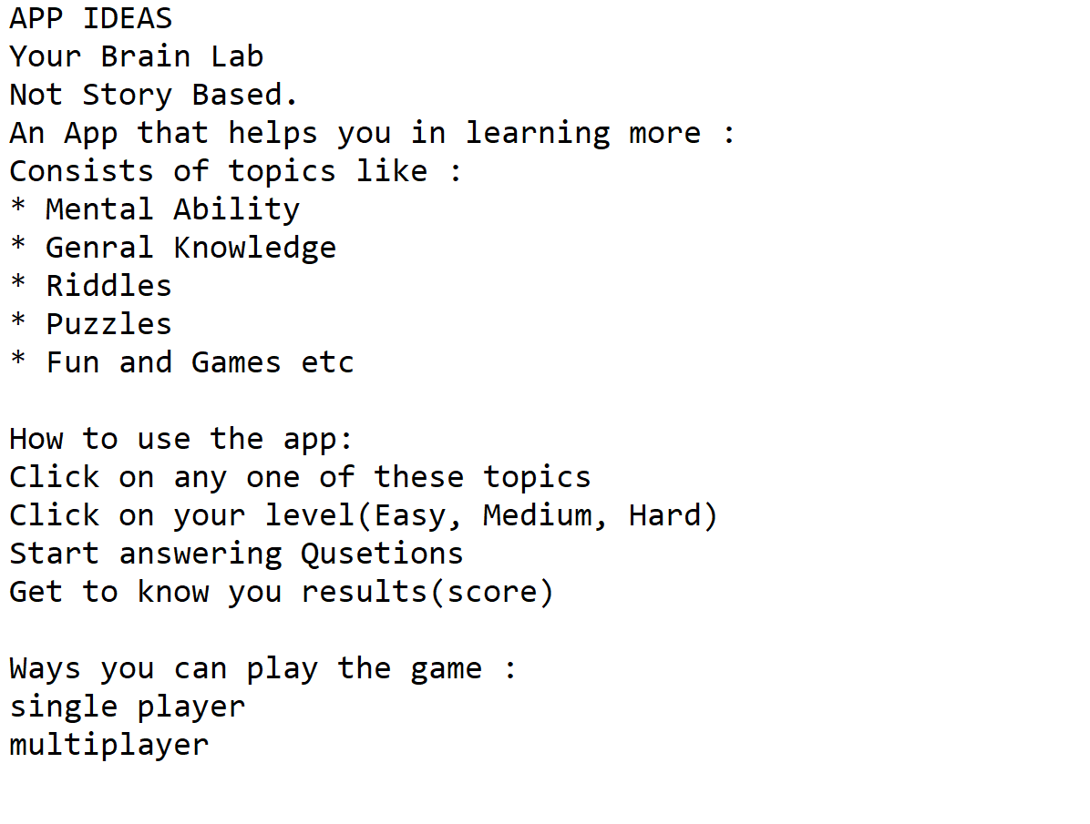

1. Which are the playing characters of this game?

* Playing characters are the ones who respond to the user based on the input from the user.
* Cars, monkeys, dinos, wizards, etc., are the playing characters in the game.

|  |  |  |
| --- | --- | --- |
| Number | Character Name | What can this character do? |
| 1 | Single player  (PC) | The game(Quiz) is played by the user only ! |
| 2 | Multiplayer  (PC) | A group of players challenge within themselves. |
| 3 | - | - |
| 4 | - | - |
| 5 | - | - |
| 6 |  |  |
| 7 |  |  |
| 8 |  |  |

1. Which are the Non-Playing Characters of this game?

* Non-Playing characters are the ones that don't have an action or behavior when the user interacts with the game.
* Hurdles, stones, bananas, coins, etc., are non-playing characters in the game.

|  |  |  |
| --- | --- | --- |
| Number | Character Name | What can this character do? |
| 1 | Single player  (PC) | The game(Quiz) is played by the user only ! |
| 2 | Multiplayer  (PC) | A group of players challenge within themselves. |
| 3 | Quiz  (NPC) | This screen constists of questions and options. |
| 4 | Topics  (NPC) | Players can choose according to their choice |
| 5 | - | - |
| 6 | - | - |
| 7 | - | - |
| 8 | - | - |

Draw your imagination of this game. What does this game look like?

* Draw the game either on your computer or on paper.
* Add images of the game scenes to show each of the playing and non-playing characters at least once.

I Hope the scrrn will look some how similar to this.

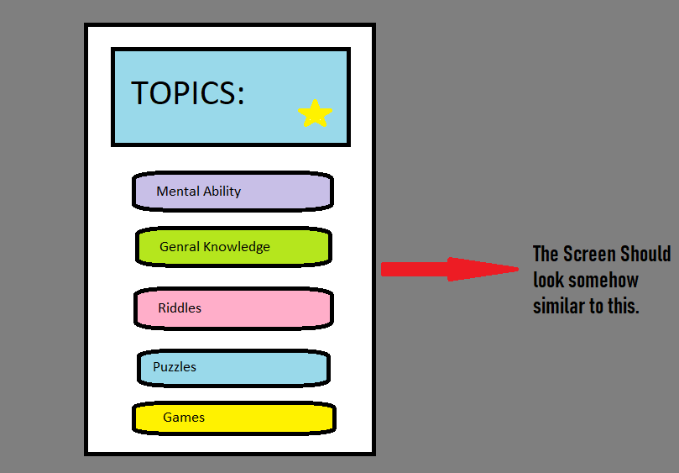

How do you plan to make your game engaging?

The difficulty level , multiplayer option, beating your previous score….

The abllity of learning and playing on the same time with interesting Quizes, puzzles etc under

Topics like:

* Mental Ability

* Genral Knowledge

* Riddles

* Puzzles

* Fun and Games