**Partners:**

**Lauren Thomas**

**Mary Hanvey**

**Assumptions**

No id should ever be changed since it is the primary key. There are restrictions for creating a new customer account and updating a customer account (fields can’t be null). However, since the staff should be the only ones changing products and orders, there aren’t restrictions. Outside of staff, others don’t know that staff.php exists so they cannot access it.

**Programming Practices**

We used MAMP to host the website on a local machine. We used jade to code in html. Php was used. All functions (outside of staff functions and cart functions) were placed in one php file. Every time a new user is created, the database does an auto increment on the id for that user. This is also done for products and orders.

**Major Challenges**

The hardest part of this was getting the database to work with php. Also setting up the add to cart feature was difficult. The php file was very hard to work with since all functions were thrown in one file. The hardest part was the staff interface. The staff interface was hard because there were so many different options for the staff and they all had to interact with the database.

**Contributions**

Mary- Database Implementation: MYSQL code for database schema, trigger

Lauren- Website front end/ backend (all php scripts), setup of development environment, report

**Walk through:**

Home page:

You can search, login or create a new account.

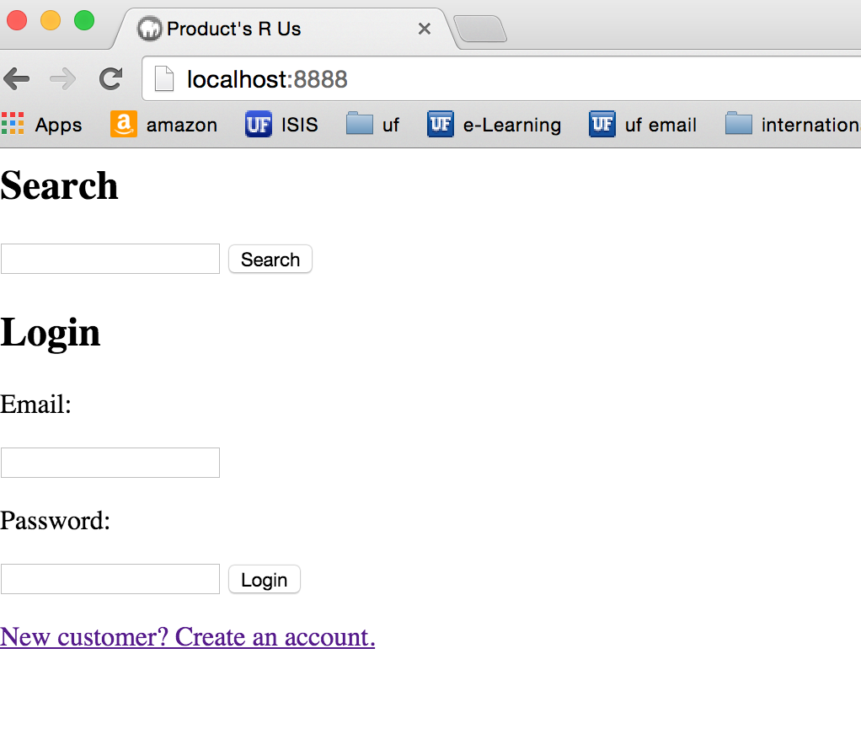

If you login, there will be a header on every page with your name, an option to sign out and an option to view account information. Session variables are set upon login to store user name, id (for accessing database) and whether or not the user is a staff member.

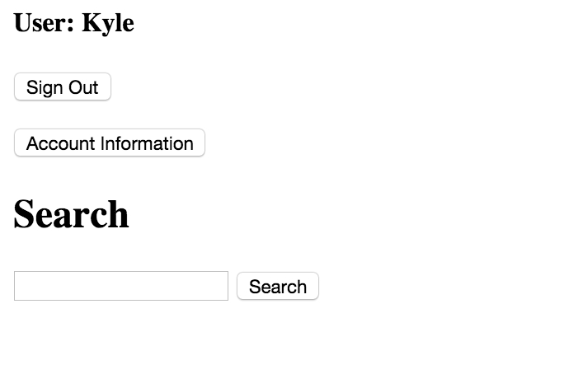

At any time, a user can log out and they are taken back to the homepage. The session is restarted to ensure a logout. Once logged in, a user can search for a product and an add to cart feature appear upon search. To add to the cart, the customer must click the radio button next to the item they’d like to add and click add to cart. The result page also has an option to search again.

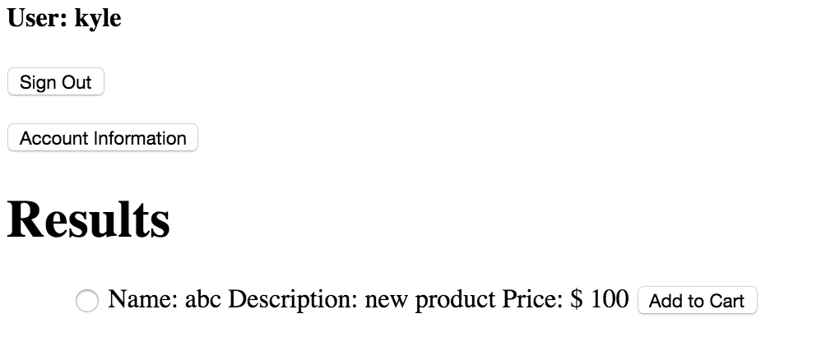

A customer can update their information by going to account information. The account information screen gives current information and has a form so information can be updated. When they update, they can leave any fields blank that they don’t want to update. Anything that isn’t blank will be updated. Once updated, customers can see the new information.

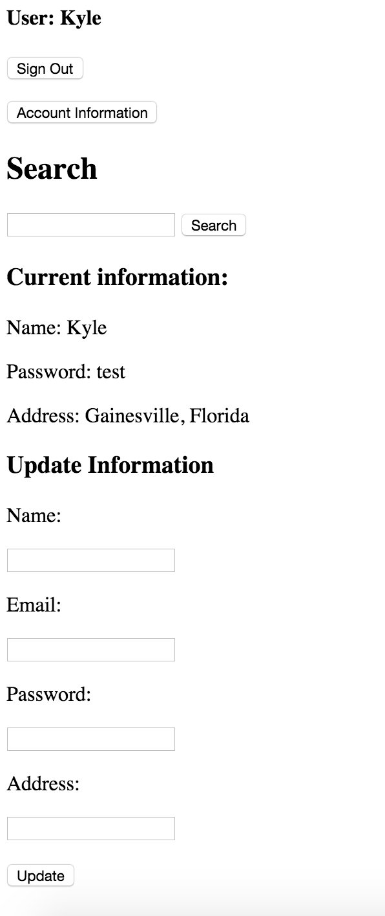

Customers may add to cart and be brought to their cart upon adding to the cart. They may search again, check out and pay, or cancel from the cart.

If they checkout (we assume pay happens) and they are brought back to index again (after this is added to the database).

Staff login:

If a member is staff, they use the same login but the session variable for staff is true and they are taken to a staff page. The options are search or staff action. Staff picks which object (user, product, order) they would like to work on.

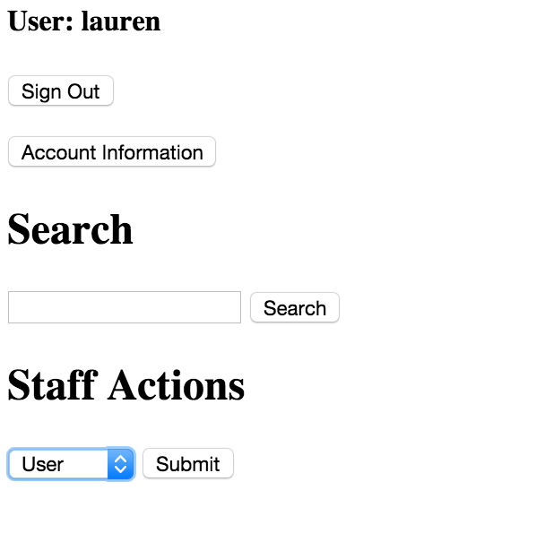

Once they choose the object, upon pressing submit, staff is brought to a page with all items in that database. They can update, add or delete from that screen.

They can either search or add a new product.