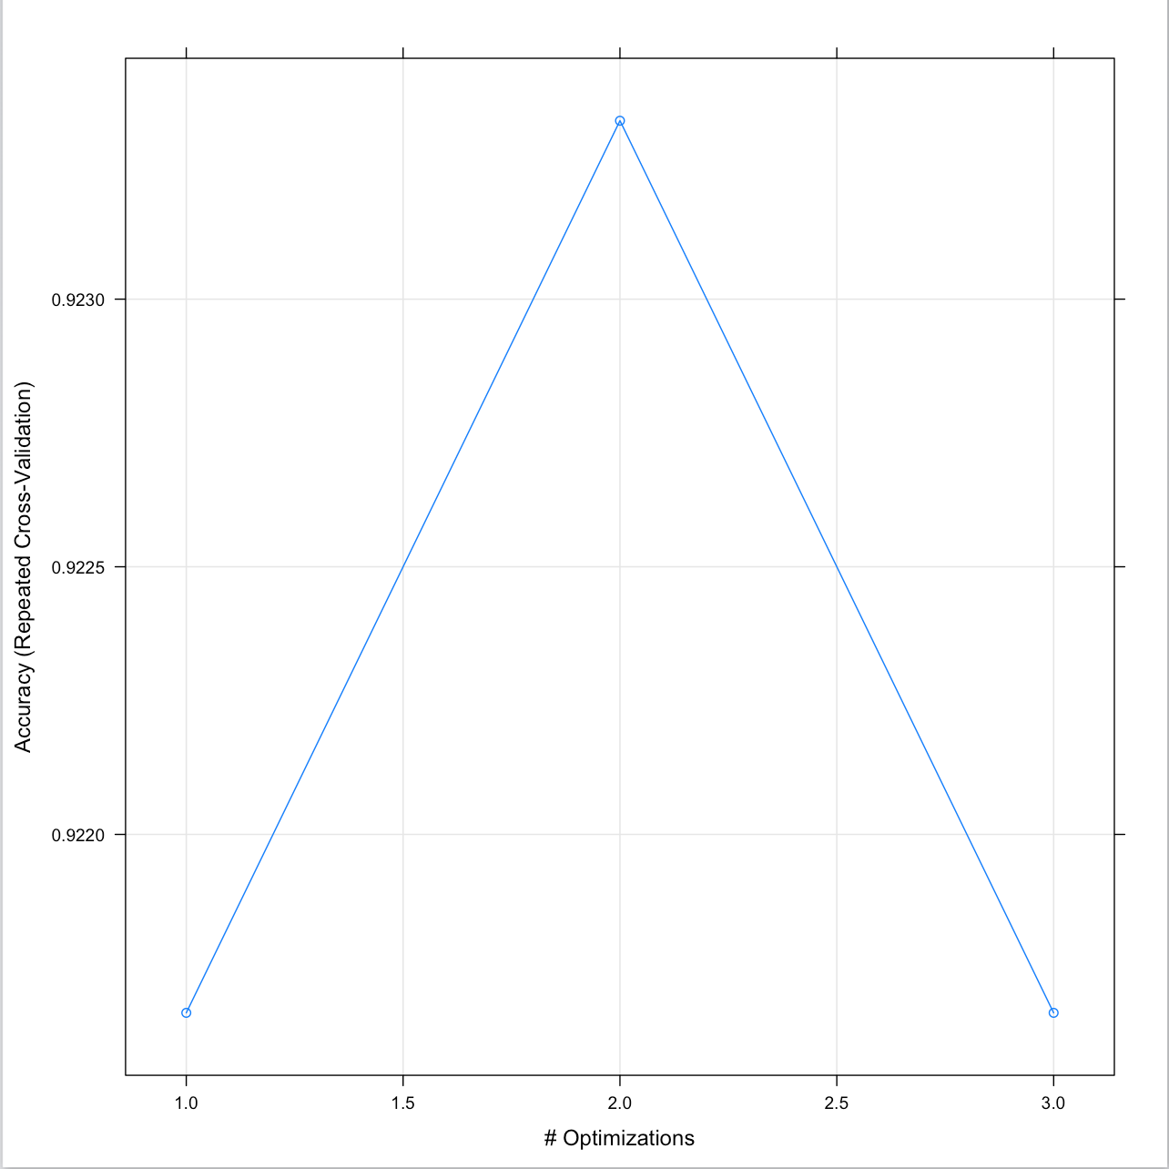**RIPPER- Iris:**

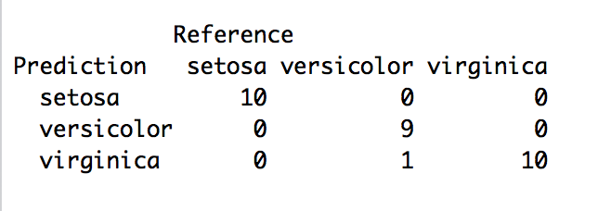

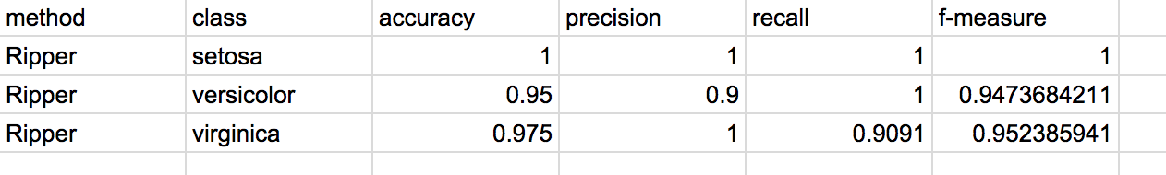

**C4.5-Iris:**

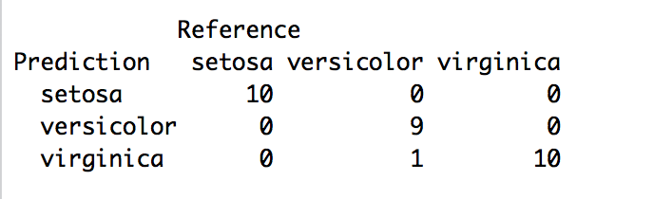

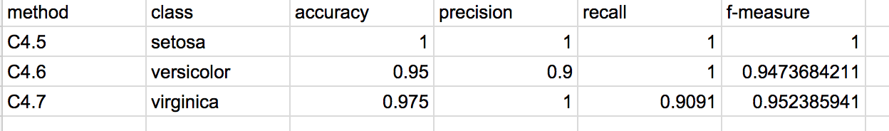

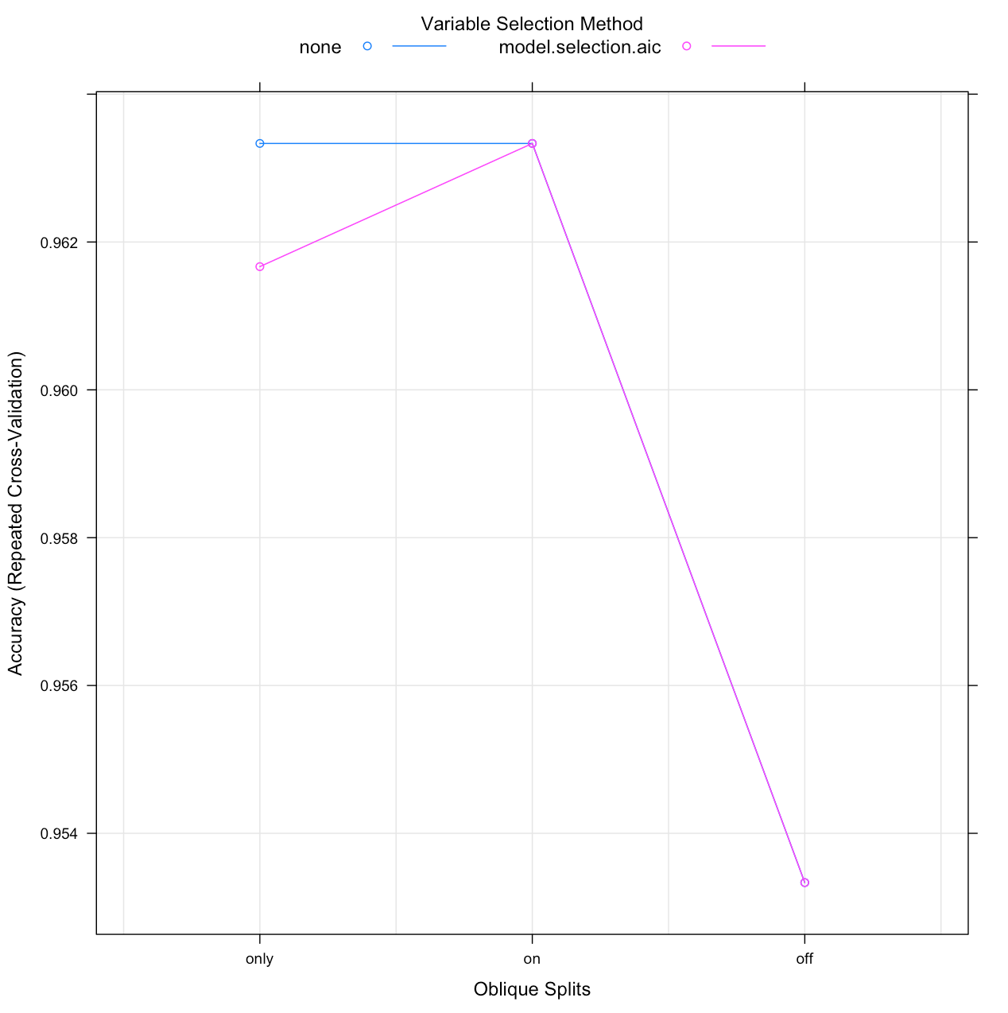**Oblique- Iris:**

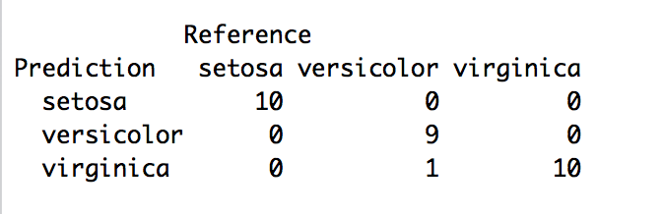

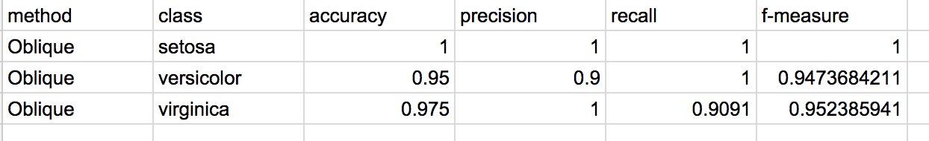

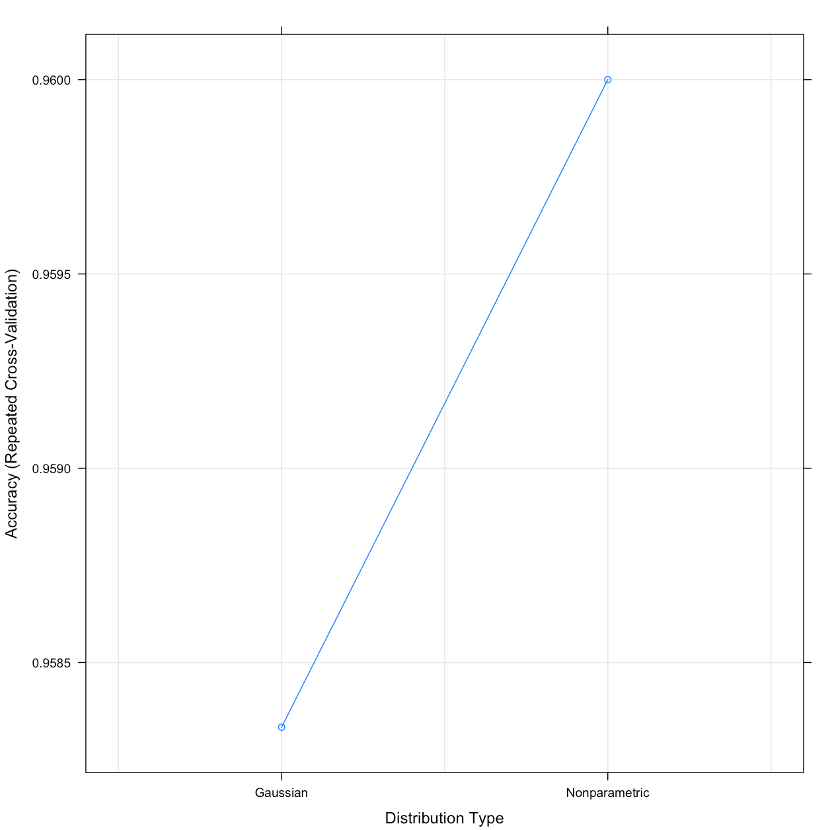**Naïve Bayes- Iris:**

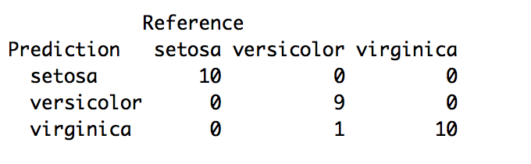

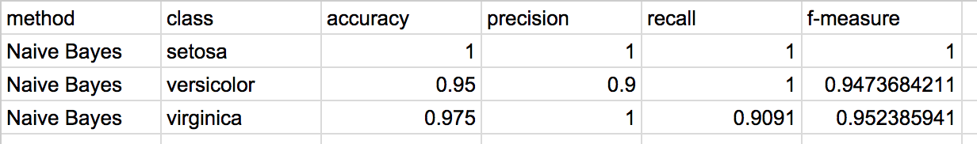

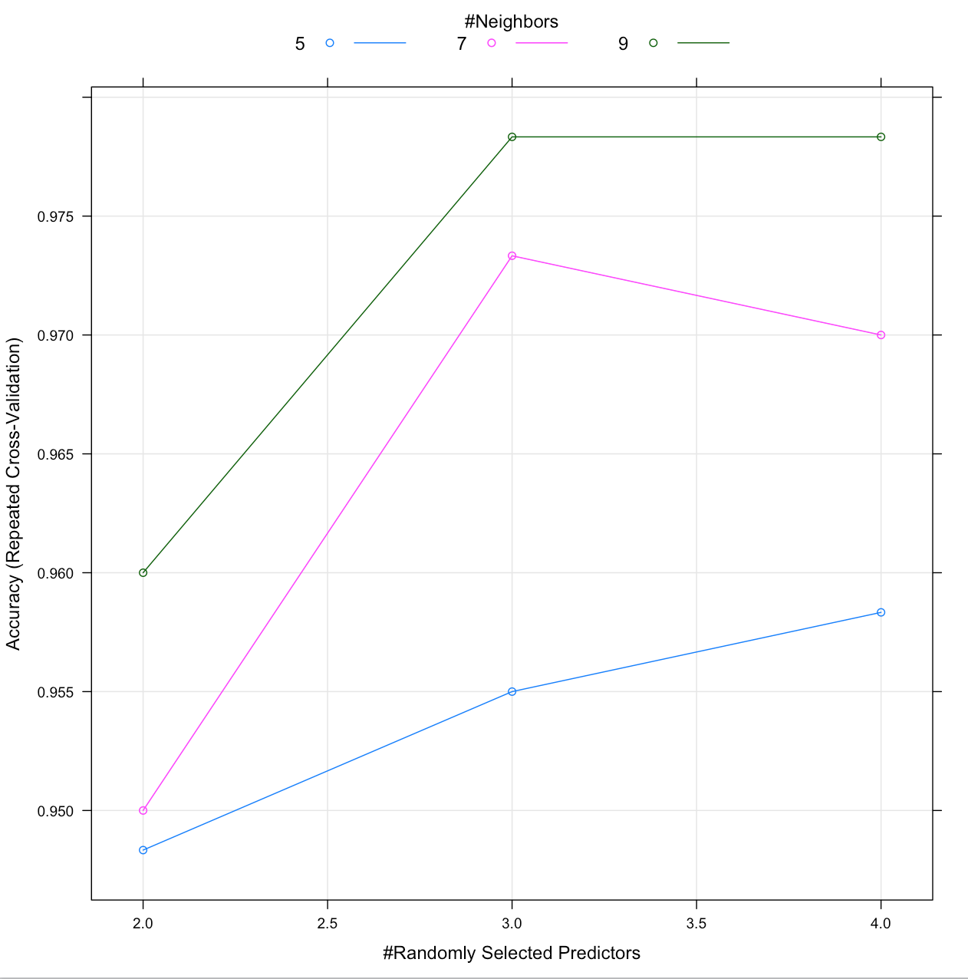

**K-Nearest Neighbor-Iris:**

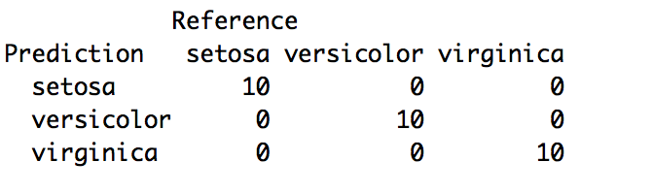

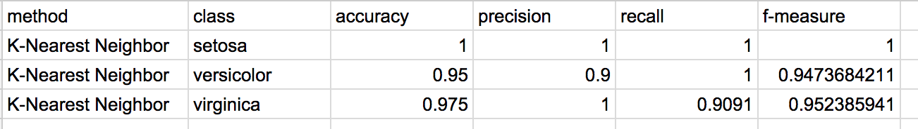

**Iris Data Set Conclusion:**

The iris data set models were all accurate. This is most likely because the data set has very different classification standards for each class so things are accurately classified. On top of this, there are only 3 classes so there is less to go wrong. Additionally the precision for this data set was very high.

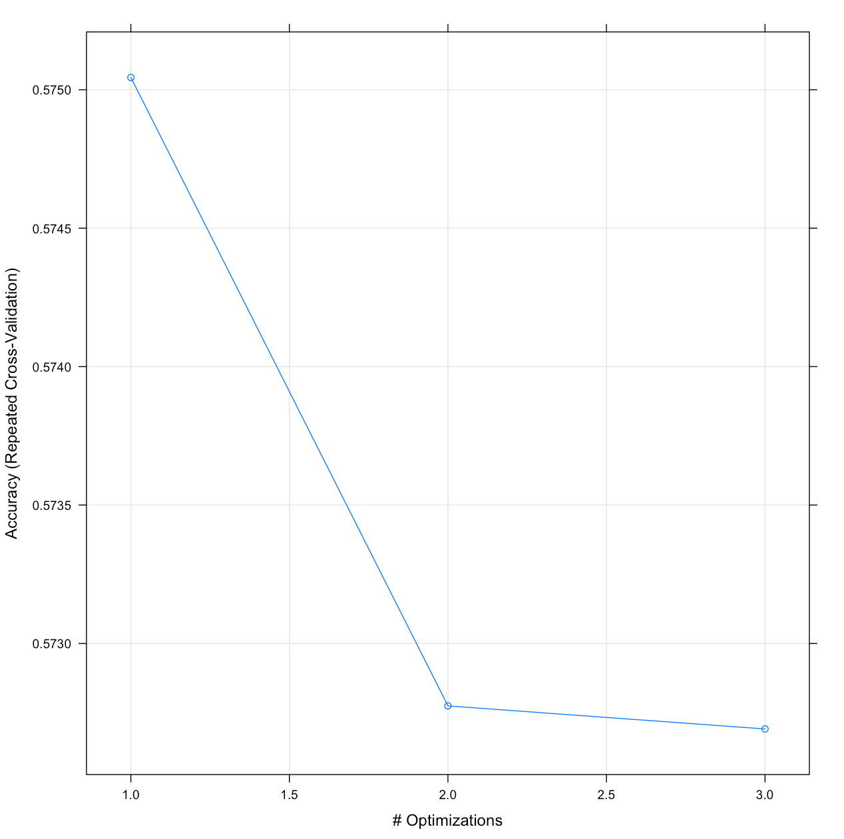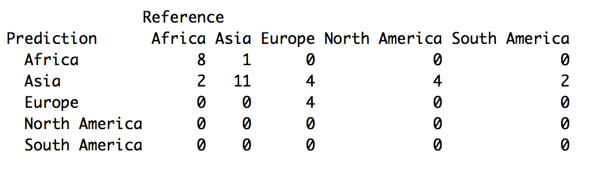**Ripper-Life Expectancy:**

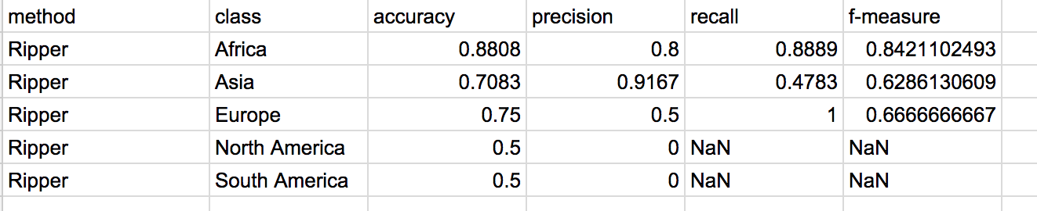

**C4.5- Life Expectancy:**

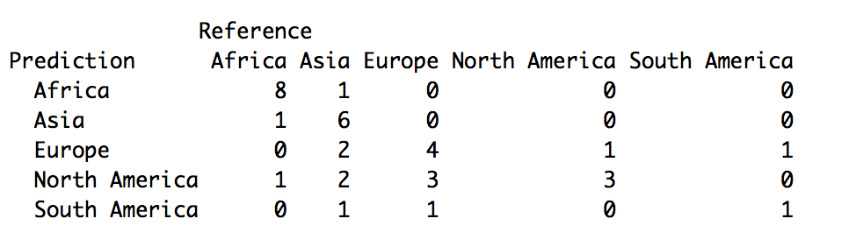

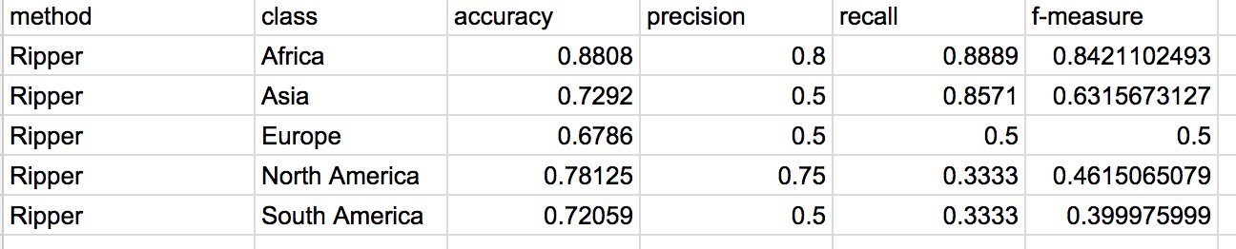

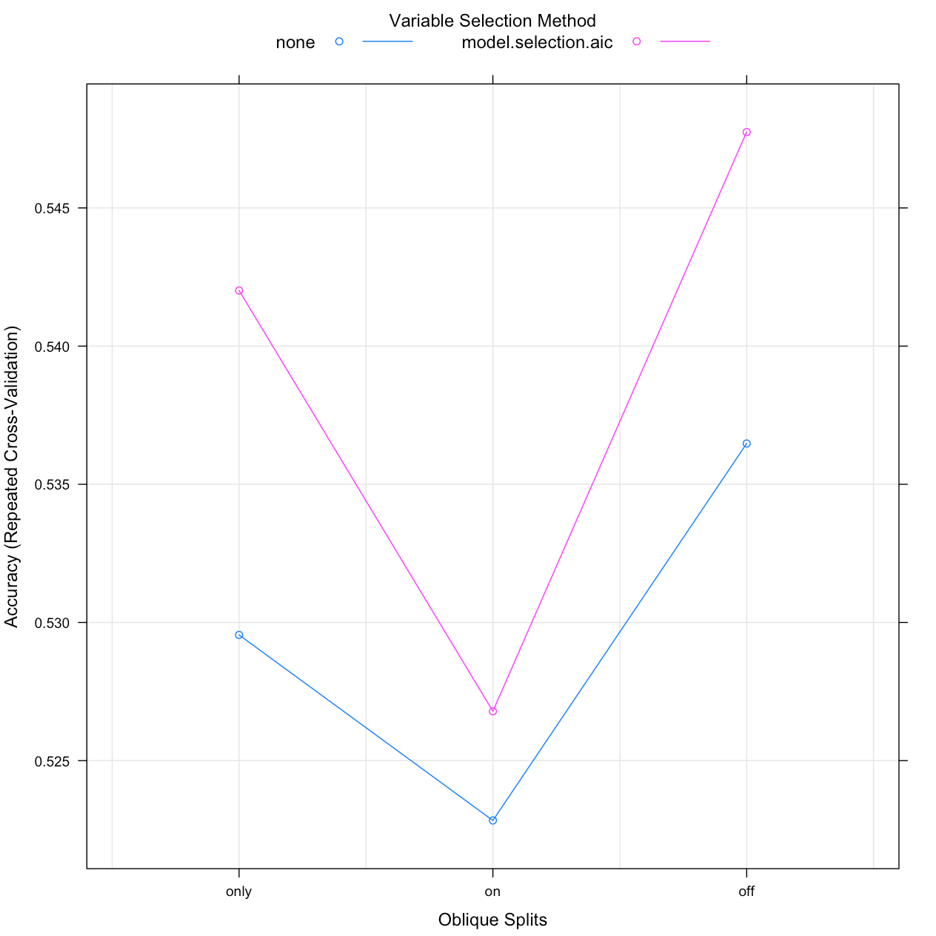**Oblique- Life Expectancy:**

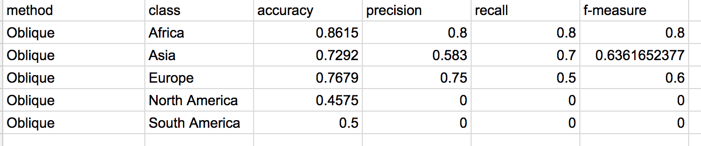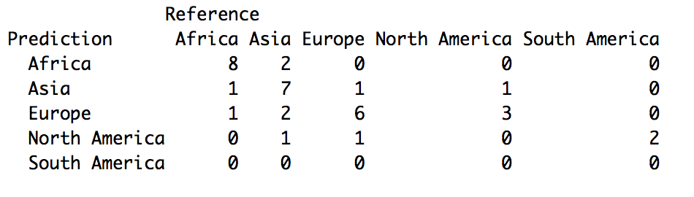

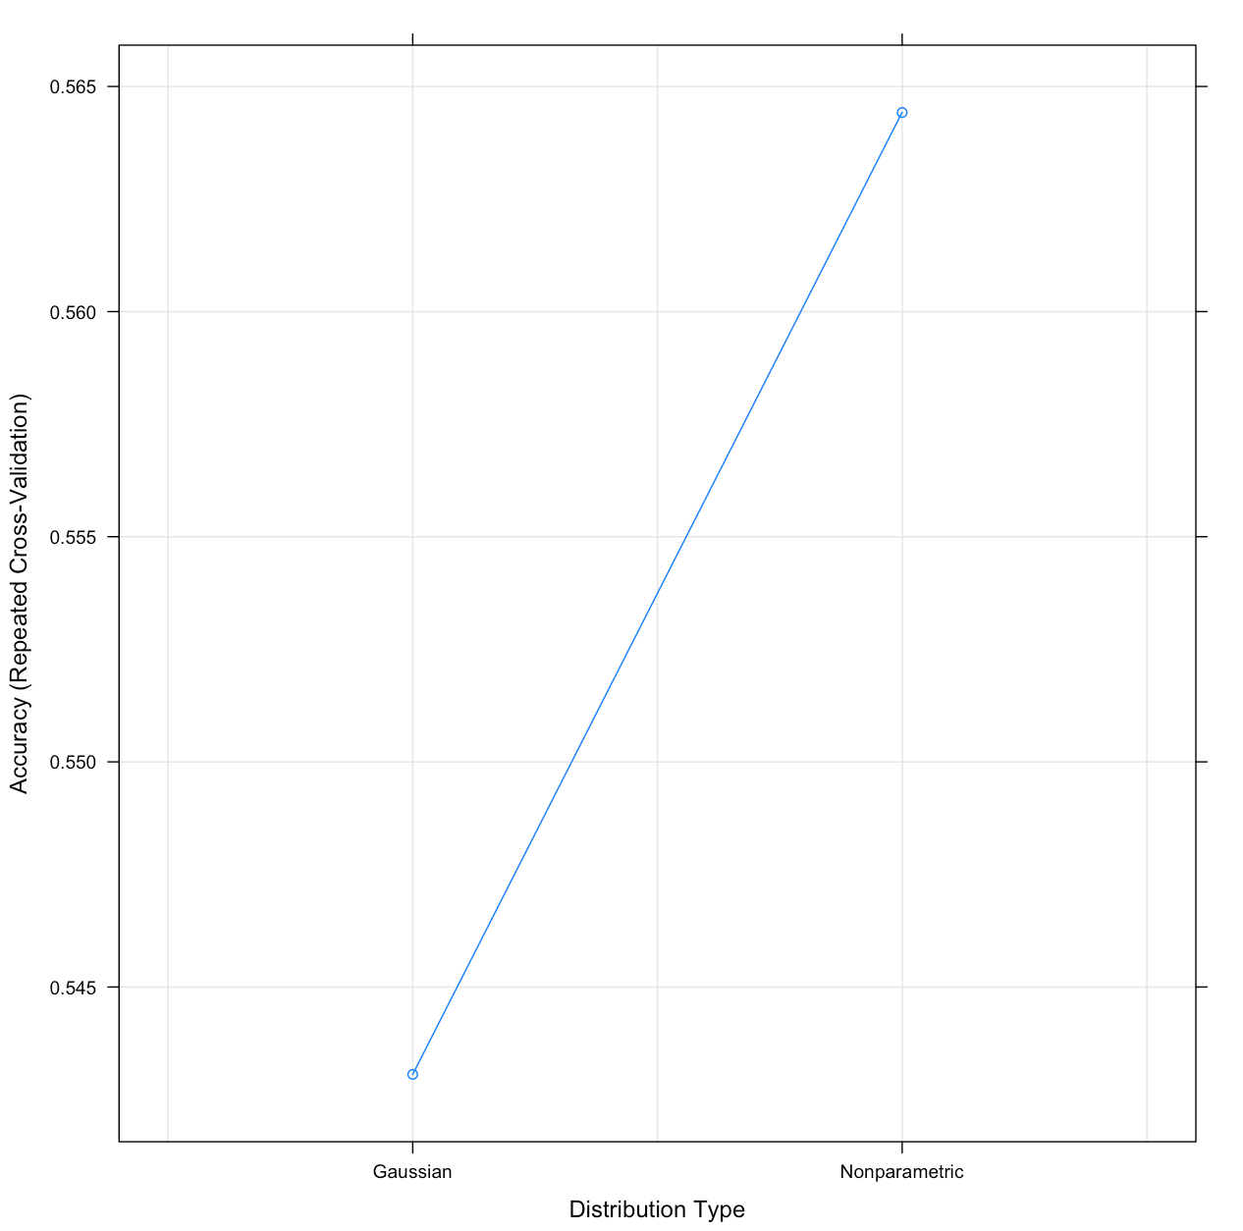

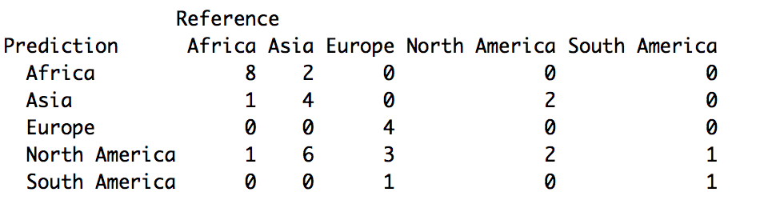**Naïve Bayes- Life Expectancy:**

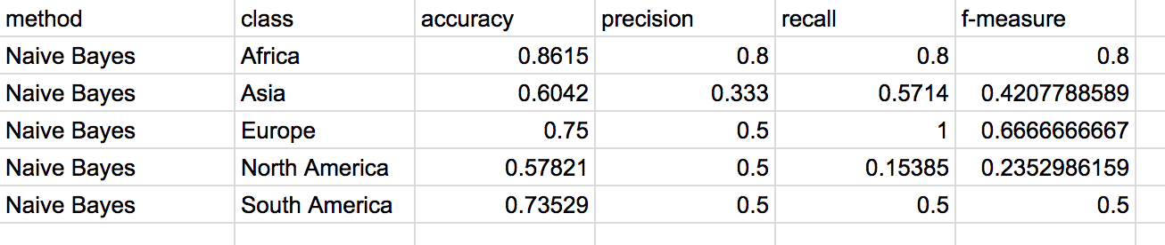

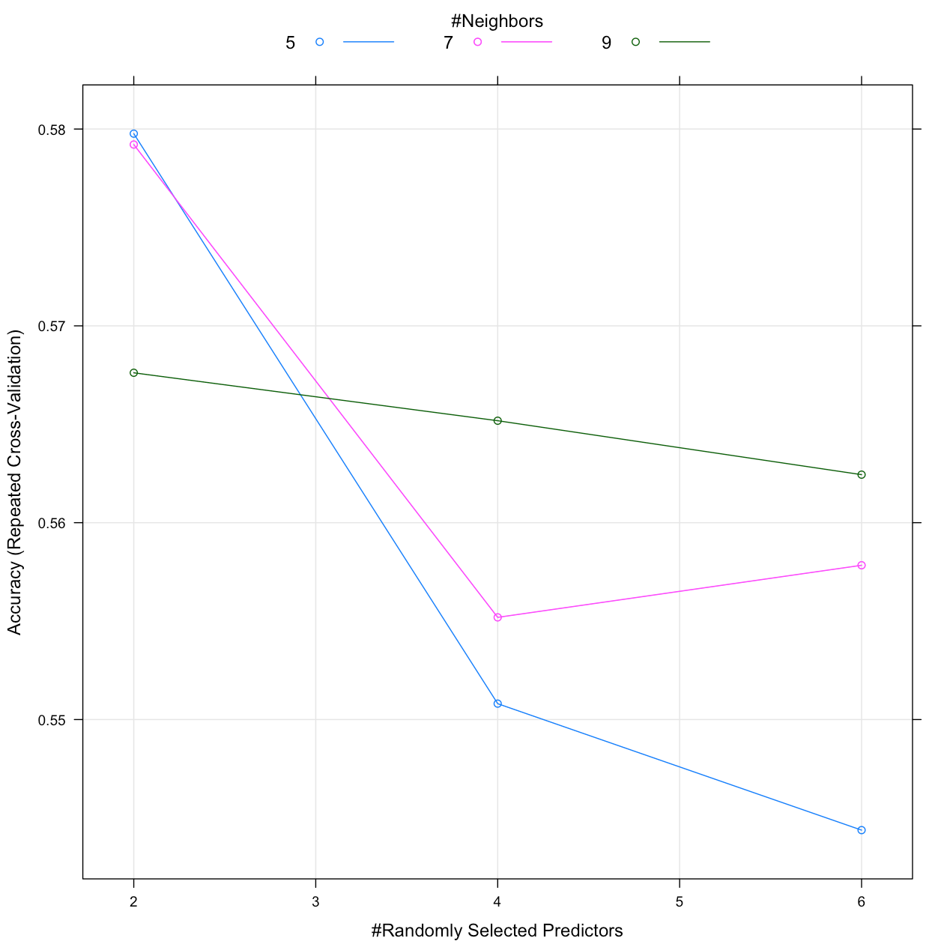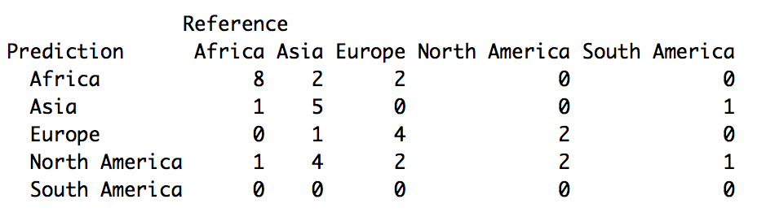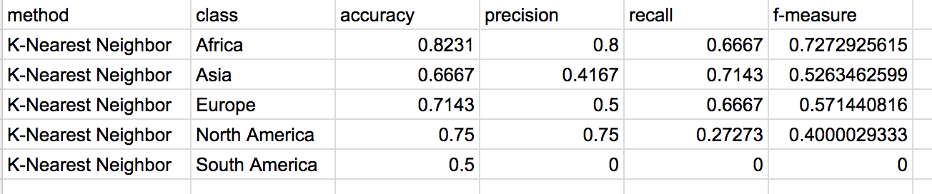**K-Nearest Neighbor- Life Expectancy:**

**Life Expectancy Data Set Conclusion:**

The life expectancy data set didn’t come up with models that were as accurate. A lot of the models misclassified South America, meaning the South America life expectancies weren’t consistent since they were consistently misclassified as one specific continent. The precision was also very low for this data set. Again this is most likely because the data set wasn’t consistent across the classifications. This also indicates that which continent a country is in doesn’t have much bearing on its life expectancy.