Heart Disease Prediction Using Decision Tree
Practical Report | Data Preparation, EDA, Model Evaluation, and Overfitting Experiment

1. Objective
Build and evaluate a Decision Tree classification system using clinical-style features. Tasks include data cleaning, EDA, an 80/20 train-test split, depth comparison, visualization, and rule interpretation.

2. Dataset and Data Preparation
Dataset note: this report uses a SYNTHETIC educational dataset of 1,200 records because an external real dataset could not be retrieved during report generation. It is not real patient data and is not clinically valid.
Dataset size after cleaning: 1,200 records.
Number of input features: 12.
Target: target (0 = No Disease, 1 = Disease).
Features: age, sex, cp, trestbps, chol, thalach, exang, fbs, oldpeak, slope, ca, thal
Cleaning: removed duplicate rows, converted columns to numeric, dropped rows with missing targets, and filled missing feature values with their medians.
Training records: 960. Testing records: 240.

3. Exploratory Data Analysis
- Target/class distribution
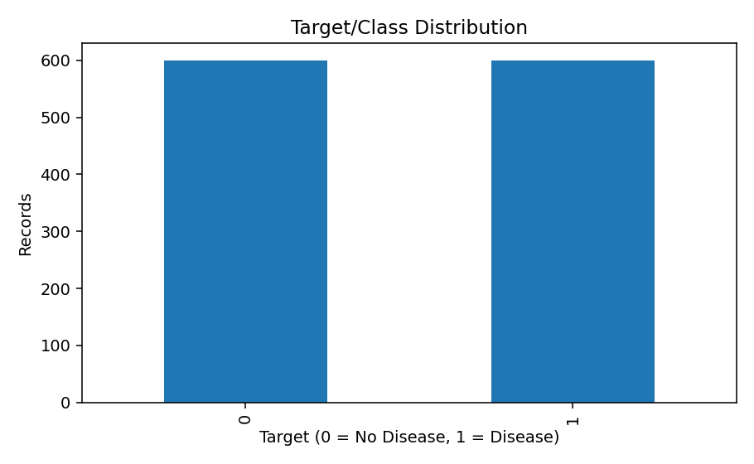
- Age distribution
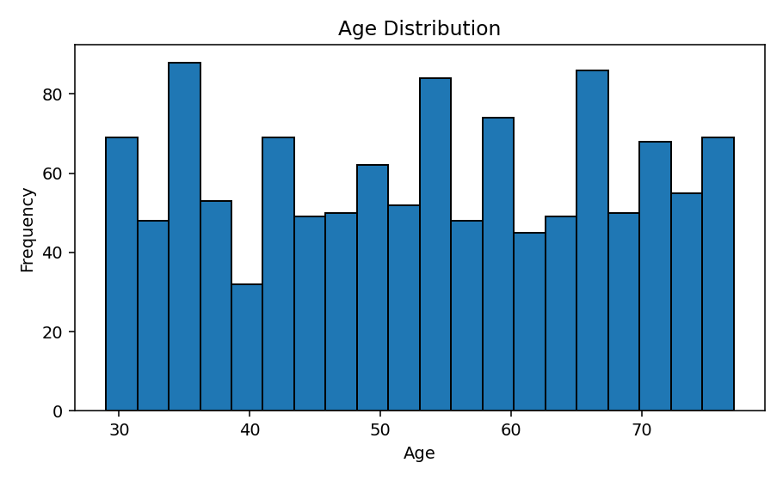
- Cholesterol distribution
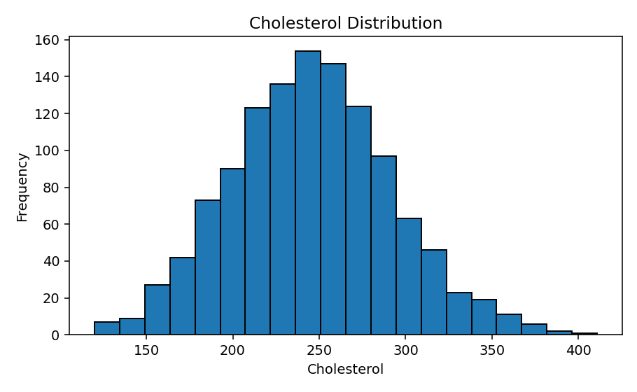
- Age versus target
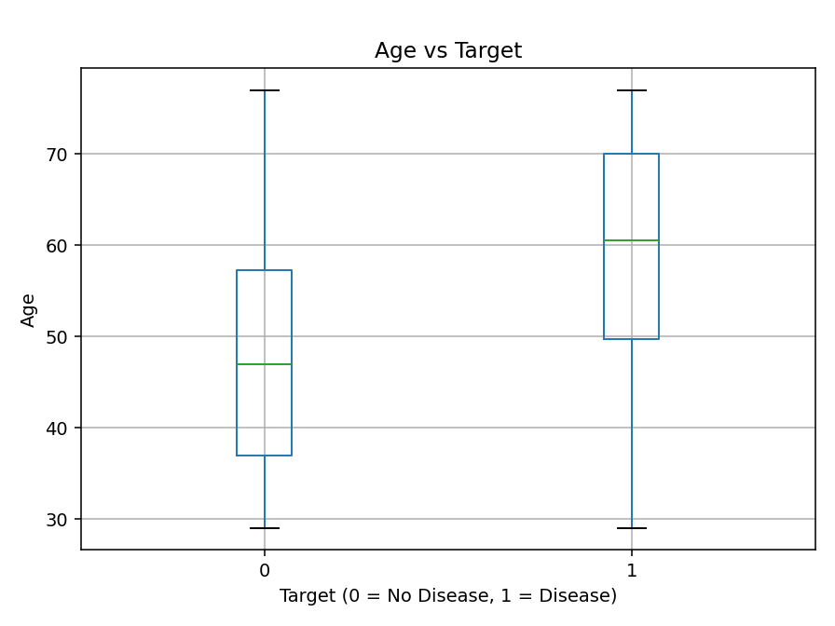
- Correlation heatmap
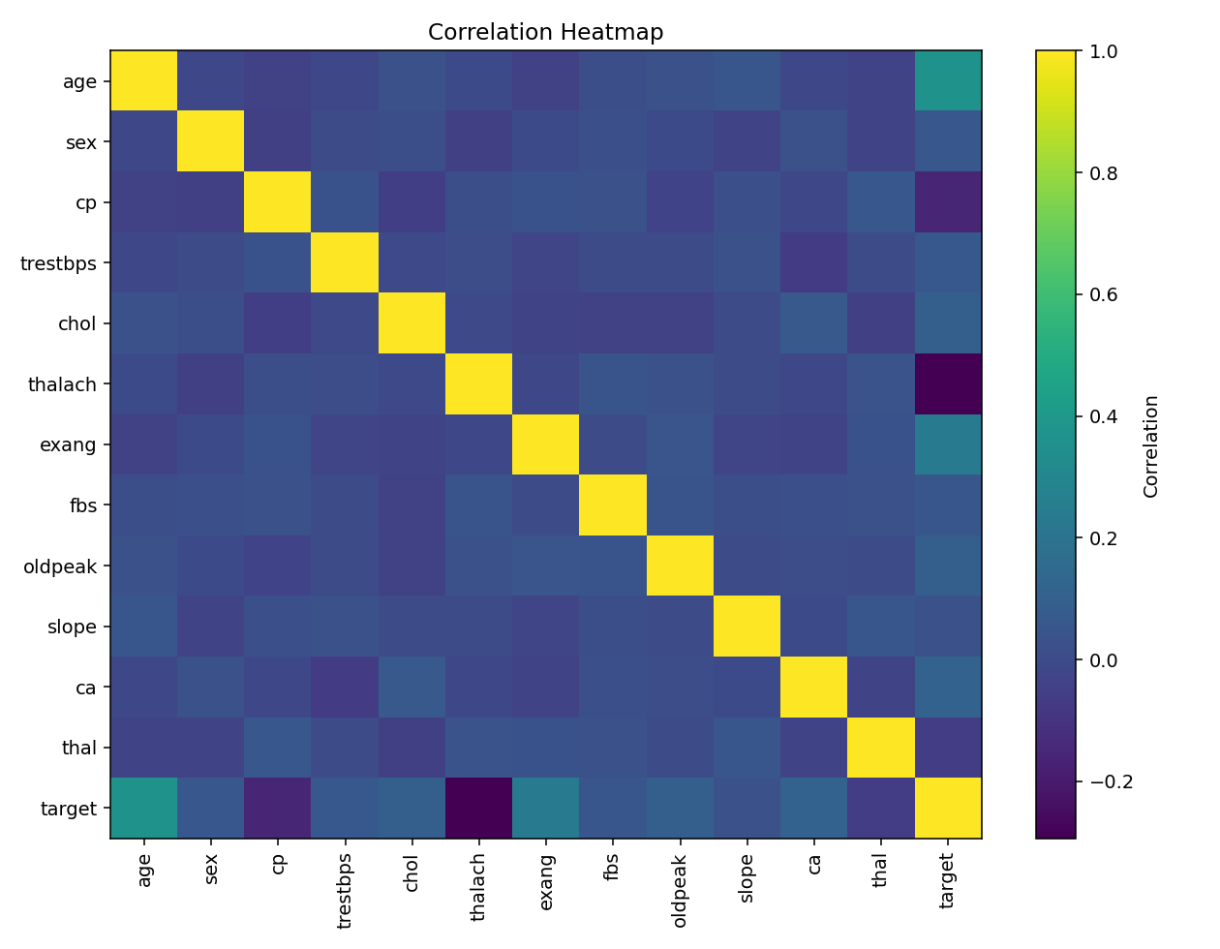

4. Five Data Insights
- Class 0 (no disease) represents 50.0% of the dataset, while class 1 (disease) represents 50.0%.
- Mean age is 48.0 for class 0 and 58.4 for class 1; this is descriptive and does not prove causation.
- Mean cholesterol is 241.1 for class 0 and 250.1 for class 1; differences are specific to this synthetic dataset.
- The age histogram shows the distribution and range of ages included in the sample.
- The correlation heatmap shows linear associations between numeric variables; correlation does not establish causation.
Top three features by absolute correlation with target: age (0.37), thalach (-0.29), exang (0.25).

5. Model Training and Evaluation
Decision Tree Classifiers were trained with max_depth values 2, 3, 5, 8, and 10 using the same stratified 80/20 split and random_state=42.
Max Depth | Training Accuracy | Testing Accuracy | Train-Test Gap
2 | 69.17% | 69.17% | 0.00 pp
3 | 73.75% | 71.25% | 2.50 pp
5 | 79.17% | 69.17% | 10.00 pp
8 | 91.04% | 65.00% | 26.04 pp
10 | 96.56% | 63.75% | 32.81 pp
Best depth by test accuracy: 3.
Training accuracy: 73.75%. Testing accuracy: 71.25%.
Training-testing gap: 2.50 percentage points.
Confusion matrix (rows = actual [0,1], columns = predicted [0,1]): [[66, 54], [15, 105]]
Actual vs predicted results are saved in actual_vs_predicted.csv.

6. Overfitting Experiment Analysis
Depth 2: training accuracy 69.17%, testing accuracy 69.17%. It may underfit if both scores are relatively low compared with deeper trees.
Depth 10: training accuracy 96.56%, testing accuracy 63.75%. A large train-test gap would suggest overfitting.
The best generalizing model should combine strong test accuracy with a reasonably small train-test gap. Interpret the comparison table rather than assuming that deeper trees are always worse.

7. Final Tree and Five Decision Rules
The model selected by highest testing accuracy uses max_depth=3.
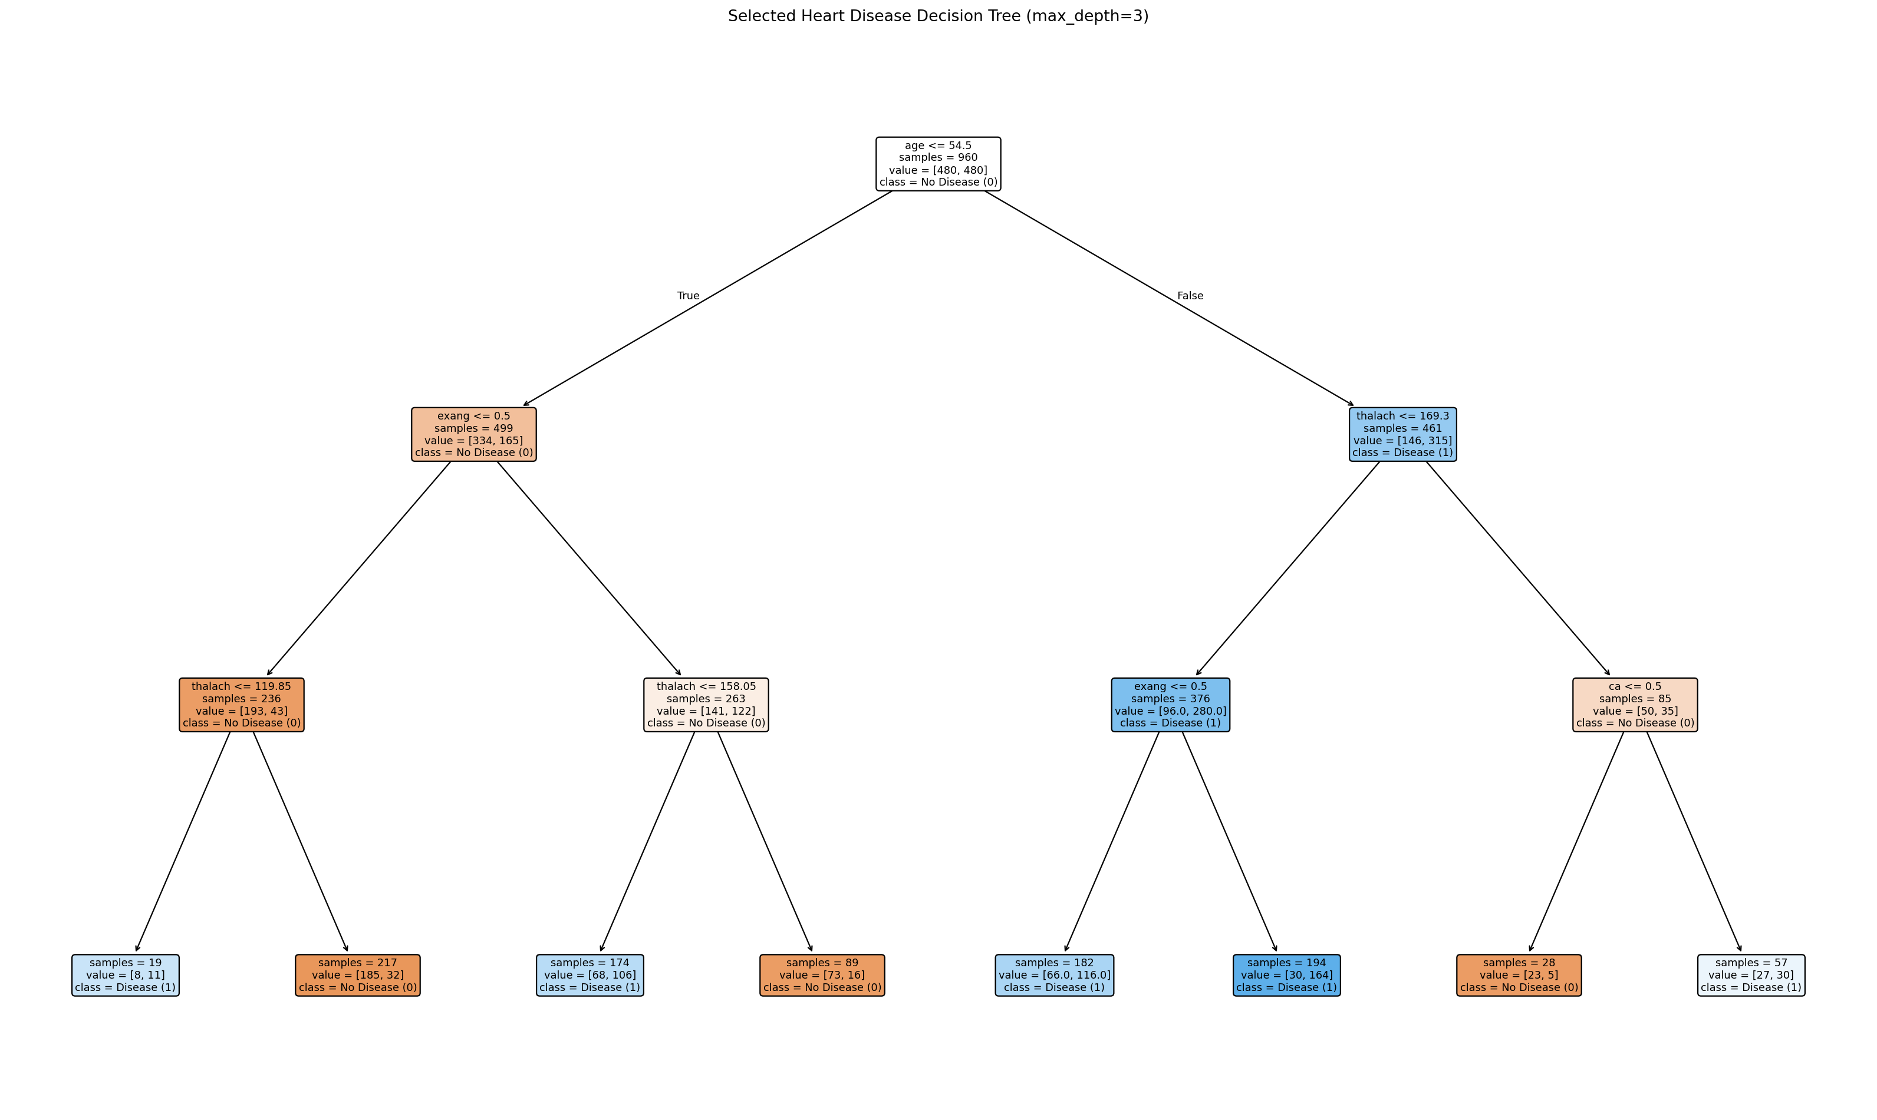
First five split rules from the trained tree:
- |--- age <= 54.50
- | |--- exang <= 0.50
- | | |--- thalach <= 119.85
- | | |--- thalach > 119.85
- | |--- exang > 0.50
In plain English, each split checks whether one feature is below or above a learned threshold. The model follows the matching branch until a leaf predicts 0 (No Disease) or 1 (Disease).

8. Final Report Summary
Dataset Size | 1,200 records (synthetic)
Number of Features | 12
Training Records | 960
Testing Records | 240
Training Accuracy | 73.75%
Testing Accuracy | 71.25%
Best Tree Depth | 3
Overfitting Observed | Assess using training-testing gap; see depth comparison
Final Model | Decision Tree Classifier
Why selected? | Depth 3 achieved the highest testing accuracy among the tested depths.
Important Observations | See five EDA insights and model-depth comparison above.

