**Credit Card Fraud Detection Design and Innovation**

|  |  |
| --- | --- |
| **Date** | **10-10-2023** |
| **Team ID** | **3890** |
| **Project Name** | **Credit Card Fraud Detection** |

**Table of Contents**

|  |  |
| --- | --- |
| 1 | Introduction |
| 2 | Problem Statement |
| 3 | Design and Innovation Strategies |
| 3.1 | Data Collection and Feature Engineering |
| 3.2 | Data Pre-processing |
| 3.3 | Model Selection and Training |
| 3.4 | Model Testing and Evaluation |
| 3.5 | Hyper Parameter Tuning |
| 3.6 | Model Deployment |
| 3.7 | Continuous Learning |
| 4 | Conclusion |

**1. Introduction**

The project aims to develop a machine learning-based system that analyzes transaction data in real-time, effectively detecting credit card fraud while minimizing false positives. This solution will help financial institutions protect against fraudulent transactions, reducing financial losses and ensuring customer trust.

**2. Problem Statement**

Develop an innovative and highly accurate credit card fraud detection system that addresses the evolving nature of fraud in the digital age. The primary objective is to minimize financial losses for both cardholders and financial institutions while maintaining a seamless user experience. The system should be capable of monitoring credit card transactions as they occur and quickly identify potentially fraudulent activities. Implement robust user authentication mechanisms to ensure that only authorized personnel can access and modify the fraud detection system.

**3. Design and Innovation Strategies**

**3.1. Data Collection and Feature Engineering**

To develop a robust fraud detection model, we start by collecting historical credit card transactions data. Sources may include transaction logs, Kaggle, UCI Machine Learning Repository and IEEE-CIS Fraud Detection. It’s imperative to ensure strict compliance with data privacy and security regulations to protect sensitive customer information.

High-quality features are vital for model performance. Feature engineering involves creating informative from raw data, such as transaction amount, merchant location, and time of day. Selecting the most relevant features for modelling like Amount and Time of a transaction held. Normalizing or Scaling features to bring them to a common scale for accurate model training.

**3.2. Data Pre-processing**

Innovation: Z-Score, IQR and SMOTE techniques.

Handling missing values through imputation or removal, Identifying and removing duplicate records with the help of pandas, dealing with outliers that could skew our model’s predictions so that it will be remove using z-score and IQR technique etc.

Normalization or scaling of features is necessary to prevent any single feature from dominating the model. Class imbalance, where fraudulent transactions are rare compared to legitimate ones, is addressed using techniques such as oversampling or under sampling technique.

**3.3. Model Selection and Training**

Innovation: Ensemble Methods, Classification Algorithms and Cross Validation Techniques.

The most powerful model for classification is Logistic Regression and Decision Tree to classify the results, improve the model by changing the various features selection.

Developing the model using ensemble techniques includes RandomForest, Gradient Boosting Variants etc.

To assess the models’ performance reliably and mitigate the risk of overfitting or underfitting, we employ cross-validation techniques. The data is typically split into three sets Training set, Validation set and Test set.

**3.4. Model Testing and Evaluation**

Innovation: Evaluation Metrics

Once the models are trained, it’s crucial to thoroughly evaluate their performance to ensure they meet the desired criteria for credit card fraud detection.

Describe the evaluation metrics used, such as accuracy, precision, recall, F1-score and the area under the ROC curve (AUC-ROC).

**3.5. Hyperparameter Tuning**

Innovation: Tuning Techniques

Optimizing hyperparameters is crucial for maximizing the performance of your credit card fraud detection models. Tuning technique includes GridSearchCV and RandomizedSearchCV for finding the best model accuracy and evaluation metrics etc.

**3.6. Model Deployment**

Innovation: Real-time Scoring and Cloud compatibility

In our pursuit of innovation and user-friendly deployment solutions, we have chosen the Streamlit platform as the backbone of our credit card fraud detection model deployment. Streamlit empowers us to create interactive and data-driven web applications seamlessly.

**3.7. Continuous Learning**

Innovation: Model Maintenance and Iterative Updates

After deploying the model into a production environment, continuous monitoring is essential. It involves real-time tracking of model performance, setting up alerts to detect potential issues or drift in data patterns and regular updates.

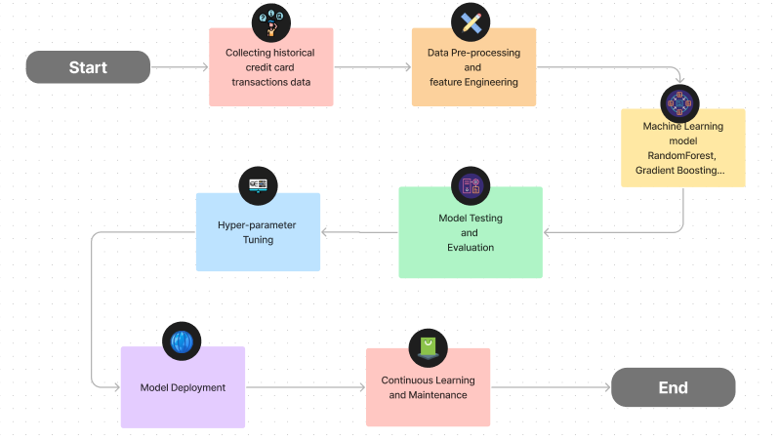

**4. Conclusion**

The Credit Card Fraud Detection project was built upon a foundation of user-centricity, ensuring that the detection of fraudulent activities didn't come at the expense of a seamless user experience. By deeply understanding the needs and expectations of various stakeholders, including cardholders, financial institutions, and fraud investigators, the project aimed to strike a delicate balance between robust security and user convenience. To achieve its primary goal of effective fraud detection, the project employed advanced machine learning techniques. These included ensemble models, deep learning, anomaly detection, and feature engineering. By doing so, the system was able to excel in identifying not only known fraud patterns but also adapt to emerging threats in real-time transactions. This project represents a holistic approach to credit card fraud detection, where precision, adaptability, cost-efficiency, and compliance were all carefully balanced to enhance security and trust in the realm of financial technology.