# Result & Discussion

**Part 01: Household E-Waste Survey Analysis**

The Household survey has been structured into a data frame with 40 responses.

**Section 1: General Information**

1. City Corporation

Out of the 13 respondents, a mix of residents from Dhaka North and South participated. This distribution helps capture diverse urban e-waste habits, though a larger sample could improve representativeness.

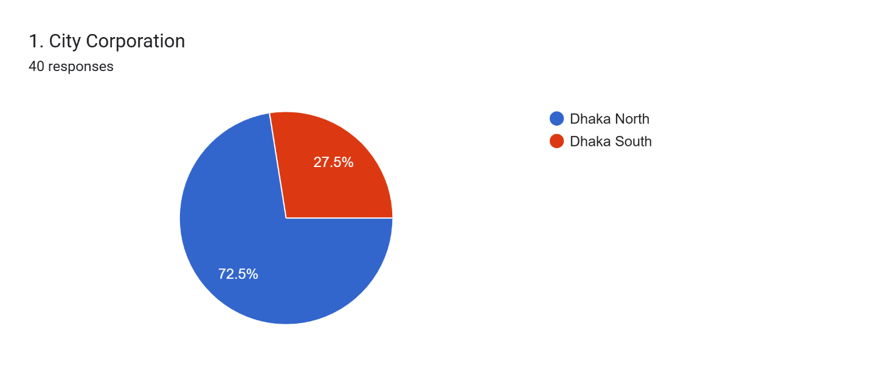

1. Household Size

Respondents reported varying household sizes, with most ranging between 4 to 6 members. This may influence the quantity of electronic products owned and discarded.

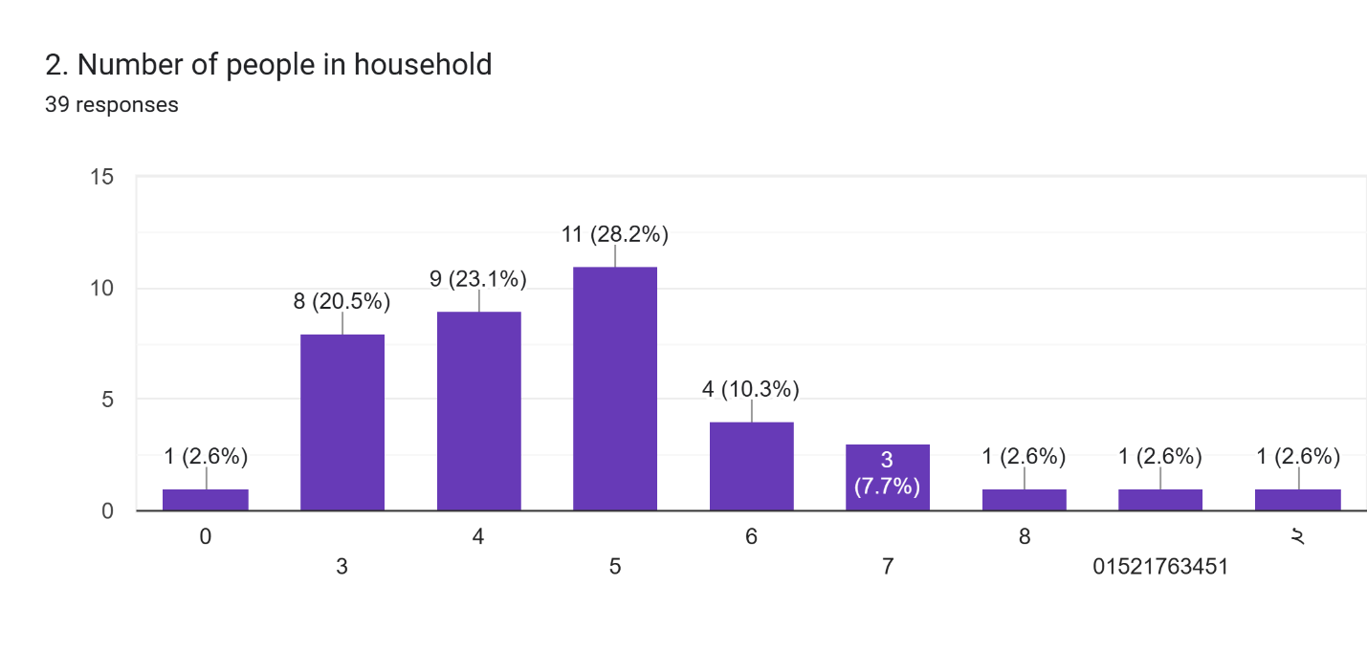

**Section 2: E-Waste Ownership, Generation & Disposal**

1. Ownership of Electronic Items

Most participants own common household electronics like mobile phones, laptops, and televisions. Refrigerators and washing machines were also widely owned, indicating a significant potential for domestic e-waste generation.

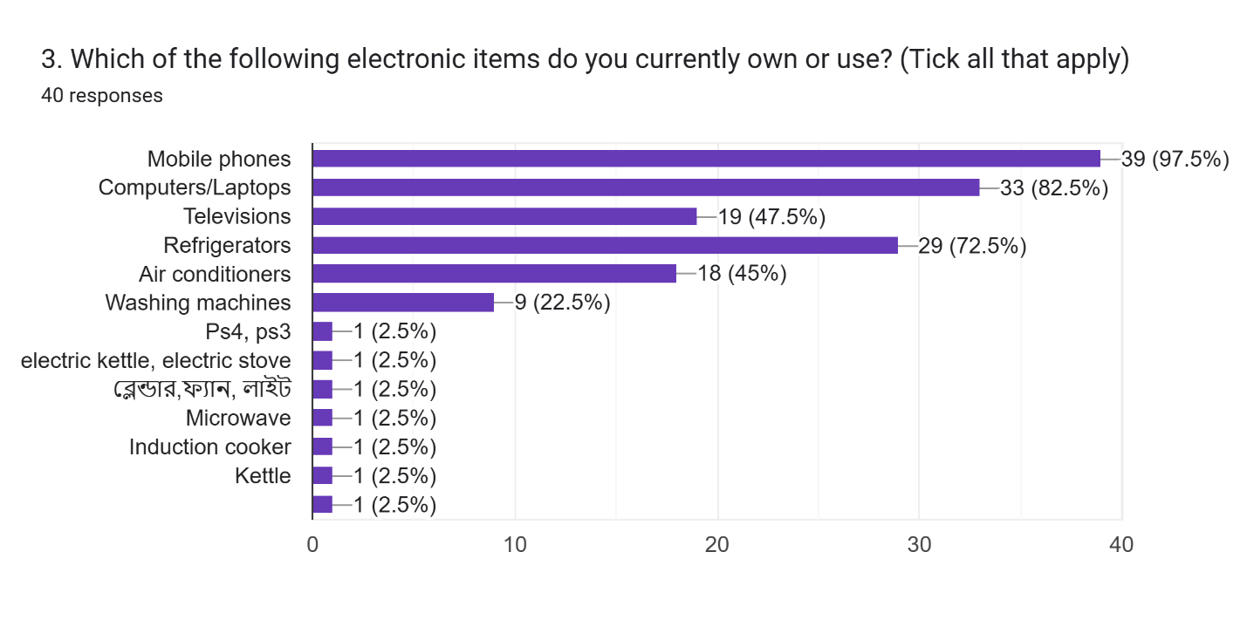

1. Discarded Items in the Past 12 Months

A noticeable portion of respondents have discarded at least one electronic item in the past year. This indicates an active generation of e-waste and potential opportunities for recycling or take-back programs.

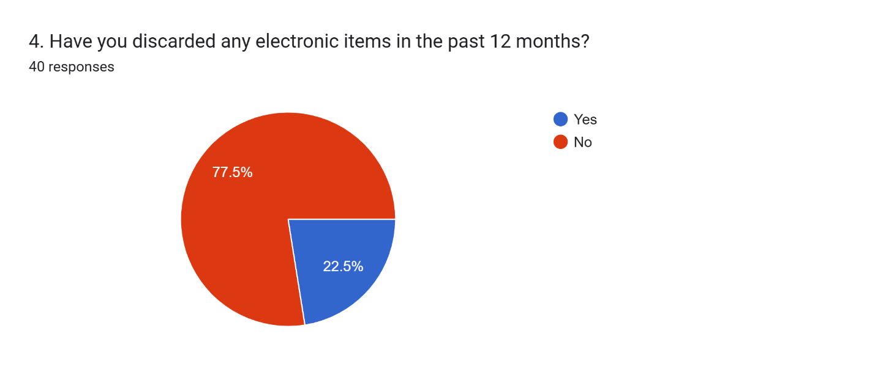

Reasons for Discarding Items

The most common reasons for discarding items were due to damage or obsolescence. This aligns with trends observed globally, where broken or outdated devices contribute heavily to e-waste volumes.

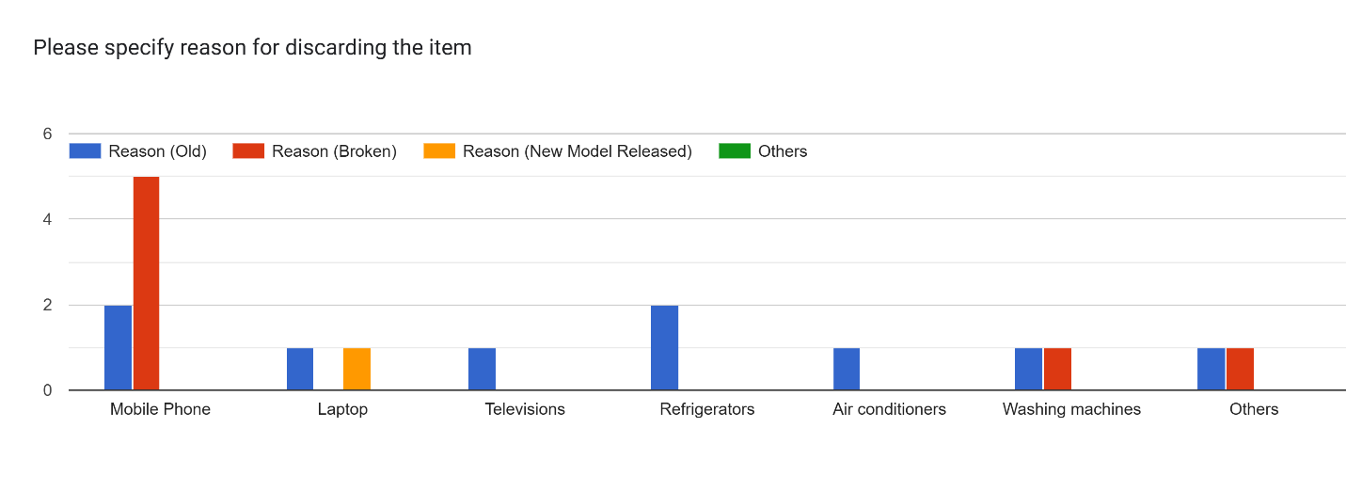

Estimated Value of Discarded Items

Although optional, a few respondents reported estimated values, highlighting the economic value lost when e-waste is improperly handled or discarded.

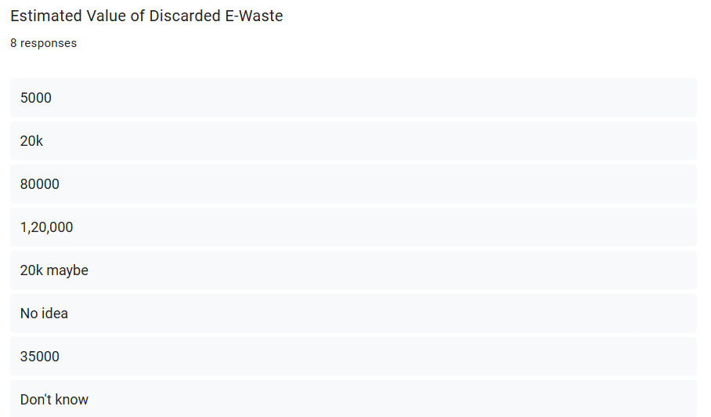

1. Common Disposal Practices

Most respondents reported either storing old electronics at home or selling them to informal collectors. Very few indicated using municipal collection points or returning to retailers, suggesting limited awareness or access to formal disposal systems.

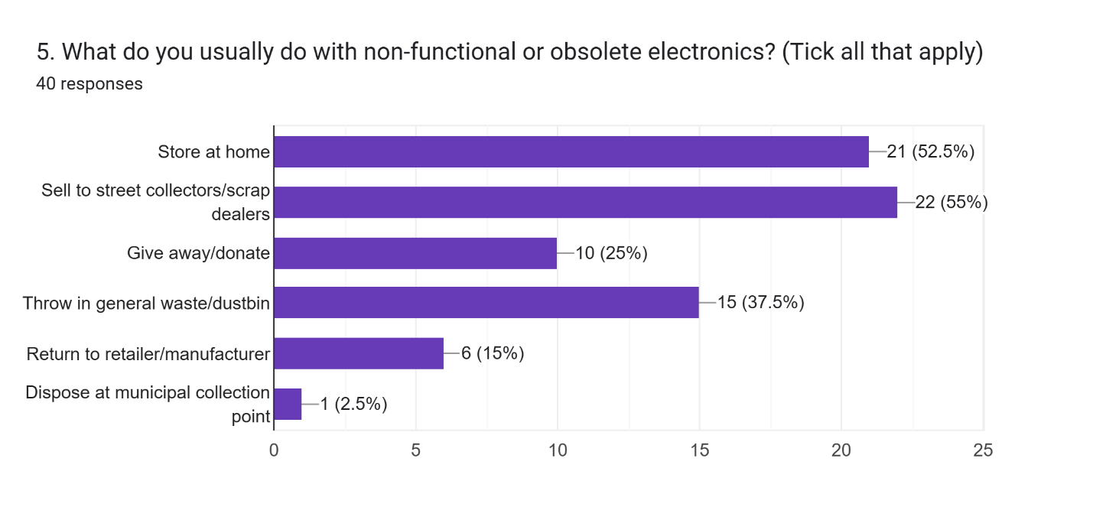

**Section 3: Awareness and Practices**

1. Awareness of Environmental/Health Risks

A majority of respondents are aware of the health and environmental risks associated with improper e-waste disposal. This awareness is encouraging but may not always translate into safe disposal behavior.

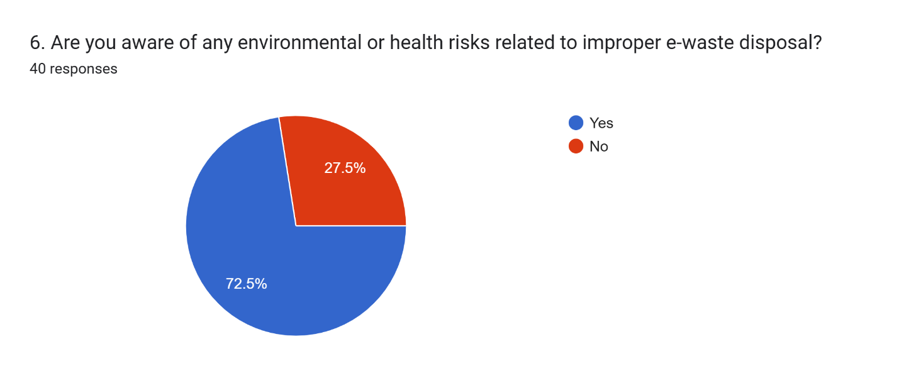

1. Familiarity with E-Waste Laws

Most respondents had not heard about existing laws on e-waste management in Bangladesh, underscoring a need for better communication and outreach from authorities.

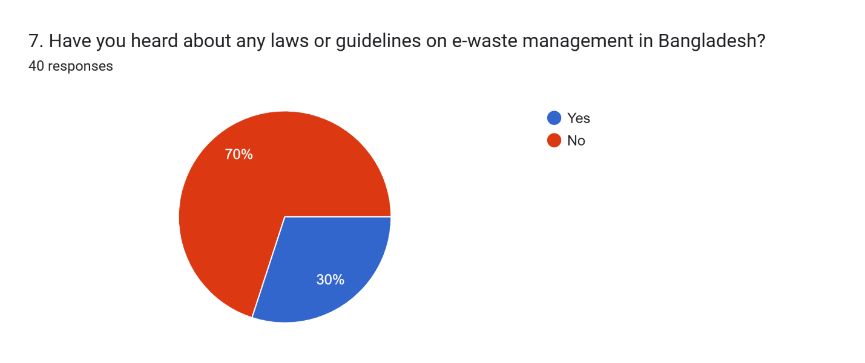

1. Sources of Information

Very few respondents reported receiving information from NGOs or media campaigns. This points to a gap in public education efforts on safe e-waste disposal practices.

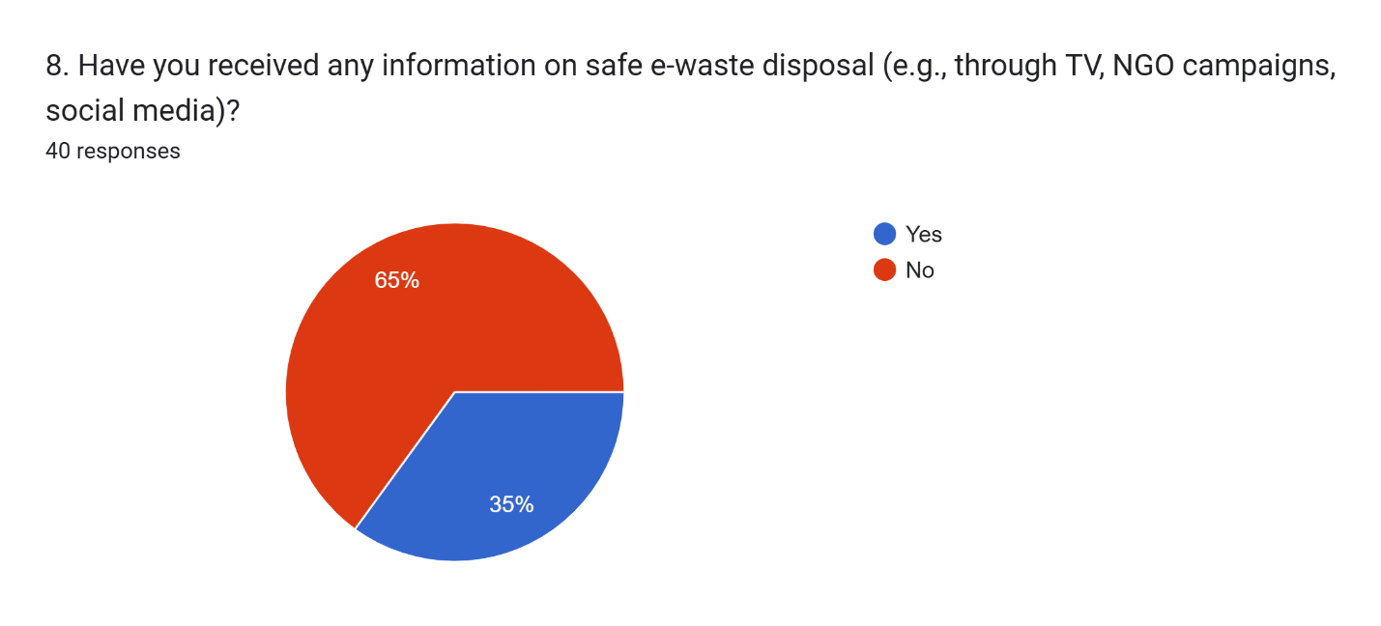

**Section 4: Barriers and Attitudes**

1. Reasons for Not Recycling or Properly Disposing

The top barriers included lack of awareness and absence of nearby collection points. These reflect systemic shortcomings that could be addressed through local infrastructure development and awareness campaigns.

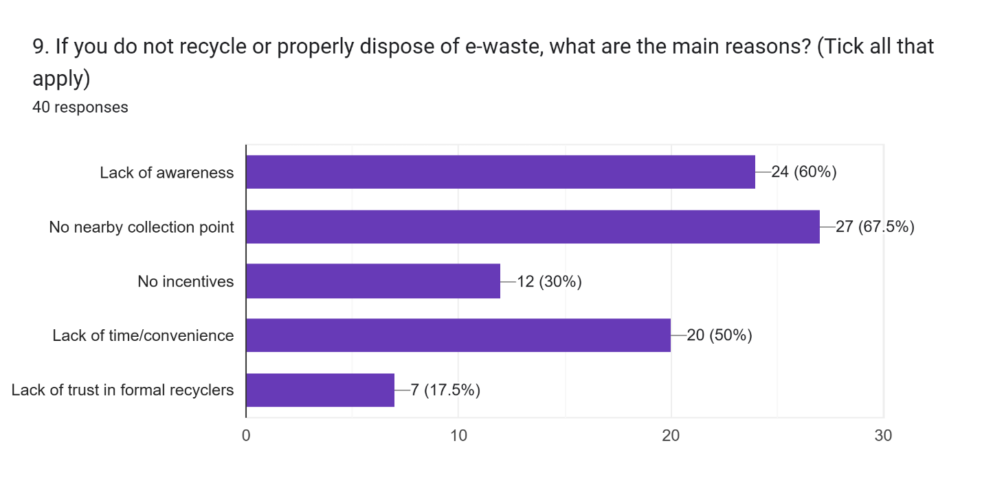

1. Willingness to Return E-Waste

Most respondents expressed willingness to return e-waste if provided with convenient services or incentives. This suggests that behavior change is possible with supportive policies and infrastructure.

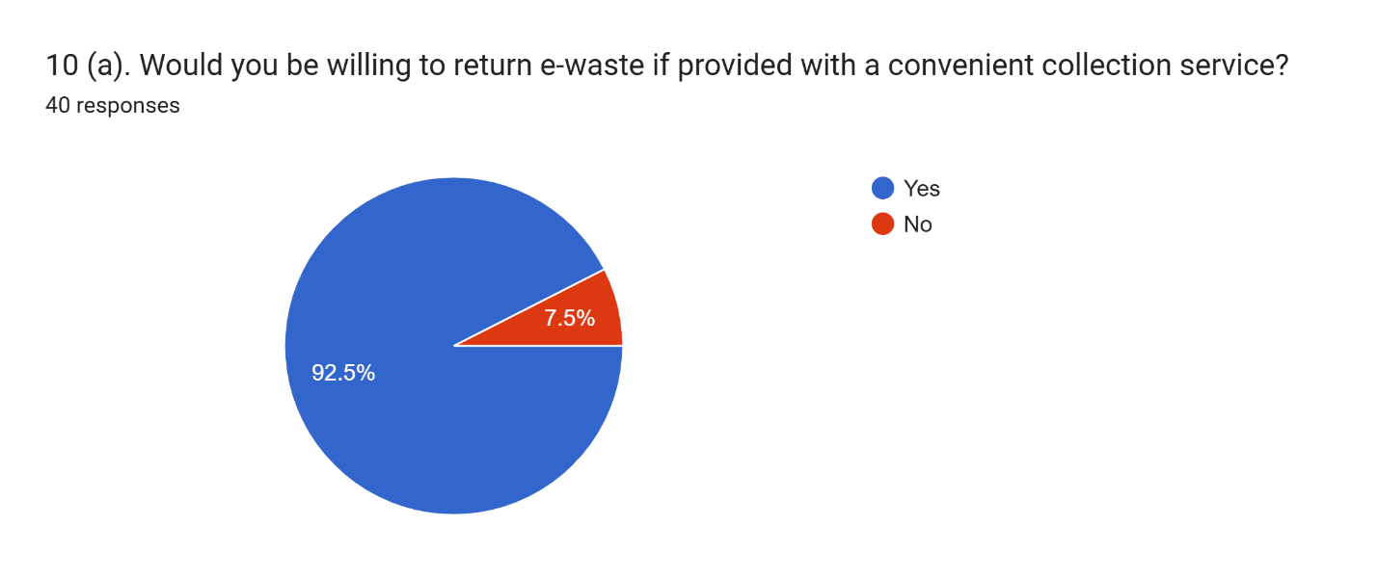

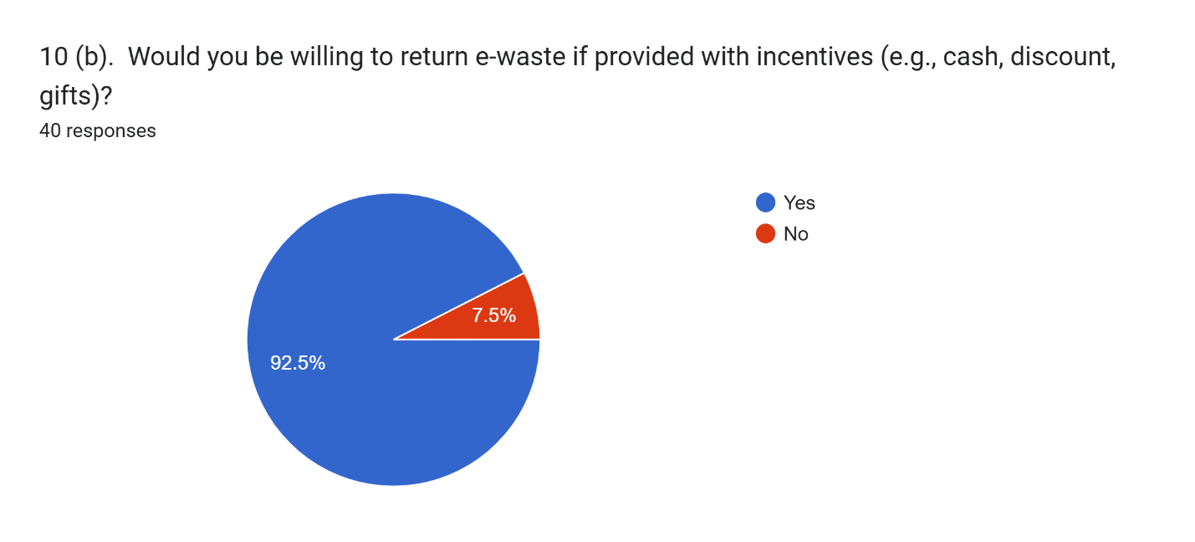

**Section 5: Health and the Environment**

1. Health Impacts

While a few participants reported health issues potentially linked to e-waste handling, most did not. However, given the small sample size and self-reporting limitations, this should be interpreted cautiously.

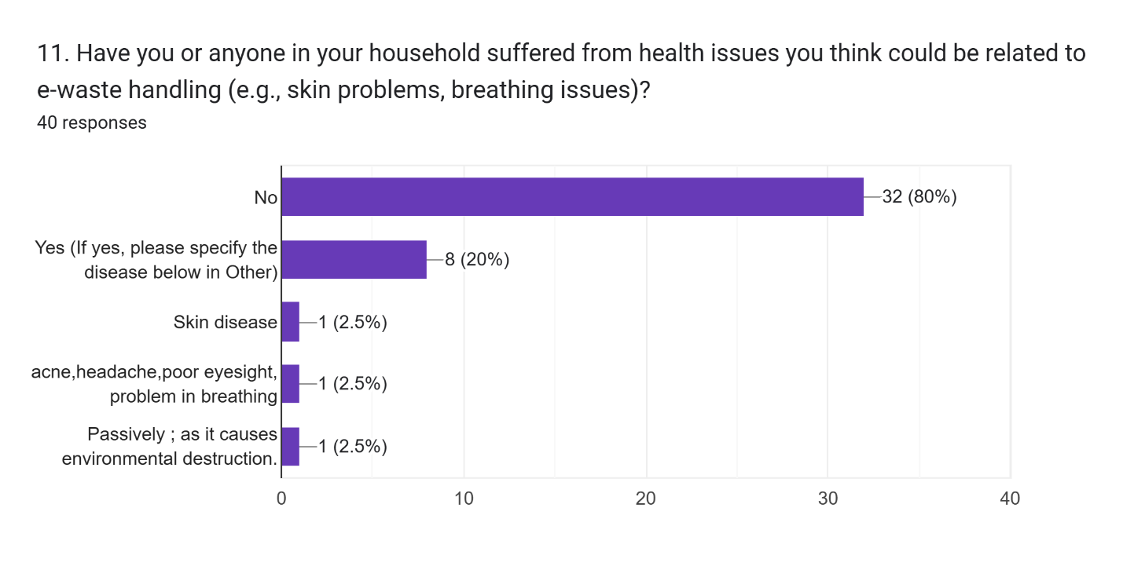

**Section 6: Suggestions**

1. Improving E-Waste Management

Respondents proposed solutions like increasing awareness, offering incentives, and establishing formal collection points. These ideas align with global best practices and could form the basis of community-focused interventions.

1. Additional Comments

Some participants emphasized the need for government action and stronger regulation. Others pointed to educational programs as a way to change disposal habits in the long term.

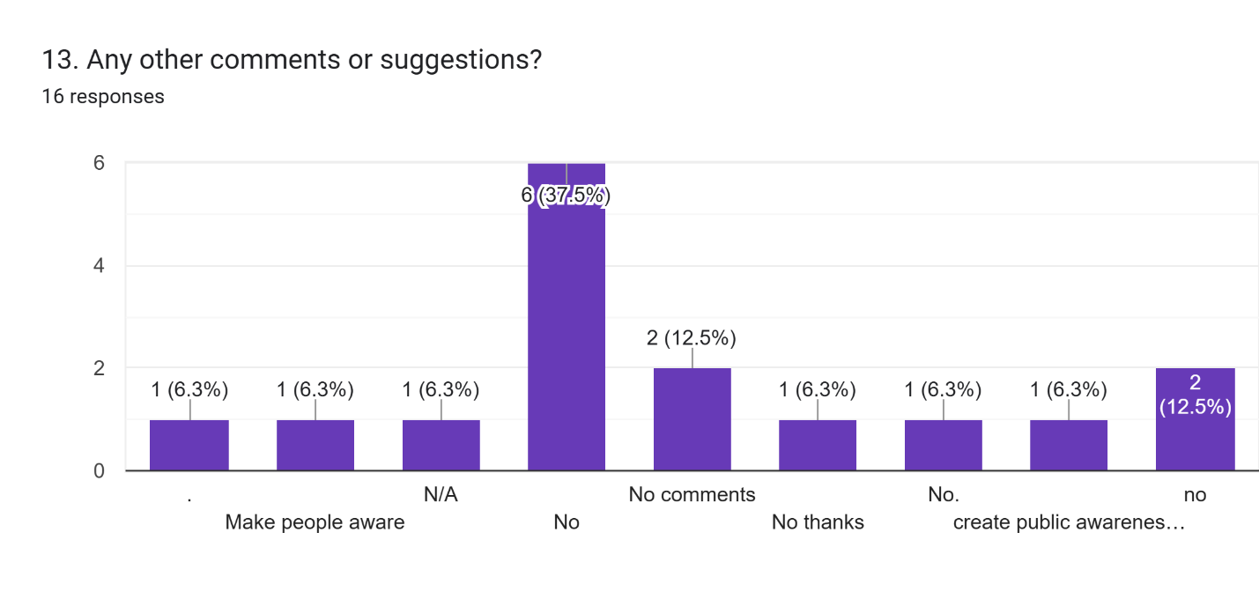

**Part 02: Scrap Dealers E-Waste Survey**

The Scrap Dealers E-Waste Survey has been structured into a data frame with 20 responses.

**Section 1: Basic Information**

1. **Business Name (Optional):**  
   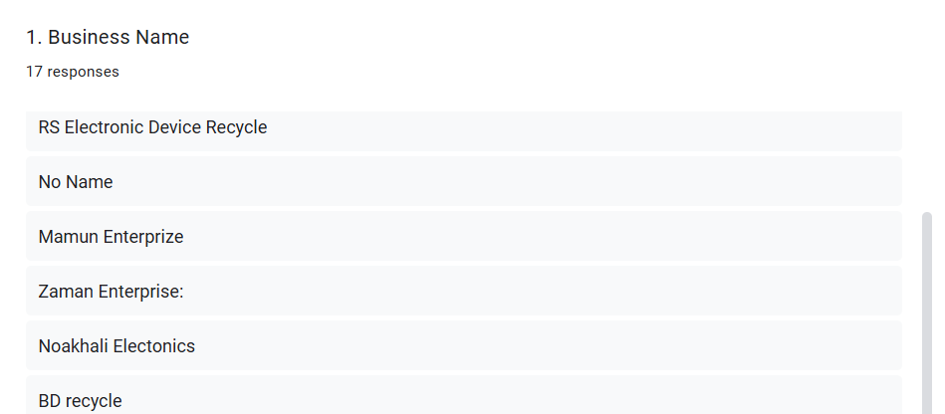
2. **City Corporation:**

The pie chart displays the distribution of respondents from different city corporations.

* **Dhaka North**: 50% of respondents
* **Dhaka South**: 50% of respondents

This equal distribution helps capture diverse urban e-waste habits, although a larger sample could improve representativeness.

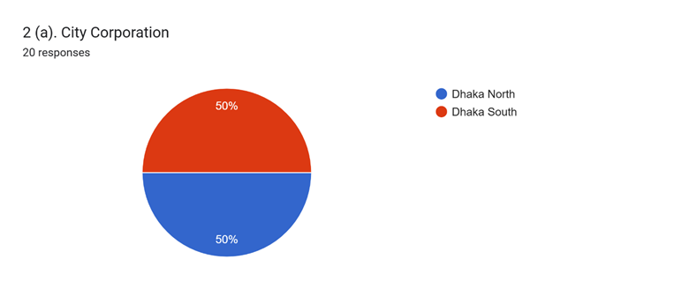

**Work Area / Locality (Thana / Ward / Road No.):**

Data was collected from respondents in specific areas, such as Kalshi and Nimtola.

1. **Age:**  
   Most respondents are between 26 and 35 years, reflecting an age group likely to own and dispose of electronics.

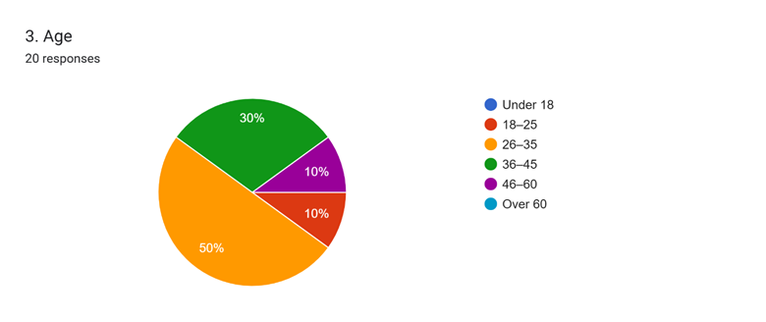

1. **Do you work individually or as part of a group/business?**  
   Majority of the people work as a part of a business.

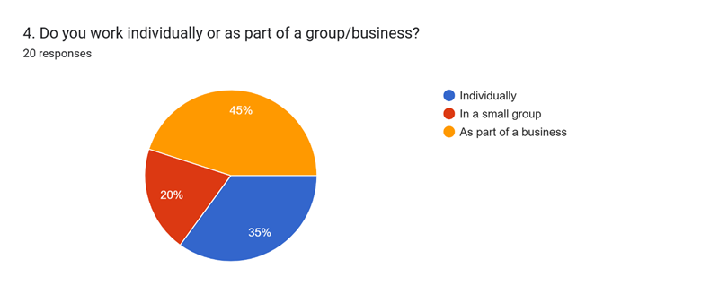

**Section 2: E-Waste Work Practices**

1. **How long have you been working with e-waste?**  
   The bar chart indicates the duration respondents have been working with e-waste.

**7 years**: 10%

**10 years**: 10%

**15 years**: 10%

**20 years**: 10%

**Other durations**: 5-10%

The data shows a range of experience, with most respondents working in the field for 7 to 20 years.

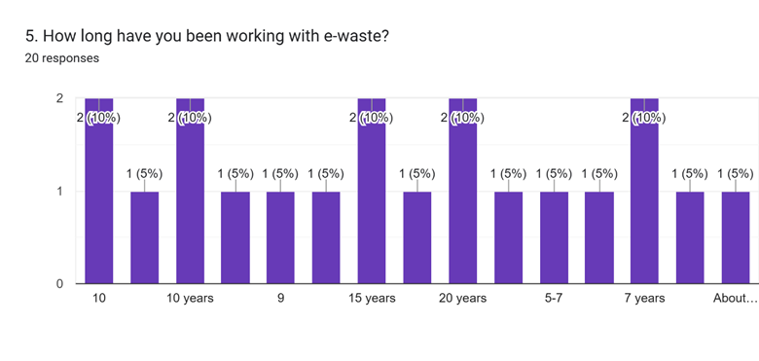

1. **Which types of e-waste do you handle most often?**   
   This bar chart lists the types of e-waste handled by respondents most frequently.

**Mobile Phones**: 55%

**Laptops/Computers**: 60%

**Televisions**: 50%

**Refrigerators**: 35%

Other items like air conditioners, batteries, and wires/cables were also mentioned, but less frequently.

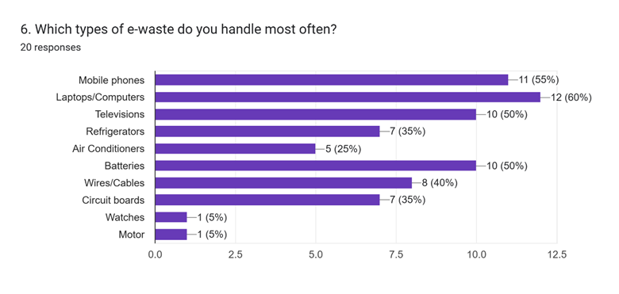

1. **Where do you collect e-waste from?**

This bar chart shows where respondents primarily collect e-waste from. E-waste collection is predominantly from households and offices, with electronic shops and scrap wholesalers also contributing.

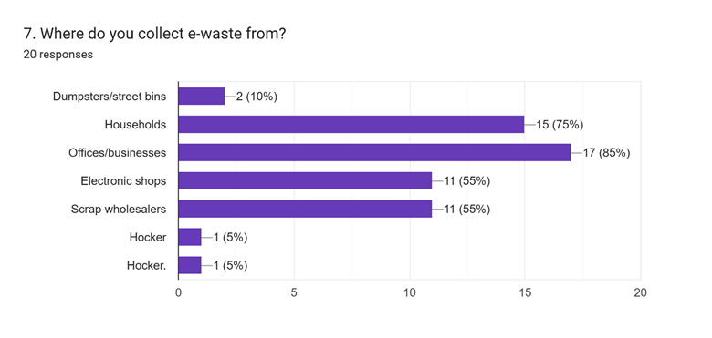

1. **How do you collect e-waste?**

Majority of e-waste is collected through buying the people.

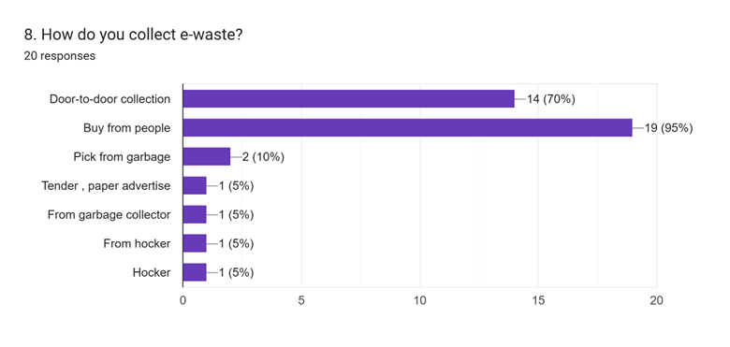

1. **Estimated Value of Discarded E-Waste (Per Month)**

The bar chart depicts the estimated value of discarded e-waste in Bangladeshi Taka (BDT) per month.The data shows a significant portion of respondents discarding e-waste valued between 30k and 50k BDT.

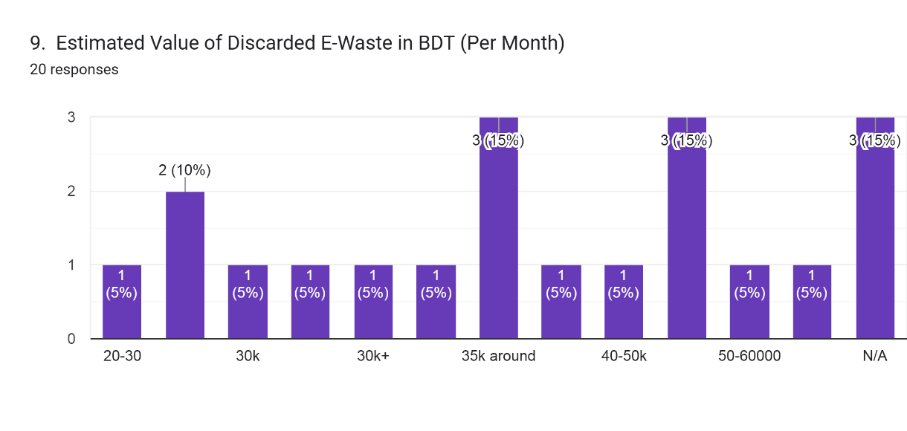

**Section 3: Recycling & Dismantling**

1. **Do you dismantle or process the e-waste yourself?**

The pie chart shows how respondents manage e-waste processing. Most respondents do not dismantle or process e-waste themselves, instead employing laborers for the task.

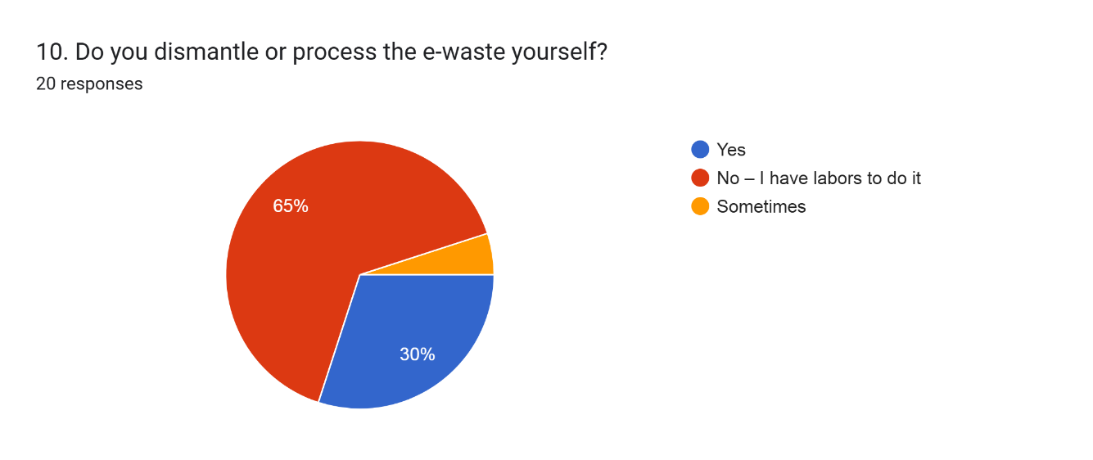

1. **What do you do with the parts after dismantling?**

Most respondents prefer selling usable parts and sending parts to larger recyclers, while a smaller number burn or discard unusable parts.

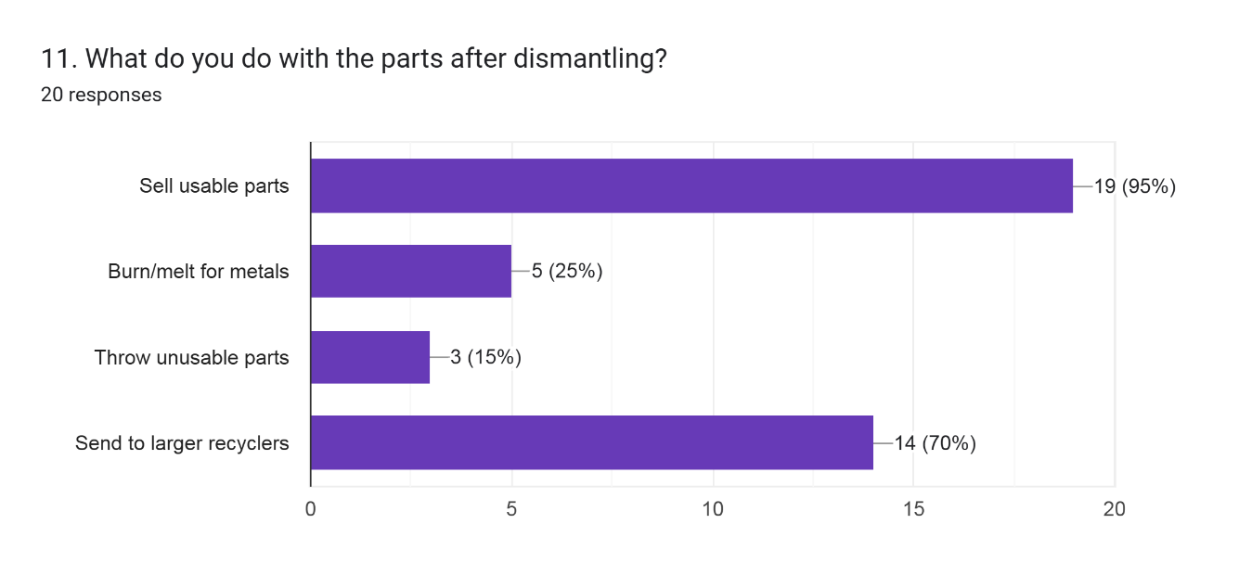

1. **Do you use any protective gear while working?**

Many respondents do not use protective gear, but a significant number wear masks or gloves while working with e-waste.

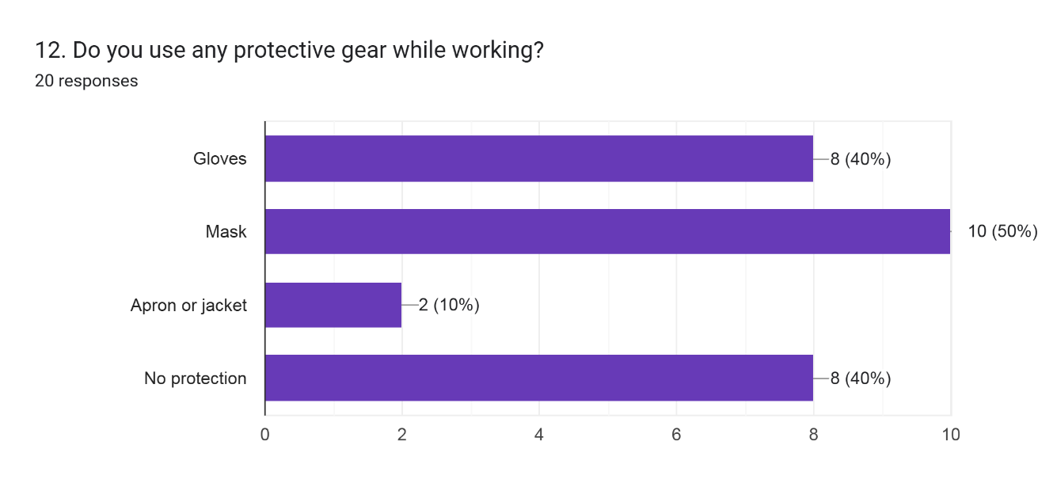

1. **Are you aware that some e-waste can harm your health or the environment?**

Most respondents are aware that e-waste can harm their health or the environment, but a portion of respondents are unaware of these risks.

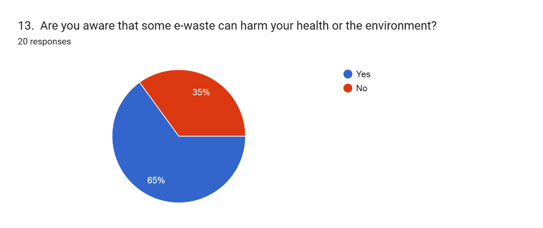

1. **Do you face any of the following problems in your work?**

Most respondents face issues related to a lack of proper tools, followed by concerns about health problems.

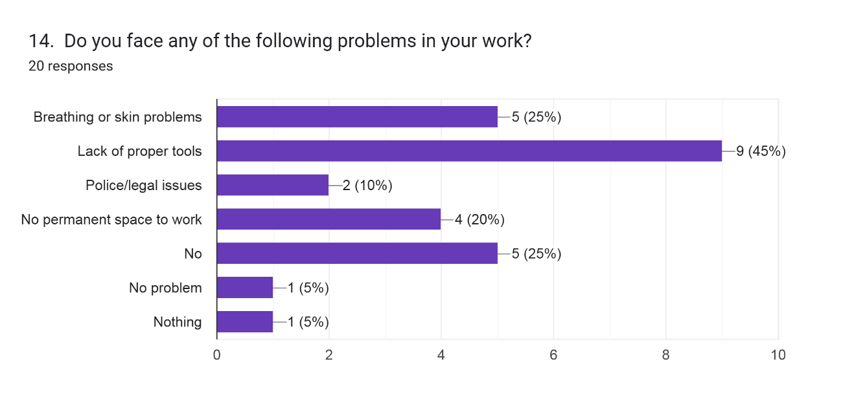

**Section 4: Knowledge and Support**

1. **Are you aware of any government rules or policies about e-waste?**

Most respondents are aware of government rules or policies related to e-waste, while a smaller portion is not familiar with them.

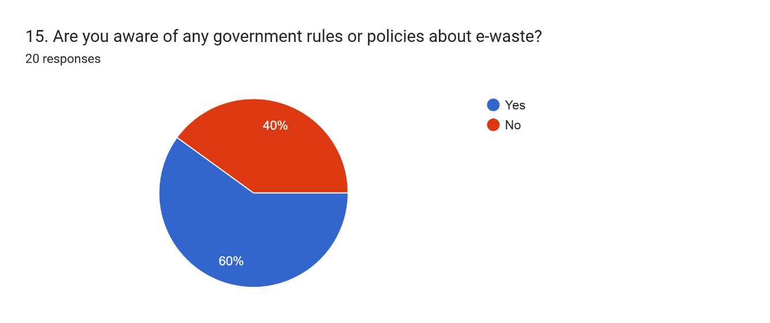

1. **Would you be interested in free training or a certificate on safe e-waste handling?**

Respondents are equally divided on their interest in training or certification, with a good portion unsure about it.

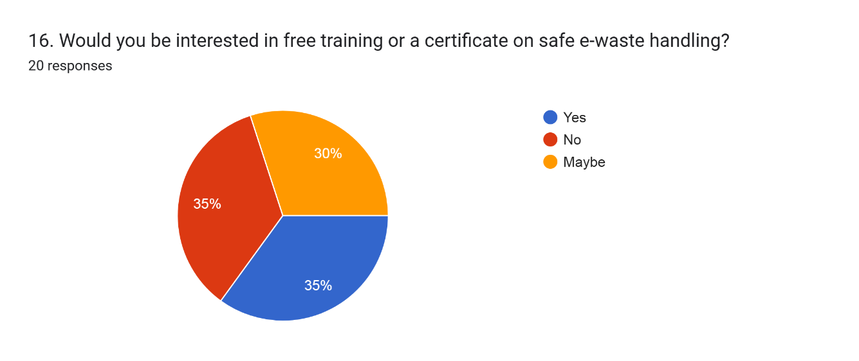

1. **How do you manage dangerous materials (like batteries, CRTs, or mercury parts)?**

A large percentage of respondents sell dangerous materials to specialized buyers, while others are less informed or improperly dispose of them.

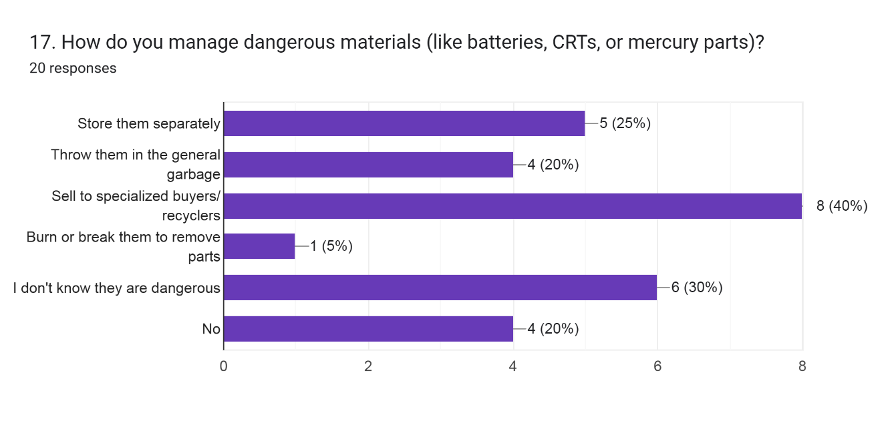

1. **What kind of support would help you do your work more safely and earn more?**

The majority of respondents (50%) would like help from the government to improve their work conditions and earnings.

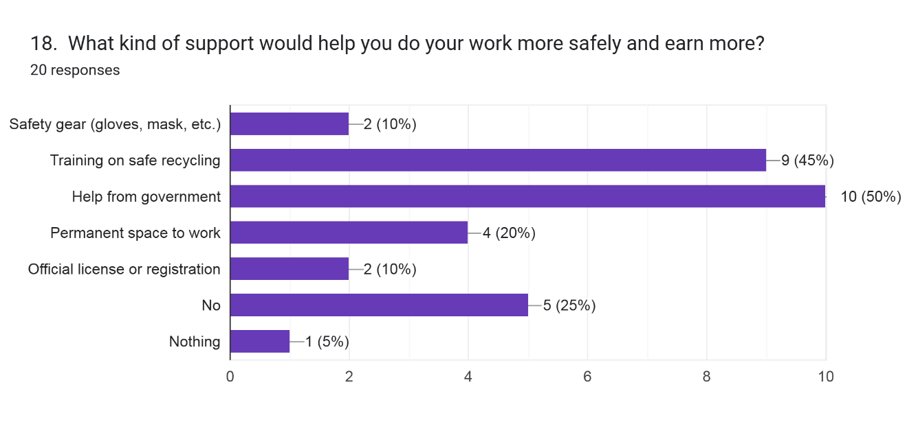

**Section 5: Final Feedback**

1. **Do you want to share anything else about your work or what you need?**

