**Task1:**

Develop a flight booking system that allows users to search for flights based on departure and destination cities, departure date, etc. Use lists and tuples to store flight information such as flight number, departure time, and available seats. Implement decision statements and loops to handle user input, display available flights, and manage booking transactions. Utilize functions for different stages of the booking process, such as searching for flights, reserving seats, and generating booking confirmations.

**Code:**

class flight_booking_system:

def __init__(self):

self.lst = [(1,'karachi','multan','10/dec/24','8:00 AM','12:00pm',2000,500),(1,'karachi','multan','10/dec/24','8:00 AM','12:00pm',2000,500),(1,'karachi','multan','10/dec/24','8:00 AM','12:00pm',2000,500),(1,'karachi','multan','10/dec/24','8:00 AM','12:00pm',2000,500)] # 1==flight n0 , 1=departure time , 2=arrival time, 3=price , 4=number of seats available

def search(self,departure,destination,date):

for i in self.lst:

if i[1]==departure and i[2]==destination and i[3]==date:

print("this seat is available ")

return 'yes'

else:

print("this seat is not avalaible")

return 'no'

def reserved_seat(self):

print('this seat is reserved from your account')

def generating_booking_confirmation(self,con,departure,destination,date):

if con=='yes' and self.search(departure,destination,date)=='yes':

self.reserved_seat()

else:

print('explore other options or try again later')

if __name__ == "__main__":

name = str(input("Enter Your Name : "))

name=flight_booking_system()

print('------welcome into the Flight Booking System-------\nchoice no 1 is search the train and avalaible seat \n choice no 2 generate booking system after search the seat')

choice=int(input("enter your choice from 1 to 2 : "))

if choice==1:

dep,desti,dat=str(input("Enter your deparure city : ")),str(input("Enter your destination city")),str(input("Enter the date of journey "))

name.search(dep,desti,dat)

elif choice==2:

dep,desti,dat=str(input("Enter your deparure city")),str(input("Enter your destination city")),str(input("Enter the date of journey "))

con=input('confirm booking yes/no? ')

name.generating_booking_confirmation(con,dep,desti,dat)

else:

print("enter correct number or contact us ")

**output**:

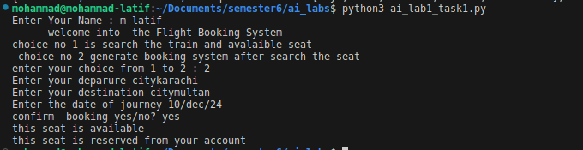

**task2:**

Write a function named analyze_sentence that takes a sentence as input and returns a dictionary containing the following information: the total number of words, the total number of characters (excluding spaces), the average word length, and a list of unique words.

**Code:**

import string

def analayze_sentance(sentance):

words=0

charecter=0

word = sentance.split()

unique_words = list(set(word))

alphabets = list(string.ascii_letters)

for i in sentance:

if i==' ':

words+=1

elif (i in alphabets):

charecter+=1

else:

pass

dict = {"words":words,"charecter":charecter,"unique word list":unique_words,"average word":words/charecter}

return dict

a=analayze_sentance('my roll number is 21b-029-se')

print(a)

**output:**



**task3:**

Create a class called Employee with private attributes __name, __id, and __salary. Implement methods to set and get these attributes. Then, create another class Manager which inherits from Employee. Override the salary method to calculate the manager's salary with an additional bonus. Test these classes by creating instances of both Employee and Manager and demonstrating encapsulation and polymorphism principles.

**Code:**

class employee:

def __init__(self,name,id,salary):

self.__name = name

self.__id = id

self.__salary=salary

def set_attribute(self,name,id,salary):

self.__name = name

self.__id = id

self.__salary =salary

def get_attribute(self):

print(f'name = {self.__name} , id = {self.__id}, salary = {self.__salary}')

def get_salary(self):

return self.__salary

def __str__(self):

return f'name = {self.__name} , id = {self.__id}, salary = {self.__salary}'

class manager(employee):

def __init__(self,name,id,salary,bonus):

employee.__init__(self,name,id,salary)

self.__bonus=bonus

def calculate_salary(self):

base=self.get_salary()

print(f'salary = {base+self.__bonus}')

print("before set the attribute ")

a=employee('m',1,200)

print(a)

print("after set the attribute through set attribute method ")

a.set_attribute('l',2,40000)

print(a)

print("before set the attribute of manager class ")

m=manager('k',44,20000,400)

print(f"salary of manager ")

m.calculate_salary()

print(m)

print("after set the attribute through set attribute method ")

m.set_attribute('m',1,200)

print(m)

**output:**

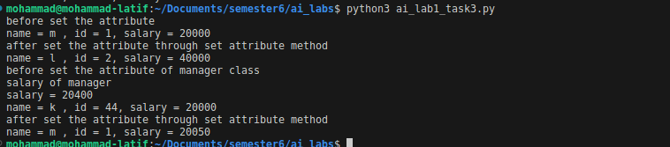

**task4:**

WAP for an inventory management system for a retail store. Utilize classes and inheritance to represent different types of products (e.g., electronics, clothing, groceries) with attributes such as name, price, quantity, etc. Implement methods to add products to the inventory, update quantities, and calculate the total value of the inventory. Ensure encapsulation by using private attributes where appropriate.

**Code:**

class inventory:

def __init__(self):

self.inventry_list = []

def add_product(self,id,product,qty,price,type):

product_detail=[id,product,qty,price,type]

self.inventry_list.append(product_detail)

print(f'product added successfully = {self.inventry_list}')

def update_qty(self,id,qty):

for i in range(len(self.inventry_list)):

if self.inventry_list[i][0]==id:

self.inventry_list=[i][2]=qty

def total_value(self):

total=0

for i in range(len(self.inventry_list)):

a=self.inventry_list[i][2] * self.inventry_list[i][2]

total+=a

print(f'total value of inventry is {total}')

class electronic_inventory(inventory):

def __init__(self):

self.inventry_list=[]

def __str__(self):

return(str(self.inventry_list))

class clothing(inventory):

def __init__(self):

self.inventry_list=[]

def __str__(self):

return(str(self.inventry_list))

class groceries(inventory):

def __init__(self):

self.inventry_list=[]

def __str__(self):

return(str(self.inventry_list))

e=electronic_inventory()

e.add_product(1,'fan',3,2000,'electronic')

e.add_product(2,'laptop',3,2500,'electronic')

print(e)

c=clothing()

c.add_product(1,'cotton cloth',3,2000,'cloth')

c.add_product(2,'cotton cloth',4,200,'cloth')

print(e)

g=groceries()

g.add_product(1,'rice',3,2000,'grocery')

g.add_product(2,'sugar',4,200,'grocery')

print(g)

**Output:**

