College Management System

# I. INTRODUCTION & SUMMARY

A college management system is important since it manages the students’ and lecturers’ works online. It should allow users to perform multiple tasks with ease. Our college management system stores, organizes, and manages a large amount of information within a single software application. The use of this system increases the efficiency of business operations and reduces overall costs.

The problems facing the current manual system are data redundancy, difficult to update and maintain, inconsistent data, insecurity, difficult to impose constraints on the various data file, and difficult to backup. The problems are not limited to the database part, there are also problems other than that. The universities provide lots of opportunities to the students however most of the students do not even know the opportunities such as a library, student club, or dining hall opportunities. It is because the college management system is not as good as it should be. A good college management system should be able to provide clear information to the students about their classes and other opportunities. Most of the college management systems do not exhibit a clear explanation about the classes and the students usually miss out on the opportunities. There are various college management systems that are currently in use. However, most of them not only have fewer properties than ours but also they inefficient and not as desired.

The college management system has lots of information to keep track of and they need to be organized well to reach data rapidly. So that we decided to design a new college database management system for our college. This new database will be used by both students and lecturers.

Our database design provides a clear explanation about the classes and their details to the lecturer and the students. Our proposed college management system already has some essential properties such that course selection conditions, former classes’ information, exam information, etc. In addition to these indispensable properties, our system provides a system that will assist the students in finding proper student clubs since the students sometimes may be alone or tired of the classes. Every college has libraries, but the library’s database and college database may be different, this will end up not to get a book from the library. So, the system provides a connection to the library database and the students will be able to keep track of what they have read or what they will read.

# II. METHODOLOGY

This project can be mainly divided into two parts, the front-end part, and the back-end part. In the front-end part, HTML and Bootstrap were used to construct a web-page. Then, this web-page was filled with the informations by using PHP programming language. We also used XAMPP software to keep database tables and to write SQL queries.

Our web-page welcomes the user with the login page. They can login to the system as a student or a lecturer. The user types were separated since they have different functions. This part was built up by using HTML, and Bootstrap was used since we did not want to spend time for appearance of the web-page.

To decide the relations between the components, we used EER diagram (Figure 1). This diagram shows the relations between the entities and it was used to create database tables.

In this project we have many tables. We keep student information on student table. We connected to student club participants table via student id and we get leader id from there we connected to student club and we get club name.

We did same thing for student book to get book names, student exam to get exam information, student current course to get student’s courses which he or she takes for this semester, student past courses to get student’s past courses which he or she did not fail, program to get program names.

We also keep information about food in dining table, course details in course table, and book details in book table.

# III. CONCLUSION

In conclusion a student can see the menu of the dining hall easily, a student can search a book with its author and can see it is available or not and it can be seen the location of the book, a student can participate clubs only clicking a button, a student can see his or her past courses that he did not failed and can see the final grade and current taken courses and their exam notes.

Especially a student can see the courses that he or she can select for the semester and can see why he can’t select because of the prerequisite.

In profile all the information about student can be seen.

IV. OUTPUT RESULTS

Since we have multiple pages, we did not share screen shots here.

# V. COMMENTS

1. We completed most of the properties that we mentioned earlier. However, we have some parts thatare not completed such that the interactive map for the students, and some properties for the lecturers.
2. Lecturer has some missing utilities and credit system not finished yet. Also, interactive map did notadded.
3. All the parts that are in the project are working correctly, except for the missing properties.

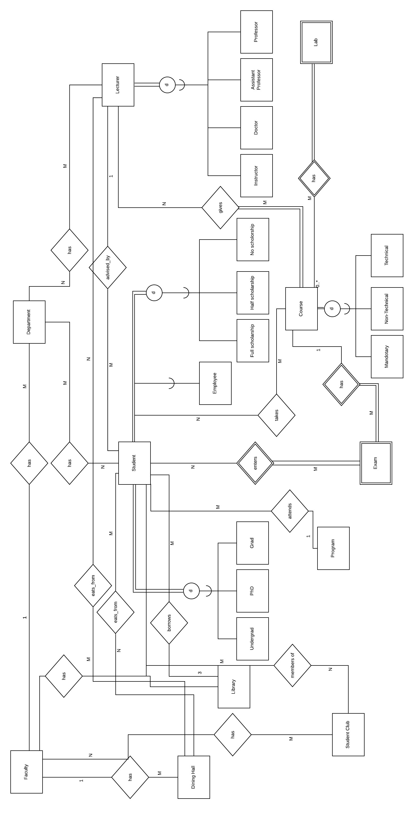

Fig. 1: EER Diagram of College Management System (CMS)