**Data modeling I using Visio and Access**

**ER Diagram:**



**Shopping Site Database: The database Shopping Site has 4 tables namely:**

* Customers
* Vendor
* Purchase
* Product

The datasheet view of each table is attached below:

**Customer:**

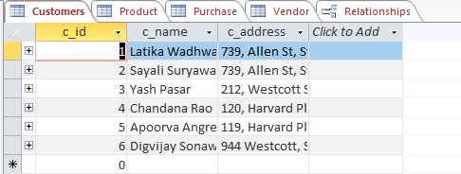

**Product:**

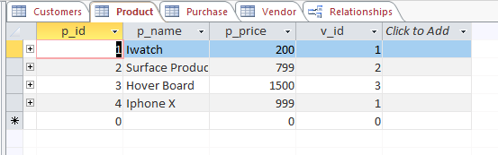

**Purchase:**

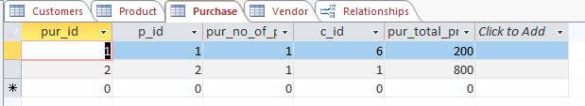

**Vendor:**

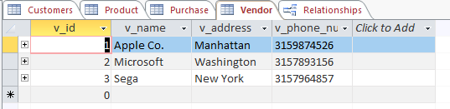

**Data Relationship Model:**

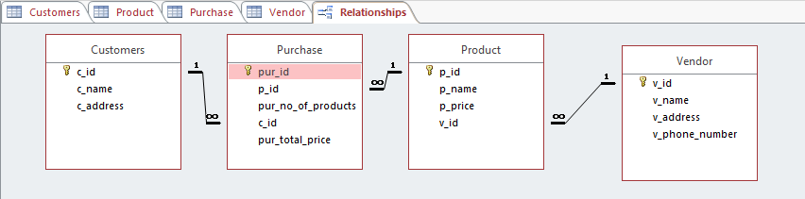

**Question:**

Currently in this ERD every purchase can only have at most one type of product. If we want to allow a purchase to have more than one type of product, how would you change this ERD to accommodate this new need? (If possible please provide corrected ERD) In order to accommodate more than one type of product in a purchase, we make a new entity named “Purchased Products” which has pur_id, p_id and pur_no_o_products as it’s attributes. Pur_id and p_id are foreign key attributes and they together form a composite key. The attributes p_id and pur_no_of_products is deleted from the purchased table. These changes will allow 1 pur_id to have many product_ids i.e. p_id and their respective quantity. The updated ER diagram is attached below: