Wadhwa **Data modeling II using Visio and Access**

Problem 2:- You need to use the relational data model to illustrate the relationships among

members of Twitter, a social media service. To simplify the problem, just consider

that any member can have a profile, and have one or more members in his/her

network.

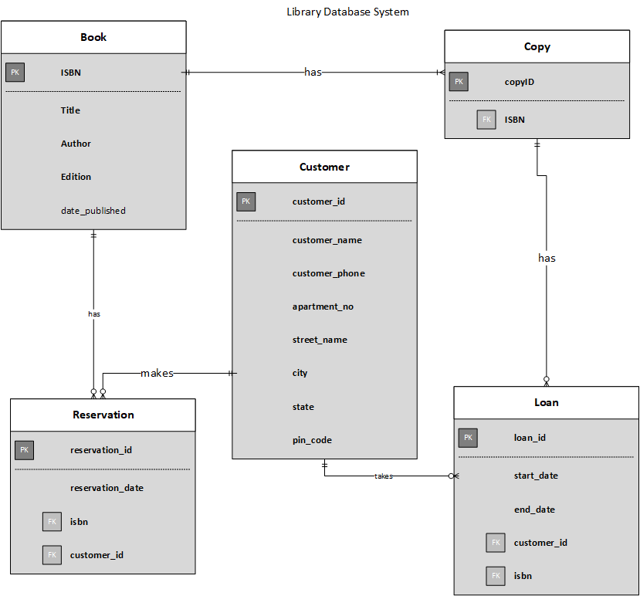

Relationship Diagram

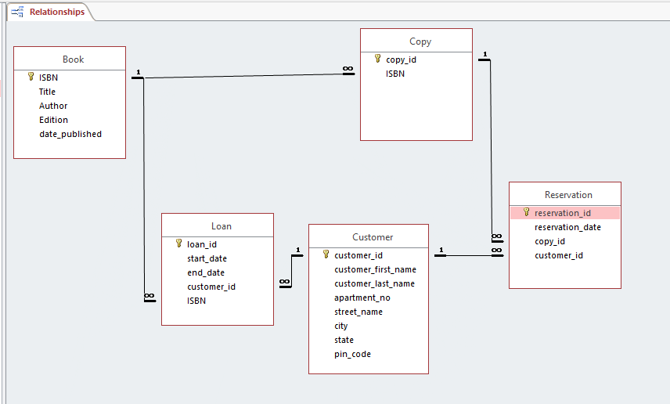

**Book:-**

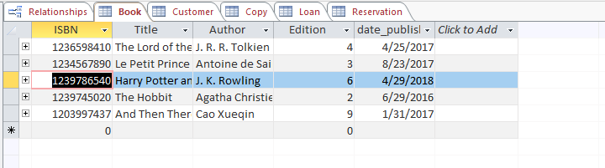

**Customer:-**

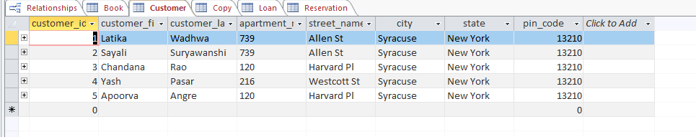

**Copy:-**

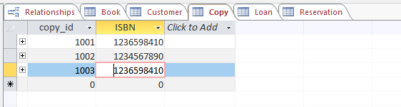

**Loan:-**

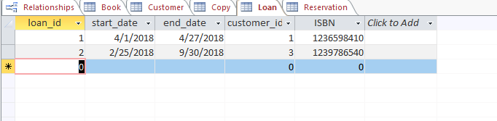

**Reservation:-**

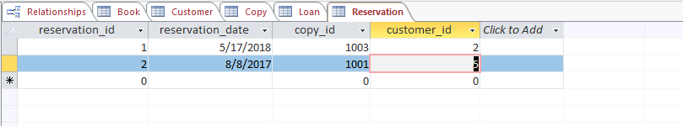

Problem 2:- You need to design a simplified Library Database System. Assume the Library

employee can loan out books to Customers, and Customer can loan out one or more

books.

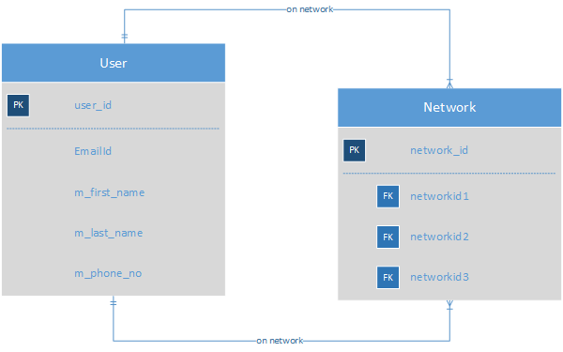

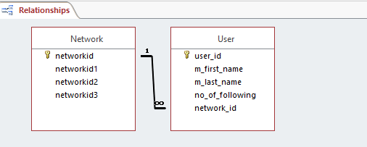

**Twitter User:-**

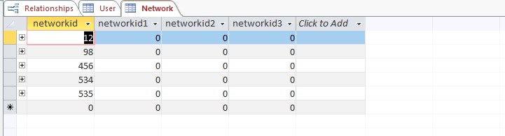

**Network:-**

