**IST 659 Lab 8**

**Company and Position(s) Form: Create a Master-Detail form (form/subform) that will allow you to add Company and their positions. Display all the Company attributes. Add a sub form for positions offered by the company and display all position attributes (Company ID may or may not be there since all the positions listed under the company belong to the company). This form should allow adding and deleting both companies and their offered positions. You may need to add a button to delete a company. Attach screen shots of your input Forms and proof that they work properly. For example, add and delete records. Use results of SELECT queries to show the results of the insertions and deletions using the forms.**

**Solution:**

**Insert New Company**

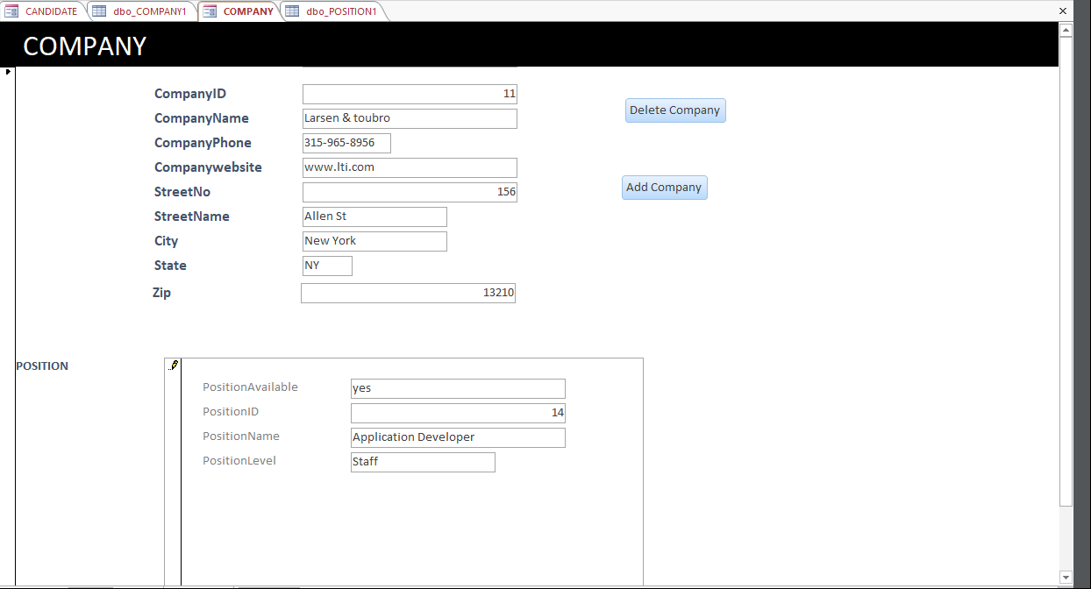

**Insert New Position**

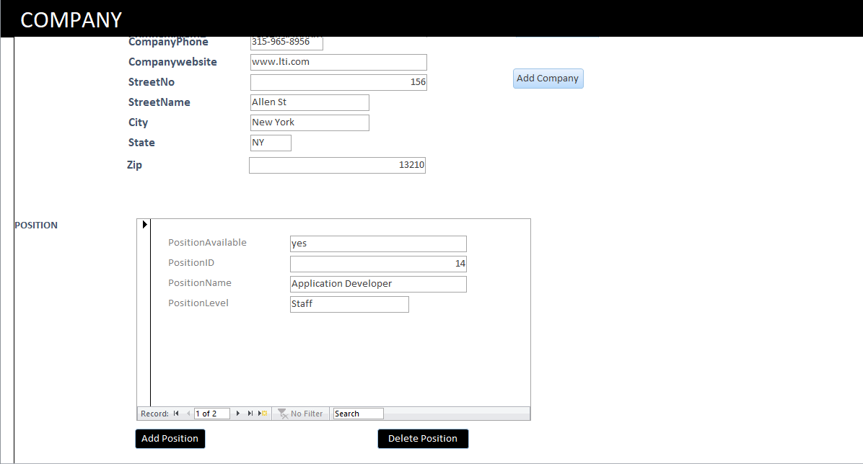

**Insert New Position 2**

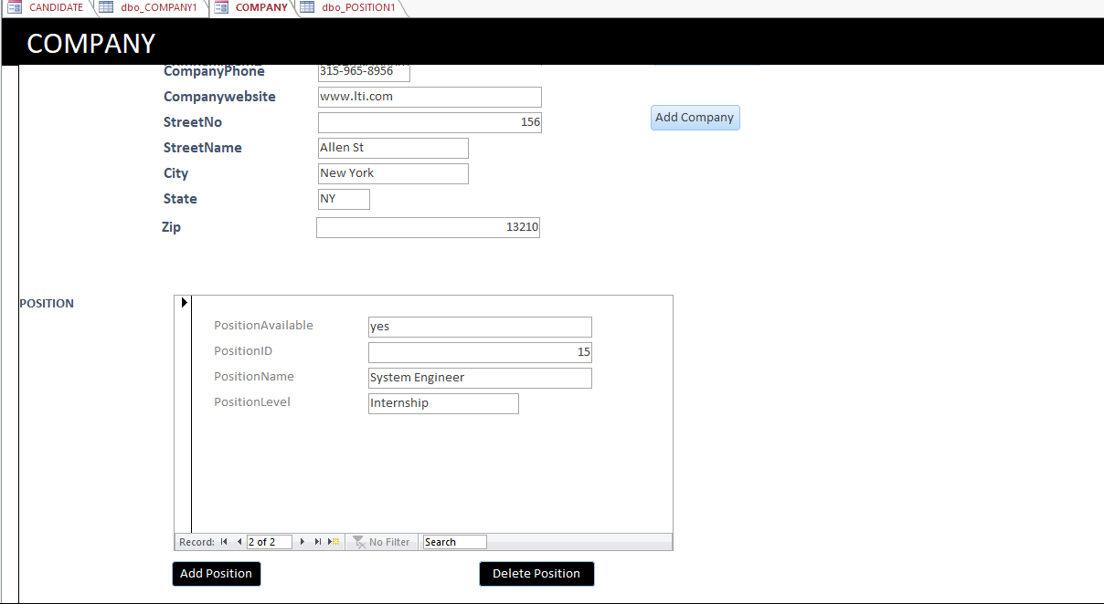

**Company Table:**

SELECT * FROM COMPANY

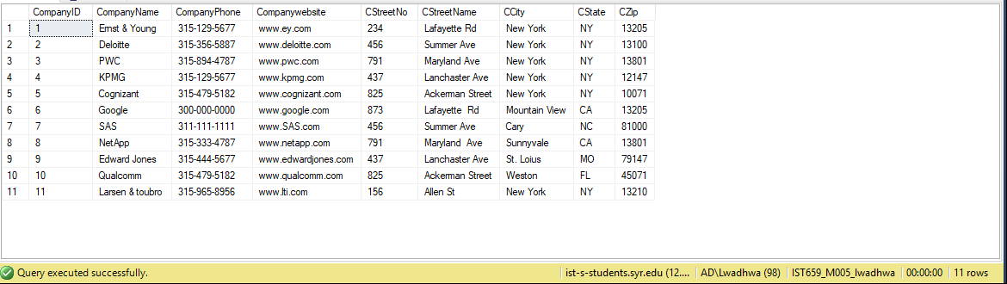

**Position Table**

SELECT * FROM POSITION

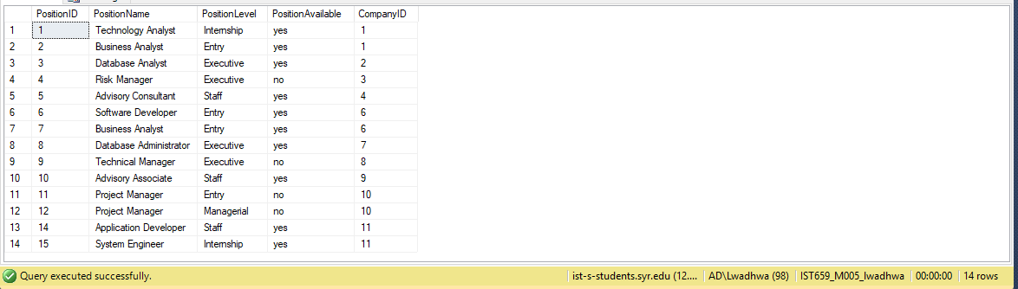

**DELETE POSTION THROUGH FORM**

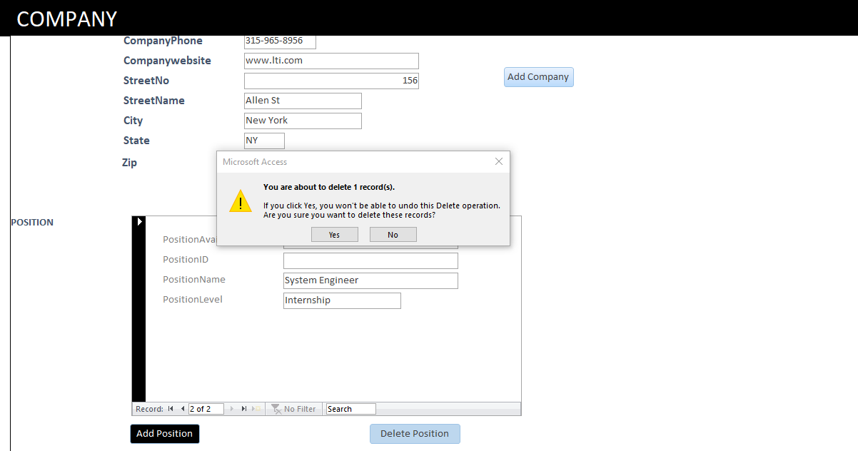

**Delete company with id 11**

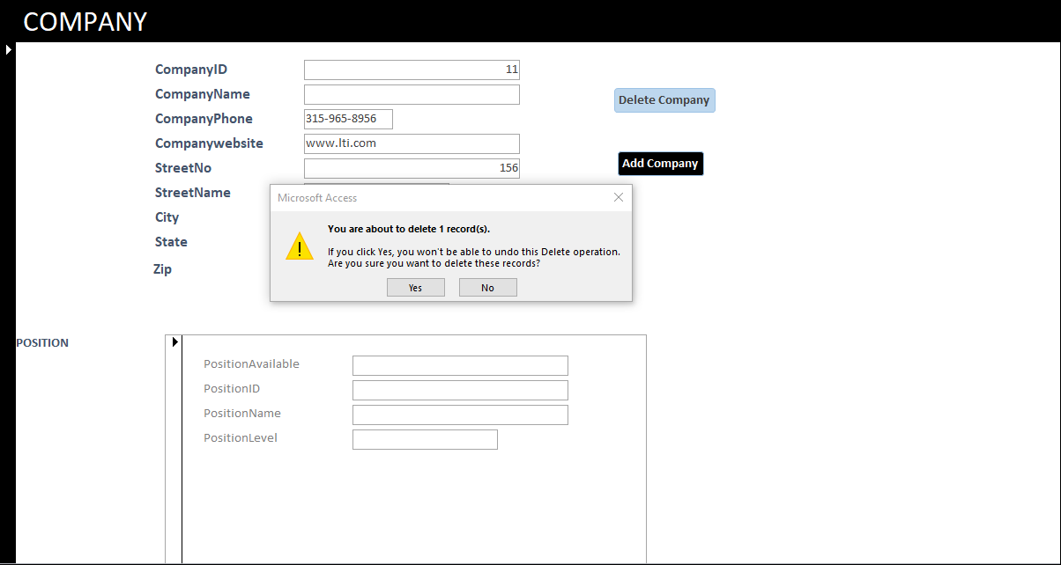

**COMPANY TABLE AFTER DELETING COMPANY**

SELECT * FROM COMPANY

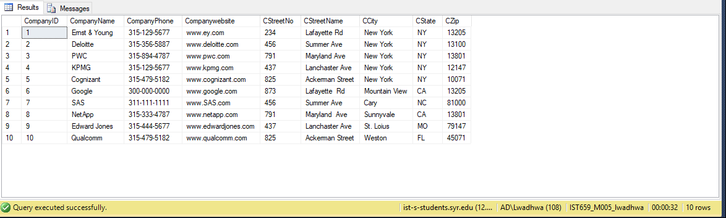

**POSITION TABLE AFTER DELETING IT FROM THE FORM**

SELECT * FROM POSITION

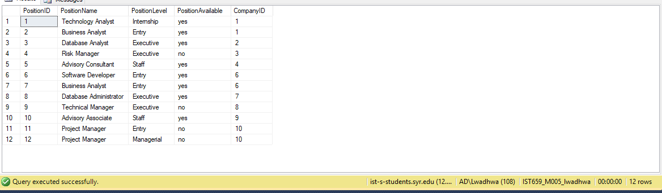

2**. Candidate and Interview Form: Create a master-detail form (form/subform) in MS Access that will allow you to select a particular Candidate and display the Interview details for that Candidate. Attach screen shots of your form and proof that it works properly**

The below Candidate form allows the user to select the available candidate id with the help of a combo box and on hitting the enter key it displays the details of the candidate and the position available for it

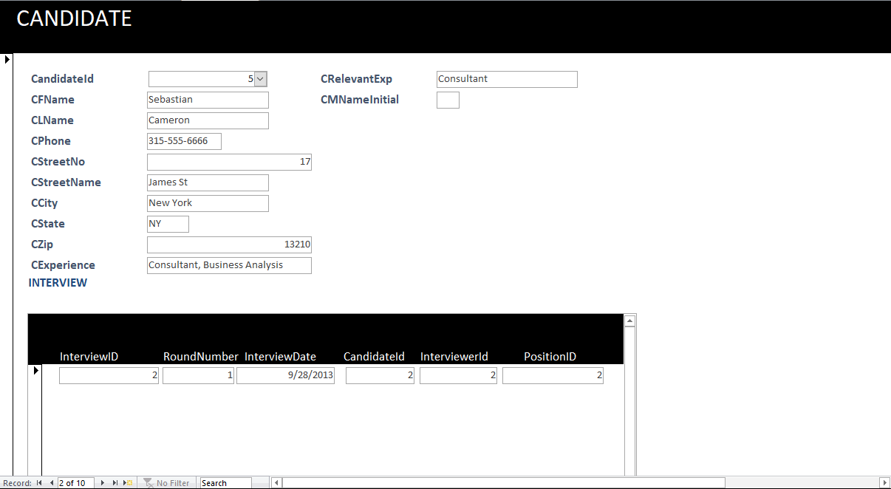

**3.Interview Summary Report: Create a report that lists all Interviews information including Interviewer ID, Interviewer’s last name and first name, Candidate ID, Candidate last and first name, Interview ID, and Interview date. Order the report by Interview Date. Also list all positions for which interviews were conducted displaying Position ID, Position name, Position Level. Attach screen shots of your report.**