**IST 659 Lab 6**

Find all candidates who were interviewed for second round (Round Number = 2)

Internship position. Show each candidate’s details which includes candidate ID,

candidate name, phone number, candidate experience, and relevant experience. */

/* Join table Interview and candidate based on the key candidateId, interview and position based on the key positionID with constraints

RoundNumber = 2 AND PositionLevel = 'INTERNSHIP'*/

SELECT CANDIDATE.CandidateId, CANDIDATE.CFName, CANDIDATE.CMNameInitial, CANDIDATE.CLName, CANDIDATE.CPhone, CANDIDATE.CExperience, CANDIDATE.CRelevantExp

FROM INTERVIEW

INNER JOIN POSITION ON INTERVIEW.PositionID=POSITION.PositionID

INNER JOIN CANDIDATE ON INTERVIEW.CandidateId=CANDIDATE.CandidateId

WHERE RoundNumber = 2 AND PositionLevel = 'INTERNSHIP'

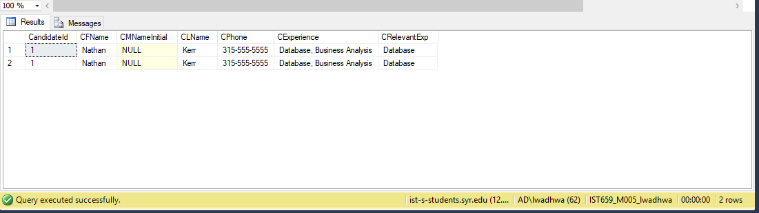

b) Find all positions whose interviews were conducted by "Amy May"(interviewer).

Show the PositionId, position level, position name and position availability.

/* Join table Interview and Interviewer based on the key interviewerId, interview and position based on the key positionID with constraints

IFName = 'Amy' AND ILName = 'May'*/

SELECT P.POSITIONID, P.POSITIONLEVEL, P.PositionName, P.POSITIONAVAILABLE

FROM INTERVIEW I

INNER JOIN INTERVIEWER IR ON I.InterviewerId=IR.InterviewerId

INNER JOIN POSITION P ON P.PositionID= I.PositionID

WHERE IR.IFName = 'Amy' AND ILName = 'May'

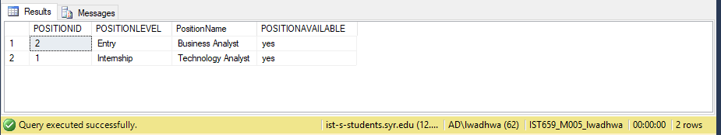

c) Find all interviewers who conducted one or more second-round interviews. Show the

Interviewer details like Interviewer ID, Interviewer phone, Intervieweremail,

Interviewer address and schedule

/* Join table(that returns interviewerID and count of interviews>2 that they have taken) and Interviewer based on the key INTERVIEWERID*/

SELECT I.INTERVIEWERID, I.IPHONE, I.IEMAIL, I.IStreetNo, I.IStreetName, I.ICity, I.IState, I.IZip

FROM (SELECT INTERVIEWERID, COUNT(INTERVIEWID) 'COUNT OF SECONDROUND INTERVIEW' FROM INTERVIEW WHERE ROUNDNUMBER = 2 GROUP BY InterviewerId HAVING COUNT(INTERVIEWID) >=1) N

INNER JOIN INTERVIEWER I ON N.INTERVIEWERID = I.INTERVIEWERID

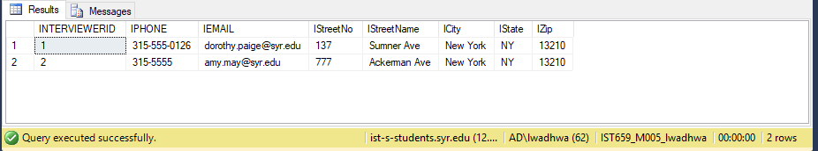

d) Find all candidates who interviewed for the position “Advisory Consultant”. Show

Candidate details and interview details.

/*Join table Interview and candidate based on the key candidateId, interview and position based on the key positionID with constraints

WHERE PositionName = 'Advisory Consultant'*/

SELECT I.*, C.*

FROM INTERVIEW I

INNER JOIN CANDIDATE C ON I.CANDIDATEID = C.CANDIDATEID

INNER JOIN POSITION P ON I.PositionID = P.PositionID

WHERE PositionName = 'Advisory Consultant'

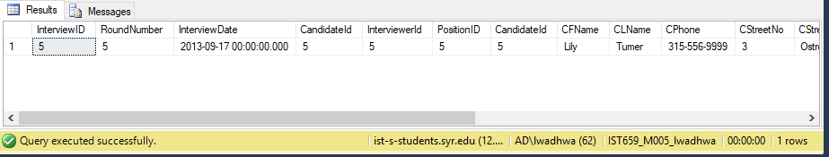

e) Find positions for all the interviews that were conducted on September 28th, 2013.

Show the PositionId, position level, position name and position availability.

/*Join table interview and position based on the key positionID with constraints

WHERE InterviewDate = '2013-09-28'*/

SELECT P.POSITIONID, P.PositionLevel, P.PositionName, P.PositionAvailable

FROM POSITION P

INNER JOIN INTERVIEW I ON P.PositionID = I.PositionID

WHERE InterviewDate = '2013-09-28'

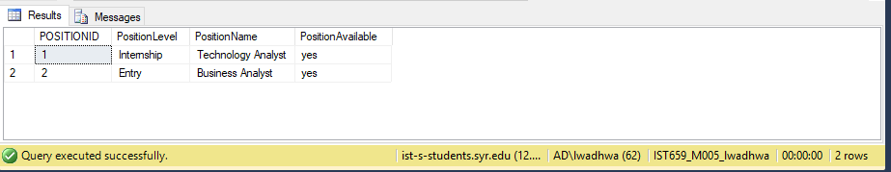

f)Find all positions for which no interviews were conducted, and delete them from the

Position table.

/* select positionId from Position table for which no interview was conducted and delete them using Delete query*/

DELETE FROM POSITION WHERE PositionID NOT IN( SELECT DISTINCT P.POSITIONID

FROM POSITION P

INNER JOIN INTERVIEW I ON P.PositionID = I.PositionID)

SELECT * FROM POSITION;

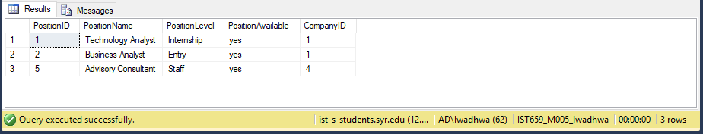

g)Find the interviewer who conducted the interview for candidate "Heather Cameron".

Update this interviewer's phone number to 315-400-5000.

UPDATE INTERVIEWER

SET IPhone ='315-400-5000'

WHERE InterviewerId IN (SELECT IR.INTERVIEWERID

FROM INTERVIEWER IR

INNER JOIN INTERVIEW I ON IR.InterviewerId = I.InterviewerID

INNER JOIN CANDIDATE C ON C.CandidateId= I.CandidateId

WHERE C.CFName= 'Heather' AND C.CLName= 'Cameron')

SELECT *

FROM INTERVIEWER IR

INNER JOIN INTERVIEW I ON IR.InterviewerId = I.InterviewerID

INNER JOIN CANDIDATE C ON C.CandidateId= I.CandidateId

WHERE C.CFName= 'Heather' AND C.CLName= 'Cameron'

