**Diwali Sales Data Analysis**

1. **Brief Description-**

Diwali Sales Analysis project! This project focuses on analyzing sales data to gain valuable insights into customer behaviour and product performance during the Diwali season. Using Python and data analysis libraries such as NumPy, Pandas, Matplotlib, and Seaborn, I've conducted an in-depth analysis based on various factors, including age, gender.

1. **Objectives/ Goals**-

A. This project explains how to analyze the sales data to gain insights into customer behaviour

B. Share a product sale summary through that company will enhance the product performance.

C. Company will improve customer satisfaction experience by analyzing sales data

D. Company will Increase the revenue

1. **Steps involve in Data Analysis-**
2. Collection of Dataset
3. Clean the data
4. Removing null values
5. Rename duplicate values
6. EDA on Gender, Age, State, Marital Status
7. Visualization
8. Max selling products
9. Conclusion
10. **Data Sources-** Kaggle.com
11. **Preprocessing steps-**
12. Import libraries

(install pip install pandas)

(install pip install numpy)

(install pip install seaborn)

(install pip install from matplotlib import pyplot as pt )

1. Fetch the data
2. Find out number of rows and column
3. Find out null values
4. If null values present than drop/ remove the null values
5. Check the duplicates
6. If duplicates present than rename it
7. Find out the type of data
8. If required change the data type if not correct
9. **EDA-**

Perform Exploratory data analysis between different values or columns

i.e.

-Gender

- Age

-State

-Marital Status

1. **Visualization-** Through Bar graph
2. **Proposed Methodology**- Used Statistical Methodology to analyze the data
3. **Tools & Technology**- Used Statistical Method in which used mean, standard deviation
4. **Outcomes/ Findings-**

* Most buyers are Female
* Males are less

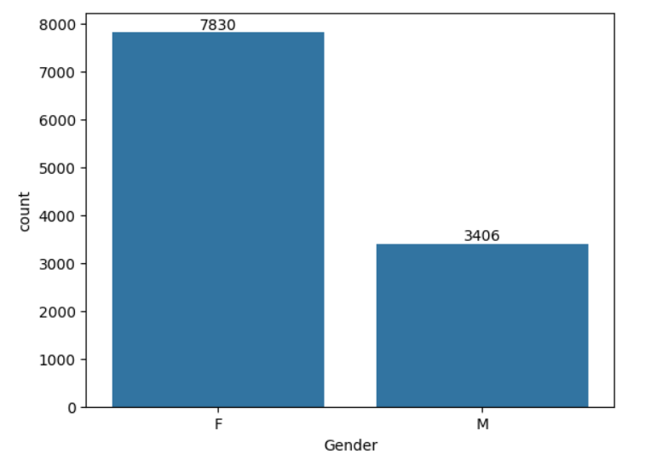

* Purchasing power of females are greater than male
* Most of the buyers are of age group between 26- 35 female

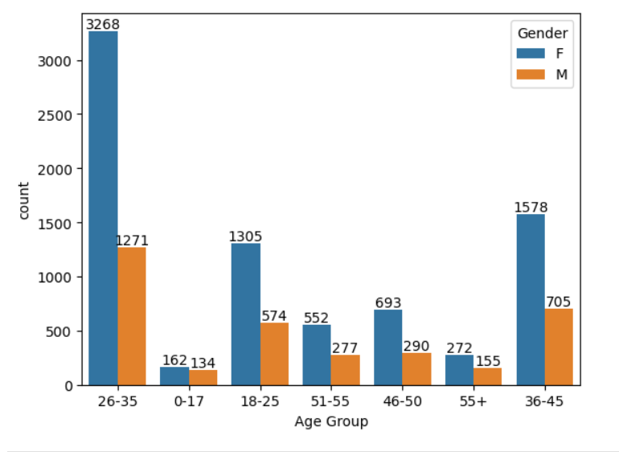

* Most of orders are from Uttar Pradesh, Maharashtra and Karnataka.
* Most of the total sales/Amount are from Maharashtra, Uttar Pradesh and Karnataka

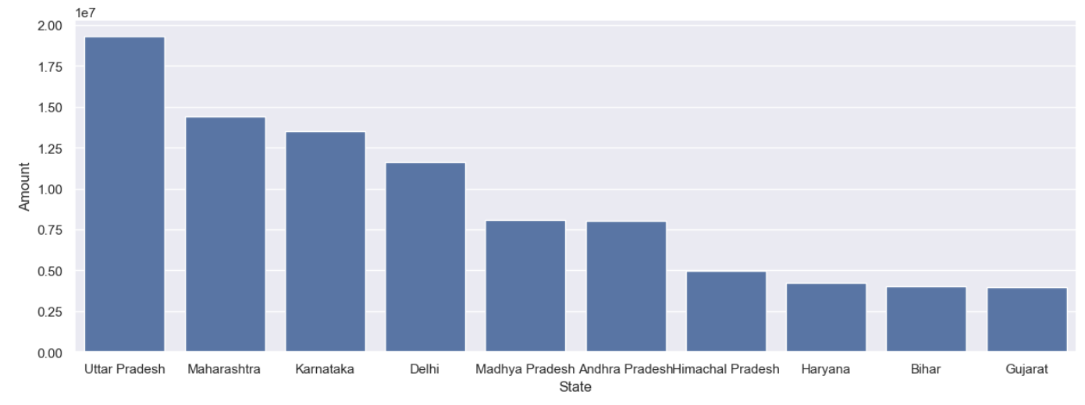

* Most of buyer’s are married women as compare to men.
* 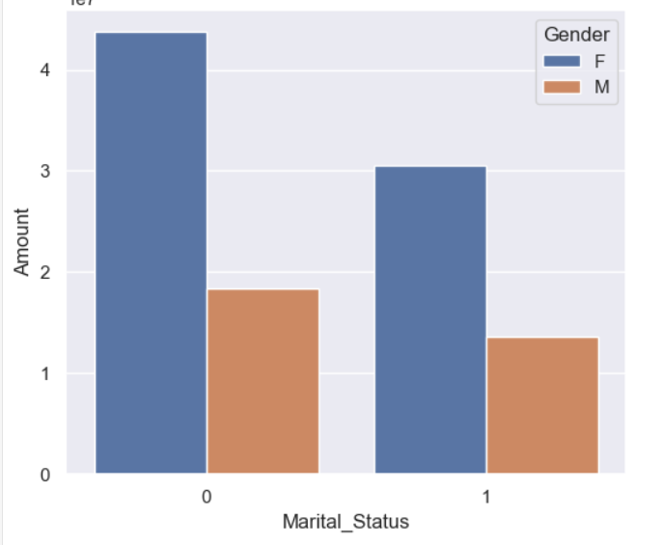

1. **Conclusion**

-Most of the buyers are married women age group between 26- 35 years from Uttar Pradesh, Maharashtra and Karnataka.

-Dashboard presentation through Power BI.

