**Employee Performance Data Analysis**

**(Discover patterns and insight into employee performance)**

1. **Brief Description**

Find out the Productivity and work quality. how employees are productive and what is their quality of work. Skills development and improvement. Achievement of goals and objective.

1. **Objectives/ Goal-** Achieving individual employee goals of employees along with organizational objectives. Also, enhance the skills and personal development of employees through the managers' help. Additionally, encourage work that helps in fulfilling business goals.
2. **Steps involve in Data Analysis-**
3. Collection of Dataset
4. Clean the data
5. Removing null values
6. Rename duplicate values
7. EDA on Gender, Age, State, Marital Status
8. Visualization
9. Max selling products
10. Conclusion
11. **Data Sources-** Kaggle.com
12. **Preprocessing steps**-
13. Import libraries

(install pip install pandas)

(install pip install numpy)

(install pip install seaborn)

(install pip install from matplotlib import pyplot as pt )

1. Fetch the data
2. Find out number of rows and column
3. Find out null values
4. If null values present than drop/ remove the null values
5. Check the duplicates
6. If duplicates present than rename it
7. Find out the type of data
8. If required change the data type if not correct
9. **Visualization-** Through Bar graph, line graph and used Power BI through Bar Chart, Pi Chart, Donut Chart, Line graph
10. **Proposed Methodology**- Used Statistical methodology to analyze the data
11. **Tools & Technology**- Used Statistical method in which used **mean** and **standard** deviation
12. **Outcomes/ Findings-**

* Exploring the relationship between the performance score, employee satisfaction and gender

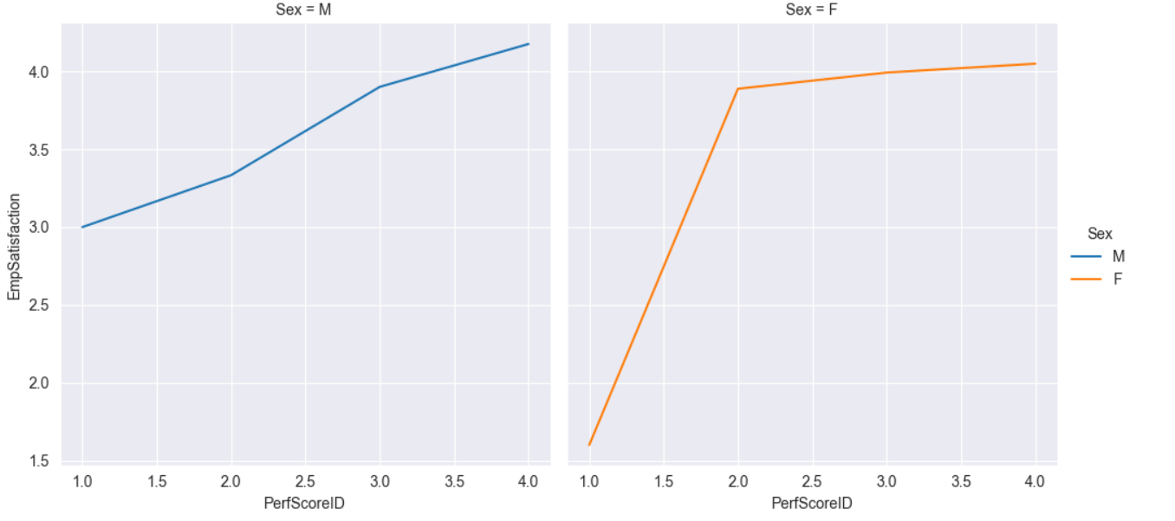

* Performance scores are correlated with Employee satisfaction. However: Males have higher satisfaction (range from 3- 4.5) compare to Females (range from 1 - 4.2).
* In general, Female with lower performance score tend to have lower satisfaction while in Male, the lowest Performance score (1) is correlated with 3 on the scale of Satisfaction
* Number of male and female employees/ Count of male and female employee department wise.

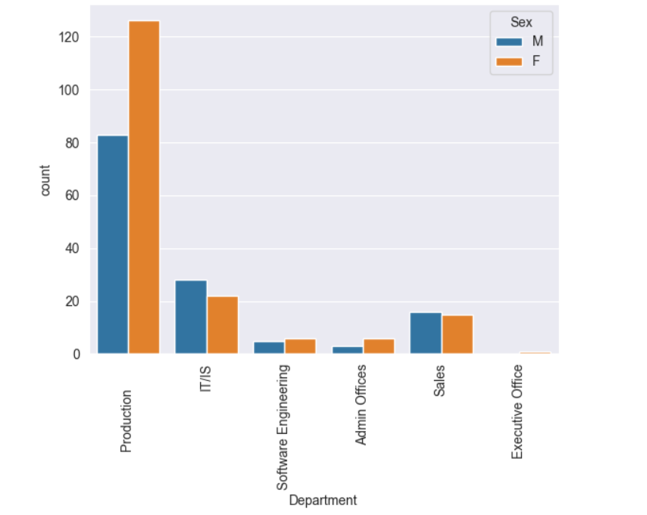

* In General, employees' satisfaction score is above average 3.9 within the range from 0-5
* Most employees have satisfaction range from 2.5 - 4.5.
* In some department like sale and production, male employees are lower satisfaction compare to female employees

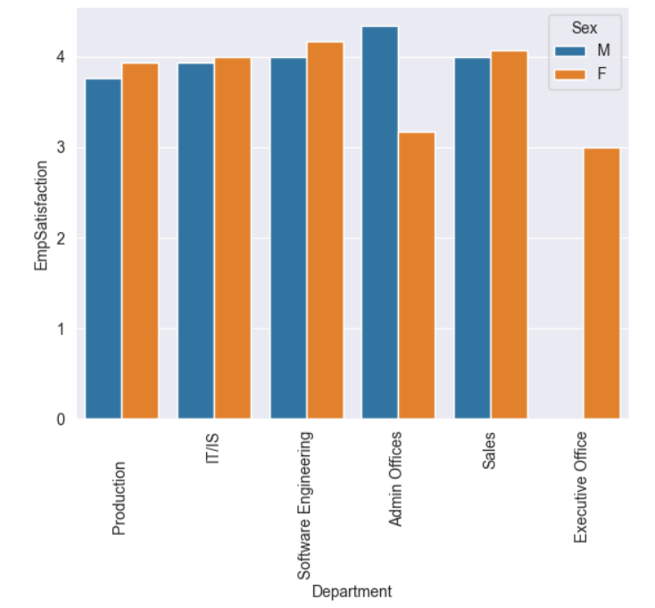

* Female employees have higher performance compare to male employees.
* However, in the software engineering department, male employees have higher performance than female employees.
* There is a gap salary between single Male and Female employees.
* Employees with married status earn almost equally in general in Male and in Female (married) earn higher than single female employee.

1. **EDA-**

Perform Exploratory data analysis between different values / columns

1. **Conclusion**

-Gender distribution is comparable between females and males and employee’s satisfaction frequently correlate with performance scores, with an average satisfaction score above 2.5. a

-Dashboard presentation through Power BI.