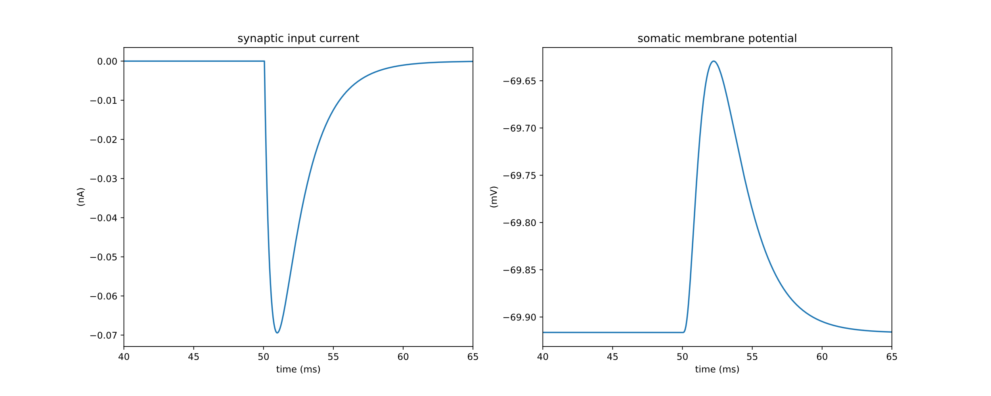

0.01 nA

5 ms

0.05 mV

A

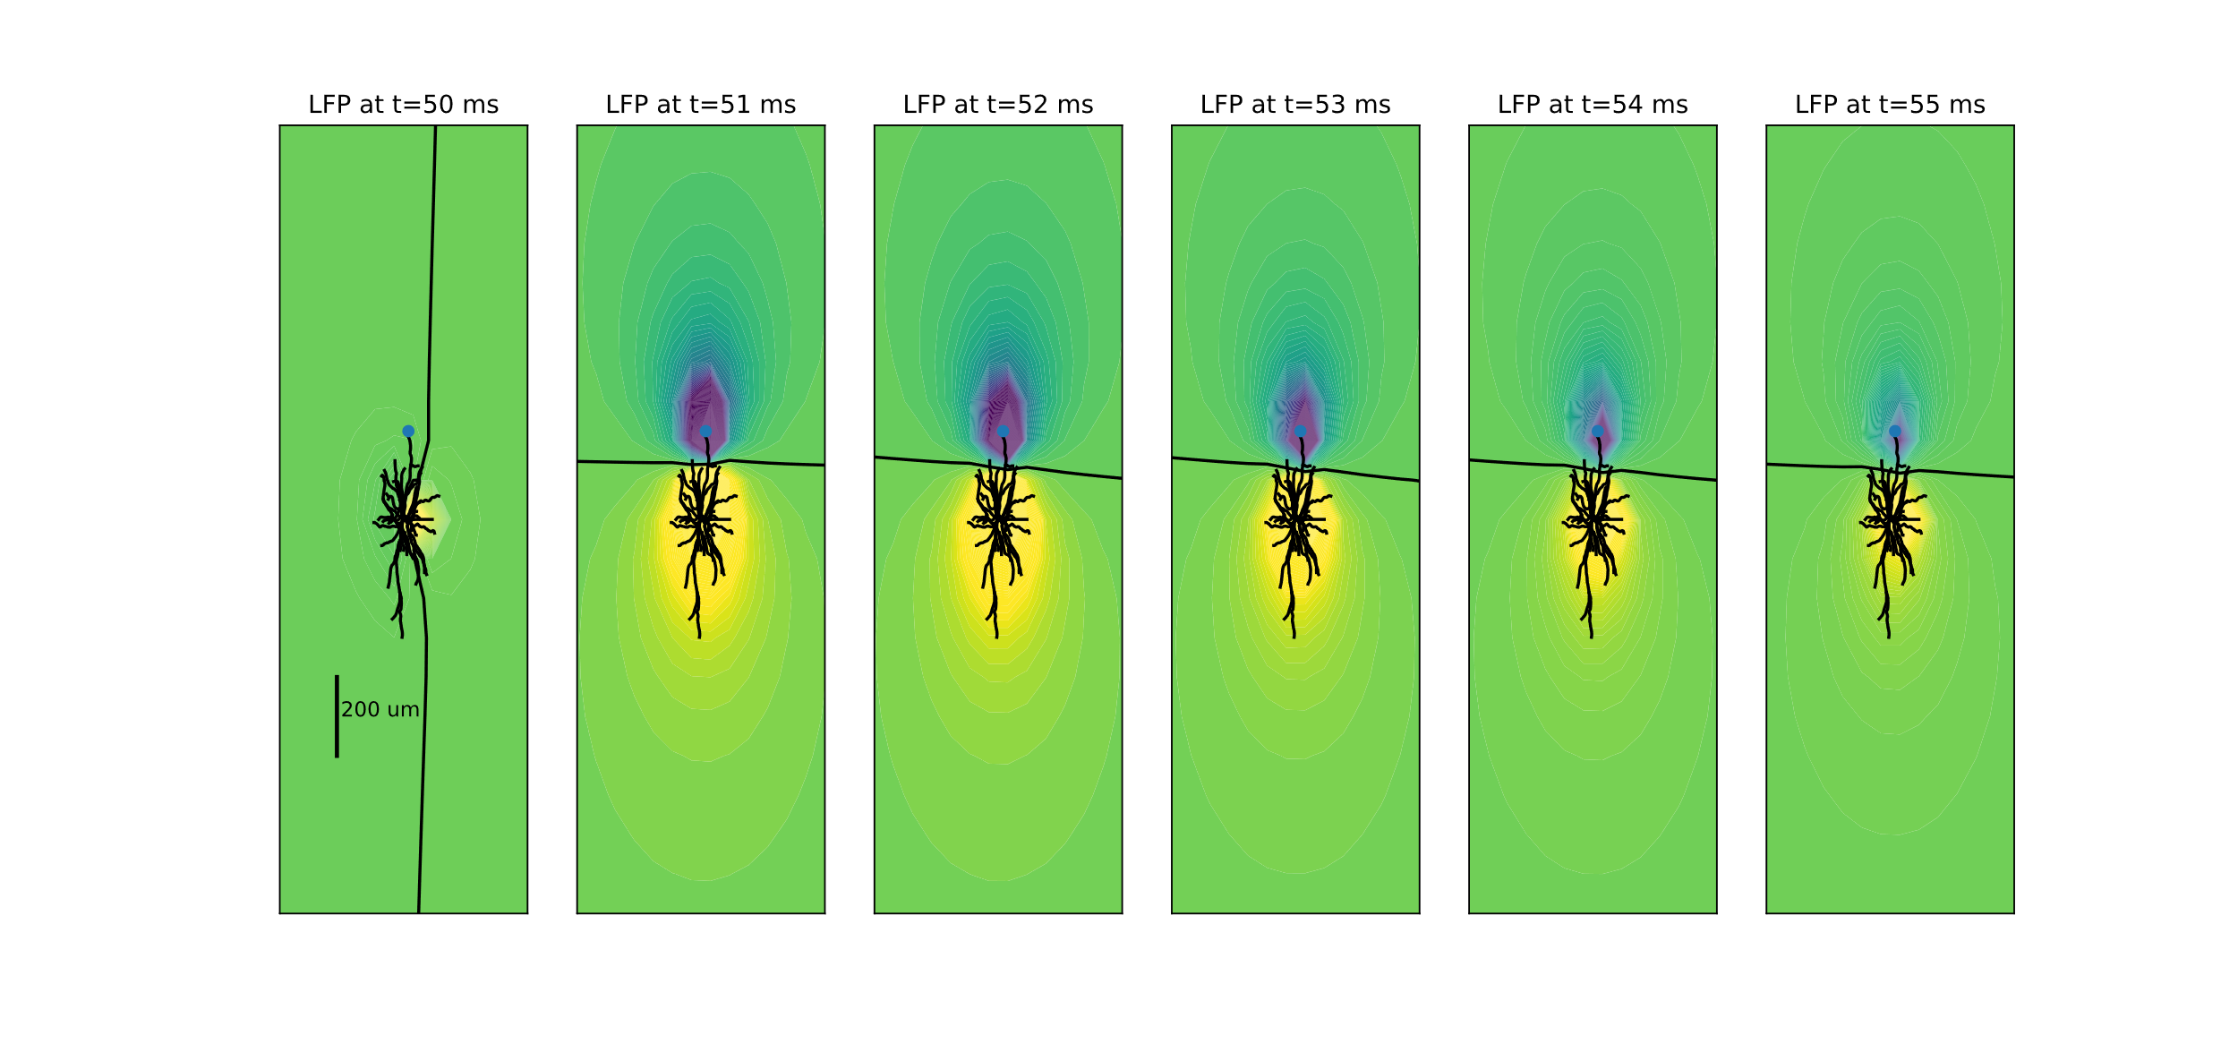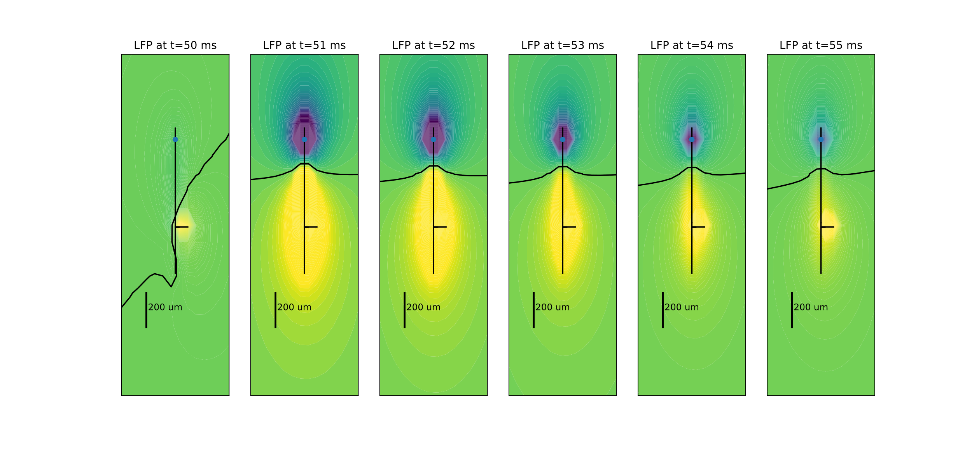

B2

B1

**Figure 1.** Single Pyramidal cell response to a synaptic input. **A:** Synaptic input current and membrane voltage response at the soma. **B:** LFP field around the cell, with time progressing from left to right. Cooler colors represent negative LFP (sink), hot colors represent positive LFP (source). Black line between sink and source is the zero potential line. Geometry is shown in black for the simple cell (1) and the detailed cell (2).