SALVADOR

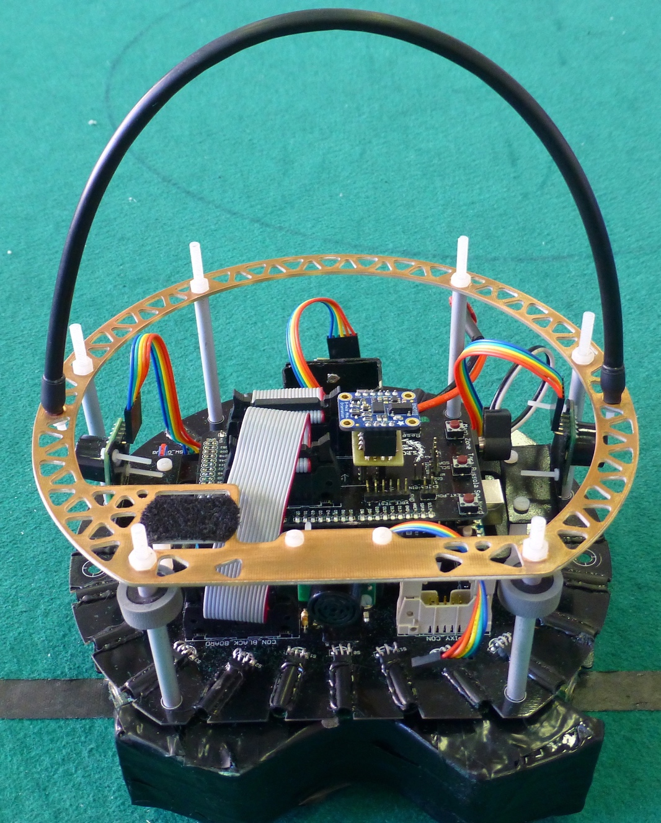

* Age: just born
* Role: goal keeper
* Electronics: New boards, IMU, line sensors
* Mechanics: New CAD design, handle and columns
* Software: New strategy

MANFREUS

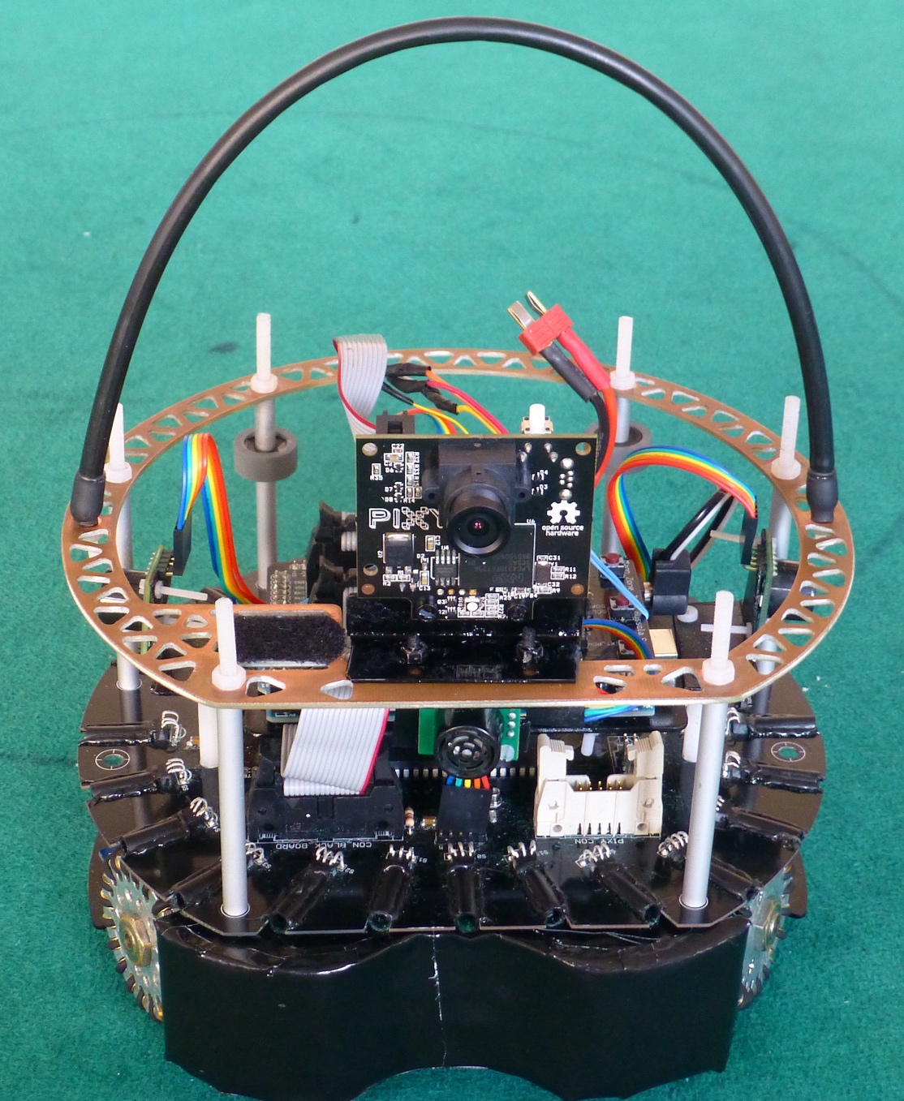

* Age: just born
* Role: goalie
* Electronics: New boards, IMU, line sensors, Pixy
* Mechanics: New CAD design, handle and columns
* Software: New strategy