
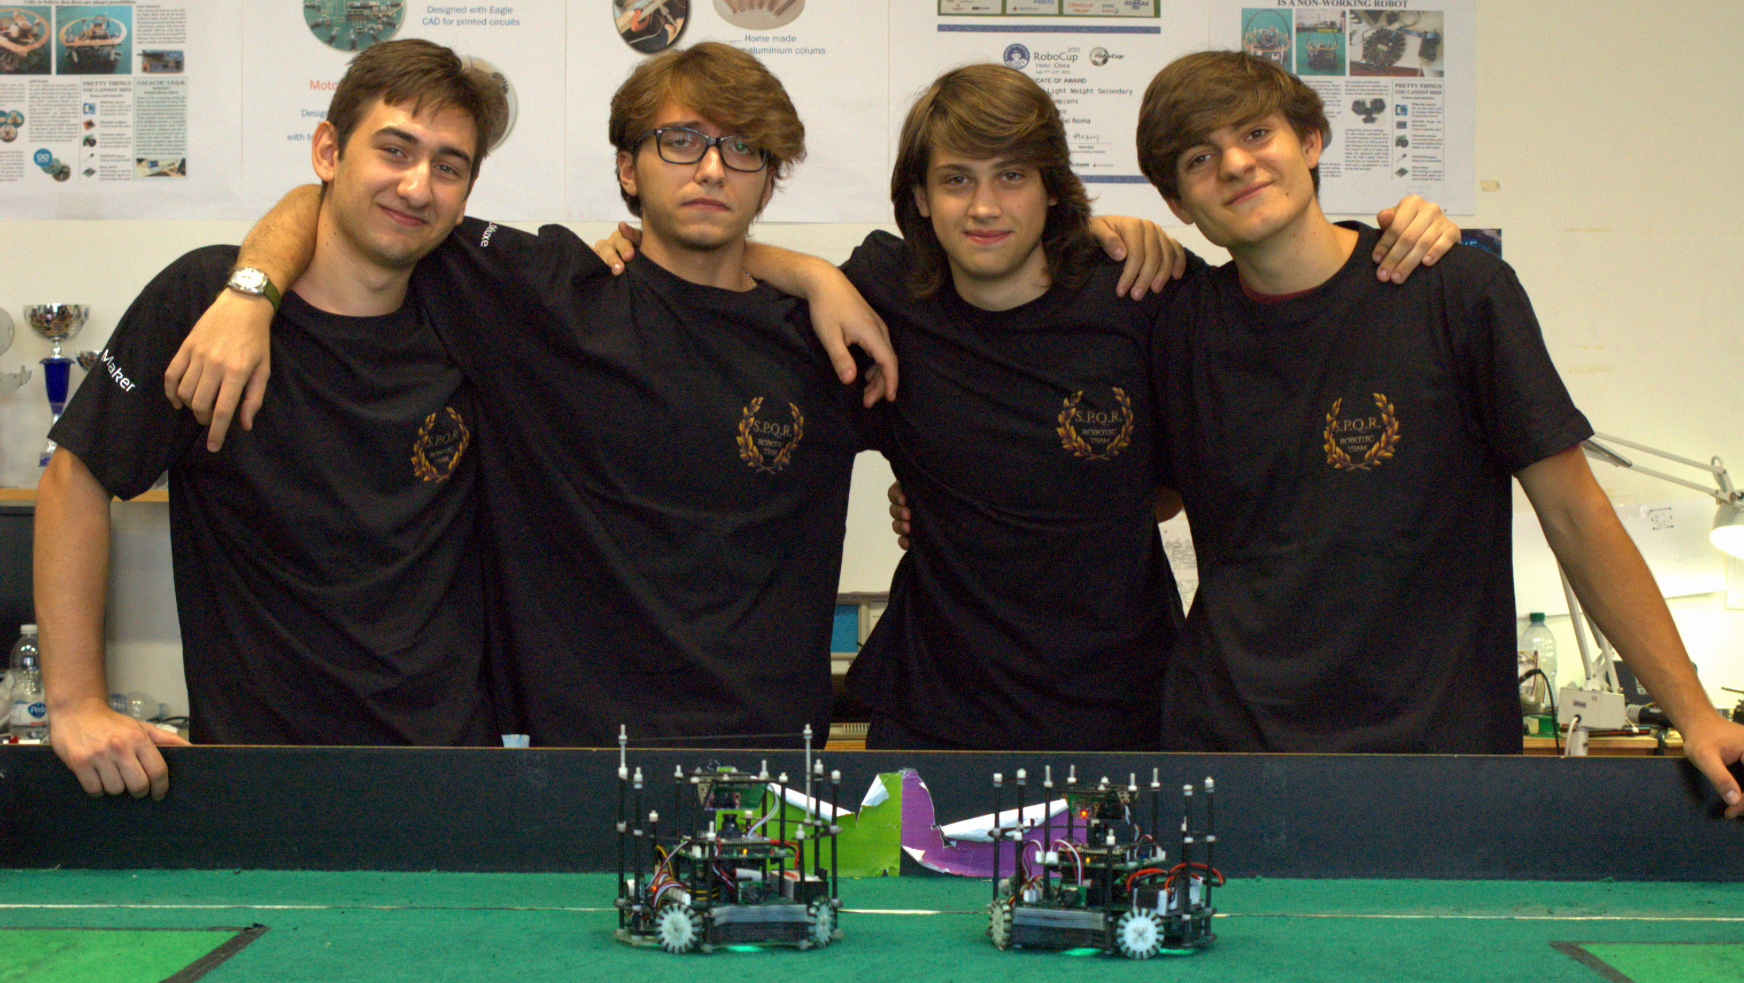

TEAM BACKSTORY

Since 2009, our school has been playing robo-soccer in the Lightweight category, and since then, we haven't lost a single match on the italian territory. We have been competing in worldwide competition as well for the past 9 years, coming up on the first place in 2015 (Hefei) and in 2016, as well as a "Best Robot Design" in 2017 (Nagoya).
Our team has always been about inventing and/or renewing what we had in the lab, and this year's no exception.

THE NEW GENERATION

We started projecting the new generation in May of this year. The new project involves:
- the usage of CAD programs such as AutoCAD
- advanced problem solving
- thinking about something that's never been made
- pushing our boundaries
- creative and innovative ideas

To give us an objective for this year's competition, we started from zero to fully understand our robots. Exception made for the microcontrollers, the camera and the motor drivers, everything was made from scratch.

ROBOT INNOVATIONS

- Hardware

Our robots have changed a lot over the past few months, and we've worked hard to make sure everything was at its best.
We now have :
- New and smaller PCBs, easier to repair and to carry
- 16 ball sensors instead of 20, easy to manage and precise
- 4 motors to move more smoothly and to have more control over the movements
- new line sensors, made by us from scratch
- Teensy 3.5 and Arduino Pro Mini, powerful and compact
- Totally new power supply management, to save some space and to understand the functioning of the robot better
- Connectors between the boards on the bottom, for a linear design
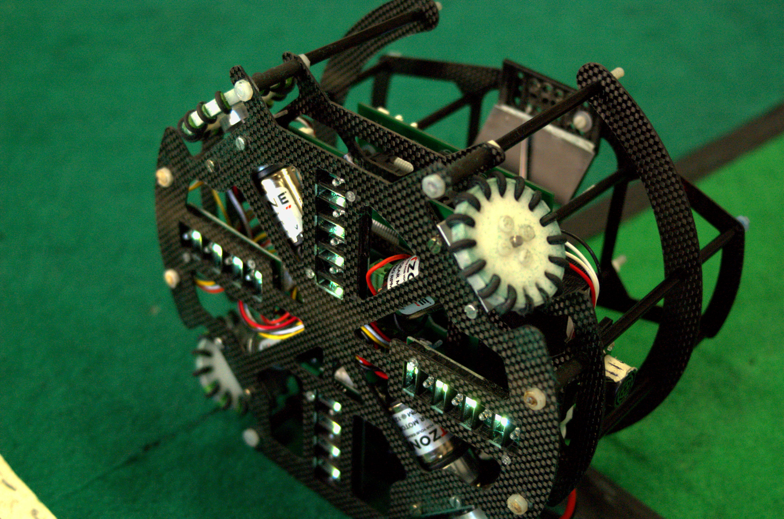
The PCBs were designed to be smaller and lighter than before, with Eagle; the μC board is 10x10 cm wide and the motor board is slightly bigger, 12x10 cm, this let us add more components without weighing too much. We designed our line sensors from scratch with Eagle as well to be more precise when in field. This and the 4 motors have significantly decreased
our out of bounds percentage.

- Design

Our design has been revolutioned for the sake of lightness and elegance because we had to have a lighter robot in order to add a motor, in fact we now have a full carbon fibre structure to sustain our PCBs and motors, as well as a brand new mirror for our OpenMV M7 Camera, to fully see the field while we're playing.
Every part of the design was projected with Fusion and AutoCAD and then 3D printed or CNC cut to measure.
We used 1 mm thick carbon sheets for the uC board and mirror support and 1,5 mm thick ones for the motor board support due to the motors' weight. US sensors, battery and additional motor supports were 3D printed, as well as mirror and line sensors supports.
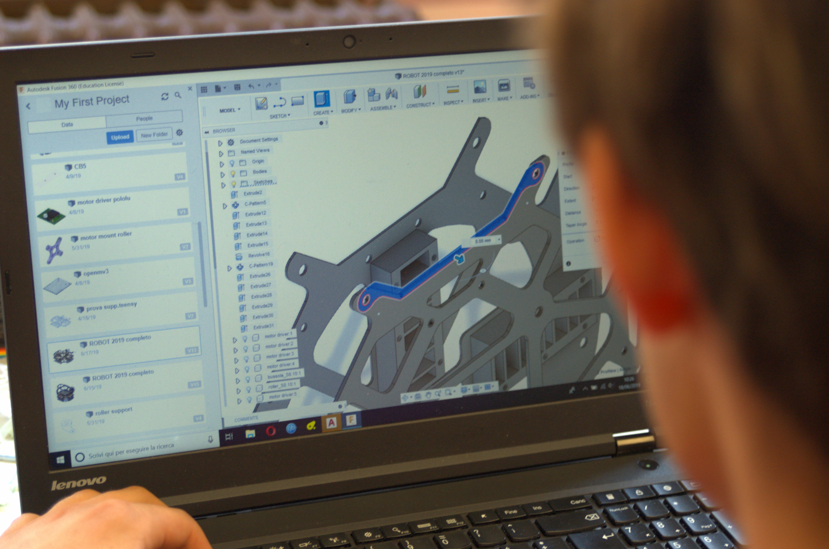

- Software

From the software's side, the Teensy 3.5 with its high frequency Cortex M4 lets us do what no one in this team has ever done.

