CS620

HW1

La’Tisa Ward UIN: 01026311

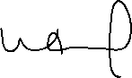

La’Tisa Ward



La’Tisa Ward

01026311

