1.)Created a combine feed

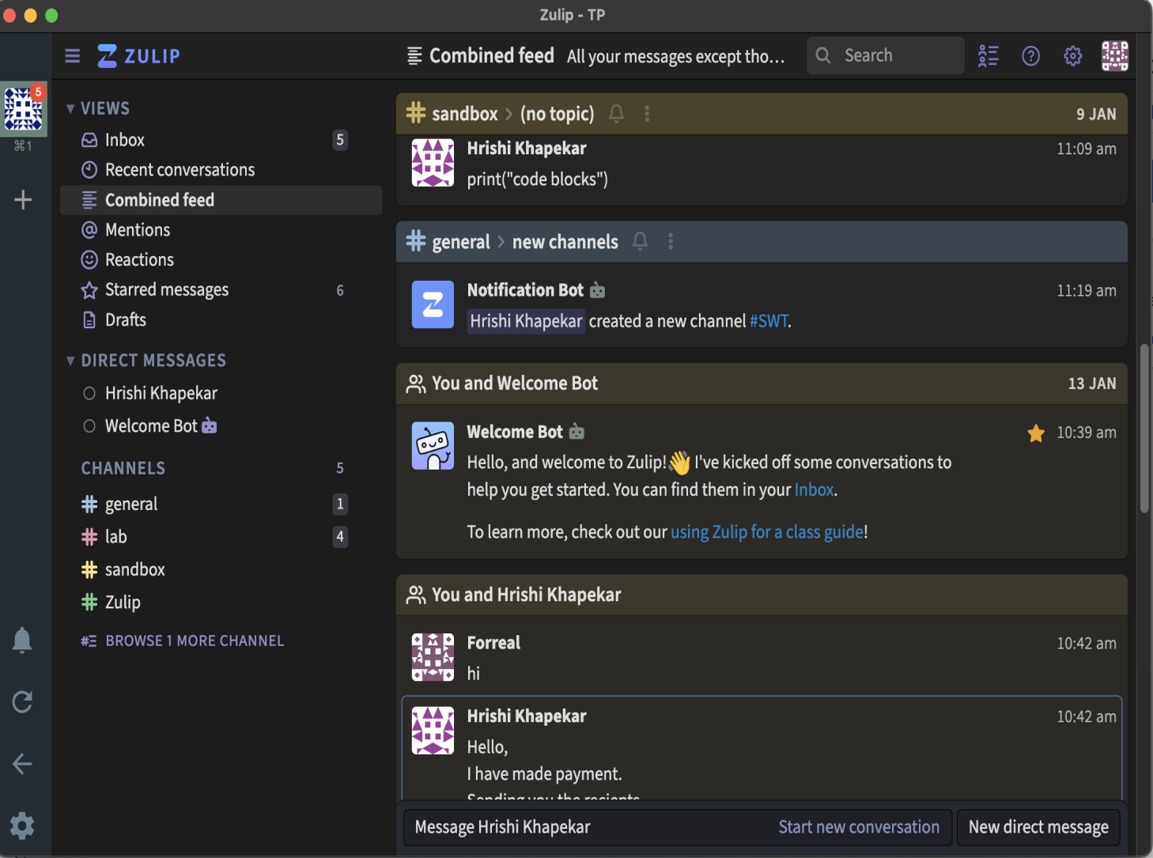

1. )Have some personal chats with my friend

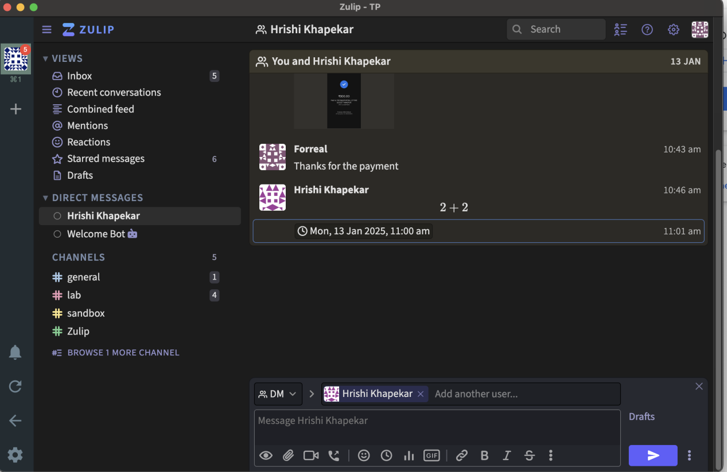

1. )Able to send some of the basic odes and discuss it with my friends on channels

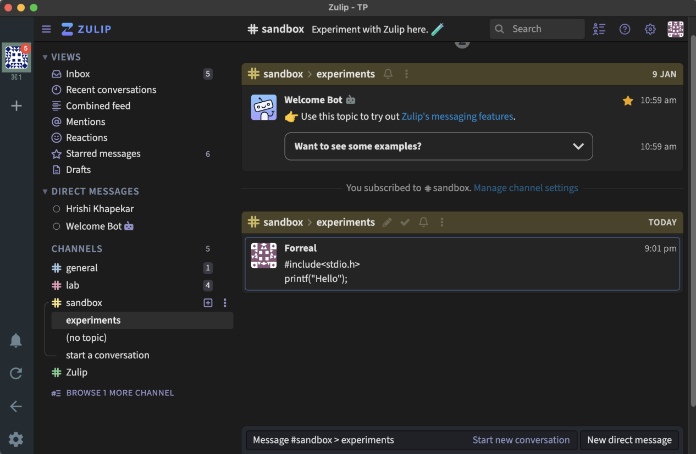

1. )Able to create different channels

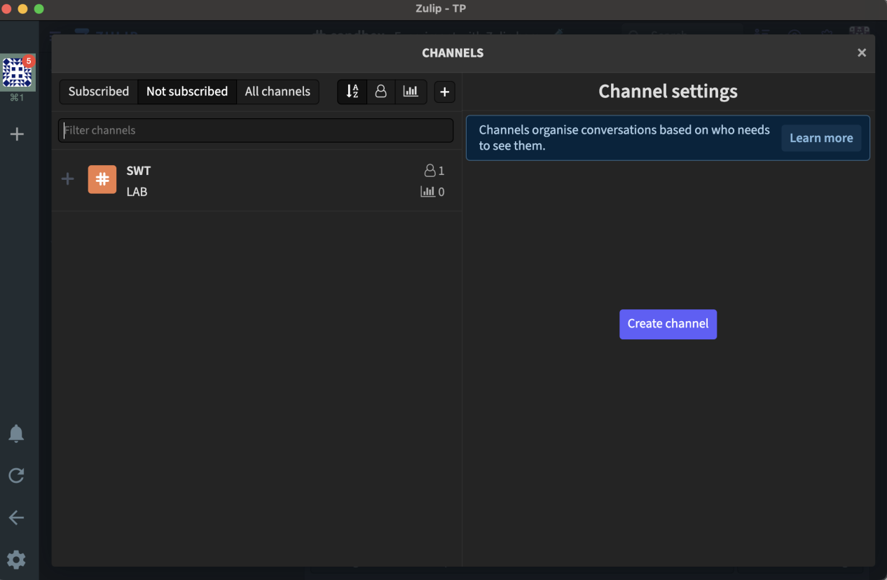

1. )Have connected with the differents friends on zulip

