Synopsis

- Introduction.
- Need for the software.
- Main Features.
- Algorithm.
- Working.
- Configuration.
- Weakness.
- Programming Language.
- Hardware Requirements.
- Software Requirements.
- Other Documents.

1. Introduction:

HideIt is a program, which is used for hiding your confidential data from 'prying eyes'. The program very cleverly hides your data inside other files so that nobody even gets a hint of your data. You can safely carry your data or keep the data in the hard disk without any problem. The program can extract the hidden data when required. Password Protection, Encryption and other options are also available for increased security.

2. Need for the software:

We are living in the information age. Data transmissions are vital and became a necessity nowadays. Whether you exchange private messages, or business / commercial secrets, you must protect your confidential information from hackers, your boss, or secret services. But we live in an insecure world where unwanted persons can access your personal information (like e-mails or personal desktop documents) and often use it against you. You can encrypt your information, but encrypted documents can be cracked by hacker’s .one solution to this to make the data invisible to others after encrypting the data. This is how HideIt works: it encrypts the actual documents and then it hides the encrypted document into an "innocent" file called carrier file.

3. Main Features

Steganography

Steganography is the art and science of hiding information by embedding messages within other, seemingly harmless messages. When a message is encrypted, it it has no meaning, and it’s easy to understand that it contains sensitive information, a secret – and someone might try to break it. Steganography solves this problem by hiding the sensitive information in a harmless file called carrier file. While normal file encryption software allows you only to scramble information, Invisible Secrets 4 also allows you to hide information in five innocent looking files types: JPEG, PNG, BMP, HTML and WAV.

This method of disguising data (steganography) is not infallible. But it considerable raise the work of any experienced code-breaker, who must identify first the right carrier, extract the sensitive data from it, and only after that (if he gets this far) – the hard work of breaking the code. Steganography is the perfect supplement for file encryption.
HideIt is thus both cryptography and steganography software.

4. Algorithm:

The program uses 2 algorithms, one for compressing and decompression of the data and another algorithm for encryption and decryption of data.

Compression algorithm:
In the real sense there is no compression going on here but only binding of data together i.e. all the required files are placed one after the other in the disk.

Encryption Algorithm:
Here a basic XOR algorithm is used, but the beauty is that the application doesn’t store the password in the result file. Instead it encrypts every byte of the file with the password creating an new byte. This encrypted byte is stored in the resultant file. This increases the security of the data.

Data Storage:
The program exploits a common concept used to store file by other applications. Every application reads the data that is required by it and throws away all the un-required data. This program stores your data as the un-required data. Suppose your data is hidden inside an JPG image then the image viewer will only work with the image data and nothing else. Therefore when the image file is viewed only the image and not your data is shown on the screen.

4. Working:

The 2 operations of this software are Hiding your Data and Retrieving the hidden data.

I. Hiding the Data:
1. Start screen:
Select 'File' from the menu and then click the 'New' option OR Click the 'New' icon in the Toolbar . See the below figure.

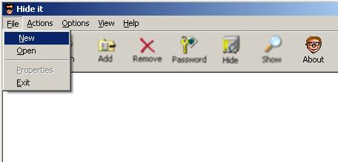

When the New button is clicked then a dialog box appears asking for the file which will hide your data inside it.
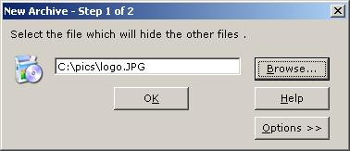
New Archive Dialog box
3.Advanced Options (OPTIONAL):
For Advanced Options such as 'Invisible Mode' click the 'Options' button. Invisible Mode option is to be used when higher security is used. See the below figure
- Invisible Mode : This mode is a high security mode. Normally if you have hidden your data inside a file with a password even then others would come to know that you are hiding something when they use this software although they cannot see the actual data but in Invisible Mode The Data is hidden a such a way that even for showing the list of hidden data the program would ask for the password. If the password is wrong then the program intentionally doesn't give out any error so that no one would get a hint actually what went wrong. Only if you provide the correct password then only the program will show the list of hidden data.
Note: Always remember the passwords you use ,since if you forget a password even the program author cannot recover your data as data is encrypted using the password.
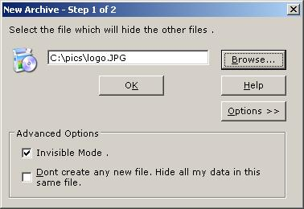
b. No creation of new file: The program normally doesn't change any original files. It makes a copy of the original file and hides all the data inside it. But if this option is chosen then the program hides all the data inside the original file and doesn't ask for a new filename. If you enable this option then the next screen for a new filename doesn't appears.
2. Save the archive:
If the checkbox in the previous dialog box is not set i.e. if you want to create a totally new file which contains your hidden data then the program shows another screen in which it collects the name and location of the file to be created A standard 'Save As Dialog box appears in which you can give the file name and location . See the below figure for the screenshot.
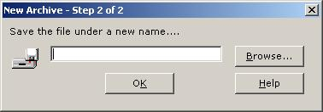
New Archive Dialog box

3. Adding Files:
Choose the 'Add' option from the 'Actions' Menu OR click the Add icon in the Toolbar to add the actual documents you want to hide. You can select any number of files.
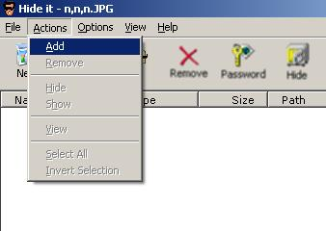

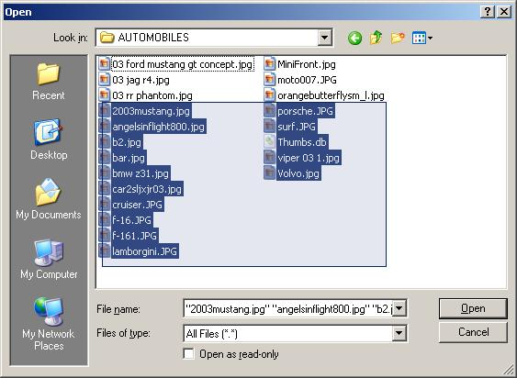

After the files are added the program screen looks like in the picture below
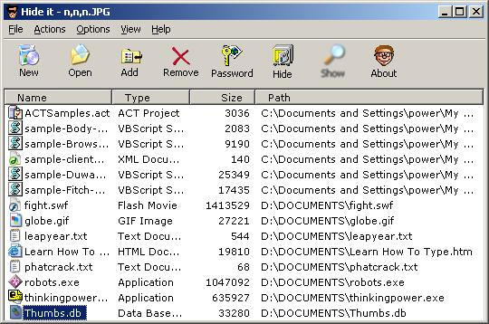

4.Hide the Archive
Click the 'Hide' button in the Toolbar or select 'Hide' option from the 'Actions' Menu.
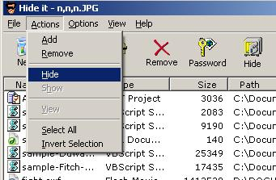

5. Password Remainder Box:
A password Remainder box appears if you have chosen to be reminded for passwords while hiding archives. If the Archive is not password protected then everybody can see your confidential data. It is always recommended to password protect your archives. See the below screen.
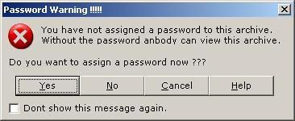

6.Password Box:
If you chose to assign a password then the following password box appears on the screen.
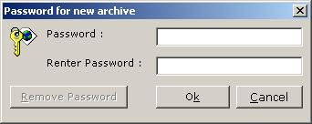
After this the program starts to hide the data inside the archive while it shows the progress bar with the messages.
7.Finished:
Congrats You have successfully hidden your data.

II . Retrieving the Data:

1.Open Option:
Choose the Open option from the menu.
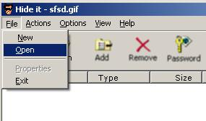

2. Open Dialog box:
The following dialog box appears. Select the file which contains your hidden data.
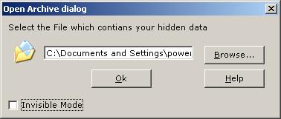

3.Open Dialog box with Invisible Mode option:
If your Data is hidden in Invisible Mode then click the Invisible Mode checkbox. When the checkbox is clicked the dialog box looks like the screenshot below. Enter the password and then click the OK button.
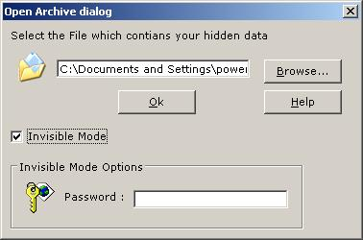

4.Program Showing Hidden Data:
The program then shows the hidden data in the file. The files shown on your screen may be different than shown here depending upon you data.
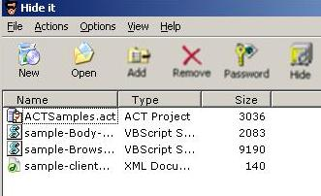

5. Extract Dialog Box:
Click the Show button on the Toolbar .The following dialog box appears on the screen. Click the Browse button and then choose the Folder where you want to extract your data to.
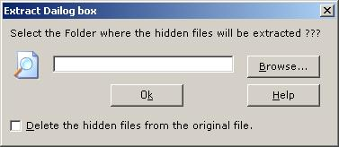

The Folder dialog box looks like the screenshot below.
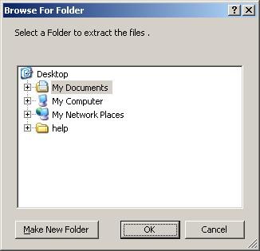

6.Removing Hidden Data:
If you want to remove the hidden data from the main file after extracting the data then click the checkbox given.
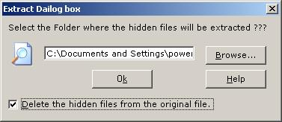

7.Finished:
Congrats You have successfully retrieved your Data.

5. Configuring the program:
The Program can be configured easily by checking or unchecking options in the configuration dialog box. For configuring click the 'Options menu' and choose 'Configure' from the menu. See the below screenshot.
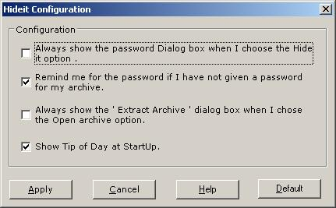

OPTIONS:
1.Always show the Password Dialog box when I chose the HideIt option.
2.Remind me for the password if I have not given a password for my archive.
3.Always show the 'Extract Archive' dialog box when I chose the Open Archive Option.
4.Show Tip of Day at startup.

Resetting the options
For resetting the options click the default button .

DESCRIPTION:
1.Always show the Password Dialog box when I chose the HideIt option.
When this option is checked the program shows the password box whenever you chose the Hideit option. By default this option is not enabled so you have to chose the password option separately if you have to password protect your archive.
2.Remind me for the password if I have not given a password for my archive.
When this option is chosen the program reminds you for the password every time you chose the hide option .It gives the option of whether you want to provide a password or not.
3.Always show the 'Extract Archive' dialog box when I chose the Open Archive Option.
When this option is chosen the program shows the extract dialog box whenever you chose to open the archive. By default this option is not enabled.
4.Show Tip of Day at startup.
This option when enabled shows the Tip of the day dialog box when the application starts.

Weakness:

The software like any other application has some weakness in it, which doesn’t make it suitable for very mission critical applications but it can be securely used by a home user or individual user. One of the weakness lies in the cryptography part. The application presently uses only a very basic form of XOR encryption. This type of encryption is not secure and can be easily broken by knowledgeable hackers.

Solution:

This problem can be eliminated by using a stronger algorithm such as Blowfish, RSA, DES, IDEA etc.

Programming Language:

The application is written using Visual Basic 6.

Hardware Requirements:

This software can run on any standard Pentium PC with a standard configuration.

Software Requirements:

Operating system: Windows9x,2000,XP.
Web browser: Any browser required for viewing the online HTML help.
Runtime Files: The vbruntime files are installed by the program setup during installation.

Other Documents:

The following documents are provided along with the synopsis.

- The application installation setup file.
- The Visual Basic source code.

